DECOLORIZATION OF REACTIVE ORANGE 16 DYE USING FABRICATED CHARCOAL BASE METALLIC COMPOSITE ELECTRODE

(Penyahwarnaan Pewarna Reaktif Oren 16 Menggunakan Elektrod Komposit Logam Berasaskan Arang)
Zuhailie Zakaria, Norazzizi Nordin, Siti Zubaidah Hasan, Noor Afzalina Baharuddin, Majd Ahmed Jumaah, Mohamed Rozali Othman*

School of Chemical Sciences and Food Technology,
Faculty of Science and Technology,
Universiti Kebangsaan Malaysia,
43600 UKM, Bangi Selangor, Malaysia

*Corresponding author: rozali@ukm.edu.my
Abstract
The effectiveness of charcoal base metallic composite electrodes using commercial activated charcoal was investigated to fabricate an effective and low cost electrode to decolorize textile industries wastewater. The mixture of charcoal-graphite-metal powder (first layer) and graphite powder-polyvinyl chloride (second layer) was mixed together and later pressed at 10 toncm⁻² to form two layers pellet. C.I. Reactive Orange 16 (RO16) was chosen as the model dye because of its high resistance towards conventional treatment methods while NaCl was selected as supporting electrolyte. The electrode efficiencies were determined by percentage of RO16 decolorization. The effect of metal used, PVC percentage, composition of charcoal and graphite and duration of electrolysis time were examined and the results indicated that application of charcoal base metallic composite electrode using pellet with the composition of C₃₀C^{G}₁₈Sn₁₂PVC₄₀-C^{G} ₆₀PVC₄₀ able to decolorized RO16 dye up to 83.3% respectively after 2 hours electrolysis time and increase proportionally with increase duration of electrolysis time. The study of activated charcoal base metallic composite electrode illustrated that reduction of PVC percentage also led to enhance in RO16 decolorization percentage. The decolorization of RO16 was determined by the changes of absorption spectrum intensity of azo chromophore (-N=N-) using UV-Vis spectrophotometer at λ = 388 and 492.50 nm.

Keywords: Activated charcoal, Reactive Orange 16, Composite, Decolorisation, Electrolysis.
Abstrak
Penggunaan elektrod komposit logam berasaskan arang menggunakan arang teraktif komersial dikaji untuk menghasilkan elektrod yang efektif dan berkos rendah dalam menyahwarna air buangan industri tekstil. Campuran serbuk arang-grafit-logam (lapisan pertama) dan serbuk grafit-polivinil klorida (lapisan kedua) dicampurkan dan kemudiannya dikenakan tekanan 10 tancm⁻² untuk menghasilkan dua lapisan pelet. C.I. Reaktif Oren 16 (RO16) dipilih sebagai pewarna contoh kerana ketahanannya yang tinggi terhadap kaedah perawatan konvensional manakala NaCl dipilih sebagai elektrolit penyokong. Keberkesanan elektrod ditentukan oleh peratus penyahwarnaan RO16. Kesan jenis logam yang digunakan, peratus PVC, komposisi arang dan grafit serta tempoh masa elektrolisis dikaji dan hasil kajian menunjukkan bahawa penggunaan elektrod komposit logam berasaskan arang menggunakan pelet dengan nisbah C₃₀ C^{G} ₁₈Sn₁₂PVC₄₀-C^{G} ₆₀PVC₄₀ berjaya menyahwarnakan RO16 sehingga 83.3% selepas 2 jam masa elektrolisis dan berkadar terus dengan peningkatan tempoh elektrolisis. Kajian terhadap elektrod komposit logam berasaskan arang teraktif menunjukkan bahawa penurunan peratus PVC juga membawa kepada peningkatan peratus penyahwarnaan RO16. Penyahwarnaan RO16 ditentukan oleh perubahan keamatan spektrum penyerapan kromofor azo (-N=N-) menggunakan spektrofotometer UV-Nampak pada λ = 388 dan 492.50 nm.

Kata kunci: Arang teraktif, Reaktif Oren 16, Komposit, Penyahwarnaan, Elektrolisis.

Introduction
Textile industry uses a lot of colorants and additional chemicals in coloring, printing and finishing process, thus, leads to production of great amounts of effluents [1, 2]. Effluent from reactive dye process cause a big environmental problem since the dye can give low degree of dye fixation to fabrics [3]. The textile dye wastewater usually has high pH, COD, temperature, strong color, low biodegrability, carcinogenic and toxic and due to their complex structure range (basic, acidic, azo, diazo, disperse, anthraquinone based and metal complex dyes), decolorization of dyes can be quite challenging [4-6]. The unfixed dyes with intense colored are extremely water soluble and highly resistant towards conventional treatment methods [3]. For over a century, electrochemical technologies such as electrodeposition, electroflotation, electrocoagulation and electrooxidation have been studied as the wastewater treatment processes. Electrodeposition is useful in recover heavy metals from wastewater stream, electroflotation is capable to eliminate oil and grease, colloidal particles and organic pollutants while electrocoagulation and electrooxidation also has been applied for wastewater treatment [7].

Research on electrooxidation for wastewater treatment began during 19th century when electrochemical decomposition of cyanide was examined and this method continues to attract considerable attention of modern day researchers [8]. The effectiveness of various electrodes in oxidizing different pollutants, study of factors which influence the process performance, enhancement of the electrochemical stability and electrocatalytic activity of the electrode materials, and investigation of the kinetics and mechanisms of degradation of pollutant have been focused for over the past 20 years [7]. This electrooxidation technique has been proven to be very powerful in treating textile dye wastewater [9]. The biodegradability of textile dye wastewater was reportedly improved after 18 minutes of electrolysis by using Ti/Pt electrode as anode and stainless steel as cathode [10]. Electrochemical process can be divided into direct oxidation or indirect oxidation process [11]. In indirect electrochemical oxidation process, the color removal and aromatic ring degradation of colored textile wastewater were performed successfully [12]. In addition, this method is safe for environment since the breakdown metabolites are mostly harmless [13, 14]. Electron is the main reagent used in electrochemical technologies are used, and it is known as ‘Clean Reagent’ [12]. Besides, there is no consumption of additional reagents and no by-product or sludge is produced during electrolysis [15].
The electrode materials selections are crucial to attain desire result in electrochemical oxidation process. In this work, activated charcoal was selected as the main element in the fabrication of charcoal base metallic composite electrode. Application of activated charcoal in water treatment is not a new discovery. Activated charcoal has emerged as a good adsorbent and capable to remove hazardous dyes from aqueous solutions [16], so base on this recovery, the use of charcoal may be suitable as the electrooxidation process may occur at the surface of anode. Activated charcoal also can be utilized to remove microorganisms in water treatment including gram-positives, gram-negatives, Candida albicans, Vahlkampfia avara, Leptospira biflexa and Trichomonas foetus [17]. Other report also reveals that polluting substances, such as arsenic, humic acid and phenol can be removed by using activated carbon from sugarcane bagasse and rice husk [18].
The aims of the present study are to fabricate low cost and environmentally friendly charcoal base metallic composite electrode and to study the decolorization of reactive orange 16 dye. UV-Vis spectrophotometer was utilized in order to gain information on degradation of RO16.
Materials and Methods

Chemicals, charcoal and dyestuff
Reactive Orange 16 (C.I. 17757) was chosen as the model dye, the solution of the dye was prepared by dissolving known amount commercially available dye in deionized water to give 1000 mg/L as stock solution. The chemical structure of RO16 is shown in Fig. 1. NaCl was purchased from R&M Chemicals and was used without further purification. Deionized water was utilized as solvent throughout this experiment. Commercial activated charcoal was obtained from BDH Chemicals.

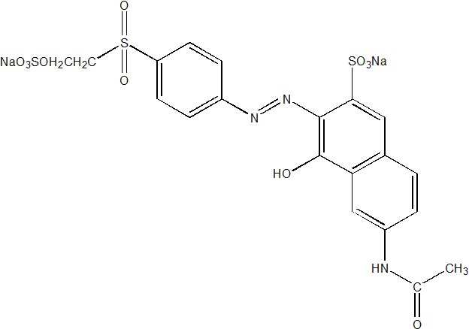

Figure 1. Chemical structure of Reactive Orange 16

Electrodes Preparation
The electrode preparation was carried out accordingly as published elsewhere [19]. The mixture of charcoal-graphite-metal powder and graphite powder-polyvinyl chloride (PVC) were mixed together and later pressed at 10 toncm⁻² to form two layers of combined pellet as illustrated in Figure 2. The total weighed of pellet produced is approximately 0.8g. The pellet was then attached to the silver wire at the second layer of electrode using silver paint and epoxy adhesive (DEVCON) (Figure 3).

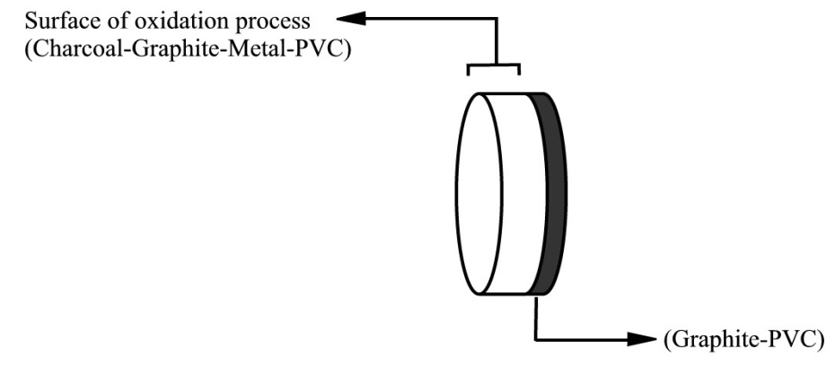

.

Figure 2. Two layers of pellet

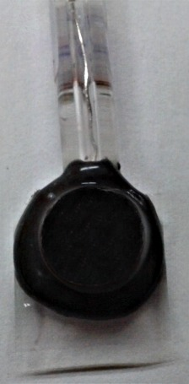

Ag wire

Glass tube

Epoxy adhesive
Anode surface
Glass slide

Figure 3. Electrode setting

Decolorisation of Reactive Orange 16 Dye
The study of RO16 decolorization was conducted at room temperature. 100 ml Pyrex glass cell was used as electrolysis cell. Charcoal base metallic composite electrode (charcoal-graphite-metal powder and graphite powder- PVC mixture) was used as anode while stainless steel rod was used as cathode. 1M NaCl and 200mg/L of RO16 solution were mixed and constantly stirred using magnetic stirrer to ensure a uniform concentration and to increase the mass transport of the electrolyte. The electrodes were then connected to the direct current power supply (TTi PSU Bench CPX400) and the electrolysis was performed at a fix voltage (10V). The experimental setup is as shown in Fig. 4. Approximately 3ml of electrolysis samples were taken and return at every 10, 20, 40, 60, 90 and 120 minutes to be measured using UV-Vis spectrophotometer during electrolysis process. The decolorization of RO16 was determined by the changes of absorption intensity of azo chromophore (-N=N-) at wavelength 492.50 nm.

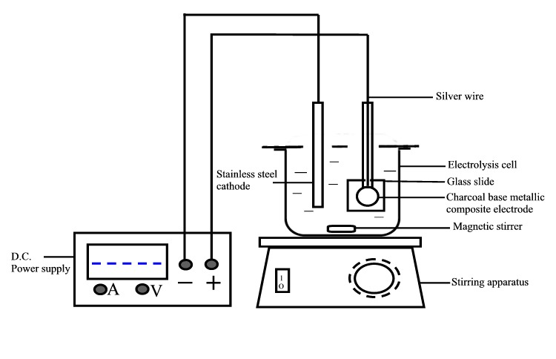

Figure 4. Experimental setup for electrolysis process

UV/Vis Spectra
The electrode efficiencies were determined by percentage of RO16 decolorization. The decolorization of RO16 was determined by the changes of absorption spectrum intensity of azo chromophore (-N=N-) using UV-Vis spectrophotometer. This paper will focus on two absorption bands of RO16 which located at 388 nm (caused by $π$-$π$* transitions due to aromatic rings bonded to the azo group) and 492.5 nm (caused by chromophobic azo compound n-$π$* transitions). Both of the bands contribute to appearance of strong orange color [20].

Results and discussion

Results obtained in the decolorizing process of 200 mg/L RO16 using different composition of charcoal base metallic composite electrode as anode is as summarized in Table 1.

Table 1. Summary of decolorization of reactive dyes (RO16) and observation on electrodes after 1 hour electrolysis time.
Electrode |  | Remarks
Layer 1 | Layer 2 | Decolorization | Precipitate | Observation on electrodes
C₄₀C^{G}₄₀ PVC₂₀ | - | No | No | Cracked
C₃₀C^{G}₃₀ PVC₄₀ | - | No | No | Cracked
C_{26.7}C^{G}_{26.7}Co_{26.7}-PVC₂₀ | C^{G}₈₀-PVC₂₀ | No | No | Unchange
C_{26.7}C^{G}_{26.7}Cu_{26.7}-PVC₂₀ | C^{G}₈₀-PVC₂₀ | No | Blue | Unchange
C_{26.7}C^{G}_{26.7}Sn_{26.7}-PVC₂₀ | C^{G}₈₀-PVC₂₀ | Yes | White | Unchange
C₅₆C^{G}₈Sn₁₆-PVC₂₀ | C^{G}₈₀-PVC₂₀ | Yes | White | Cracked
C₄₀C^{G}₂₄Sn₁₆-PVC₂₀ | C^{G}₈₀-PVC₂₀ | Yes | White | Cracked
C₃₂C^{G}₃₂Sn₁₆-PVC₂₀ | C^{G}₈₀-PVC₂₀ | Yes | White | Cracked
C₂₄C^{G}₄₀Sn₁₆-PVC₂₀ | C^{G}₈₀-PVC₂₀ | Yes | White | Unchange
C₈C^{G}₅₆Sn₁₆-PVC₂₀ | C^{G}₈₀-PVC₂₀ | Yes | White | Unchange
C₅₆C^{G}₁₆ Sn₈-PVC₂₀ | C^{G}₈₀-PVC₂₀ | - | - | Brittle electrode
C₄₀C^{G}₁₆ Sn₂₄-PVC₂₀ | C^{G}₈₀-PVC₂₀ | - | - | Brittle electrode
C₃₂C^{G}₁₆ Sn₃₂-PVC₂₀ | C^{G}₈₀-PVC₂₀ | Yes | Grey | Cracked
C₂₄C^{G}₁₆ Sn₄₀-PVC₂₀ | C^{G}₈₀-PVC₂₀ | Yes | Yellow & grey | Unchange
C₈C^{G}₁₆ Sn₅₆-PVC₂₀ | C^{G}₈₀-PVC₂₀ | Yes | White | Unchange
C₂₄C^{G}₂₄Sn₁₂-PVC₄₀ | C^{G} ₆₀-PVC₄₀ | Yes | White | Slightly cracked
C₃₀C^{G}₁₈Sn₁₂-PVC₄₀ | C^{G} ₆₀-PVC₄₀ | Yes | White | Slightly cracked

Table 1 summarizes all the electrodes fabricated for this study, their capability to decolorize RO16 dye and the observation on electrodes after electrolysis. Three different approaches of electrode fabrication were attempted which are type of metals, ratio of electrode composition and percentage of PVC. Pellets which consist of charcoal-graphite-PVC alone showed no ability to decolorize the dye solution and cracked after 1 hour electrolysis time. Metal was added to the composition and among the metals used, only tin (Sn) showed the potential to decolorize the dye. The ratio of charcoal, graphite and tin were varied to investigate the most durable electrode, yet, able to decolorize RO16 dye. Electrode with higher charcoal composition has lower mechanical strength. In order to enhance the mechanical strength of the pellet, percentage of PVC was increased. 40% of PVC was used instead of 20% of PVC. The precipitates observed in this study contain colored compounds possibly due to incomplete degradation of organic compound.

The charcoal base metallic composite electrode fabricated was made up of two layers of pellet. The first layer is the surface for oxidation process (Charcoal-graphite-metal powder-PVC), while the second layer was composed of graphite powder-PVC mixture which attached to the silver wire. The second layer was added because since the pellet contained charcoal as the main component, the resulting pellet became less dense, allowing solution to penetrate through where silver wire cannot be attached to the pellet completely.
Finally, C₃₀C^{G}₁₈Sn₁₂PVC₄₀-C^{G}₆₀PVC₄₀ composite was chosen as the final composition. Even though the ratio of charcoal in this pellet is high, it still maintained its good mechanical strength. Although electrode with lower ratio of charcoal and PVC such as C₈C^{G}₅₆Sn₁₆PVC₂₀-C^{G}₈₀PVC₂₀ gives better mechanical strength compared to C₃₀C^{G}₁₈Sn₁₂PVC₄₀-C^{G}₆₀PVC₄₀ composite, but the electrode material cost is higher than the latter electrode. As one of the objectives of this study was to fabricate low cost electrode with tolerable mechanical strength and its efficiency in removing color, the latter electrode was chosen. The charcoal base metallic composite electrode fabricated in this study has good quality as working electrode since it able to degrade RO16 dye, low cost and easily prepared.

Decolorization of Reactive Orange 16 dye: Effect of electrode composition
Figure 5 and 6 presents the effect of various ratios of CC^{G}SnPVC₂₀-C^{G}₈₀PVC₂₀ electrodes towards color removal. From the graph indicate that the higher the ratio of charcoal in the electrode, the efficiency to decolorize dye solution decreases. However, from this graph, it can be seen that the percentage of decolorization is still high and acceptable, thus, proven the ability of the electrodes to degrade the dye.

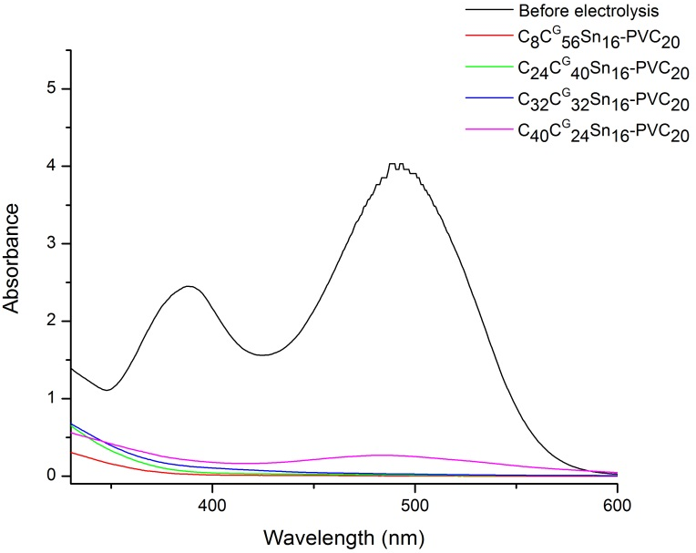

Figure 5. UV-Vis spectra of RO16 decolorization using various ratios of C-C^{G}-Sn -PVC₂₀ electrode (1st layer) (2nd layer consists of C^{G}₈₀-PVC₂₀)

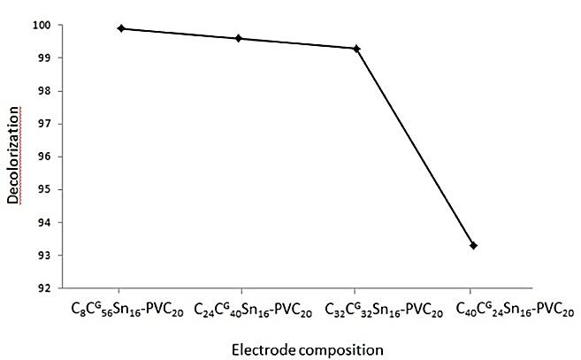

Figure 6. Effect of electrode composition (composition of the 2nd layer are C^{G}₈₀-PVC₂₀)
Effect of PVC percentage
The study of activated charcoal base metallic composite electrode illustrated that reduction of PVC percentage led to enhance in RO16 decolorization percentage. The effect of PVC percentages are shown in Fig. 7 and 8. The study was conducted using heterogenous size of commercial activated charcoal and the electrode pellets were prepared using 20 and 40% of PVC. The results imply that the electrode with higher percentage of PVC causes reduction in electrode efficiency to degrade RO16 dye, probably due to high electrical resistance to the pellet with high amount of PVC [21]. Thus, lower percentage of PVC has to be used. Nonetheless, this will decrease the compactness and mechanical strength, hence, contributing to easily breakable electrode. Electrode pellet fabricated using less than 20% of PVC cannot be used as electrode since it is very brittle and shattered before electrolysis process was conducted.

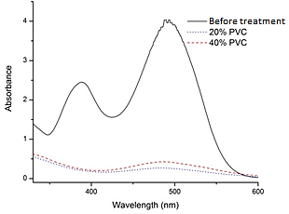

Figure 7. UV-Vis spectra of RO16 degradation of commercial activated charcoal base metallic composite electrode using 20% and 40% PVC.

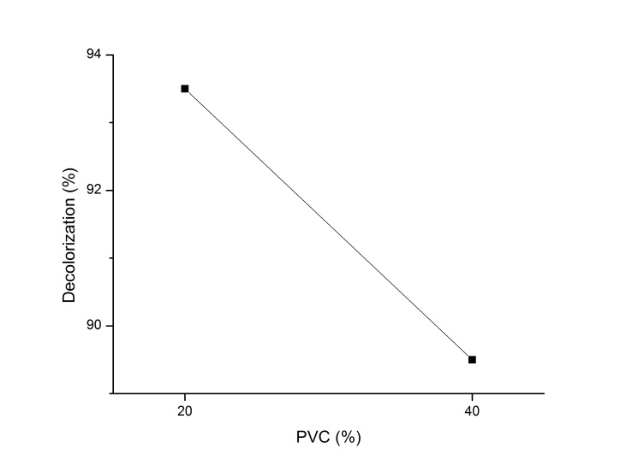

Figure 8. Effect of PVC percentage

Effect of electrolysis time
The experiments were conducted for two hours using the chosen electrode composition (C₃₀C^{G}₁₈Sn₁₂PVC₄₀-C^{G}₆₀PVC₄₀) and the results obtained are as shown in Fig. 9. Activated charcoal (commercial available) base metallic composite electrode was able to degrade RO16 up to 57.9% and 83.3% after 60 and after 120 minutes of electrolysis time respectively. As both of the peaks decrease, the intensity of RO16 color also decreases. The decreasing of the absorbance bands at 493 nm and 388 nm indicates the breakage of azo bonds and degradation of aromatic rings [20]. The efficiency of activated charcoal (commercial available) base metallic composite electrodes in degrading azo chromophore was proven since the two bands were almost vanished completely after being electrolyze for 120 minutes. The percentage of color removal increases proportionally with the electrolysis time.

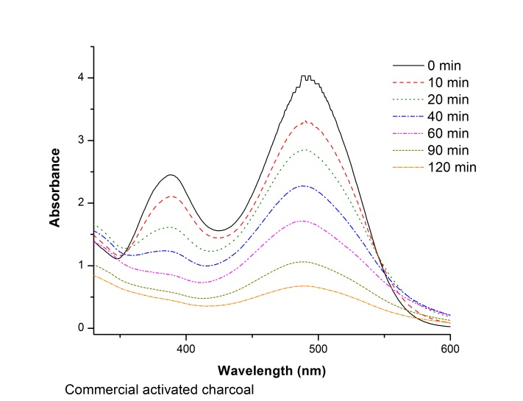

Figure 9. UV-visible spectral of RO16 degradation using activated charcoal (commercially available) base metallic composite electrode.
The degradation of RO16 dye (pollutant) in this experiment worked through electrooxidation process which involves direct anodic oxidation and indirect anodic oxidation. In the direct anodic oxidation process, the pollutant was absorbed on the charcoal base metallic composite electrode surface (anode). The anodic electron transfer reaction destroyed the pollutant [22]. Besides that, in an indirect oxidation process, the dye compound was destroyed in the bulk solution by oxidation reaction by strong electrochemical generated oxidants such as hypochlorite and chlorine [23]. The hypochlorite/chlorine was converted from chloride ion from sodium chloride that was used as supporting electrolyte in this experiment.

The anode material is one of the factors that contribute to the effectiveness of electrode to decolorize RO16 solution. Charcoal is acknowledged as excellent adsorbent while graphite and tin are known as good electric conductor. Besides, graphite also has potential as electrocatalyst [16, 24].

Cost estimation for different types of electrode
Table 2 presents the example of different anodes used in the study on decolorization of reactive dyes and cost estimated for different type of electrodes. The first electrode in the table is the charcoal base metallic composite electrode fabricated in this work. Even though this electrode took the longest time to decolorize reactive dye, the cost of the charcoal base metallic composite electrode is the lowest.
Type of Electrode | Decolorization |  | Type Commercial Dye | Energy consumption (kWh/L) | COD Removal (%) | Cost (RM) |  |  | Ref.
Type of Electrode | Time  (min) | (%) | Type Commercial Dye | Energy consumption (kWh/L) | COD Removal (%) | Electrode material (RM/ electrode) | Energy consumption (kWh/g _{COD removal}) | Total  (RM/g _{COD removal}) | Ref.
C₃₀C^{G}₁₈Sn₁₂PVC₄₀- C^{G} ₆₀PVC₄₀ composite | 120 | 83.3 | Reactive Orange 16 | 0.03 | 44 | 2.52 | 110 | 43.22 | -
Ag_{28.5} C^{G} _{66.5}PVC₅ composite | 100 | 99 | Reactive Orange 4 | 0.80 | 91 | 20.84 | 122 | 65.98 | [25]
Graphite rod | 60 | 99 | Reactive Blue 109 | 0.08 | 89 | 1989.94 | 55 | 2010.29 | [9]
Palladium plate | 85 | 98 | Reactive Blue 109 | 0.08 | 73 | 2112.65 | 67 | 2137.44 | [9]
Iridium plate | 45 | 99 | Reactive Blue 109 | 0.08 | 81 | 7500.54 | 61 | 7523.11 | [9]
Platinum plate | 30 | 99 | Reactive Blue 109 | 0.08 | 94 | 6275.46 | 52 | 6294.70 | [9]
Table 2. Example of different anodes used in the study on decolorization of reactive dyes and cost estimation.

Conclusions
In this study, the efficiency in decolorization of RO16 dye using low cost and environmentally friendly fabricated commercial activated charcoal base metallic composite electrodes performed successfully. The reduction of the absorption bands can be observed after 120 minutes (83.3 %). From the result obtained, it can be concluded that commercial activated charcoal base metallic composite electrodes have good potential in degrading RO16 textile dye and the optimum composition of the electrode is C₃₀C^{G}₁₈Sn₁₂PVC₄₀-C^{G}₆₀PVC₄₀. The reduction of PVC amount used in the pellet might help to improve the efficiency of the electrodes. Nevertheless, we have to find a way to avoid the decreases of mechanical strength of the pellet.
Acknowledgement
The authors are grateful to Department of Chemistry and Food Technology, Faculty of Science and Technology, Universiti Kebangsaan Malaysia for instrumental facilities and grant FRGS/2/2013/SG01/UKM/01/1 for the financial support.
References
- López-Grimau, V. and Gutierrez, M. (2006) Decolourisation of simulated reactive dyebath effluents by electrochemical oxidation assisted by UV light. Chemosphere 62(1): 106-112.
- Gonçalves, M. S. T., Pinto, E. M. S., Nkeonye, P. and Oliveira-Campos, A. M. F. (2005) Degradation of C.I. Reactive Orange 4 and its simulated dyebath wastewater by heterogeneous photocatalysis. Dyes and Pigments 64(2): 135-139.
- Willmott, N., Guthrie, J. and Nelson, G. (1998) The biotechnology approach to colour removal from textile effluent. Journal of the Society of Dyers and Colourists 114(2): 38-41.
- Liakou, S., Pavlou, S. and Lyberatos, G. (1997) Ozonation of azo dyes. Water Science and Technology 35(4): 279-286.
- Šíma, J. and Hasal, P. (2013) Photocatalytic Degradation of Textile Dyes in a TiO2/UV System. Chemical Engineering 32.
- Robinson, T., Mcmullan, G., Marchant, R. and Nigam, P. (2001) Remediation of dyes in textile effluent: a critical review on current treatment technologies with a proposed alternative. Bioresource technology 77(3): 247-255.
- Chen, G. (2004) Electrochemical technologies in wastewater treatment. Separation and purification Technology 38(1): 11-41.
- Kuhn, A.T. (1971) Electrolytic decomposition of cyanides, phenols and thiocyanates in effluent streams—a literature review. Journal of Applied Chemistry and Biotechnology 21(2): 29-34.
- Nordin, N., Amir, S. F. M., Riyanto and Othman, M. R. (2013) Textile Industries Wastewater Treatment by Electrochemical Oxidation Technique Using Metal Plate. International Journal of Electrochemical Science 8(9): 11403-11415.
- Vlyssides, A.G., Loizidou, M., Karlis, P. K., Zorpas, A. A. and Papaioannou, D. (1999) Electrochemical oxidation of a textile dye wastewater using a Pt/Ti electrode. Journal of Hazardous Materials 70(1–2): 41-52.
- Rajeshwar, K., Ibanez, J.G. and Swain, G.M. (1994) Electrochemistry and the environment. Journal of Applied Electrochemistry 24(11): 1077-1091.
- Maljaei, A., Arami, M. and Mahmoodi, N.M. (2009) Decolorization and aromatic ring degradation of colored textile wastewater using indirect electrochemical oxidation method. Desalination 249(3): 1074-1078.
- Öğütveren, Ü.B. and Koparal, S. (1994) Color removal from textile effluents by electrochemical destruction. Journal of Environmental Science and Health . Part A: Environmental Science and Engineering and Toxicology 29(1): 1-16.
- Pelegrini, R., Peralta-Zamora, P., De Andrade, A. R., Reyes, J. and Durán, N. (1999) Electrochemically assisted photocatalytic degradation of reactive dyes. Applied Catalysis B: Environmental 22(2): 83-90.
- Andrade, L.S., Tasso, T. T., Da Silva, D. L., Rocha-Filho, R. C., Bocchi, N. and Biaggio, S. R. (2009) On the performances of lead dioxide and boron-doped diamond electrodes in the anodic oxidation of simulated wastewater containing the Reactive Orange 16 dye. Electrochimica Acta 54(7): 2024-2030.
- Iqbal, M.J. and Ashiq, M.N. (2007) Adsorption of dyes from aqueous solutions on activated charcoal. Journal of Hazardous Materials 139(1): 57-66.
- Van Duck, P.J. and van de Voorde, H. (1984 )Activated charcoal and microflora in water treatment. Water Research 18(11): 1361-1364.
- Kalderis, D., Koutoulakis, D., Paraskeva, P., Diamadopoulos, E., Otal, E., Valle, J. O. D. and Fernández-Pereira, C. (2008) Adsorption of polluting substances on activated carbons prepared from rice husk and sugarcane bagasse. Chemical Engineering Journal 144(1): 42-50.
- Riyanto, Salimon, J. and Othman, M. R. (2007) Perbandingan hasil pengoksidaan elektrokimia etanol dalam larutan alkali yang menggunakan elektrod platinumpolivinilklorida (Pt-PVC) dan kepingan logam Pt. Sains Malaysiana 36(2): 175-181.
- Migliorini, F.L., Braga, N. A., Alves, S. A., Lanza, M. R. V., Baldan, M. R. and Ferreira, N. G. (2011) Anodic oxidation of wastewater containing the Reactive Orange 16 Dye using heavily boron-doped diamond electrodes. Journal of Hazardous Materials 192(3): 1683-1689.
- Albertús, F., Llerena, A., Alpı́Zar, J., Cerdá, V., Luque, M., Rı́Os, A. and Valcárcel, M. (1997) A PVC–graphite composite electrode for electroanalytical use. Preparation and some applications. Analytica chimica acta 355(1): 23-32.
- Chatzisymeon, E., Xekoukoulotakis, N. P., Coz, A., Kalogerakis, N. and Mantzavinos, D. (2006) Electrochemical treatment of textile dyes and dyehouse effluents. Journal of Hazardous Materials 137(2): 998-1007.
- Rajkumar, D. and Kim, J.G. (2006) Oxidation of various reactive dyes with in situ electro-generated active chlorine for textile dyeing industry wastewater treatment. Journal of Hazardous Materials 136(2): 203-212.
- Moore, R.R., Banks, C.E. and Compton, R.G. (2004) Basal plane pyrolytic graphite modified electrodes: Comparison of carbon nanotubes and graphite powder as electrocatalysts. Analytical Chemistry 76(10): 2677-2682.
- Nordin, N. (2012) Penggunaan elektrod komposit dalam penyahwarnaan air sisa industri tekstil melalui pengoksidaan elektrokimia. Tesis Sarjana, Universiti Kebangsaan Malaysia, Bangi.

