

COMPARISON OF THREE SAMPLE PREPARATION METHODS FOR ANALYIS OF CHEMICAL WARFARE AGENT
SIMULANTS IN WATER

(Perbandingan Tiga Kaedah Penyediaan Sampel bagi Analisis Agen Simulan Senjata Kimia
di dalam Air)

Alessandro Sassolini^{1,4}*, Andrea Malizia^{1,2}, Fabrizio D’Amico^{1,2}, Orlando Cenciarelli^{1,2}, Mariachiara Carestia^{1,2}, Daniele Di Giovanni^{1,2}, Leonardo Palombi^{2,3}, Maurizio Guidotti⁴, Carlo Bellecci^{1,2}, Pasquale Gaudio^{1,2}

¹Department of Industrial Engineering,
²Department of Industrial Engineering and School of Medicine and Surgery,
³Department of Bio-Medical & Prevention, School of Medicine and Surgery,
University of Rome Tor Vergata, Rome, Italy
⁴Regional Agency of Environmental Protection, Rieti, Italy

*Corresponding author: alessandro.sassolini@arpalazio.it

Received: 9 March 2015; Accepted: 5 April 2015

Abstract
Analytical chemistry in CBRNe (Chemical Biological Radiological Nuclear explosive) context requires not only high quality data; quickness, ruggedness and robustness are also mandatory. In this work, three samples preparation methods were compared using several organophosphorus pesticides as test compounds, used as simulants of nerve CWA (Chemical Warfare Agents) to choose the one with best characteristics. Result was obtained better with the Dispersive Liquid-Liquid Micro Extraction (DLLME), relatively new in CBRNe field, obtaining uncertainty for different simulants between 8 and 15% while a quantification limit between 0.01 and 0.08 µg/l. To optimize this extraction method, different organochlorinated solvents also tested but not relevant difference in these tests was obtained. In this work, all samples were analyzed by using a gas chromatography coupled with mass spectrometer (GC-MS) and also with Gas Chromatograph coupled with Nitrogen Phosphorous Detector (NPD) for DLLME samples to evaluate a low cost and rugged instrument adapt to field analytical methods with good performance in terms of uncertainty and sensibility even if poorer respect to the mass spectrometry.

Keywords: NBC deployable laboratory, CBRNe, chemical warfare agents, dispersive micro liquid - liquid extraction, nerve agent simulants

Abstrak

Kontek analisis kimia di CBRNe (letupan radiologikal nuclear kimia biologi) memerlukan bukan hanya data yang berkualiti tinggi; kepantasan, kelasakan dan ketegugan juga adalah mandatori. Di dalam kajian ini, tiga kaedah penyediaan sampel dibandingkan menggunakan beberapa racun perosak organofosforus sebagai sebatian ujian, yang digunakan sebagai simulan CWA (Agen Senjata Kimia) untuk memilih ciri-ciri terbaik. Keputusan yang diperolehi adalah lebih baik dengan kaedah Pengekstrakan Mikro Cecair - Cecair Serakan (DLLME), yang agak baru di dalam bidang CBRNe, yakni ujian ketakpastian bagi simulant berbeza di antara 8 dan 15% manakala had kuantifikasi di antara 0.01 dan 0.08 μg/l. Untuk mengoptimumkan kaedah pengekstrakan ini, pelarut organoklorin berbeza juga diuji tetapi perbezaan tidak relevan telah diperolehi di dalam kajian ini. Di dalam kajian ini, semua sampel telah dianalisis dengan menggunakan kromatografi gas bergabung dengan pengesan spektrometer jism (GC-MS) dan juga kromatografi gas bergabung dengan pengesan nitrogen fosforus (NPD) untuk sampel DLLME untuk menilai kebolehupayaan instumen yang kos rendah dan lasak dengan prestasi yang baik dari aspek ketakpastian dan sensitif meskipun kurang berbanding spektrometri jisim

Kata kunci: Makmal NBC, CBRNe, agen senjata kimia, pengekstrakan mikro cecair – cecair serakan, ejen saraf simulan

Introduction
CBRNe risks represent a real concern for both safety and security. The radiological disasters of Fukushima and Chernobyl, the chemical disasters of Bhopal and Seveso, the recent use of nerve agents in Syria or the biological emergencies such as the H1N1 flu epidemic represent just few examples of CBRNe accidents that can be due either to intentional and un-intentional events. An efficient defense strategy based on a complex set of tools that include protection of critical infrastructures [1,2,3], predictive simulations of attack’s consequences [4,5] and study of real case happened [6] are a basic requirement to mitigate the effects of a CBRNe event. In this context, analytical capabilities represent key competences and are important for different tasks: ion mobility based techniques are frequently used in the field of methods detection [7,8]. However in some situations, gas chromatography can be a useful alternative [9]. Laboratory identification methods commonly use separation technologies [10] integrated with different spectrometric techniques [11, 12]. In 2005, the NATO STANAG 4632 proposed the minimal requirements and capabilities of CBRNe deployable laboratories. The mentioned standardization agreement is an attempt to make available high analytical capabilities on site, where the threat of modern CBRNe is higher, and they represent a useful help to manage CBRNe disasters and to monitor environmental pollution during field operation. Chemical deployable analytical laboratories have a great potential, however they require affordable but not too much complicated protocols, because the personnel operating in these structures usually have a lower technical profile in training and formation respect to scientific technicians working in a homeland reference laboratory.

Some specific analytical protocols have been proposed; for example, the Organization for the Prohibition of Chemical Weapons (OPCW) and United States of America Environmental Protection Agency (EPA) developed field methods [13, 14] for sample preparation and analysis are based on Liquid - Liquid Extraction (LLE), both with dichloromethane as extracting solvent. Further example is analytical methods based on Solid Phase Micro Extraction [15, 16] (SPME). This technique was developed during the nineties for environmental application is now well known in CBRN field. Although both approaches are extensively tested, they show some critical aspects from a field analytical point of view. For example, LLE need several minutes and have a poor sensibility if not followed by solvent evaporation which is time consuming and not always easy in fieldwork. Meanwhile SPME method needs more or less time but the problem that there are some difficulties to optimize the analytical method and store samples for later work or forensic needs. A third way is recently available, the Dispersive Liquid - Liquid Micro Extraction (DLLME), which this method already has been well referenced [17 - 21] for environmental pollutants.

The first aim of this work is to compare these different analytical methods and evaluate their fastness and their analytical performance, both in terms of sensibility and reproducibility, in order to choose the best extraction protocol for use in CBRNe deployable laboratories. The second aim is to optimize and evaluate thoroughly DLMME method that is still new in CBRNe sector. In this work, organophosphorus pesticides as nerve agent simulants were used due to their chemical similarity with real agents [22].

Materials and Methods
Preparation of standards
Nerve agent simulants used following pesticides: Dichlorvos (CAS 62-73-7), Parathion ethyl (CAS 56-38-2), Ethion (CAS 563-12-2) and Azinphos-ethyl (CAS 2642-71-9) were purchased from Dr Erhenstorfer GmbH, Augsburg, Germany; Fenitrothion (CAS 122-14-5) and Malathion (CAS 121-75-5) were purchased from Riedel de Haen AG, Seelze, Germany. Standards were prepared by dissolving each pesticide in ultrapure acetone (Fluka GmbH, Seelze, Germany) to a final concentration of 5µg/ml.

Sample’s size for every preparation technique is 35 ml of spiked water sample that was put in a 40ml vial already containing 1 g of sodium chloride (Sigma Aldrich, St. Louis, MO, USA) and 1 ml of phosphate buffer solution (PBS) at pH 7 (Sigma Aldrich, St. Louis, MO, USA) to improve the extractions.

Sample Preparation of Liquid – Liquid Extraction (LLE)
Sample was added to the vial containing 5 ml of dichloromethane then vortexed for 2 minutes, leave for few minutes to allow phase separation. Then 1 ml of this solvent was transferred into vial for further GC-MS analysis.

Sample Preparation of Solid Phase Micro Extraction (SPME)
The direct immersion of SPME approach was used in this study. For organophosphorus pesticides, 100 µm coated PolyDiMethylSiloxane (PDMS) fiber (Supelco from Sigma Aldrich, St. Louis, MO, USA) was used according to proprietary [23] and scientific literature [24]. The fiber was immersed for 10 minutes in the water’s samples which stirred using magnetic stirrer at room temperature. The fiber was retracted and desorbed in GC-MS injector for analysis.

Sample Preparation of Dispersive Liquid – Liquid Micro Extraction (DLLME)
The technique use two different organic solvents mixed: the first one, defined as dispersant, is water-soluble; the other one, which represents the real extraction solvent, is insoluble in H₂O. This second solvent, defined as extracting, is present in minor amount and it is denser then water, in order to facilitate the subsequent recovery phase. After the mixing of the two solvents in an aqueous phase, they separate instantly: the organic pollutants that could be present in the water sample move to the extracting solvent, which, being hydrophobic and denser than water, precipitates on the bottom of glassware and then was recovered and analyzed with the most appropriate technique. Time needed for the extraction is less than a minute, as extracting solvent in this work have been used 350 µl of a chlorinated solvent. In this work, 6.650 ml of ultrapure acetone (Fluka GmbH, Seelze, Germany) was used as disperser solvent. Solvents mixture was added to samples with a dispenser and
200µl of the hydrophobic phase containing nerve agent simulants was recovered and put it in a vial for the further analysis. During the comparison of DLMME with other techniques, carbon tetrachloride have been used obtained (CAS 56-23-5) from Carlo Erba, Milano, Italy, its relative density is 1.58 g/cm³.

During the DLMME optimization phase, another two chlorinated extracting solvents: tetrachloroethylene (CAS 127-18-4) and trichloroethylene (CAS 79-01-6) also have been used (Carlo Erba, Milano, Italy). Relative density (g/cm³) of the extraction solvents are the following: tetrachloroethylene (1.62) and trichloroethylene (1.46). Only during the optimization phase, Phenanthrene-D₁₀ (PhD10) (CAS 1517-22-2) used was pursued by Sigma Aldrich (St. Louis, MO, USA) as syringe and process standard, dissolved in chlorinated extraction solvents, at concentration of 5 µg/ml to increase the control of the extraction process.

Gas Chromatographic Analysis
The instrument used in this work is a GC Agilent 7890 equipped with a MS 5975 and with an auto sampler 7693. The GC working conditions for MS analysis were: column HP5MS; length = 30 m; ID = 0.25 mm; initial oven temperature = 100 °C, for 3 min; temperature rise rate = 10 °C min⁻¹ up to 210 °C, 3 °C min⁻¹ up to 250 °C and 10 °C min⁻¹ up to 300 °C for 2 min. Carrier gas = He; inlet mode is splitless at 250 °C. Sample volume injected=1 μl; transfer line temperature = 300 °C. Only for injection with SPME the inlet temperature was 270 °C with splitless mode.

A second GC Agilent 7890 equipped with an Nitrogen Phosphorous Detector (GC-NPD) was used in this work only for sample prepared with DLLME, to evaluate the performance of a simpler, rugged and less expensive instrument that could be, however, easier to manage in a deployable lab. The GC conditions for NPD equipped instrument were: column HP5MS; length = 30 m; ID = 0.25 mm; initial oven temperature = 100 °C for 1 min; temperature rise rate = 20 °C min⁻¹ up to 300 °C for 4 min; carrier gas = He; inlet mode is spitless at 250 °C; sample volume injected = 2 μl; NPD temperature = 290 °C; hydrogen flow = 3 ml min⁻¹; air flow = 60 ml min⁻¹; makeup = nitrogen at 30 flow = 30 ml min⁻¹.

Results and Discussion
Comparison of Extraction Methods
Water samples used for analysis came from different Italian lakes in order to simulate real conditions. The Relative Standard Deviation (RSD) from a set of six independent experimental tests at spiked concentration for each simulant of 5µg/l, represent data uncertainty (see Table 1). The Limit of Quantification (LOQ) was calculated for the Mass Spectrometer as the concentration corresponding (signal) to an instrumental response (noise) that is ten times the average background in an extracted blank sample (Table 1). Considering both uncertainty and sensibility, the extraction method with best performance is DLLME, which obtain a lower RSD and offer approximately the same LOQ of SPME. The poor performance of the liquid - liquid extraction (LLE) are expected, mainly due to the single extraction and the lack of the usual reduction step of the solvent’s volume that simulating the field condition cannot be done. However, more surprising are the high uncertainties associated to the SPME extraction, probably caused by short time used in this step, which has probably prevented the establishment of a stable equilibrium between SPME and water, thus reducing the reproducibility of the measurements.

Table 1. LOQ and RSD with LLE, SPME and DLMME using 6 replicates
Simulant | RSD  USING  LL (%) | MSD – LOQ  (µg/l) | RSD  USING  SPME (%) | MSD – LOQ  (µg/l) | RSD  USING  DLLME (%) | LOQ  (µg/l)
Dichlorvos | 25 | 0.2 | 25 | 0.05 | 8 | 0.01
Fenitrothion | 27 | 2.5 | 33 | 0.5 | 11 | 0.01
Malathion | 30 | 0.8 | 45 | 0.06 | 10 | 0.03
Parathion ethyl | 23 | 0.6 | 30 | 0.01 | 15 | 0.01
Ethion | 31 | 0.25 | 50 | 0.03 | 12 | 0.01
Azinphos ethyl | 30 | 2.5 | 46 | 0.05 | 11 | 0.08

Evaluation of Different Solvents in DLLME
Figure 1 shows a GC-MS standard chromatogram. Four different standard levels of concentration (0.05, 0.1, 0.2, 0.5 µg/ml) were considered and the response linearity of was evaluated for each analyte from R². A calibration curve of sample was reported in Figure 3 and the R² values for all the simulants in Table 3. In Figure 2, a typical GC-MS chromatogram, was showed which obtained from the analysis of the recovered pesticide pollutant in water. Phenanthrene-D₁₀ was added to chlorinated solvent in concentration of 5µg/ml both as syringe and as internal standard, to allow the control of the extraction process and reduce the uncertainty correcting the volume of injection. Also in this phase, six independent experimental tests was performed to calculate the RSD for the three extracting solvent evaluated (Table 2). In these tests, the final spiking concentration was 5µg/l for each simulant and it can be considered acceptable for all the simulants. Calculation of both LOQ for Mass Spectrometer and NPD detector follow the same rule expressed in previous paragraph, the instrumental response corresponding to a concentration ten times the average background in an extracted blank sample (Table 2).

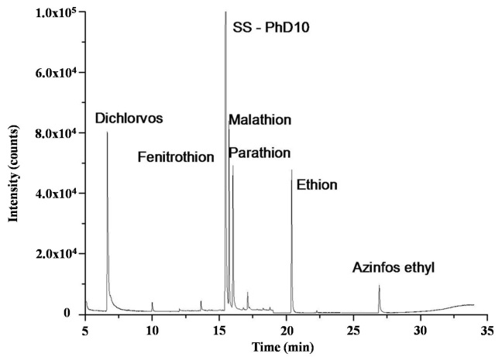

Figure 1. GC-MS standard full scan chromatogram (Phenanthrene-D₁₀ as syringe and process standard).
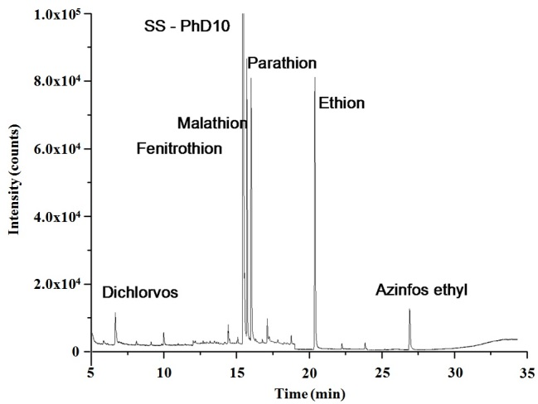

Figure 2. GC-MS full scan chromatogram of spiked sample extracted with carbon tetrachloride (Phenanthrene-D₁₀ as syringe and process standard).

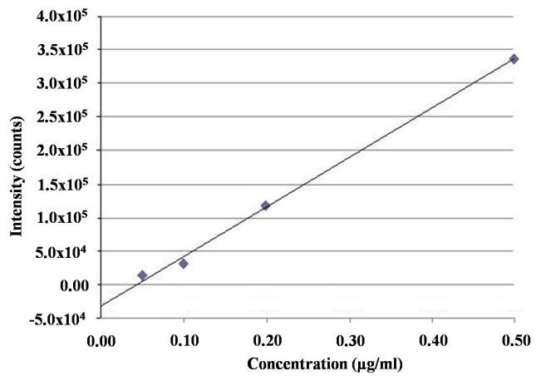

Figure 3. Calibration curve obtained using Azinphos ethyl at four level of concentrations.

Table 2. Analytical accuracy evaluation for the simulants extraction using carbon tetrachloride as solvent.
Simulant | RSD | R² | MSD – LOQ  (µg/l) | NPD – LOQ  (µg/l)
Dichlorvos | 7.6% | 0.99 | 0.01 | 0.05
Fenitrothion | 6.6% | 0.99 | 0.01 | 0.05
Malathion | 5.3% | 1.00 | 0.03 | 0.03
Parathion ethyl | 10.7% | 1.00 | 0.01 | 0.03
Ethion | 12.0% | 0.99 | 0.01 | 0.06
Azinphos ethyl | 7.8% | 1.00 | 0.08 | 0.15

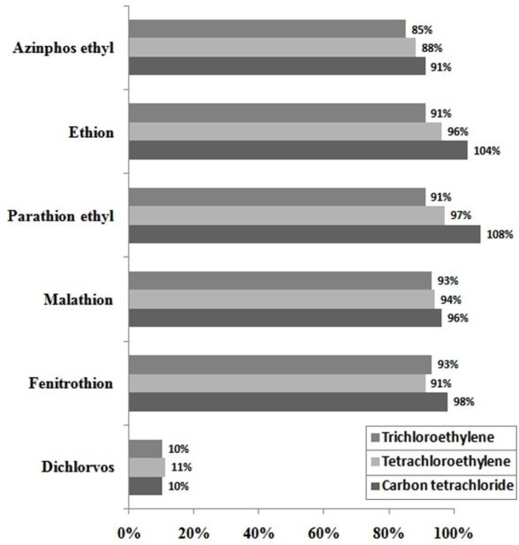

Figure 4. Recovery of simulants from water samples using different extraction solvent.

In between the three chlorinated solvents used in DLMME, there is only a slightly difference in efficiency in advantage of carbon tetrachloride, the other two extraction solvents show only small differences in efficiency compared to carbon tetrachloride. All tested pesticides have good recovery with the exception of Dichlorvos, as shown in Figure 4. This result is due to high volatility and solubility in water of this compound respect to the other tested pesticides.

Conclusion
Sample preparation can be more time consuming and more complex than the analysis itself, and it represents a critical step to obtain good analytical results but this aspect is often overlooked respect to the choice of instrumentation. The DMLLE method compared with others sample preparation techniques offers high sensibility, low uncertainty but also quickness, easiness of use and ruggedness. All these features are very important for NBC deployable laboratory activities: decision makers need to know from analysts, as soon as possible, the nature of the contamination, in order to apply the appropriate countermeasures. Indeed the time factor is crucial in the response to a CBRN event. The NBC labs, often deployed in inhospitable areas of the world to prevent and contrast the effects of a possible CBRN event, can apply this method to conjugate the needs of obtaining good analytical data and working in field conditions also with instruments as GC-NPD that have less logistic need respect to GC-MS.

Acknowledgement
Special acknowledgment for the support received to realize this work goes to the Directive Board of International Master Courses in Protection against CBRNe events (http://www.mastercbrn.com).

References
- Brown, G., Carlyle, M., Salmerón, J., and Wood, K. (2006). Defending critical infrastructure. Interfaces, 36(6): 530-544.
- Rinaldi, S.M., Peerenboom, J.P., and Kelly, T.K. (2001). Identifying, understanding, and analyzing critical infrastructure interdependencies. Control Systems, IEEE, 21(6):11-25.
- Sassolini, A., Malizia, A., D’Amico, F., Carestia, M., Di Giovanni, D., Cenciarelli, O., Bellecci, C., and Gaudio, P. (2014). Evaluation of the effectiveness of titanium dioxide (TiO₂) self cleaning coating for increased protection against CBRN incidents in critical infrastructures. Defense S&T Technical Bulletin, 7(1): 9-17.
- Wein, L.M., and Liu, Y. (2005). Analyzing a bioterror attack on the food supply: the case of botulinum toxin in milk. Proceedings of the National Academy of Sciences of the United States of America, 102(28): 9984-9989.
- Cacciotti, I., Aspetti, P.C., Cenciarelli, O., Carestia, M., Di Giovanni, D., Malizia, A., D’Amico, F., Sassolini, A., Bellecci, C., and Gaudio, P. (2014). Simulation of Caesium-137 (¹³⁷Cs) local diffusion as a consequence of the Chernobyl Accident Using Hotspot. Defence S&T Technical Bulletin, 7(1): 18-26.
- Cenciarelli, O., Pietropaoli, S., Frusteri, L., Malizia, A., Carestia, M., D'Amico, F., Sassolini, A., Di Giovanni, D., Tamburrini, A., Palombi, L., Bellecci, C., and Gaudio, P. (2014). Biological emergency management: the case of Ebola 2014 and the air transportation involvement. Journal of Microbial Biochemistry and Technology, 6: 247-253.
- Steiner, W.E., Klopsch, S.J., English, W.A., Clowers, B.H., and Hill, H.H. (2005). Detection of a chemical warfare agent simulant in various aerosol matrixes by ion mobility time-of-flight mass spectrometry. Analytical chemistry, 77(15), 4792-4799.
- Mäkinen, M. A., Anttalainen, O. A., and Sillanpää, M. E. (2010). Ion mobility spectrometry and its applications in detection of chemical warfare agents. Analytical chemistry, 82(23): 9594-9600.
- Smith, P. A., Koch, D., Hook, G.L., Erickson, R.P., Jackson Lepage, C.R., Wyatt, H.D., Betsinger, G., and Eckenrode, B.A. (2004). Detection of gas-phase chemical warfare agents using field-portable gas chromatography–mass spectrometry systems: instrument and sampling strategy considerations. TrAC Trends in Analytical Chemistry, 23(4): 296-306.
- Hooijschuur, E.W., Hulst, A.G., De Jong, A.L., de Reuver, L.P., van Krimpen, S.H., van Baar, B.L., Wils, E.R.J., Kientz. C.E., and Brinkman, U.A.T. (2002). Identification of chemicals related to the chemical weapons convention during an interlaboratory proficiency test. TrAC Trends in Analytical Chemistry, 21(2): 116-130.
- Hooijschuur, E. W., Kientz, C. E., & Brinkman, U. A. T. (2002). Analytical separation techniques for the determination of chemical warfare agents. Journal of Chromatography A, 982(2): 177-200.
- Sigeikin G., Rybalchencko I.V., and Kireyev A.F. (2007). General strategy for identification of toxic chemicals and relevant compounds in verification laboratory. Atlantic Association for Research in the Mathematical Sciences, 6(1): 9-15.
- Technical Secretariat of the OPCW. (2009). Agilent 6850 GC with 5975 series or upgraded 5973 inert MSD on-site analysis. The Hague, QDOC/LAB/WI/GCMS10, Rev. 0, Annex 3.
- United States Environmental Protection Agency (EPA). (2007). Method 3571: Extraction of solid and aqueous samples for chemical agents. Available on Line at: http://www.epa.gov/osw/hazard/testmethods/pdfs/3571.pdf. Last Access: July 28, 2014.
- Popiel, S., and Sankowska, M. (2011). Determination of chemical warfare agents and related compounds in environmental samples by solid-phase microextraction with gas chromatography. Journal of Chromatography A, 1218 (47), 8457-8479.
- Kimm, G. L. (2002). Application of Headspace Solid Phase Microextraction and Gas Chromatography/Mass Spectrometry for Rapid Detection of the Chemical Warfare Agent Sulfur Mustard. Uniformed Services University of The Health Sciences, Bethesda, MD. Department of Preventive Medicine and Biometrics.
- Berijani, S., Assadi, Y., Anbia, M., Milani Hosseini, M.R., and Aghaee, E. (2006). Dispersive liquid–liquid microextraction combined with gas chromatography-flame photometric detection: Very simple, rapid and sensitive method for the determination of organophosphorus pesticides in water. Journal of Chromatography A, 1123(1): 1-9.
- Cheng, J., Zhou, Y., Zuo, M., Dai, L., and Guo, X. (2010). Application of dispersive liquid–liquid microextraction and reversed phase-high performance liquid chromatography for the determination of two fungicides in environmental water samples. International Journal of Environmental and Analytical Chemistry, 90(11): 845-855.
- Fattahi, N., Assadi, Y., Hosseini, M.R.M., and Jahromi, E.Z. (2007). Determination of chlorophenols in water samples using simultaneous dispersive liquid–liquid microextraction and derivatization followed by gas chromatography-electron-capture detection. Journal of Chromatography A, 1157(1), 23-29.
- Rezaee, M., Assadi, Y., Milani Hosseini, M.R., Aghaee, E., Ahmadi, F., and Berijani, S. (2006). Determination of organic compounds in water using dispersive liquid–liquid microextraction. Journal of Chromatography A, 1116(1): 1-9.
- Sarafraz-Yazdi, A., and Amiri, A. (2010). Liquid-phase microextraction. TrAC Trends in Analytical Chemistry, 29(1): 1-14.
- Bartelt-Hunt, S. L., Knappe, D. R., and Barlaz, M. A. (2008). A review of chemical warfare agent simulants for the study of environmental behavior. Critical Reviews in Environmental Science and Technology 38(2): 112-136.
- Application Note 794-0717 SUPELCO GC Analysis of Organophosphorus Pesticides (OP-Pest) on a 5% Phenyl Column after SPME using 100 μm PDMS Fiber Access Online: http://www.sigmaaldrich.com/catalog/product/supelco/7940717?lang=it&region=IT#
- Eisert, R., and Levsen, K. (1995). Determination of organophosphorus, triazine and 2, 6-dinitroaniline pesticides in aqueous samples via solid-phase microextraction (SPME) and gas chromatography with nitrogen-phosphorus detection. Fresenius' Journal of Analytical Chemistry, 351(6): 555-562.

