

VOLTAMMETRIC ANALYSIS OF REACTIVE BLACK 5 DYE: INTERFERENCE STUDIES BY HEAVY METALS AND OTHER
AZO DYES

(Analisis Voltammetrik Terhadap Pewarna Reaktif Black 5: Kesan Gangguan Logam Berat dan Pewarna Azo yang Lain)

Nur Syamimi Zainudin*, Mohamad Hadzri Yaacob, Noor Zuhartini Md Muslim, Zulkhairi Othman

School of Health Sciences,
Forensic Science Programme
Universiti Sains Malaysia, 16150 Kubang Kerian, Kelantan, Malaysia

*Corresponding author: nursyamimizainudin@yahoo.com

Received: 10 February 2015; Accepted: 5 March 2015

Abstract
The studies of any possiblity that heavy metals such as copper (Cu), lead (Pb), cadmium (Cd), chromium (Cr), iron (Fe), zinc (Zn), manganese (Mn) and nickel (Ni) and other azo dyes such as Reactive Orange 16, Red 106 and Yellow 42 will interfere the measurement of RB5 using the differential pulse cathodic stripping voltammetry (DPCSV) technique are described. This study is a part of method development for voltammetric determination of RB5 which will be used to analyze wastewaters from batik industry. A 2 mg/L RB5 was firstly scanned under the optimum parameters, followed by addition of a series of concentration from 2 to 5 mg/L of each metals and other reactive azo dyes standard solutions into voltammetric cell containing 2 mg/L RB5. Results show that the present of 2 mg/L Fe, 3 mg/L Cu and more than 3 mg/L Ni, Mn, Pb, Cd, Zn and Cr have interfered the measurement of 2 mg/L RB5. All azo dyes at 2 mg/L level interfered the measurement of RB5.

Keywords: Reactive Black 5, interference study, heavy metals, reactive azo dye

Abstrak
Kajian mengenai kemungkinan logam berat seperti kuprum (Cu), plumbum (Pb), kadmium (Cd), kromium (Cr), besi (Fe), zink (Zn), mangan (Mn) dan nikel (Ni) serta pewarna azo yang lain seperti Reaktif Orange 16, Red 106 and Yellow 42 mengganggu pengukuran RB5 menggunakan teknik Differential Pulse Cathodic Stripping Voltammetry (DPCSV) diterangkan. Kajian ini sebahagian daripada pembangunan kaedah voltammetrik yang akan digunakan dalam penentuan voltammetrik RB5 di dalam air sisa dari industri batik. Pada awalnya, RB5 yang berkepekatan 2 mg/L diimbas menggunakan parameter-parameter optima dan diikuti pengimbasan setiap logam berat dan pewarna azo reaktif lain yang ditambah dengan siri kepekatan 2 sehingga 5 mg/L yang dimasukkan ke dalam sel voltammetrik yang mengandungi 2 mg/L RB5. Keputusan menunjukkan kehadiran 2 mg/L besi, 3 mg/L kuprum dan lebih daripada 3 mg/L Ni, Mn, Pb, Cd, Zn and Cr mengganggu pengukuran 2 mg/L RB5. Semua pewarna reaktif pada kepekatan 2 mg/L mengganggu pengukuran RB5.

Keywords: Reaktif Black 5, kesan gangguan, logam berat, pewarna reaktif azo

Introduction
Reactive Black 5 (RB5) or [2,7-naphthalenedisulfonic acid, 4-amino-5-hydroxy-3,6-bis ((4 - ( (2 (sulfooxy) ethyl) sulfonyl) phenyl) azo)-tetrasodium salt], which its structure is shown in Figure 1 is categorized as reactive vinyl sulphonate azo dye. The chemical formula is C₂₆H₂₅N₅O₁₉S₆.4Na and molecular weight (MW) is991.82 g/mol. It contains two –N=N- bonds and two vinylsulphone as the reactive groups. The two azo groups acts as the chromophores to enable the dyes to absorb light in the visible spectrum and responsible for the corresponding colours [1] whereas the reactive groups are covalently bonded with –OH or –NH₂ groups that present on the fibers to give excellent wash fastness property [2, 3].

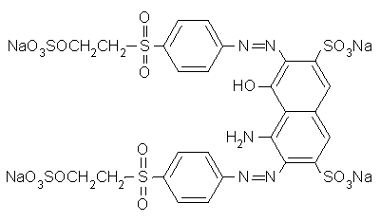

Figure 1. Chemical structure of RB5

Textile industry is considered as one of the major water consumers as it utilizes large volume of water and chemicals for wet processing of the textiles and thus contributes to the river pollution [4, 5]. Homemade batik industry is a part of this textile industry. Preliminary studies show that discharged wastewaters from the homemade batik industry contain dyes, heavy metals, grease, wax, suspended solid (TSS) and have high chemical oxygen demand (COD) [6, 7]. Heavy metals such as copper (Cu), lead (Pb), cadmium (Cd), chromium (Cr), iron (Fe), zinc (Zn), nickel (Ni) were literiturely reported present in the wastewaters from batik and textile industries [8, 9, 10].

This paper describes the studies of any possiblity that these heavy metals and other azo dyes will interfere the measurement of RB5 using the differential pulse cathodic stripping voltammetry (DPCSV) technique in attempt to develope voltammetric determination of RB5 in the wastewaters from batik industry. Information on the possible interfering azo dyes were obtained from a carried out survey among local batik manufacturers.

Materials and Methods
Materials and Reagents
All chemicals used were analytical reagent grade quality and the solutions were prepared in the deionized water. RB5 dye standard (MW = 991.82 gmol⁻¹) was obtained from Sigma Aldrich. For preparation of 200 mg/L RB5 stock solution, 20 mg RB5 standard was dissolved in 100 mL volumetric flask. Standard working solution of 20 mg/L was prepared by appropriate dilution of the stock solution. Reactive Red 42, Reactive Yellow 106 and Reactive Orange 16 dyes solution were prepared by the same procedure as the RB5 preparation. 20 mg/L standard solution of each Cu (II), Pb (II), Cd (II), Cr (II), Ni (II), Fe (II), Mn (II) and Zn (II) were prepared by diluting 2 mL of the 1000 mg/L stock solution in 100 mL volumetric flask. BRB solution as the supporting electrolyte was prepared in 1000 mL deionized water, which composed of mixture of 2.47 g boric acid, 2.30 mL glacial acetic acid and 2.70 mL ortho-phosporic acid. 0.1 M sodium hydroxide was used to adjust the pH of the BRB solution to the desired value and high purity mercury, 99.999% was used for HMDE.

Instrumentations
The voltammetric experiments were carried out using VA 757 Computrace Metrohm Voltammetric Analyzer with 663 VA Stand, consisted of Multi-Mode Electrode (MME) and a 40 mL capacity voltammetric cell. The MME consists of a HMDE as the working electrode (WE), a platinum wire as the auxiliary electrode (AE) and an Ag/AgCl as the reference electrode (RE). The VA 757 was connected to a computer for data processing and for all pH measurements, Hanna Instruments Microprocessor pH meter was employed.

Differential Pulse Stripping Voltammetry Measurement
9 mL of BRB solution at pH 2.5 was put into voltammetric cell and purged by a stream of purified nitrogen for at least 15 minutes to remove dissolved oxygen. 1 mL of 20 mg/L RB5 dye was then spiked to give a final concentration of 2 mg/L and the solution was repurged for 2 minutes. The optimum operational parameters applied for the voltammetric measurements were initial potential (E_{i}) = +250 mV, final potential (E_{f}) = -600 mV, scan rate (v) = 5 mV/s, accumulation time (t_{acc}) = 80 s, accumulation potential (E_{acc}) = 0 mV and pulse amplitude = 75 mV. For investigation the response of peak height (I_{p}) and peak potential (E_{p}) of 2 mg/L RB5, a series of concentration from 2 to 5 mg/L of the metal standard solutions were spiked into the voltammetric cell. The relative error (%) for each spiked concentration of these metals to the I_{p} of RB5 dye was then calculated. The same procedures were applied for studying the effect of other azo dyes such as Reactive Orange 16, Reactive Yellow 42 and Reactive Red 106 to the I_{p} and E_{p} of 2 mg/L RB5.

Results and Discussion
The possible interfering heavy metals were spiked into the voltammetric cell containing 2 mg/L RB5 standard solution in BRB solution at pH 2.5 and scanned using optimum experimental conditions, as previously mentioned. The effect of these interfering substances on I_{p} and E_{p} has been observed. The RB5 solution without any added heavy metals and other azo dyes gave three cathodic peaks which the dominant second cathodic peak appeared at -65.50 mV with I_{p} of 224 nA, as shown in Figure 2. For addition of Cu, Pb, Cd and Cr, a single peak was obtained at +100 mV, -320 mV, -500 mV and -610 mV, respectively together with the RB5 peak. The voltammograms are shown in Figure 3 to Figure 6. The decreasing I_{p} of the second reduction peak of RB5 with increasing concentrations of these metals are due to their competing ability with the RB5 to be adsorbed at the mercury electrode surface [11, 12].

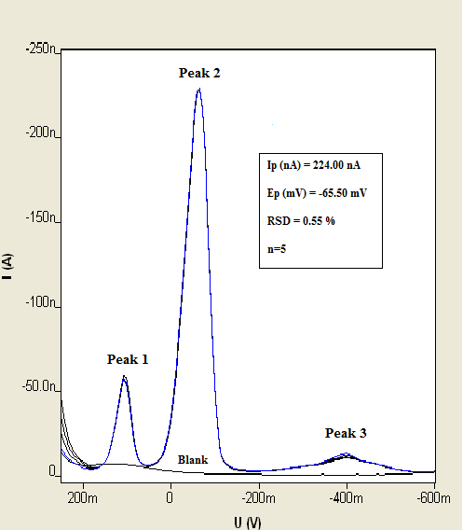
Figure 2. Cathodic stripping voltammograms of 2 mg/L RB5 dye obtained in BRB solution at pH 2.5. Parameter conditions; E_{i} = +250 mV, E_{f} = -600 mV, v = 5 mV/s, t_{acc} = 80 s, E_{acc} = 0 mV, and pulse amplitude = 75 mV

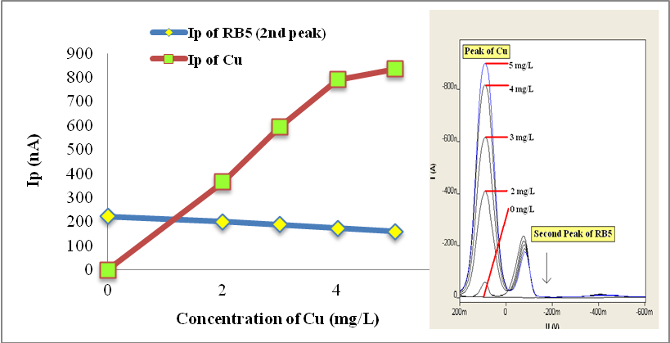
Figure 3. Plot of RB5 and Cu peak height against concentration of Cu in voltammetric cell containing 2 mg/L RB5 standard solution. Insert: Voltammograms of the study

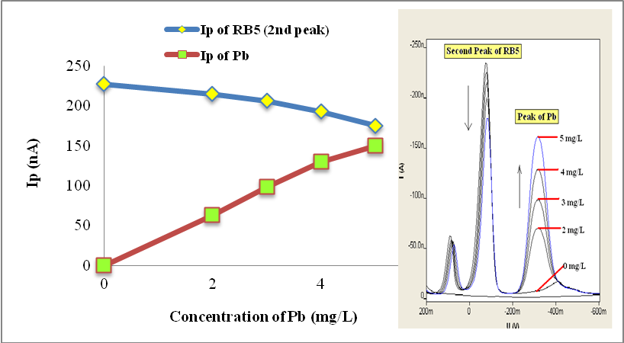
Figure 4. Plot of RB5 and Pb peak height against concentration of Pb in voltammetric cell containing 2 mg/L RB5 standard solution. Insert: Voltammograms of the study

. 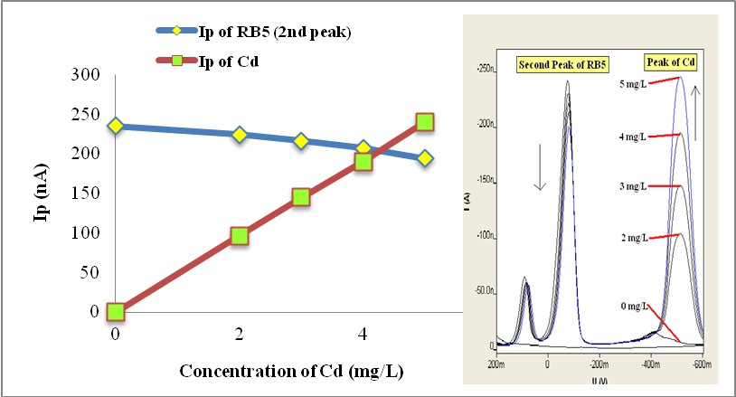
Figure 5. Plot of RB5 and Cd peak height against concentration of Cd in voltammetric cell containing 2 mg/L RB5 standard solution. Insert: Voltammograms of the study

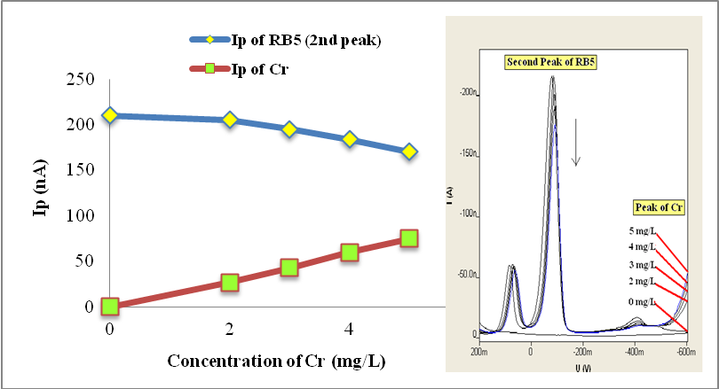
Figure 6. Plot of RB5 and Cr peak height against concentration of Cr in voltammetric cell containing 2 mg/L RB5 standard solution. Insert: Voltammograms of the study

For the suitable selectivity of any developed method upon any interfering substances, the relative error should be ±10 % [13]. The relative errors for the RB5 response with the addition of 2 mg/L of each heavy metals were -9.91 %, -3.52 %, -4.68 % and -2.38 % for Cu, Pb, Cd and Cr, respectively and -15.32 %, -8.37 %, -8.09 % and -7.14 % were obtained for 3 mg/L addition of respective Cu, Pb, Cd and Cr. The results are shown in Table 1.

Table 1. Effect of Cu, Pb, Cd and Cr on the peak height (I_{p}) of 2 mg/L RB5
Possible Interfering  Heavy Metals | Concentrations  (mg/L) | Relative Error/  Signal Changes  (%) | Note
Cu | 2.0  3.0  4.0 | -9.91  -15.32  -22.07 | No interference  Interfere  Interfere
Pb | 2.0  3.0  4.0 | -3.52  -8.37  -14.98 | No interference  No interference  Interfere
Cd | 2.0  3.0  4.0 | -4.68  -8.09  -11.91 | No interference  No interference  Interfere
Cr | 2.0  3.0  4.0 | -2.38  -7.14  -12.38 | No interference  No interference  Interfere

None reduction peak appeared within the used potential range for Fe, Ni, Mn and Zn, which shows that no other redox reaction was took place within the potential range. The relative errors for RB5 dye responses with the 2 mg/L addition of Fe, Ni, Mn and Zn were -10.81 %, -4.39 %, -3.62 % and -2.27 %, respectively, as shown in Table 2. For addition of 3 mg/L of these respective heavy metals, the obtained relative errors were –14.60 %, -7.89 %, -9.95 % and -5.91 %. From the results, it shows that 3 mg/L Cu and more than 2 mg/L Fe have interfered to 2 mg/L RB5 measurements. Recent report stated that the maximum concentration of Cu, Pb and Cd in batik wastewater are 0.57, 0.20 and 0.01 mg/L [14] which are considered very low content to interfere the measurement of RB5 using developed voltammetric technique.

Table 2. Effect of Fe, Ni, Mn and Zn on the peak heigth (I_{p}) of 2 mg/L RB5
Possible Interfering  Heavy Metals | Concentrations  (mg/L) | Relative Error/  Signal Changes  (%) | Note
Fe | 2.0  3.0  4.0 | -10.18  -14.60  -21.24 | Interfere  Interfere  Interfere
Ni | 2.0  3.0  4.0 | -4.39  -7.89  -14.47 | No interference  No interference  Interfere
Mn | 2.0  3.0  4.0 | -3.62  -9.95  -14.48 | No interference  No interference  Interfere
Zn | 2.0  3.0  4.0 | -2.27  -5.91  -11.36 | No interference  No interference  Interfere

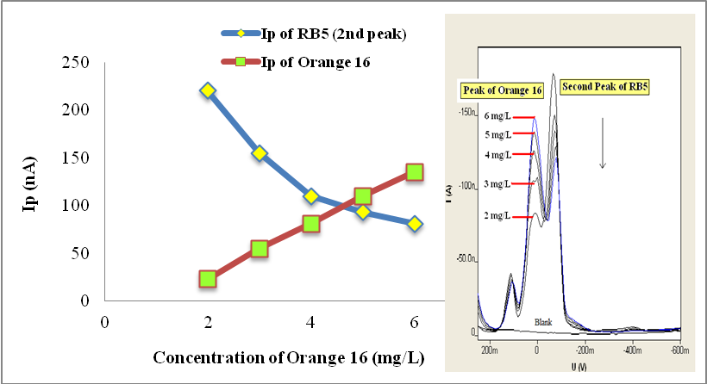
Figure 7. Plot of RB5 and Orange 16 peak height against concentration of Orange 16 in voltammetric cell containing 2 mg/L RB5 standard solution. Insert: Voltammograms of the study

The other azo dyes used for this study were Reactive Orange 16, Reactive Yellow 42 and Reactive Red 106. These three dyes have been used based on the results of carried out survey among batik manufacturers and dye sellers at Kota Bharu and Pantai Cahaya Bulan area which show that these dyes are mostly used in batik processing. A series of 2 to 6 mg/L standard solution of these azo dyes were spiked into the voltammetric cell containing 2 mg/L RB5 standard solution and scanned using the optimum instrumental parameters. The voltammograms of RB5 with the additions of Orange 16, Yellow 42 and Red 106 with the present of 2 mg/L RB5 are shown in Figure 7 to Figure 9, respectively.

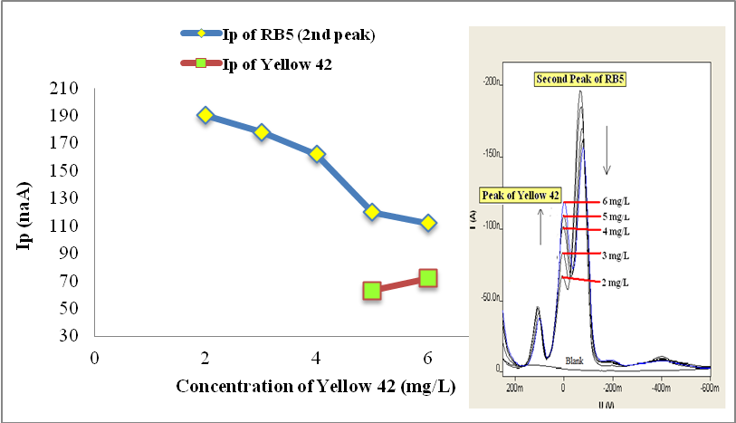
Figure 8. Plot of RB5 and Yellow 42 peak height against concentration of Yellow 42 in voltammetric cell containing 2 mg/L RB5 standard solution. Insert: Voltammograms of the study

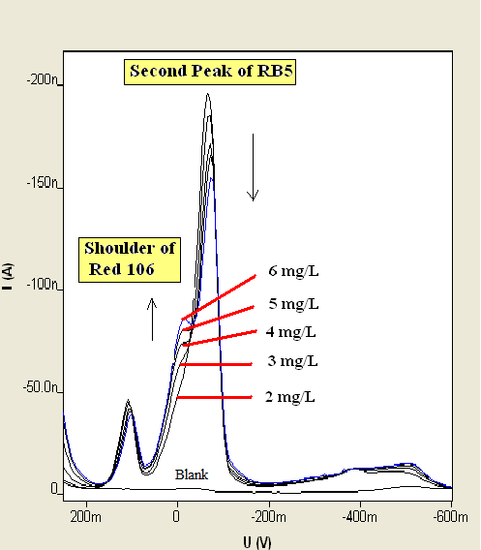
Figure 9. Voltammograms of RB5 with concentration of 2 to 6 mg/L of Red 106 in voltammetric cell containing 2 mg/L RB5 standard solution

The addition of 2 mg/L Orange 16 dye gave a new a new peak which is appearently observed at E_{p} of +17.90 mV. At the same time the RB5 peak deminished gradually. With addition of 2 to 6 mg/L of Yellow 42 dye, a new shoulder appeared with addition of 2 to 4 mg/L Yellow 42 and a new peak at E_{p} of +0.00 mV appeared on the voltammograms when 5 mg/L of Yellow 42 was added. RB5 peak gradually deminished as same as happened when Orange 16 was added. For Red 106 dye, only new shoulder appeared with the addition of standard solution eventhough its concentration has been increased. It was observed that the presence of 2 mg/L standard solution of these azo dyes has caused the I_{p} of RB5 dye to decrease significantly and very high relative errors percentage have been obtained. These results are shown in Table 3.

Table 3. Effect of other azo dyes on the peak height (I_{p}) of 2 mg/L RB5
Possible Interfering Azo Dyes | Concentrations  (mg/L) | Relative Error/  Signal Changes  (%) | Note
Orange 16 | 2  3 | -21.92  -52.05 | Interfere  Interfere
Red 106 | 2  3 | -12.80  -18.00 | Interfere  Interfere
Yellow 42 | 2  3 | -13.24  -18.72 | Interfere  Interfere

Conclusion
It was concluded that the present of 2 mg/L Fe, 3 mg/L Cu and 4 mg/L of Ni, Mn, Pb, Cd, Zn and Cr have interfered the measurement of 2 mg/L RB5. 2 mg/L of Reactive Orange 16, Red 106 and Yellow 42 dyes also already interfered the 2 mg/L RB5 measurement.

Acknowledgement
The authors are gratefully acknowledges the Universiti Sains Malaysia (USM) for awarding Short Term Grant No: 304/PPSK/61312057. Also we would like to thank all the laboratory staff for their fully co-operation and assistance. Not forgetten, thank to all batik manufactures and dye sellers at Kota Bharu and Pantai Cahaya Bulan that involved in the carried out survey.

References
- Méndez-Martínez, A.J., Dávila-Jiménez, M.M., Ornelas-Dávila, O., Elizalde-González, M.P., Arroyo-Abad, U., Sires, I. and Brillas, E. (2012). Electrochemical reduction and oxidation pathways for Reactive Black 5 dye using nickel electrodes in divided and undivided cells. Electrochimica Acta, 59: 140-149.
- Esteves, F. and Cunha, E.P. (2005). Voltammetric study and electrochemical degradation of reactive dyes. 5th World Textile Conference. June 2005, Portoroz. Slovenia.
- Jović, M., Stanković, D., Manojlović, D., Andelković, I., Milić, A., Dojčinović, B. and Roglić, G. (2013). Study of the electrochemical oxidation of reactive textile dyes using platinum electrode. International Journal of Electrochemical Sciences, 8: 168-183.
- Radi, A.E., Nassef, H.M. and El-Basiony, A. (2013). Electrochemical behaviour and analytical determination of Reactive Red 231 on glassy carbon electrode. Dyes and Pigments, 99: 924-929.
- Ellouze, E., Tahri, N. and Amar, R.B. (2012). Enhancement of textile wastewater treatment process using Nanofiltration. Desalination, 286: 16-23.
- Nora’aini, A. and Suhaimi, N.S. (2009). Performance evaluation of locally fabricated asymmetric nanofiltration membrance for batik industry effluent. World Applied Sciences Journal, 5: 46-52.
- Rashidi, H.R., Sulaiman, N.M.N. and Hashim, N.A. (2012). Batik industry synthetic wastewater treatment using nanofiltration membrance. Procedia Engineering, 44: 2010-2012.
- Normala, H. and Goh, S.Y. (2010). Removal of heavy metals from textile wastewater using zeolite. Environment Asia, 3: 124-130.
- Lokhande, R.S., Singare, P.U. and Pimple, D. (2011). Toxicity study of heavy metals pollutants in wastewater effluent samples collected from Taloja Industrial State of Mumbai India. Resources and Environment, 1: 13-19.
- Imtiazuddin, S.M., Mumtaz, M. and Mallick, K.A. (2012). Pollutants of wastewater characteristics in textile industries. Journal of Basic and Applied Science, 8: 554-556.
- Brahman, P.K., Dar, R.A. and Pitre, K.S. (2013). Adsorptive stripping voltammetric study of Vitamin B1 at multi-walled carbon nanotube paste electrode. Arabian Journal of Chemistry, Article in Press.
- Dar, R.A., Brahman, P.K., Tiwari, S. and Pitre, K.S. (2011). Adsorptive stripping voltammetric determination of podophyllotoxin, an antitumour herbal drug, at multi-walled carbon nanotube paste electrode. Journal of Application Electrochemistry, 41: 1311-1321.
- Ghoreishi, S.M., Behpour, M. and Golestaneh, M. (2012). Simultaneous determination of sunset yellow and tartrazine in soft drinks using gold nanoparticles carbon paste electrode. Food Chemistry, 132: 637-641.
- Noor Syuhadah S., N. Z. Md Muslim and H. Rohasliney. (2015). Determination of Heavy Metal Contamination from Batik Factory Effluents to the Surrounding Area. International Journal of Chemical, Environmental & Biological Sciences, 3: 7-9.

