

DYSPROSIUM(III) ISATIN 2-METHYL-3-THIOSEMICARBAZONE: SYNTHESIS, STRUCTURAL AND CHARACTERIZATION

(Disprosium(Iii) Isatin 2-Metil-3-Tiosemikarbazon: Sintesis, Struktur dan Pencirian)

Nur Nadia Dzulkifli, Yang Farina Abd Aziz*, Bohari M Yamin

School of Chemical Science and Food Technology,

Faculty of Science and Technology,

Universiti Kebangsaan Malaysia, 43600 UKM Bangi, Selangor, Malaysia

*Corresponding author: farina@ukm.edu.my

Received: 30 April 2015; Accepted: 20 May 2015

Abstract
Dy(Is2MeTSC)₃ [Is2MeTSC= isatin 2-methyl-3-thiosemicarbazone] was synthesized by condensation method. The compounds were structurally characterized by elemental analysis, FT-IR, UV-Vis, TGA and X-ray crystallographic study. The results of the elemental analyses for the compounds were in good agreement with the theoretical values. The X-ray crystallographic structures for Is2MTSC showed that in the solid state, the compound existed in the thione form, where the C=S bond length was shorter than a single bond C-S, which was 1.82 Å. Is2MTSC adopted an orthorhombic system, a = 14.3434(9), b = 8.4242(5), c = 17.8518(11) Å and Z = 8. The FT-IR spectral data implied a tri-dentate bonding of Is2MeTSC to Dy(III) ion through carbonyl oxygen, azomethine nitrogen and thiocarbonyl sulfur.

Keywords: Dyprosium(III), thiosemicarbazone, isatin

Abstrak
Dy(Is2MeTSC)₃ [Is2MeTSC= isatin 2-metil-3-tiosemikarbazon] telah disintesis dengan kaedah pemeluwapan. Struktur sebatian telah dilakukan penciriaan melalui analisis unsur, FT-IR, UV-Vis, TGA dan kajian kristalografi sinar-X . Keputusan analisis unsur bagi sebatian yang diperoleh adalah sepadan dengan nilai teori. Struktur kristalografi sinar X untuk sebatian Is2MTSC menunjukkan bahawa dalam keadaan pepejal, sebatian wujud dalam bentuk tion, di mana panjang ikatan C=S adalah lebih pendek daripada ikatan tunggal C-S, iaitu 1.82 Å. Is2MTSC mempunyai sistem ortorombik, a = 14.3434(9), b = 8.4242(5), c = 17.8518(11) Å dan Z = 8. Data spektrum FT-IR mencadangkan ikatan tri-dentat Is2MeTSC kepada ion Dy (III) melalui karbonil oksigen, azometina nitrogen dan tiokarbonil sulfur.

Kata kunci: Disprosium(III), tiosemikarbazon, isatin

Introduction
Isatin, also known as 1H-indole-2,3-dione, is one of the thiosemicarbazone derivatives with a versatile chemical building block and is able to form a large number of heterocyclic molecules [1]. The compound possesses an indole ring structure as shown in Figure 1, which is common to many pharmaceuticals [2, 3].

Thiosemicarbazone derivatives usually coordinate to metal ions through bidentate (N, S) coordination that results from the dissociation of hydrazinic proton, giving thiolate, S and forming a five-membered chelate ring [4]. The specialty of thiosemicarbazone is that it is not only related to the presence of electron donor, but also regarding the bonding scheme with a metal ion. As a bidentate ligand, it can coordinate anionically, either bonding to metal ions through imine nitrogen and sulfur atoms (II), or via hydrazinic nitrogen and sulfur atoms (III), forming five- and four-membered chelate rings, respectively [5]. Lanthanide ions have a special configuration 4f electrons and variable coordination environments. Based on the sharp f-f transitions and high quantum yields, lanthanide compounds are the most important components for luminescence materials [6]. Lanthanide ions have high affinity with hard bases such as oxygen or nitrogen atoms from organic ligands.

Isatin Indole ring

Figure 1. Structures of isatin and indole ring.

Materials and Methods
All reagents and reactants were of analytical grade and used without further purification. The melting points of the synthesized compounds were determined using the Electrothermal IA 9100. The elemental analysis was performed on the CHNS/O Model Fision EA 1180 and Thermo Finnigan Flash EA 1112 Series. ¹³C and ¹H NMR (Nuclear Magnetic Resonance) spectra were recorded on a 600 MHz FT-NMR Cryoprobe using DMSO-d₆ (deuterated dimethyl sulfoxide) as a solvent and tetramethylsilane as an internal reference. Chemical shifts were recorded in parts per million (δ). The infrared spectra of the ligands were recorded as KBr discs on FTIR Perkin Elmer model GX spectrophotometer in the 4000-400 cm⁻¹ range. The electronic absorption spectra were recorded on a Shimadzu UV-1650 PC and were measured in the range 200-800 nm in DMF.

X-ray crystallography
Determination of the crystals structure of ligand determination was carried out on a Bruker Smart APEX CCD area detector diffractometer equipped with graphite mono-chromatised Mo-Kα (λ=0.71073Å) [7]. All data collection was carried out at 296K. Data collection: SMART [8]; cell refinement: SAINT [9]; data reduction: SAINT; program(s) used to solve structure: SHELXTL [10]; program(s) used to refine structure: SHELXTL [10] molecular graphics: SHELXTL [10]; software used to prepare material for publication: SHELXTL and PLATON [11]. Crystallographic data for the compounds Is2MTSC have been deposited with the Cambridge Crystallographic Data Centre, CCDC reference numbers (1007736). This information may be obtained free of charge from The Director, CCDC, 12 Union Road, Cambridge, CB2 1EZ, UK.

Synthesis of the isatin 2-methyl-3-thiosemicarbazone
The reaction steps involved in the synthesis of isatin 2-methyl-3-thiosemicarbazone and the complex are shown in Figure 2.

Synthesis of isatin 2-methyl-3-thiosemicarbazone [Is2MTSC]: An ethanolic solution (10 mL) of 2-methyl-3-thiosemicarbazide (0.105 g,s 10 mmol) was added to an ethanolic solution (10 mL) of isatin (0.147 g, 10 mmol) followed by the addition of five drops of acetic acid (M). The mixture was heated under reflux for 2 hours. The mixture was filtered to remove unreacted solid material and the filtrate was left standing at room temperature to obtain single orange crystals. Yield: 90%. Melting point: 208.4-210.4°C. Analysis: Calculated (%): C 51.28, H 4.30, N 23.93, S 13.66. Found (%): C 51.57, H 6.34, N 25.97, S 11.70.

Synthesis of Dy(III) 2-methyl-3-thiosemicarbazone [Dy(Is2MTSC)₃]. An ethanolic solution (5 mL) of NaOH (0.012 g, 0.3 mmol) was added to an ethanolic solution (30 mL) of isatin 2-methyl-3-thiosemicarbazone (0.0717 g, 0.3 mmol) followed by the addition of an ethanolic solution (10 mL) of Dy(III) nitrate hexahydrate (0.046 g, 0.1 mmol). The precipitate was filtered and rinsed with hot ethanol. Yield: 72 %. Melting point: > 350°C. Analysis: Calculated (%): C 41.79, H 3.16, N 19.50, S 11.14. Found (%): C 44.13, H 2.77, N 19.99, S 8.31.

Figure 2. Reaction steps involved in the synthesis of isatin 2-methyl-3-thiosemicarbazone and the complex.

Results and Discussion

Physical Properties
The ligand and complex exist in red crystal and yellowish powder form. The compounds are stable in air. The ligand is soluble in organic solvents, whereas the complex is only soluble in DMF and DMSO. The molar conductivity value of the complex in DMF is 16.63 ohm⁻¹cm²mol⁻¹ in range, which indicates the non-electrolyte characteristic and non-ionic structure with general composition Dy(Is2MTSC)₃ [12-14]. The elemental analysis data shows that the complex is formed in the ratio of 1:3 (metal:ligand). Magnetic susceptibilities of the complex have been measured by the Gouy’s method at room temperature (37°C) [15]. The complex is paramagnetic due to the existence of 4f electrons, which are effectively shielded by 5s² and 5p⁶ electrons [16].

Infared Spectroscopy

A comparability test of stretching bands of specific functional group was made among the ligand and complex spectra as shown in Figure 3. In principle, the ligands can exhibit thione-thiol tautomerism since it contains a thioamide –NH-C=S functional group [17,18]. The stretching band of ν(S-H) is absent in the 2550-2600 cm⁻¹ region but the ν(N(2)-H) band is present, thereby indicating that the ligands remain as the thione tautomer in the solid state [19]. The absence of a sharp stretching band at 1726 cm⁻¹ owing to the stretching band of C=O group and the stretching band shifted to a lower wavenumber showing that the oxygen from carbonyl group has coordinated to Dy(III) ion after deprotonation [20]. The stretching band of nitrate ion, NO₃⁻ is absent in the Dy(Is2MTSC)₃ spectrum, which indicates that the nitrate ion, NO₃⁻ ion did not coordinate with Dy(III) ion [21]. The strong intensity stretching band at 1601 cm⁻¹ in the ligand spectrum is attributed to ν(C=N) absorption, which shifted to a lower wavenumber and suggests an interaction between the imino nitrogen and metal ion [22,23]. The value of the ν(C=S) stretching band for the complex decreased slightly by 2 cm⁻¹ [Is2MTSC=1097 cm⁻¹], which presumes that the ligand remained as the thione form. The band at 451 cm⁻¹ in the complexes is attributed to ν(Dy-N). Meanwhile, the band at 416 cm⁻¹ is attributed to ν(Dy-O).

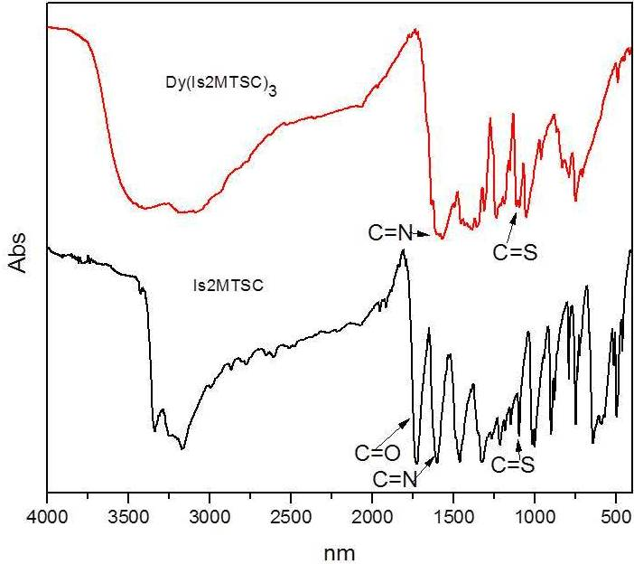

Figure 3. IR s pectra (KBr) of Is2MTSC and Dy(Is2MTSC)₃

Electronic spectra
The UV-Vis spectra of Is2MTSC and its complex were recorded in the range 300-800 nm (c = 10⁻⁵ M) as shown in Figure 4 . The ligand has two absorption bands at 302 and 405 nm, which are ascribed to the π-π* and n-π* intraligand transitions and usually refer to transitions in the azomethine unit and aromatic ring [24,25]. Sreekanth et al [26] suggested that the n-π* transition regarding N and S atoms usually occur at a lower energy than π-π*. The complex spectrum has little effect on these transitions, in which n-π* absorption shifted to higher energy. Agarwal et al [27] suggested the transition is related to the covalent character of the metal-ligand bond. Besides that, the n-π* absorption is expected to overlap with π-π* absorption due to the formation of complex. Dy(III) ions did not involve in the absorption of the complex because of the f-f transitions are Laporte forbidden, where they are assumed as too weak to be visible.

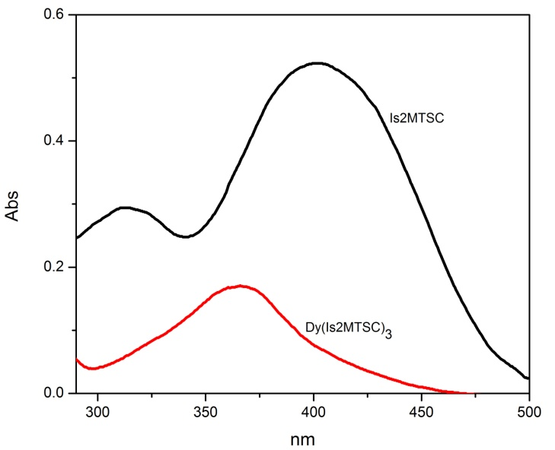
Figure 4. lectronic spectra (DMSO) of Is2MTSC and Dy(Is2MTSC)₃

Thermogravimetric analysis (TGA)

The thermal stability of Dy(Is2MTSC)₃ was determined by the TGA technique. The TGA curve of the complex as shown in Figure 5 was produced within the temperature up to 800ºC. The complex showed thermal stability up to 360°C, indicating the absence of coordinated water and solvent molecules. Besides that, it is indicated that the complex has been formed by the coordination between Is2MTSC with Dy(III) ion. The complex decomposes only in one step, and the loss of all substances is expected for the final residue of metal oxides. The remaining product with residue percentage of 39.85% could be due to the formation of Dy₂O₃ [28,29].

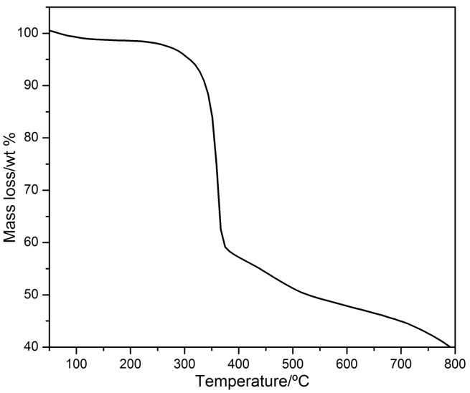

Figure 5. TGA curve of Dy(Is2MTSC)₃

Nuclear magnetic resonance (NMR)
The complex is not suitable to be characterized using NMR because it exhibits paramagnetic properties. The bonding arrangement of the ligand, Is2MTSC was further confirmed by NMR spectra. Multiplet peaks were observed at δ=6.8-7.6 ppm due to aromatic protons. CH₃ protons of azomethine moiety appeared as a singlet at δ=3.5 ppm. A doublet peak at δ=10.98 ppm was assigned to NH₂ protons. The ¹³C NMR spectrum for Is2MTSC showed downfield peaks at 183.0 and 182.1 ppm, which were referred to C=O and C=S. The peak was observed at 158.0 ppm due to azomethine moiety.

Figure 6. Isatin 2-methyl-3-thiosemicarbazone, (Is2MTSC).

Crystal structure
The molecular structure of the ligand along with the atomic numbering scheme is shown in Figure 6. The crystal data and structure refinement and H-bonding parameters of the ligand are shown in Table 1 and 2.

Table 1. Crystal data and structure refinement for the complexes
 | Is2MTSC
Gross formula | C₁₀H₁₀N₄OS
M (g/mol) | 234.28
Wavelength, Mo Kα (Å) | 0.71073
Crystal system | Orthorhombic
Space group  Crystal shape  Color | Pbca  Block  Orange
a, Å | 14.3434(9)
b, Å | 8.4242(5)
c, Å | 17.8518(11)
α, degree | 90.00
β, degree | 90.00
γ, degree | 90.00
V, Å^{3s} | 2157.1(2)
Z  T, K  Theta (max)  Theta (min) | 8  293(2)  28.37  2.84
Crystal size, mm  h  k  l | 0.35,0.60,0.33  -19 19  -11 11  -23 23
F(000)  Reflections  Parameters  Restraints | 976  2691  147  0
Goodness-of-fit on F² | 1.185

Table 2. Crystal data and structure refinement for the ligand
 | D---H...A | Type | D – H (Å) | H...A (Å) | D...A (Å) | D – H...A (°)
1 | N1—H1A..N3 | Intra | 0.86 | 2.25 | 2.612(2) | 105
2 | N1—H1A..S1 | Inter | 0.86 | 2.69 | 3.5115(19) | 160
3 | N1—H1B..O1 | Inter | 0.86 | 2.13 | 2.973(2) | 167
4 | N4—H4..S1 | Inter | 0.86 | 2.56 | 3.3979(17) | 166
5 | C10—H01A..S1 | Intra | 0.96 | 2.67 | 3.030(3) | 103
6 | C10—H01B..O1 | Inter | 0.96 | 2.52 | 3.260(3) | 134
7 | C6—H6..S1 | Inter | 0.93 | 2.80 | 3.552(3) | 138
Symmetry codes:
No. 2: 1-x, -½+y, ½-z | No. 3 : 1-x, ½+y, ½-z | No. 4 : x, ½-y, ½+z
No. 6 : ½-x, ½+y, z | No. 7 : x, 3/2-y, ½+z

The non-hydrogen atoms of the ligand are planar. The indole ring N4/C2/C3/C4/C5/C6/C7/C8/C9[Is2MTSC] fragment is planar with maximum deviations of 0.048(2) for C(3) atom from the least square plane, respectively. For the crystal structure of Is2MTSC, the molecules are linked by intermolecular hydrogen bonds, N1—H1A..S1, N1—H1B..O1, N4—H4..S1, C10—H01B..O1 and C6—H6..S1 (symmetry codes as shown in Table 2) and forms a one-dimensional chain along the c axis (Figure 7).

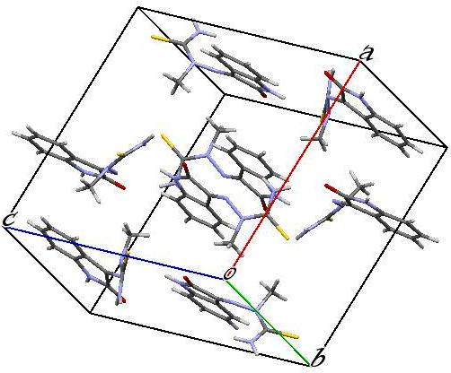

Figure 7. Packing diagram of Is2MTSC with intermolecular hydrogen bonds along c axis.

Conclusion
The present study has provided structurally interesting of Dy(Is2MTSC)₃ complex was synthesized with the molar ratio 3:1 (ligand:metal) and characterized by elemental analyses, infrared, electronic spectra, TGA and nuclear magnetic resonance. The single crystal X-ray diffraction study has proved that the ligands exist as the thione tautomer. From the physicochemical characterization of the complex, it has been determined that the ligand acts as a bidentate to metal ions.

Acknowledgement
The authors would like to thank the Faculty of Science and Technology, Universiti Kebangsaan Malaysia and the Centre for Research and Instrumentation (CRIM) for the research facilities, as well as the provision of laboratory facilities and technical assistance. The authors also gratefully acknowledge the research grant from GUP-2012-022, FRGS/2/2013/ST01/UKM/01/2 and the scholarship from the MyBrain15 scheme.

References
- Beraldo, H. and Gambino, D. (2004). The Wide Pharmacological Versatility of Semicarbazones, Thiosemicarbazones and Their Metal Complexes. Mini-Review in Medicinal Chemistry, 4 (1): 31-39.
- Atalay, T. and Akgemci, E. G. (1998). Thermodynamic Studies of Some Complexes of 2-Benzoylpyridine 4-phenyl-3-thiosemicarbazone. Turkish Journal of Chemistry, 22: 123-128.
- Seda, S., Baybars, K., Fatma, K. and Sevgi, H. B. (2009). Theoretical and Spectroscopic Studies of 5-fluoro-isatin-3-(N-benzylthiosemicarbazone) and its Zinc(II) Complex. Journal of Molecular Structure, 917: 63-70.
- Lobana, T. S., Khanna, S., Hundal, G., Butcher, R. J. and Castineiras, A. (2009). Mono- and di-nuclear complexes of thiosemicarbazones with copper(I): Synthesis, spectroscopy and structures. Polyhedron, 28: 3899–3906.
- Basuli, F., Peng, S. M. and Bhattacharya, S. (2000). Unusual Coordination Mode of Thiosemicarbazone Ligands. A Search for The Origin. Inorganic of Chemistry, 39 (6): 1120-1127.
- Hongzhen, X. and Guanzhong, L. (2013). Crystal Structures and Fluorescence Properties of Lanthanide Complexes Prepared with 2,2’-Biphenyldicarboxylic Acid and 2,2’:6’,2’’-Terpyridine. Journal of Rare Earths. 31 (6): 639-644.
- Awang, N. W., Hasbullah, S. A., Yusoff, S. F. M. and Yamin, B. M. (2014). N-[Ethyl(2-hydroxyethyl)carbamothioyl]-3-fluorobenzamide. Acta Crystal, E70: o570.
- Bruker. (2009). SMART, SAINT and SADABS. Bruker AXS Inc., Madison, Wisconsin, USA.
- Bruker. (2008). APEX2, SAINT and SADABS. Bruker AXS Inc., Madison, WI.
- Sheldrick, G. M. (2008). A short history of SHELX. Acta Cryst, A64: 112-122.
- Spek, A. L. (2009). Structure validation in chemical crystallography. Acta Cryst, D65: 148-155.
- Yasemın, D. K. and Bahrı, U. (2010). Unusual Template Condensation of Benzophenone Thiosemicarbazones and Salicylaldehydes with Nickel(II). Journal of Coordination Chemistry. 63 (5): 828-836.
- Thays, D. S. S., Letícia, R. T., Roberta, L. Z., Sonia, R. W. L. and Heloisa, B. (2009). Iron(III) Complexes with N4-para-tolyl-thiosemicarbazones: Spectral and Electrochemical Studies and Toxicity to Artemia Salina. Journal of Coordination Chemistry. 62 (6): 958-966.
- Thaker, B. T. and Modi, C. K. (2002). Synthesis and Characterizaion of Lanthanide Complexes of 1-Phenyl-3-Methyl-5-Hydroxy-4-Pyrazolyl-Phenyl Ketone-2’-Picolinoyl Hydrazone. Indian Journal of Chemistry, 41A :2544-2547.
- Mital, S. P.; Singh, R. V. and Tandon, J. P. (1981). Spectral Thermal and X-ray Diffraction Studies of La(III) and Sm(III) Complexes of Nitrogen and Sulphur Donor. Journal of Inorganic and Nuclear Chemistry, 43: 3187-3195.
- Ram, K. A. Surendra P. Rajiv G. and Sushil K. S. (2006). Synthesis and Preliminary Structural Characterization of Some Lanthanide(III) Semicarbazone Complexes. Bulletin of the Chemical Society of Ethiopia, 20 (1): 167-172.
- Seleem, H. S., El-Shetary, B. A., Khalil, S. M. E., Mostafa, M. and Shebl, M. (2005). Structural Diversity in ssCopper(II) Complexes of Bis(thiosemicarbazone) and Bis(semicarbazone) Ligands. Journal of Coordination Chemistry. 58: 479-493.
- Khlood, S. and Abou-Melha. (2008). Octahedral Co(II) and Ni(II) Complexes of Schiff Bases Semicarbazone and Thiosemicarbazone, Synthesis, Biological, Spectral, and Thermal Studies. Journal of Coordination Chemistry, 61 (13): 2053-2067.
- Liu, Y. Y., Ma, J. F. and Yang, J. (2007). Syntheses and Structures of Zn(II) and Ni(II) Complexes of 4-N-(acetylacetone amine)acetophenonehiosemicarbazone. Journal Coordination of Chemistry, 60 (14): 1579-1586.
- Dubey, R. K., Mariya, A. and Mishra, S. K. (2011). Synthesis and Spectral (IR, NMR, FAB-MS and XRD) Characterization of Lanthanide Complexes Containing Bidentate Schiff Base Derived from Sulphadiazine and O-Vanillin. International Journal of Basic and Applied Chemical Sciences, 1 (1): 70-78.
- Meyers, R. A. (2000). Interpretation of Infrared Spectra, A Practical Approach John Coates In Encyclopedia of Analytical Chemistry R.A. Meyers (Ed.).; John Wiley & Sons Ltd, Chichester.
- Tamboura, F. B., Diouf, O., Barry, A. H., Gaye, M. and Sall, A. S. (2012). Dinuclear Lanthanide(III) Complexes with Large-Bite Schiff Bases Derived from 2,6-diformyl-4-Chlorophenol and Hydrazides: Synthesis, Structural Characterization and Spectroscopic Studies. Polyhedron, 43: 97-103.
- Jeferson, G. D. S., Solange, M. S. V. W., James, L. W. and Heloisa, B. (2009). Zinc(II) Complexes of 2-pyridine-derived N(4)-p-tolylthiosemicarbazones: Study of In Vitro Antibacterial Activity Journal of Coordination Chemistry. 62 (9): 1400-1406.
- Kurt, Y. D., Ulkuseven, B., Tuna, S., Erguven, M. and Solakoglu, S. (2009). Iron(III) and Ni(II) Template Complexes Derived from Benzophenone Thiosemicarbazones. Journal of Coordination Chemistry, 62 (13): 2172-2181.
- Tudor, R. Elena, P. Simona, P. Rodica, G. Nicolae, S. Adelina, C. Alexandra, P. and Mircea, L. (2010). Synthesis, Characterization Antibacterial and Antiproliferative Activity of Novel Cu(II) and Pd(II) Complexes with 2-hydoxy-8-R-tricyclo[7.3.1.0.^{2,7}] tridecane-13-one Thiosemicarbazone. European Journal of Medicinal Chemistry, 45: 1627-1634.
- Sreekanth, A. and Kurup, M. R. P. (2004). Synthesis, EPR and Mossbauer Spectral Studies of New Iron(III) Complexes with 2-benzoylpyridine-N(4), N(4)-(butane-1,4-diyl) thiosemicarbazone (HBpypTsc): X-ray Structure of [Fe(BpypTsc)₂]FeCl₄.2H₂O and The Free Ligand. Polyhedron, 23: 969-978.
- Ziyad, A. T., Abdulaziz, M. A. and Waleed, A. M. (2012). Structural, Luminescence and Biological Studies of Trivalent Lanthanide Complexes with N,N’-Bis(2-Hydroxynaphthylmethylidene)-1,3-Propanediamine Schiff Base Ligand. Journal of Luminiscence, 132: 2832-2841.
- Sulekh, C., Smriti, R. and Sangeeta, S. (2014). Synthesis and Spectroscopic Studies of Cobalt(II) Complexes with Nitrogen-Oxygen and Nitrogen Sulphur Donor Ligands. India Journal of Pharmaceutical Sciences and Research, 5 (11): 4718-4723.
- Kong, K., Zhang, H., Ruijun, M. A., Chen, Y., Chu, H. and Zhao, Y. (2013). Synthesis, characterization and enhanced luminescence of terbium complexes with 2-pyrazinecarboxylic acid and butanedioic acid by inert-fluorescent lanthanide ions. Journal of Rare Earth, 1: 32-36.

