

COMPARATIVE ANALYSIS OF PHENOLIC CONTENT AND ANTIOXIDATIVE ACTIVITIES OF EIGHT MALAYSIAN
TRADITIONAL VEGETABLES

(Analisis Perbandingan Kandungan Fenolik dan Aktiviti Antipengoksida Lapan Sayuran Tradisional di Malaysia)

Nur Huda-Faujan¹*, Zulaikha Abdul Rahim¹, Maryam Mohamed Rehan¹, Faujan Bin Haji Ahmad²

¹Food Biotechnology Program, Faculty of Science and Technology,
Universiti Sains Islam Malaysia, Bandar Baru Nilai, 71000 Nilai, Negeri Sembilan, Malaysia
²School of Chemistry, Faculty of Applied Sciences,
Universiti Teknologi MARA, 40450 Shah Alam, Selangor, Malaysia

*Corresponding author: nurhuda@usim.edu.my

Received: 12 April 2015; Accepted: 27 May 2015

Abstract
Vegetables have been believed to exhibit antioxidant activities due to its phenolic content. Thus, this study was carried out to determine the total phenolic content of water and ethanolic extracts of Malaysian traditional vegetables and assess their antioxidant activities. Eight samples of Malaysian traditional vegetables were dried and extracted its phenolic compounds using water and ethanolic solvent. Total phenolic content of the extracts were compared and evaluated using Folin-Ciocalteu and Prussian Blue reagent. The antioxidant activity were assessed using ferric thiocyanate assay and DPPH free radical scavenging assays. Results found that total phenolic content of water extracts ranged from 7.08 to 14.76 mg GAE (Folin-Ciocalteu assay) and 3.50 to 7.82 mg GAE (Prussian Blue assay). However, the content of phenolic of ethanolic extracts ranged from 5.21 to 15.86 mg GAE (Folin-Ciocalteu assay), and 1.84 to 11.54 mg GAE (Prussian Blue assay). The highest antioxidant activity was observed in water extracts of Etlingera elatior (75.6%) and ethanolic extracts of Sauropus androgynus (78.1%). Results also found that the best half maximal inhibitory concentration or IC₅₀ were demonstrated by water and ethanolic extracts of Sauropus androgynus which demonstrated 0.077 mg/mL and 0.078 mg/mL, respectively. Hence, this study obtained that most of the Malaysian traditional vegetables have a potential source of natural antioxidant.

Keywords: Folin-Ciocalteu method, Prussian Blue assay, antioxidant activities, Malaysian vegetables

Abstrak
Sayuran dipercayai boleh mempamerkan aktiviti antipengoksida disebabkan oleh kandungan fenoliknya. Oleh itu, kajian ini telah dijalankan untuk menentukan jumlah kandungan fenolik dalam sayuran tradisional Malaysia serta menilai aktiviti antipengoksidanya. Lapan jenis sayuran tradisional Malaysia telah dikeringkan dan diekstrak sebatian fenoliknya dengan menggunakan air dan pelarut etanol. Kandungan fenolik daripada ekstrak sampel telah dibandingkan dan dinilai menggunakan kaedah Folin-Ciocalteu dan reagen Prussian Biru. Aktiviti antipengoksida telah dinilai menggunakan asai ferik tiosianat dan asai pemerangkapan radikal bebas DPPH. Keputusan kajian telah menunjukkan bahawa jumlah kandungan fenolik ekstrak air adalah dari 7.08 ke 14.76 mg GAE (asai Folin-Ciocalteu) dan, dari 3.50 ke 7.82 mg GAE (asai Prussian Biru). Walau bagaimanapun, kandungan fenolik ekstrak etanol bernilai dari 5.21 ke 15.86 mg GAE (asai Folin-Ciocalteu) dan 1.84 ke 11.54 mg GAE (asai Prussian Biru). Aktiviti antipengoksida tertinggi telah diperhatikan pada ekstrak air Etlingera elatior (75.6%) dan ekstrak etanol Sauropus androgynus (78.1%). Keputusan kajian juga telah mendapati bahawa separuh perencatan maksimum atau IC₅₀ yang terbaik telah dipamerkan oleh ekstrak air dan etanol Sauropus androgynus dengan nilai 0.077 mg/mL dan 0.078 mg/mL, masing-masing. Oleh itu, kajian ini menunjukkan bahawa kebanyakan sayuran tradisional Malaysia berpotensi sebagai sumber bahan antipengoksida semula jadi.

Kata kunci: Kaedah Folin-Ciocalteu; Asai Prussian Biru; aktiviti antipengoksida; sayuran Malaysia

Introduction
The importance of health implication by consumption of vegetables has been acknowledged by many scientists. Epidemiological studies reported that consumption of vegetables have linked in prevention of some chronic and degenerative diseases such as cancer, diabetes, osteoporosis, and cardiovascular disease [1-3]. The discoveries of the importance of dietary micronutrients in vegetables have made them being demanded in many sectors include food, pharmaceutical, and agricultural industries. This eventually increased the awareness of public on the importance and beneficial effects of consumption of vegetables in their diet.

Malaysia is well known to have rich and diverse kinds of traditional vegetables or locally known as ulam. These vegetables have been consumed by people in Malaysia for many years ago especially for old people in countryside. In fact, Mansor [4] reported that there were more than 120 species of traditional vegetables in Malaysia. It is commonly eaten as fresh or raw as salad, or cooked through boiling or blanching and very popular especially among the Malay communities [5]. The fruit kernels, rhizomes, young leaves, and shoots are normally selected for consumption. These vegetables usually can be found mainly in the countryside area, which planted by the villagers or grow by itself in the forest. However, in the last few years, some of these vegetables has been grown commercially for market place [3].

Vegetables are very high in fiber but low in calories. It provides with the main source of carbohydrates, proteins, minerals, and vitamins, which are crucial for growth and health as well as mind. There are also contain phytochemicals such as phenolics, carotenoids, lignans, and lycopenes. These phytochemicals have been reported to have potential health benefits such as anti-tumour [3], anti-allergenic, anti-inflammatory, anti-microbial, and anti-thrombotic [6-7]. The health effect of consumptions of vegetables might be due to the antioxidant activities of the plants especially from phenolic compounds [8-9]. Phenolic compounds were believed to have redox properties, which allow them to act as reducing agents, hydrogen donators, and singlet oxygen quenchers as well as have a potential as metal chelation action [10].

The explorations of natural antioxidants from vegetables have received much attention to apply as suitable antioxidants to replace synthetic antioxidant in food products. These naturally-occurring antioxidants can also be formulated into capsules or tablets as nutraceutical products that can assist to prevent oxidative damage from occurring in human body [11]. Thus, the extensive study of traditional vegetables may provide advantages for more awareness of potential phenolic antioxidant and might have beneficial effect to both food and health [12]. In fact, for the last few decades, there have been convergences of interest among researchers in this field since clear scientific information is very necessary. Studies reported that antioxidant activities in the Malaysia traditional vegetables include Averrhoa bilimbi [13-15], Cosmos caudatus [3,5,14], Centella asiatica [3,5,16], Morinda citrifolia [17], Polygonum minus [3,5,18], Oenanthe javanica [3,5], and Melicope Lunu ankeda [18] were associated with their phenolic contents.

Phenolic contents and its antioxidant activities in plants have been evaluated by numerous methods. These methods include ferric reducing antioxidant power (FRAP) assay, ß-carotene bleaching assay, thiobarbituric acid (TBA) assay, oxygen radical absorbance capacity (ORAC), 1,1-diphenyl-2-picrylhydrazyl (DPPH) free radical scavenging activity, and cupric reducing antioxidant capacity (CUPRAC) reagents. All these methods have their own advantages and disadvantages [19], and one procedure cannot identify all possible mechanisms of antioxidant activity. Therefore, most researchers combine several methods to evaluate the relationship between the phenolic content and their antioxidant activities of the plants.

Hence, the objectives of this study were to assess and compare total phenolic content of eight Malaysian traditional vegetables using Folin-Ciocalteu and Prussian Blue assays and its antioxidant activities using in vitro methods of FRAP and DPPH assays. The correlation between total phenolic content and its antioxidant activities were also investigated in this study.

Materials and Methods
Chemicals
Ethanol, Folin-Ciocalteu reagent, sodium carbonate (Na₂CO₃), ferric chloride (FeCl₃), potassium ferricyanide (K₃Fe(CN)₆), linoleic acid, disodium hydrogen phosphate, hydrochloric acid (HCl), gallic acid, and trichloroacetic acid were purchased from Sigma Chemical Co. (St. Louis, MO, USA). Ammonium thiocyanate (NH₄SCN) and ferrous chloride (FeCl₂) were purchased from Merck (Merck KGaA, Darmstadt, Germany).

Sample Collection
Eight Malaysian traditional vegetables were selected in this study were Anacardium occidentale shoot, Carica papaya shoot, Curcuma longa leaves, Etlingera elatior, Manihot esculenta shoot, Pithecellobium jiringa, Psophocarpus tetragonolobus, and Sauropus androgynus. These samples were locally known as pucuk gajus, pucuk betik, daun kunyit, bunga kantan, pucuk ubi, jering, kacang kelisa, and cekur manis, respectively. All samples were purchased from wet market around Bandar Baru Nilai, Negeri Sembilan, Malaysia. Prior to extraction, samples were prepared based on Mohd Zin et al. [17]. The samples were washed under running tap water before being chopped into smaller pieces. Then, the samples were dried at 45ºC for 24 to 48 hrs using dehydrator (Excalibur Food Dehydrator 3000) and were grounded using domestic blender (Panasonic MX-337) to powder.

Water Extraction
Samples were extracted using water according to Wong et al. [11] with slight modification. Firstly, 5.0 g samples were soaked with distilled water in ratio water: sample (10:1) and the mixtures were left at room temperature (25ºC) for an hour in the dark condition with occasional agitation. Then, the aqueous extracts were filtered through Whatman No. 1 filter paper to obtain crude extract. The residual water was removed by evaporating the extract using rotary evaporator (BÜCHI Rotavapor R-215) at 80ºC and 50 rpm rotation. The crude extract were collected, weighed, and diluted to 5 mg/mL and were then stored at 4ºC until further analysis.

Ethanolic Extraction
The dried and fine homogenized sample were weighed and transferred into a beaker. Prior to the extraction, 70% ethanol was added into the samples with the ratio of 1:7 (w/v) and was stored in the dark condition for three days. The extracts were then filtrated through Whatman No. 1 filter paper before evaporating the residual solvent using rotary evaporator at 75ºC and 50 rpm rotation. The crude extract obtained were collected, weighed, and diluted to 5.0 mg/mL and were then stored at 4ºC until further analysis.

Determination of Total Phenolic Content: Folin-Ciocalteu Assay
Total phenolic content of extracts were determined using Folin-Ciocalteu assay method according to Singleton and Rossi [20] and Hoff and Singleton [21] using external calibration of gallic acid solution (10, 20, 30, 50, and 100 ppm). Briefly, 2.5 mL of 10-fold diluted Folin-Ciocalteu reagent and 2.0 mL of 7.5% solution of Na₂CO₃ were added into 1.0 mL of 0.5 mg/mL sample extract. Finally, the absorbance of reaction mixture was measured at 765 nm using spectrophotometer (Spectronic GENESYS 20) after 15 mins heating at temperature of 45°C. Results were expressed as mg gallic acid equivalent (GAE) using an equation obtained from gallic acid calibration curve. All analysis were carried out in triplicate.

Prussian Blue Assay
Prussian Blue assay was done according to the method of Gupta and Verma [22] with a slight modification. Briefly, 1.0 mL sample was diluted with 50 mL distilled water. Next, 3 mL of 0.5 M ferric chloride (FeCl₃) in 0.1 N HCl and 3.0 mL potassium ferricyanide (K₃Fe(CN)₆) were added into the diluted samples. The color immediately developed after 10 to 15 mins. Then, the absorbance was measured at 725 nm using spectrophotometer (Spectronic GENESYS 20). Gallic acid was also used as the standard reference phenolic compound. The total phenolic content were measured by GAE determined from standard gallic acid calibration (10, 20, 30, 50, and 100 ppm) curve. Results were expressed as mg GAE and were carried out in triplicate.

Determination of Antioxidant Activity: Ferric Thiocyanate Assay
The antioxidant capacity of all extracts was carried out according to the ferric thiocyanate assay [23]. Four milligram of samples were dissolved in 4 mL of 99.5% (w/v) ethanol and were mixed with linoleic acid (2.51% v/v) in 99.5% (w/v). Next, ethanol (4.1 mL), 0.05 M phosphate buffer pH 7.0 (8 mL) and distilled water (3.9 mL) were added into the mixture and was kept in screw-cap container in a dark storage at 40ºC. Then, 0.1 mL of this solution was added with 9.7 mL of 75% (v/v) ethanol and 0.1 mL of 30% (w/v) NH₄SCN. Precisely, 3 mins after the addition of 0.1 mL of 20 mM ferrous chloride (FeCl₂) in 3.5% (v/v) HCl to the reaction mixture, the absorbance of the producing red color was measured at 500 nm using spectrophotometer (Spectronic GENESYS 20) for seven days. Using the absorbance reading, the percentage of inhibition of linoleic acid was calculated according to the following formula (equation 1):

Absorbance of sample
Linoleic acid peroxidation inhibition (%) = [100 – ( ) x 100] (1)
Absorbance of control

DPPH Radical Scavenging Activity Assay
The DPPH radical scavenging activity assay was determined according to the method of Azlim Almey et al. [24]. Different concentrations of diluted sample extracts (1.0, 2.0, 3.0, 5.0, and 10.0 mg/mL) were prepared. First, 6.0 mg of DPPH was dissolved in 100 mL methanol to make up a DPPH solution. Then, 2.0 mL of DPPH solution were transferred into a test tube and 1.0 mL of each diluted sample extracts were mixed with the solution. 1.0 mL of methanol was added into 2.0 mL DPPH solution as a control. The standard reference used was gallic acid. The solution mixture was shaken vigorously and placed in a dark condition for 30 mins. Then, the absorbance of the mixture was determined at 517 nm using spectrophotometer (Spectronic GENESYS 20). The scavenging activity of the extracts was calculated using the following (equation 2):

Absorbance of sample
Scavenging activity (%) = [1- ( ) x 100] (2)
Absorbance of control

DPPH radical scavenging activities of the samples were expressed as half maximal inhibitory concentration (IC₅₀) values, which indicate the concentration of extracts that required to scavenge 50 % of DPPH free radicals. The IC₅₀ values were estimated by plotting the graph of scavenging activity against concentration (10, 20, 30, 50, and 100 ppm) of gallic acid.

Statistical Analysis
All experimental results were analyzed using Minitab software (Minitab Version 15.1.10). Every measurement of each assay and sample was done in triplicate. The experimental data were calculated using complete randomized design (CRD) and analysis of variance (ANOVA). The Duncan’s multiple range test (DMRT) and one-way ANOVA were used to determine the significant differences among means from triplicate analysis at p<0.05. Pearson’s correlation test was also determined to assess correlation between means.

Results and Discussion
Extraction yield and Total Phenolic Content
The yields of water and ethanolic extracts of vegetables are shown in Figure 1. From the Figure, the highest yield of extracts were demonstrated in water and ethanolic extracts of Anacardium occidentale shoot with percentage of yield of 3.10% and 1.98%, respectively. The lowest extraction yields were obtained in water extracts of Manihot esculenta shoot (0.22%) and ethanolic extracts of Etlingera elatior (0.05%). Results found that the yields of water extracts were varied in the range between 0.22 and 3.10% while the ethanolic extracts yields were in the range between 0.05 and 1.98%.
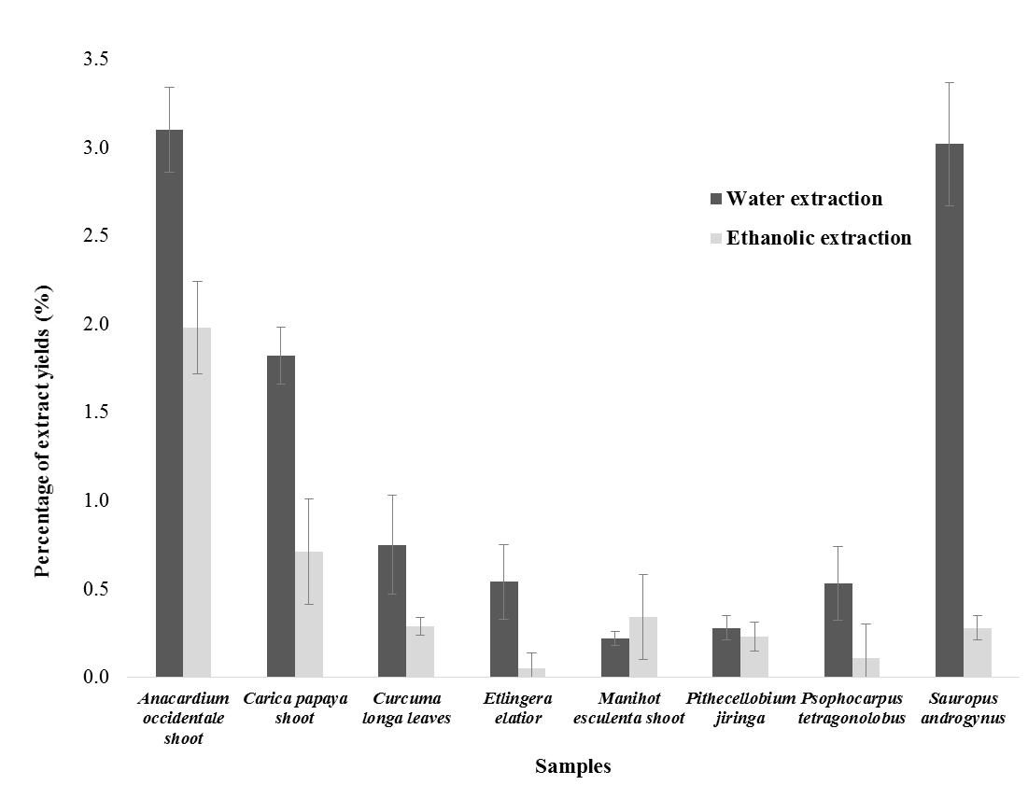

Figure 1. Yields of water and ethanolic extracts of vegetables

The amount of extraction yields are depends on the solvent and method of extraction. Water and ethanol are the most commonly solvents used in plant extraction because of their low toxicity and safer to be used [13, 18, 25]. The different polarity of different solvent will obtain different amount of extraction yield. Furthermore, water was always used for blanching and boiling the traditional vegetables before people consuming vegetables [11, 18]. This result also revealed that water extraction of vegetables was higher than ethanolic extraction except for Manihot esculenta shoot (Figure 1). Hence, polar solvent such as water, ethanol, and methanol were proven to be more efficient to produce high yield in leaves as well as to extract phenolic compounds [13, 18, 26-27].

Table 1 shows the total phenolic content of water and ethanolic extracts determined using Folin-Ciocalteu and Prussian-Blue assays. From the table, results showed that the total phenolic content of water extracts of vegetable ranged from 7.08 to 14.76 mg GAE when were determined using Folin-Ciocalteu assay. However, the total phenolic content of water extracts of vegetables varied in the range between 3.50 and 7.82 mg GAE when were measured using Prussian-Blue assay. In the ethanolic extracts, total phenolic content of vegetables were varied in the range between 5.21 and 15.86 mg GAE, and between 1.84 and 11.54 mg GAE when determined using Folin-Ciocalteu and Prussian-Blue assays, respectively. Analysis of total phenolic content using Folin-Ciocalteu assay clearly found that water and ethanolic extracts of Anacardium occidentale shoot had the highest (p<0.05) total phenolic content. However, water and ethanolic extracts of Manihot esculenta shoot obtained the highest (p<0.05) total phenolic content when were measured using Prussian-Blue assay. In general, results found that most of the phenolic content of extracts were higher when determined using Folin-Ciocalteu assay compared to Prussian-Blue assay, except for ethanolic extracts of Manihot esculenta shoot and Psophocarpus tetragonolobus.

Previously, González et al. [28] reported that the percentage of phenolic content of propolis from different area in Argentina ranged between 3.25 and 33.49 GAE (analyzed using Folin-Ciocalteu), and 2.36 and 22.86 GAE (analyzed using Prussian Blue assay). Total phenolic content in red wine was also higher when were determined using Folin-Ciocalteu assay (5.14 to 13.3 mg/L GAE) compared with Prussian-Blue assay (1.8 to 4.8 mg/L GAE). However, the content of phenolic determined using Folin-Ciocalteu assay and Prussian Blue assay was approximately similar in white wines [29].

Table 1. Total phenolic content of water and ethanolic extracts measured by Folin-Ciocalteu
and Prussian-Blue assays
 | Total phenolic content (mg GAE / g extracts)
Samples | Water extracts |  | Ethanolic extracts
Samples | Folin-Ciocalteu assay | Prussian-Blue assay | Folin-Ciocalteu assay | Prussian-Blue assay
Anacardium occidentale shoot | 14.76ª | 3.57e | 15.86ª | 7.72^{b}
Carica papaya shoot | 10.63^{c} | 3.69e | 7.17^{c} | 5.10^{c}
Curcuma longa leaves | 7.08e | 4.09d^{e} | 8.86b^{c} | 7.73^{b}
Etlingera elatior | 10.76^{c} | 3.50e | 9.72^{b} | 7.49^{b}
Manihot esculenta shoot | 12.37^{b} | 7.82ª | 8.90^{bc} | 11.54ª
Pithecellobium jiringa | 7.91e | 5.48^{c} | 5.38^{d} | 1.84e
Psophocarpus tetragonolobus | 8.86^{d} | 4.22^{d} | 5.21^{d} | 6.70^{c}
Sauropus androgynus | 12.38^{b} | 6.71^{b} | 6.97^{cd} | 3.62^{d}
Data were expressed in triplicate analysis. Values with the same lowercase within each column were not significantly different (p>0.05).

The different in phenolic contents values from both methods is accounted by reagent sensitivity, different redox potential of the system used, and reducing capacity [28]. In fact, method of Folin-Ciocalteu reagent is not strictly specific for phenolic compounds measurements because there are other components that can react with this reagent such as ascorbic acid [13, 24], and anthocyanin [29]. In red wine, the contents of anthocyanin is higher than in white wine, thus, the different values of phenolic content determined in both assays could be explained by reaction of anthocyanin with Folin-Ciocalteu reagent [29]. This fact may also explain the finding in this study. Furthermore, Folin-Ciocalteu reagent can also act as medium for ionizing phenols, making them as reducing agents. The reaction is enhanced in alkaline condition since the additional of sodium carbonate create the alkaline environment. On contrary, Prussian-Blue reagent work in acidic condition where phenolic compounds were unionized resulting in their low reducing power as compared to Folin-Ciocalteu reagent [28].

Folin-Ciocalteu and Prussian-Blue assays are the most two common methods in determining total phenolic content in plants. Both are based on color changes a result of sample oxidized by specific reagent. Folin-Ciocalteu reagent consist of phosphotungstic (H₃PW₁₂O₄₀) and phosphomolybdic (H₃PMo₁₂O₄₀) acids that will oxidize phenolic compound to blue oxides of tungstene (W₈O₂₃) and molybdene (Mo₈O₂₃) [24]. In Prussian Blue assay, the method is based on the formation of ferricyanide-ferrous [(Fe(CN)⁶)³-Fe²⁺] ion complex as a result of reduction of red ferric (Fe³⁺) to blue ferrous (Fe²⁺) ion by phenolic compounds. HCl is added in the reagent mixture in the assay preparation to increase the stability of ferric chloride (FeCl₃), thus, speed up the reaction to complete [31]. The formation of oxidized blue color in both reactions indicates the quantity of phenolic compounds that can be measured using spectrophotometer at specific wavelength [29, 30]. Various types of phenolic compounds also generate different responses of blue color intensity to the different assay [20, 32-33].

In fact, both assays have their own advantages for phenolic contents measurement in extracts. Folin-Ciocalteu assay method is more stable and reproducible method compared to Prussian-Blue assay. Prussian-Blue assay method is unstable due to the formation of undesirable precipitation of extract with the reagent and it will increase with incubation time. However, Prussian-Blue assay is more rapid and sensitive as this assay allows the detection of phenolic contents at sample extracts concentration lower than 1.10^{–6} mg/mL. Thus, a highly skilled operator is required to conduct Prussian-Blue assay preparation. Furthermore, the handling of the reactive mixture of K₃Fe(CN)₆ and FeCl₃ is a critical in conducting Prussian assay and laborious [28].

In this study, it was also obtained that most of water extracts of vegetables contained higher phenolic compounds compared with ethanolic extracts when determined using Folin-Ciacalteu assay. Othman et al. [18] reported that total phenolic content of Melicope Lunu ankeda (locally known as tenggek burung) and Polygonum minus (locally known as kesum) were higher in water extracts than in ethanolic extract. However, phenolic contents of Murraya koenigii or curry leaves and Eugenia polyantha or Salam leaves were higher in ethanolic extracts. Previously, phenolic compounds in henna leaves [34] and from sorghum leaf [35] were more efficient to extract with water as compared with methanol solvent. Water was also the best solvent for extracting tea catechins, than 80% methanol or 70% ethanol [36].

The choice of extraction solvents such as water, acetone, ethyl acetate, alcohols (methanol, ethanol, and propanol) and their mixtures [37] will influence the yields of phenolic contents. In fact, most of aqueous solvent extracts have been shown to give higher total phenolic content as compared to absolute solvent. Turkmen et al. [38] reported that the use of aqueous acetone to extract phenolic compounds from black tea obtained the highest values of total phenolic content compared to other absolute acetone. Alcoholic solvents are not highly selective for phenolic compounds. However, they are more preferred for extracting phenolic compounds from natural sources as they provides comparatively high yield with water. The efficiency and extractability of alcohol as solvent can be enhanced by increasing their polarity and the addition of water with absolute concentration of alcohol solution [39]. Total phenolic content of vegetative parts of Pluchea indica is higher when extract using 50% ethanol solvent followed by aqueous ethanol and absolute ethanol [40]. Furthermore, the phenolic contents of Lathyrus maritimus L. seed extracted using acetone-water system obtained higher amount than using absolute ethanol-water or methanol-water systems [41]. Perhaps, the addition of water in absolute solvent help to increase the extractability of sample as the polarity of solvent increased [42].

The efficiency of phenolic contents of sample extraction can be enhanced by increasing the amount of water to the solvent. This could be explained in term of hydroxyl bond occur between water and phenolic compounds. It is known that oxygen molecule from solvent will form hydrogen bond with hydroxyl groups of phenolic compounds. Therefore, as more water molecules present in extraction system, more oxygen atom in water molecules are available for the hydrogen bond formation with phenolic compounds. This will allow more phenolic compounds is extracted and resulting in higher extraction yield and total phenolic compounds. Water extracts lead in more hydrogen bond formation with all hydroxyl groups even with the phenolic compounds that bound to the other compounds such as sugar [42]. However, absolute solvent may only restricted to bond with compound with hydroxyl groups of phenolic compounds. Hence, total phenolic content extracted were significantly influenced by different types of solvent and the properties of the phenolic components of the plants types [42-43].

Antioxidant Activities of Vegetables: Ferric reducing antioxidant power of vegetable extracts
Results of FRAP analysis of water and ethanolic extracts of vegetables after incubation with linoleic acid for seven days are shown in Figure 2 and Figure 3, respectively. The Figures show that the absorbance reading of the mixture of linoleic acid and vegetables extracts increased during seven days incubation at 40 ºC. All samples of linoleic acid in assays oxidized when incubating with vegetables but with different reaction rate. At initial incubation, the lowest absorbance reading measurements were shown in water extract of Etlingera elatior (0.0019) and ethanolic extract of Carica papaya shoot (0.0060). After seven day incubation, the absorbance values of negative control (without any extracts) was 0.4010 and was significantly (p<0.05) increased with all water and ethanolic extracts of vegetables as predicted. The highest percentage of inhibition of linoleic acid peroxidation was observed in water extract of Etlingera elatior (75.6%) and ethanolic extract of Sauropus androgynus (78.1%).

Different extracts may have different types and amounts of phenolic compound that can slow down peroxidation rate of unsaturated bond in linoleic acid. The highest value of absorbance reading in negative sample assay was due to the highest rate of linoleic acid peroxidation since it was not inhibited by any compounds in any extracts. The percentage of inhibition linoleic acid was measured at seven days incubation compared with the initial incubation. Results found that the highest inhibition percentage of linoleic acid peroxidation of water and ethanolic extracts were observed in Etlingera elatior (75.6%) and extracts of Sauropus androgynus (78.1%), respectively. The percentage of inhibition of linoleic acid peroxidation of water extracts in the descending order were Etlingera elatior (75.6%), Psophocarpus tetragonolobus (70.8%), Sauropus androgynus (69.3%), Manihot esculenta shoot (69.3%), Carica papaya (68.3%), Curcuma longa leaves (64.8%), Pithecellobium jiringa (62.3%), and Anacardium occidentale shoot (59.6%). The percentage of inhibition of linoleic acid of ethanolic extracts ranged between 63.6 and 78.1%.

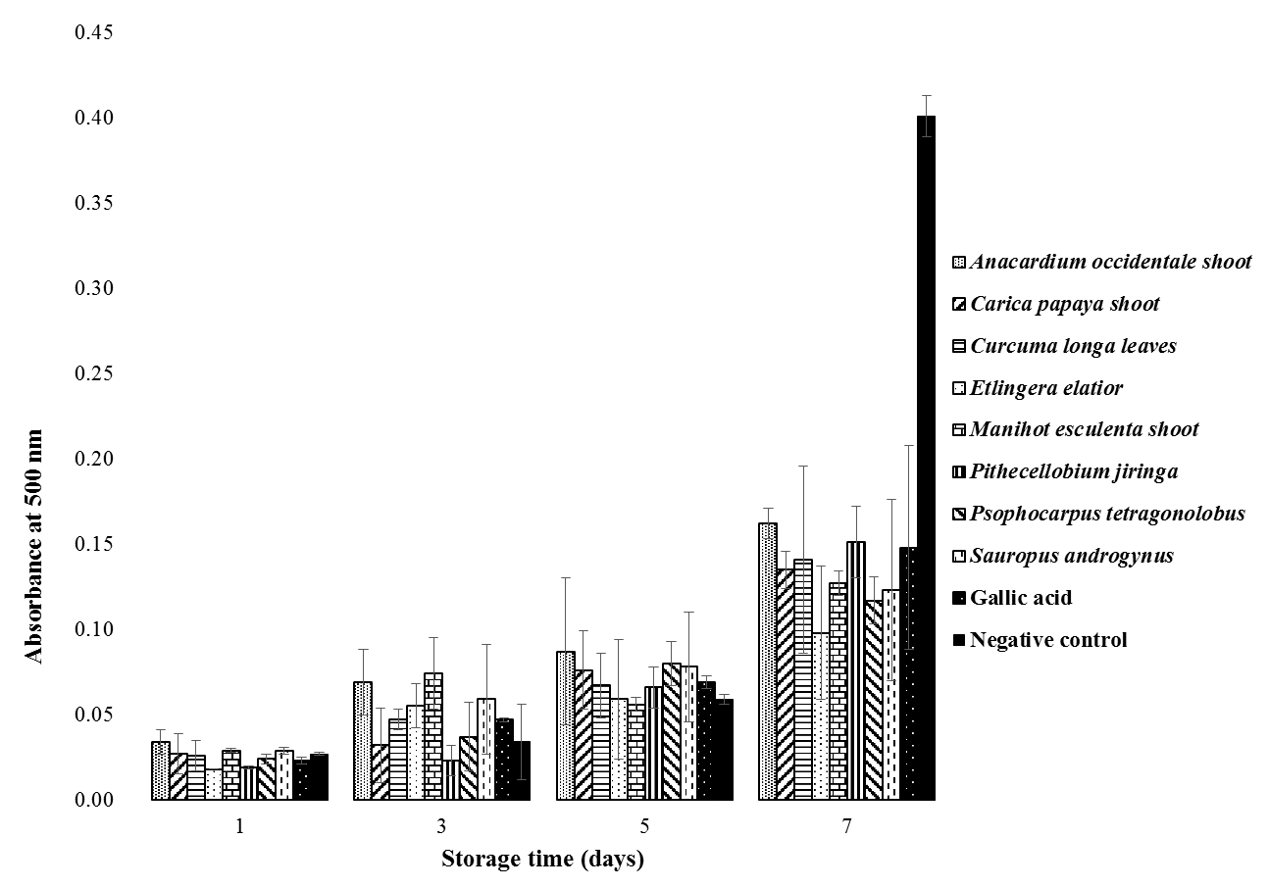

Figure 2. FRAP analysis of water extracts of vegetables. Data were expressed as mean and were analyzed in triplicate

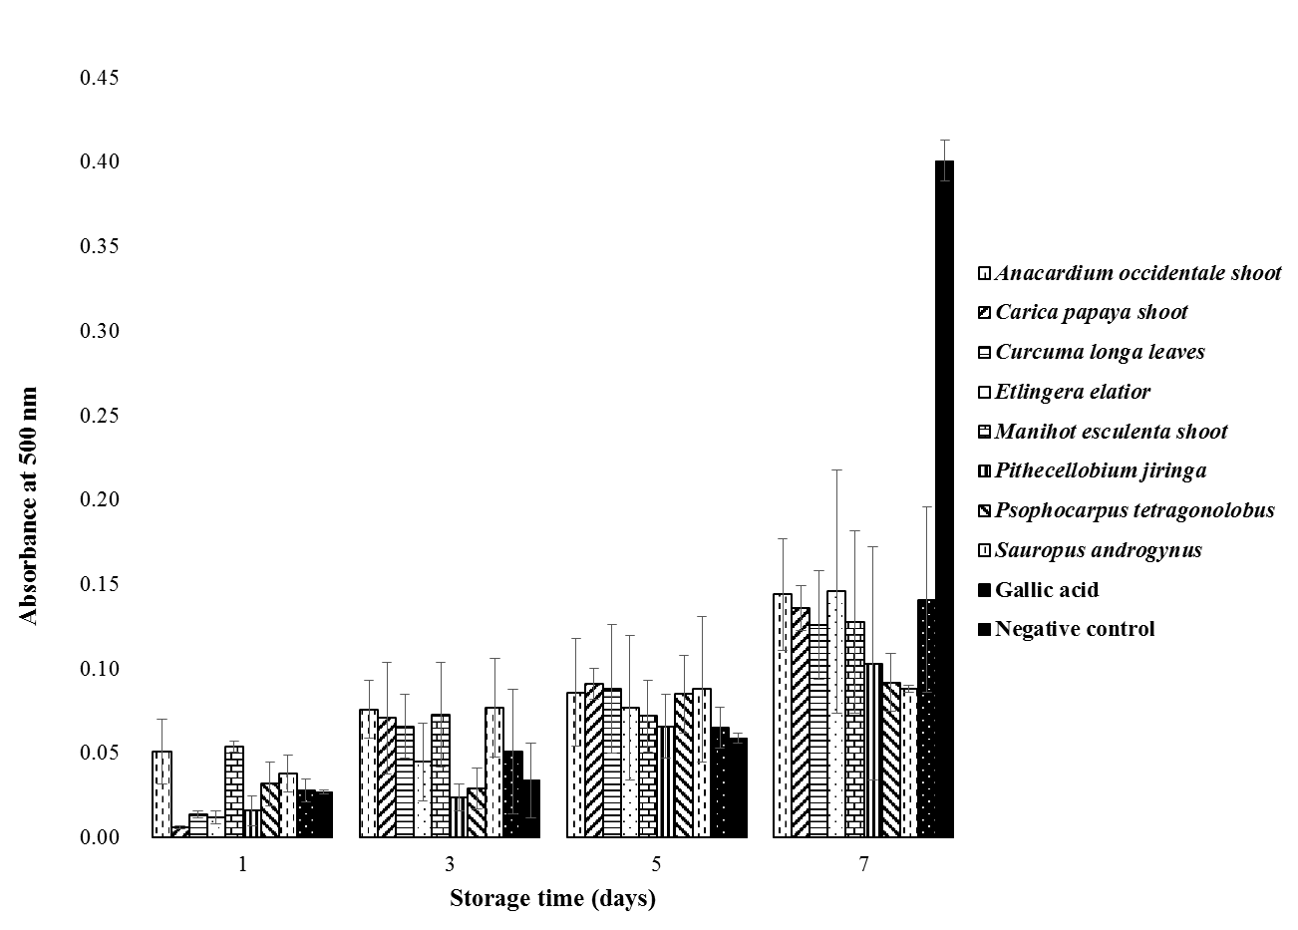
Figure 3. FTC analysis of ethanolic extracts of vegetables. Data were expressed as mean and were analyzed in triplicate

Previously, Huda-Faujan et al. [44] reported that percentage of inhibition of linoleic acid peroxidation of water extracts of five Malaysian vegetables ranged between 52.1 and 67.7%. The vegetables tested was Murraya koeniigi, Polygonum minus, Centella asiatica, and Oevanthe javanica. However, percentage of linoleic acid inhibition of methanolic extracts of the vegetables ranged between 63.6 and 70.6% [5]. Furthermore, the highest percentage (78.4%) of inhibition of linoleic acid peroxidation in Terminalia arjuna was performed in the stem bark of 80% methanolic extract. However, the leaves part of the samples extracted with 80% ethanol demonstrated the lowest percentage (61.9%) of inhibition of linoleic acid peroxidation [45].

In the present study, it was found that the percentage of linoleic acid peroxidation inhibition by gallic acid was 63.9%. The percentage of the inhibition was similar (p>0.05) that demonstrated by water extract of Carica papaya shoot and Curcuma longa leaves. According to Catha et al. [45] percentage of inhibition of linoleic acid peroxidation by Butylated Hydroxyl Toluene (BHT) which is a synthetic antioxidant (91.3%) exhibit significantly higher (p<0.05) activity that all extract of Terminalia arjuna. In several experiments of antioxidant activity, gallic acid exhibited more effective to inhibit oxidation than BHT. However, in general, natural antioxidant was obtained less effective to protect linoleic acid against peroxidation. An effective natural antioxidant may suggested to be used in combination of two or more mixtures to protect linoleic acid.

Antioxidant Activity of Vegetables Extracts using DPPH Assay
The radical scavenging activity of water and ethanolic extracts of vegetables using DPPH assay are shown in Figure 4 and Figure 5, respectively. Results demonstrated that the DPPH free radical scavenging activity of extracts increased with increasing in sample concentration. At 1.0 mg/mL, water extract of Curcuma longa leaves obtained the highest scavenging activity (p<0.05), while at the same concentration Manihot esculenta shoot demonstrated the lowest scavenging activity of DPPH free radical [Figure 3(a)]. However, the scavenging activity of Manihot esculenta was not significantly different with Pithecellobium jiringa at 1.0 mg/mL. From Figure 3(b), the highest scavenging activity of ethanolic extract was obtained in Psophocarpus tetragonolobus at concentration 1.0 mg/mL.

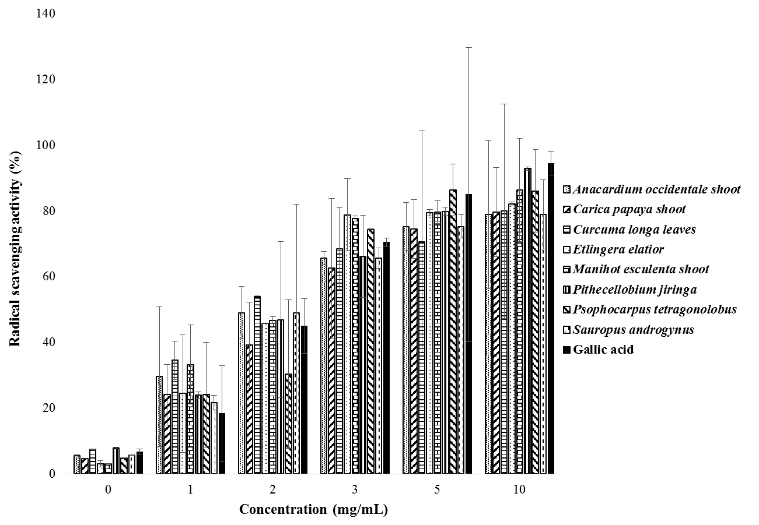

Figure 4. The radical scavenging activities of water extracts of vegetables using DPPH assay.

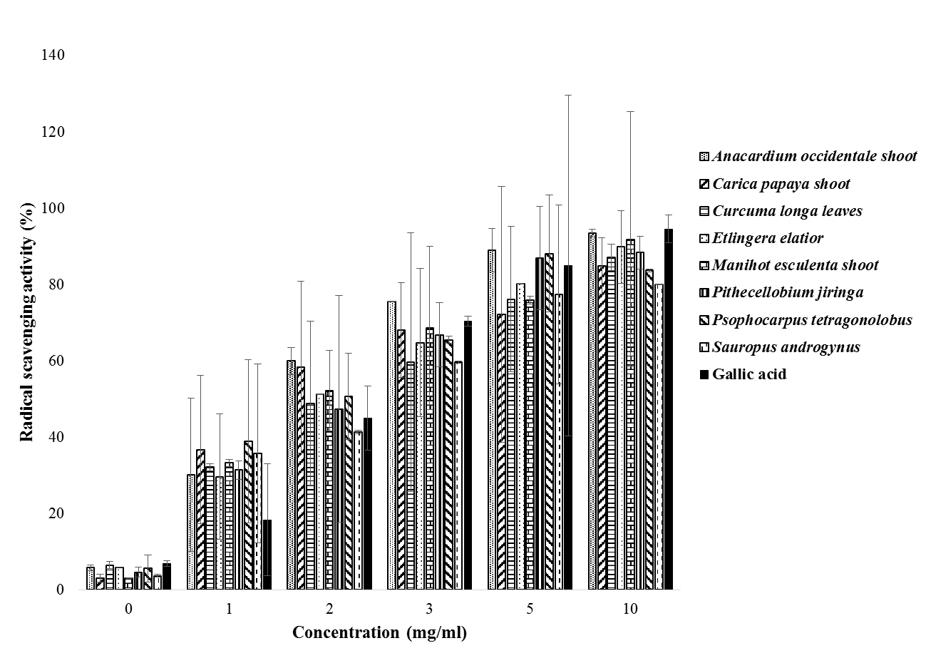

Figure 5. The radical scavenging activities of ethanolic extracts of vegetables using DPPH assay.

One of the most of widely used methods for determining antioxidant activity of sample extracts is DPPH radical scavenging activity assay [18, 33, 45]. The assay was developed based on the ability of antioxidant properties in the extracts to scavenge the stable radical DPPH [48]. In the present study, it was demonstrated that the antioxidant activity of extracts was depending on the extract concentration. In general, antioxidant activity of extracts increased with concentration of extracts in assay. Other studies also reported the similar trend of the DPPH radical scavenging activity of various extracts [13, 18, 33, 45]. However, at concentration of 6 mg/mL, the scavenging activity of sample extracts start to become plateau and this could due to the decreasing amount of DPPH radical in the assay. The scavenging activity of extracts might be due to the presence of phenolic hydroxyl groups in phenolic compounds. Results also obtained that most of ethanolic extracts demonstrated higher antioxidant activity compared to water extracts. In fact, Prior et al. [46] reported that this could be due to the better solubility of DPPH radicals in organic acid especially in ethanol compared to water solvent. Furthermore, Spigno et al. [39] reported that higher antioxidant activity of extracts should be found in alcoholic extracts compared to water extracts because alcoholic solvents maximize DPPH radicals interaction with antioxidant present in extracts.

Table 2 shows data of IC₅₀ of water and ethanolic extracts of vegetables and expressed as mg/mL. The extract concentration that provide 50% inhibition or IC₅₀ was calculated from the graph plotted inhibition percentages against tested samples extracts. Result obtain that the best IC₅₀ activity of extracts were demonstrated by water and ethanolic extract of Sauropus androgynus (0.077 mg/mL and 0.078 mg/mL, respectively). However, the IC₅₀ value of water extract of Pithecellobium jiringa (0.091 mg/mL) and ethanolic extract of Anacardium occidentale shoot (0.092 mg/mL) were not significantly (p>0.05) different with gallic acid. In fact, the lower the IC₅₀ value, the higher the antioxidant activity is examined as the IC₅₀ values defined the concentration of extract that causes 50% loss of the DPPH activity [47]. Previously, Olajuyigbe and Afolayan [48] obtained that the IC₅₀ of water and ethanolic extracts of Ziziphus.mucronata subsp. mucronata were 0.065 mg/mL and 0.042 mg/mL, respectively. The IC₅₀ of ethanolic extracts of various parts of Cinnamomum cassia ranged between 0.072 and 0.208 mg/mL.

Correlation of Phenolic Contents and Antioxidant Activities of Vegetables Extracts
Table 3 shows result of correlation analysis between total phenolic content and antioxidant activity of vegetables. The results obtain that total phenolic content were low and negatively correlated with antioxidant activities in linoleic acid. Nevertheless, all positive correlation between total phenolic content and scavenging activity of DPPH free radical were observed in all samples of extracts. Ethanolic extracts were strongly correlated with DPPH free radical assay and was consistent with other studies [13, 18, 29, 49]. This study also demonstrated that phenolic contents of ethanolic extracts obtained higher correlation with DPPH free radical assay compared with water extracts. DPPH is known to react specifically with low molecular weight phenolic compounds [50] as well as DPPH interaction and solubility is maximized in alcoholic solvent with the existance of extract [38, 46]. However, several studies also found that total phenolic content did not correlate with antioxidant assay [51-52]. The reasons for the reports might be due to the high amount of reducing agent in the extracts [25] that can interfere the results. In fact, extraction procedure can greatly influence the antioxidant activity as different solvent affected the antioxidant activity significantly [18]. Furthermore, different methods used in analysis of antioxidant activity may also give different value of antioxidant activity for same extract. Various types of components in sample extracts will also react differently with different reagents and different mechanisms. Thus, there was no specific method that can produce accurate result for certain analysis and various methods with different principles must be applied to obtain more accurate and precise results.

Table 2. Inhibitory concentration IC₅₀ of water and ethanolic extracts (mg/mL).
Samples | Inhibitory concentration (IC₅₀)
Samples | Water extraction | Ethanolic extraction
Anacardium occidentale shoot | 0.088ª | 0.092ª
Carica papaya shoot | 0.078^{d} | 0.083^{c}
Curcuma longa leaves | 0.078^{d} | 0.085^{c}
Etlingera elatior | 0.080^{c} | 0.088^{ab}
Manihot esculenta shoot | 0.085^{b} | 0.090ª
Pithecellobium jiringa | 0.091ª | 0.087^{b}
Psophhocarpus tetragonolobus | 0.084^{b} | 0.082^{c}
Sauropus androgynus | 0.077^{d} | 0.078^{d}
Gallic acid | 0.093ª | 0.093ª
Data were expressed as mean and were analyzed in triplicate. Value with the same lowercase within each column are not significantly different (p>0.05).

Table 3. The result of correlation analysis of water and ethanolic extracts of vegetables.
 | Pearson correlation coefficient (r)
Total phenolic content | Inhibition of linoleic acid oxidations | Scavenging activity of DPPH free radical
- Water extraction
Folin-Ciocalteu assay | -0.083 | 0.049
Prussian-Blue assay | 0.072 | 0.128
- Ethanolic extraction
Folin-Ciocalteu assay | -0.718 | 0.702
Prussian-Blue assay | -0.569 | 0.589

Conclusion
From this study, it can be concluded that all water and ethanolic extracts of Malaysian traditional vegetables contain various amount of total phenolic compounds when were determined using both Folin-Ciocalteu and Prussian Blue assays. In general, most of the ethanolic extracts of the vegetables obtained slightly higher antioxidant activity in both FRAP and DPPH assays. However, total phenolic content and antioxidant activity was only have positive correlation when were determined using DPPH assay. Thus, this study obtained that the traditional Malaysian vegetables can be a potential source of natural antioxidant. Nevertheless, further work is needed to identify and isolate the individual phenolic compounds to determine the in vitro and in vivo of antioxidant mechanism in this vegetable.

Acknowledgement
The authors are grateful to Faculty Science and Technology, Universiti Sains Islam Malaysia, Malaysia for the use of all laboratory facilities, apparatus, and financial support of this entire work. Thanks and appreciation also to Ms. Normah Haron, Laboratory Assistant, Faculty Science and Technology, Universiti Sains Islam Malaysia, for their assistance in this work.

References
- Xia, E. Q., Deng, G. F., Guo, Y. J. and Li, H. B. (2010). Biological activities of polyphenols from grapes. International Journal of Molecular Sciences, 11(2): 622-646.
- Soerjomataram, I., Oomen, D., Lemmens, V., Oenema, A., Benetou, V., Trichopoulou, A., Coebergh, J. W., Barendregt, J. and de Vries, E. (2010). Increased consumption of fruit and vegetables and future cancer incidence in selected European countries. European Journal of Cancer, 46(14): 2563-2580.
- Norhanom, A. W., Ashril, Y. and Mustafa, A. M. (1999). Anti-tumour activity in local ulam. In: Ali, A.M., Shaari, K. and Zakaria, Z. (Eds.) Phytochemicals and Biopharmaceutins from the Malaysian Rainforest. pp. 135-141. Malaysia: FRIM, Kuala Lumpur.
- Mansor, P. (1988). Teknologi sayur-sayuran. pp. 1-5. Malaysia: MARDI, Kuala Lumpur.
- Huda-Faujan, N., Noriham, A., Norrakiah, A. S. and Babji, A. S. (2009). Antioxidant activity of plants methanolic extracts containing phenolic compounds. African Journal of Biotechnology, 8(3): 484-489.
- Asif, M. and Khodadadi, E. (2013). Medicinal uses and chemistry of flavonoid contents of some common edible tropical plants. Journal of Paramedical Sciences, 4(3): 119-138.
- Mushtaq, M. and Wani, S. M. (2013). Polyphenols and human health: a review. International Journal of Pharma and Bio Sciences, 4(2): B338-B360.
- Nagavani, V. and Rao, T. R. (2010). Evaluation of antioxidant potential and qualitative analysis of major polyphenols by RP-HPLC in Nyamphaea nouchali brum flower. International Journal of Pharmacy and Pharmaceutical Sciences, 2(Suppl 4): 98–104.
- Shiban, M. S., Al-Otaibi, M. M. and Al-Zoreky, N. S. (2012). Antioxidant activity of pomegranate (Punica granatum L.) fruit peels. Food and Nutrition Sciences, 3(7): 991-996.
- Rice-Evans, C. A., Miller, N. J., Bolwell, P. G., Bramley, P. M. and Pridham, J. B. (1995). The relative anti-oxidant activities of plant derived polyphenolic flavonoids. Free Radical Research, 22(4): 375-383.
- Wong, S. P., Leong, L. P. and Koh, J. H. W. (2006). Antioxidant activities of aqueous extracts of selected plants. Food Chemistry, 99(4): 775-783.
- Dimitrios, B. (2006). Sources of natural phenolic antioxidants. Trends in Food Science & Technology, 17: 505-512.
- Nor Asna, A. and Noriham, A. (2014). Antioxidant activity and bioactive components of oxalidaceae fruit extracts. The Malaysian Journal of Analytical Sciences, 18(1): 116-512.
- Abas, F., Lajis, N. H., Israf, D. A., Khozirah, S. and Umi Kalsom Y. (2006) Antioxidant and nitric oxide inhibition activities of selected Malay traditional vegetables. Food Chemistry, 95(4): 566-573.
- Rahman, M. M., Habib, M. R., Hasan, M. A., Al-Amin, M., Saha, A. and Mannan, A. (2014). Comparative assessment on in vitro antioxidant activities of ethanol extracts of Averrhoa bilimbi, Gymnema sylvestre and Capsicum frutescens. Pharmacognosy Research, 6(1): 36-41.
- Zainol, M. K., Abd-Hamid, A., Yusof, S. and Muse, R. (2003). Antioxidative activity and total phenolic compounds of leaf, root and petiole of four accessions of Centella asiatica (L.) Urban. Food Chemistry, 81(4): 575-581.
- Mohd Zin, Z., Abdul-Hamid, A. and Osman, A. (2002). Antioxidative activity of extracts from mengkudu (Morinda citrifolia L.) root, fruit and leaf. Food Chemistry, 78(2): 227-231.
- Othman, A., Mukhtar, N. J., Ismail, N. S. and Chang, S. K. (2014). Phenolics, flavonoids content and antioxidant activities of 4 Malaysian herbal plants. International Food Research Journal, 21(2): 759-766.
- Apak, R., Güçlü, K., Demirata, B., Özyürek, M., Çelik, S. E., Bektaşoğlu, B., Berker, K. I. and Özyurt, D. (2007). Comparative evaluation of various total antioxidant capacity assays applied to phenolic compounds with the CUPRAC assay. Molecules, 12(7): 1496-1547.
- Singleton, V. L. and Rossi, J. A. (1965). Colorimetry of total phenolics with phosphomolybdic phosphotungstic acid. American Journal of Enology and Viticulture, 16(3): 155-158.
- Hoff, J. F. and Singleton, K. I. (1977). A method for determination of tannin in foods by means of immobilized enzymes. Journal of Food Science, 42(6): 1566-1569.
- Gupta, C. and Verma, H. (2011). Visual estimation and spectrophotometric determination of tannin content and antioxidant activity of three common vegetables. International Journal of Pharmaceutical Sciences and Research, 2(1): 189-196.
- Osawa, T. and Namiki, M. (1981). A novel type of antioxidant isolated from leaf wax of Eucalyptus leaves. Agricultural and Biological Chemistry, 45(3): 735-739.
- Azlim Almey, A. A., Ahmed Jalal Khan, C., Syed Zahir, I., Mustapha Suleiman, K., Aisyah, M. R. and Kamarul Rahim, K. (2010). Total phenolic content and primary antioxidant activity of methanolic and ethanolic extracts of aromatic plant’s leaves. International Food Research Journal, 17: 1077-1084.
- Moure, A., Cruz, J. M., Franco, D., Dominguez, J. M., Sineiro, J. and Dominguez, H. (2001). Natural antioxidants from residual sources. Food Chemistry, 72: 45-171.
- Singh, P.P. and Saldaña, M. D. A. (2011). Subcritical water extraction of phenolic compounds from potato peel. Food Research International, 44(8): 2452-2458.
- Bimakr, M, Abdul Rahman R, Saleena Taip F, Ganjloo A, Salleh L. M, Selamat J, Hamid A., Zaidul I. S. M. (2011). Comparison of different extraction methods for the extraction of major bioactive flavonoid compounds from spearmint (Mentha spicata L.) leaves. Food and Bioproducts Processing, 2011; 89(1): 67-72.
- González, M., Guzmán, B., Rudyk, R., Romano, E. and Molina, A. A. (2003).Spectrophotometric determination of phenolic compounds in propolis. Latin American Journal of Pharmacy, 22(3): 243-248.
- Stratil, P., Kuban, V. and Fojtova, J. (2008). Comparison of the phenolic content and total antioxidant activity in wines as determined by spectrophotometer methods. Czech Journal of Food Sciences, 26(4): 242-253.
- Conforti, F., Statti, G., Uzunov, D. and Menichini, F. (2006). Comparative chemical composition and antioxidant activities of wild and cultivated Laurus nobilis L. leaves and Foeniculum vulgare subsp. piperitum (Ucria) coutinho seeds. Biological & Pharmaceutical Bulletin, 29(10): 2056-2064.
- Naczk, M. and Shahidi, F. (2004). Extraction and analysis of phenolics in food. Journal of Chromatography A, 1054(1-2): 95-111.
- Saeed, N., Khan, M. R. and Shabbir, M. (2012). Antioxidant activity, total phenolic and total flavonoid contents of whole plant extracts Torilis leptophylla L. BMC Complementary and Alternative Medicine, 2012; 12:221.
- Ikram, E. H. K., Kho, H. E., Jalil, A. M. M., Ismail, A., Isris, S., Azlan, A., Nazri, H. S. M., Dito, N. A. M. and Mokhtar, R. A. M. (2009). Antioxidant activity and total phenolic content of Malaysian underutilized fruits. Journal of Food Composition and Analysis, 22(5): 388-393.
- Hosein, H. K. M. and Zinab, D. (2007). Phenolic compounds and antioxidant activity of Henna leaves extracts (Lawsonia inermis). World Journal of Dairy & Food Sciences, 2(1): 38-41.
- Agbangnan, P. C., Tachon, D. C., Dangou, J., Chrostowska, A., Fouquet, E. and Sohounhloue, D. C. K. (2012). Optimization of the extraction of sorghum’s polyphenols for industrial production by membrane processes. Research Journal of Recent Sciences, 1(4): 1-8.
- Khokhar, S. and Magnusdottí, S. G. M. (2002). Total phenol, catechin, and caffeine contents of teas commonly consumed in the United Kingdom. Journal of Agricultural and Food Chemistry, 50(3): 565-570.
- Garcia-Salas, P., Morales-Soto, A., Segura-Carretero, A. and Fernández-Gutiérrez, A. (2010). Phenolic compound-extraction systems for fruit and vegetable samples. Molecules, 15(12): 8813-8826.
- Turkmen, N., Velioglu, S., Sari, F. and Polat, G. (2007). Effect of extraction conditions on measured total polyphenol contents and antioxidant and antibacterial activities of black tea. Molecules, 12(3): 484-496.
- Spigno, G., Tramelli, L. and De Faveri, D. M. (2007). Effects of extraction time, temperature and solvent on concentration and antioxidant activity of grape marc phenolics. Journal of Food Engineering, 81(1): 200-208.
- Normala, H. and Suhaimi, M. I. (2011). Quantification of total phenolics in different parts of Pluchea indica (less) ethanolic and water extracts. Pertanika Journal of Science & Technology, 19(1): 19-24.
- Chavan, U. D. and Amarowicz, R. (2013). Effect of various solvent systems on extraction of phenolics, tannins and sugars from beach pea (Lathyrus maritimus L.) International Food Research Journal, 20(3): 1139-1144.
- Dai, J. and Mumper, R. J. (2010). Plant phenolics: extraction, analysis and their antioxidant and anticancer properties. Molecules, 15(10): 7313-7352.
- Khoddami, A., Wilkes, M. A. and Roberts, T. H. (2013). Techniques for analysis of plant phenolic compounds. Molecules, 18(2): 2328-2375.
- Huda-Faujan, N., Noriham, A., Norrakiah, A. S. and Babji, A. S. (2007). Antioxidative activities of water extracts of some Malaysian herbs. ASEAN Food Journal, 14(1): 61-68.
- Chatha, S. A. S., Hussain, A. I., Asad, R., Majeed, M. and Aslam, N. (2014). Bioactive components and antioxidant properties of Terminalia arjuna L. extracts. Journal of Food Processing and Technology, 5(2): 1-5.
- Prior, R. L., Wu, X. and Schaich, K. (2005). Standardized methods for the determination of antioxidant capacity and phenolics in foods and dietary supplements. Journal of Agricultural and Food Chemistry, 53(10): 4290-4302.
- Proestos, C., Lytoudi, K., Mavromelanidou, O. K., Zoumpoulakis, P. and Sinanoglou, V. J. (2013). Antioxidant capacity of selected plant extracts and their essential oils. Antioxidants, 2(1): 11-22.
- Olajuyigbe, O. O. and Afolayan, A. J. (2011). Phenolic content and antioxidant property of the bark extracts of Ziziphus mucronata Willd. subsp. mucronata Willd. BMC Complementary and Alternative Medicine, 11(130): 1-8.
- Li, X., Wu, X. and Huang, L. (2009). Correlation between antioxidant activities and phenolic contents of Radix Angelicae Sinensis (Danggui). Molecules, 14(12): 5349-5361.
- Paixão, N., Perestrelo, R., Marques, J. C. and Câmara, J. S. (2007). Relationship between antioxidant capacity and total phenolic content of red, rose and white wines. Food Chemistry, 105(1): 204-214.
- Amin, I. and Lee, W. Y. (2005). Effect of different blanching times on antioxidant properties in selected cruciferous vegetables. Journal of the Science of Food and Agriculture, 85(13): 2314-2320.
- Yu, J., Ahmedna, M. and Goktepe, I. (2007). Peanut protein concentrate: production and functional properties as affected by processing. Food Chemistry, 103(1): 121-129.

