

TREATMENT OF PALM OIL MILL EFFLUENT (POME) USING MEMBRANE BIOREACTOR

(Rawatan Effluen Kilang Kelapa Sawit (POME) menggunakan
Membran Bioreaktor)

Abd. Aziz Mohd Azoddein*, Hazlan Bin Haris, Faten Ahada Mohd Azli

Faculty of Chemical Engineering and Natural Resources,
University Malaysia Pahang, Lebuhraya Tun Razak, 26300 Kuantan, Pahang Darul Makmur.

*Corresponding author: aaziz@ump.edu.my

Received: 7 January 2015; Accepted: 1 April 2015

Abstract
Malaysia is the largest producer and exporter of palm oil. Palm oil mill effluent (POME) which is highly polluting effluent is becoming a major problem to environment as if it not being treated well before discharged based on standard limit imposed by The Malaysian Department of Environment (DOE) for effluent discharged. Samples from mixing ponds which act as activated sludge are collected and being analyze using water analyzer method to obtain parameters such as BOD, COD, suspended solid, turbidity and pH. Wastewater samples from facultative ponds are also being analyzed than mix with activated sludge treated in the bioreactor. Results from lab-scale bioreactor are used in membrane bioreactor pilot plant system to treat the wastewater. Results from bioreactor treatment in pilot plant scale show a decrement 61.2 % of BOD and 58.9% of COD, suspended solid and turbidity are also reducing up with pH in range of 5-9.After the wastewater was treated in the ultrafiltration membrane system, high quality water with total of deterioration for all parameter are up to 99.9% and pH up to7.39. This results show that the membrane bioreactor (MBR) treatment system are highly effective in treating POME.

Keywords: Palm Oil Mill Effluent (POME), Biological Oxygen Demand (BOD), Chemical Oxygen Demand (COD), Membrane Bioreactor (MBR)

Abstrak
Malaysia merupakan pengeluar terbesar dan pengeksport minyak sawit. Palm efluen kilang minyak (POME) yang sangat mencemarkan efluen menjadi satu masalah yang besar kepada alam sekitar seolah-olah ia tidak dirawat dengan baik sebelum dilepaskan berdasarkan had standard yang dikenakan oleh Jabatan Alam Sekitar (JAS) Malaysia bagi effluen yang dilepaskan. Sampel dari kolam pencampuran yang bertindak sebagai enapcemar diaktifkan dikumpulkan dan menganalisis yang menggunakan kaedah analisa air untuk mendapatkan parameter seperti BOD, COD, pepejal terampai, kekeruhan dan pH. Sampel air sisa dari kolam fakultatif juga sedang dianalisis daripada campuran dengan enapcemar diaktifkan dirawat dalam bioreaktor. Keputusan daripada bioreaktor berskala makmal digunakan dalam bioreaktor membran sistem kilang perintis untuk merawat air kumbahan. Keputusan dari rawatan bioreaktor dalam skala loji perintis menunjukkan susutan 61.2% daripada BOD dan 58.9% daripada COD, pepejal terampai dan kekeruhan juga mengurangkan dengan pH dalam julat 5-9.After air sisa yang dirawat dalam sistem membran ultraturasan, tinggi air berkualiti dengan jumlah kemerosotan untuk semua parameter adalah sehingga 99.9% dan pH sehingga to7.39.This keputusan menunjukkan bahawa sistem rawatan bioreaktor membrane (MBR) adalah sangat berkesan dalam merawat POME.

Kata Kunci: Efluen Kilang Minyak Sawit (POME), Permintaan Oksigen Biokimia (BOD), Permintaan Oksigen Kimia (COD), Membran Bioreactor (MBR)

Introduction
The history of palm oil can be traced back to the days of the Egyptian paraohs 5000 years B.C. It was introduced to Malaysia at the start of the 20th century and commercially produced in 1917. Palm oil's unique composition makes it versatile in its application in food manufacturing and in the chemical, cosmetic and pharmaceutical industries. Its semi-solid physical properties are needed in much food preparation. Its non-cholesterol quality and digestibility make it popular as source of energy, while its technical and economic superiority makes it preferable as base material in the manufacture of various non-edible products. Besides that, for countries like Malaysia, Thailand, Indonesia, Colombia and other tropical developing regions, the palm oil industry has been an important economic contributor and impressive export and production of palm oil. Then, a huge production of the effluent has turned out to be main source of water pollution [1].

The Malaysian experience in effluent control in the palm oil industry due to the opening of the factory vastly. Palm oil mill effluent (POME) contains a high concentration of organic matter. This polluting effluent with its high content of chemical oxygen demand (COD), 50,000 mg/L, biological oxygen demand (BOD), 30,000 mg/L, oil and grease, 6000 mg/L, suspended solids, 59,350 and 750 mg/L of total nitrogen can easily cause severe pollution of waterways due to oxygen depletion and other related effects [2].

The membrane bioreactor (MBR) concept has received considerable attention from design engineers, public health professional and research workers interested in process alternative for industrial wastewater treatment such as POME [3]. Membrane technology is a highly potential solution for the treatment of POME since the current conventional treatment system shows its lack of efficiency and this unfortunately leads to the environmental pollution issues. The conventional system based on biological treatments of anaerobic and aerobic systems need proper maintenance and monitoring as the processes depend solely on microorganisms to degrade the pollutants. Membrane bioreactor systems (MBRs) have, over the past ten years, emerged as an effective solution to transforming various wastewaters into high quality effluent suitable for discharge into the environment and increasingly into a reusable product. According to a comprehensive review by Visvanathan et al [4], MBR systems have been used to treat various types of wastewater.

A membrane bioreactor (MBR) combines the activated sludge process with a membrane separation process. The reactor is operated similar to a conventional activated sludge process but without the need for secondary clarification and tertiary steps like sand filtration. Low-pressure membrane filtration, either microfiltration (MF) or ultrafiltration (UF) is used to separate effluent from activated sludge [5]. The two main MBR configurations involve either submerged membranes or external circulation (side stream configuration) as shown in Figure 1.

Alternative process that can be used to treat POME is by evaporation. Using POME containing 3-4% total solid as feed, about 85% the water in the POME can be recovered with distillate. Unfortunately, the energy requirement is a major constraint in this process, whereby under standard condition, specific energy consumption is very high where 1 kg of steam is required per 1 kg of water evaporated [6].

Materials and Methods
Palm Oil Mill Effluent (POME)
POME samples were obtained from Felda Palm Industries Sdn. Bhd. Felda Lepar Hilir 3, Gambang, Pahang. The samples were taken at facultative pond which has upper aerobic zone and a lower anaerobic zone.

Bioreactor Procedure (lab –Scale)
There were 3 bioreactor tanks. The tanks were filled with POME from facultative pond. The first tank was equipped with aerator without stirrer. The second tank was filled with POME and it was equipped with stirrer without aerator. As for the third tank, it was equipped with both aerator and stirrer. All three tanks were kept running, the samples were taken from each tank every three days and were analyzed using a water analyzer.

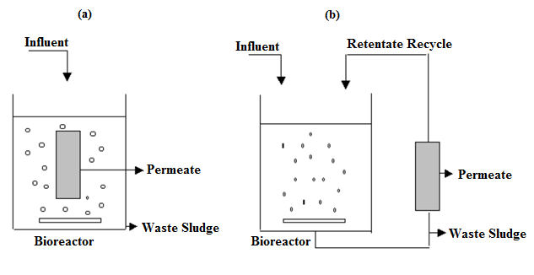
Figure 1. Configuration of MBR systems: (a) submerged MBR, (b) side-stream MBR.

Preparation of wastewater
A mixture by using different ratio of wastewater and activated sludge was prepared and filled into the bioreactor. Assuming that the bacteria will decompose the excessive nutrients in the wastewater and when the nutrients was fully decomposed, bacteria will die and was sedated at the bottom of the tank.

Membrane Bioreactor System Procedure (Pilot Plant Scale)
The tank of the bioreactor was filled with the wastewater at level 150L with the certain ratio of 70% of wastewater and 30% of activated sludge. The wastewater was being analyzed every three days using the water analyzer. In the membrane treatment system, the wastewater was given a pressure (maximum pressure 5 bar) to allow the wastewater to penetrate in the ultrafiltration membrane. Furthermore, the most common capacity for current MBR installations ranges is in the 50,000 – gallon-per-day to 500,000 gallon-per-day systems [7].

Wastewater Analysis: BOD Analysis
Hach DR 2400 spectrophotometer was used to analyze the concentration of BOD. A series of at least five or six, portions of well-mixed samples were then transferred to a separate 300-mL glass stopper BOD bottles were measured using serological pipette. After that, each bottle was filled with seeded or unseeded dilution water just below the lip and the stopper of the bottles was pressed to mix. The bottles were placed in an incubator at 20 ± 1° C, in the dark for five days.

COD Analysis
The concentration of COD was analyzed using COD Digestion Reactor Hach DRB 200. A 100 mL of homogenized sample was blended for 30 seconds. Meanwhile the COD Reactor was turned on to 150 °C. The cap of a COD Digestion Reagent Vial was removed and the vial was held at a 45-degree angle to pipette 2.00 mL (0.2 mL for the 0 to 15000 mg/L range) of sample into the vial. After that the vial was recapped tightly. The outside of the COD vial was being rinsed with deionized water and the vial was wiped until it is clean with a paper towel. The vial was inverted gently several times to mix the contents. The vial was placed in the preheated COD Reactor and was heated for 2 hours. After that, the reactor was turned off and left for 20 minutes for the vials to cool to 120 °C or less.

Turbidity Analysis
Turbidity of the sample was analyzed using Hach 2100Q Portable Turbidimeter. The sample was collected in a clean container and the sample was filled into cell to the line (about 15 mL). A thin film of silicone oil was applied then wipe with a soft cloth to obtain an even film over the entire surface. The instrument placed on a flat, sturdy surface. The sample cell was then being put in the instrument cell compartment and the lid was closed

Suspended Solid Analysis
500 mL of sample was blended in a blender at high speed for exactly two minutes. 25 mL of the blended sample was poured into a first sample cell. For second sample was filled with 25 mL of tap water or deionized water. Each cell then placed into cell holder to determine the result.

pH Analysis
The sample was poured in a beaker. The sample was being swirled and the electrode was placed in the beaker. The entire sensing end was submerged and then the result was recorded when the pH value is stable using Mettler Toledo pH meter.

Results and Discussion
The experiment that has been done before and after treatment using three different ratios which are 70% of wastewater with 30% of Activated sludge, 80% of wastewater with 20% of Activated Sludge and 90% of wastewater with 10% of Activated Sludge. The measured characteristics are biological oxygen demand (BOD), chemical oxygen demand (COD), turbidity, suspended solid and pH. The characteristics of POME and standard discharge limit by Malaysia Department of the environment (DOE) are shown in Table 1.

Table 1. Characteristics of POME and standard discharge limit by Malaysian Department
of the Environment (DOE)
Parameter | Concentration | Standard limit
Chemical Oxygen Demand (COD) | 25,000 mg/L | -
Biological Oxygen Demand (BOD) | 50,000 mg/L | 100 mg/L
pH | 4.7 | 5 – 9
Suspended Solids | 18,000 mg/L | 400 mg/L

The fastest treatment tank is the one using 70% of wastewater, 30% of activated sludge ratio which underwent a treatment only for 9 days meanwhile treatment tank using 80% of wastewater, 20% of activated sludge ratio and 90% of wastewater, 10% of activated sludge ratio took 15 days and 24 days. The comparison different ratio and characteristics as summarized in Table 2.

Table 2. Comparison different ratio and characteristics
Parameter | Ratio Characteristic
 | 70% of Wastewater with 30% of Activated Sludge | 80% of Wastewater with 20% of Activated Sludge | 90% of Wastewater with 10% of Activated Sludge
BOD | 9 days | 15 days | 24 days
COD | 9 days | 15 days | 24 days
pH | 9 days | 15 days | 24 days
Lab – Scale Bioreactor: Process Determination of Biological Oxygen Demand (BOD₅)
From Table 3 and Figure 2, it shows the initial and final data from the experiment in dissolved oxygen measurement to determine the biological oxygen demand (BOD) using 70% of wastewater, 30% of activated sludge. The concentration of BOD₅ after both stirrer and aerator is 51 mg/L, after stirrer is 110 mg/L and after aerator is 80 mg/L. The treatment tank that equipped with both stirrer and aerator is the effective way to treat the wastewater in complying with the standard requirement of Department of Environment (DOE) before discharging the POME into the river.

Table 3. Data for Biological Oxygen Demand (BOD₅) using
70% of Wastewater : 30% of Activated Sludge
Day | Tank
 | Stirrer (mg/L) | Aerator (mg/L) | Stirrer + Aerator (mg/L)
1 | 1039 | 1039 | 1039
3 | 783 | 745 | 700
6 | 415 | 364 | 313
9 | 110 | 80 | 51

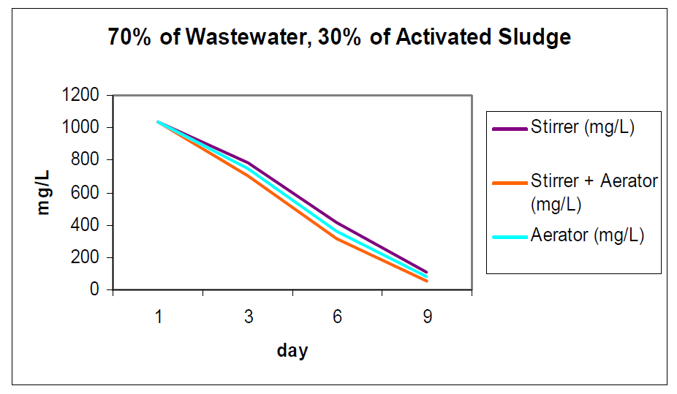
Figure 2. Graph of Biological Oxygen Demand (BOD5) versus day of treatment using 70% of Wastewater: 30% of Activated Sludge

Process Determination of Chemical Oxygen Demand (COD)
It can simplify that the deterioration of COD is proportional to deterioration of BOD after this treatment. The concentration of COD after both stirrer and aerator is 105 mg/L, after stirrer is 347 mg/L and after aerator is 207 mg/L (Table 4). Moreover, the treatment tank that equipped with both stirrer and aerator is also the effective way to treat the wastewater and fulfilled the standard requirement of Department of Environment (DOE) before discharging the POME into the river. Figure 3 were illustrate the decreasing of the chemical oxygen demand (COD).

Table 4. Data for Chemical Oxygen Demand (COD) using
70% of Wastewater : 30% of Activated Sludge
Day | Tank
 | Stirrer (mg/L) | Aerator (mg/L) | Stirrer + Aerator (mg/L)
1 | 2258 | 2258 | 2258
3 | 1543 | 1422 | 1294
6 | 867 | 698 | 576
9 | 347 | 207 | 105

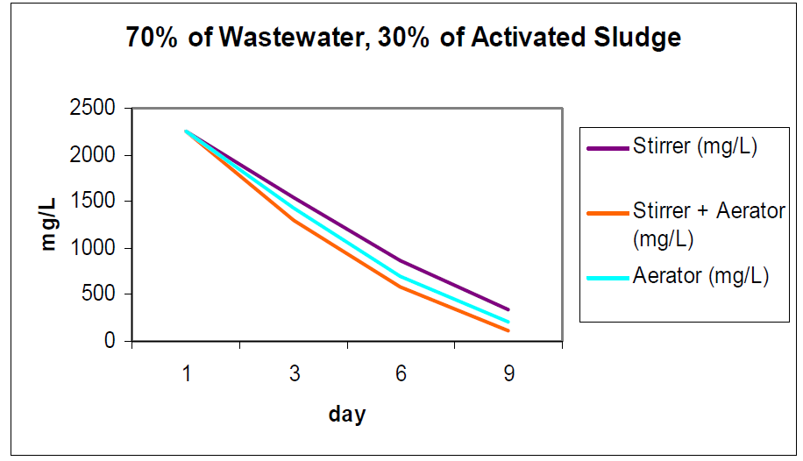

Figure 3. Graph of Biological Oxygen Demand (COD) versus day of treatment using 70% of Wastewater: 30% of Activated Sludge

Process Determination of pH
The data from the experiment has been done before and after treatment. It shows the initial and final data from the experiment to determine the pH value of the sample as summarized in Table 5.

From the graph in Figure 4, it is obvious that the ratio do influence the value of pH whereby the wastewater composition change from acidic condition to alkaline condition. POME has low value of pH and because of that, it direct effect on soil chemical properties such as affects supply of mineral macro and micro nutrients for plant growth, soil pH and soil buffer capacity [8]. The value of pH for both the stirrer and aerator has the highest pH which is from 5.4 to 8.6 while for only stirrer and aerator is 7.9 and 8.3. Despite the fact that the increasing value of pH from acidic solution to alkaline solution, all three ratios is in the range that acceptable for discharging to the river.

Table 5. Data for pH using 70% of Wastewater : 30% of Activated Sludge
Day | Tank
 | Stirrer | Aerator | Stirrer + Aerator
1 | 5.4 | 5.4 | 5.4
3 | 6.3 | 6.6 | 6.9
6 | 7.2 | 7.7 | 8.0
9 | 7.9 | 8.3 | 8.6

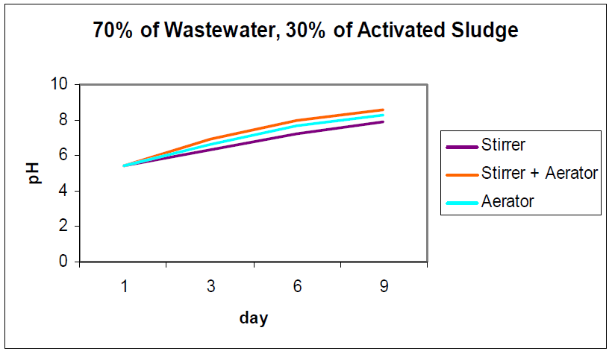

Figure 4. Graph of pH versus day of treatment using 90% of Wastewater : 10% of Activated Sludge

Result Using Membrane Bioreactor Pilot Plant System
A similar treatment has been carried out using a ratio of 70% of wastewater and 30% of activated sludge facilitated with stirrer and aerator in larger scale method by using membrane bioreactor. Table 6 below showed the data from the experiment that has been done before and after treatment using 70% of wastewater, 30% of activated sludge and the tank that equipped with stirrer and aerator. It shows the initial and final data from the experiment.

From Table 6, treatment of the wastewater in the bioreactor is not complete as all parameters do not correspond to the Department of Environment standard. In day six of the treatment, the wastewater is channeled to the membrane system for further treatment and final results as shown in Table 7.

Table 6. Data for Pilot Plant Scale using 70% Wastewater: 30% of Activated Sludge
and tank equipped with stirrer and aerator
Day | Parameter
 | BOD  (mg/L) | COD  (mg/L) | pH | Turbidity  (NTU) | Suspended Solid (mg/L)
1 | 1309 | 2563 | 6.40 | 528.0 | 739.0
3 | 730 | 1498 | 7.39 | 467.0 | 601.0
6 | 315 | 663 | 8.40 | 349.1 | 353.3

Table 7. Data for Treatment Using Membrane System (Ultrafiltration Membrane)
Parameters | Before | After
BOD (mg/L) | 315 | 0.00
COD (mg/L) | 663 | 0.00
pH | 8.40 | 7.39
Turbidity (NTU) | 349.1 | 0.01
Suspended Solid (mg/L) | 353.3 | 0.00

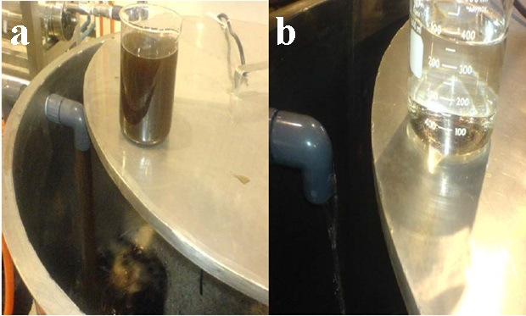

Figure 5. Treated wastewater sample using membrane system (ultrafiltration) which is (a) before treatment and b) after treatment

During experiment, 70% of wastewater, 30% of activated sludge works in decreasing the BOD value quickly, since the amount of bacteria appear to be higher in that waste compare to the other ratio. During treatment, bacteria from activated sludge decompose the carbon compounds in the wastewater. Therefore, if more bacteria is used in the wastewater, COD level will decrease faster. From the result of pH after treatment, the value of pH reading is increasing. It is because; waste is in acidic condition when it is released into the treating pond. In the bioreactor, the pH reading changed indicating that it is now alkaline. Suspended solid is related with turbidity. If the concentration of suspended solid is high, turbidity is also high.

Conclusion
The objective of this research is to treat palm oil mill effluent (POME) using membrane bioreactor and has successfully proven that it could lower the important parameters that are biological oxygen demand (BOD) and chemical oxygen demand (COD) so that both parameters correspond to the Department of Environment standard. From the result in pilot plant scale for bioreactor system, both biological oxygen demand and chemical oxygen demand reduces up to 61.2 % and 58.9% within six days. The pH reading should be in the standard DOE which is 5 to 9 so that it could be released to the streams and after treatment; the value of pH for all three ratios is in the range that acceptable for discharging. Suspended solid and turbidity is also reducing up 35.3% and 20.4%. After the wastewater was treated in the ultrafiltration membrane system, high quality water with total of deterioration for all parameter is up to 99.9% and pH up to 7.39.

The suitable recommendation to optimize the result is to run the experiment and does the analysis directly after the sample being collected within twenty four hours, keep the sample in a dark place. Besides, supply of oxygen to the wastewater is important to avoid the microorganism depletion of oxygen.

Acknowledgement
The author would like to thank the University Malaysia Pahang and Felda Palm Industries Sdn. Bhd. Felda Lepar Hilir 3, Gambang, Pahang for supporting this research.

References
- Wai, L. L., Kassim, M. A., Muda, K., Loh, S. K. and Affam, A. C. (2014). Conventional method and emerging wastewater polishing technologies for palm oil mill effluent treatment. Journal of Environmental Management 149: 222-235.
- Chin, K. K. Lee, S. W. and Mohammad H. H. (1996). A study of palm oil mill effluent treatment using a pond system. Water Science and Technology 34: 119–123.
- Leslie G. and Chapman S. (2003). Membrane bioreactors for municipal wastewater treatment - An Australian perspective. In Proc. Australian Water Association Annual Conference, Perth, Australia.
- Visvanathan C., R. B. Aim and Parameshwaran, K. (2000). Membrane separation bioreactor for wastewater treatment. Critical Review Environ Science Technology 30(1):1–48.
- Stephenson T. (2000). Membrane Bioreactors for Wastewater Treatment. WA Publishing, London.
- Ricardo Carrere. (2001).The Bitter Fruit of Oil Palm: Dispossession and Deforestation, World Rainforest Movement, Montevideo, Uruguay pp 1-5.
- R. Reidy. (2005). Filtration Industry Analyst by Elsevier Ltd.
- Rusan, M.J.M, Hinnawi, S. and Rusan L., (2007). Long term effect of wastewater irrigation of forage crops on soil and plant quality parameters, Desalination 215:143–152.

