

EVALUATION OF THE COMPRESSIVE STRENGTH OF CEMENT-SPENT RESINS MATRIX MIXED WITH BIOCHAR

(Penilaian Kekuatan Mampatan Matriks Simen-Resin Terpakai yang dicampur dengan Bioarang)

Zalina Laili^{1, 2}*, Muhamad Samudi Yasir¹, Mohd Abdul Wahab², Nur Azna Mahmud²,
Nurfazlina Zainal Abidin²

¹Nuclear Science Programme,

School of Applied Physics, Faculty of Science and Technology

Universiti Kebangsaan Malaysia, 43600 UKM Bangi, Selangor Darul Ehsan< Malaysia

²Waste & Environmental Technology Division

Malaysian Nuclear Agency (Nuclear Malaysia), 43000 Bangi, Kajang, Selangor Darul Ehsan, Malaysia

*Corresponding author: liena@nm.gov.my

Received: 2 April 2015; Accepted: 25 May 2015

Abstract

The evaluation of compressive strength of cement-spent resins matrix mixed with biochar was investigated. In this study, biochar with different percentage (5%, 8%, 11% 14% and 18%) was used as alternative admixture material for cement solidification of spent resins. Some properties of the physical and chemical of spent resins and biochar were also investigated. The performance of cemented spent resins with the addition of biochar was evaluated based on their compressive strength and the water resistance test. The compressive strength was evaluated at three different curing periods of 7, 14 and 28 days, while 4 weeks of immersion in distilled water was chosen for water resistance test. The result indicated that the compressive strength at 7, 14 and 28 days of curing periods were above the minimum criterion i.e. > 3.45 MPa of acceptable level for cemented waste form. Statistical analysis showed that there was no significant relationship between the compressive strength of the specimen and the percentage of biochar content. Result from the water resistance test showed that only one specimen that contained of 5% of biochar failed the water resistance test due to the high of spent resins/biochar ratio. The compressive strength of cement solidified spent resins was found increased after the water resistance test indicating further hydration occurred after immersed in water. The results of this study also suggest that the specimen with 8%, 11%, 14% and 18% of biochar content were resistance in water and suitable for the leaching study of radionuclides from cement-biochar-spent resins matrix.

Keywords: biochar, cement, compressive strength, solidification, spent resins, water resistance

Abstrak

Penilaian terhadap kekuatan mampatan matriks simen-resin terpakai yang dicampur dengan bioarang telah dijalankan. Dalam kajian ini, bioarang dengan peratusan yang berbeza (5%, 8%, 11% 14% dan 18%) telah digunakan sebagai bahan tambah bagi pemejalan menggunakan simen ke atas resin terpakai. Beberapa sifat fizik dan kimia resin terpakai dan bioarang juga dikaji. Prestasi resin terpakai yang disimenkan dengan ditambah bioarang dinilai berdasarkan kekuatan mampatan dan ujian ketahanan air. Hasil kajian menunjukkan kekuatan mampatan pada 7, 14 dan 28 hari masa pengawetan adalah melebihi kriteria minimum aras penerimaan bentuk sisa, iaitu 3.45 MPa. Analisis statistik menunjukkan tiada perkaitan signifikan di antara kekuatan mampatan spesimen dan peratusan kandungan bioarang. Hasil kajian ke atas ketahanan air pula menunjukkan hanya satu spesimen, iaitu yang mengandungi 5% bioarang gagal dalam ujian ketahanan air. Kekuatan mampatan spesimen didapati meningkat selepas ujian ketahanan air. Ini menunjukkan berlaku kesinambungan dalam penghidratan selepas direndam di dalam air. Keputusan daripada kajian ini juga mencadangkan spesimen dengan kandungan bioarang sebanyak 8%, 11%, 14% dan 18% adalah tahan di dalam air dan sesuai untuk menjalani kajian larut lesap radionuklid daripada matriks simen-bioarang-resin terpakai.

Kata kunci: bioarang, simen, kekuatan mampatan, pemejalan, resin terpakai, ketahanan air

Introduction
Spent resins are one of the low level radioactive wastes that are constantly generated in nuclear reactor. These spent resins often contain high concentration of radionuclides from activation and fission product. Generally, these spent resins need to be treated and transformed into stable form prior to their final disposal. Besides, the requirements for acceptable levels at disposal facilities are free liquids and the stability of waste form [1]. Thus, the method that favoured in many countries for the treatment of spent resins is based on cementation process. The cementitious system has many attributes which make them suitable for solidification of spent resins due to its simple operation, low cost and endurance in the disposal environment [2]. However, cementation of spent resins has some drawbacks in term of radionuclides retention and it tends to swell after contact with water which can result in the fracture of cemented spent resins.

Normally, various admixtures can be used to improve the cementation process of spent resins such as by adding zeolite, fly ash, silica fume and blast furnace slag during the cementation process [3]. In this study, biochar was used as admixture for cementation of low level spent resins. Biochar has been chosen as a focus in this work because of its adsorptive properties that mimics the effects of activated carbon. Generally, bioachar is one product of fast pyrolysis of biomass and it is a stable solid and rich in carbon. It molecules consist of large molecules with multiple carbon rings, nitrogen and oxygen, and embedded ions [4]. The electric charge on the surface of the molecule and each charge site will attract and adsorb ion of opposite polarity. Studies have been reported on the use of biochar for removing organic pollutants [5] and heavy metals [6], as well as radionuclides [7] from aqueous solution. Thus, it is believed that the addition of biochar to cement can reduce the leaching of radionuclides from cemented spent resins. However, before carrying out the leaching tests there are some critical properties that must be considered to ensure the cemented spent resins durability in disposal facility. One of the properties of the highest interest is the mechanical strength. Therefore, the purpose of this study was to investigate and evaluate the effect of biochar on the mechanical strength i.e. compressive strength of cemented spent resins. The water resistance test was also conducted in order to determine the durability of the cement-biochar-spent resins matrix. It was evaluated in term of compressive strength after immersion in water. This is due to the fact that the compressive strength is an important consideration in the safe handling, transportation and disposal of radioactive waste [8].

Materials and Methods

Collection and Preparation of Materials
Biochar used in this study was obtained from Universiti Putra Malaysia, Serdang Selangor. The biochar was produced from the pyrolysis of oil palm empty fruit bunch (EFB) at medium temperature (250 – 450°C). It was ground and sieved by USA Standard Sieve No. 18 (corresponding to 1 mm) before used in the formulation studies. Spent resins were obtained from Malaysian Nuclear Agency, Bangi Selangor. These spent resins were generated from 1MW PUSPATI TRIGA Reactor (RTP). The spent resins were synthetic cation and anion exchange resins i.e. nuclear grade mixed bed resins (Amberlite IRN-50). Ordinary Portland cement (OPC) used to solidify spent resins was supplied by Lafarge Malaysia Berhad. It is local OPC manufactured according to British Standard BS EN 197-1: 2000 – CEM II/B – M 32.5.

Biochar Characterization
Some properties of biochar were investigated. pH of biochar was determined by dissolving 1.0 g of biochar in 100 ml of distilled water and then shaking for 24 hours and after that pH was determined using a pH meter (Trans Instruments Model BP 3001). Bulk density for biochar was determined according to analogue VDLUFA-Method A 13.2.1 [9]. Biochar sample (at least 300 ml) was filled into graduated cylinder and the mass is determined by weighting. The volume of the biochar sample was read after 10 times compression by means of falling. The density of biochar in g/m³ was calculated from the mass and the volume of the biochar sample. Water holding capacity of biochar was determined according to DIN ISO 14238-2011 [9]. Biochar sample of 2 mm fraction was soaking in water for the period of 24 hrs. Then, the sample has been placed on a dry sand bed for about 2 hrs to remove free water. The saturated biochar sample was weight and then dried at 40ºC in a compartment dryer. After drying, the biochar sample was weight again for estimate the water holding capacity. The carbon (C), hydrogen (H), nitrogen (N) and sulphur (S) contents of the biochar was determined using CHNS Analyser (Model CHNS-932, USA). Proximate analysis was conducted to measure a moisture content (ASTM E949), volatile matter (ASTM E897-88) and ash content (ASTM E830-87). Morphological characterizations were carried out by using scanning electron microscope (SEM-EDX) (model FEI 400). Analysis of radionuclides content in biochar was measured using Canberra n-type high purity germanium (HPGe) gamma spectrometer system with 30% relative efficiency and a resolution of 1.9 keV at 1332.5 keV of Co-60.

Spent Resins Characterization
The pH and conductivity of spent resins were measured by dissolving 30 g of spent resins in 100 ml of distilled water. The mixture was stirred for about 24 hours. Then, the pH and conductivity were determined by using a pH meter (Trans Instruments Model BP 3001) and the conductivity meter (Trans Instrument model HC 3010), respectively. Determination of water content was conducted by dried the spent resins to a constant mass in an oven at 105°C and then its water content was calculated. Analysis of radionuclides content in spent resins was measured using Canberra n-type high purity germanium (HPGe) gamma spectrometer.

Preparation of Specimens
Cylindrical cement specimens of 10 cm diameter and 10 cm height were prepared by mixing a different amount of biochar (5%, 8%, 11%, 14% and 18%) (wt/wt) with a constant amount of cement and spent resins. Table 1 showed the mixture design (by wt %) of this study. In all cases the water to cement ratio (w/c) was 0.7. This w/c ratio was used because it showed the good workability without excessive bleeding water. After sufficient mixing, the pastes were poured into cylindrical plastic moulds. After a setting time of 24 h the specimens were demoulded and allowed to cure for 7, 14 and 28 days sealed in plastic bags at room temperature. After the desired curing time, the specimens were subjected to compressive strength test and water resistance test.

Table 1. Mixture composition of biochar, cement, water and spent resins
used in the solidification study.
Biochar  (wt %) | Cement  (wt %) | Water  (wt %) | Spent resins (wt %) | Total  (wt %)
5  8  11  14  18 | 47  45  44  42  40 | 32  32  31  30  28 | 16  15  14  14  14 | 100  100  100  100  100

Compressive Strength Test
The compressive strength tests were conducted according to the test protocol specified by ASTM C-39/C39M-09a Method [10]. The compressive strength test was measured with ENERPAC (Model P-84/USA) unconfined compression machine with maximum load of 1000 psi/700 bar. The minimum compressive strength of 3.45 MPa (500 psi) was used to evaluate the solidified spent resins as recommended by the US Nuclear Regulatory Commission (NRC) Standard [8].

Water Resistance Test
The specimens were immersed in distilled water at 25ºC ± 1 for 21 days in water resistance test. The specimens were also visually inspected for evidence of cracking and swelling after water resistance test. If there was no significant immersion effects, the specimens were tested for compressive strength test. The criteria of water resistance tests were no swelling, no crumbling and the compressive strength must have at least 3.45 MPa (500 psi), but not less than 75% of the pre-immersion value [8]. Weight change was also evaluated by weighing the specimens before and after immersion test.

Statistical Analysis
Statistical analysis was performed using SAS System for Windows Release 6.12. Regression analysis was conducted to study the relationship between biochar content and compressive strength of the specimens. Furthermore, the Analysis of Variance (ANOVA) was performed to determine the differences of compressive strength between immersed and non-immersed specimens.

Results and Discussion
Physicochemical Properties of Biochar
The selected physicochemical properties of biochar are shown in Table 2. As shown in Table 1, biochar exhibit the alkaline pH value. This alkaline pH was due to organic acids and phenolic substances and the formation of alkali salts during pyrolysis [11]. The bulk density of biochar is a measurement to show how tightly biochar particles are pressed together. The result showed that biochar has low bulk density and this indicates that biochar has high capacity to absorb water. The result for water holding capacity showed that biochar produced from EFB was able to retain about 48% of water. The result also showed that biochar has low moisture content (6%). The ash content was about 31% and this indicates the amount of inorganic material in the biochar [11]. The fixed carbon and volatile matter content of biochar were 40.22% and 22.1%, respectively. The result from elemental analysis showed that biochar was carbon rich and had carbon (C) content around 45.3%, in which it indicates the class 2 biochar (30-60% of C) according to IBI standard [12]. This black carbon might affect the colour of cemented spent resins matrices. The results of gamma spectrometry analysis showed that only natural radionuclides (Ra-226, Ra-228 and K-40) were detected in the biochar. SEM image of EFB biochar showed the formation of uniform pores and smooth wall surface under 1000x magnification (Figure 1) and this may be beneficial for radionuclides adsorption.

Table 2. Selected physicochemical characteristics of biochar.
Characteristic | Value
pH | 9.25 ± 0.1
Bulk density (g/m³) | 0.040 ± 0.15
Water holding capacity (%) | 48 ± 0.2
Proximate Analysis (% wet basis)
Moisture content | 6.41±0.37
Ash content | 31.27± 1.78
Fixed carbon | 40.22±1.14
Volatile matter | 22.10±1.00
Elemental Analysis (% dry basis)  C | 45.3 ±11.62
H | 2.48±0.22
N | 3.01±1.32
S | <0.05
Radionuclides Content (Bq/g)  Ra-226 | 0.023 ± 0.002
Ra-228 | 0.0087 ± 0.0045
K-40 | 2.27±0.06

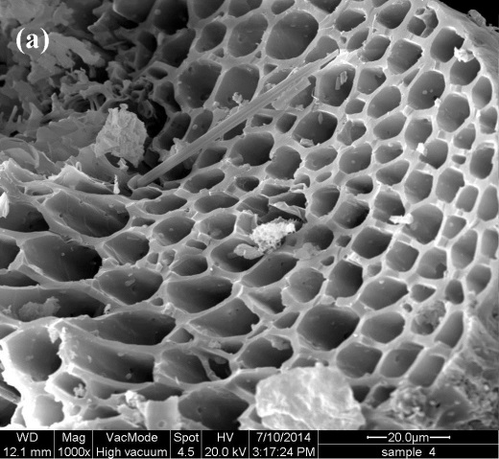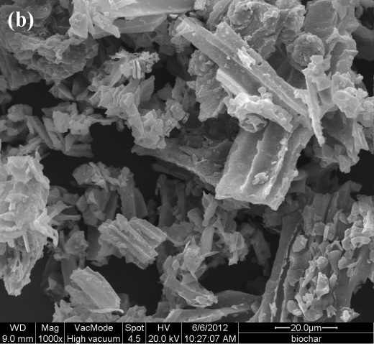

Figure 1. SEM images showing a (a) pore structure and (b) smooth wall surface of EFB biochar at 1000x magnification

Properties of Spent Resins
Some important properties of spent resins are shown in Table 3. The result showed that the spent resins were in the acidic condition. The water content in the spent resins was about 38.3% which indicates that the dewatering process for the spent resins is unnecessary before the formulation study. The conductivity of spent resins leachate was 24.6 µS. This indicates that a small amount of ions was released into the solution. The result of radionuclides analysis showed that the spent resins from PUSPATI TRIGA Reactor (RTP) contained of Mn-54, Co-60, Zn-65, Eu-152 and Cs-134.

Table 3. Selected properties of spent resins
Characteristics | Spent resins
pH  Water content (%)  Conductivity (µS) | 5.81 ± 0.11  38.33  24.6
Radionuclides content (Bq/g)  Mn-54  Co-60  Zn-65  Cs-134  Eu-152 | 0.081 ± 2 x 10⁻³  11.94 ± 0.2  0.01 ± 3 x10⁻⁴  2.02 x 10⁻² ± 6.5 x 10⁻⁴  1.0 ± 9.7 x 10⁻³

Compressive Strength
A total of fifteen specimens were prepared and tested at five different biochar contents (5%, 8%, 11%, 14% and 18%) and three different curing periods (7,14 and 28 days). Three measurements were performed at each data point and the average of compressive strength was reported. The result is presented in Figure 2. Based on the results, the compressive strength increases as the age of the specimen increases. This is due to the fact that hydration rate for specimen at 7 days is lower than that of the specimen at 14 and 28 days. Since the Portland cement was used as a binder in the formulation, it was expected that the compressive strength increases as the curing period increases. Hence, it exhibits the concrete-like behaviour. Basically, for cement based material, tricalcium silicate (C₃S) is responsible for short term strength (days to month) of the specimen and dicalcium silicate (C₂S) is contribute to long term strength (~years) [13]. The result also shows that all the compressive strength values were above the minimum criterion of compressive strength for cemented waste forms i.e. 3.45 MPa as suggested by US Nuclear Regulatory Commission (NRC) Standard. At 7 days, the compressive strength increases until the biochar content increases to 8% and beyond this percentage the compressive strength slightly decreases. It is apparent from the figure 2 that the compressive strength at 14 days is proportional to the amount of biochar content. However, at 28 days the compressive strength was increase as the biochar content increase except for 18% of biochar content. Nevertheless, at this point (18% of biochar content) the compressive strength has achieved equal strength to that of the specimen at 14 days of curing periods. Regression analysis for the specimen at 28 days showed that the amount of biochar content has no significant linear effect on compressive strength at 5% significant level. This finding suggests that there are other factors affect the development of strength of the cement-biochar-spent resins matrix such as the spent resins loading or water-to-cement ratio. Figure 3 is SEM image of spent resins solidified in cement-biochar matrix. It can be seen that the spent resins were only physically encapsulated in cement-biochar matrix.

Figure 2. Compressive strength of cement-biochar-radioactive resins matrix as a function of biochar content at different curing periods

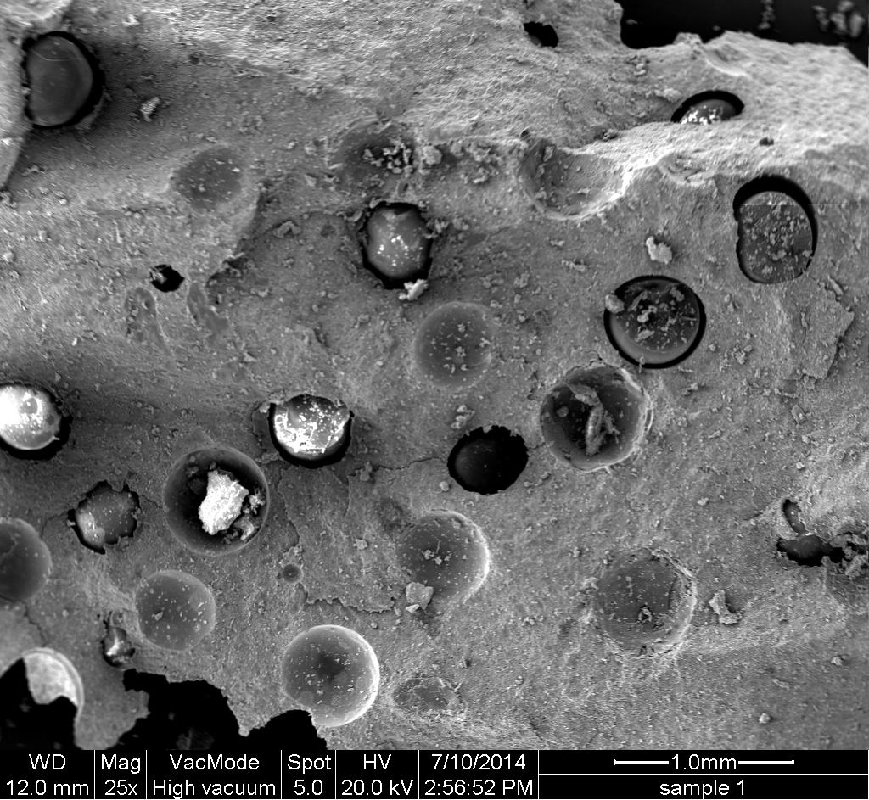

Figure 3. SEM image of solidified spent resins in cement-biochar matrix at 25x magnification

Effect of Water Immersion on the Compressive Strength
Immersion stability is important especially for solidification of spent resins [14]. The effect of water immersion on the compressive strength of specimen is shown in Table 4. The visual observation showed that only one specimen (contained of 5% of biochar) failed the water immersion test. This specimen was swelled, cracked and crumbled after 4 weeks of immersion test. For this case, spent resins content is relatively high compared to biochar content. Thus, when the specimen was immersed in the water, this solidified radioactive resin absorbed more water and tends to swelled and thus cracks may develop. Moreover, this may contribute to decrease on the compressive strength. Based on the result in Table 4, it was clearly showed that compressive strength was increased after the immersion test except for specimen with 5% of biochar content. The compressive strength increased in the range of 9-53% and the compressive strength values were also above the minimum criterion of compressive strength (>3.45MPa) for cemented waste form. This may be due to an amount of binder that did not fully react with water during the conventional hydration process. Thus, when immersed in water, there is sufficient water to maintain the continuous hydration of cement [15]. Besides, incomplete filling of space between clinker grains by hydration products creates mesopores [16]. During the immersion test, this mesopores may fill with water and then reduced due to gel formation. As the hydration process proceed, the pores of the paste gradually filled with hydration product [17]. Hence, this may be contribute to the increased of compressive strength. The result from ANOVA revealed significant difference in the compressive strength for the non-immersed and immersed specimens (P< 0.05). This indicates that immersion of specimen in water affect the strength development. This finding also suggest that the specimen with 8%,11%,14% and 18% can be tested for leaching test because of good water resistance.

Table 4. Compressive strength of cement-biochar-radioactive resins matrix
with and without water immersion
Biochar content (%) | (Compressive Strength MPa)
Biochar content (%) | Without water immersion | With water immersion
5 | 6.2 ± 0.7 | 0
8 | 7.35 ± 1.4 | 11.3 ± 1.9
11 | 9.76 ± 2.0 | 16.2 ± 2.0
14 | 10.11± 1.6 | 11.03 ± 2.0
18 | 9.19 ± 2.0 | 10.8 ± 0.4

Figure 4 showed the weight of the specimen before and after immersion test. The difference weight due to immersion test was in the range 2-8%. The slightly increased of the specimen weight may be due to absorption of water by spent resins and biochar. The result also reveal that, the pH and conductivity of distilled water that used to immerse the specimen was found increased after the water resistance test (Figure 5 and 6). The pH and conductivity were increased due to leaching of ions from the waste form. This most probably related to the leaching of calcium (Ca) as cement was used as a binder to solidified spent resins. When hardened cementitious material contacts with water, the calcium hydroxide in hydrated cement paste will be leached out [18]. The analysis of radionuclides content in the leachate after the immersion test showed that only a small activity concentration of Co-60 was detected in the leachate (Table 5).

Figure 4. Comparison of the specimen weight before and after the immersion test

Figure 5. The pH of water before and after immersion test

Figure 6. The conductivity of water before and after the immersion test

Table 5. Radionuclides analysis in leachant after the immersion test
Sample | Radionuclides | Activity concentration (Bqml⁻¹)
BC 8% | Co-60 | 7.0 x 10⁻³ ± 4.3 x 10⁻⁴
BC11% | Co-60 | 6.0 x 10⁻³ ± 4.0 x 10⁻⁴
BC14% | Co-60 | 6.1 x 10⁻³ ± 4.8 x 10⁻⁴
BC18% | Co-60 | 5.7 x 10⁻³ ± 4.3 x 10⁻⁴

Conclusion
The evaluation of compressive strength of cement-spent resins matrix mixed with biochar was investigated. The results of the investigation show that the addition of biochar to cement has no significant effect on the compressive strength of cement solidified spent resins. This suggests that there are other factors affect the development of strength of the cement-biochar-spent resins matrix. However, all the compressive strength of the specimens was found above the minimum criterion (> 3.45MPa) for cemented waste form. The evidence from this study also suggests that the specimen with 8%, 11%, 14% and 18% of biochar content were resistance in water and thus, suitable for the leaching study of radionuclides from cement-biochar-spent resins matrix. It was also shown from the SEM image that biochar material has the formation of uniform pores which may be beneficial for radionuclides adsorption. This study has found that generally the durability of the specimen in water, as well as the compressive strength after immersed in water was affected by the spent resins to biochar ratio. A further study investigating the effect of spent resins to biochar ratio on compressive strength would be recommended.

Acknowledgement
The authors would like to thank the Ministry of Science, Technology & Innovation, (MOSTI) for the financial funding under the Sciencefund program (Project No. 03-03-01-SF0135) and Nuclear Malaysia for providing laboratory facilities for this work.

References
- Vanderperre,S., Centner,B. and Charpentier, D. (2010). Radioactive Spent Ion-Exchange Resins Conditioning by the Hot Supercompaction Process at Tihange NPP, WN2010 Conference Transcript 6: pp. 4954-496.
- Junfeng, L. Gang, Z. and Jianlong, W. (2005). Solidification of low-level radioactive waste resins in ASC-zeolite blends. Nuclear Engineering and Design 235: 817-820.
- Wang, J. and Wan, Z. (2015). Treatment and disposal of spent radioactive ion-exchange resins produced in the nuclear industry. Progress in Nuclear Energy, 78:47-55.
- Yarrow, D. (2014). How to make biochar. Access online www.dyarrow.org/CarbonSmartFarming/CSF6-Adsorption.pps [6 Mac 2015].
- Yang, Y. and Sheng, G. (2003). Pesticide adsorptivity of aged particulate matter arising from crop residue burns. J.Agri.Food Chem. 51:5047-5051.
- Beesley, L. and Marmiroli, M. (2011). The immobilization and retention of soluble arsenic, cadmium and zink by biochar. Environmental Pollution. 159: 474-480.
- Kumar, S., Loganathan, V.A, Gupta, R.B and Bannet, M.O. (2011). An Assessment of U(VI) removal from groundwater using biochar produced from hydrothermal carbonization. Journal of Environmental Management, 92:2504-2512.
- European Biochar Certificate. (2013). Analytical methods, http://www.european-biochar.org/en/analytical%20methods [3 Mac 2015].
- ASTM Standards (2008). Standard test method for compressive strength of cylindrical concrete specimen C39/C39M-05. ASTM International. United States.
- Siskind, B. and Cowgill, M. G. (1992). Techincal justifications for the test and criteria in the waste form technical position appendix on cement stabilisation. Proceedings of Waste Management '92, pp. 1753-1759.
- Laird, D.A. (2010). Pyrolysis and biochar oppurtunities for distributed production and soil quality enhancement. Proceeding of the Sustainable Feedstock for Advance Biofuel Workshop. pp. 257-281.
- IBI. (2012). Standardized product definition and product testing guidelines for biochar that in used in soi1.http://www.biochar-international.org [13 Mac 2015].
- Ylmen, R., Jaglid, U. Steenari, B. and Panas, I. (2009). Early hydration and setting of Portland cement monitored by IR, SEM and vicat techniques. Cement and Concrete Research, 39: 433-439.
- Suh, I.S, Kim, J.H., Han, W. and Park, H.W. 1991. Acceptance criteria and their evaluation techniques for solidified waste forms. Proceeding of Waste Management, pp. 735-740.
- Ma, H. and Li, Z. (2013). Realistic pore structure of Portland cement paste: Experimental study and numerical stimulation. Computers and Concrete11: 317-336.
- Glasser, F. P. (1997). Fundamnetal aspects of cement solidification and stabilisation. Journal of Hazardous Materials, 52:151-171.
- Atahan, H. N., Oktar, N. O. and Tasdemir, M. A. (2009). Effects of water-cement ratio and curing time on the critical pore width of hardened paste. Construction and Building Materials, 23:1196-1200.
- Carde, C. and Fraincois, R.(1999). Modelling the loss of the strength and porosity increase due to the leaching of cement paste.Cement Conrete Compossite., 21:181-188.

