

A SIMPLE THIN LAYER CHROMATOGRAPHY METHOD FOR SEPARATION OF SELECTED NATURAL STEROID HORMONES

(Kaedah Kromatografi Lapisan Nipis yang Mudah bagi Pemisahan Hormon Steroids Semulajadi Terpilih)

Joanna Nowakowska¹, Kaja Rudnicka-Litka¹*, Krzesimir Ciura¹, Piotr Pikul¹, Jakub Piotrowicz²

¹Department of Physical Chemistry, Faculty of Pharmacy,

Medical University of Gdańsk, Al Gen J Hallera 107, 80-416, Gdańsk, Poland

²Department of Economics and Law,

Maritime Institute in Gdańsk, Długi Targ 41/42, 80-830, Gdańsk, Poland

*Corresponding author: kaja.kinga.rudnicka@gmail.com

Received: 14 April 2015; Accepted: 28 May 2015

Abstract
Chromatographic properties of seven steroids: estrogens (β-estradiol and estrone), androgens (testosterone, methyltestosterone, trans-androsterone), progesterone and cholesterol have been studied by planar chromatography with usage of High Performance Thin Layer Chromatography (HPTLC) and Thin Layer Chromatography (TLC) plates. Normal, reversed and cyano-bonded silica stationary phases were tested with five binary mobile phases (acetonitrile-water, acetonitrile-DMSO, acetonitrile-methanol, acetone-petroleum ether, acetone-water) in which the concentration of organic modifier varied from 0 to 100% (v/v). This study reports the optimization of steroid hormones separation. Principal Component Analysis (PCA) based on calculated molecular descriptors quantitatively differentiating solutes was performed in order to investigate the similarity and dissimilarity between tested compounds. The separation abilities of mobile and stationary phases were compared based on separation factor α. Chromatographic retention data and possible retention mechanisms also were discussed.

Keywords: thin layer chromatography, separation factor, binary phases, steroids

Abstrak
Sifat kromatografi tujuh steroid: estrogen (β-estradiol dan estron), androgen (testosteron, metiltestosteron, trans-androsteron), progesteron dan kolesterol telah dikaji oleh kromatografi satah dengan pengunaan plat kromatografi lapisan nipis (TLC) dan kromatografi lapisan nipis berprestasi tinggi (HPTLC). Fasa pegun normal, terbalik dan silika terikat siano diuji dengan lima fasa bergerak binari (asetonitril-air, asetonitril-DMSO, asetonitril-metanol, petroleum-aseton eter, aseton-air) di mana kepekatan pengubahsuai organik diubah daripada 0 hingga 100% (v/v). Kajian ini melaporkan keadaan optimum bagi permisahan hormon steriod. Analisis komponen prinsipal (PCA) berasaskan kiraan kuantitatif molekul yang membezakan bahan larut dilakukan untuk menentukan persamaan dan perbezaan di antara sebatian yang diuji. Keupayaan pemisahan fasa bergerak dan pegun dibandingkan berdasarkan kepada faktor pemisahan α. Data tambatan kromatografi dan kebarangkalian mekanisma tambatan juga turut dibincang.

Kata kunci: Kromatografi lapisan nipis, faktor pemisahan, fasa binari, steroid

Introduction
Steroids play a vital role in many biological processes and have also numerous therapeutic applications. Steroid hormones regulate metabolism, water - mineral balance and control the development and functioning of the sexual organs, as well as other biological differences between the sexes. Steroid drugs are used as anti-inflammatory drugs, anti-asthmatic drugs, synthetic hormones, potassium sparing diuretic or contraceptive drugs. Moreover, some synthetic steroids (nandrolone, dromostanolone and etc) are often used illegally as doping agents in sport, since they stimulate protein synthesis and muscle-building action [1].

The core of steroids is composed of seventeen carbon atoms bonded together. They form skeleton with three cyclohexane rings and one cyclopentane ring, generally arranged in a 6-6-6-5 fashion. The great diversity of steroids structures and their wide range of polarities present crucial problems for the simultaneous analysis of different classes of steroids. Therefore, analysis of these compounds requires a well-equipped laboratory where such chromatography techniques as gas chromatography, high performance liquid chromatography, thin layer chromatography and even supercritical liquid chromatography are readily available [1-3].

Thin-layer chromatography [TLC) continues to be an important method for qualitative analysis of steroids because of its inherent advantages - numerous samples can be analyzed simultaneously and quickly, and multiple separation techniques and detection procedures can be applied [3]. A variety of samples including steroids such as biological [4, 5], environmental samples [6], plants [7,8] and pharmaceutical formulations [9] were analyzed by TLC. Both Normal-Phase TLC (NP-TLC) [10] and Reversed-Phase TLC (RP-TLC) [11-12] were successfully applied in steroids separation. Moreover, many modified stationary phases were also tested in the analysis of steroids, such as NH₂ layers [13-14], diol plates [14] and silica impregnated with silver nitrate [15].

Separation factor α – also known as selectivity factor or relative retention - is a measure of chromatographic system’s selectivity. Selectivity of chromatographic system refers to mutual influence of substances selected with mobile and stationary phases. This parameter depends mainly on chemical structure of analytes and also on types and properties of both phases. The selectivity of chromatographic system might be described as distance between maximum of adjacent chromatographic peaks. Relative retention reflects differences in influence of both ingredients with mobile and stationary phases and is defined by equation 1 [16]:

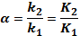 (1)

in which k₁, k₂ is the retention factors of substances 1 and 2, K₁ and K₂ is the distribution coefficients. An equation 1 shows that separation factor is equal to relation of partition coefficients in balanced state or factors of both substances’ retention. When α =1, separation has not been achieved for those substances.

The objectives of our investigations were to study the separation of selected steroids by various TLC and HPTLC systems. The novelty in this study is the use of cyano-bonded silica gel (CN). Results obtained on CN were compared with silica gel and C₁₈ bonded silica gel. Different aqueous and non-aqueous mobile phases were also tested. Finally the best chromatographic system for the separation of tested compounds, have been proposed as well as possible retention mechanisms on CN-TLC were discussed.

Materials and Methods
Reagents and Mobile Phases
The solutes (β-estradiol, estrone, testosterone, methyl testosterone, trans-androsterone, progesterone, cholesterol) were purchased from Sigma-Aldrich (UK). All reagents used as mobile phases (acetonitrile, acetone, methanol, DMSO and petroleum ether) were HPLC – reagent grade from Sigma-Aldrich (Steinheim, Germany). Sulphuric acid (POCh, Poland) was used to prepare the visualizing reagents. Solutions of the steroids (1 mgL⁻¹) were prepared by dissolving appropriately weighed amounts in methanol. Binary phases (acetonitrile-water, acetonitrile-DMSO, acetonitrile-methanol, acetone-petroleum ether, acetone-water) were executed by mixing appropriate quantities of pure organic solvents in the proportions from 0 to 100% v/v.

Chromatography
Chromatography was performed on 5 cm × 10 cm Kieselgel 60 WF_{254s} TLC plates and Kieselgel 60 F₂₅₄, Kieselgel 60 CN F_{254s}, RP-18 F_{254s}, RP-18 WF_{254s} HPTLC plates manufactured by Merck (Darmstadt, Germany). The chromatographic chambers (7 x 11 cm) were previously saturated with mobile-phase vapour. When using water – organic modification mixture as mobile phase, Kieselgel 60 WF_{254s} TLC plates and RP-18 WF_{254s} HPTLC plates dedicated on water--containing mobile phases were used. Chromatograms were developed to a distance of 8 cm at room temperature (20 ± 2ºC). The substances were separated as a mixture and as individual standards. They were visualized by spraying the plates with a 1:4 (v/v) mixture of concentrated sulphuric acid and methanol and then heated in an incubator at 120ºC for approximately 10 min, and then the compounds were detected in both UV light and visible light as coloured spots. All studies were repeated three times and the calculated average was used in further studies. Significantly different results were rejected.

Molecular Modeling
HyperChem 8.08 software with ChemPlus Extension (Hypercube, Waterloo, Canada) was used for the calculation of a large number of molecular descriptors. Before this calculation, the structures were constructed using the OpenBabel software. The structures were first optimized using the molecular mechanic calculations (MM+). The molecular modeling structural descriptors (energetic parameters) were computed using the semi-empirical calculation method Austin Model 1 (AM1). Finally, numerous molecular descriptors quantitatively differentiating solutes were calculated such as molecular bulkiness-related descriptors (Total Energy, Binding Energy, Isolated Atomic Energy, Electronic Energy, Core-Core Interaction, Heat of Formation, Surface Area, Volume, Volume Van der Wals, Hydration Energy, cLog P, Refractivity, Polarizability, Mass), molecular polarity-related descriptors (Energy HOMO and LUMO, δ_{max}, δ_{min}, μ). The number of H-Bond donor and acceptor can be found in the PubChem database (http://pubchem.ncbi.nlm.nih.gov/).

Principal Component Analysis
The data was mean‑centered and scaled to unit variance (Z-score scaling) before PCA analysis in order to prevent highly abundant components dominating in the final result over the components present in much smaller quantities. The PCA procedure was performed on the data matrix, where the rows (cases) correspond to the steroids hormones, whereas the columns (variables) correspond to the molecular descriptors. All statistical calculations were performed using STATISTICA 9.1 (StatSoft, Tulsa, Oklahoma, USA).

Results and Discussion
Tested group included seven steroids: estrogens (β-estradiol and estrone), androgens (testosterone, methyltestosterone, trans-androsterone), progesterone and cholesterol. Figure 1 was presented chemical structures of tested compounds.

In order to investigate the similarity and dissimilarity between tested compounds the PCA was performed. This technique is a very efficient way of multivariate data analysis. Its goal is to extract the important information from the table, to represent it as a set of new orthogonal variables called principal components. The performed PCA based on calculated molecular descriptors quantitatively differentiating solutes such as molecular bulkiness-related descriptors, molecular polarity-related descriptors and the number of H-Bond donor and acceptor. The first three components account for about 94.01% of the total variance. The score plot presented in Figure 2 demonstrates the similarities and dissimilarities between tested substances. As might have been expected slight differences between androgens were observed. Value of first principal component (PC1) differentiates compounds into two groups: androgens and estrogen, as well as two outliners: cholesterol and progesterone. The values of PC1 located progesterone near androgens. Structurally progesterone is similar to testosterone; the only difference between these two compounds is functional group in position C-17. The hydroxyl group in testosterone is in this position, whereas in the molecule of progesterone in the same position acetyl group is placed. The second (PC2) and third principal component (PC3) differentiates progesterone on androgens. Interestingly, cholesterol has similar values of PC2 and PC3 as β-estradiol and estrone.

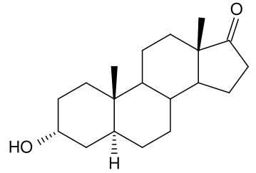(1) | 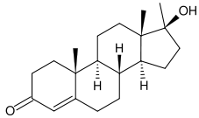(2)
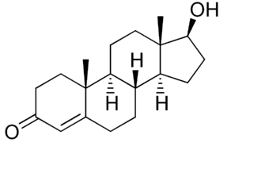(3) | 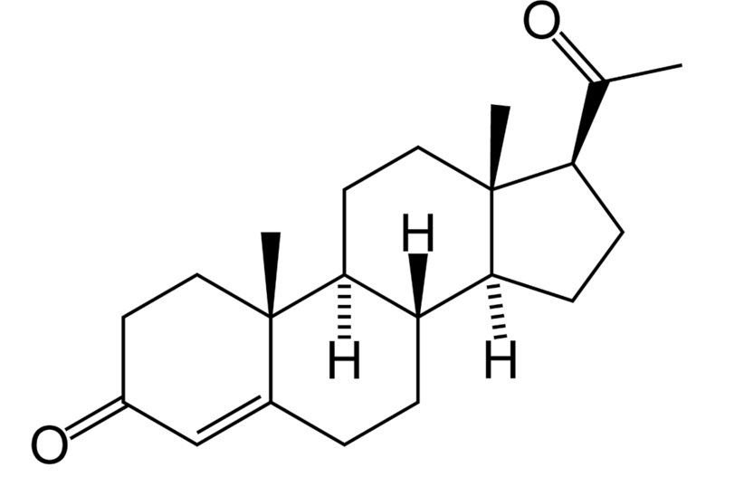(4)
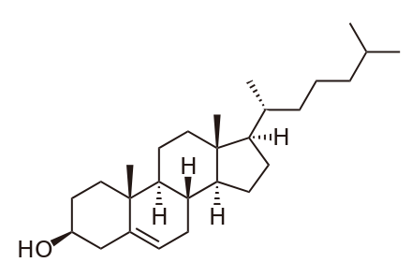  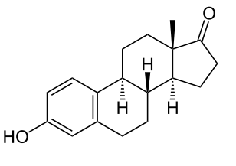(5) | 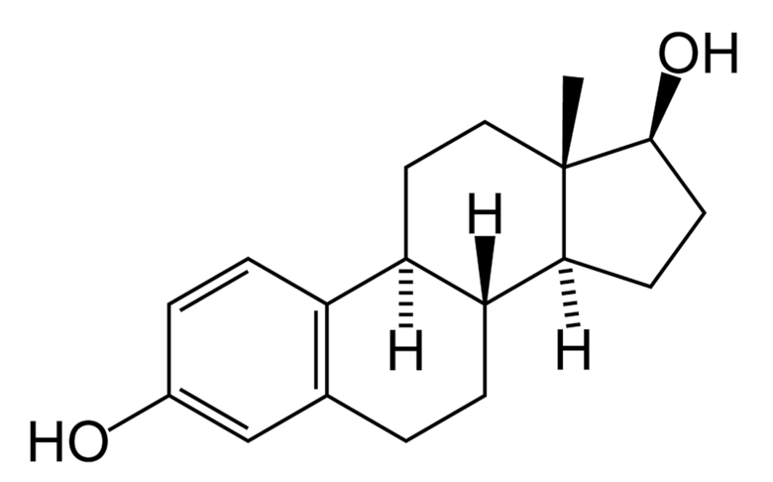(6)

(7)

1. Trans-androsterone, 2. Methyltestosterone, 3. Testosterone, 4. Progesterone, 5. Estrone, 6. β-Estradiol,
7. Cholesterol

Figure 1. Chemical structures of seven steroids

Figure 2. The score plot of the first, second and third principal components

The values of separation factors α between analyzed androgens and progesterone were presented in Table 1. A separation can be regarded effective when α is higher as 1,5. Generally, the highest values of separation factor between progesterone and tested androgens were observed when water-containing mobile phases were used. Small differences of this role occurred when silica gel was used. The best separation between testosterone and progesterone was observed on RP-TLC in particular when acetonitrile-water (40:60) as eluent was used. The lowest values of separation factors were obtained between methyl testosterone and progesterone. Methyl testosterone (clog P 3,91) is more lipophilic that testosterone (clog P 3,84), as it has additional methyl group. The same situation occurred when the retention between trans-androsterone (clog P 4,25) and progesterone (clog P 4,63) were compared. The separation factors have decreased in RP-TLC and CN-TLC. In RP-TLC the chromatographic process is described by partition and as might have been expected the separation is reduced when the difference on the lipophilicity between solutes is smaller. The cyano-bonded silica gel has intermediate properties between reserved and normal phases material (17). On this stationary phases were observed a strong dipole and moderate hydrophobic interaction. The decrease on separation factor α can suggest that the hydrophobic interaction determined the steroids - stationary phases interaction on CN bonded silica gel when water- water-containing mobile phases were used.

Better separation was observed on silica gel. From a practical point of view, acetone-water (20:80) can be recommended in order to separate methyl testosterone from progesterone. On the other hand, using binary mobile phase consisting 30% v/v acetonitrile in water, the highest value of selectivity factor was obtained between trans-androsterone and progesterone. Only in two chromatographic systems a significant separation between methyl testosterone and testosterone was observed, on RP-TLC with acetone-petroleum ether (10:90) as mobile phase and NP-TLC with acetone-water (40:60). The highest value of separation factor α was calculated in chromatographic systems including silica gel as stationary phases.

Significant difference was observed in the ability to separate methyl testosterone or testosterone from trans-androsterone. CN-TLC can separate testosterone from trans-androsterone with water-containing mobile phases whereas the effective separation of more lipophilic methylo testosterone from trans-androsterone was impossible. Regarding obtained results on RP-TLC the same conclusions can be drawn. On silica gel the separation factor α between methyl testosterone or testosterone and trans-androsterone was high (2,27), which means that they could be easily separated, when mixture of acetone-water (20:80) as mobile phases was used. For both compounds the values α are the same, as they have the same retention factor in this chromatographic systems.

Table 1. The highest values of the parameter α between tested androgens and progesterone
using different mobile phases (v/v).
Adsorbent | Eluent (v/v) | Testosterone  /Progesterone | Methyltestosterone /Progesterone | trans-Androsterone /Progesterone
CN | ACN-MeOH | 1,33^{L} | 1,27^{L} | 1,29^{A}
CN | ACN-H₂O | 2,15E | 1,97E | 1,54^{F}
CN | ACN-DMSO | 1,33^{L} | 1,41^{K} | 1,19^{K}
CN | DMK-H₂O | 2,48E | 2,00E | 1,72^{F}
CN | DMK-PET | 1,49^{C} | 1,36^{C} | 1,26^{J}
C₁₈ | ACN-MeOH | 1,40^{L} | 1,48^{L} | 1,34E
C₁₈ | ACN-H₂O | 3,27E | 2,37E | 2,37E
C₁₈ | ACN-DMSO | 1,63E | 1,48^{L} | 1,27^{L}
C₁₈ | DMK-H₂O | 2,59E | 1,88E | 1,88E
C₁₈ | DMK-PET | 1,73^{B} | 1,59^{C} | 1,67^{B}
Si | ACN-MeOH | 1,47^{K} | 1,47^{K} | 1,47^{K}
Si | ACN-H₂O | 1,71^{C} | 1,51^{C} | 2,50^{C}
Si | ACN-DMSO | 1,74^{J} | 1,83^{J} | 1,71^{J}
Si | DMK-H₂O | 2,46^{C} | 2,46^{C} | 1,38^{D}
Si | DMK-PET | 1,74^{B} | 1,55^{B} | 1,55^{B}
Concentration of mobile phases: ^{A}-0:100 ^{B}-10:90 ^{C}-20:80 ^{D}-30:70 ^{E}-40:60 ^{F}-50:50 ^{G}-40:60 ^{H}-30:70 ^{J}-20:80
^{K}-10:90 ^{L}-0:100

Table 1 (Cont’d). The highest values of the parameter α between tested androgens and progesterone
using different mobile phases (v/v).
Adsorbent | Eluent (v/v) | Testosterone/  Methyltestosterone | Testosterone/  trans-Androsterone | trans-Androsterone /Methyltestosterone
CN | ACN-MeOH | 1,06^{H} | 1,26^{C}  1,53E | 1,26^{C}  1,40E
CN | ACN-H₂O | 1,13^{F} | 1,26^{C}  1,53E | 1,26^{C}  1,40E
CN | ACN-DMSO | 1,05^{L} | 1,15^{L} | 1,18^{K}
CN | DMK-H₂O | 1,24E | 1,55^{D} | 1,36^{C}
CN | DMK-PET | 1,17^{D} | 1,32^{D} | 1,14^{C}
C₁₈ | ACN-MeOH | 1,23^{A} | 1,13^{G} | 1,29^{D}
C₁₈ | ACN-H₂O | 1,43^{F} | 1,43^{F} | 1,17^{L}
C₁₈ | ACN-DMSO | 1,38E | 1,81E | 1,31E
C₁₈ | DMK-H₂O | 1,38E | 1,70^{D} | 1,35^{C}
C₁₈ | DMK-PET | 1,54^{B} | 1,63^{B} | 1,08E
Si | ACN-MeOH | 1,12^{C} | 1,27^{L} | 1,19^{C}
Si | ACN-H₂O | 1,99E | 1,46^{C} | 1,99E
Si | ACN-DMSO | 1,08^{L} | 1,27^{L} | 1,18^{L}
Si | DMK-H₂O | 1,23^{D} | 2,27^{C} | 2,27^{C}
Si | DMK-PET | 1,34^{B} | 1,43^{B} | 1,09E
Concentration of mobile phases: ^{A}-0:100 ^{B}-10:90 ^{C}-20:80 ^{D}-30:70 ^{E}-40:60 ^{F}-50:50 ^{G}-40:60 ^{H}-30:70 ^{J}-20:80
^{K}-10:90 ^{L}-0:100

Table 2 presents separation between estrogens and progesterone. As might have been expected the obtained separation factor α between both estrogens was often less than 1.5. The highest value of the parameter α (2,43) betweenβ-estradiol and estrone was observed when using RP-TLC with acetonitrile– dimethyl sulfoxide (30:70 v/v) as a mobile phase. Additionally, on silica gel and C₁₈ bonded silica gel with acetone-petroleum ether satisfying separation of these two compounds took place. Excellent separation was observed between estrogens and progesterone on C₁₈ bonded silica gel with acetonitrile– dimethyl sulfoxide as mobile phase.

The separation factors α between cholesterol and other solutes are summarized in Table 3. Among the analyzed compounds cholesterol is present in the largest quantities in biological samples, thus the separation of other analytes from cholesterol is really important. The effective separation was observed on C₁₈ bonded silica gel, when acetonitrile-methanol was used as mobile phase. Good results were obtained in pure methanol, with exception of estrone. Better separation of this compound was achieved with the addition of acetonitrile (40:60). Excellent separation was observed on silica gel when acetone-water was used as mobile phase. In this chromatographic systems cholesterol migrated around the front of the mobile phase whereas tested hormones were eluted slightly. In comparison with previous study on diol plates [29], the value of separation factor α between steroid hormones (estradiol, testosterone) and cholesterol was higher when silica gel with mixtures of acetone and water was used.

Table 2. The highest values of the parameter α between tested estrogens and progesterone
using different mobile phases (v/v).
Adsorbent | Eluent (v/v) | β -Estradiol/  Estrone | β-Estradiol/  Progesterone | Estrone/  Progesterone
CN | ACN-MeOH | 1,35^{K} | 1,48^{F} | 1,42^{K}
CN | ACN-H₂O | 1,71^{D} | 1,74^{F} | 1,55^{C}
CN | ACN-DMSO | 1,26^{K} | 1,38^{H} | 1,57^{J}
CN | DMK-H₂O | 1,50^{F} | 2,11^{J} | 1,44^{J}
CN | DMK-PET | 1,65^{B} | 2,22^{B} | 1,42^{D}
C₁₈ | ACN-MeOH | 1,64^{L} | 2,55^{K} | 3,61^{K}
C₁₈ | ACN-H₂O | 1,43E | 4,24E | 3,78^{K}
C₁₈ | ACN-DMSO | 2,43^{D} | 14,53^{F} | 14,53^{F}
C₁₈ | DMK-H₂O | 1,28^{K} | 2,39^{F} | 2,63^{F}
C₁₈ | DMK-PET | 1,94^{B} | 3,07^{D} | 3,38^{D}
Si | ACN-MeOH | 1,40^{K} | 1,38^{D} | 1,40^{K}
Si | ACN-H₂O | 1,35^{L} | 1,79^{C} | 2,26^{C}
Si | ACN-DMSO | 1,64^{J} | 1,90^{J} | 3,12^{J}
Si | DMK-H₂O | 1,28^{D} | 1,99^{D} | 2,56^{D}
Si | DMK-PET | 1,99^{C} | 3,20^{B} | 1,88^{B}
Concentration of mobile phases: ^{A}-0:100 ^{B}-10:90 ^{C}-20:80 ^{D}-30:70 ^{E}-40:60 ^{F}-50:50 ^{G}-40:60 ^{H}-30:70 ^{J}-20:80 ^{K}-10:90 ^{L}-0:100

Table 3. The highest values of the parameter α between tested steroids and cholesterol
using different mobile phases (v/v).
Adsorbent | Eluent (v/v) | trans-Androsterone | Methyltestosterone | Testosterone
CN | ACN-MeOH | 1,83^{D} | 1,73^{D} | 1,73^{D}
CN | ACN-H₂O | 9,89^{D} | 7,51^{D} | 6,93^{D}
CN | ACN-DMSO | 1,93^{H} | 1,93^{H} | 1,93^{H}
CN | DMK-H₂O | 4,17^{F} | 4,75^{F} | 5,17^{F}
CN | DMK-PET | 4,69E | 5,31E | 5,76E
C₁₈ | ACN-MeOH | 6,95^{L} | 8,11^{L} | 7,70^{L}
C₁₈ | ACN-H₂O | 8,56^{K} | 9,01^{K} | 7,70^{L}
C₁₈ | ACN-DMSO | 11,96E | 9,12E | 6,62E
C₁₈ | DMK-H₂O | 2,68^{F} | 2,08^{F} | 1,76^{F}
C₁₈ | DMK-PET | 3,17^{D} | 3,31^{D} | 2,90^{D}
Si | ACN-MeOH | 2,53^{L} | 2,97^{L} | 3,22^{L}
Si | ACN-H₂O | 3,37^{D} | 5,94^{D} | 4,33^{D}
Si | ACN-DMSO | 2,53^{L} | 2,97^{L} | 3,22^{L}
Si | DMK-H₂O | 164,04^{B} | 95,12^{B} | 79,95^{B}
Si | DMK-PET | 2,45E | 2,34^{B} | 2,52^{C}
Concentration of mobile phases: ^{A}-0:100 ^{B}-10:90 ^{C}-20:80 ^{D}-30:70 ^{E}-40:60 ^{F}-50:50 ^{G}-40:60 ^{H}-30:70 ^{J}-20:80
^{K}-10:90 ^{L}-0:100

Table 3 (Cont’d). The highest values of the parameter α between tested steroids and cholesterol
using different mobile phases (v/v).
Adsorbent | Eluent (v/v) | Progesterone | Estrone | β-Estradiol
CN | ACN-MeOH | 1,83^{D} | 1,63^{D} | 1,35^{D}
CN | ACN-H₂O | 11,00^{D} | 11,00^{D} | 6,42^{D}
CN | ACN-DMSO | 1,93^{H} | 1,40^{H} | 1,40^{H}
CN | DMK-H₂O | 2,42^{F} | 3,30^{F} | 4,96^{F}
CN | DMK-PET | 4,31E | 5,10E | 5,10E
C₁₈ | ACN-MeOH | 5,49^{L} | 1,77^{G} | 2,50^{L}
C₁₈ | ACN-H₂O | 6,73^{K} | 3,47E | 2,50^{L}
C₁₈ | ACN-DMSO | 10,78E | 1,70^{F} | 1,70^{F}
C₁₈ | DMK-H₂O | 3,61^{F} | 1,98^{J} | 1,55^{J}
C₁₈ | DMK-PET | 2,25^{D} | 1,85^{D} | 1,85^{D}
Si | ACN-MeOH | 2,23^{L} | 1,81^{D} | 2,33^{L}
Si | ACN-H₂O | 6,46^{D} | 4,54^{D} | 4,54^{D}
Si | ACN-DMSO | 2,23^{L} | 1,72^{L} | 2,33^{L}
Si | DMK-H₂O | 164,04^{B} | 114,33^{B} | 104,13^{B}
Si | DMK-PET | 1,69^{D} | 1,84^{D} | 4,83^{B}
Concentration of mobile phases: ^{A}-0:100 ^{B}-10:90 ^{C}-20:80 ^{D}-30:70 ^{E}-40:60 ^{F}-50:50 ^{G}-40:60 ^{H}-30:70 ^{J}-20:80
^{K}-10:90 ^{L}-0:100

Conclusion
The suggested HPTLC and TLC methods have proven to be simple, rapid and low cost for effective separation of the tested steroids. Excellent separation between cholesterol and other tested compounds was observed on silica gel when acetone-water was used as mobile phase. From the practical point of view, in order to separate tested hormones NP-TLC and RP-TLC can be recommended. Some of analyzed chromatographic systems can be recommended for further studies in which the biological, pharmaceutical or environmental samples would be examined. Similar chromatographic behavior of tested steroids was observed on CN-bonded plates, consequently this stationary phases does not has good ability to separate of tested steroids.

References
- Bhawani S. A, Sulaiman O., Hashim R. and Ibrahim M. N. (2010). Thin-Layer Chromatographic Analysis of Steroids: A Review. Trop. J. Pharm. Res. 9(3): 301-313
- Lamparczyk H. (1992). Handbook of Chromatography: Analysis and Characterization of Steroids, Boca Raton, Florida, CRC Press
- Osamu N. (2012). Steroid analysis for medical diagnosis, J. Chromatogr. A. 935(1-2): 267–278.
- Fenske M. (1998). Determination of cortisol in plasma and urine by thin-layer chromatography and fluorescence derivatization with isonicotinic acid hydrazide, Chromatographia 47(11-12): 695-700.
- Fenske M. (1997). Determination of cortisol in guinea pig urine by high-performance thin-layer chromatography, high-performance liquid chromatography, and thin-layer chromatography/radioimmunoassay, Chromatographia 44(1-2): 50-54.
- Zarzycki P. K., Ślączka M. M, Włodarczyk E. and Baran M. J. (2013). Micro-TLC Approach for Fast Screening of Environmental Samples Derived from Surface and Sewage Waters, Chromatographia 76(17-18): 1249-1259.
- Balde A. M, Apers S.,. De Bruyne T. E., Van Den Heuvel H., Claeys M., Vlietinck A. J. and Pieters L. A. C. (2000). Steroids from Harrisonia abyssinica, Planta Med. 66(1): 67-69
- Jadhav A. N, Rumalla C. S, Avula B. and Khan I. A. (2007). HPTLC method for determination of 20-Hydroxyecdysone in sida rhombifolia L. and dietary supplements, Chromatographia 66(11): 797-800
- Reza F. A, Rajabi K. A, Mojtaba S. (2006). Stability-indicating high-performance thin-layer chromatographic determination of levonorgestrel and ethinyloestradiol in bulk drug and in low-dosage oral contraceptives, Anal. Chim. Acta 572(1): 237-242.
- Vingler P., Gerst C., Boyera N., Galey I, Christelle C, Bernard B. A., Dzido T, Tardieu F., Hennion C., Filthuth H., Charpak G. (1999). Low-level radioquantitation of lipids and steroids in the pilosebaceous gland-a journey to the limit of a sparking chamber, J. Planar Chromatogr. 12, 244-254.
- Momosea T., Murea M., Iidab T., Gotoc J. and Nambara T. (1998). Method for the separation of the unconjugates and conjugates of chenodeoxycholic acid and deoxycholic acid by two- dimensional reversed-phase thin-layer chromatography with methyl β-cyclodextrin., J. Chromatogr. A 811(1-2): 171-180.
- Sasaki T., Wakabayashi M., Yamaguchi T., Kasuga Y., Nagatsuma M., Lida T. and Nambara T. (1999). Separation of double congugates of bile acids by two-dimensional high performance thin-layer chromatography with tetra-n-butylammonium phosphate and methyl β-cyclodextrin, Chromatographia 49(7): 681-685.
- Fenske M. (1995). Improved detection of steroids on NH2 layers, Chromatographia 41(7):175-177.
- Klaus R., Fischer W. and Hauck H. E. (1994). Analysis and chromatographic separation of some steroid hormones on NH2 layers, Chromatographia 39(7-8): 97-10215.
- Pyka A. (2009). Spectrodensitometry application to analytical identification of estradiol, hydrocortisone, testosterone and cholesterol on Diol plates., J. Liq. Chromatogr. Related Technol 32(8): 1084-1095.
- Li T., Li J. and Li H. (1995). Modified and convenient preparation of silica impregnated with silver nitrate and its application to the separation of steroids and terpenoids., J. Chromatogr. A. 715(2): 372-375.
- Kirkland J. J. (1997). Modern Practice of Liquid Chromatography, New York, John Ed. Wiley-Interscience
- Wall P. E. (2005). Thin Layer Chromatography: A Modern Practical Approach, Royal Society of Chemistry, Cambridge.

