

DEVELOPMENT AND VALIDATION OF A STABILITY-INDICATING RP-HPLC METHOD FOR DETERMINATION OF AMBRISENTAN IN BULK DRUGS

(Pembangunan dan Validasi Kaedah KCPT-Fasa Terbalik yang Stabil bagi Penentuan Ambrisentan di dalam Dadah Pukal)

Mohammed Nazeerunnisa¹, Lakshmi Garikapati², Syama Sundar Bethanabhatla^{1,3}*

¹Department of Chemistry,
Acharya Nagarjuna University, Nagarjuna Nagar-522510, India
² Centre for Pharmaceutical Sciences,
Jawaharlal Nehru Technological University, Hyderabad – 500085, India.
³Vice Chancellor,
Yogi Vemana University, Kadapa-516003, India.

*Corresponding author: profbsyamsundar@yahoo.co.in

Received: 18 February 2015; Accepted: 17 April 2015

Abstract
A stability-indicating reversed phase high-performance liquid chromatographic (RP-HPLC) method was developed for quantitative determination of ambrisentan and its potential related substances in bulk drugs. Drug substance was subjected to various stress conditions such as hydrolysis, oxidation, photolysis and thermal degradation as per International Conference on Harmonization (ICH) guidelines to investigate the stability indicating nature of the method. Significant degradation was found in acidic stress conditions. Efficient chromatographic separation was accomplished on a Phenomenex Luna C₁₈ (250 × 4.6 mm, 5 µm) column with a mobile phase composed of 0.02 M ammonium acetate buffer (pH = 4.2), and acetonitrile in 52:48 (v/v) ratio at a flow rate of 1.0 mL/min and column temperature of 25 ˚C. The eluents were monitored with a photo diode array (PDA) detector at a wavelength of 215 nm. The developed liquid chromatographic method was validated with respect to linearity, accuracy, precision, limits of detection and quantitation, and robustness. Regression analysis showed correlation co-efficient values greater than 0.997 for ambrisentan and its five impurities. Accuracy of the method was established based on the recovery obtained between 92.8 – 103.5% and 99.2 – 100.7% for impurities and ambrisentan, respectively.

Keywords: ambrisentan, RP-HPLC, forced degradation, stability indicating, validation

Abstrak
Kestabilan kaedah kromatografi cecair berprestasi tinggi - fasa terbalik (KCPT-Fasa Terbalik) telah dibangunkan bagi penentuan kuantitatif terhadap ambrisentan dan potensi bahan berkaitannya di dalam dadah pukal. Peubahan dadah adalah tertakluk kepada pelbagai keadaan tekanan seperti hidrolisis, pengoksidaan, fotolisis dan degradasi terma seperti dinyatakan di dalam garis panduan International Conference on Harmonization (ICH) bagi menkaji kaedah kestabilan. Kemerosotan yang ketara telah ditemui dalam keadaan tekanan berasid. Pemisahan kromatografi yang berkesan telah dicapai oleh turus Phenomenex Luna C18 (250 × 4.6 mm, 5 μm) dengan fasa bergerak terdiri daripada 0.02 M larutan penampan ammonium asetat (pH = 4.2), dan asetonitril dalam nisbah 52:48 (v/v) pada kadar aliran 1.0 mL/min dan suhu turus adalah 25 ˚C. Eluen dipantau oleh pengesan photo diode array (PDA) pada panjang gelombang adalah 215 nm. Kaedah kromatografi cecair yang dibangunkan kemudian telah ditentusahkan terhadap kelinearan, ketepatan, ketepatan, had pengesanan dan kauntifikasi, dan keteguhan. Analisis regresi menunjukkan nilai korelasi bersama mencapai 0.997 untuk ambrisentan dan lima bendasing. Ketepatan kaedah yang dibangunkan berdasarkan perolehan semula masing – masing di antara 92.8 – 103.5% dan 99.2 – 100.7% untuk bendasing dan ambrisentan.

Kata Kunci: ambrisentan, RP-HPLC, degradasi paksa, petunjuk kestabilan, validasi

Introduction
Ambrisentan, chemically known as (2S)-2-[(4,6-dimethylpyrimidin-2-yl)oxy]-3-methoxy-3,3-diphenylpropanoic acid, is an endothelin receptor antagonist selective to endothelin type –A (ET-A) indicated for the treatment of pulmonary arterial hypertension, a rare and complex life-threatening disease whose pathology is multifactorial and associated with progressive vasoconstriction, vascular remodeling, and in situ thrombosis of the pulmonary arteries lead to right ventricular failure and finally to death [1-3]. Ambrisentan was approved worldwide under different brand names Volibris (EU), Letairis (US), and Pulmonext (India) in various strengths ranging from 2.5–10 mg.

A thorough literature survey revealed that only few chromatographic methods are available for the analysis of ambrisentan in the presence of related substances. Quantification of ambrisentan in rat plasma by LC-MS method was reported [4]. Chiral HPLC methods for the quantitative determination of ambrisentan were also reported [5, 6]. Stability indicating RP-HPLC methods for determination of ambrisentan in presence and absence of impurities were also reported [7, 8]. However, these methods did not address the analysis of ambrisentan in the presence of all possible impurities. Recently, a stability indicating RP-HPLC method was published and also described the characterization of stress degradation products by LC-MS/MS [9], but it showed a large base line drift towards negative side as it utilizes gradient elution mode for separation. In this context, we have developed a selective isocratic stability indicating RP-HPLC method for quantitative determination of ambrisentan and its all possible impurities in the bulk drugs. Forced degradation studies of ambrisentan and validation of the developed HPLC method were carried out according to ICH guidelines [10, 11].

Materials and Methods
Chemicals and Reagents
HPLC purity water was obtained from a Milli-Q water purification system (Millipore synergy, France). HPLC grade acetonitrile and analytical reagent grade benzophenone (Imp-1), ammonium acetate, acetic acid, hydrochloric acid, and sodium hydroxide were purchased from Rankem, Mumbai, India. Hydrogen peroxide was purchased from S.D. Fine Chemicals Pvt. Ltd., Mumbai, India. Standards and samples of ambrisentan, methyl 3,3-diphenyloxirane-2-carboxylate (Imp-2), methyl 2-hydroxy-3-methoxy-3,3-diphenylpropanoate (Imp-3), (S)-2-hydroxy-3-methoxy-3,3-diphenylpropanoic acid (Imp-4), and 4,6-dimethyl-2-(methylsulfonyl)pyrimidine (Imp-5) were procured from a local industry, Hyderabad, India. Structures of ambrisentan and impurities are shown in Figure 1. Mixture of water and acetonitrile (2:3 v/v) was used as diluent. All required sample solutions, and solvents were filtered through 0.45 µm PTFE filter papers.

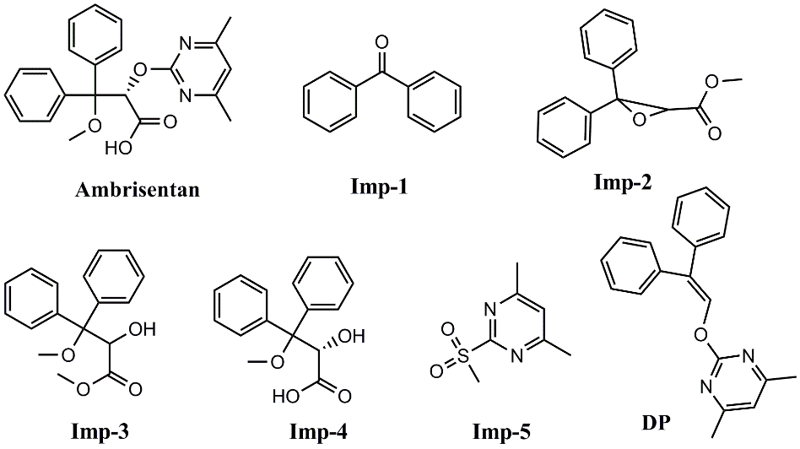

Figure 1. Chemical structures of ambrisentan, impurities (Imp-1, Imp-2, Imp-3, Imp-4, and Imp-5), and degradation of product (DP).

High Performance Liquid Chromatography
A binary pump module HPLC system (Shimadzu, Kyoto, Japan) equipped with two LC-20AD pumps, a DGU-20A₅ degasser unit, a SPD-M20A diode array detector, a SIL-20AC auto sampler, a CTO-20AC column oven and CBM-20A communications bus module was used for method development and validation studies. The chromatographic system was controlled by Lab Solutions data acquisition software. A Luna C₁₈ (Phenomenex, USA) column (250 × 4.6 mm, 5 µm) was used with the mobile phase consisting of 0.02M aqueous ammonium acetate buffer (pH = 4.2 adjusted with acetic acid) (solvent A), and acetonitrile (solvent B) in an isocratic elution mode (A:B 52:48 v/v) pumped through column at a flow rate of 1.0 mL/min and at a column temperature of 25 ˚C. The sample injection volume was 10 µL. Eluents were monitored at a detection wavelength of 215 nm.

Preparation of Analytical Solutions
Stock solutions of ambrisentan (2.0 mg/mL) and each impurity (0.5 mg/mL) were prepared by dissolving the appropriate amounts in minimum amount of acetonitrile and then diluted to volume with diluent. Working solutions for method development and validation studies were prepared by adequately mixing the stock solutions with diluent. For degradation studies, ambrisentan (2.0 mg/mL) was prepared and diluted to volume with diluent to get final concentration of 1.0 mg/mL after adding stress media such as acid, base and water in hydrolysis, aqueous hydrogen peroxide in oxidation, and water in photolysis.

Specificity and Forced Degradation
Specificity is the ability of the method to measure the analyte (ambrisentan) response unequivocally in the presence of its possible impurities. The specificity of the developed HPLC method for ambrisentan was determined in the presence of its process related impurities (Imp-1 to Imp-5 at 0.15%) and degradation products formed under stress. Stress testing of the drug substance can help to identify the possible degradation products, which in turn can help to identify the degradation pathways and the intrinsic stability of the drug molecule. Ambrisentan was subjected to various stress conditions such as acid (0.1 N HCl, 4 h, 60 ˚C), base (0.5 N NaOH, 8 h, 60 ˚C), neutral hydrolysis (8 h, 60 ˚C), and oxidation (3% H₂O₂, 48 h) conditions in solution state. For thermal studies, ambrisentan powder was spread in a Petri dish (≈ 1.0 mm thickness) and kept at 100 ˚C for 7 days in a dry air oven. The drug was exposed to both fluorescent and UV light in a photostability chamber (Sanyo, UK) for a period of 1.2 million Lux hours and 200 Wh/m², respectively in both solid and solution states for the photolytic stress study. Different stress conditions were followed to achieve significant degradation. The collected degradation samples of acid and base hydrolysis were neutralized and all the degradation samples were diluted five times for assay determination. Assays were performed by comparison with standard and the mass balances (%assay + %impurities + %DPs) were calculated for stressed samples. PDA detector was used for peak purity and homogeneity determination of ambrisentan peak.

Method Validation
The developed method was validated as per International Conference on Harmonization (ICH) Q2R1 guideline to ensure that the performance characteristics of the method meet the requirements for its intended applications. Same method is used for validation studies for assay and related substances determination individually.

System suitability
The system suitability was conducted throughout the validation studies by using 800 µg/mL of ambrisentan solution spiked with1.2 µg/mL (0.15%) of related substances (Imp-1 to Imp-5) and evaluated by making six replicate injections.

Limits of detection (LOD) and limits of quantitation (LOQ)
The limits of detection (LOD) and quantitation (LOQ) for ambrisentan and its five related substances were estimated at signal-to-noise ratios of 3:1 and 10:1, respectively by injecting a series of diluted solutions with known concentration.

Precision
The system precision was evaluated by injecting six replicates of standard solution for both assay (ambrisentan 100 µg/mL) and related substances (ambrisentan (800 µg/mL) spiked with 0.15% of each impurity) methods individually. The precision of the related substances and assay methods were investigated by injecting six individual test preparations of ambrisentan (800 µg/mL) spiked with 0.15% of each impurity and ambrisentan (100 µg/mL), respectively. The intermediate precisions were evaluated on a different day by a different analyst using different batch column and instrument located within the same laboratory with the similar type of sample solutions. Precision at the LOQ level was done by injecting three individual preparations of mixture of all five impurities spiked to ambrisentan at their LOQ level. The %RSDs of the peak areas of ambrisentan and each impurity were calculated for precision studies.

Accuracy
Accuracy of the related substance method was evaluated by spiking known amounts of the impurities to the test sample and calculating the percent recovery. For related substances, the recovery studies were performed in triplicate at three concentration levels (50, 100 and 150%) to specification level (0.15%) of impurities (i.e., 0.6, 1.2, and 1.8 µg/mL) with respect to ambrisentan drug substance concentration 800 µg/mL. The accuracy of the ambrisentan assay was evaluated in triplicate at the three concentration levels 50, 100 and 150% (i.e., 50, 100 and 150 µg/mL) to ambrisentan specification concentration 100 µg/mL, and the recovery was calculated for each concentration.

Linearity
Linearity of the related substance method was established by analyzing series of dilute solutions at six different concentration levels ranging from LOQ to 250% to the specification level of impurities (i.e., LOQ, 0.6, 1.2, 1.8, 2.4, and 3.0 µg/mL) spiked to ambrisentan drug substance (800 µg/mL). The calibration curves were drawn by plotting the peak areas of impurities against their corresponding concentrations. Similarly, assay method linearity was established by injecting ambrisentan at five different concentration levels ranging from 50 to 150% (i.e., 50, 75, 100, 125, and 150 µg/mL) to ambrisentan concentration 100 µg/mL. The correlation coefficients (r²), slopes and Y-intercepts of impurities and ambrisentan were determined from their respective calibration plots.

Robustness
Robustness study was carried out to check the influence of small variations in the optimized chromatographic conditions. The typical parameters investigated include flow rate (±10% to 1.0 mL/min), mobile phase pH (±0.2 to 4.2), organic modifier concentration (±3% to 48%) and column temperature (±2 ˚C to 25 ˚C). System suitability parameters and changes in assay of ambrisentan and recoveries of impurities were checked. In all the above deliberately altered experimental conditions, the mobile phase compositions were held constant.

Solution Stability and Mobile Phase Stability
The solution stability of ambrisentan and its impurities was carried out by leaving unspiked and spiked sample solutions in a tightly capped volumetric flask at 2-8 ˚C for 48 h. Content of impurities and assay of ambrisentan were determined at 8h intervals. Mobile phase stability was assessed by comparing freshly prepared sample solutions and freshly prepared reference standard solution up to 48 h.

Results and Discussion
Method Development and Optimization of Chromatographic Conditions
The main objective of the development of liquid chromatographic method was to get good separation of process related impurities (Imp-1, Imp-2, Imp-3, Imp-4, and Imp-5), and degradation product generated during stress conditions from ambrisentan. Individual separation of all analytes is also aimed at this method development. Major degradation product (DP) found in this study is olefin (i.e., 2-((2,2-diphenylvinyl)oxy)-4,6-dimethylpyrimidine) as shown in Figure 1. The results concurred with the study reported by Ramisetti and Kuntamukkala [9]. DP was selected for method development and remaining degradation products were neglected as their formation is very insignificant. For the method development ambrisentan unspiked and spiked with all impurities, and stress generated samples were simultaneously injected on to HPLC system. In the development of a selective method, attempts were made using different mobile phase compositions using C₁₈ columns of different brands. Mobile phase compositions used are aqueous ammonium acetate and potassium dihydrogen orthophosphate buffers, acetonitrile and methanol; C₁₈ columns are Waters Symmetry, Phenomenex Luna. Preliminary study showed that ammonium acetate and acetonitrile gave better results compared to others. Therefore, this mobile phase was selected for further method development. Both columns exhibited the co-elution of polar analytes Imp-4 and Imp-5 at higher acetonitrile content and good resolutions at lower. However, lack of ambrisentan peak symmetry was observed on Symmetry column compared to Luna column. Isocratic elution trials were selected for method development as gradient programs resulted large base line drift. Attempts were finally made with Luna column and buffer with different strengths in isocratic elution mode based on observations found in earlier trials. After several trials, very good separation of all analytes with peak symmetry was accomplished on a Luna C₁₈ column (250 x 4.6 mm, 5 µm) with mobile phase consisting of ammonium acetate buffer (0.02M, pH=4.2 adjusted with acetic acid) and acetonitrile at a ratio of 52:48 (v/v) with a flow rate of 1.0 mL/min and at a column temperature of 25 ˚C. Separation of ambrisentan and its five process related impurities under optimized conditions is shown in Figure 2.

Specificity and degradation behavior of ambrisentan
The assay of ambrisentan for three determinations was found to be 99.6 % with %RSD of 0.4; while in the presence of impurities (0.15 % w/w) it was 99.4 % with %RSD of 0.8. It suggests that the assay did not change in the presence of impurities, indicating the specificity of method in presence of impurities. No significant degradation of ambrisentan was observed under neutral and basic hydrolytic, oxidative, photolytic, and thermolytic stress conditions. Significant degradation of ambrisentan drug substance was observed in acidic hydrolytic stress conditions as shown in Figure 2. One degradation product is formed, and is depicted as DP in Figure 1. Peak purity test results obtained from PDA detector confirmed that the ambrisentan peak was homogeneous and pure in all the analyzed stress samples. The mass balance of stressed samples was found in the range of 98.5 to 99.8%. The forced degradation results are summarized in Table 1.

Table 1. Summary of forced degradation studies
Stress condition | Time | Assay  (% w/w) | Mass balance  (% w/w) | Remarks
Acid hydrolysis  (0.1N HCl, 60 ˚C) | 4 h | 93.3 | 98.5 | One degradation product (DP) was observed
Base hydrolysis  (0.5N NaOH, 60 ˚C) | 8 h | 99.3 | 99.3 | No degradation was observed
Neutral hydrolysis  (H₂O, 60 ˚C) | 8 h | 99.8 | 99.8 | No degradation was observed
Oxidation  (3% H₂O₂) | 2 days | 99.1 | 99.1 | No degradation was observed
Thermal  (100 ºC) | 7 days | 99.6 | 99.6 | No degradation was observed
Photo :  Solid  Solution | 1.2x10⁶ Lux h,  200 Wh/m² | 99.5  98.9 | 99.5  98.9 | No degradation was observed

Method Validation: System suitability
System suitability data given in Table 2 indicating that the system was suitable for use as the tailing factor for all the analytes was less than 1.4 and the resolution between any of the two adjacent eluting analytes was greater than 3.1. It also confirms the good selectivity of the method.

Limits of Detection (LOD) and Limits of Quantitation (LOQ)
The LOD and LOQ results of ambrisentan and its five process related impurities estimated at signal-to-noise ratios of 3:1 and 10:1, respectively are summarized in Table 2.

Precision
The %RSD results of precision studies (system, method, intermediate and at LOQ) for both ambrisentan assay and related substances methods were found in the range of 0.37-0.85 and 0.91-5.24, respectively confirming the good precision of the developed method. The %RSD results of precision studies are given in Table 2.

Accuracy
Table 2 shows the recovery results of accuracy studies. Percentage recovery of ambrisentan assay in the drug substance was ranged from 99.2-100.7 %, and the percentage recoveries of related substances were obtained in the range from 92.8-103.5 %.These good recovery results confirming the quantitative ability of the method.

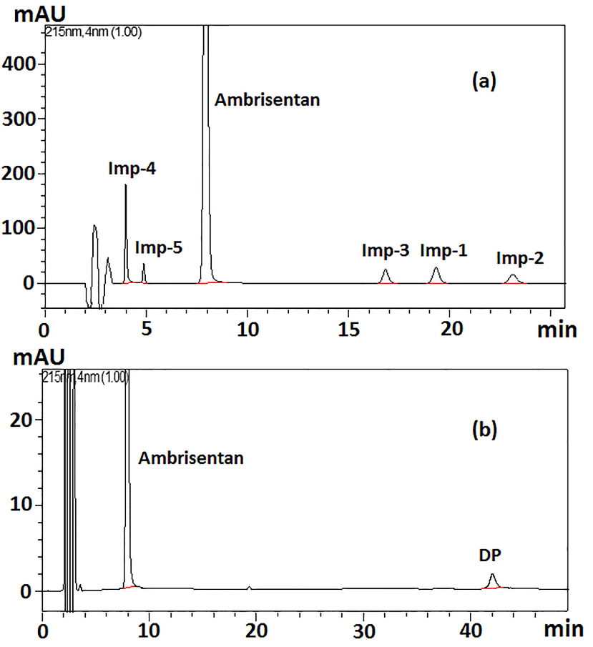

Figure 2. Typical chromatograms of ambrisentan (a) spiked with impurities and (b) acidic hydrolysis stress samples.

Linearity
Linearity data of ambrisentan and impurities is given in Table 2. The linear calibration plot for the ambrisentan assay was obtained over the study range (50–150µg/mL) and the correlation co-efficient obtained was equal to 0.9999. The linear calibration plots for the related substances were drawn over the calibration ranges LOQ to 3.0 µg/mL, and correlation coefficients obtained were greater than 0.997. The obtained results for both assay and related substances methods showed an excellent correlation between the peak area and analyte concentration revealed the good linearity of the method.

Robustness
Evaluation of deliberately varied conditions such as flow rate (0.9 and 1.1 mL/min), pH (4.0, and 4.4), acetonitrile concentration (45 and 51%), and column temperature (22 and 28 ˚C) showed that the resolution between any two adjacent analytes was greater than 2.5 and tailing factors obtained below 1.6; and variability in the estimation of ambrisentan assay and related substances recovery was within ±2 and ±7%, respectively indicating the robustness of the method.

Solution stability and Mobile Phase Stability
The %RSDs of peak areas of ambrisentan assay and five impurities during the solution and mobile phase stability experiments were within 1% and 8%, respectively. No significant change observed in ambrisentan assay and content of impurities during solution stability and mobile phase stability experiments confirming that sample solutions and mobile phase used during the study were stable up to 48 hours.

Table 2. System suitability, linearity, sensitivity, precision, and accuracy data
Parameter | Imp-1 | Imp-2 | Imp-3 | Imp-4 | Imp-5 | Ambrisentan
System suitabilityª
RT (min) | 19.18 | 22.93 | 16.71 | 3.88 | 4.87 | 7.55
RRT | 2.54 | 3.04 | 2.21 | 0.51 | 0.65 | 1.000
Rs | 3.17 | 4.20 | 16.10 | - | 4.15 | 8.38
k′ | 3.95 | 4.92 | 3.31 | - | 0.26 | 0.95
As | 1.28 | 1.19 | 1.22 | 1.39 | 1.25 | 1.16
N | 8550 | 9251 | 8315 | 4006 | 6918 | 5573
Linearity^{b}
Range (µg/mL) | 0.2-3.0 | 0.2-3.0 | 0.3-3.0 | 0.06-3.0 | 0.3-3.0 | 50-150
r² | 0.9979 | 0.9984 | 0.9982 | 0.9989 | 0.9987 | 0.9998
Slope | 41071 | 40054 | 44430 | 34352 | 9927.2 | 65940
Intercept | 233.63 | 159.79 | 319.17 | 666.17 | 604.15 | 18093
Sensitivity^{b}
LOD (µg/mL) | 0.07 | 0.07 | 0.1 | 0.02 | 0.1 | 0.1
LOQ (µg/mL) | 0.20 | 0.20 | 0.3 | 0.06 | 0.3 | 0.35
Precision (%RSD)ª
System | 1.89 | 1.80 | 2.28 | 1.85 | 3.52 | 0.54
Method | 1.24 | 2.64 | 3.11 | 0.91 | 1.55 | 0.37
Intermediate | 2.34 | 4.03 | 3.24 | 1.03 | 1.62 | 0.85
LOQ | 4.85 | 1.85 | 1.98 | 3.46 | 5.24 | -
% Recovery (Accuracy)ª
50% level | 96.3 | 98.7 | 98.3 | 92.8 | 95.5 | 100.7
100% level | 103.5 | 102.3 | 96.4 | 95.2 | 95.5 | 100.1
150% level | 102.1 | 95.7 | 99.2 | 100.3 | 94.7 | 99.2
RT = Retention time, Rs = Resolution, k^{l} = Retention factor, As = Tailing factor, N = Number of theoretical plates, r² = Correlation coefficient. ª Average of six determinations, ^{b} Average of three determinations.

Conclusion
A simple isocratic stability-indicating RP-HPLC method was developed and validated for the determination of ambrisentan and its related substances in bulk drugs. The forced degradation behaviour of ambrisentan was studied as per ICH prescribed guidelines. One degradation product was formed under stress conditions as detected by HPLC. The developed method was found to be selective, accurate, sensitive and precise, and is applicable for detecting process related substances and possible degradation product which may be present at trace level in bulk drugs.

References
- Frampton, J. E. (2011). Ambrisentan. American Journal of Cardiovascular Drugs, 11(4): 215–226.
- Barst, R.J. (2007). A review of pulmonary arterial hypertension: role of ambrisentan. Vascular Health and Risk Management, 3 (1): 11-22.
- Klinger, J. R., Oudiz, R. J., Spence, R., Despain, D., Dufton. C. (2011). Long-Term Pulmonary Hemodynamic Effects of Ambrisentan in Pulmonary Arterial Hypertension. The American Journal of Cardiology, 108 (2): 302-307.
- Nirogi, R., Kandikere, V., Komarneni, P., Aleti, R., Padala, N. S. P., Kalaikadhiban, I. (2012). LC-ESI-MS/MS method for quantification of ambrisentan in plasma and application to rat pharmacokinetic study. Biomedical Chromatography, 26 (10): 1150-1156.
- Douša, M., Gibala, P. (2012). Rapid determination of ambrisentan enantiomers by enantioselective liquid chromatography using cellulose-based chiral stationary phase in reverse phase mode. Journal of Separation Science, 35 (7): 798-803.
- Kaja, R. K., SurendhraNath, K. V., Babuji, K., Satyanarayana, P. V. V., Kumar, K. S. (2009). A validated LC method for the enantiomeric separation of ambrisentan in bulk drug and pharmaceutical dosage forms. Analytical Chemistry: An Indian Journal, 8 (2): 155-160.
- Narayana, M. B. V., Chandrasekhar, K. B., Rao, B. M. (2014). A validated specific stability-indicating RP-HPLC assay method for ambrisentan and its related substances. Journal of Chromatographic Science, 52 (8): 818-825.
- Satheeshkumar, N., Naveenkumar, G. (2014). A stability-indicating reversed-phase high-performance liquid chromatography method for ambrisentan: an endothelin receptor antagonist. Journal of Chromatographic Science, 52 (8): 894-898.
- Ramisetti, N. R., Kuntamukkala, R. (2014). LC-MS/MS characterization of forced degradation products of ambrisentan: development and validation of a stability-indicating RP-HPLC method. New Journal of Chemistry, 38 (7): 3050-3061.
- International Conference on Harmonization, ICH. (2003). Q1A(R2): Stability testing of new drug substances and products.
- International Conference on Harmonization, ICH (2003). Q2(R1): Validation of analytical procedures: test and methodology.

