

NEW FUNCTIONALISED SOL-GEL HYBRID SORBENT COATING FOR STIR BAR SORPTIVE EXTRACTION OF SELECTED NON-STEROIDAL ANTI INFLAMMATORY DRUGS IN HUMAN URINE SAMPLES

(Bahan Salutan Baharu Hibrid Sol-Gel Terfungsi Untuk Pengekstrakan Erapan Bar Berputar Ubat Anti-Radang Bukan Steroid Terpilih Dalam Sampel Urin Manusia)

Mashkurah Abd Rahim¹ , Wan Aini Wan Ibrahim*^{1, 2}, Zainab Ramli^{1, 2}, Mohd Marsin Sanagi^{1, 2}

¹Separation Science and Technology Group (SepSTec),
Department of Chemistry, Faculty of Science,
²Ibnu Sina Institute for Scientific & Industrial Research (ISI-SIR),
Universiti Teknologi Malaysia, 81310 UTM, Johor Bahru, Johor, Malaysia

*Corresponding author: wanaini@kimia.fs.utm.my, waini@utm.my

Received: 30 January 2015; Accepted: 1 April 2015

Abstract
A new sol-gel hybrid material, methyltrimethoxysilane-cyanopropyltriethoxysilane (MTMOS-CNPrTEOS) was successfully synthesized and used as a coating material in stir bar sorptive extraction (SBSE) of selected non-steroidal anti-inflammatory drugs (NSAIDs) in urine samples. The MTMOS-CNPrTEOS hybrid was synthesized by hydrolysis and condensation of MTMOS and CNPrTEOS in the presence of trifluoroacetic acid as catalyst via sol–gel method. Several factors influencing the synthesized sol-gel hybrid MTMOS-CNPrTEOS process such as mole ratio of MTMOS-CNPrTEOS, NaOH concentrations as etching solution, etching time, coating time and water content were investigated and optimized in this study. The optimum synthesis conditions obtained were 1:1 mol ratio of MTMOS-CNPrTEOS, 1 M NaOH as etching solution, 60 min etching time, 2 h coating time and 6 mmol water. The sol-gel hybrid MTMOS-CNPrTEOS synthesized under the optimum conditions was used to determine selected NSAIDs in human urine samples using normal stacking mode capillary electrophoresis with ultraviolet detection. MTMOS-CNPrTEOS SBSE method demonstrated good linearity (60 to 20,000 µg L⁻¹) with excellent coefficient of determination (r² > 0.9990). The sol-gel hybrid MTMOS-CNPrTEOS SBSE method showed low limit of detection (35 – 41 µg L⁻¹) with good precision (RSD < 6 %, n = 3) and excellent extraction recoveries (83.5 – 98.9%) for the selected NSAIDs. The sol-gel hybrid MTMOS-CNPrTEOS SBSE method demonstrated good potential as an alternative sorbent in SBSE method for NSAIDs.

Keywords: Sol-gel hybrid, stir bar sorptive extraction, non-steroidal anti-inflammatory drugs, normal stacking mode, capillary electrophoresis-UV detection

Abstrak

Sol-gel hibrid baharu, metiltrimetoksisilana-sianopropiltrietoksisilana (MTMOS-CNPrTEOS) telah berjaya disintesis dan digunakan sebagai bahan baharu penyalutan untuk pengekstrakan erapan bar berputar (SBSE) dalam penentuan ubat anti-radang bukan steroid (NSAIDs) terpilih di dalam sampel urin manusia. Hibrid MTMOS-CNPrTEOS disintesis melalui hidrolisis dan kondensasi MTMOS dan CNPrTEOS dengan kehadiran asid trifluoroasetik sebagai mangkin melalui kaedah sol-gel. Beberapa faktor yang mempengaruhi proses penghasilan hibrid sol-gel MTMOS-CNPrTEOS seperti nisbah mol MTMOS-CNPrTEOS, kepekatan NaOH sebagai larutan punaran, masa punaran, masa salutan dan kandungan air dalam proses sol-gel telah dikaji dan dioptimumkan. Keadaan sintesis yang optimum ialah 1:1 nisbah mol MTMOS-CNPrTEOS, 1 M NaOH sebagai larutan punaran, 60 min masa punaran, 2 jam masa salutan dan 6 mmol air. Hibrid sol-gel MTMOS-CNPrTEOS yang disintesis di bawah keadaan optimum telah digunakan untuk menentukan NSAID terpilih dalam sampel urin manusia menggunakan mod normal tersusun elektroforesis rerambut dengan pengesan ultralembayung. Kaedah hibrid sol-gel MTMOS-CNPrTEOS SBSE menunjukkan kelinearan yang baik (60 - 20,000 μg L⁻¹) dengan pekali penentuan, r² > 0.9990 yang cemerlang. Kaedah hibrid sol-gel MTMOS-CNPrTEOS SBSE ini menunjukkan had pengesanan yang rendah (35 - 41 μg L⁻¹) dengan ketepatan yang baik (RSD < 6%, n = 3) dan pengembalian pengekstrakan yang cemerlang (83.5 – 98.9%) untuk NSAID terpilih. Kaedah hibrid sol-gel MTMOS-CNPrTEOS menunjukkan potensi tinggi sebagai pengerap alternatif untuk kaedah SBSE.

Kata kunci: Hibrid sol-gel, pengekstrakan bar berputar, ubat anti radang bukan steroid, mod tersusun normal, elektroforesis rerambut-pengesan ultralembayung

Introduction
The developments of sol-gel hybrid material have been reported as combination of two or more integrating components material which gives lot of advantages. Sol–gel technology provides a convenient tool for the fabrication of hybrid materials. The ease with which these materials can be prepared, modified, and processed in conjuction with their high optical quality, photochemical and electrochemical stability, and good mechanical and chemical stability has made them an attractive alternative to the conventional organic polymers for various optical applications, composite material fabrication, and chemical sensor development [1]. Materials prepared using sol–gel technology can range from the relatively "simple" inorganic glasses to the more chemically and physically complex hybrid composites. Sol-gel method has been successfully used for the synthesis of a novel hybrid sorbent material for use in solid phase extraction of organophosphorus pesticides [2].

Acid-catalyzed conditions initially lead to chain elongation and to the formation of linear polymers. Cross-linking occurs by accidental interlinking of chains and leads to homogeneous, relatively dense gels. In contrast, base-catalyzed reactions lead to highly crosslinked sol particles as cross-linking already starts at the early stages in the process The water to silane ratio, the nature and concentration of the catalyst and the alkoxide precursors are specific parameters that strongly affect the relative rates of hydrolysis and condensation which, in turn, dictate the properties of the final material [3]. The structure, texture and morphology of hybrid sol-gel are strongly influenced by the synthesis conditions, such as pH, water content and reagent concentration [4].

Cyanopropylsiloxanes are among the most useful stationary phases as it exhibits both polar and polarizable characteristics at both low and high temperatures. The polar property of cyanopropyltriethoxysilane has attracted great interest among researchers. Wan Ibrahim et al. [5] have successfully synthesized and characterized polydimethylsiloxane–cyanopropyl-triethoxysilane derived hybrid coating for the SBSE of two non-steroidal anti-inflammatory drugs (NSAIDs) from aqueous samples. Sol-gel MTMOS-CNPrTEOS organic-inorganic hybrid sorbent was synthesized and used as sorbent in solid phase extraction to extract various polarities of organophosphorus pesticides in water samples [6]. In this study, MTMOS was selected as precursor due to its ability to forms more flexible network and capable to form superhydrophobic silica aerogel. The MTMOS gives more open structure and may effectively relieve stresses during drying, thus minimizing crack of coating [7]. The sol-gel hybrid MTMOS-CNPrTEOS involved the process of hydrolysis and polycondensation of a sol-gel precursor (MTMOS) and polycondensation of its hydrolysis product between themselves [8].

The determination of non-steroidal anti-inflammatory drugs (NSAIDs) in biological samples provides useful information with a view to assessing their safety, therapeutic effect and mechanism of action. As a result, it has a strong impact on areas such as forensic toxicology [9, 10]. The chemical structure, partition coefficient (log K_{o/w}) and dissociation constant of a solution (pK_{a}) for the selected NSAIDs studied are given in Table 1. NSAIDs are becoming the most commonly used medicines around the world because their effectiveness in suppressing or preventing inflammation [11]. The pharmacological actions of NSAIDs are related to the inhibition of cyclooxygenase (COX), a key enzyme of prostaglandin biosynthesis, at the site of inflammation. They may lead to severe toxic effects in cases of acute over dosage or chronic abuse, although NSAIDs perceived to be safe drugs. Therefore, they have been detected in clinical and forensic toxicological analyses [12]. Liquid–liquid extraction (LLE) and solid-phase extraction (SPE) are well-established procedures for concentrating analytes in various matrix samples [13,14], but these methods are rather laborious, time consuming and require moderate to large amounts of high-purity organic solvents that are potentially toxic and expensive [15]. Therefore, solventless sample preparation techniques such as liquid-phase microextraction (LPME) [16], supercritical fluid extraction (SFE) [17] and solid phase microextraction (SPME) [18-20] had already been proposed for the analysis of NSAIDs in the last decade.

Given the advantage of MTMOS base material with cyano phase, it is our interest to incorporate both precursors to extract polar and non-polar analytes simultaneously. In this paper, we report the optimization of sol-gel process in synthesizing sol-gel hybrid MTMOS-CNPrTEOS material. Several sol-gel parameters affecting the synthesis of MTMOS-CNPrTEOS namely, etching solvent and concentration, etching time, coating time, water content and mol ratio of MTMOS-CNPrTEOS were examined. Optimum sol-gel process were used to synthesize the sol-gel hybrid MTMOS-CNPrTEOS material and employed for the extraction of selected NSAIDs in human urine sample using capillary electrophoresis analysis in normal stacking mode with UV detection.

Table 1. pK_{a} and log K_{o/w} values of NSAIDs studied
Analytes | Chemical structure | pK_{a} | log K_{o/w}
Diclofenac sodium  (Dic) |  | 4.15 ª | 1.56ª
Ketoprofen  (Keto) |  | 4.45^{b} | 3.12^{b}
Naproxen  (Nap) |  | 4.15^{b} | 3.18^{b}

ª Ref. 12. ^{b}http://www.drugbank.ca (accessed on 23 June 2014).

Materials and Methods
Reagents
Cyanopropyltriethoxysilane (CNPrTEOS), methyltrimethoxysilane (MTMOS), trifluoroacetic acid (TFA) and poly(methylhydrosiloxane) (PMHS) were purchased from Sigma Aldrich (St Louis, MO, USA). Sodium hydroxide (NaOH), sodium chloride (NaCl), ethanol, acetonitrile and methanol were purchased from Merck (Darmstadt, Germany). All solvents were of HPLC analytical grade. Disodium hydrogen phosphate salt, Na₂HPO₄.12H₂O was purchased from Reidel-de-Haen (Seelze, Germany). All chemicals were of analytical reagent grade. Deionized water of 18.2 MΩ was purified by Nano ultrapure water system (Barnstead, USA). Disposable nylon filters (0.22 µm pore size) were from Millipore (Madrid, Spain). All selected NSAIDs namely ketoprofen (Keto), diclofenac sodium (Dic), naproxen (Nap) and ibuprofen (Ibu) as internal standard were purchased from Dr. Ehrenstorfer GmbH (Augsburg, Germany). Stock standard solutions (1000 µg mL⁻¹ of each analytes) were prepared in methanol and diluted as needed. All standard solutions were stored at 4˚C in the refrigerator when not in use.

Preparation of sol-gel hybrid MTMOS-CNPrTEOS coating
The in-house prepared glass encased stir bar (23 mm × 5 mm) was cleaned with 5 mL water, followed by etching process with 1 M NaOH solution for 60 min and then placed in 0.1 M HCl solution for 2 h before rinsed with 5 mL water. Finally it was dried at 150°C for 3 h in an oven. The sol-gel material was prepared in a 2 mL polyethylene bullet-shape tube; 140 μL MTMOS, 240 μL CNPrTEOS, 100 μL water, 25 μL PMHS and 200 μL of 95% TFA (13 M) were mixed in a beaker and vortexed for 2 min before centrifuged at 12,000 rpm for 5 min. The preparation steps were repeated using 479 μL, 718 μL and 956 μL CNPrTEOS at constant 140 μL MTMOS. All the other conditions were kept constant (1 M NaOH, 60 min etching time, 2 h coating time, 100 µL amount of water and one time dipping). The best compositions were determined by the highest extraction efficiency (relative response factor) of the sol composition of the selected NSAIDs. The mixture was allowed to react at room temperature for 30 min. A clear solution without layer was obtained for the sol-gel solution. The glass stir bar was coated by immersing vertically into the MTMOS-CNPrTEOS sol solution for 2 h (1× dipping). It was taken out and dried in an oven at 100°C for 4 h and then allowed to cool to room temperature for 30 min in a vacuum desiccator. The coated glass stir bar was kept in the desiccator when not in use and cleaned using ethanol in a Hettich Zentrifugen ultrasonic bath (Tuttlingen, Germany) for 5 min before used for extraction of NSAIDs. This is to wash away any impurities trapped in the sorbent material.

Stir bar sorptive extraction
10 mL of diluted urine sample (pH 2.2, 2 % salt addition) spiked with a mixture of ketoprofen, diclofenac sodium and naproxen (1 µg mL⁻¹) was introduced into a beaker. The stir bar coated with optimized sol-gel hybrid MTMOS-CNPrTEOS was immersed into the sample solution and the extraction process was allowed for 10 min with stirring at 300 rpm at 25°C. The stir bar was removed from the sample solution and dried with lintless tissue. Next, the stir bar was placed in a 2 mL Eppendorf vial filled with 1 mL of methanol. The absorbed analytes were desorbed from the stir bar into methanol using ultra-assisted liquid desorption. The methanol containing extracted analytes was dried with a slow flow of purified nitrogen to dryness and added with 100 µL of methanol containing ibuprofen as internal standard. The extracted NSAIDs were analyzed by using capillary electrophoresis with UV detection at 214 nm.

Electrophoresis conditions
The CE system used for analysis was an Agilent Technologies equipped with temperature control and ultraviolet detector (Santa Clara, USA). Prior to the first use, a new capillary of 64.5 cm × 50 µm i.d (effective length, 56 cm to the detector window) was conditioned by passing 1 M NaOH solution for 30 min followed by washing with deionized water for 30 min and finally equilibrating with an appropriate running buffer for 30 min. Between runs, the capillary was washed with 0.1 N NaOH, water and run buffer for 10 min each. In summary, the optimized normal stacking mode (NSM) condition is as follows15 s hydrodynamic injection at 50 mbar; UV detection separation wavelength 214 nm; 30 mM phosphate buffer pH 7 ; separation voltage and temperature 27 kV and 25°C, respectively were used for further analysis.

Real sample analysis
The urine samples were collected from three healthy volunteers, after obtaining their consent and stored at -4°C prior to use. Before the SBSE process, the samples were diluted to 1:1 with distilled water. Spiked urine samples were prepared by spiking standard mixture (1 µg mL⁻¹) into 10 mL of diluted urine sample and subsequently, the pH was adjusted to 2.2 using 1 M of HCl solution.

Results and Discussion
Optimization of sol-gel process parameters
The effect of mol ratio of MTMOS to CNPrTEOS on the characteristic of sol-gel coating as SBSE coating was carried out by using four different mol ratios of MTMOS: CNPrTEOS (1:1, 1:2, 1:3 and 1:4). All the different mol ratio of sol-gel hybrid MTMOS-CNPrTEOS produced a homogeneous sol solution but with different gelling time. The sol-gel mol ratio of 0.5:1 MTMOS-CNPrTEOS hybrid produced a non-homogeneous sol solution, thus it was not included in the study for further analysis. Even though the higher concentration of CNPrTEOS precursor was expected to strengthen the gel skeleton, the MTMOS was kept at 1 mol in order to control the gelation as more concentrated system will increase the reactivity of sol–gel system [21]. Increasing the addition of CNPrTEOS to the reaction lengthened the siloxane network which delayed the gelation time [22]. Therefore, the sol-gel mol ratio 1:1 MTMOS-CNPrTEOS was selected as the best sorbent coating composition for further analysis as it exhibited the highest ability to extract the selected NSAIDs (based on relative response factor) (Figure 1).

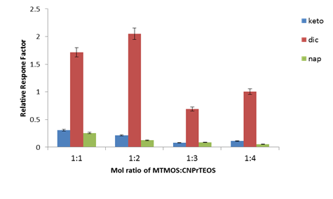
Figure 1. Effect of four different mol ratios of MTMOS: CNPrTEOS on the extraction efficiency (based on relative response factor) of the selected NSAIDs. Sol-gel process conditions: 1 M NaOH as etching solution, 60 min etching time, 2 h coating time, 6 mmol water and 1: 1 mol ratio of MTMOS : CNPrTEOS. CE conditions: 15 s at 50 mbar hydrodynamic injection, UV detection separation wavelength 214 nm, phosphate buffer pH 7 at concentration 30 mM, separation voltage and temperature 27 kV and 25°C

The transition from a sol to a gel is defined as the gelation point in which the point when links between the sol particles are formed to such an extent a solid material [23]. The gelation time was found to increase from 1 h to 5.2 h as the mol ratio of MTMOS-CNPrTEOS was increased from 1:1 to 1:4. This is due to the fact that MTMOS gets hydrolyzed in the early stages of the reaction to form silica clusters. As the CNPrTEOS content increase in the sol, the hydrolysis and condensation reactions are slowed down due to the less number of –Si-(OH) groups and more non-hydrolysable –Si-(C₂H₅)₃ groups in the sol. At lower mol ratio of CNPrTEOS in the sol, only few stable –Si-(C₂H₅)₃ groups are attached to the silica clusters and hence shorter gelation time was observed [24]. However, at higher mol ratio of MTMOS-CNPrTEOS, larger number of –Si-(CH₃)₃ groups are attached to the silica and hence, increased the gelation time. The 1:1 mol ratio sol-gel MTMOS-CNPrTEOS was selected as it took shorter gelling time resulting in faster formation of the MTMOS-CNPrTEOS sol-gel hybrid material.

The concentration of NaOH as etching solution, etching time, coating time and water content were optimized in sol-gel process using the classical one variable at a time (OVAT) methodology [25]. Quantitative calculations of selected NSAIDs were made based on relative respone factor obtained from NSM-CE-UV analysis. Stable adhesive bonding is needed for sol-gel hybrid coated in silica glass stir bar. Wet chemical etching treatment by using NaOH solution as etching solution is a rapid way to prepare surface of silica glass stir bar substrate for bonding with coating material [26, 27]. When hydroxyl groups were introduced to glass stir bar by NaOH solution, the oxygen content increased on the silica glass surface [28]. Figure 2 shows that the relative response factor (RRF) of selected NSAIDs increased significantly with an increase in the concentration of NaOH solution, but decreased when the concentration of NaOH solution was increased to 1.5 M. The decreased in extraction efficiency (RRF) is most probably due to the increase in coating thickness when more hydroxyl groups are present on the glass surface, causing slower equilibration time [29]. Therefore, 1 M NaOH solution was selected for further studies to maximize extraction efficiency while extending the performance of the glass stir bar coated MTMOS-CNPrTEOS.

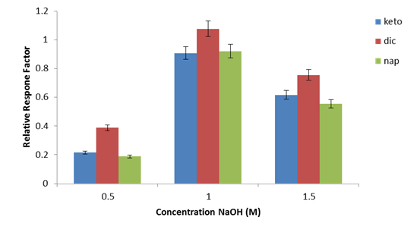
Figure 2. Extraction efficiency (relative response factor) of selected NSAIDs using different concentrations of NaOH as etching solution in synthesizing sol-gel hybrid MTMOS-CNPrTEOS SBSE. Sol-gel process conditions: 1:1 mol ratio of MTMOS-CNPrTEOS, 60 min etching time, 2 h coating time and 6 mmol water. CE conditions: 15 s at 50 mbar hydrodynamic injection, UV detection separation wavelength 214 nm, phosphate buffer pH 7 at concentration 30 mM, separation voltage and temperature 27 kV and 25°C.

Further improvement in the extraction efficiency of the sol-gel hybrid MTMOS-CNPrTEOS was accomplished by optimizing the etching time of NaOH solution. In Figure 3, the extraction efficiency of selected NSAID increased gradually as the etching time increased from 30 to 60 min, but decreased when etching time was increased to 90 min. Decreasing extraction efficiency, longer etching time was due to more hydroxyl group present on the surface of stir bar and it became saturated with hydroxyl group causing slower in equilibrium time [30]. Thus, 60 min etching time was selected as the optimum etching time to prepare the sol-gel hybrid MTMOS-CNPrTEOS.

The effects of different coating time in sol-gel hybrid MTMOS-CNPrTEOS for selected NSAID were evaluated and their extraction efficiency is shown in Figure 4. Coating time is the duration the glass stir bar was dipped (manually) in the sol solution. The result shows that the amount of selected NSAID extracted increased significantly as the coating time was increased from 0.5 h to 2 h, but decreased significantly when the coating time was increased to 2.5 h. This is most probably due to the increase in coating thickness causing slower equilibration time [29]. Therefore, 2 h coating time was selected for further analysis.

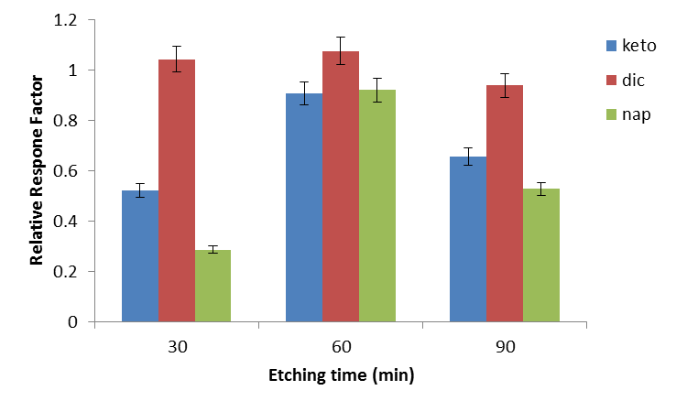
Figure 3. Extraction efficiency (relative response factor) of selected NSAIDs using different etching times in synthesizing sol-gel hybrid MTMOS-CNPrTEOS SBSE. Sol-gel process conditions: 1:1 mol ratio of MTMOS-CNPrTEOS, 1 M NaOH as etching solution, 1 h coating time (1× dipping) and 6 mmol water. CE conditions: 15 s at 50 mbar hydrodynamic injection, UV detection separation wavelength 214 nm, phosphate buffer pH 7 at concentration 30 mM, separation voltage and temperature 27 kV and 25°C. CE conditions: As in Figure 2.

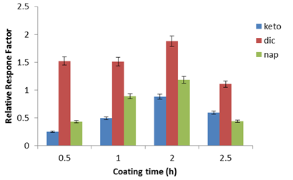
Figure 4. Extraction efficiency (relative response factor) of selected NSAIDs using different coating times in synthesizing sol-gel hybrid MTMOS-CNPrTEOS SBSE. Sol-gel process conditions: 1:1 mol ratio of MTMOS-CNPrTEOS, 1 M NaOH as etching solution, 60 min etching time and 6 mmol water. CE conditions: 15 s at 50 mbar hydrodynamic injection, UV detection separation wavelength 214 nm, phosphate buffer pH 7 at concentration 30 mM, separation voltage and temperature 27 kV and 25°C

Hydrolysis of silica alkoxides is a versatile technique which can produce different materials according to different parameters and acid or base catalysis reaction. The critical parameter is Si:H₂O ratio. The mol ratio of Si: H₂O in the sol should be at least 2: 1 to approach complete hydrolysis of the alkoxide and the water quantity should be 2–5 times the stoichiometric proportion [30]. Thus, in order to investigate the effect of water concentrations, the mol ratio of water was varied from 2 to 8 mmol while the ratio of MTMOS and CNPrTEOS remained at 1:1 mol ratio. Figure 5 depicts that the addition of 6 mmol of water produced the highest extraction efficiency (relative respone factor) of selected NSAIDs. Studies on the effect of water to TMOS ratio on the size of silica aerogel micro particles found that higher ratios gave smaller particles [23]. However, as the water ratios were increased to 8 mmol, the chemical reactions were accelerated and the gelation time decreased. The hydrolysis and condensation process may be retarded, thus decreased the extraction efficiency of the analytes. In this study, the optimum sol-gel process as are follows: 1 M NaOH solution, 60 min etching time, 2 h coating time, 6 mmol water, 1× dipping and 1:1 mol ratio of MTMOS-CNPrTEOS.

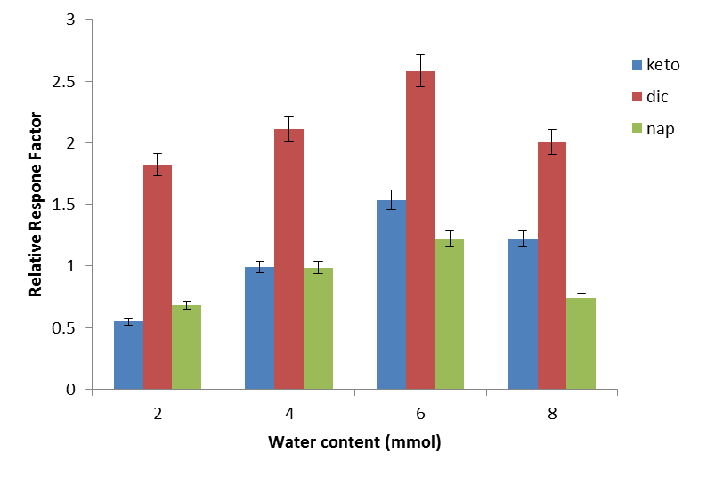
Figure 5. Extraction efficiency (relative respone factor) of selected NSAIDs using different amounts of water in the synthesis of sol-gel hybrid MTMOS-CNPrTEOS SBSE. Sol-gel process conditions: 1:1 mol ratio of MTMOS-CNPrTEOS, 1 M NaOH as etching solution, 60 min etching time and 2 h coating time (1 × dipping). CE conditions: 15 s at 50 mbar hydrodynamic injection, UV detection separation wavelength 214 nm, phosphate buffer pH 7 at concentration 30 mM, separation voltage and temperature 27 kV and 25°C

Method validation
Under the optimum sol-gel conditions, method validation was carried out in term of linearity, detection limits, reproducibility and recovery. Sol-gel MTMOS-CNPrTEOS hybrid SBSE validation data obtained are shown in Table 2. Good coefficient of determination (r² > 0.9990) was achieved from sol-gel hybrid MTMOS-CNPrTEOS SBSE method. The linearity range was tested in the range of 60 - 20,000 µg L⁻¹ for all selected

NSAIDs. The LODs were in the range 35 - 41 µg L⁻¹ with acceptable RSD (< 6 %, n = 3). The acidic NSAIDs are a group of substances, for which maximum residue limits (MRL) have been set by the European Union (EU). The tolerance value in poultry muscle tissue or biological samples (the national agreed value for these specific matrixes) for all NSAIDs analytes is 50 μg kg⁻¹. The LODs obtained from the proposed method is below the tolerance level which proved that the method is reliable due to the strong interaction between MTMOS-CNPrTEOS sol-gel hybrid and analytes. Table 3 shows the precision data for batch-to-batch and within batch for the sol-gel hybrid MTMOS-CNPrTEOS coating. Good RSDs (< 5.7%, n = 3) of the extraction was obtained for both batch-to-batch and within-batch assays. The results showed that the sol-gel hybrid reproducible and reliable.

Table 2. Method validation of sol-gel hybrid MTMOS-CNPrTEOS SBSE using NSM-CZE method
NSAID | Linear Range  (µg L⁻¹) | LOD  (µg L⁻¹) | LOQ  (µg L⁻¹) | r² | RSD(%)
Diclofenac sodium | 60 - 20,000 | 35 | 58 | 0.9958 | 1.4
Ketoprofen | 75 - 20,000 | 41 | 73 | 0.9991 | 5.8
Naproxen | 70 - 20,000 | 38 | 69 | 0.9979 | 4.2

Table 3. Precision data for sol-gel hybrid MTMOS-CNPrTEOS coated glass stir bar
Batch to batch (RSD %, n = 3) |  |  |  |  | Within batch (RSD %, n = 3)
NSAID | Batch 1 | Batch 2 | Batch 3 |  | Stir bar 1 | Stir bar 2 | Stir bar 3
Dic | 2.83 | 3.41 | 2.91 |  | 3.21 | 2.92 | 2.73
Keto | 4.36 | 3.96 | 5.58 |  | 4.25 | 4.82 | 5.69
Nap | 5.54 | 3.27 | 4.32 |  | 3.44 | 3.66 | 4.17
Dic: Diclofenac sodium Keto: Ketoprofen Nap: Naproxen

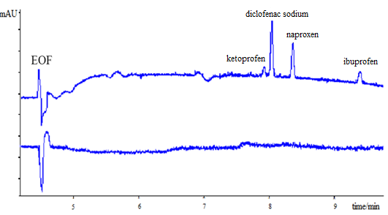
(b)
(a)
Figure 6. Electropherogram of (a) blank urine (b) spiked urine sample (1 µg mL⁻¹ of each NSAIDs). NSM-CZE conditions: 15 s hydrodynamic injection at 50 mbar; UV detection separation wavelength 214 nm; 30 mM phosphate buffer pH 7; separation voltage 27 kV and temperature 25°C.

Real sample analysis
Under the optimum conditions, the developed method of sol-gel hybrid MTMOS-CNPrTEOS was applied for the determination of selected NSAIDs in the three donor urine samples. Figure 6 represents NSM-CZE electropherogram of blank urine sample of donor 1 and spiked urine sample of donor 1 after SBSE. No interfering peaks at the retention time of the target analytes were observed which further confirmed that the urine matrix hardly affect the SBSE process. Table 4 shows the relative recovery and RSD (%) of sol-gel hybrid MTMOS-CNPrTEOS SBSE for selected NSAIDs in the three different donor spiked urine samples. The results showed good relative recoveries for sol-gel hybrid MTMOS-CNPrTEOS in the range of 83.5 - 98.9% with RSDs values ≤ 8.95% in three different donor urine samples.

Table 4. Percentage relative recovery and RSD (%) of sol-gel hybrid MTMOS-CNPrTEOS SBSE for
selected NSAIDs in three different donor spiked urine samples
 |  | Relative recovery (%), (% RSD, n = 3)
Sample/ Analyte |  | Ketoprofen |  |  | Diclofenac sodium |  |  | Naproxen
 |  | 2 µg mL⁻¹ | 15 µg mL⁻¹ |  | 2 µg mL⁻¹ | 15 µg mL⁻¹ |  | 2 µg mL⁻¹ | 15 µg mL⁻¹
Donor 1 |  | 83.49 (1.23) | 87.03(7.05) |  | 94.69(2.43) | 90.04(2.43) |  | 96.07(1.22) | 88.83 (3.96)
Donor 2 |  | 91.07 (8.95) | 88.11(8.94) |  | 84.33 (3.97) | 98.95(8.58) |  | 91.30(7.86) | 92.94 (3.25)
Donor 3 |  | 94.24 (7.85) | 90.63(6.42) |  | 96.15 (3.23) | 93.75(7.65) |  | 91.17(5.26) | 95.64(2.73)

Conclusion
The new synthesized sol-gel hybrid MTMOS-CNPrTEOS was successfully used an SBSE coating and shown to have high potential for extraction of NSAIDs from urine samples directly with no sample preparation (only dilution). Quantitative recoveries (> 83%, RSD <9%, n = 3) of NSAIDs were obtained using the new MTMOS-CNPrTEOS SBSE method. The dual nature of the coating material enables simultaneous extraction of polar and non-polar NSAIDs from urine samples. This saves time and cost.

Acknowledgement
This work was supported by Research University Grant (GUP) (vote number: 01H94, and 04H22) and Ministry of Education Malaysia (MOHE). The Ministry of Education Malaysia (MOE) is acknowledged for My Brain 15 Fellowship (MyPhD) award to M. Abd Rahim.

References
- Lisa, C. K. and Eliezer, M. R. (1994). Sol-gel optic: processing and application. Berlin: Springer International Series.
- Wan Ibrahim, W. A., Veloo, K. V., and Sanagi, M. M. (2012). Novel sol-gel hybrid methyltrimethoxysilane-tetraethoxysilane as solid phase extraction sorbent for organophosphorus pesticides. J. Chromatogr. A, 1229:55-62.
- Rao, A. V. and Haranath, D. (1999). Effect of Methyltrimethoxysilane as a Synthesis Component on the Hydrophobicity and some physical properties of silica aerogels. Microporous Mesoporous Mater., 30: 267–273.
- Brambilla, R., Poisson, J., Miranda, M. S. L., Cardoso, M. B. and Butler, I. S. (2011). Sol-gel preparation of aminopropyl-silica-magnesia hybrid materials. J. Sol-Gel Sci. Tech., 2: 1–10.
- Wan Ibrahim, W. A., Abdul Keyon, A. S., Prastomo, N. and Atsunori, M. (2011). Synthesis and characterization of polydimethylsiloxane-cyanopropyltriethoxysilane-derived hybrid coating for stir bar sorptive extraction. J. Sol-Gel Sci. Technol., 59: 28–134.
- Wan Ibrahim, W. A., Wan Ismail, W. A. and Sanagi, M. M. (2013). Selective and Simultaneous Solid Phase Extraction of Polar and Non- Polar Organophosphorus Pesticides Using Sol-Gel Hybrid Silica-Based Sorbent. J. Tec., 62(3): 83–87.
- Colon, L. A., Guo, Y. and Fermier, A. (1997). Capillary Electrochromatography. Anal.Chem. 69: 461A–467A.
- Lopes, A. L. and Augusto, F. (2004). Preparation and characterization of polydimethylsiloxane/poly(vinylalcohol) coated solid phase microextraction fibers using sol–gel technology. J. Chromatogr. A. 1056: 13–19.
- Ebell, M. H. (2004). NSAIDs vs opiates for pain in acute renal colic. Am. Fam. Physician. 70(9): 1682–1690.
- Gajraj, N. M. (2003). The effect of cyclooxygenase-2 inhibitors on bone healing. Reg. Anesth. Pain. med. 28(5): 456–465.
- Chiang, J. and Huang, S. (2008). Simultaneous derivatization and extraction of amphetamine and methylenedioxyamphetamine in urine with headspace liquid-phase microextraction followed by gas chromatography-mass spectrometry. J. Chromatogr. B. 1185: 19–22.
- Pountos, I., Georgouli, T., Bird, H. and Giannoudis, P. V. (2011). Nonsteroidal anti-inflammatory drugs: prostaglandins, indications, and side effects. Int. J. Interferon. Cytokine Mediator. Res. 3: 19–27.
- Albero, B., Sanchez-Brunete, C. and L. Tadeo, J. (2003). Determination of Organophosphorus Pesticides in Fruit Juices by Matrix Solid-Phase Dispersion and Gas Chromatography. J. Agric. Food Chem. 51: 6915–6921.
- Lin, W. C., Chen, H. C. and Ding, W. H. (2005). Determination of pharmaceutical residues in waters by solid-phase extraction and large-volume on-line derivatization with gas chromatography-mass spectrometry. J. Chromatogr. A. 1065(2): 279–285.
- Basheer, C., Alnedhary, A. A., Rao, B. S. M., Valliyaveettil, S. and Lee, H. K. (2006). Development and application of porous membrane-protected carbon nanotube micro-solid-phase extraction combined with gas chromatography/mass spectrometry. Anal. Chem. 78(8): 2853–2858.
- He, Y. and Kang, Y. J. (2006). Single drop liquid-liquid-liquid microextraction of methamphetamine and amphetamine in urine. J. Chromatogr. A. 1133: 35–40.
- Allen, D. L. and Oliver, J. S. (2000). The use of supercritical fluid extraction for the determination of amphetamines in hair. Forensic Sci. Int.107(1-3), 191–199.
- Fan, Y., Feng, Y. Q., Zhang, J. T., Da, S. L. and Zhang, M. (2005). Poly(methacrylic acid-ethylene glycol dimethacrylate) monolith in-tube solid phase microextraction coupled to high performance liquid chromatography and analysis of amphetamines in urine samples. J. Chromatogr. A. 1074: 9–16.
- Chou, C. C. and Lee, M. R. (2005). Solid phase microextraction with liquid chromatography–electrospray ionization–tandem mass spectrometry for analysis of amphetamine and methamphetamine in serum. Anal. Chim. Acta. 538: 49–56.
- Zhou, J. and Zeng, Z. (2006). Novel fiber coated with β-cyclodextrin derivatives used for headspace solid-phase microextraction of ephedrine and methamphetamine in human urine. Anal. Chim. Acta. 556(2): 400–406.
- Segro, S. S., Cabezas, Y. and Malik, A. (2009). Ultra-high-stability, pH-resistant sol-gel titania poly(tetrahydrofuran) coating for capillary microextraction on-line coupled to high-performance liquid chromatography. J. Chromatogr. A. 1216(20): 4329–4338.
- Moner-Girona, M., Roig, A. and Molins, E. (2003). Sol-Gel Route to Direct Formation of Silica Aerogel Microparticles. J. Sol-gel Sci. Techol. 26: 645–649.
- Guido, K., Caseri, W., Bourgeat-Lami, E., Zhu, J. and A. Wilkie, C. (2007). Hybrid material: Synthesis, characterization and application. Guido, K., Ed., 2nd edition, Wiley-Vch Verlag GmbH.
- Pandey, S. and Mishra, B. S. (2011). Sol-gel derived organic-inorganic hybrid materials : synthesis , characterizations and applications. J. Sol-gel Sci Technol. 57: 126-138.
- Khan, B. A., Farid, A., Asi, M. R., Shah, H. and Badshah, A. K. (2009). Determination of residues of trichlorfon and dimethoate on guava using HPLC. Food Chem. 114(1): 286–288.
- Kaplan, S. L. and Rose, P. W. (1991). Plasma surface treatment of plastics to enhance adhesion. Int. J. Adhes. Adhes. 11(2): 109–113.
- Momose, Y., Noguchi, M. and Okazaki, S. (1989). Ar, O and CF₄ plasma treatment of poly-(vinylidene fluoride), polyimide and polyamidoimide and its relationship to wettability. Nucl. Inst. Methods Phy. Res. 39: 805–808.
- Gerenser, L. J. (1993). XPS studies of in situ plasma-modified polymer surfaces. J. Adhes. Tech. 7(10): 1019–1040.
- Varinder, K., Ashok, K. M. and Neelam, V. (2006). Applications of solid - phase microextraction for the determination of metall ic and organometallic species. Wiley Inter Science publication.
- Nicolaon, G.A. and Teichner, S,J. (1968). New preparation process for silica xerogels and aerogels and their textural properties. Bull. Soc. Chim. France 5: 1900–1906.

