

Antioxidant Activity and Anticarcinogenic Properties of combination extract of soursop (AnNona muricata Linn)
and pearl grass (Hedyotis corymbosa (L.) Lam.)

(Aktiviti Antioksidan dan Antikarsinogenik daripada Ekstrak Campuran Durian Belanda (Annona Muricata Linn) dan Rumput Mutiara (Hedyotis Corymbosa (L.) Lam.)

Susi Endrini¹*, Suherman², Wahyu Widowati³

¹Faculty of Medicine,
YARSI University Cempaka Putih 10510 Jakarta, Indonesia
²Faculty of Medicine and Health Sciences,
Muhammadiyah University of Jakarta, Jakarta, Indonesia
³Faculty of Medicine,
Maranatha Christian University, Jl. Prof drg. Suria Sumantri No.65, Bandung 40164, Indonesia

*Corresponding author: susi.endrini@yarsi.ac.id

Received: Day Month Year; Accepted: 25 February 2015

Abstract
Soursop (Annona muricata) has numerous traditional medicinal uses in South American and the Caribbean, and it has become a popular nutritional medicinal supplement. In the other hand, pearl grass (Hedyotis corymbosa (L.) Lam.) has long been used traditionally as an anti-inflammatory. In this study, soursop and pearl grass combined to obtain extracts that have anticancer effects and anti-inflammatory effects, as most patients with cancer, particularly advanced breast cancer often experience inflammation. Two types of combination of extracts made ​​by different solvents ie ethanol extract combination (CSEPE) and water extract combination (CSWPW) have been used. The anticarcinogenic properties of both extracts have been studied by using MTT assay. The antioxidative activity of the extracts which could contribute to their cytotoxic properties was also studied by using DPPH assay. The results showed that the combination extract of ethanolic extract of soursop and pearl grass (CSEPE) has potential anticarcinogenic properties and the properties was decreased during the increment of incubation time but increased with the increasement of doses. However, the combination extract of water extract of soursop and pearl grass (CSWPW) did not displayed the potential anticarcinogenic properties. The anticarcinogenic properties of CSEPE could be due to their high antioxidant activities.

Keywords : MTT assay, soursop, pearl grass, MCF-7, antioxidant activity, cytotoxic properties

Abstrak
Durian belanda (Annona muricata) mempunyai banyak kegunaan perubatan tradisional di Amerika Selatan dan Caribbean, dan ia telah menjadi suplemen pemakanan perubatan popular. Di sisi lain, rumput mutiara (Hedyotis corymbosa (L.) Lam.) telah lama digunakan secara tradisional sebagai anti-radang . Dalam kajian ini, durian belanda dan rumput mutiara digabungkan untuk mendapatkan ekstrak yang mempunyai kesan anti-kanser dan anti-radang, kerana kebanyakan pesakit kanser, terutama kanser payudara teruk kerap mengalami keradangan. Dua jenis kombinasi ekstrak dibuat menggunakan pelarut yang berbeza iaitu gabungan ekstrak etanol (CSEPE) dan gabungan ekstrak air (CSWPW). Kesan anti-karsinogenik kedua-dua ekstrak telah dikaji dengan menggunakan asai MTT. Aktiviti antioksidan daripada ekstrak yang boleh menyumbang kepada sitotoksik mereka juga dikaji dengan menggunakan asai DPPH. Hasil kajian menunjukkan bahawa ekstrak gabungan ekstrak etanol daripada durian belanda dan rumput mutiara (CSEPE) mempunyai potensi antikarsinogenik dan kesannya telah menurun dalam tempoh kenaikan masa pengeraman tetapi meningkat dengan peningkatan dos. Walau bagaimanapun, ekstrak gabungan ekstrak air durian belanda dan rumput mutiara (CSWPW) tidak mempunyai kesan antikarsinogenik. Kesan antikarsinogenik daripada CSEPE mungkin disebabkan aktiviti antioksidannya yang tinggi.

Kata kunci:: asai MTT, durian belanda, rumput mutiara, MCF-7, aktiviti antioksidan, kesan sitotoksik

Introduction
Soursop (Annona muricata) has numerous traditional medicinal uses in South American and the Caribbean, and it has become a popular nutritional medicinal supplement. Fruit, seeds, bark, leaves, and roots have all been used to treat intestinal parasites, coughs (including asthma and bronchitis), liver ailments, inflammation, diabetes, and hypertension, among many uses, seeds are insecticidal and a preparation from the leaves has been used to kill headlice and bedbugs [1]. Numerous studies on anticarcinogenic properties of soursop have been found.

On the other hand, pearl grass (Hedyotis corymbosa (L.) Lam.) has the synonym name, Oldenlandia corymbosa, Linn. According to Kusuma and Zaky [2], the whole plant of pearl grass can be used as medicine. It has long been used traditionally as an anti-inflammatory diuretics, antipyretic, and antitoxin and enhances phagocytosis white blood cell and hormonal immunity [3]. This grass can also treat various diseases, such as hepatitis, gallbladder inflammation, hypertension, tonsilis, bronchitis, mumps, pneumonia, colitis appendicitis, urinary tract infections, pelvic inflammatory, boils and ulcers [4].

Until now, cancer is still one of the biggest causes of death in the world and the number is increasing every year [5]. In Indonesia, breast cancer is one of the leading causes of death for women. Most patients who have breast cancer detected at an advanced stage generally have experienced inflammation in her breast.

In this study, mixture of soursop and pearl grass was used to obtain extracts that have anticancer effects and anti-inflammatory effects. The research was conducted to determine the anticarcinogenic properties of combination of soursop extract and pearl grass extract, by the microculture tetrazolium salt (MTT) assay on the human breast carcinoma dependent-hormone (MCF-7) cell lines. Two types of combination of extracts made ​​by different solvents ie ethanol extract combination (CSEPE) and water extract combination (CSWPW) have been used. The antioxidative activity of the extracts which could contribute to their cytotoxic properties was also studied.

Materials and Methods
Plant Materials and Extractions
For preparing the ethanolic extract, the dried whole plant of pearl grass (1 kg) and the dried soursop leaves (1 kg) were extracted with 70% ethanol at room temperature. The extracts were then filtered through a Whatman No. 1 filter paper. The collected filtrates were evaporated to dryness under vacuum at 40°C using a rotary evaporator (N-1000V-W, Eyela, Japan). The extraction methods were obtained from Ali et al. [6] with slight modification. After evaporation, the yield of dried ethanolic extracts (SE) and (PE) were about 10% of the original plant samples. Extracts were made by mixing a combination of ethanol extract soursop with pearl grass ethanol extract of each 1: 1 (CSEPE).

For preparing the water extract, the dried whole plant of pearl grass (1 kg) and the dried soursop leaves (1 kg) were extracted with water at room temperature. The extracts were then filtered through a Whatman No. 1 filter paper. The collected filtrates were dried using freeze dried method and the dried water extract (SW) and (PW) have been collected. CSWPW Extracts were made by mixing a combination of soursop water extract with pearl grass water extract of each 1: 1.

Culturing of cells
MCF-7 cell lines was obtained from American Type Culture Collection (ATCC, USA). The cells were grown in Dulbecco’s Modified Eagle medium (Gibco, USA) supplemented with 10% of fetal calf serum, 100 IU/ml penicillin and 100 μg/ml of streptomycin (Gibco, USA) using 25 cm² flasks (Nunc, Denmark), in a CO₂ incubator (Sanyo, Japan) at 37°C.

MTT assay
The viability of cells was determined with trypan blue. Exponentially growing cells were harvested, counted by using hemocytometer,and diluted with medium, yielding a concentration of 1 x 105 cells ml⁻¹. From this cell suspension, 100 μl were pipetted into 96 well microtiter plates (Nunc, Denmark) and these wells were incubated for 24 h in 5% CO₂ incubator (Sanyo, Japan) at 37°C. The diluted range of test extracts being added. After adding the extract samples, new medium were added to make up the final volume of 200 μl each well. The plate was incubated in 5% CO₂ incubator (Sanyo, Japan) at 37°C for 24 and 48 hours. Then, 20 μl of MTT reagent (Roche, USA) was added into each well. This plate was incubated again for 4 hours in CO₂ incubator (Sanyo, Japan) at 37°C. After incubation, 200 μl solubilization solution (Roche, USA) was added into each well. The cell was then left overnight at 37°C, 5% CO₂ incubator. Finally, the absorbance was read with the ELISA reader (LX-800).

Determination of the scavenging activity
1,1-Diphenyl-2-picrylhydrazyl free radical scavenging assay (DPPH) was carried out according to the following procedure. Each extract at various concentrations (10, 50, 100, 200 and 600 ppm) was added to a 1.5 × 10⁻⁴ M solution of DPPH in methanol and the reaction mixture was shaken vigorously. The amount of DPPH remaining was determined at 520 nm, and the radical scavenging activity was obtained from the following equation (1):

Radical scavenging activity (%) = [(OD control – OD sample) / OD control] × 100 (1)

where OD is optical density. The antioxidant activity of plant extract was partially expressed as IC₅₀, which was defined as the concentration (in ppm) of extract required to inhibit the formation of DPPH radicals by 50%.

Results and Discussion
Anticarcinogenic properties
As was mentioned, two types of combination of extracts made ​​by different solvents such as ethanol extract combination (CSEPE) and water extract combination (CSWPW). Both combination extracts were tested for their anticancer activities on MCF-7 cell lines by the MTT assay. The IC₅₀-value of CSEPE and CSWPW against MCF-7 cell lines in different incubation time (24 hours and 48 hours) were shown in Table 1. Doxorubicin has been used as a positive standard and it has the IC₅₀- value of 0.147 μM and 0.000325 μM against MCF-7 on 24 hours and 48 hours incubation time, respectively. The standard curve of MCF-7 cell lines was shown in Figure 1. The morphology of treated-cell lines and untreated were shown in Figures 2 & 3. From morphology of cell, we can found that the anticancer activities increased with the increment of doses.

Table 1. IC₅₀ - value of Extracts on 24 hours and 48 hours incubation time
Treatment | IC₅₀ (24 hours incubation)  (μg/ml) | IC₅₀ (48 hours incubation)  (μg/ml)
Combination of ethanolic extract of soursop and pearl grass (CSEPE) | 42.397 | 80.449
Combination of water extract of soursop and pearl grass (CSWPW) | 301.419 | 201.561

Table 2. DPPH radical scavenging activity of CSEPE and CSWPW
Extracts/Compounds | IC₅₀ (ppm)
Combination of ethanolic extract of soursop and pearl grass (CSEPE) | 3.948
Combination of water extract of soursop and pearl grass (CSWPW) | 451.968
Ascorbic acid | 2.701

DPPH radical scavenging activity
The result of the determination of the radical scavenging activity of CSEPE and CSWPW were lower than of synthetic antioxidant vitamin C (Ascorbic acid). The IC₅₀ values of all samples were shown in Table 2. CSEPE extract showed higher antioxidant activities than CSWPW. The samples demonstrated a dose-dependent DPPH radical scavenging activity.

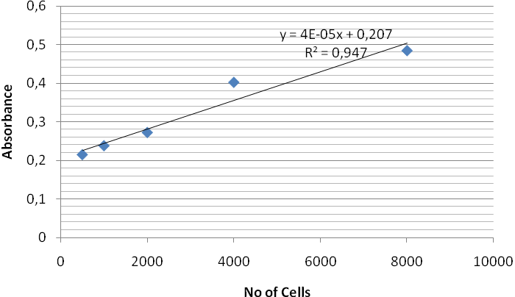
Figure 1. Standard curve of MCF-7

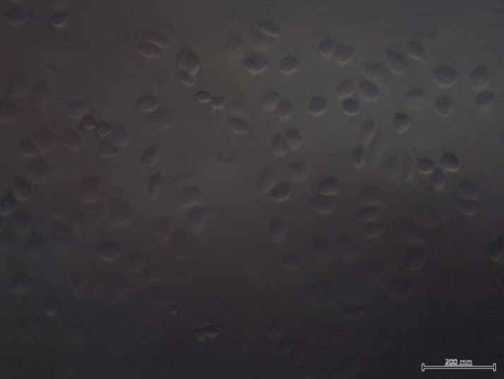
Figure 2. Morphology of MCF-7 cell lines untreated

Concentration | 1000 µg/ml | 250 µg/ml | 62.5 µg/ml
Combination of ethanolic extract of soursop and pearl grass (CSEPE) | 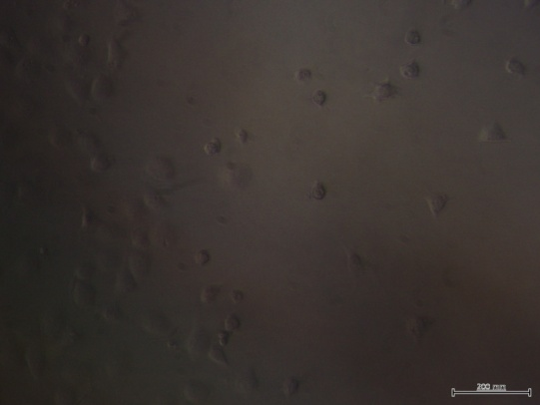 | 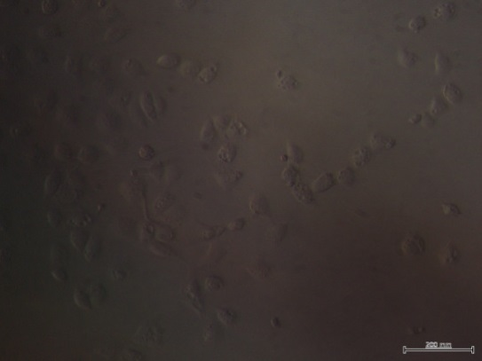 | 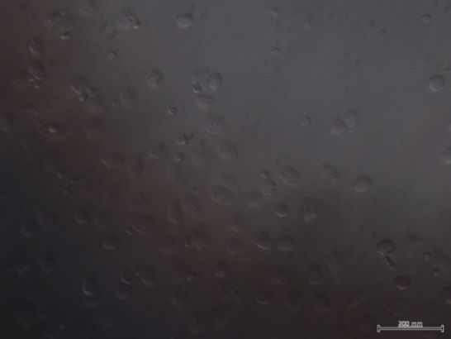
Combination of water extract of soursop and pearl grass (CSWPW) | 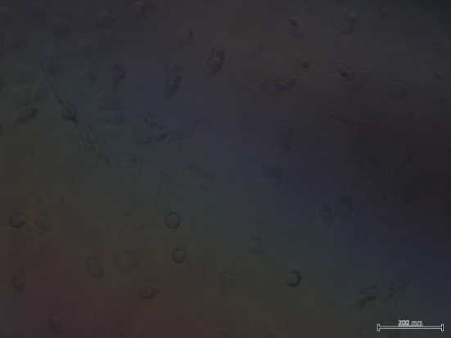 | 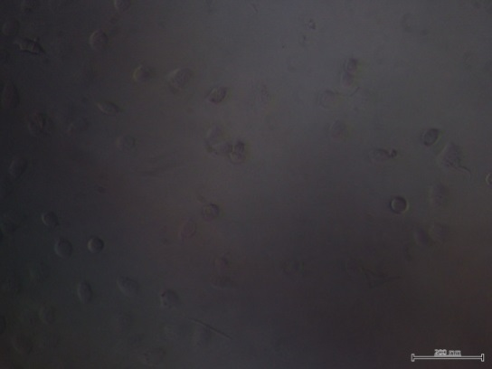 | 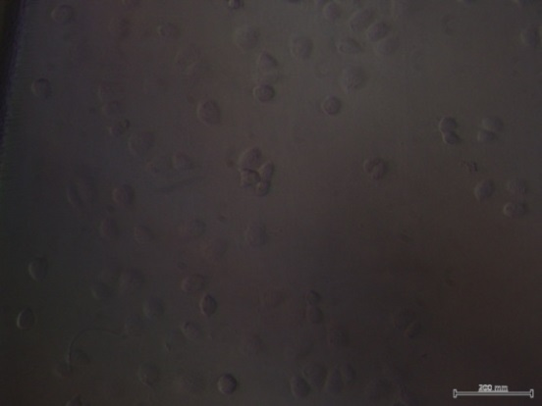
Doxoru  bicin | 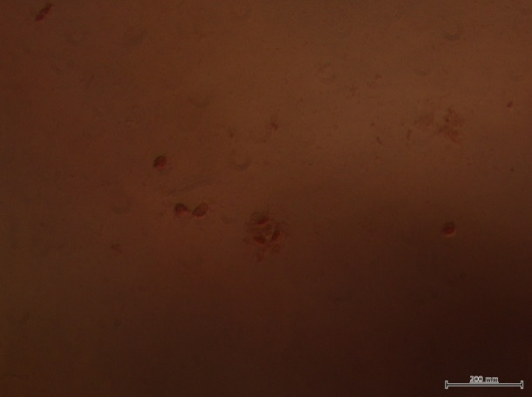 | 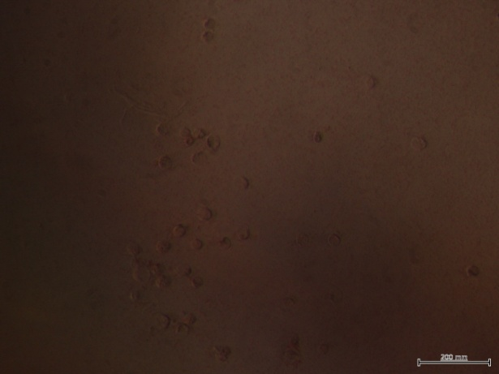 | 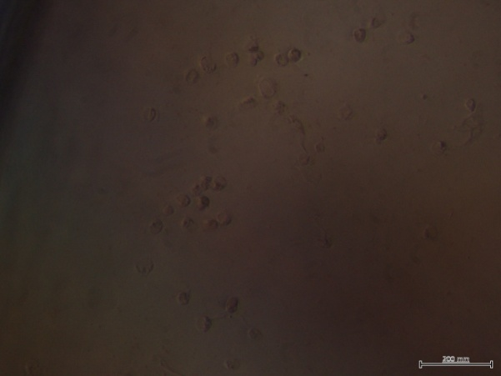

Figure 3. Morphology of MCF-7 cell lines treated by different treatments and doses.

This study has been shown that the combination extract of ethanolic extract of soursop and pearl grass (CSEPE) has potential anticarcinogenic properties and the properties was decreased during the increment of incubation time but increased with the increment of doses. The highest anticarcinogenic properties of this extract has been displayed by the lowest IC₅₀- value that has been achieved. However, the combination extract of water extract of soursop and pearl grass (CSWPW) did not displayed the potential anticarcinogenic properties. Paul et al. [7] have been found that HeLa cells treated with 75 μg of a crude leaf extract of Annona muricata showing 80% of cell inhibition. They also found the bioactive compounds of the crude leaf extract of Annona muricata such as Anonaine, Friedelin, Isolaureline, Annonamine, Anomurine, Kaempferol, Asimilobine, Quercetin, Xylopine. On the other hand, Lee et al. [8] was reported that pearl grass extract had a significant inhibition of cell growth and induction of cell apoptosis in COLO 205 (colon cancer), Hep3B (hepatocellular carcinoma) and H460 (lung cancer) cell lines.

The anticarcinogenic properties of combination extract of ethanolic extract of soursop and pearl grass could be due to their high antioxidant activities. Free radical scavenging is generally the accepted mechanism for antioxidants to inhibit lipid oxidation. Antioxidants, inhibitors of lipid peroxidation, are important not only for food protection but also for the defense of living cells against oxidative damage [9]. The preferable method for evaluation of the scavenging free radicals activities is 1,1-diphenyl-2 -picrylhydrazyl test – DPPH [10]. DPPH in comparison with other methods is able in a relatively short time evaluate the scavenging free radicals activities. Therefore, in this study the DPPH test was used. According to Sasikumar et al. [11], the pearl grass extract exhibited high antiradical activity against ABTS, nitric oxide and hydroxyl radicals with EC₅₀ value of 150, 130, and 170 μg/ml respectively. The pearl grass extract also enhanced the immunocompetence of mice after sub-lethal irradiation [12]. The pearl grass extract were reported to have a number of common bioactive constituents, including geniposidic acid, geniposide, oleanolic acid and ursolic acid [13-14]. Oleanolic acid and ursolic acid exhibited strong inhibition on tumor growth and accelerated the recovery from radiation injuries in mice [15]. Geniposidic acid and geniposide possessed antitumor and radioprotective activities [16]. Geniposidic acid was also demonstrated to facilitate the conjugation and biliary excretion of alphanaphthylisocyanate and/or its toxic metabolites. An acylated flavonol glycoside isolated from pearl grass exhibited antioxidative effects on xanthine oxidase inhibition, xanthine-xanthine oxidase cytochrome c and TBAMDA systems [17]. Other phytochemicals found in pearl grass are n-bezoyl-L-phenylalanylphenylalaninol acetate, asperuloside acid,deacetyl asperulosidic acid and scandoside [18]. The mechanisms of the anticarcinogenic properties of the ethanolic extract (CSEPE) is being studied.

Conclusion
The combination extract of ethanolic extract of soursop and pearl grass (CSEPE) has potential anticarcinogenic properties and the properties was decreased during the increment of incubation time but increased with the increment of doses. However, the combination extract of water extract of soursop and pearl grass (CSWPW) did not displayed the potential anticarcinogenic properties. The anticarcinogenic properties of combination extract of ethanolic extract of soursop and pearl grass could be due to their high antioxidant activities.

Acknowledgement
We gratefully acknowledge for the financial support of Directorate General for Higher Education, National Ministry of Republic of Indonesia for research grant of Desentralisation (Hibah Unggulan Perguruan Tinggi) YARSI University 2012-2013.

References
- Courteau, J. (2012). Annona muricata. Encyclopedia of Life. Available at : http://www.eol.org/. Accessed June, 2012
- Kusuma, F. R, and Zaky, B. M. (2005). Efficacious Wild Plant Drugs. Jakarta:Agromedia Pustaka.
- Dalimarta, S. (2005). Traditional Remedy for the Treatment of Hepatitis. New York: SowerSelf Reliance.
- Permadi, A. (2006). Urine facilitating Medicinal Plants. London: Sower Self Reliance.
- Tjindarbumi, D.M. (2002). Cancer in Indonesia, Present and Future. Jpn. J. Clin. Oncol. 32 Suppl 1: S17-21.
- Ali, A. M., Macjen, M., Hamid, M, Lajis, N. H, El, S. S and Murakoshi, M. (1996). Antitumor promoting and antitumor activities of the crude extract from leaves of Juniperus chinensis. J. Ethnopharmacol. 53: 165-169.
- Paul, J., Gnanam, R., Jayadeepa, R. M. and Arul, L. (2013). Anti cancer activity on Graviola, an exciting medicinal plant extract vs various cancer cell lines and a detailed computational study on its potent anti-cancerous leads. Curr Top Med Chem.13(14):1666-73.
- Lee, H. Z., Bau, D., Kuo, C. L., Tsai, R. Y., Hen, Y. C. and Chan, Y.H. (2011). Clarification of the phenotypic characteristics and anti-tumor activity of Hedyotis diffusa. Am. J. Chin. Med. 39(1): 201-213.
- Barbaste, M., Berke´e, B., Dumas, M., Soulet, S., Delaunay, C.L., Castagnino, C., Arnaudinaud, V., Che`eze, C. and Vercauteren, J. (2002). Dietary antioxidants, peroxidation and cardiovascular risks. J. Nutr. Health Aging 6: 209–223.
- Brand-Williams, W., Cuvelier, M. E. and Berset, C. (1995). Use of free radical method to evaluate antioxidant activity, Food Sci. Technol. 28(1): 25–30.
- Sasikumar, J. M., Maheshu,V., Aseervatham, G. S. and Darsini, D.T. (2010). In vitro antioxidant activity of Hedyotis corymbosa (L.) Lam. aerial parts. Indian J. Biochem. Biophys. 47 (1): 49-52.
- Yang, J. J., Hsu, H.Y., Ho, Y. H. and Lin, C. C. (1997). Comparative study on the immunocompetence of three different kinds of Peh-Hue-Jue-Chi-Cao, Hedyotis diffusa, H. corymbosa and Mollugo pentaphylla after sublethal whole body x-irradiation. Phytother. Res. 11: 428–432.
- Wijayakusuma, H. (2004). Overcome Cancer Image. London:Puspaswara.
- Soenanto, H. and Kuncoro, S. (2005). Destroy Kidney Stones with Herbs Plant. Jakarta: Puspa Swara.
- Hsu, H. Y., Yang, J. J. and Lin, C. C. (1997). Effects of oleanolic acid and ursolic acid on inhibiting tumor growth and enhancing the recovery of hematopoietic system post-irradiation in mice. Cancer Letter 111: 7–13.
- Hsu, H. Y., Yang, J. J., Lin, S. Y. and Lin, C. C. (1997). Comparison of geniposidic acid and geniposide on antitumor radioprotection after sublethal irradiation. Cancer Letter 113: 31–37.
- Lu, C. M., Yang, J. J., Wang, P. Y.and Lin, C. C. (2000). A new acylated flavonol glycoside and antioxidant effects of Hedyotis diffusa. Planta Med. 66:374–377.
- Lin, C. C., Ng, L. T. and Yang, J. J. (2004). Antioxidant Activity of Extracts of Peh- Hue-Juwa-Chi-Cao in a Cell Free System. Am. J. Chin. Med. 32(3):339–349.

