MICROPOROUS CARBON SPHERES SOLID PHASE MEMBRANE TIP EXTRACTION FOR THE ANALYSIS OF NITROSAMINES IN WATER SAMPLES

(Pengekstrakan Muncung Membran Fasa Pepejal Sfera Karbon Berliang Mikro bagi Analisis Nitrosamin di dalam Sampel Air)

Mohammed Salisu Musa^{1,3}, Mohd Marsin Sanagi^{1,2 *} and Hadi Nur² , Wan Aini Wan Ibrahim¹

¹ Department of Chemistry, Faculty of Science, Universiti Teknologi Malaysia, 81310 UTM Johor Bahru, Johor, Malaysia.
² Ibnu Sina Institute for Fundamental Science Studies, Nanotechnology Research Alliance, Universiti Teknologi Malaysia, 81310 UTM Johor Bahru, Johor, Malaysia.
³Department of Pure and Industrial Chemistry, Faculty of Science, Bayero University Kano, Nigeria.

*Corresponding author: marsin@kimia.fs.utm.my

Abstract
A simple solid phase membrane tip extraction (SPMTE) utilizing microporous carbon spheres (MCS) was developed for the analysis of nitrosamines in aqueous samples. The method termed MCS-SPMTE was optimized for various important extraction parameters namely conditioning organic solvent, extraction time, effects of salt addition and pH change, desorption time, desorption solvent and sample volume. Under the optimized conditions, the method indicated good linearity in the range of 10-100 µg/L with coefficients of determination, r² ≥ 0.9984. The method also demonstrated good reproducibility with %RSDs values ranging from 2.2 – 8.9 (n = 3). Limit of detection (LOD) and limit of quantification (LOQ) for the method ranged from 3.2 - 4.8 µg/L and 10.9 – 15.9 µg/L respectively. Recoveries for both tap-water and lake water samples spiked at 10 µg/L were in the range of 83.2 - 107.5%.

Keywords: Hydrothermal reaction, microporous carbon spheres, nitrosamines, solid phase membrane tip extraction, gas chromatography mass spectrometry

Abstrak
Pengekstrakan muncung membrane fasa pepejal yang ringkas menggunakan sfera karbon berliang (MCS) telah dibangunkan bagi analisis nitrosamina di dalam sampel akues. Kaedah yang dikenali sebagai MCS-SPMTE telah dioptimumkan bagi pelbagai parameter penting iaitu pengkondisi pelarut organik, masa pengekstrakan, kesan penambahan garam dan perubahan pH, masa penyahjerapan, pelarut penyahjerap dan isipadu sampel. Di bawah keadaan optimum, kaedah ini menunjukkan kelinearan yang baik dalam julat 10-100 µg/L dengan koefisien penentuan, r² ≥ 0.9984. Kaedah itu juga menunjukkan kebolehulangan yang baik dengan nilai %RSDs dalam julat 2.2 – 8.9 (n = 3). Had pengesanan (LOD) dan had penentuan (LOQ) bagi kaedah itu adalah masing-masing di antara 3.2 - 4.8 µg/L dan 10.9 – 15.9 µg/L. Perolehan semulabagi sampel air paip dan air tasik yang dimasukkan kepekatan yang diketahui 10 µg/L adalah dalam julat 83.2 - 107.5%.

Kata kunci: Tindak balas hidroterma, sfera karbon berliang mikro, nitrosamina, pengekstrakan muncung membran fasa pepejal, kromatografi gas-spektrometri jisim

Introduction
Spherically-shaped carbon materials have become familiar for some decades and their properties have been exploited in different areas [1]. Nanoporous carbon spheres have been of great interest due to their potential applications especially in gas separation, as molecular sieves, catalyst support and etc. [2]. Among other carbon materials, carbon spheres are attractive candidates due to their uniformity, high thermal stability and excellent conductivity as well as their numerous other applications such as an adsorbent [3]. They are also used in hydrogen storage [4,5] and drug delivery [6,7]. A number of research findings on the use of carbon spheres as an adsorbent have been reported in the literature. Sun et al. [8] reported that active spherical carbon is an excellent adsorbent for CO₂ at elevated pressures, and as a result can be used as superior solid adsorbent in a prime swing adsorption process for pre-combustion CO₂ capture in some power plants where CO₂ pressure is high. In another research, the potential of activated carbon spheres as adsorbent in solid phase extraction was explored by Konicki et al. [9], and the study showed that hollow mesoporous carbon nanosphere is an effective adsorbent for the removal of acid dyes from aqueous solutions. Ambersorb 572 (a carbonaceous spherical bead) which was first proposed by Jenskin et al. [10], has been commonly employed in analytical procedures as an adsorbent in solid phase extraction cartridges for nitrosamine enrichment.

Analysis of nitrosamines in water has received considerable attention for some decades because a large number of nitrosamines are identified as probable human carcinogens that are directly released into the environment from industrial sources or as a result of nitrosation or oxidation reactions from different precursors [11]. These compounds tend to target organs like kidney, liver, lungs, eyes and skin [12]. Most nitrosamines have been found in primary effluents in wastewater treatment plants (WWTPs) at concentrations of 5 - 25 ng/L [13]. Extraction of nitrosamines from various samples has been largely carried out by liquid-liquid extraction [14,15] and solid phase extraction [15-17] in conjunction with chromatographic quantification. Apart from its time-consuming, use of large volumes of organic solvents and multistage operation, LLE turns out to deliver low nitrosamines recoveries because nitrosamines have very low partition coefficients in octanol/water system. Compared with LLE, SPE offers reduced analysis time and less organic solvent consumption; however, the hydrophobic nature of the most commonly used adsorbent (activated carbon) results into low recoveries of the highly polar nitrosamines [18]. Therefore, development of a selective and sensitive method for detecting low levels of nitrosamines especially in water matrices using novel materials with suitable structure and better adsorption properties is highly important.

In the present study, microporous carbon spheres were successfully synthesized by hydrothermal treatment of sucrose and applied as an adsorbent in solid phase membrane tip extraction (SPMTE) for the first time for the analysis of selected nitrosamines (Figure 1) in water samples. The extraction parameters were optimized and the technique was assessed in terms of extraction efficiency in spiked tap and lake water samples.

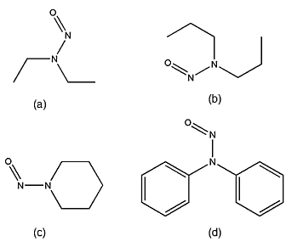

Figure 1. The chemical structures of (a) NDEA, (b) NDPA, (c) NPIP and (d) NDPhA.

Materials and Methods
Reagents
Microporous carbon spheres used in this study were hydrothermally synthesized from sucrose (Sigma-aldrich, 99.5%; EMD Chemicals, ACS grade) and activated using KOH obtained from Merck (Darmstadt, Germany) as described elsewhere [4, 19-21]. All solvents (acetonitrile, methanol, ethanol, dichloromethane, 2- propanol and acetone) were of analytical grade supplied by Sigma Aldrich (Madrid, Spain) and used without further purification. High purity deionized water was obtained from a Milli-DI water purification system (Molsheim, France). Inert PTFE membrane (having pore size of 2 µm and diameter 47 mm) and nylon syringe filter (0.45 µm pore size) were purchased from Membrana (Wuppertal, Germany). Analytical grade nitrosamine standards, N-nitrosodiethylamine (NDEA), N-nitrosodipropylamine (NDPA), N-nitrosopiperidine (NPIP) and N-nitrosodiphynylamine (NDPhA) were supplied by SUPELCO (Bellefonte, PA USA). Stock standard solutions containing 1000 µg/mL of each nitrosamine were prepared in methanol and kept in amber vials at -4ºC in the dark. Standard working solutions were prepared on daily basis by dilution of stock solution in deionized water. Sodium thiosulfate (grade AR) was used as dechlorination agent in real samples.

Chromatographic Conditions
All analyses were carried out on an Agilent 5973 series gas chromatograph controlled by Chemstation software (Hewlett-Packed, Palo Alto, USA). The GC was equipped with MS detector and 30 m × 0.25 mm i.d., 0.15 µm HP-Wax (cross-linked polyethylene glycol) capillary column (Hewlett-Parked, USA). Helium was used as carrier gas at a flow rate of 1 mL/min while the injection port and detector temperatures were kept at 200°C and 280°C, respectively. The oven temperature program was 50°C, held for 1 min; ramped to 100°C at 20°C/min,

held for 0.5 min; ramped to 220°C at 30°C/min, and held for 3 min. The sample injection was splitless mode using an injection volume of 1 µL.

Instrumental
Characterizations including morphology, size and porosity nature of the product were carried out on a Jeol JSM-6390LV scanning electron microscope (SEM) and a transition electron microscope (TEM). The Brunauer-Emmett-Teller (BET) surface area of the material was measured by N₂ adsorption-desorption isotherms after degassing at 110°C using metrometrics ASAP 2010 surface area analyser (Georgia, USA). The surface functional groups were detected by version 5.3 Perkin Elmer FTIR spectrometer with KBr pellets.

Synthesis of Microporous Carbon Spheres (MCS)
In the present work, carbon spheres were prepared from 0.8 mol/L sucrose solution. The solution was sonicated for 5 min and transferred into a 100 mL stainless steel autoclave. The autoclave was heated at 170°C for 5 h in an empty oven. After the hydrothermal reaction, the product formed was allowed to cool to room temperature and then centrifuged at 3500 rpm for 5 min. A black precipitate was collected and washed five times each with absolute ethanol and deionized water. The washed precipitate was finally dried at 90°C overnight which resulted in black solid particles recognized to be carbon spheres (CSs). The synthesized carbon spheres were activated using KOH (2.0 mol/L) through pyrolysis. In this case, 0.15 g of CSs was mixed with 2.0 mL of the prepared KOH solution in a combustion boat and positioned at the center of a combustion tube. The pyrolysis was performed in a tube furnace maintained at 450°C for 1 h under flowing nitrogen. After the pyrolysis, the tube furnace was allowed to cool to room temperature in the flowing nitrogen environment. The cooled product was washed several times with deionized water until pH 7 and finally dried in oven at 110°C overnight to obtain the microporous carbon spheres (MCS).

Sample Collection
Two water samples namely tap water and lake water were sourced and used to evaluate the method. The samples were collected directly from flowing tap located in the Faculty of Science, and at the Universiti Teknologi Malaysia lake Johor Bahru campus. The lake-water was collected at approximately a depth of 0.5 m from the center using pre-cleaned 1-L amber bottle. Tap water was opened and allowed to flush at high flow rate for at least 2 min to stabilize the temperature. Collection of the tap water sample was made after reducing the flow rate in a separate 1-L pre-cleaned amber bottle. The samples were transported to the laboratory in ice-packed containers. Upon arrival, 100 mg of sodium thiosulphate was added to each sample as dechlorination agent and stored at -4°C until analysis within five days. Samples were filtered through 0.45 µm syringe filters prior to extraction.

MCS-SPMTE Procedure
The SPMTE procedure was performed as previously reported [22-23]. In the present work, microporous carbon spheres enclosed in a conically designed PTFE-membrane pouch was attached to a 1000-µL capacity pipette tip and immersed in the spiked test sample (Figure 2). The sample was stirred at 1000 rpm for 20 min. At 5 min interval, 600 µL of the spiked sample was slowly withdrawn into the tip, held for 3 s and then released back into the sample vial at approximately the same rate. At the end of the extraction time, the pouch containing the adsorbent was detached from the tip, dried under air stream to remove any residual water and placed in a 500 µL safe-lock tube. Finally, the analytes were desorbed by ultrasonication for 20 min in 100 µL of iso-propanol and 1 µL was injected into the GCMS.

Figure 2. Schematic diagram of MCS-SPMTE setup.

Results and Discussion

Microporous carbon spheres and its porous properties
The scanning electron microscopy (SEM) images of the product before activation (NCS) and after activation (MCS) have confirmed that the products are spherical in shape as shown in Figures 3 (a and b). The presence of some distorted structures were observed (Figure 3b) probably due to the broken carbon spheres during activation and those that were not destroyed appeared to have very rough surfaces due to the formation of pores. A high magnification TEM image (Figure 3c) disclosed clearly the porous nature of the product.
Figure 3. SEM image of NCS (a), SEM image of MCS (b) and TEM image of MCS (c).

From the N₂ adsorption analysis, the BET surface area of the activated carbon spheres was 308 g m⁻² with an average pore size of 1.7 nm which confirmed that the resulting material is microporous in nature. Observation of type I sorption isotherm and an open loop hysteresis which looks more of H4 hysteresis (Figure 4a) have further affirmed the microporous nature of the material. Type I sorption isotherm and open loop hysteresis are often obtained on microporous materials [24]. Figure 4 (b) shows the FTIR spectrum of the microporous carbon spheres. The band at 3789 cm⁻¹ is attributed to the presence of hydroxyl groups (-OH) which resulted from atmospheric moisture. Two other bands identified to be always present on carbon spheres as reported by Deshmukh et al. [25] appeared at 2923 cm⁻¹ and 1620 cm⁻¹ giving information on C-H groups and C=C groups, respectively.

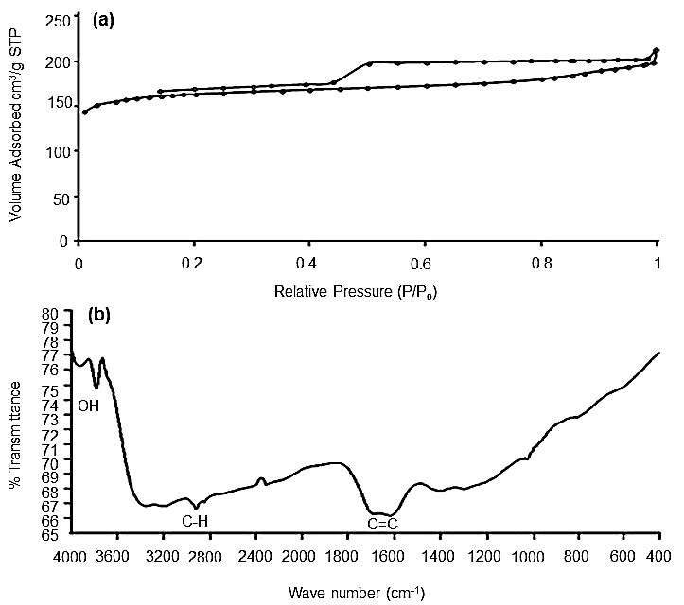

Figure 4. N₂ adsorption-desorption isotherm for MCS (a) and FTIR spectrum for MCS (b).

Optimization of MCS-SPMTE

Conditioning solvent and extraction time
Selection of conditioning organic solvent to ensure consistent interaction between the adsorbent and target analytes is a crucial factor in SPMTE. In this work, solvents of different polarities (dichloromethane, methanol, isopropanol, acetone and acetonitrile) were examined to select the best organic conditioning solvent for the adsorbent. It was found that conditioning of the SPMTE pouch with isopropanol yielded the highest peak area response for all the analytes as compared to other solvents (Figure 5). Therefore, to obtain the best extraction efficiency, isopropanol was used as the conditioning organic solvent in subsequent analyses.

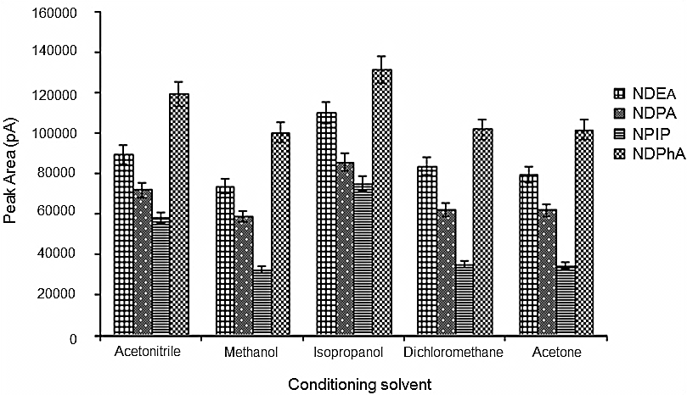

Figure 5. Effect of conditioning organic solvent on MCS-SPMTE of selected N-nitrosamines from spiked deionized water. Legends: NDEA = N-nitrosodiethylamine, NDPA = N-nitrosodipropylamine, NPIP = N-nitrosopiperidine, NDPhA = N-nitrosodiphenylamine. Extraction conditions: 1 µg/mL of spiked water sample; amount of MCS = 3 mg; extraction time: 20 min; sample volume: 20 mL; desorption solvent: 100 µL isopropanol; desorption time: 20 min; (peak areas were determined on the basis of average values of peak area of target analytes, n = 3). Error bars represent standard deviation of results, n = 3.

Different extraction times in the range of 5 - 25 min were examined to configure the time at which equilibrium is reached. Highest extraction efficiency was achieved at 20 min (Figure 6). There was constant increase of extraction efficiency from 5 up to 20 min suggesting continuous mass transfer of the analytes. The decrease in the peak area at 25 min could be due to saturation of the analyte on the adsorbent which occasionally results in back extraction.

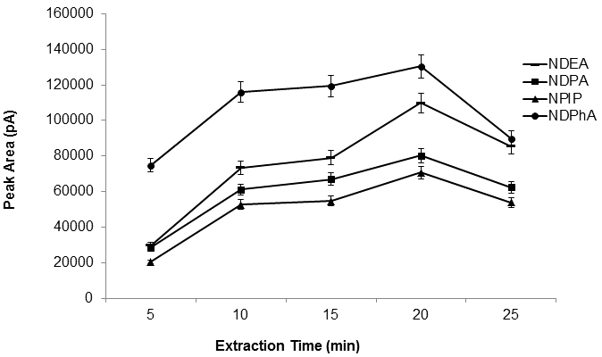

Figure 6. Effect of extraction time on MCS-SPMTE of selected N-nitrosamines from spiked deionized water. Legends and MCS-SPMTE conditions are as in Figure 5 with isopropanol as conditioning solvent.

Salt addition and Sample pH
Addition of salt affects the ionic strength of the sample solution as well as the solubility of target analytes. The effect of salt addition on the extraction efficiency was evaluated by adding NaCl from 0 - 10% (w/v) into the sample solution. It was observed from Figure 7 that the peak areas of the analytes attained highest values when no NaCl was added. Addition of salt did not indicate any positive effect on the extraction efficiency but rather a decrease was noticed. Therefore, no salt addition was employed throughout subsequent extraction. The decrease in extraction efficiency upon addition of NaCl could be due to the inhibitory effect of chloride ions on the formation of volatile nitrosamines at pH values higher than 4.0 as described by Hilldrum [26].

Figure 7. Effect of salt addition on MCS-SPMTE of selected N-nitrosamines from spiked deionized water. Legends and MCS-SPMTE conditions are as in Figure 5.

The pH of a solution can be changed to enable the analytes to exist in their molecular or ionic forms for effective extraction. The pKa values of the target analytes involved in this study were approximately 3.5 and hence can be easily extracted at pH 5.5 or above. Different pH conditions ranging from 2.5 to 10.5 were examined. Highest extraction efficiency was noticed at pH 6.5 (Figure 8) and thus, pH 6.5 was selected as the optimum pH value and used in subsequent analyses.

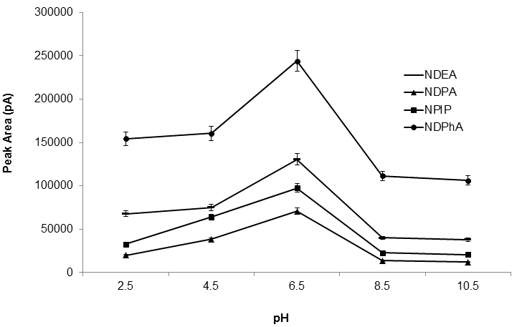

Figure 8. Effect of sample pH on MCS-SPMTE of selected N-nitrosamines from spiked deionized water. Legends and MCS-SPMTE conditions are as in Figure 5

Desorption time, desorption solvent and sample volume
Desorption was carried out by ultrasonication at 5, 10, 15, 20, and 25, min. It was observed that desorption time of 20 min produced the highest peak area responses (Figure 9). No further increase in peak area was observed at desorption time of above 20 min and therefore 20 min was selected and used in subsequent extractions.

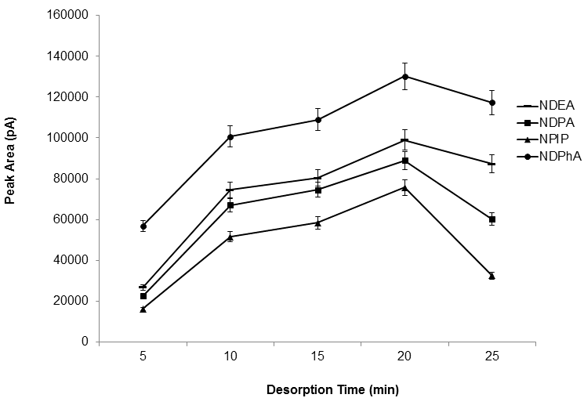

Figure 9. Effect of desorption time on MCS-SPMTE of selected N-nitrosamines from spiked deionized water. Legends and MCS-SPMTE conditions are as in Figure 5.

Five different solvents with different relative polarities namely methanol (0.762), acetonitrile (0.460), acetone (0.355), isopropanol (0.546) and dichloromethane (0.309) were tested as desorption solvents. Being polar in nature, nitrosamines should be better desorbed by a solvent having higher relative polarity than those with lower values. In this case, best extraction efficiency was achieved using isopropanol with relative polarity value of 0.546 (Figure 10).

Figure 10. Effect of desorption solvent on MCS-SPMTE of selected N-nitrosamines from spiked deionized water. Legends and MCS-SPMTE conditions are as in Figure 5.

Sample volume is another important extraction parameter in SPMTE. A series of sample volumes ranging from 5 to 25 mL spiked at 1 µg/mL was investigated. Recovery was highest using sample volume of 20 mL while 5 mL of sample volume gave the lowest recovery. Generally, lower sample volumes resulted in poorer recoveries possibly due to non-saturation of the adsorbent at these volumes (5-15 mL).

Figure 11. Effect of sample volume on MCS-SPMTE of selected N-nitrosamines from spiked deionized water. Legends and MCS-SPMTE conditions are as in Figure 5.

Method Validation
In order to validate the applicability of the described MCS-SPMTE technique, detection characteristics (linear response range; limits of detection, LODs; limits of quantification, LOQs; and precision) of the optimized method coupled with GCMS were investigated. Table 1 indicated a linear range of 10 - 100µg/L for all the analytes with correlation coefficients in the range of 0.9984 - 0.9994. The LODs, defined as a signal/noise (S/N) ratio of 3 obtained were in range of 3.2 - 4.8 µg/L, while the LOQs, calculated as S/N ratio of 10 were in the range of 10.9 - 15.9 µg/L.

Table 1. Analytical Performance of MCS-SPMTE method
 |  |  |  | MCS-SPMTE
Analyte |  | Linear range (µg/L) |  | r² LOD (µg/L) LOQ (µg/L)
NDEA |  | 10 - 100 |  | 0.9994 3.2 10.9
NDPA |  | 10 - 100 |  | 0.9988 4.8 15.9
NPIP |  | 10 - 100 |  | 0.9984 4.3 14.5
NDPhA |  | 10 - 100 |  | 0.9987 4.5 15.0

To investigate the precision of the method, precision tests were conducted using 10, 50 and 100 µg/L spiked deionized water (Table 2). The results indicated good RSDs of ≤ 9% (n = 3) for all the analyses carried out.

Table 2. Precision of MCS-SPMTE for selected N-nitrosamines in spiked deionized water at low, medium and high analyte concentrations
Analyte | %RSD ( n = 3) Analyte concentration
Analyte | 10 µg/L | 50 µg/L | 100 µg/L
NDEA | 4.8 | 5.1 | 3.9
NDPA | 3.6 | 1.9 | 1.7
NPIP | 4.5 | 3.3 | 0.8
NDPhA | 2.5 | 2.2 | 8.9

Method Application
The MCS-SPMTE method combined with GCMS was applied to the analysis of nitrosamines in tap and lake water samples. Analysis of blank samples indicated negative results for nitrosamines in both samples. Typical chromatograms obtained for blank (a) and spiked (b) water samples are shown in Figure 12. The analytical performance of the optimized MCS-SPMTE, method was assessed in terms of percent recovery using spiked tap and lake water samples (Table 3).

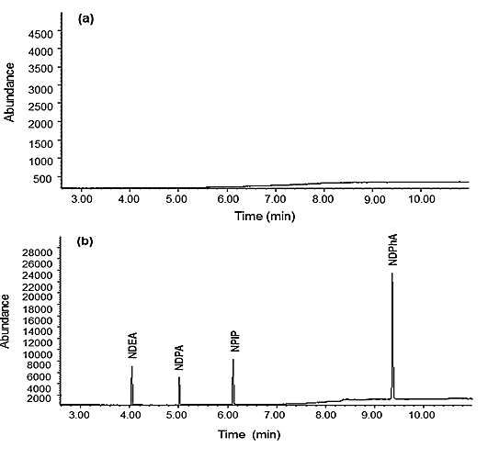

Figure 12. GCMS chromatograms for blank water sample (a) and water sample spiked with 1 µg/mL each of NDEA, NDPA, NPIP and NDPhA (b). GCMS conditions: HP-Wax with cross-linked polyethylene glycol capillary column (30 m × 0.25 mm I.D. × 0.15 µm particle size), helium carrier gas at a flow rate of 1 mL/min, injection volume of 1 µL (splitless mode) at oven temperature program as follows: 50°C, held for 1 min; ramped to 100°C at 20°C/min, held for 0.5 min; ramped to 220°C at 30°C/min, and held for 3 min.

Table 3. MCS-SPMTE recoveries (% RSD, n = 3) of N-nitrosamines spiked to water samples at 10 µg/L levels
 |  | Tap water |  | Lake water
 |  | Spiked concentration |  | Spiked concentration
N-nitrosamine |  | 10 µg/L |  | 10 µg/L
NDEA |  | 107.5 (1.8) |  | 100.2 (2.7)
NDPA |  | 85.0 (2.0) |  | 83.2 (2.2)
NPIP |  | 95.6 (0.5) |  | 93.8 (1.5)
NDPhA |  | 104.1 (2.7) |  | 102.8 (1.5)

Conclusions
In the present study, a suitable and effective adsorbent, MCS, has been successfully prepared and utilized in the development of a simple microextraction technique termed MCS-SPMTE for the quantitative analysis of nitrosamines in aqueous matrices. The developed method has shown acceptable precision and satisfactory recoveries of nitrosamines in water samples. The eco-friendly nature and use of small amounts of adsorbent and solvent have made MCS-SPMTE to be a good alternative microextraction method for the analysis of nitrosamines in water.

Acknowledgements
The authors would like to thank Universiti Teknologi Malaysia and the Ministry of Education Malaysia (MOE) for financial supports through Research Grant Vote Number Q.J130000.2526.03H79 and Bayero University, Kano, Nigeria for studentship for M.S. Musa.

References

1. Tang, S., Tang, Y., Vongehr, S., Zhao, X. and Meng, X. (2009). Nanoporous carbon spheres and their application in dispersing silver nanoparticles. Appl. Surf. Sci., 255(11): 6011-6016.
2. Auer, E., Freund, A., Pietsch, J. and Tacke, T. (1998). Carbon as supports for industrial precious metal catalysts. Appl. Catal A., 173: 259-271.
3. Chen, J., Xia, N., Zhou, T., Tan, S., Jiang, F. and Yuan, D. (2009). Mesoporous Carbon Spheres: Synthesis, Characterization and Supercapacitance. Int. J. Electrochem, Sci., 4: 1063-1073.
4. Li, M., Li, W. and Liu, S. (2011). Hydrothrmal synthesis, characterization, KOH activation of carbon spheres from glucose. Carbohydr. Res., 346: 999-1004.
5. Wang, Q., Li, H., Chen, L., and Huang, X. J. (2001). Monodispersed hard carbon spherules with uniform nanopores. Carbon, 39: 2211-2214.
6. Discher, B. M., Won, Y. Y., Ege, D. S., Lee, J. C. M., Bates, F. S. and Discher, D.E. (1999) Polymersomes: tough vesicles made from diblock copolymers. Science, 284: 113–115.
7. Meier, W. (2000). Polymer nanoparticles. Chem. Soc. Rev., 29: 295–303.
8. Sun, N., Sun, C., Liu, H., Liu, J., Stevens, L., Drage, T., Snape, C.E., Li, K., Wei, W. and Sun, Y. (2013). Synthesis, characterization and evaluation of activated spherical carbon materials for CO2 capture. Fuel, 113: 854-862.

9. Konicki, W., Cendrowski, K., Chen, X. and Mijowska, E. (2013). Application of hollow mesoporous carbon nanospheres as an high effective adsorbent for the fast removal of acid dyes from aqueous solutions. Chem. Eng. J., 228: 824-833.
10. Jenskin, S. W., Koester, C. J., Taguchi, V. Y., Wang. D. T., Palmentier, J. P. and Hong, K .P. (1995). N-nitrosodimethylamine in drinking water using a rapid, solid-phase extraction method. Environ. Sci. Pollut. Res., 2(4): 207-210.
11. Afonso Perea, A. M. (2006). Chromatographic Analysis of the Environment, Nollet (Ed.).; CRC Press: Boca Raton.
12. Robinson, B. (2003). Nitrosamine solutions. Robacchemicals, west bromwick B70 0AH UK. 1-10. Ref: 03/2003.
13. Krauss, M., Longree, P., Dorusch, F., Ort, C. and Hollender, J. (2009). Occurrence and removal of N-nitrosamines in wastewater treatment plants. Water Res., 43(17): 4381-4391.
14. Mitch, W. A., Gerecke, A. and Sedlak, D. L. (2003). A N-Nitrosodimethylamine (NDMA) precursor analysis for chlorination of water and waste water. Water Res., 37: 3733-3741.
15. Rosenberg, I. E., Gross, J. and Spears, T. (1980). Analysis of nitrosamines in cosmetic raw materials and finished product by high pressure liquid chromatography. J. Soc. Cosmet. Chemists, 31: 237-252.
16. Grebel, J.E., Young, C. C. and Suffet, I. H. (2000). Solid phase microextraction of N-nitrosamines. J. Chromatogr. A., 1117: 11-18.
17. Boyd, J. M., Hrudey, S. E. Richardson, S. D. and Li, X. F. (2011). Solid phase extraction and high performance liquid chromatography mass spectrometry analysis of nitrosamines in treated drinking water and wastewater. Trends in Anal. Chem., 30(9): 1410-1421.
18. Nawrocki, J. and Andrzejewski, P. (2011). Nitrosamines and water. [Review]. J. Hazard. Mater., 189(1-2): 1-18.
19. Ryu, J., Suh, Y., Suh, D. J. and Ahn, D. J. (2010). Hydrothermal preparation of carbon microspheres from mono-saccharides and phenolic compounds. Carbon, 48(7): 1990-1998.
20. Chen, J., Xia, N., Zhou, T., Tan, S., Jiang, F. and Yuan, D. (2009). Mesoporous Carbon Spheres: Synthesis, Characterization and Supercapacitance. Int. J. Electrochem. Sci., 4: 1063-1073.
21. Lillo-Ro´denas, M. A., Cazorla-Amoro´s, D. and Linares-Solano, A. (2003). Understanding chemical reactions between carbons and NaOH and KOH An insight into the chemical activation mechanism. Carbon, 41: 267–275.
22. See, H. H., Sanagi, M. M., Ibrahim, W. A. and Naim, A. A. (2010). Determination of triazine herbicides using membrane-protected carbon nanotubes solid phase membrane tip extraction prior to micro-liquid chromatography. J. of Chromatogr. A., 1217(11): 1767-1772.
23. Yahaya, N., Sanagi, M. M., Nur, H., Ibrahim, W. A., Kamaruzaman, S. and Aboul-Enein, H. Y. (2014). Solid-phase membrane tip extraction combined with liquid chromatography for the determination of azole antifungal drugs in human plasma. Anal. Methods, 6: 3375-3381.
24. Lowell, S., Shields, J. E., Thomas, M. A. and Thommes, M. (2004). Characterization of porous solids and powders: Surface area, pore size and density, 4thEd.; Springer: Dordrecht, The Netherlands.
25. Deshmukh, A. A., Mhlanga, S. D. and Coville, N. J. (2010). Carbon spheres. Mat. Sci. Engr. R., 70(1-2): 1-28.
26. Hildrum, K. I. (1975). Formation of N-nitrosamines from the nitrosation of spermidine and spermine. Doctor of Philosophy (Ph.D.) thesis, Oregon State University, Corvallis. http://hdl.handle.net/1957/27257

