

EFFECT OF PH BUFFER ON SELF-HEALING HYDROGEL

(Kesan Penggunaan Larutan Penimbal pH Terhadap Swa Pemulihan Hidrogel)

N.A. Sirajuddin, M.S. Md Jamil*, M.A.S. Mat Lazim

School of Chemical Sciences and Food Technology,
Faculty Science & Technology,
Universiti Kebangsaan Malaysia, 43600 UKM Bangi, Selangor, Malaysia

*Corresponding author: suzeren@ukm.edu.my

Received: 8 December 2014; Accepted: 14 January 2015

Abstract
Autonomous healing of damage is a common phenomenon in living organisms but is hardly ever encountered in synthetic materials. Disulﬁde chemistry is used to introduce a self-healing ability in a covalently cross-linked hydrogel. This result is achieved by introducing disulﬁde groups in the network that are able to exchange, leading to renewal of cross-links across the damaged surfaces. ATR results showed that C=C had disappeared once the gel was formed and the percentage of gel fraction is 86%. The gel being cut shows highest healing efficiency in borax-sodium hydroxide buffer (pH 10) which is 95%. The combination of this unique self-healing properties and applicability for a large variety of polymers makes this approach ideal for biomedical applications.

Keywords : disulfide bond, basic medium, self-healing hydrogel

Abstrak
Pemulihan autonomik ke atas sebarang kerosakan atau kecederaan merupakan suatu fenomena yang berlaku pada organisma hidup tetapi sukar untuk diaplikasikan pada bahan sintetik. Keupayaan swa pemulihan dapat dicapai dengan menggunakan ikatan kovalen dinamik iaitu ikatan disulfida ke dalam suatu jaringan polimer. Ini kerana ikatan disulfida berupaya untuk putus dan cantum sekaligus dapat membawa kepada pembentukan semula taut silang pada permukaan yang terjejas. Hasil daripada ATR menunjukkan puncak C=C pada monomer telah hilang apabila gel sudah terbentuk dan peratusan keberhasilan gel adalah sebanyak 86%. Keberkesanan pemulihan paling tinggi adalah pada gel yang telah direndam dalam larutan penimbal borax-natrium hidrosida (pH 10) iaitu sebanyak 95%. Gabungan uniq antara ciri-ciri swa pemulihan dan kebolehupayaan tinggi dalam swa pemulihan menjadikan hidrogel ini amat sesuai untuk digunakan dalam aplikasi bioperubatan.

Kata kunci: Ikatan disulfida, medium alkali, swa pemulihan hidrogel

Introduction
Recent years have witnesses an increasing interest in the development of “smart materials” that can sense changes in their environment. Consequently, “smart materials” have been developed in order to deliver longer product life spans and reduced maintainance and life-cycle costs which it is able to detect damage and repair themselves accordingly, in a controlled fashion with minimum possible human intervention [1-6]. Several concepts have been developed to provide the self-healing property to the material, such as microcapsule based systems, microvascular systems and nonareservoirs [7]. Composite systems often require the contact of the crack to the nano/microdomains that contain a crosslinker, catalyst or monomer and initiates a polymerization that blocks or heals the crack. However, the irreversible systems can heal only once, which is a potential drawback. Therefore, there is an increasing interest on reversible systems which can break and heal repeatedly upon external stimuli [8].

Polymer gels are considered as a potential “smart” or “intelligent” matter with a specific stimuli-responsive performance. The stimulus includes sovent composition, pH, temperature, addition of salts, electric field, light irradiation, and so forth [9]. Early 2012, Phadke and his colleague demonstrated the permanently cross-linked hydrogels by using A6ACA as a model systems can be engineered to exhibit self-healing in an aqueous environment. They achieve this feature by arming the hydrogel network with flexible-pendant side chains carrying an optimal balance of hydrophilic and hydrophobics moities that allows the side chain to mediate hydrogen bonds across the hydrogel interfaces with minimal steruc hindrance and hydrophilic collapse. In their cases, the healable hydrogel is highlu pH dependent with strong healing observed below pH 3, weak healing at pH 4 and no healing above pH 4.5. This indicates that only highly protonated hydrogels are capable of healing if hydrogen bonding is involves [10].

Deng et al. [11] have prepared the hydrogel by combining acylhydrazone and disulfide bonds together in the same system. The hydrogel can automatically repair damage to it under both acidic (pH 3 and 6) and basic (pH 9) conditions through acylhydrazone exchange or disulfide exchange reactions. Disulfide bond firmation is usually favored at basic pH, and the presence of an oxidizing agent such as oxidized glutathion increases the rate or oxidative folding, whereas the presence of denaturants such as urea or guanidine hydrochloride (GdnHCl) hampers the folding process [12].

In the present study, a covalently crosslinked cystine hydrogel was prepared, and reducible decomposition of hydrogels in the physical condition was assessed. The effects of pH buffer that can healed the damage poly(HEMA) hydrogel was investigated. The redox-responsive by using reducing and oxidizing agents of poly(HEMA) hydrogel will be revealed in another report. These work is a promising as a unique materials that can encourage the biomedical and tissue engineering field to be more developed in the future.

Materials and Methods
Materials and Sample Preparation
Monomer 2-hydroxyethyl methacrylate (HEMA) with Mw 130.14 g/mol, potassium persulfate, (KPS ACS reagent with Mw 270.32 g/mol), L-cystine (with Mw 240.30 g/mol), N’, N’- Methylenebis(acrylamide) (MBA) (with Mw 154.17 g/mol), and solvent dimethyl sulfoxide (DMSO with Mw 78.13 g/mol) were purchased from Sigma Aldrich (Malaysia). Buffer solution were purchased from R&M Chemicals; Phthalate (pH 4.00 ± 0.02 at 20ºC), Phosphates (pH 7.00 ± 0.02 at 20ºC and Borax-Sodium Hydroxide (pH 10.00 ± 0.05 at 20ºC). All chemicals were used as received.

The hydrogel were prepared in aqueous solutions at 22 ºC in the presence of 0.09 M KPS initiator, 4 M HEMA monomer and 0.04 M L-cystine cross-linker. The reaction was carried out in the beaker and the solution was then poured into petri dish. The polymerization was conducted at 45 ºC for 5 hours. Hydrogel without disulfide cross-linker was prepared using the same procedure but different in concentration of cross-linker; 0.05 M MBA.

Healing Procedure
Both samples which gel with and without disulfide cross-linker was cut into two pieces using scissors and two halves from each of the original hydrogels were put together rapidly to have their freshly created fracture surfaces brought into contact. Then, each sample was soaked in each buffer medium (without pH, Phthalate, Phosphates and Borax-Sodium Hydroxide) for 24 hours at room temperature. These healing procedure experiments were totally done in the same size of petri dish.

Determination of gel fraction
Freshly prepared hydrogels was dried to a constant weight in a convection oven at 60ºC. Dried hydrogels were then extracted at room temperature in DMSO /distilled water for 2 days. The extraction process was done to remove any sol that may be present in the hydrogel. The extracted hydrogels were then dried again in the oven at 60ºC until a constant weight is achieved. The percent (%) of gel fraction was calculated using the equation as below (equation 1):

$\frac{G_{d}}{G_{0}}x 100$ (1)
where G₀ is the dried initial weight before extraction and G_{d} is constant dried weight of hydrogels after extraction [13].

Mechanical measurement
The dried gel was cut into dumbbell shape and was tested with Testometric M500-50CT Universal Testing Machine. Tensile test were performed on gel before and after healing condition. The load cell used was 10 kN with speed 15 mm/min. This mechanical testing was done on 5 samples for each condition. Dimension with all length ratios used confirm to the standard of American Society for Testing and Materials [14]. In order to evaluate the healing behaviour quantitatively, healing efficiency can be expressed as the percentage ratio of stress, R(σ), before and after healing as shown in equation 2 [15].

$R\left(σ\right)= \frac{σ_{healed}}{σ_{initial}} x 100$ (2)

Rheological measurement
The temperature sweep measurement were performed on Anton Paar Rheoplus/32 Rheometer with oscillatory measurements at 1 Hz, while the temperature was increased at the rate of 5 ºC/min between 25-120 ºC and the thickness dimension used was 1 mm.

Morphological study
Photos for self-healing hydrogel with and without disulfide in each condition were taken accordingly.

Results and Discussion
A self-healing system in hydrogel materials was achieved by bonding and de-bonding of disulfide bond by direct attack of the hydroxyl groups that presence in the pH buffer. This system based on cross-linked hydrogel of poly(2-hydroxyethyl methacrylate) was prepared.

Gel Fraction
Crosslinking of poly(HEMA) hydrogel involves two possible reactions which are free radical polymerization and condensation process. Based on ATR spectrum, free radical polymerization was confirmed to be occur in this study since the C=C peak from monomer had disappeared when hydrogel was formed [16]. Further investigation was done to know the percentage of gel fraction. Percentage of gel fraction for this study is 86% which is considerably high thus approved the crosslinking of poly(HEMA) hydrogel.

Buffer effect on thiol-disulfide interchange reactions
Buffers used to formulate proteins should not serve as substrates or inhibitors. They should exhibit little or no change in pH with/without temperature, show insignificant penetration through biological membranes, and have maximum buffer capacity at a pH where the protein exhibits optimal stability [17]. In this study, buffer at certain pH must be able to heal the cut surface of poly(HEMA) hydrogel.

From Figure 1, the Tg of poly(HEMA) hydrogel seems to be decreased. The glass transition temperature of hydrogel without soaked in any buffer is at 49ºC. Meanwhile, after soaked with phthalate, phosphate and borax buffer, the Tg is decreased to 47.8ºC, 45.6ºC and 41.2ºC, respectively [17-20].

The Tg depends on molecular weight, side branches, steric hindrance, covalent and noncovalent bonding (disulfide bonding, hydrogen bonding, hydrophobic interactions) within the molecular ratio of amorphous and crystalline regions, presence of plasticizer, copolymers and other physical conditions such as pressure [21]. In this case, the decreasing in Tg might due to the degradation of disulfide bond thus affected degree of cross-linking which closely related to the Tg value.
Besides, the water presence in the buffer can be one of the Tg value decreaes as moisture played an important role in lowering the temperature at which the networking reaction occurs. The plasticizing effects of water is known to enhance the mobility of the amorphous molecules. It appears that moisture facilitates the initiation of the reaction at a given temperature, but once th ereaction occurs, the degree of cross-linking is independent of moisture content [22].

a)
b)
47.8ºC

49ºC

d)
c)
41.2ºC
45.6ºC
Figure 1. The Tg of poly(HEMA) hydrogel after being tested a) without any buffer solution and soaked with b) phthalate buffer (pH 4), c) Phoshate buffer (pH 7) and d) Borax-Sodium hydroxide buffer (pH 10).

Role of base medium buffer on self-healing poly(HEMA) hydrogel
Deng and his colleagues [11] claimed that disulfide bond demonstrated the hydrogel self-healable under basic condition. In this study, poly(HEMA) hydrogel shows the highest percentage of healing efficiency in borax-sodium hydroxide buffer which is a basic medium followed by phosphate buffer (Table 1). This is because chemical degradation of disulfide bonds has been studied in both peptides and proteins with most of the disulfide bond degradation observed under neutral and basic conditions [12].

Table 1. Percentage of healing efficiency at different medium
Medium (buffer) | Maximum Stress (N/mm²) | $$R\left(σ\right)= \frac{σ_{healed}}{σ_{initial}} x 100$$
Without buffer | 0.20 ± 0.63 | 14 %
Phthalate (pH 4) | 0.28 ± 0.19 | 19 %
Phosphate (pH 7) | 0.52 ± 0.20 | 35 %
Borax-Sodium Hydroxide (pH 10) | 1.40 ± 0.10 | 95 %

The tensile test showed that borax-sodium hydroxide buffer which is a basic medium gives the highest percentage of healing efficiency of 95%, with an ultimate tensile strength at 1.40 N/mm², as shown in Figure 2. The results obtained were in agreement with mechanism degradation of disulfide bond described below [12] (Figure 3).

The hydroxyl attack of the disulfide bond produces sulfenic acid and thiolate anion (1, Fig. 3). The thiolate anion 1 can proceed to attack another disulfide bond on another protein molecule to produce a thiolate dimer intermediate 2 (pathway a, Fig. 3). This intermediate (2) undergoes three possible reactions as shown in pathways b, c, and d. In pathway b, intra-molecular nucleophilic attack of the sulfenic acid by the thiolate anion produces dimer 3 with two intermolecular disulfide bonds. Intermediate 2 can form sulfenic acid dimer 4 by abstracting a proton from water (pathway c). Higher molecular weight oligomers such as trimer 5 can be produced via intermolecular disulfide bond reactions utilizing pathway d. The thiolate anion 1 can also undergo an intermolecular reaction between the sulfur atom of the sulfenic acid group and a disulfide in another molecule to produce an intermediate dimer 6, as shown in pathway e. The resulting thiolate 6 oligomerizes by reacting with another protein molecule to generate a trimer 7 (pathway f); further intermolecular reactions lead to higher molecular weight oligomers. Intermediate 6 can also react with water to form a dimer molecule (8) with two free thiols.

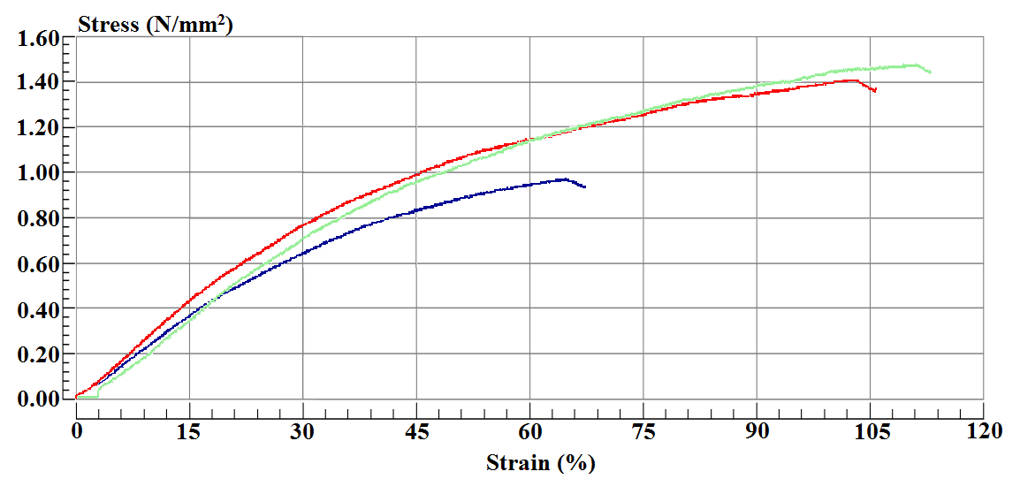
a)
b)
Second healing
First healing
Before healing

Figure 2. a) Pattern of self-healing poly(HEMA) hydrogel in different medium and b) Stress-strain curves of self-healing poly(HEMA) hydrogel in base medium.

Figure 3. The mechanism of degradation of disulfide bonds in homopolymer under neutral and basic conditions. The degradation of the disulfide bond involves a direct attack on the sulfur atom by hydroxyl anions.

Morphological observation
As we have mentioned before, a control hydrogel was prepared to ensure that the self-healing hydrogel via buffer solution were only occur in the presence of disulfide bond. Figure 4 below shows the self-healing poly(HEMA) hydrogel with methylene bis-acrylamide (MBA) as the crosslinker while Figure 5 shows the self-healing with cystine as the crosslinker.

Conditions | Before healing | After healing
Without buffer | 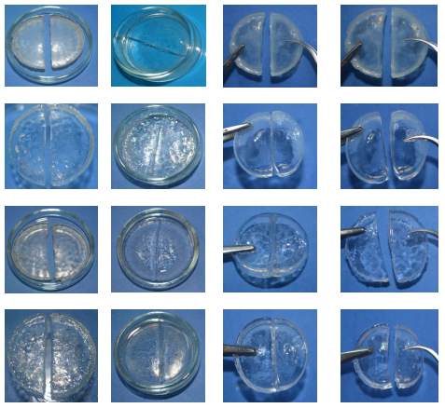
Phthalate buffer
(pH 4)
Phosphate buffer
(pH 7)
Borax-Sodium hydroxide buffer
(pH 10)

Figure 4. Self-healing hydrogel was not occur in every medium tested.

Conditions | Before healing |  | After healing
Without buffer |  | 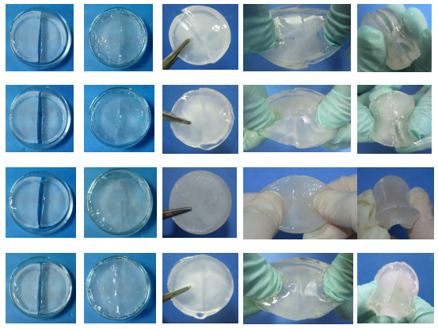
Phthalate buffer
(pH 4)
Phosphate buffer
(pH 7)
Borax-Sodium hydroxide buffer (pH 10)

Figure 5. Presence of the disulfide cross-linker have made the self-healing property is achievable

Conclusion
Self-healable poly(HEMA) hydrogel occur in the basic medium (presence of hydroxyl group) as it displays the highest percentage of healing efficiency (95%) compared to the other medium, along with the best self-healing durability. This study represents a most fundamental level approach to the development of new stimuli-responsive materials. Eventually, this study approach opens the door to the development of new structurally dynamic systems that use a multitude of components designed to work synergistically and lead to the evolution of new, increasingly complex materials behavior and responses.

Acknowledgement
The authors acknowledge the financial support of this study by Government of Malaysia through FRGS/1/2012/SE07/UKM/03/1, GGPM-2012-014 and ERGS/1/2012/TK04/UKM/03/3 grant. The authors also wish to thank the Universiti Kebangsaan Malaysia for the continuous support of this project.

References
- Moulin, E., Cormos, G., & Giuseppone, N. (2012). Dynamic combinational chemistry as a tool for the design of functional materials and devices. Chemical Society reviews, 41(3): 1031–1049.
- Cougon, F. B. L. & Sanders, J. K. M. (2012). Evolution of dynamic combinational chemsitry. Accounts of Chemical Research, 45: 2211–2221.
- Giuseppone, N. (2012). Toward self-constructing materials: A systems chemistry approach. Accounts of Chemical Reseasrch, 45(12): 2178–2188.
- Otto, S. (2012). Dynamic molecular networks: From synthetic receptors to self-replicators. Accounts of Chemical Research, 45(12): 2200–2210.
- Barboiu, M. (2010). Dynamic interactive systems: Dynamic selection in hybrid organic-inorganic constitutional networks. Chemical Communications, 46: 7466–7476.
- Aida, T., Meijer, E. W., & Stupp, S. I. (2012). Functional supramolecular polymers. Science, 335(6070): 813–817.
- Lanzara, G., Yoon, Y., Liu, H., Peng, S., & Lee, W. I. (2009). Carbon nanotube reservoirs for self-healing materials. Nanotechnology, 20(33): 335704.
- Bergman, S. D., & Wudl, F. (2008). Mendable polymers. Journal of Materials Chemistry, 18: 41-62.
- Shibayama, M., & Tanaka, T. (1993). Volume phase transition and related phenomena of polymer gels. Advances in Polymer Science, 109: 1–62.
- Phadke, A., Zhang, C., Arman, B., Hsu, C.-C., Mashelkar, R. A., Lele, A. K., Tauber, M. J., Arya, G., & Varghese, S. (2012). Rapid self-healing hydrogels. Proceeding of the National Academy Science of U.S.A,. 109: 4383−4388.
- Deng, G., Li, F., Yu, H., Liu, F., Liu, C., Sun, W., Jiang, H. & Chen, Y. (2012). Dynamic hydrogels with an environmental adaptive self-healing ability and dual responsive sol-gel transitions. ACS Macro Letters, 1: 275−279.
- Trivedi, M. V., Laurence, J. S., & Siahaan, T. J. (2009). The role of thiols and disulfides on protein stability. Current Protein and Peptide Science, 10: 614-625.
- Mohd Amin, M. C. I., Ahmad, N., Halib, N., & Ahmad, I. (2012). Synthesis and characterization of thermo- and pH-responsive bacterial cellulose/acrylic acid hydrogels for drug delivery. Carbohydrate Polymers, 88: 465-473.
- ASTM D5045-99 (2007). Standard test methods for plane-strain fracture toughness and strain energy release rate of plastic materials. American Society for Testing and Materials.
- Yamaguchi, M., Ono, S., & Okamoto, K. (2009). Interdiffusion of dangling chains in weak gel and its application to self-repairing material. Materials Science Engineering B, 162(3): 189–194.
- Sirajuddin, N. A., Md Jamil, M. S., & Mat Lazim, M. A. S. (2014). Effect of cross-link density and the healing efficiency of self-healing poly(2-hydroxyethyl methacrylate) hydrogel. e-Polymers, 14(4): 289-294.
- Ugwu, S. O., & Apte, S. P. (2004). The effect of buffers on protein conformational stability. Pharmaceutical Technology, 86-113.
- Brownsey, G. J., Noel, T. R., Parker, R., & Ring, S. G. (2003). The glass transition behavior of the globular protein bovine serum albumin. Biophysical Journal, 85: 3943-3950.
- Saluja, A., Badkar, A. V., Zeng, D. L., Nema, S., & Kalonia, D. S. (2007). Ultrasonic storage modulus as a novel parameter for analyzing protein-protein interactions in high protein concentration solutions: Correlation with static and dynamic light scattering measurements. Biophysical Journal, 92: 234-244.
- Reis, J., Sitaula, R., & Bhowmick, S. (2009). Water activity and glass transition temperatures of disaccharide based buffers for desiccation preservation of biologics. Journal of Biomedical Science and Engineering, 2: 594-605.
- Sperling, L. H. Glass-rubber transition behavior in Introduction to Physical Polymer Science. L. H. Sperling, ed. (1986). Wiley Interscience: New York. p. 224-295.
- Madeka, H., & Kokini, J. L. (1996). Effect of glass transition and cross-linking on rheological properties of zein: Development of a preliminary state diagram. Cereal Chemistry, 73(4): 433-438.

