

SOLID STATE SELF-HEALING SYSTEM: EFFECTS OF USING IMMISCIBLE HEALING AGENTS

(Sistem Swa-pemulihan Keadaan Pepejal: Kesan Menggunakan Agen Pemulihan Tidak Larut)

N. N Muhamad and M. J. Mohd Suzeren*

School of Chemical Sciences and Food Technology,
Faculty of Science and Technology,
Universiti Kebangsaan Malaysia, 43600 Bangi, Selangor, Malaysia

*Corresponding author: suzeren@ukm.edu.my

Received: 8 December 2014; Accepted: 14 January 2015

Abstract
The solid state self-healing system was obtained by employs a thermosetting epoxy resin, into which a thermoplastic is dissolved. The aim of this study is to identify the effect of using immiscible healing agents, which are polyvinyl chloride and polyvinyl alcohol, on solid state self-healing system. Healing was achieved by heating the fractured resins to a specific temperature; above their glass transition temperature (Tg) which obtained from dynamic mechanical analysis (DMA) in order for thermal expansion to occur. The thermal properties and bonding formed in the epoxy resins were characterized by means of Fourier Transform Infrared Spectroscopy (FTIR). Izod impact test was performed in preliminary work. Further work then has been done using compact tension test to demonstrate details self-healing capability of the different specimens. Under compact tension test, it was found that healable resin with PVC has highest healing efficiency followed PVA with 7.4% and 3% of average percentage healing efficiencies respectively. These results are due to the different solubility parameters of the thermoset/network and thermoplastic polymer which led to the phase separation. Morphological studies using microscope optic prove the fracture-healing process and morphological properties of the resins.

Keywords: solid state self-healing; healing effieciency; compact tension test; impact test

Abstrak
Sistem swa-pemulihan keadaan pepejal disediakan dengan melarutkan polimer termoplastik dalam resin epoksi termoset. Tujuan kajian ini dijalankan adalah untuk mengenalpasti kesan menggunakan agen pemulihan tidak larut, iaitu polivinil klorida dan polivinil alkohol, ke atas sistem swa-pemulihan keadaan pepejal. Pemulihan telah dicapai dengan memanaskan resin yang telah patah atau retak pada suhu spesifik, iaitu di atas suhu peralihan kaca (T_{g}) yang diperoleh dari analisis mekanikal dinamik (DMA) bagi membolehkan pengembangan terma berlaku. Sifat terma dan ikatan yang terbentuk dalam resin epoksi dicirikan menggunakan Spektroskopi Inframerah Transformasi (FTIR). Ujian impak Izod telah dijalankan dalam kerja permulaan. Ujian tekanan padat telah seterusnya dijalankan bagi mengkaji kebolehan swa-pemulihan specimen yang berbeza dengan lebih terperinci. Hasil daripada ujian tekanan padat, resin pemulihan dengan agen pemulihan PVC menunjukkan keberkesanan pemulihan yang tertinggi diikuti dengan agen pemulihan PVA, dengan masing-masing memiliki purata peratusan keberkesanan pemulihan 7.4% dan 3%. Keadaan ini adalah disebabkan oleh perbezaan parameter kelarutan polimer termoset dan termoplastik yang membawa kepada pemisahan fasa. Pencirian morfologi menggunakan mikroskop optik membuktikan proses patah-pulih dan sifat morfologi resin.

Kata kunci: Swa-pemulihan keadaan pepejal; keberkesanan pemulihan; ujian tekanan padat; ujian impak

Introduction
Advanced thermosetting polymer composites are susceptible to damage induced by mechanical, chemical, thermal, UV radiation, or a combination of these factors [1]. This could lead to the formation of micro cracks deep within the structure where detection and external intervention are difficult or impossible [1-4]. In response, the concept of self-healing polymeric materials was proposed as a mean of healing invisible micro cracks [5]. This self-healing concept or basic mechanism has been inspired from biological systems [6]. Intrinsic systems of self-healing materials possess a latent self-healing functionality that is triggered by damage or by an external stimulus; i.e., heat or intense photo illumination [2, 7, 8]. These materials rely on chain mobility and entanglement, reversible polymerizations, melting of thermoplastic phases, hydrogen bonding, or ionic interactions to initiate self-healing [9]. Because each of these reactions is reversible, multiple healing events are possible.

A solid-state healable system was identified as an alternative technology for intrinsic self-healing system [10-13]. This system employs a thermosetting resin as a matrix of which a thermoplastic is dissolved. Upon healing a fractured resin system, the thermoplastic materials can become mobile above a particular temperature and diffuse throughout the thermosetting matrix. Some chains bridging closed cracks and thereby facilitating healing. The solubility parameters are matched so that the ‘healing agent’ remains uniformly dissolved in the matrix without phase separation [13].

In other studies, Meure and colleagues [14, 15] studied the healable resin with polyethylene-co-methacrylic acid (EMAA) as immiscible healing agent. This healing agent restores strength to the damaged resin via binding within EMAA and between the EMAA and the epoxy resin. The recovery system of healable resin with immiscible healing agent used the ‘brick and mortar’ concept where healing agent act as brick and resin act as mortar. As heating the system, the brick will undergo thermal expansion and viscous ﬂow which leads to healing across the fracture plane in the epoxy resin. Microscopy also showed that small bubbles in the EMAA particles act as a new healing agent delivery mechanism wherein expansion during heating forced larger volumes of healing agent into the damaged region of the resin.

The work reported herein represents the crack-healing study of new linear polymers as immiscible healing agents which are polyvinyl chloride and polyvinyl alcohol, on solid state self-healing using standard epoxy resin. The efficiency for healing damage of the healable resin of each linear polymer was examined.

Materials and Methods
Materials
The matrix system was chosen to be a blend of base thermosetting resin, diglycidyl ether of bisphenol-A (DGEBA) with of 384.36g/mol, cured with nadic methylene anhydride (NMA) and Benzyldimethylamine (BDMA), purchased from Sigma–Aldrich. Stoichiometric ratios of 100.0, 81.2 and 2.0 for epoxy-hardener-catalyst mixture were used. Different linear thermoplastic polymers were used as healing agents, which are polyvinyl chloride with of 43,000 g/mol, and polyvinyl alcohol with of 10,000 g/mol.

Matrix Preparation
8% (w/w) of these linear thermoplastics was dissolved into the DGEBA at 90ºC under stirring for 24 hours. The mixture was a viscous liquid which could be degassed at 90˚C. NMA and BDMA were then blended in the mixture at 90˚C before being degassed again. The degassed resin blend was poured into pre-heated silicone rubber bar moulds to produce Izod impact specimens. The blend was cured 90ºC for 4 hours followed by a postcure at 150ºC for 1 hour.

Solubility Parameter Calculation
The solubility parameter of the healing agents and a model of the NMA-cured diglycidylether of bisphenol A were calculated using the group contribution methodology of Hoy [16] from The Hoy Solubility Parameter Software (Computer Chemistry Consultancy, Germany).

Assessment of Matrix Healing through Mechanical Testing
In preliminary work, Izod impact tests were used to measure the effectiveness of the repairing technique and the efficiency of healing recovery of fractured strength relative to the virgin fracture toughness. Testing of the ability of the matrix to heal was carried out using izod impact testing machine Ray-Ran Test Equipment RR/IMT (RR/MT/100), manual clamping vice with a specimen adapter for ASTM D256. The Izod samples with dimensions 64 mm x 13 mm x 4 mm were made from the mouldings. A notch was introduced using a motorized notching cutter. This cuts a BS standard notch (4 mm) in a single pass which was sharp and reproducible. Under test, these samples were fully broken into two halves. Gentle pressure was applied to ensure that the two faces were in intimate contact and in alignment (Figure 1). The samples have been healed at 160ºC for 6 hours to compare the percentage recovery in impact strength for the healable resin system.

Platform
Force applied to keep it flat
Broken specimen
Screw to keep specimen in intimate contact

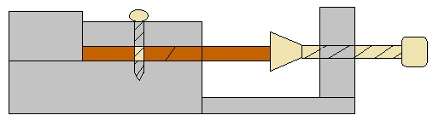
Figure 1. Schematic diagram of the healing platform for the fractured Izod impact specimens.

Testing of the ability of the matrix to heal using compact tension testing was carried out, with samples being prepared according to BS13586:2000 [13], with the dimensions shown in Figure 2. A sharp pre-crack was then created in the samples by gently tapping a fresh razor blade into a machined starter notch. In addition, a 3 mm diameter hole in the plane of the growing crack at 8 mm from the tip of the notch was introduced (Figure 2). This hole will prevent the crack from propagating through the specimen and so prevent complete fracture [12, 17]. The samples were loaded to fracture using a universal testing machine (Instron 5566 model). The tests were carried out using a load cell with a capacity of 10 kN at room temperature (about 23 °C) and a test speed of 10 mm/min. In testing, the compact tension (CT) specimens need to be loaded by means of the two pins through the holes into resin specimen before applying the load for fracture. Samples of the healing resin system were tested, alongside unmodified samples consisting of the resin blend only. The unmodified system was subjected to the same tests as the healing matrix to determine whether any healing eﬀect was truly a result of the thermoplastic addition or not.

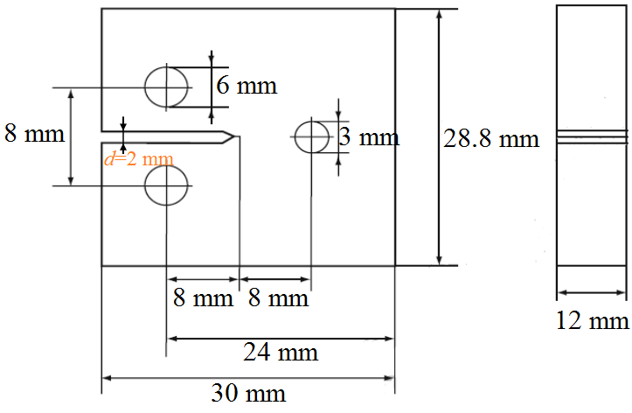

Figure 2. Dimensions of the compact tension test specimens

Under both tests, samples were repeatedly healed and tested throughout the study, to examine the effect of repeated healings on the efficiency of impact strength recovery. Each sample was tested 3 times, making a total of 9 tests at each healing temperature. Considering the qualitative nature of the Izod impact test and compact tension test, the efficiency of impact strength recovery was calculated from the impact energies, R_{E}, equation 1 [12],

(1)

where E_{healed} and E_{initial} are the post-healing and initial impact energies, respectively. R_{E} is the percentage recovery in impact strength. The resin healing efficiency (H_{E}) has been re-estimated from equation (2)[12], where R_{E} and R˚_{E} are the recovery percentage of healable resin and residual healing effect of unmodified DGEBA resin (containing no healing agent) respectively.

(2)

Characterization
ATR spectra were recorded at room temperature using Spectrum ASCII PEDS 400 ATR Spectrometer at range of 4000 - 650 cm⁻¹ to determine the functional group in the resin system. DMTA was performed on a TA Instruments Thermal Analysis DMA 2980 Dynamic Mechanical Analyzer operating in the single cantilever-bending mode at an oscillation frequency of 1Hz with sample specimens dimension 35mm x 15mm x 5mm. Data were collected from room temperature to 180ºC at a scanning rate of 2ºC/min. The morphology of the sample crack surfaces from Izod impact test were observed using optical range microscopy (Axiolab A45090 Image Analyzer) with Zeiss camera.

Results and Discussion
The healing capability of a solid state self-healing system is considered to occur by the diffusion of the linear healing agent in the thermosetting resin to the surfaces of a crack to provide a mechanism for closure [18]. In this study, immiscible healing agents were used to investigate the efficiencies of the healable resins for healing damage in thermoset matrix upon thermal stimulus using thermal expansion mechanism.

FTIR Analysis
The curing reaction in epoxy resin can be observed by infrared spectrum as shown in Figure 3. The spectrum shows that all of the matrixes have been cured. Thus reduce the possibility of future curing that will affect the healing capability of self-healing resin. Throughout all resin system (Figure 3b–d), the opening of the epoxy ring from curing process was expected to reduce the intensity of the asymmetric ring stretching band for the epoxy ring at wavelength of 915 cm⁻¹. The formation of ester group also can be seen at 1730 cm⁻¹ for all healable resins. There were also peaks for hydroxyl (–OH) functional group in the range of 3300-3600 cm⁻¹ in the spectrum of unmodified DGEBA resin (Figure 3b) and healable resins (Figure 3 c,d). The peaks are quite broad and clear for almost cases, indicates the presence of self-associated hydroxyl group. DGEBA-based resins are synthesized via the addition of epichlorohydrine and bisphenol A so oligomers with a relatively narrow distribution of polymerization degrees are obtained instead, where n is typically 0.2. DGEBA oligomers typically contain a certain amount of hydroxyl groups, that play an important catalytic role in the kinetics of the curing process, providing a higher viscosity which is dependent on n [19]. The existence of hydroxyl groups in healable resins are very importance to introduce the self-healing mechanism at crack surface through hydrogen bonding physically.

Glass Transition Temperature (T_{g})
The glass transition temperature (T_{g}) of unmodified DGEBA and healable resins were determined by dynamic mechanical thermal analysis (DMTA). Determination of Tg for each sample are important so that minimal healing temperature can be identified. At this temperature, the linear polymer will start mobilized and diffused to the crack plane [20]. Glass transition temperatures (T_{g}) were defined as the maximum in tan δ. Figure 4(a) shows the DMTA curves for the unmodified DGEBA and healable resins. The T_{g} for unmodified DGEBA resin appeared at 139˚C while for healable resins containing PVC and PVA are 136˚C and 134˚C respectively. The T_{g} of healable resin with immiscible healing agent have been shifted. These values are not considerably dissimilar, and reveal that virtually all the linear thermoplastic is present in the DGEBA resin as a dispersed second phase. Healable resins containing PVC and PVA, T_{g} are significant different compared to the unmodified resin, proving that PVC and PVA are less compatible as linear-healing agent with the cured resin. This is likely because of the different solubility parameter values of the network and thermoplastic polymer (Figure 4(b)). The Hoy Solubility Parameter Software from Computer Chemistry Consultancy, Germany was used to simplify the calculation of solubility parameters using Hoy’s method [16].

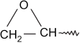
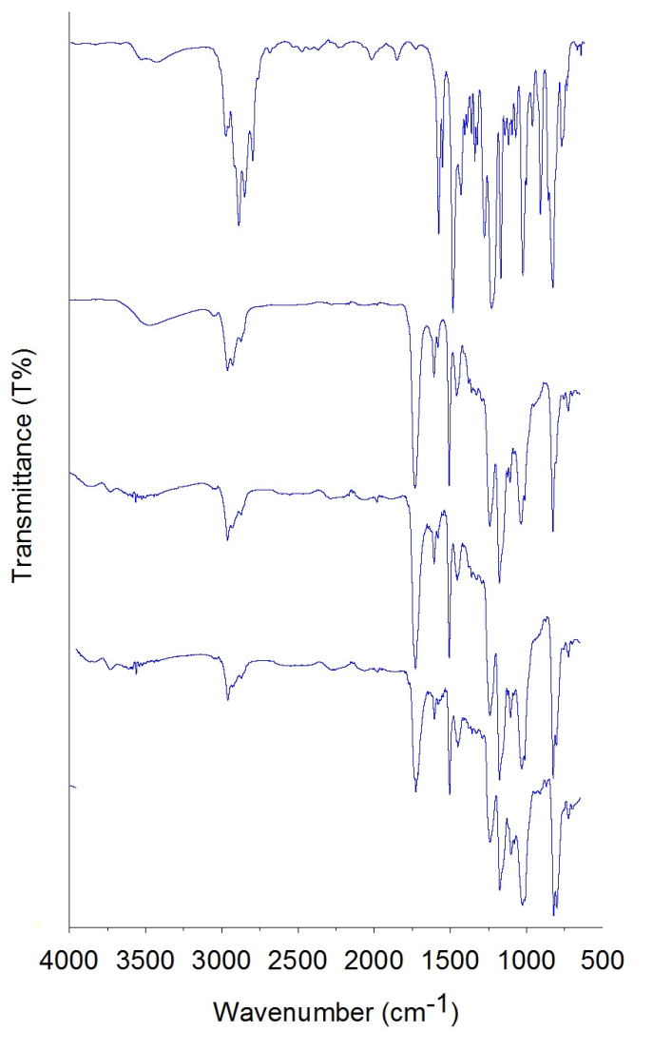
1730 cm⁻¹
Ester group
910 cm⁻¹
3511 cm⁻¹
O-H group

(a)
(d)
(c)
(b)
Figure 3. FTIR spectra of (a) DGEBA (b) unmodified DGEBA resin, (c) healable DGEBA resin containing PVC and (d) healable DGEBA resin containing PVA

Table 1. Summary of Tg and solubility parameter value for each resin
Sample | Tg (˚C) | Solubility Parameter (J/cm³)^{1/2}
Unmodified DGEBA resin | 139 | 21.88
Healable resin (PVC) | 136 | 20.17
Healable resin (PVA) | 134 | 27.05

139˚C
136˚C
134˚C
Figure 4. Dynamical mechanical thermal analysis (DMTA) traces for the NMA-cured bisphenol A epoxy resin of unmodified resin, healable resin containing PVC and healable resin containing PVA

Izod Impact Test
The self-healing efficiencies is calculated based on data from recovery of healable resins. The preliminary work has been done using Izod impact test. The percentage recovery (R_{E}) and percentage of healing efficiency (H_{E}) in Izod impact strength after fracture as a function of the varying healing agent is given in Figure 5.
(a)
(b)

Figure 5. The percentage recovery and percentage of healing efficiency in Izod impact strength (RE) of epoxy resin after healing at 6 hours at 160 ºC (a) The percentage of healing efficiency in Izod impact strength (HE) of epoxy resin after healing at 6 hours at 160 ºC (b)

(a)

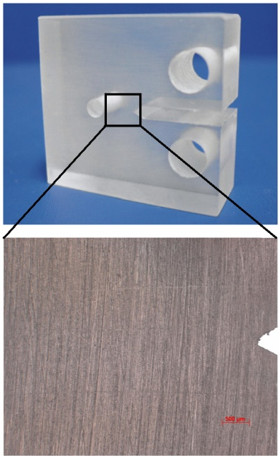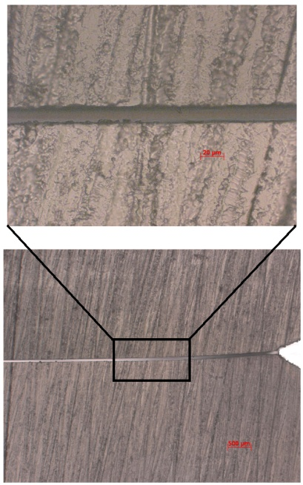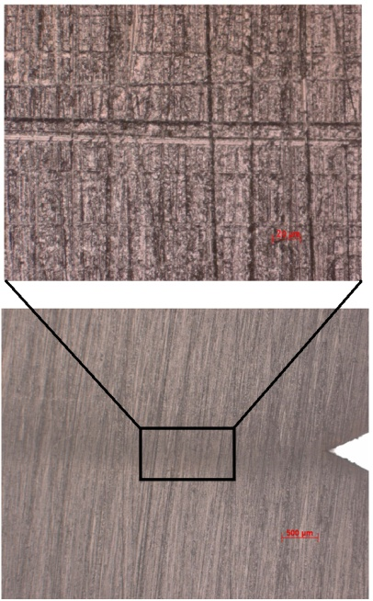

Before
crack
After
crack
After healing
(b)

Figure 6. The percentage recovery and percentage of healing efficiency in compact tension strength (RE) of epoxy resin after healing at 6 hours at 160 ºC (a) The percentage of healing efficiency in compact tension strength (HE) of epoxy resin after healing at 6 hours at 160 ºC (b)

Compact Tension Test
Further work then was done using compact tension test for details study on self-healing capability for both healable resins. Compact tension tests on both the unmodified resin and the modiﬁed healing resin system containing 8% (w/w) of the healing agent gave the load to failure results. From the load to failure results, the percentage recovery (R_{E}) and percentage of healing efficiency (H_{E}) in compact tension strength after fracture in comparison to those obtained from the unmodified resin was calculated as shown in Figure 6. Figure 6 (a) shows that the unmodified resin can be thermally healed to a limited extent after 6 h at 160˚C.

The graph shows a 19.7% recovery in impact strength for the unmodified resin after one healing event. This could be attributed to a slight undercure of the samples in the curing schedule. To compensate for this, the healing efficiency (H_{E}) of healable resins was calculated using equation 2. Thus, H_{E} contribution to healing from the addition of the healing agent can be examined. Figure 6(b) clearly indicated the healing effects of the healed resin-thermoplastic blend specimens calculated from equation 2. For the resin blends containing PVC and PVA as a healing agent, signiﬁcant recovery of the initial compact tension strength was observed after the ﬁrst healing cycle. In these cases, the level of healing efficiency builds for both healable resins containing PVC and PVA for first cycle are 16% and 7% respectively. Subsequent healing cycles lead to signiﬁcant recovery in compact tension strength although at a lower level than for the ﬁrst cycle, with 3.3 and 1% for a second healing and with 2.6 and 1.4% for the third cycle. However, there are a reduction in the healing efficiency of the both healable resins containing PVC and PVA after first healing event. The reason for this decreased recovery is due to the possibility of aging [21-23], and will be explored in further research.

In thermoset/thermoplastic blending system, the healing effect were reasoned by either the diffusion of healing agent to the crack surface upon heat stimulus (above T_{g} temperature) [24] (Figure 7 (a)) or volumetric thermal expansion of healing agent above its melting point in excess of epoxy brick expansion [25].The diffusion system was based on thermal diffusion of a healing agent that affects the entanglements and molecular inter-diffusion within the epoxy resin required for crack closure.

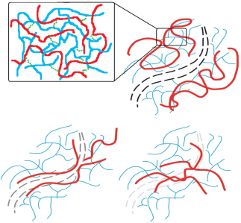
Microfine fracture
Linear healing agent agnetagent
After healing process
Diffusion equilibration by randomisation and crack-closure
Diffusion and surface wetting
Hydrogen bonding
Epoxy resin agent
Upon healing
After crack
Fracture
in epoxy resin
Expansion
of healing agent
Healed
thermoplastic
particle
Mortar
(resin DGEBA)
Brick
(Healing agent)
Before healing process
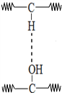
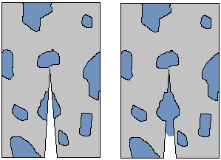

(b)
(a)

Figure 7. (a) Schematic of self-healing mechanism of the solid state healing resin, (b) Schematic of healing mechanism of the solid state healing resin with immiscible healing agent

However, the healable resins containing PVC and PVA show the existence of phase separation, thus it did not considered as homogenous system. The recovery system of healable resin with immiscible healing agent used the concept of ‘brick and mortar’ where healing agent act as brick and resin act as mortar [15]. As heating the system, the brick will undergo thermal expansion and viscous ﬂow which leads to healing across the fracture plane in the epoxy resin as shown in (Figure 7). Based on the impact and compact tension test results obtained, it was shown that PVC and PVA have a limited effect on healing efficiency. An explanation could be that the healing agent is not completely dissolved in the thermosetting DGEBA matrix because of the different solubility parameter value between the matrix and the healing agent. The solubility parameter value for polymeric matrix resin has been found to be 21.88 (J/cm³)^{1/2} while for healing agents PVC and PVA are 20.17 (J/cm³)^{1/2} and 27.05 (J/cm³)^{1/2} respectively. These values are not considerably dissimilar, and reveal that virtually all the linear thermoplastic is present in the DGEBA resin as a dispersed second phase. The phase separation that occurs in the healable resin with immiscible healing agent cause a reduction in the percentage of healing efficiency in the system.

Although phase separation is needed in concept of bricks and mortar that occurs in immiscible system, the distribution of healing agents must be uniformly dispersed. Figure 8 shows the illustration of distribution of healing agent that might be occurs in the system.

Mortar
(matrix resin)

Brick
(healing agent)
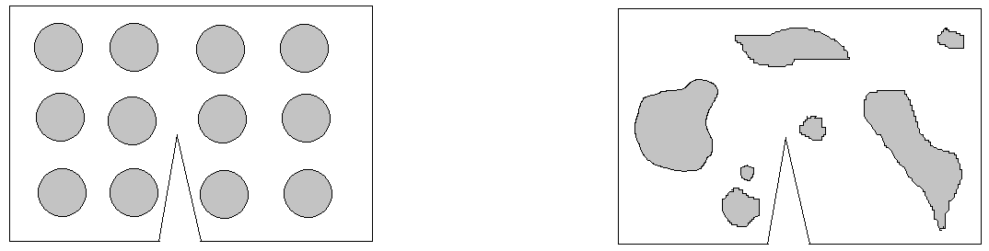
(a) (b)

Figure 8. A relatively uniformly dispersed (a) and irregular shapes and broadly-distribution size of healing agent in the system (b)

The irregular shapes and broadly-distribution size of healing agents in the system somewhat effect the thermal expansion mechanism in the healing process. Thus reduced the healing efficiencies in the system. The different types of distribution of healing agent can be seen based on morphology of the sample with immiscible healing agent as shown in Figure 9.

Microscopy Analysis
Optical microscope was used to investigate the surface morphology of the unmodified and healable resins. The healing capability and the visualization of the fracture-healing process for healable resins were observed through the surface morphology using optical microscopy (Figure 9). Comparing the images of epoxy resin, the crack can be seen clearly in samples that were introduce crack (Fig 9b,e,h) and heating for 6 h causes the crack to virtually disappear (Fig 9c,f,i). The phase separation effect in healable resins of PVC and PVA also can be clearly verified in Figure 9 (d-i).

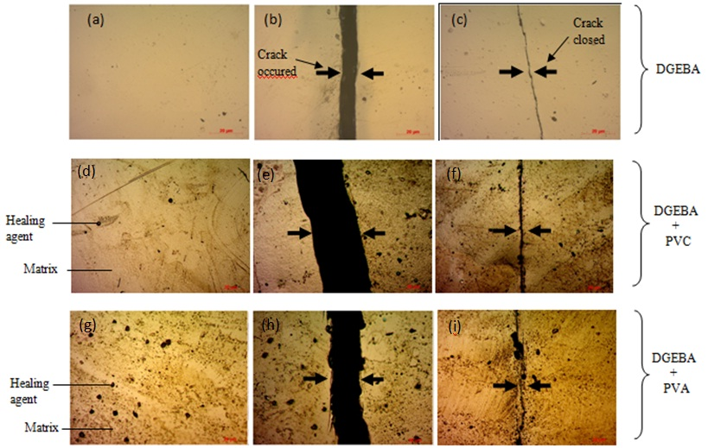
Figure 9. Visualization of the fracture-healing process for unmodified DGEBA resin (a, b, c) and healable resin with PVC (d, e, f) and PVA (g, h ,i). Optical microscopy images of (a, d, g) the surface of the sample before fracture, (b, e, h,) the crack on a completely fractured samples, (c, f, i) the cracked surface after thermal mending

Conclusion
The healing efficiency in a matrix resins by using immiscible healing agents, which are PVC and PVA is attempted. It is clearly that all the healable resins matrix can recover a significant amount of its pre-cracked mechanical properties under a healing cycle but at low efficiency. The results are also repeatable throughout the whole study. From compact tension test results, it was shown that healable resin with PVC has highest healing efficiency followed by PVA with 7.4% and 3% of average percentage healing efficiencies respectively. These results are strongly relates to solubility parameter value of polymeric resin and all healing agents. The healing effect of healable resin with immiscible healing agent is due to the thermal expansion. The reduction in healing efficiency when using immiscible healing agent may be due to the different distribution of the healing agent in the cured matrix.

Acknowledgement
The authors willing to acknowledge the financial support by Government of Malaysia through grant number of FRGS/1/2012/SE07/UKM/03/1, GGPM-2012-014 and ERGS/1/2012/TK04/UKM/03/3. The authors also wish to thank the School of Chemical Sciences and Food Technology, Faculty of Science and Technology, Centre for Research and Instrumentation Management (CRIM), and National University of Malaysia for providing facilities and support of this project.

References
- Pang, J. W. C. & Bond, I. P. (2005). ‘Bleeding composites’—damage detection and self-repair using a biomimetic approach. Composites Part A: Applied Science and Manufacturing, 36 (2): 183-188.
- Wu, D. Y., Meure, S., & Solomon, D. (2008). Self-healing polymeric materials: A review of recent developments. Progress in Polymer Science, 33 (5): 479-522.
- Astrom, B. T., Manufacturing of polymer composites. 1997: CRC Press.
- Charalambides, M., Hardouin, R., Kinloch, A., & Matthews, F. (1998). Adhesively-bonded repairs to fibre-composite materials I. Experimental. Composites Part A: Applied Science and Manufacturing, 29 (11): 1371-1381.
- Jud, K., Kausch, H. H., & Williams, J. G. (1981). Fracture mechanics studies of crack healing and welding of polymers. Journal of Materials Science, 16 (1): 204-210.
- Trask, R. S., Williams, H. R., & Bond, I. P. (2007). Self-healing polymer composites: mimicking nature to enhance performance. Bioinspiration & Biomimetics, 2 (1): 1-12.
- Kalista, S. J. & Ward, T. C. (2007). Thermal characteristics of the self-healing response in poly(ethylene-co-methacrylic acid) copolymers. Journal of The Royal Society Interface, 4 (13): 405-411.
- Murphy, E. B. & Wudl, F. (2010). The world of smart healable materials. Progress in Polymer Science, 35 (1–2): 223-251.
- Blaiszik, B. J., Kramer, S. L. B., Olugebefola, S. C., Moore, J. S., Sottos, N. R., & White, S. R. (2010). Self-Healing Polymers and Composites. Annual Review of Materials Research, 40.
- Hou, L. & Hayes, S. (2002). A resistance-based damage location sensor for carbon-fibre composites. Smart Materials and Structures, 11 (6): 966.
- Hayes, S. A. & Jones, F. R., Self healing composite materials, in UK Patent Application 2004.
- Hayes, S. A., Zhang, W., Branthwaite, M., & Jones, F. R. (2007 b). Self-healing of damage in fibre-reinforced polymer-matrix composites. Journal of The Royal Society Interface, 4 (13): 381-387.
- Hayes, S. A., Jones, F. R., Marshiya, K., & Zhang, W. (2007 a). A self-healing thermosetting composite material. Composites Part A: Applied Science and Manufacturing, 38 (4): 1116-1120.
- Meure, S., Varley, R. J., Wu, D. Y., Mayo, S., Nairn, K., & Furman, S. (2012). Confirmation of the healing mechanism in a mendable EMAA–epoxy resin. European Polymer Journal, 48 (3): 524-531.
- Meure, S., Wu, D. Y., & Furman, S. (2009). Polyethylene-co-methacrylic acid healing agents for mendable epoxy resins. Acta Materialia, 57 (14): 4312-4320.
- Hoy, K. (1970). New values of the solubility parameters from vapor pressure data. Journal of Paint Technology, 42 (541): 76-118.
- Chen, X., Dam, M. A., Ono, K., Mal, A., Shen, H., Nutt, S. R., Sheran, K., & Wudl, F. (2002). A Thermally Re-mendable Cross-Linked Polymeric Material. Science, 295 (5560): 1698-1702.
- Hayes, B. S. & Seferis, J. C. (2001). Modification of thermosetting resins and composites through preformed polymer particles: A review. Polymer Composites, 22 (4): 451-467.
- González, M. G., Cabanelas, J. C., & Baselga, J. (2012). Applications of FTIR on Epoxy Resins–Identification, Monitoring the Curing Process, Phase Separation and Water Uptake. Infrared Spectroscopy–Materials Science, Engineering and Technology.
- Rahmathullah, M. A. M. & Palmese, G. R. (2009). Crack-healing behavior of epoxy–amine thermosets. Journal of applied polymer science, 113 (4): 2191-2201.
- Fraga, F., Castro-Dı́az, C., Rodrı́guez-Núñez, E., & Martı́nez-Ageitos, J. M. (2003). Physical aging for an epoxy network diglycidyl ether of bisphenol A/m-xylylenediamine. Polymer, 44 (19): 5779-5784.
- Marouani, S., Curtil, L., & Hamelin, P. (2012). Ageing of carbon/epoxy and carbon/vinylester composites used in the reinforcement and/or the repair of civil engineering structures. Composites Part B: Engineering, 43 (4): 2020-2030.
- Demčenko, A., Koissin, V., & Korneev, V. A. (2014). Noncollinear wave mixing for measurement of dynamic processes in polymers: Physical ageing in thermoplastics and epoxy cure. Ultrasonics, 54 (2): 684-693.
- Wool, R. P. (2008). Self-healing materials: a review. Soft Matter, 4 (3): 400-418.
- Luo, X., Ou, R., Eberly, D. E., Singhal, A., Viratyaporn, W., & Mather, P. T. ( 2009). A thermoplastic/thermoset blend exhibiting thermal mending and reversible adhesion. Applied Materials and Intefaces, 1 (3): 612-620.

