

MECHANISTIC STUDIES OF SOLID STATE SELF-HEALING SYSTEMS

(Kajian Mekanistik Sistem Swa-Pemulihan Dalam Keadaan Pepejal)

Mohd Suzeren Md Jamil¹*, Siti Mastura Makenan¹, Noor Nabilah Muhamad¹, Azwani Mat Lazim,
Frank Jones²

¹School of Chemical Sciences and Food Technology, Faculty of Science and Technology,
Universiti Kebangsaan Malaysia, 43600 Bangi, Selangor, Malaysia
²Department of Material Science & Engineering,
University of Sheffield, S1 3JD, United Kingdom

*Corresponding author: suzeren@ukm.edu.my

Received: 8 December 2014; Accepted: 14 January 2015

Abstract
The kinetics of diffusion and healing efficiency of healable resins at different healing times or with different concentrations of healing agent (HA) were studied. The reduction in healing efficiency at concentrations of HA greater than 8.0 weight total percentage was demonstrated to be caused by phase separation. Thus, the HA need to be soluble in the epoxy resin network for optimum healing efficiency.

Keywords: self-healing; healing efficiency; healing agent

Abstrak
Kinetik penyusupan dan keberkesanan pemulihan resin pemulihan pada masa pemulihan yang berbeza atau dengan kepekatan agen pemulihan (HA) yang berbeza telah dikaji. Penurunan keberkesanan pemulihan pada kepekatan HA yang lebih tinggi daripada 8.0 peratus berat keseluruhan adalah disebabkan oleh pemisahan fasa. Oleh itu, HA perlu larut dalam jaringan resin epoksi untuk keberkesanan pemulihan yang optimim.

Kata Kunci :swa-pemulihan; keberkesanan pemulihan; agen pemulihan

Introduction
Composite materials are widely used in industry and exhibit superior properties; e.g., high strength-to-weight and stiffness-to-weight ratios. Despite these advantages, the composite structures are susceptible to macro and/or micro-damage which can be induced during the loading, fatigue or degradation [1, 2]. Micro-damage caused by relatively light impacts causing barely visible impact damage but has the potential to grow in response to fatigue loading [3]. Therefore, the damage repair at early stage is essential.

In response, a new approach of the “Self-healing system” has been developed. Self-healing polymers possess the ability to heal in response to damage using resources inherently available to the system. The first reported approach to a self-healing system was described by Dry [4] and has subsequently been developed by several researchers [5-8]. To date, self-healing has been demonstrated by three conceptual approaches: capsule-based healing systems [7], vascular healing systems [4], and intrinsically healing polymers [5, 8].

Intrinsic self-healing systems possess latent self-ability to either break and reform covalent bonds, or involve molecular rearrangement under an external stimulus to trigger enhanced mobility and bond reformation in the damage region [9, 10]. These polymers exhibit the ability to undergo multiple repair cycles even upon damage at the same site.

Based on the “Diffusional solid state self-healing system”, Hayes et al. [6, 11] had reported the incorporation of a soluble linear polymer of poly(bisphenol-A-co-epichlorohydrin) with $\overline{M}$_{w} of 44000 g/mol into the matrix resin, so that the material remained in a single phase. The healing agent should be reversibly bonded through hydrogen bonding and upon heating at minimum healing temperature; it diffuse into the crack plane, filling the crack and mechanically interlocking with the surrounding matrix material [10]. Hayes et al. [11] further demonstrated that an optimum healing agent concentration of approximately 7.5% by weight of resin can provide the “actual” healing efficiency with 46-19% recovery of impact strength within the third healing cycles. Meanwhile, the preliminary studies done by Hayes et al. [6] had reported that 50-70% recovery of the fracture energy (G_{1C}) and fracture toughness (K_{1C}) for the healable resin when containing up to 20% by weight of healing agent. The difference appears to lie in the testing procedure including the implementation of small holes on the centre of Compact Tension (CT) specimen for crack arrest [11-13]. The aim of this study was to quantify the correlation between the healing agent of different concentration; and the kinetics of diffusion (or healing efficiency) of healable resins. A clear understanding on the fundamental mechanism in solid state self-healing resin system may significantly improve the optimization of healing performance.

Materials and Methods
Material and Sample Preparation
The polymer matrix used was a thermosetting resin consisting of diglycidyl ether of bisphenol-A (DGEBA) with $\overline{M}$_{n} of 384.36 g/mol obtained from Delta Resin Ltd, UK. The anhydride curing agent used was nadic methyl anhydride (NMA) while the benzyldimethylamine (BDMA) (both supplied by Robnor Resin Ltd) was used as cationic initiator for the ring opening polymerization. Linear polymer of Poly(bisphenol-A-co-epichlorohydrin) (or PDGEBA); from Sigma Aldrich Ltd., were used as a healing agent (Figure 1).
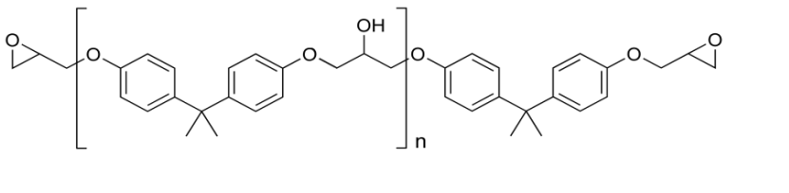
(a)

Figure 1. Chemical structures of PDGEBA.

The control (or non-healable) resin was prepared by heating the DGEBA at 90 ⁰C for 15 minutes under the mechanical stirrer. NMA hardener was added and stirred for 15 minutes until it was completely dissolved which was followed by BDMA for 5 minutes and a further stirring. The ratios by weight of 100.0, 81.2 and 2.0 for the epoxy-hardener-catalyst mixture were used [11, 17, 18]. The resin mixture was degassed in a vacuum oven at 90 ⁰C to eliminate air bubbles before being purred into the silicon mole. The blend was cured in an air convection oven at 90 ºC for 4 hours followed by post curing at 150 ⁰C for 2 hours before being allowed to cool down to 25 ⁰C at 2 ⁰C/min.

For the self-healing (or healable) resin, the healing agent; PDGEBA, was dissolved into the DGEBA under mechanical stirring at 90 ⁰C for approximately 24 hours to form a homogeneous solution [6]. The total duration for stirring was highly dependent on the concentration of healing agent that varies from 4.5 to 15.0 % by weight (wt%) of the matrix resin. After this point, the method for sample preparation followed the similar procedure of the control resin with the addition of the NMA and BDMA for curing.

Assessment of Healing
The healing capability of the resin was calculated based on the Compact tension test using the specific dimensions with all length ratios corresponding to the British Standard; ISO 13586:2000, as shown in Figure 2 [19](BS ISO 13586:2000. Plastics- Determination of fracture toughness (G_{1C} and K_{1C}) - linear elastic fracture mechanics (LEFM) approach.). A sharp pre-crack was then created in the samples by gently tapping a fresh razor blade into a machined starter notch. In addition, a 3 mm diameter hole in the plane of the growing crack was introduced to prevent the crack from propagating through the specimen (Figure 2) [5, 11]. Thus, the arrested crack was precisely aligned in intimate contact for healing.

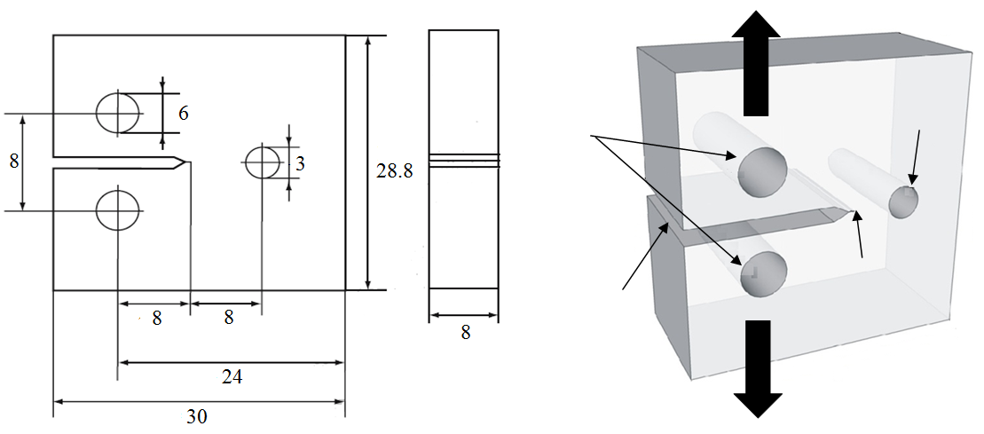
Hole-crack for arrest to prevent specimen complete fracture
Hole for loading pin
Tensile load
Crack notch
Machined notch

Figure 2. Dimensions of the compact tension test specimens (in mm) [19](BS ISO 13586:2000. Plastics- Determination of fracture toughness (G_{1C} and K_{1C}) - linear elastic fracture mechanics (LEFM) approach.).

Sample was loaded to fracture at a test speed of 10 mm/min using Tensile Testing Machine Type T5002 from a J.J. Lloyd Instrument[19](BS ISO 13586:2000. Plastics- Determination of fracture toughness (G_{1C} and K_{1C}) - linear elastic fracture mechanics (LEFM) approach.). The magnitude of the loads and the corresponding displacements was simultaneously recorded with Easylogger DS1M12 software. The crack’s length was measured visually from both side of each sample using a travelling microscope with precision of 10 µm. Samples of the healable resin system were tested, alongside reference samples consisting of the control resin sample. At least five specimens were carried out for each set of data. The calculation of percentage recovery (R_{K}) is described in equation 1.

$R_{K}=\frac{100 x K_{1c} of the post or healed sample }{K_{1c} of the initial sample}$ (1)

Following the initial fracture, all of the samples were immediately healed at 140 ºC ; which is near the T_{g} of the control resin, for 4, 6, 8 or 10 hours before cooling back to 25 ⁰C at 2 ⁰C/min in each healing cycle [20].

Optical Microscopy for Healing Analyst
Optical images were taken using a Reichert-Jung POLYVAR MET light optical microscope, attached to a CCD Colour Camera model KC-512NTX (KODO). Adjustment was made for the sample dimension (as shown in Figure 2) with the specimen width of 3 mm. Due to sample transparency, the pictures were taken in transmitted light mode.

Results and Discussion
A “Solid state self-healing system” in thermoset materials was achieved by incorporating a compatible linear healing agent in the network matrix resin [10, 11]. The healing agent should be reversibly bonded to the cross-linked epoxy resin. Upon heating at the minimum healing temperature, the linear polymer was released to diffuse through the network to the crack surface [23, 24]. This system was based on thermal diffusion of a healing agent that affects the entanglements and molecular inter-diffusion within the epoxy resin required for crack closure. The crack healing process was described schematically as shown in Figure 3.

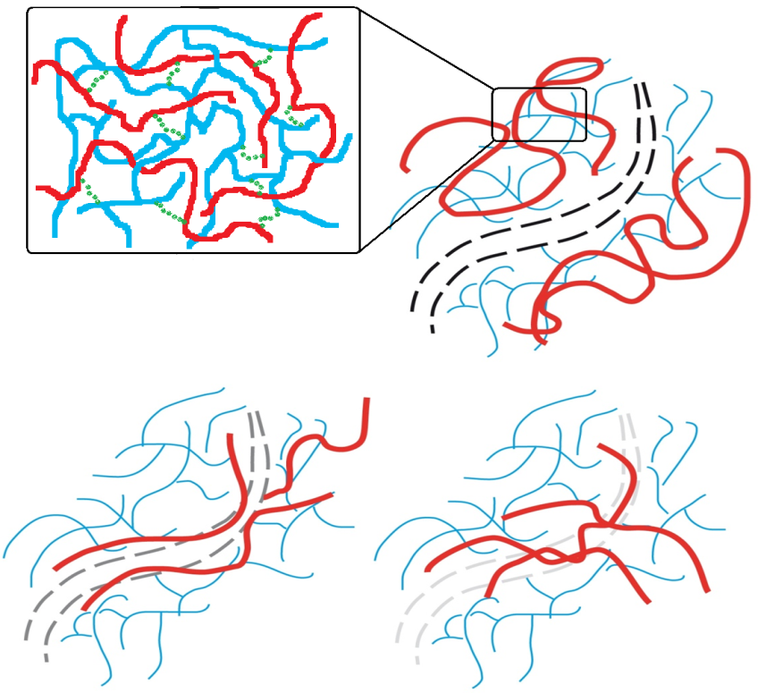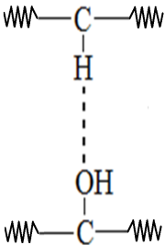

Diffusion and surface wetting
Diffusion equilibration by randomisation and crack-closure
Microfine fracture
Epoxy resin
Linear healing agent
Hydrogen bonding

After healing process

Before healing process

Figure 3. Schematic of self-healing mechanism of the solid state healing resin.

After healing process
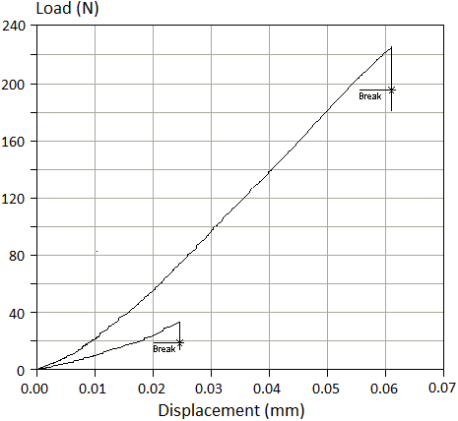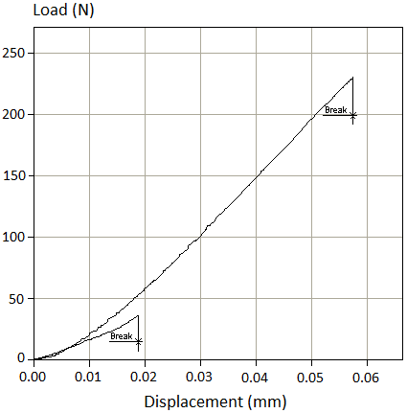

- (b)

Figure 4. The load-displacement curve for the compact tension test of the (a) control resin or; the healable resin containing 7.5 wt% of (b) of PDGEBA ($\overline{M}$_{n} of 44000 g/mol)

Meanwhile, the compact tension tests were used to quantify and verify the successful self-healing of resins (Figure 4). For the control resin, the average values of fracture toughness (K_{1C}) from the initial fracture and after healing were found to be 768 $±$28 kPa.m^{1/2} and 94 $±$ 34 kPa.m^{1/2} (Figure 4a). Furthermore, based on the calculation of percentage recovery (R_{K}) (Equation (1)), 12.8% and 64.7% recovery in fracture toughness for the healable resin with 7.5 wt% of PDGEBA (Figure 4b) were recorded. It is expected that mobility of the PDGEBA (healing agent) was constrained due to chemical bonding with the matrix resin during the curing process. However, this limited healing effect might be attributed to a slight post-cure of the samples. Thus, the mobility (diffusion) of healing agent within the matrix resin was required for crack closure (Figure 3).

Compact tension testing was employed for the assessment of the healing performance by measuring the recovery of fracture toughness (K_{1C}) [6, 11, 12, 25]. The load-displacement curves for repeated healing of the control and healable resins were obtained as shown in Figure 5a-b.

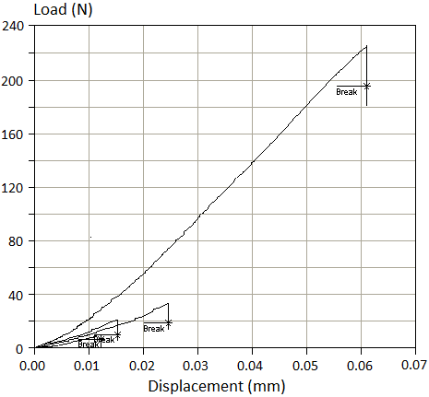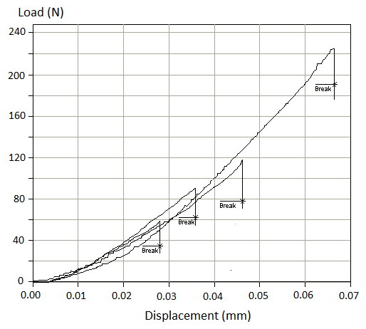
Before healing process

After healing process
- (b)
Figure 5. The load-displacement curves for repeated healing of the (a) control and healable resins from the compact tension test. The healable resins contain 7.5 wt% of (b) PDGEBA (with $\overline{M}$_{w} of 44000g/mol). The samples were healed at 140 ºC for 6 hours in each healing cycle.

Table 1. The fracture toughness (initial fracture) of the control and healable resins
containing 7.5 wt% of healing agent.
Materials | F_{Q} (N) | K_{1C} (kPa m^{1/2})
Control resin (Without HA) | 223.47 $±$ 19.74 | 768 $±$ 28
Healable resin (with 7.5 wt% of HA) $\overline{M}$_{w} of 44000g/mol | 213.73 $±$ 21.18 | 736 $±$ 46

From Table 1, the addition of healing agent to the matrix resin did not significantly change the value of K_{1C}. Furthermore, for the control resin, 12.4, 7.1 and 4.5 % recovery in fracture toughness (R_{K}) could be observed within the third healing cycles, as shown in Figure 5a. Again, this might be attributed to the chain slippage in the polymer network and/or a slight post-cure of the samples especially in the first healing cycle when the percentage recovery was highest. The recovery process was dependent on the healing temperature or the presence of un-reacted monomer. The detailed study on this aspect will be explored in near future.

To compensate for the residual healing effect in the control resin system, the actual “Healing efficiency” (H_{E}) was obtained (Equation 2) by correcting for healing in the control system from Equation (1).

H_{E} = R_{K} − R_{K}⁰ (2)

whereas R_{K}⁰ is the residual healing effect of control resin (containing no healing agent). Furthermore, the kinetics of healing was investigated from the use of healing agent at different concentration on self-healing resin system.

Effect of Healing Time on Healing Efficiency
The healing efficiency of the healable resin as a function of healing time (with 4, 6, 8 or 10 hours in each cycle) were shown in Figure 6. An optimum concentration of 7.5 wt% healing agent was chosen based on previous studies [11].

Figure 6. The graph of healing efficiency (H_{K}) as a function of healing time for the healable resin containing 7.5 wt% of HA

From Figure 6, the average healing efficiency of 35.4 to 49.1 % was obtained with the increase of healing time from 4 to 10 hours in the first healing cycle of the healable resin (with HA of 44000 g/mol). Furthermore, a reduction in the H_{K} of the healable resin after repeated healing cycles and with increased healing time was recorded. From Figure 6 for healable resin, about 47.5, 36.5 and 37.6 %; or 73.5, 54.7 and 54.5% reduction in H_{K} was recorded after healing at 12 or 30 hours (4 or 10 hours in each cycle) within the third healing cycle. The reduction in healing efficiency after repeated healing is considered to occur from the effect of physical ageing of the matrix resin. A full detailed study on the relation between the physical ageing (free volume) and the diffusion of healing agent will be explored in future to establish the fundamentals of healing.

Effect of Healing Agent Concentration on Healing Efficiency
The change in healing efficiency of the self-healing resin system containing the dissolved healing at concentrations between 4.5 and 15% by weight of matrix resin and after three times healing cycles was studied (Figures 7).

Figure 7. The healing efficiency (H_{K}) of healable resin as a function of the concentration of PDGEBA ($\overline{M}$_{w} of 44000 g/mol) . The samples were healed at 140 ºC for 6 hours in each healing cycle.

From Figure 7, at healing agent concentrations of 6.5-8.5 wt%, optimum recoveries were obtained. In Figure 7, about 41-46 % of healing efficiency was recorded for the samples within this range of healing agent concentrations. The H_{K} recorded were reduced to 29-33 and 21-25 % after second and third healing cycles. Since the optimum recovery of healable resin system were found to be at healing agent concentrations of 6.5-8.5 wt%, the decrease of healing efficiency from samples with lower healing agent concentrations might largely cause by the concentration of molecules available to bridge the crack faces.

For the higher concentrations of healing agent, much reduced recoveries were also observed as shown in Figure 7. From graphs, the average levels of H_{K} were only around 33, 24, 16 and 12% for samples containing 9.5, 10.5, 12 and 15 wt% of healing agent after the first cycle, respectively. For the latter cycles, the capability of the samples to heal was not reliable. The reduction in healability of the resin above 7.5 wt% of healing agent has also been reported elsewhere [10, 11]. Since the mechanism of the healing might be attributed to the diffusion of the soluble linear healing agent, we postulated that the reduced healing efficiency at higher concentration caused by its immobilization which is attributed to its phase separation. There is simply less thermoplastic miscible with the epoxy, such that there is reduced capacity for molecular scale migration through the unoccupied or free volume within the matrix resin for crack closure.

In addition, in the case of mixing higher concentration healing agent (> 8.5wt% of HA) in the epoxy resin, a problem of entrapment air bubble, dissolvability and achieving uniformity was often difficult. These effects produced a poor dispersity of the healing agent molecule on the crack surfaces causing incomplete coverage of the fracture plane, resulting in a lower healing efficiency, conclusively.

Optical Microscopy Observation
This “Healing capability” of the self-healing resin was further verified using optical microscopy. Figure 8 showed characteristic optical micrographs of the compact tension specimen from the healable resin (before and after healing process). The microcrack in the sample after fracture was clearly seen in Figure 8d with the magnification of 2.5x or in Figure 8c at a higher magnification of 20x. After healing at 140 ⁰C for 6 h, this microcrack was apparently healed as shown in Figure 8f (at 2.5x) and 8e (at 20x); in which the crack was filled up and the two fracture surfaces were brought into contact.

Fracture surface
- (c) (e)
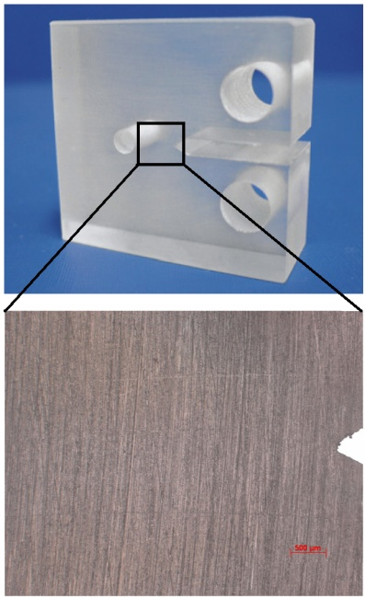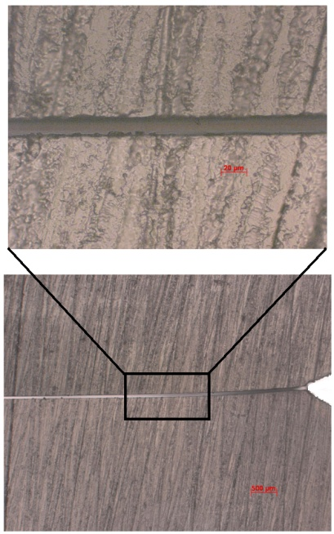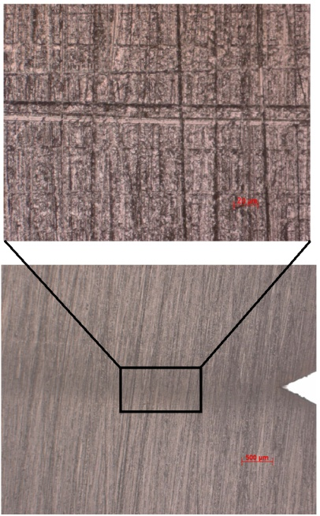

(a)
(e)
(b) (d) (f)
Sample before fracture
Sample after fracture
Sample after healing process

Figure 8. Optical graph of the compact tension specimen from the resin containing 7.5 wt% healing agent before and after healing process.

Conclusion
There was a definite correlation between the kinetics of diffusion of the healing agent in a self-healing system. Overall, within the third healing cycle, the healable resin system consisting of 7.5 wt% of HA and 6 hours healing time had optimised the healing performance. Further increases in healing agent concentration could significantly reduce the healing performance of the system due to the effect of phase separation.

Acknowledgement
The authors acknowledge the financial support of this study by Government of Malaysia through grant number of FRGS/1/2012/SE07/UKM/03/1, GGPM-2012-014 and ERGS/1/2012/TK04/UKM/03/3. The authors also wish to thank the University of Sheffield and National University of Malaysia for the continuous support of this project.

References
- Chawla, K. K., Composite materials: Science and engineering, Second edition. 1998, New York: Springer-Verlag.
- Shyr, T. & Pan, Y. (2003). Impact resistant and damage characteristics of composite laminates. Composite Structures, 62: 193-203.
- Mitrovic, M., Hahn, H. T., Carman, G. P., & Shyprykevich, P. (1999). Effect of loading parameters on the fatigue behavior of impact damage composite laminates. Composite Science and Technology, 59: 2059-2078.
- Dry, C. (1996). Procedures developed for self-repair of polymer matrix composite materials. Composite Structures, 35(3): 263-269.
- Chen, X., Dam, M. A., Ono, K., Mal, A., Shen, H., Nutt, S. R., Sheran, K., & Wudl, F. (2002). A thermally re-mendable cross-linked polymeric material. Science, 295(5560): 1698-1702.
- Hayes, S. A., Jones, F. R., Marshiya, K., & Zhang, W. (2007). A self-healing thermosetting composite material. Composites Part A: Applied Science and Manufacturing, 38(4): 1116-1120.
- White, S. R., Sottos, N. R., Geubelle, P. H., Moore, J. S., Kessler, M. R., Sriram, S. R., Brown, E. N., & Viswanathan, S. (2001). Autonomic healing of polymer composites. Nature Materials, 409: 794-797.
- Kalista, S. J., Self-healing of thermoplastic poly(ethylene-co-methacrylic acid) copolymers following projectile puncture, in Virginia Polytechnic Institute and State University2003.
- Bergman, S. D. & Wudl, F., Re-mendable polymers, in Self healing materials: An alternative approach to 20 centuries, Van Der Zwaag, S., Editor. 2007, Springer. p. 45-68.
- Jones, F. R., Zhang, W., & Hayes, S. A., Thermally induced self healing of thermosetting resins and matrices in smart composites, in Self healing materials: An alternative approach to 20 centuries, Van Der Zwaag, S., Editor. 2007, Springer: The Netherland. p. 69-93.
- Hayes, S. A., Zhang, W., Branthwaite, M., & Jones, F. R. (2007). Self-healing of damage in fibre-reinforced polymer-matrix composites. Journal of The Royal Society Interface, 4(13): 381-7.
- Chen, X., Wudl, F., Mal, A. K., Shen, H., & Nutt, S. R. (2003). New thermally remendable highly cross-linked polymeric materials. Macromolecules, 36(6): 1802-1807.
- Rahmathullah, M. A. M. & Palmese, G. R. (2009). Crack-healing behavior of epoxy-amine thermosets. Journal of Applied Polymer Science, 113(4): 2191-2201.
- Oprea, S., Vlad, S., Stanciu, A., & Macoveanu, M. (2000). Epoxy urethane acrylate. European Polymer Journal, 76: 373-378.
- Yang, B., Shi, H., Pramoda, K. P., & Goh, S. H. (2007). Enhancement of stiffness, strength, ductility and toughness of poly(ethylene oxide) using phenoxy-grafted multiwalled carbon nanotubes. Nanotechnology, 18: 1-7.
- Chattopadhyay, D. K., Siva Sankar Panda, & Raju, K. V. S. N. (2005). Thermal and mechanical properties of epoxy acrylate/methacrylates UV cured coating. Progress in Organic Coating, 54: 10-19.
- Barrère-Tricca, C., Halary, J. L., & Dal Maso, F. (2002). Relationship between epoxy resin properties and weepage of glass-reinforced filament-wound pipes. Oil & Gas Science and Technology, 57: 169-175.
- Boogh, L. & Mezzenge, R., Processing principles for thermoset composites, in Comprehensive composites materials, Kelly, A. & Zweben, C. H., Editors. 2000, Elsevier Science: The Amsterdam.
- BS ISO 13586:2000. Plastics- Determination of fracture toughness (G_{1C} and K_{1C}) - linear elastic fracture mechanics (LEFM) approach: British Standards Institute
- Zhang, W., Self healing epoxy resin and composites, in University of sheffield2008.
- Vickerman, J. C. & Briggs, D., TOF-SIMS: Surface analysis by mass spectroscopy. 2001, Chichester: IM Publications.
- Swait, T. J., Interfacial optimisation of glass fibre reinforced composites by plasma polymerisation, in University of Sheffield2009.
- Wool, R. P. (2008). Self-healing materials: A review. Soft Matter, 4(3): 400-418.
- Wool, R. P. & O'Connor, K. M. (1981). A theory of crack healing in polymers. Journal of Applied Physics, 52(10): 5953-5963.
- Luo, X., Ou, R., Eberly, D. E., Singhal, A., Viratyaporn, W., & Mather, P. T. (2009). A thermoplastic/thermoset blend exhibiting thermal mending and reversible adhesion. Applied Materials and Intefaces, 1(3): 612-620.

