

BIOMIMETIC SYNTHESIS OF SILVER NANOPARTICLES USING THE LICHEN Ramalina dumeticola AND THE ANTIBACTERIAL ACTIVITY

(Sintesis Biomimetik Nanozarah Perak Menggunakan Liken Ramalina dumeticola dan Aktiviti Antibakteria)

Laily B Din¹*, Ropisah Mie^{1,3}, Mohd Wahid Samsudin¹, Azizan Ahmad¹, Nazlina Ibrahim²

¹School of Chemical Sciences and Food Technology,
²School of Biosciences and Biotechnology,
Faculty of Science and Technology,
Universiti Kebangsaan Malaysia, 43600 UKM Bangi, Selangor, Malaysia
³Faculty of Applied Sciences,
Universiti Teknologi MARA, Negeri Sembilan Branch,
72000 Kuala Pilah, Negeri Sembilan, Malaysia

*Corresponding author: lbdin@ukm.edu.my

Received: 6 January 2015; Accepted: 10 February 2015

Abstract
Silver nanoparticles (AgNPs) has been successfully synthesized by reduction of silver nitrate with an aqueous extract of the lichen Ramalina dumeticola. The aqueous extract of Ramalina dumeticola was treated with 45 mL of 1 mM silver nitrate at room temperature (24-25 °C) for 24 hours. The ultraviolet-visible (UV-Vis) absorption spectroscopy has been used to monitor the formation of AgNPs. Physical appearance of AgNPs characterized by transmission electron microscopy (TEM) showed formation of AgNPs with average particle size of 13 nm. X-ray diffraction (XRD) techniques displayed the AgNPs as cubic structure. The UV-Vis absorption spectroscopy results showed a strong resonance centered on the surface of AgNPs at approximately 433 nm. The in vitro antibacterial activity of the synthesized AgNPs was investigated against eight bacterial strains using a disc diffusion method and it’s showed inhibition against all of them. The results revealed that the above AgNPs have potential as antibacterial agent.

Keywords: lichen extract, Ramalina dumeticola, silver nanoparticles, antibacterial activity

Abstrak
Nanozarah perak (NZAg) berjaya disintesis melalui penurunan argentum nitrat dengan ekstrak akueus liken Ramalina dumeticola. Ekstrak akueus Ramalina dumeticola diolah dengan 45 mL larutan argentum nitrat 1 mM pada suhu bilik (24-25 °C) selama 24 jam. Spektroskopi penyerapan ultraungu-boleh nampak (UU-BN) digunakan untuk mengawasi pembentukan NZAg. Penampakan fizikal NZAg dicirikan dengan mikroskopi transmisi elektron (MTE) yang menunjukkan pembentukan NZAg pada saiz zarah purata 13 nm. Teknik pembelauan sinar-X (PSX) memperlihatkan NZAg sebagai struktur kubik. Hasil spekroskopi penyerapan UU-BN menunjukkan resonans kuat yang berpusat pada permukaan NZAg pada kira-kira 433 nm. Aktiviti antibakteria in-vitro NZAg yang disintesis disiasat melawan lapan strain bakteria menggunakan kaedah peresapan cakera dan ia menunjukkan perencatan terhadap kesemuanya. Hasil ini mendedahkan bahawa NZAg di atas mempunyai potensi sebagai agen antibakteria.

Kata kunci: ekstrak liken, Ramalina dumeticola, nanozarah perak, aktiviti antibakteria

Introduction
The development of easy, reliable and eco-friendly methods helps to increase interest in the synthesis and application of nanoparticles that are beneficial for mankind. Silver nanoparticles (AgNPs) are of great scientific interest due to their significant role in biological systems, living organisms and medicine [1, 2]. They are beneficial as antimicrobials and therapeutic agents [3-5], and the development of AgNPs as an antibacterial agent is in progress. Previous techniques such as radiation assisted, thermal decomposition, sonochemical and electrochemical used in the production of AgNPs somehow lead to the presence of toxic chemicals on the surface of AgNPs and unsuitable for medical application [6]. Therefore, biomimetic method which focusing on the use of resources from nature such as plant extracts, bacteria and fungi provide an alternative for pharmaceutical and biomedical applications [7-9]. Metabolites found in plant extracts or nature sources such as papaya extract [10], Lippia citriodora extract [11], Boswellia serrata extract [12], Rumex hymenosepalus extract [13] and Parmotrema praesorediosum extract [14] have been proven to be an effective capping and stabilizing agents for AgNPs [15].

In this study, we attempted to explore the use of lichen Ramalina dumeticola extract as a reducing agent of silver ions in the production of AgNPs. We report the synthesis of AgNPs from the reduction of silver nitrate and the aqueous extract of the lichen Ramalina dumeticola was used as a reductant as well as a stabilizer. The physical characterization and antibacterial activity of the synthesized AgNPs against eight pathogenic microorganisms were evaluated in this study.

Materials and Methods
Materials
Ramalina dumeticola was collected from highland area at Fraser Hills, Pahang Malaysia. A voucher specimen UKMBBFR1 was deposited at the herbarium of Universiti Kebangsaan Malaysia (UKM), Silver nitrate was purchased from Merck, Germany. For the antibacterial assays, Mueller-Hinton Agar (MHA), Mueller-Hinton Broth (MHB) and Nutrient Broth (NB) were purchased from Oxoid Ltd., UK.

Biomimetic synthesis of AgNPs
Dried powder of the lichen, Ramalina dumeticola (3.0 g) was mixed with 45 mL of ultrahigh purity (Milli-Q) water. The mixture was heated for 20 minutes at 80°C to denature the enzymes. The solution was filtered through a filter paper to remove plant residues. For the synthesis of AgNPs, about 10 mL of the lichen aqueous extract was carefully added into 30 mL of 1 mM silver nitrate solution and allowed to react at room temperature of 24-25°C for 24 hours. The ultrahigh purity water was used to avoid the presence of chloride ions and to prevent the formation of silver chloride precipitate. The appearance of yellowish brown color of the solution suggested the formation of AgNPs. The solution containing the AgNPs was centrifuged at 5000 rpm for 20 minutes. The pellet was resuspended in 20 mL ultrahigh purity water and the centrifugation process was repeated thrice to get rid of any non-reacted biological material. The purified pellet was then freeze dried to get AgNPs powder. A dried AgNPs powder was further used for characterization studies.

Characterization of AgNPs
The reduction of silver ions was monitored by measuring the ultraviolet-visible (UV-Vis) spectra of the solution. The UV-Vis spectral analysis was conducted using a UV 2450 Shimadzu double-beam spectrophotometer, operated at a resolution of 2 nm in the range from 300 to 600 nm. The formation of AgNPs was confirmed by transmission electron microscopy (TEM), energy-dispersive spectroscopy (EDS) and X-ray diffractometry (XRD). TEM analysis of AgNPs was performed using a Philips CM12 instrument operated at an accelerating voltage at 80 kV. The size distribution of the AgNPs was calculated from the TEM images by measuring the diameter of approximately 50 nanoparticles. Furthermore, the presence of elemental silver was confirmed through EDS and phase identification of AgNPs was done using an X’Pert Pro X-ray diffractometer operating at a voltage of 40 kV and a running current of 30 mA with Cu K_{α} radiation in a θ-2θ configuration.

Evaluation of the antibacterial activity of AgNPs
The antibacterial activity of AgNPs was evaluated against eight pathogenic bacteria including four Gram-positive (Staphylococcus epidermidis, methicillin-resistant Staphylococcus aureus (MRSA), Bacillus subtilis and Streptococcus faecalis) and four Gram-negative (Proteus vulgaris, Pseudomonas aeruginosa, Serratia marcescens and Salmonella typhi) by using the disc diffusion method [16]. Gentamycin (30 µg discs) was used as the positive control and sterile distilled water as the negative control. Sterile paper discs were placed on the agar plates, and 10 µL of 100 µg/mL (w/v) of the AgNPs were applied to the discs. All the plates were incubated at 37°C for 18-24 hours and the antibacterial activity was assessed based on the inhibition zone formed around the discs.

Results and Discussion
Reduction of silver ions into AgNPs during exposure to the plant extracts or natural resources can be monitored by change in colour. Krishnaraj et al reported the surface plasmon resonance phenomenon of nanoparticles exhibited dark reddish-brown colour in aqueous solution [17]. Figure 1 shows the color changes when the aqueous extract of Ramalina dumeticola was mixed with a 1 mM of silver nitrate solution. The mixture was kept at room temperature for 24 hours. The appearance of a yellowish brown color in the reaction vessel indicated the formation of AgNPs [18]. According to Shankar et al, AgNPs exhibit a yellowish brown color in aqueous solution due to the excitation of surface plasmon resonance in the AgNPs [19].

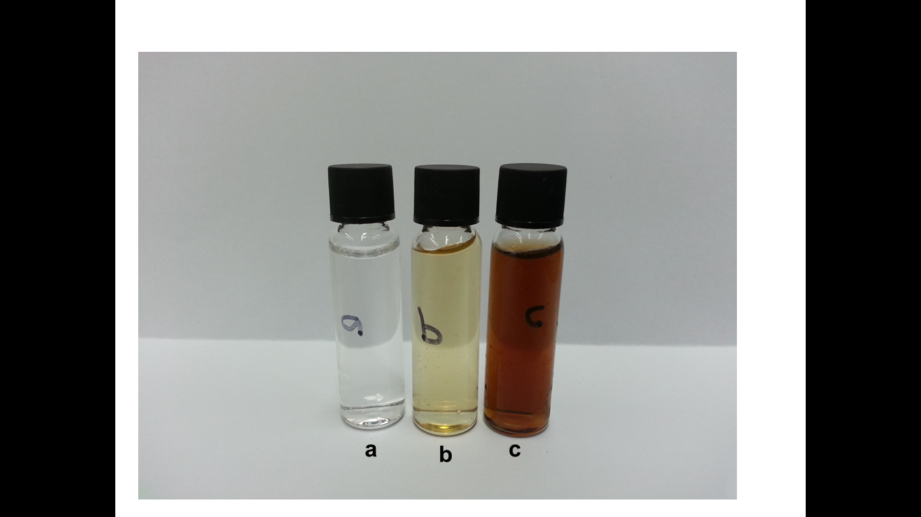

Figure 1. The 1 mM AgNO₃ solution (a), aqueous extract of Ramalina dumeticola (b) and the mixture of Ramalina dumeticola in 1 mM AgNO₃ after 24 h of reaction (c).

The synthesized AgNPs were further characterized by UV-Vis spectroscopy. As illustrated in the UV-Vis spectrum, the surface plasmon resonance of AgNPs was centered at approximately 433 nm (Figure 2), indicating the presence of AgNPs in the solution. Based on Mulvaney, the formation of AgNPs in aqueous solution can be monitored using UV-Vis spectra which displayed the characteristic surface plasmon resonance band of AgNPs ranging from 400 to 450 nm [20]. The absorbance of AgNPs depends mainly upon size and shape [21]. The technique outlined above has proven to be very useful for the analysis of nanoparticles [22-24].

Transmission Electron Microscopy (TEM) was used to analyze the morphology and size distribution of the AgNPs. TEM image in Figure 3 shows that the particles were polydispersed and mostly spherical. The particle size histograms of AgNPs (illustrated on the right-hand side of Figure 3) suggested that the particles ranged in size from 6 to 28 nm with an average diameter of 13 nm.

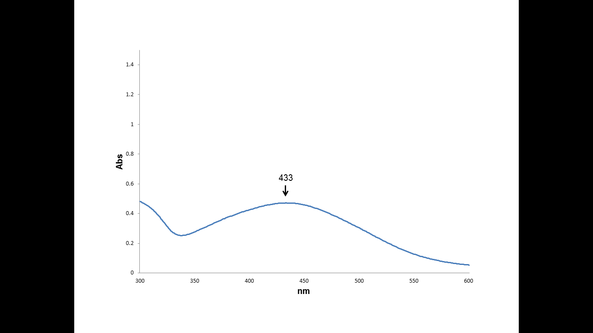
Figure 2. UV-Vis absorption spectrum of AgNPs synthesized using aqueous extract of Ramalina dumeticola.

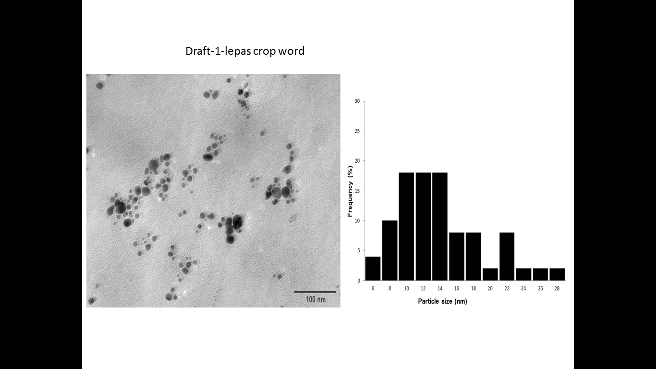

Figure 3. TEM image of AgNPs obtained using Ramalina dumeticola extract after 24 h of reaction (left) and the particle size distribution (right).

Figure 4 shows XRD patterns for AgNPs synthesized by Ramalina dumeticola. Four intense peaks were observed at 2θ = 38.1°, 44.3°, 64.4°, 77.4°, which correspond to the (111), (200), (220), and (311) crystallographic planes of face-centered cubic (fcc) silver, respectively. This result was consistent with the results of Jain et al [10], Cruz et al [11], Mie et al [14] and Gilaki [25]. The crystallite domain size was calculated from the width of the XRD peaks, using the Debye-Scherrer equation: D = (0.94λ)/(β cos θ), where D is mean crystallite domain size, λ is the wavelength of Cu_{kα}, β is the full width at half maximum (FWHM) and θ is the Bragg diffraction angle. The (111) plane was chosen to calculate crystalline size. From the Debye-Scherrer equation, the average crystallite size of synthesized AgNPs was 17.1 nm, which is in a good agreement with the particle size determined by TEM analysis. X-ray Diffraction analysis is commonly used for determining the chemical composition and crystal structure of a material; therefore, detecting the presence of silver nanoparticles in plants extracts can be achieved by using XRD [26].

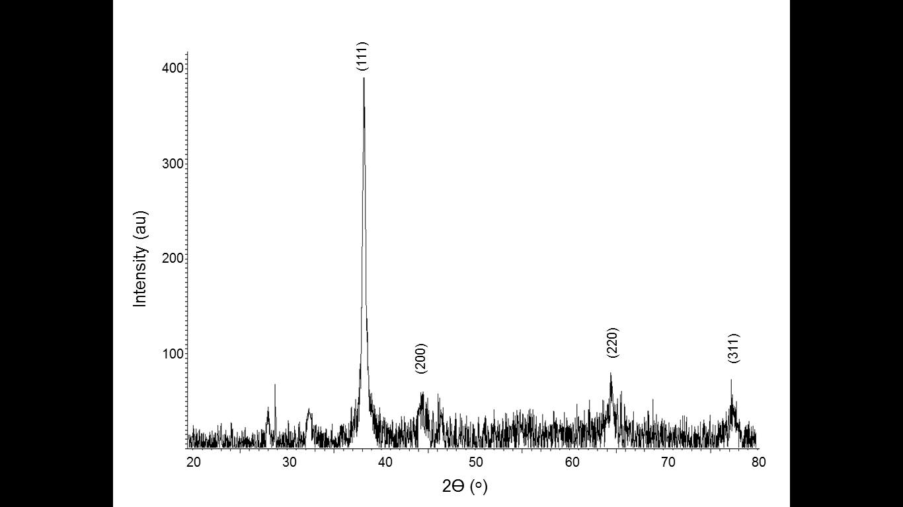

Figure 4. X-ray diffraction pattern of prepared AgNPs

Table 1. Mean zone of inhibition (mm) of AgNPs synthesized by Ramalina dumeticola against eight pathogenic microorganisms. Diameter of disc is 6 mm.
Bacteria | Zone of inhibition (mm)
Bacteria | 100 µg/mL aqueous extract | 100 µg/mL AgNPs
Proteus vulgaris | 6 | 10.5±0.7
Pseudomonas aeruginosa | 6 | 9.5±3.5
Serratia marcescens | 6 | 7.5±0.7
Salmonella typhi | 6 | 8.5±2.1
Staphylococcus epidermidis | 6 | 7±0.0
MRSA | 6 | 9.5±0.7
Bacillus subtilis | 6 | 7.5±0.0
Streptococcus faecalis | 6 | 7.5±0.0

For antibacterial effects of AgNPs, our results reveal that AgNPs synthesized using an aqueous extract of Ramalina dumeticola have potential antibacterial activity against Gram-positive and Gram-negative bacteria. Figure 5 shows the antibacterial activity of AgNPs against P. vulgaris and B. subtilis. The diameters of the inhibition zones for the all tested pathogens are listed in Table 1. At a concentration of 100 µg/mL, the AgNPs efficiently inhibited the growth of Gram-negative bacteria and show limited antibacterial action against Gram-positive bacteria. According to Kim et al, the antibacterial effects of AgNPs may be associated with the characteristics of certain bacterial species [4]. A literature survey shows that smaller AgNPs having a large surface area available for interaction would have stronger antibacterial effects than larger AgNPs [27]. It is also possible that AgNPs not only interact with the membrane surface, but may also penetrate inside bacteria [28]. AgNPs are better at anchoring to or penetrating the cell wall of Gram-negative bacteria due to the thinner peptidoglycan layer compared to Gram-positive bacteria. However, the exact mechanism by which silver ions and AgNPs exert their antibacterial effect remains to be identified.

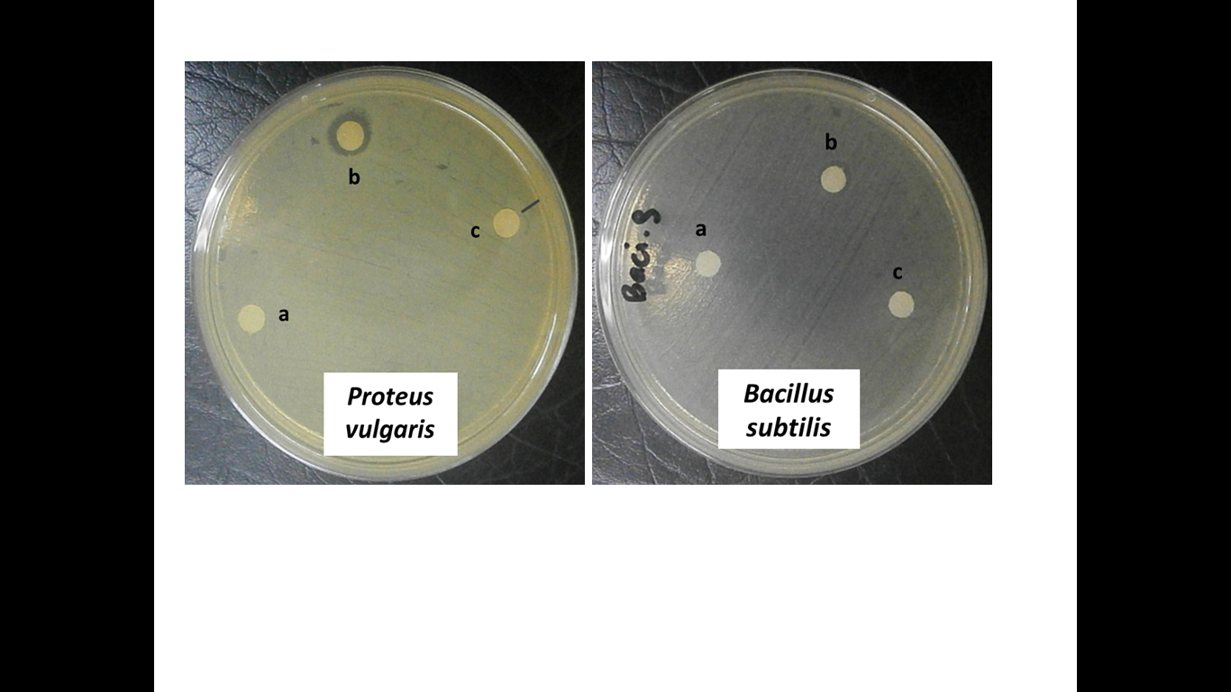

Figure 5. Antibacterial activities assay against Proteus vulgaris and Bacillus subtilis by the disc diffusion method. (a) Distilled water, (b) synthesized AgNPs (c) the Ramalina dumeticola aqueous extract.

Conclusion
Our results reveal that silver nanoparticles synthesized using an aqueous extract of lichen Ramalina dumeticola shows potential antibacterial activity against all tested Gram-positive and Gram-negative bacteria. The synthesized AgNPs had an average particle size of 13 nm with a cubic structure. Thus, the application of synthesized AgNPs based on these findings may lead to valuable discoveries in various fields such as in medical devices as well as the pharmaceutical and biomedical industries.

Acknowledgement
This research was financially supported by the Ministry of Higher Education, Malaysia under the Exploratory Research Grant Scheme (ERGS/1/2012/STG01/UKM/01/3). We would also like to thank Centre for Research & Instrumentation UKM, Faculty of Science & Technology UKM and UiTM Negeri Sembilan for providing research facilities.

References
- Gurunathan, S., Kalishwaralal, K., Vaidyanathan, R., Deepak, V., Pandian, S. R. K. & Muniyandi, J. (2009). Biosynthesis, purification and characterization of silver nanoparticles using Escherichia coli. Colloids Surf B, 74: 328-335.
- Parashar, V., Parashar, R., Sharma, B. & Pandey, A.C. (2009). Parthenium leaf extract mediated synthesis of silver nanoparticles: a novel approach towards weed utilization. Digest Journal of Nanomaterials & Biostructures, 4: 45-50.
- Rai, M., Yadav, A. & Gade, A. (2009). Silver nanoparticles as a new generation of antimicrobials. Biotechnol Advances, 27: 76-83.
- Kim, J. S., Kuk, E., Kim, J. H., Park, S. J., Lee, H. J., Kim, S. H., Park, Y. K., Park, Y. H., Hwang, C. Y., Kim, Y. K., Lee, Y. S., Jeong, D. H. & Cho, M. H. (2007). Antimicrobial effects of silver nanoparticles. Nanomedicine: Nanotechnology, Biology and Medicine, 3: 95-101.
- Suman, T.Y., Rajasree, S.R.R., Kanchana, A. & Elezabeth, S.B. (2013). Biosynthesis, characterization and cytotoxic effect of plant plant mediated silver nanoparticles using Morinda citrifolia root extract. Colloids and Surfaces B: Biointerfaces, 106: 74-78.
- Fahlman, Ds. (2007). Material Chemistry. Springer
- Deepika, H., Jacob, L., Mallikarjuna, Nadagouda, N. & Varma, R.S. (2013) Greener technique for the synthesis of silver nanoparticles using plant extracts, enzymes, bacteria, biodegradable polymers and Microwaves. Sustainable Chemistry & Engineering, 1(7): 703-712.
- Rad, M.S., Rad, J.S., Gholam, A.H., Abdolhossein, M. & Dhrubo, J.S. (2013) Biological synthesis of gold and silver nanoparticles by Nitraria schoberi fruits. American Journal of Advanced Drug Delivery, 2: 174-179.
- Johnson, I. & Prabu, H.J. (2015). Green synthesis and characterization of silver nanopaerticles by leaf extracts of Cycas circinalis, Ficus amplissima, Commellina benghalensis and Lippia nodiflora. International Nano Letter, 5: 43-51.
- Jain, D., Daima, H. K., Kachhwaha, S. & Kothari, S. L. (2009) Synthesis of plant-mediated silver nanoparticles using papaya fruit extract and evaluation of their anti microbial activities. Digest Journal of Nanomaterials and Biostructure, 4(3): 557-563.
- Cruz, D., Fale, P. L., Mourato, A., Vaz, P. D., Serralheiro, M. L. & Lino, A. R. L. (2010). Preparation and physicochemical characterization of Ag nanoparticles biosynthesized by Lippia citriodora (Lemon Verbena). Colloids and Surfaces B: Biointerfaces, 81: 67-73.
- Kora, A.J., Sashidar, R.B. & Arunachalam, J. (2012). Aqueous extract of gum olibanum (Boswellia serrata) : A reductant and stabilizer for the biosynthesis of antibacterial silver nanoparticles. Process Biochemistry, 47: 1516-1520.
- Rodriguez-Leon, E., Iniguez-Palomares, R., Navarro, R.E, Herrera-Urbina, R., Tanori, J., Iniguez-Palomares, C. & Maldonado, A. (2013) Synthesis of silver nanoparticles using reducing agents obtained from natural sources (Rumex hymenosepalus extracts). Nanoscale Research Letters, 8: 318-326.
- Mie, R., Samsudin, M. W., Din, L. B., Ahmad, A., Ibrahim, N. & Adnan, S. N. A. (2014). Synthesis of silver nanoparticles with antibacterial activity using the lichen Parmotrema praesorediosum. International Journal of Nanomedicine, 9: 121-127.
- Chandran, N., Padmanaban, S. & Sahadevan, R. (2012). International Journal of Nanomaterials and Biostructures, 2(2): 16-21.
- Clinical and Laboratory Standards Institute. (2006) M7-A7, Methods for dilution antimicrobial susceptibility tests for bacteria that grow aerobically; approved standard - seventh edition. Wayne, PA: CLSI.
- Krishnaraj, C., Jagan, E. G., Rajasekar, S., Selvakumar, P., Kalaichelvan, P. T. & Mohan, N. (2010). Synthesis of silver nanoparticles using Acalypha indica leaf extracts and its antibacterial activity against water borne pathogens. Colloids Surf B, 76: 50-56.
- Ahmad, A., Mukherjee, P., Senapati, S., Mandal, D., Islam, K. M. & Kumar, R. (2003). Extracellular Biosynthesis of Silver Nanoparticles using the Fungus Fusarium Oxysporum. Colloids and Surfaces B: Biointerfaces, 28(4): 313-318.
- Shankar, S. S., Rai, A., Ankamwar, B., Singh, A., Ahmad, A. & Sastry, M. (2004). Biological Synthesis of Triangular Gold Nanoprisms. Nature Materials, 3: 482-488.
- Mulvaney, P. (1996). Surface palsmon spectroscopy of nanosized metal particles. Langmuir 12: 788-800.
- Kerker, M. (1985). The optics of colloidal silver: something old and something new. J Colloid Interface Sci, 105: 297-314.
- Henglein, A. (1993). Physicochemical properties of small metal particles in solution: microelectrode reactions, chemisorption, composite metal particles, and the atom-to-metal transition. J Phys Chem. 97: 5457-5471.
- Sastry, M., Mayya, K. S. & Bandyopadhyay, K. (1997). pH-dependent changes in the optical properties of carboxylic acid derivatized silver colloidal particles. Colloid Surf A, 127: 221-228.
- Sastry, M., Patil, V. & Sainkar, S. R. (1998). Electrostatically controlled diffusion of carboxylic acid derivatized silver colloidal particles in thermally evaporated fatty amine films. J Phys Chem B, 102: 1404-1410.
- Gilaki, M. (2010). Biosynthesis of silver nanoparticles using plant extracts. Journal of Biological Science, 10(5): 465-467.
- Panneerselvam, C., Ponarulselvam, S., Murugan, K., Kalimuthu, K. & Thangamani, S. (2102). Synthesis of silver nanoparticles using leaves of Catharanthus roseus Linn. G. Don and their antiplasmodial activities. Asian Pac J Trop Biomed, 7: 574-580.
- Kvitek, L., Panacek, A., Soukupova, J., Kolar, M., Vecerova, R., Prucek, R. (2008). Effect of surfactants and polymers on stability and antibacterial activity of silver nanoparticles (NPs). J Phys Chem C, 112: 5825-5834.
- Morones, J. R., Elechiguerra, J. L., Camacho, A., Holt, K., Kouri, J. & Ramirez, J. T. (2005). The bactericidal effect of silver nanoparticles. Nanotechnology, 16: 2347-2353.

