

forensic analysis of BLUE ballpoint pen inks USING ultraviolet-visible spectrometer and ultra-performance liquid chromatograph

(Analisis Forensik Pen Mata Bulat Dakwat Biru Menggunakan Spektrometer Ultralembayung-Nampak dan Kromatografi Cecair Berprestasi Ultra)

Loong Chuen Lee*, Karldiv Tarvin Singh Shandu, Nor Syahirah Mohamad Razi, Ab Aziz Ishak,
Khairul Osman

Forensic Science Program, School of Diagnostic & Applied Health Sciences,
Faculty of Health Sciences,
Universiti Kebangsaan Malaysia, Jalan Raja Muda Abdul Aziz, 50300 Kuala Lumpur, Malaysia

*Corresponding author: lc_lee@ukm.edu.my

Received: 7 January 2015; Accepted: 25 February 2015

Abstract
Twelve varieties of blue ballpoint pens were selected and analyzed using UV-Vis spectrometer and ultra-performance liquid chromatography (UPLC). The aim of the study was to determine discrimination power (DP) of these methods in differentiating pen inks collected from the market in Malaysia. Discrimination analysis of 66 possible pen-pair of blue ballpoint pens was carried out via one-way ANOVA based on obtained chromatogram and spectra. A total of 18 peaks were determined as coming from inks based on the chromatographic data extracted at three different wavelengths (279, 370 and 400 nm). While for the UV-Vis spectrometer analysis, presence of peaks at 303, 545, 577 and 584 nm wavelengths were recorded. UV-Vis spectral data were mainly produced by the colorant components (i.e., dyes) found in inks and UPLC may detect ink components other than dyes, i.e., additives. As conclusion, the DP for UV-Vis and UPLC were determined to be 72.12% and 98.48%, respectively. This manuscript demonstrates the potential of UPLC for discriminating pen inks based on non-dye components. Additionally, the dye components in inks do not seem to play important role in discrimination of pen inks.

Keywords: forensic ink analysis, ballpoint pen inks, UV-Vis spectrometer, ultra-performance liquid chromatography, discrimination power

Abstrak
Dua belas jenis pen mata bulat biru yang terpilih telah dianalisis menggunakan spektrometer Ultralembayung-Nampak dan kromatografi cecair berprestasi ultra. Tujuan kajian ini adalah untuk menentukan kuasa pembezalayanan kaedah tersebut dalam membezalayan dakwat pen yang dikumpulkan dari pasaran di Malaysia. Analisis pembezalayan terhadap 66 pasangan pen mata bulat biru telah dijalankan melalui ANOVA sehala berdasarkan kromatogram dan spektrum yang diperolehi. Sejumlah 18 puncak telah ditentukan adalah berasal dari dakwat berdasarkan data kromtogram yang diekstrak pada tiga panjang gelombang yang berlainan (279, 370 and 400 nm). Manakala untuk analisis spektrometer UV-Nampak, kehadiran puncak pada panjang gelombang 303, 545, 577 and 584 nm telah direkodkan. Data spektra UV-Nampak adalah dihasilkan terutamanya dari komponen pewarna, i.e. pewarna. yang dijumpai dalam dakwat dan UPLC besar kemungkinnya mengesan komponen dakwat selain daripada pewarna, i.e., bahan tambah. Sebagai kesimpulan, kuasa pembezalayan bagi UV-Nampak dan UPLC masing-masing telah ditentukan sebagai 72.12% and 98.48%. Manuskrip ini mendemonstrasikan potensi UPLC untuk membezalayan dakwat pen berdasarkan komponen bukan-pewarna. Tambahan, komponen pewarna dalam dakwat tidak kelihatan memain peranan penting dalam pembezalayan dakwat pen.

Kata kunci: analisis dakwat forensik, dakwat pen mata bulat, spektrometer UV-Nampak, kromatografi cecair prestasi ultra, kuasa pembezalayan

Introduction
Forensic document examination composed of handwriting examination and ink analysis. This study will be related to the field of ink analysis. Ink analysis is needed to reveal useful information about forgery of a particular questioned document by determining the specific pen used for preparing the questioned documents [1]. The main objective of most ink analysis is to determine whether two pieces of written text originated from a single individual pen [2]. Ballpoint pen is one of the most frequently used writing instruments found present on questioned documents. Ballpoint pen inks are complex mixtures of coloring components, i.e., dyes and non-coloring components, i.e. solvent and additives [3].

The aim of this research was to determine the discrimination power (DP) of both UV-Vis spectrometer and UPLC methods in analyzing blue ballpoint pen inks found in the Malaysian market. The DP is a measurement of the selectivity of the method to differentiate the pen ink analyzed [2].On one hand, UV-Vis spectrometer is a well-established technique to investigate the coloring components in pen inks [4]. On the other hand, UPLC coupled with photodiode array detector will be used to analyze the non-dye components in inks as the chromatogram will be scanned at the range below 500 nm.

Materials and Methods
Sampling
Samples composed of twelve varieties of blue ballpoint pen inks were as shown in Table 1. Two different models were chosen from each of the brands and a total of four individual pens were purchased to represent each model to make up a population of 48 blue ballpoint pens. A sheet of A4 white copy paper (Double A, 80gsm) made in Thailand was used as substrate for depositing inks.

Table 1. Details and identification number of each selected varieties of blue ballpoint pens.
Each variety of pens was assigned with an identification number (ID no.).
ID no. | Model/Brand | Number of pens
A | Faber-Castell Click Ball 1422 | 4
B | Faber-Castell Ball Pen 1423 | 4
C | G’soft GS PDA2 | 4
D | G’soft GS R100 | 4
E | Faster CX444 | 4
F | Faster CX1006 | 4
G | Bic RS2 | 4
H | Bic BU3 | 4
I | MGM Fino | 4
J | MGM e-Rite 716 | 4
K | Paper Mate Kilometrico | 4
L | Paper Mate KV2 | 4

Sample preparation
Each pen was used to prepare three specimens by writing ‘HUNDRED THOUNSAND ONLY’ three times on the substrate. After that, the ink entry was cut into standard size (20 x 0.5 mm) and extracted in a test tube containing 1.5 mL methanol (HPLC grade, Fisher Scientific UK Ltd). Prior to UPLC analysis, the extracted inks were filtered with a NALGENETM filter (0.2 µm nylon membrane).

UPLC analysis
All UPLC work was carried out on Waters® ACQUITY UPLCTM system that consisted of the ACQUITY UPLC Binary Solvent Manager, the ACQUITY UPLC Sample Manager and the Waters 2996 Photodiode Array Detector with a low volume flow cell. ACQUITY BEH C₁₈ (2.1×150 mm) with 1.7µm particle size was used to separate the ink components. Injection volume of sample was set at 7.5 uL and the whole separation process completed within 8 minutes. Two types of mobile phases used were 60v% of acetonitrile with 40v% of methanol (solvent A) and 10 mM ammonium acetate (solvent B). Waters® EmpowerTM chromatography data software was used to control, collect and analyze all data. Chromatograms of all samples were extracted at 279, 370 and 400 nm.

UV-Vis analysis
All experimental spectroscopy was carried out on a WPA Biowave LifeScience UV-Vis spectrometer using quartz cuvettes with a path-length of 10 mm. All spectra were scanned from 200-800 nm. For both UPLC and UV-Vis methods, the blank paper and blank solvent samples were also prepared and analyzed in the same manner as the samples and were used as the standard.

Data Analysis
All the statistical analysis was carried out using statistical package SPSS (Statistical Package for the Social Sciences, Window version 15.0, SPSS Inc., Chicago, USA). Discrimination analysis was conducted based on the data obtained from UV-vis spectrum and chromatogram. One-way ANOVA was conducted to determine pen-pair that can be discriminated in an objective way. With 12 varieties of ballpoint pens, there are 66 possible pen pairs ([12(11)]/2= 66). Any pair that gives p-value less than 0.05 would be labeled as discriminated or vice versa. After that, discriminating power (DP) was calculated using the following equation 1 [5]:

(1)

where M is the number of non-discriminated pairs of samples and n is the total number of samples. The DP is a measurement of the selectivity of the ink analysis technique to differentiate the blue ballpoint pen inks analyzed [2].

Results and Discussion
Ultra Performance Liquid Chromatography Technique
Each of the ink chromatograms was compared against that of blank paper and blank solvent to determine the peaks that coming from ink components. As a result, a total of 18 peaks were selected in which wavelength 279, 370 and 400 nm contributed ten, four and four retention time, respectively. All peak area values were normalized in order to rule out the bias from the unequal amount of ink deposited on paper as well as different ink extraction efficiency. Example of chromatogram extracted at 370 nm was shown in Figure 1. One way ANOVA was conducted using all aforementioned 18 peaks as variables to discriminate 66 pairs of blue ballpoint pens. Figure 2 summarized the results for all 66 possible pairs of blue ballpoint pens. The DP of UPLC was determined to be 98.48%.

UV-Vis Spectrometry Technique
For each pen samples, the presence of peak at 303, 545, 577 and 584 nm wavelengths and their peak heights were recorded. The data collected were normalized accordingly to rule out the bias from the unequal amount of ink deposited on paper as well as different ink extraction efficiency. One way ANOVA was conducted using all aforementioned four peaks as variables to discriminate 66 pairs of blue ballpoint pens. Figure 3 summarized the results for discrimination analysis of all 66 possible pairs of blue ballpoint pens. Discrimination power obtained by UV-Vis spectrometry technique was calculated as 71.21%.

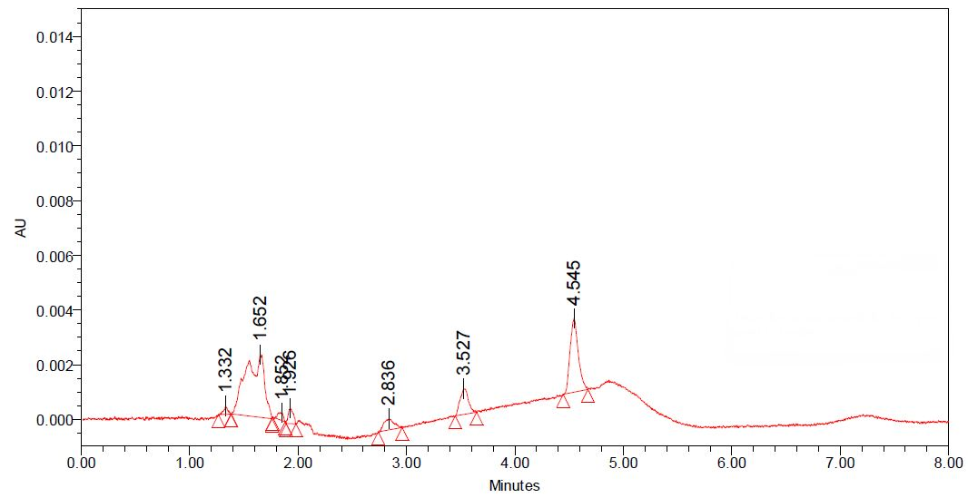

Figure 1. Chromatogram of pen A extracted at 370 nm.

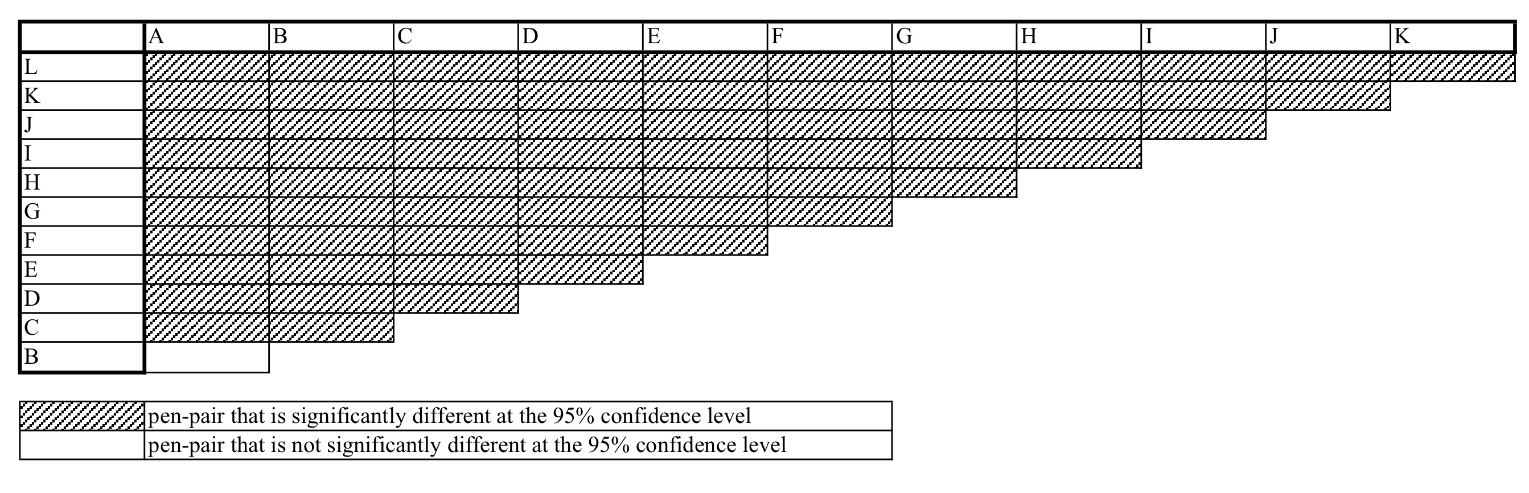
Figure 2. Matrix showing summary result of differentiation of blue ballpoint pen inks based on UPLC chromatograms via one way ANOVA analysis

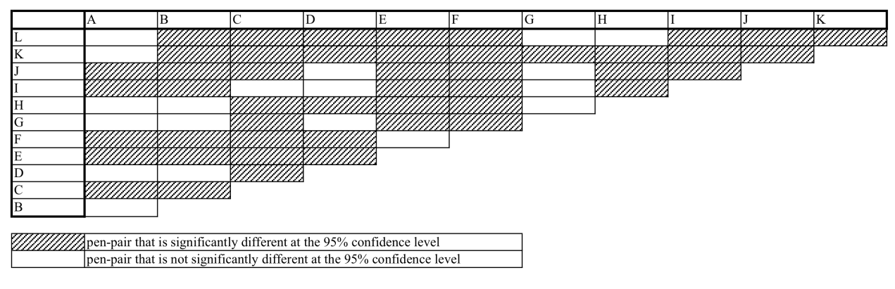
Figure 3. Matrix showing summary result of differentiation of blue ballpoint pen inks based on UV-Vis spectra via one way ANOVA analysis

Comparison of UPLC and UV-Vis spectroscopy techniques
The DP of UV-Vis spectrometer (71.21%) was determined to be lower than that of UPLC (98.48%). There were nineteen pen-pair that cannot be differentiated based on their UV-Vis spectra. Obviously, A-B was the only one pen-pair that was indistinguishable by both techniques. This might indicate that both varieties of pen inks were containing highly similar ink composition and this is supported by the fact that they are coming from the same manufacturer, i.e. Faber-Castell.

UV-Vis spectra showed information mainly about the major blue dye component. Previous studies have indicated that most of the major dye components of ballpoint pen inks have maximum absorption at wavelength more than 500 nm [3, 6-7]. As the chromatogram was scanned at wavelength below 500 nm, it only showed information about the ink components other than major dye components, i.e. additives. Additives are used for finely tuning the characteristics of the pen inks, including driers, plasticizers, waxes, greases, soaps and detergents [6].

Conclusion
In conclusion, the results of this study indicated that UPLC was more powerful than UV-Vis spectrometer as indicated by its high DP. In other words, the study demonstrated the ink components other than dyes, i.e. plasticizers, waxes, greases, were showing better differentiation ability. This might due to the fact that most of the pen manufacturers are using the same or highly similar dye, i.e. crystal violet.

Acknowledgement
A greatly thankful to all the science officers from forensic science program, Faculty of Health Sciences, UKM, for the support, equipment and facilities provided. The authors wish to thank Ms. Hartinah Annuar for revising the grammar of the article. This work has been kindly supported by the Fundamental Research Grant Scheme, Kementerian Pendidikan Malaysia (Grant No. FRGS/2/2013/ST06/UKM/02/1).

References
- Kher, A., Mulholland, M., Green, E. & Reedy, B. (2006) Forensic classification of ballpoint pen inks using high performance liquid chromatography and infrared spectroscopy with principal components analysis and linear discriminant analysis. Vibrational Spectroscopy 40(2): 270-277.
- Weyermann, C., Bucher, L., Majcherczyk, P., Mazzella, W., Roux, C. & Esseiva, P. (2012) Statistiscal discrimination of black gel pen inks analysed by laser desoprtion/ionization mass spectrometry. Forensic Science International 217: 127-133.
- Hofer, R. (2004) Dating of ballpoint pen ink. Journal of Forensic Sciences 49(6): 1353-1357.
- Senior, E. Hamed, M. Masoud, E. Shehata. 2012. Characterization and dating of blue ballpoint pen inks using PCA of UV-Vis absorption spectra, IR spectroscopy and HPTLC Journal of Forensic Sciences 57(4): 1097-1093.
- Weyermann, C., Marquis, R., Mazzella, W. & Spengler, B. (2007) Differentiation of Blue Ballpoint Pen Inks by Laser Desorption Ionization Mass Spectrometry and High‐Performance Thin‐Layer Chromatography. Journal of Forensic Sciences 52(1): 216-218.
- Thanasoulias, N. C., Parisis, N. A. & Evmiridis, N. P. (2003) Multivariate chemometrics for the forensic discrimination of blue ball-point pen inks based on their Vis spectra. Forensic Science International 138(1-3): 75-84.
- Lee, P.. & Di Gioia, A.. (2005a). Acquity UPLC seapration of triarylmethane ink dyes (part 1). Waters Corporation, Application note 720001262EN.

