

EFFECTS OF MODIFIED CHITOSAN TO THE PROPERTIES OF
POLY (N-ISOPROPYLACRYLAMIDE/O-NITROCHITOSAN) NETWORK

(Kesan Kitosan Terubahsuai Terhadap Sifat Rangkaian Poli (N-Isopropilakrilamida/O-Nitrokitosan))

Noriah Abdul Rahman¹ and Sharina Abu Hanifah^{1, 2}*

¹School of Chemical Sciences and Food Technology,
²Polymer Research Center,
Faculty of Science and Technology,
Universiti Kebangsaan Malaysia, 43600 UKM Bangi, Selangor, Malaysia

*Corresponding author: sharina@ukm.edu.my

Received: 4 December 2014; Accepted: 24 February 2015

Abstract
New chitosan derivative was successfully prepared that changed swelling property of NIPAAm based polymer network. An interpenetrating polymer network (IPN), N-isopropylacrylamide/O-nitrochitosan (NONK) was synthesized in the presence of ammonium persulfate using solution polymerization technique. Two compositions of IPN were used; 90% of NIPAAm and 10% of ONK (w/w) poly (NONK91) and 80% of NIPAAm and 20% of ONK (w/w) poly (NONK82). A new vibration of the C–N bond formed between NH from ONK and CH₂ from NIPAAm were detected at 1154 and 1171 cm⁻¹ using Attenuated Total Reflection Fourier-transform Infrared (ATR-FTIR) spectroscopy. The primary amine became a secondary amine, and the peaks of amide I (C=O peak) and amide II (N–H) were broadened. The structure of ONK was confirmed using Nuclear Magnetic Resonance (NMR). At 10 °C, it was found that IPN poly (NONK82) had the highest swelling percentage, 1171%, compared to poly (NIPAAm) at 467%. Micrograph from scanning electron microscopy (SEM) indicated large pores were formed on the IPN NONK surface when ONK ratio was further increased. ONK and NIPAAm, have good miscibility in polymer networks. This ONK contributes significant effect towards swelling behavior of NIPAAm.

Keywords: N-isopropylacrylamide (NIPAAm), O-nitrochitosan (ONK), Interpenetrating Polymer Network

Abstrak
Satu terbitan baru kitosan telah berjaya disediakan yang mengubah sifat pembengkakan polimer rangkaian berasaskan NIPAAm. Polimer rangkaian saling tembus (IPN) N-Isopropilakrilamida/O-nitrokitosan (NONK) disintesis dengan kehadiran ammonium persulat menggunakan teknik pempolimeran larutan. Dua komposisi IPN digunakan; 90% NIPAAm dan 10% of ONK (w/w) poli (NONK91) dan 80% NIPAAm dan 20% NIPPAm dan 20% ONK (w/w) poli(NONK82). Satu terbitan baru kitosan berjaya dilakukan, O-nitrokitosan (ONK) yang disintesis dari kitosan sebelum ia ditindak balas dengan N-Isopropilakrilamida (NIPAAm). Getaran baru bagi ikatan C-N terbentuk di antara NH dari ONK dan CH₂ dari NIPAAM dikesan pada 1154 dan 1171 cm⁻¹ menggunakan spektroskopi (ATR-FTIR). Amina primer menjadi amina sekunder dan puncak pada amida I (C=O) dan amida II (N-H) menjadi lebih lebar. Stuktur ONK dipastikan menggunakan NMR. Pada 10ºC , didapati IPN poli (NONK82) mempunyai peratusan pembengkakan paling tinggi, 1171 % berbanding poli (NIPAAM) pada 467 %. Mikrograf dari mikroskopi imbasan elektron mendapati liang besar terbentuk pada permukaan IPN NONK apabila nisbah ONK ditingkatkan. ONK dan NIPAAm mempunyai daya kecampuran yang baik apabila digabungkan dalam jaringan polimer. ONK menyumbang kepada kesan signifikan terhadap sifat pembengkakan NIPAAm.

Kata Kunci: N-isopropilakrilamida (NIPAAm), O-nitrokitosan (ONK), Polimer Rangkaian Saling Menembus

Introduction
Chitosan, a polysaccharide which composes of β-(1-4)-linked D-glucosamine units, has been derived from chitin through deacetylation process [1]. Chitosan and its derivatives are used in various fields: biomedical [2], pharmaceutical [3] and food industrial [4]. Currently, considerable attention is given to smart hydrogels that can undergo a reversible and discontinuous volume phase change in response to environmental stimuli, such as changes in pH and temperature [5, 6]. Among these hydrogels, poly N-isopropylacrylamide, poly (NIPAAm) is the most widely studied because it is temperature and pH responsive, which are crucial to the human body. Normally, this polymer is synthesized in a form of gel or beads. It is used for drug delivery, to separate the bioactive molecules and acts as a catalyst [7]. This polymer is unique because it has a low critical solution temperature (LCST) with approximately 30 - 32°C. In order to obtain other unique properties for applications such as drug delivery and biosensors, NIPAAm has been introduced into biocompatible and biodegradable chitosan. The advantage of chitosan over other polysaccharides (cellulose, starch and galactomannans) is that its chemical structure can undergo specific modifications at C-2 position [8].

The combination and conjugation of copolymers have the advantage of creating copolymers with improved properties [9]. For example, reaction of an AB-crosslinked graft copolymer based on maleilated chitosan with NIPAAm was carried out through a two-steps reaction [5]. Carboxymethyl chitosan-g-NIPAAm has improved its thermal and mechanical properties and water content [10]. In addition, poly (NIPAAm)/carboxymethyl chitosan (poly (NIPAAm)/CMCS) membrane has been synthesized as described in the literature Chen et al.(2007) with no change in the LCST shift when the CMCS is introduced into NIPAAm. The DSC and optical transmittance results indicate that hybrid hydrogel with low chitosan composition exhibits an obvious phase transition. The PNCM0.2 was not thermo-sensitive in distilled water but it showed discontinuous volume phase transition in pH 2 and a continuous one in pH 8 buffer.

In this paper, new chitosan derivative was successfully synthesized to use for the preparation of IPN (NIPAAm/ONK). The effects of chitosan modification will be discussed on the physical properties of IPN (NIPAAM)/ONK. ONK shows significant effect towards swelling behavior of NIPAAm based polymer network. ONK has improved the IPN swelling and deswelling in the lower temperature. This research study has potential in medical and pharmaceutical areas, mainly for the controlled release of drug. ONK can be one of biocompatible and biodegradable polymer for the future as CMCS.

Materials and Methods
Materials
Chitosan (Sigma Aldrich) was used as a raw material for the ONK synthesis. Both NIPAAm (Aldrich) and ammonium persulfate were stored at room temperature until used. Acetic acid (Systerm) and ethanol (Systerm) were used as solvents. Deionized water was used as a solvent during the polymerization procedure. All chemicals were used without further purification.

Synthesis of O-Nitrochitosan
The O-nitrochitosan (ONK) was prepared by adding five grams of chitosan to 100 mL of an isopropanol solution and stirring with a glass rod. Sodium hydroxide (50% w/v) was introduced drop wise over the first 10 min. The solution was stirred using a magnetic stirrer. After 1 hour, nitric acid was added drop wise while stirring. The solution was then submerged into water bath at 55°C for a few minutes. The solution was filtered and precipitated in methanol. 1 % acetic acid (v/v) was added until the solution achieved pH 7.0. ONK was purified via precipitation and washed with ethanol three times [11]. The product was filtered and dried in an oven for one day at 60°C.

Preparation of Poly (N-Isopropylacrylamide-O-Nitrochitosan) (NONK)
The NONK was prepared via solution polymerization of aqueous precursor solutions containing NIPAAm, ONK and ammonium persulfate (APS). Three different polymeric membranes with various monomer composition was prepared—100% NIPAAm (w/w), 90% of NIPAAm and 10% of ONK (w/w) poly (NONK91) and 80% of NIPAAm and 20% of ONK poly (NONK82). In a round-bottomed flask equipped with a magnetic stirrer, an individual mixture containing various quantities of NIPAAm and ONK were mixed with 1.6% w/w of APS initiator. The mixture was then dissolved in 5 mL of deionized water and purged with nitrogen gas for 10 minutes. Then, NONK was refluxed continuously for 7 hours at 70°C. Petroleum ether was used to wash the product.

Characterization Methods
Attenuated Total Reflection Fourier-transform Infrared (ATR-FTIR) spectroscopy was carried out using Spectrum 400 FTIR/FT-NIR spectrophotometer (Universal ATR). The spectra were collected in the range of 4000 to 650 cm⁻¹ over 64 scans with a resolution of 4 cm⁻¹. The measurements were made at room temperature on a diamond using a variable-angle ATR unit at a nominal incident angle of 458°. The optical alignment of the unit was set up to achieve a maximum throughput of the infrared beam to the detector. Samples, in powder form, were taken randomly from the whole sample. The curve-fitting simulations of the ATR-FTIR spectra were performed using the standard Origin 6.0 software package.

¹H and ¹³C NMR spectra were obtained from Bruker AVANCE III 600 MHz spectrometer. The ONK sample (5 mg) was diluted in 3 mL of CH₃COOH/D₂O (50:1, v/v). All analysis were performed at ambient temperature, 27 °C, using 16 scan pulse accumulation and an LB parameter of 0.30 Hz. The spectral width was 20 ppm with 65 K data points [12].

Dried NIPAAm, poly (NONK91) and poly (NONK82) hydrogels were immersed in deionized water at 4°C, 10°C and 60 °C in a closed container. The weight changes of the samples were recorded after 24 hours, and the percentage of water contents were then calculated using the following equation 1:

Weight of swelled sample – weight of the dried sample
Swelling ratio = x 100% (1)
Weight of the dried sample

At chosen times, the samples were taken out and carefully wiped with filter paper to remove any excess water prior to weighing [13].

Scanning Electron Microscopy (Carl Zeiss EVO MA10-SEM) was used to analyze the sample morphology. The samples (ONK, poly (NONK91) and poly (NONK82)) were prepared by freeze-drying under an argon gas flow and coated with a conductive layer of sputtered gold [14].

Results and Discussion
IPN hydrogels of poly (NIPAAm)/ONK were prepared via free radical polymerization in the presence of ONK. ONK was synthesized from chitosan. Figure 1 shows the reaction from chitosan to ONK. The product refers to ONK is a form of yellow powder with a darker and rougher texture compared to the pure chitosan. The synthesis was carried out in an alkaline sodium hydroxide medium. Under these conditions, the alcoholate anion was more reactive, and O-substitution occurs [13]. Figure 2 shows the reaction between the ONK and NIPAAm.

Figure 1. Synthesis scheme of O-nitrochitosan.

Figure 2. Synthesis scheme of IPN poly (NIPAAm)/ONK)

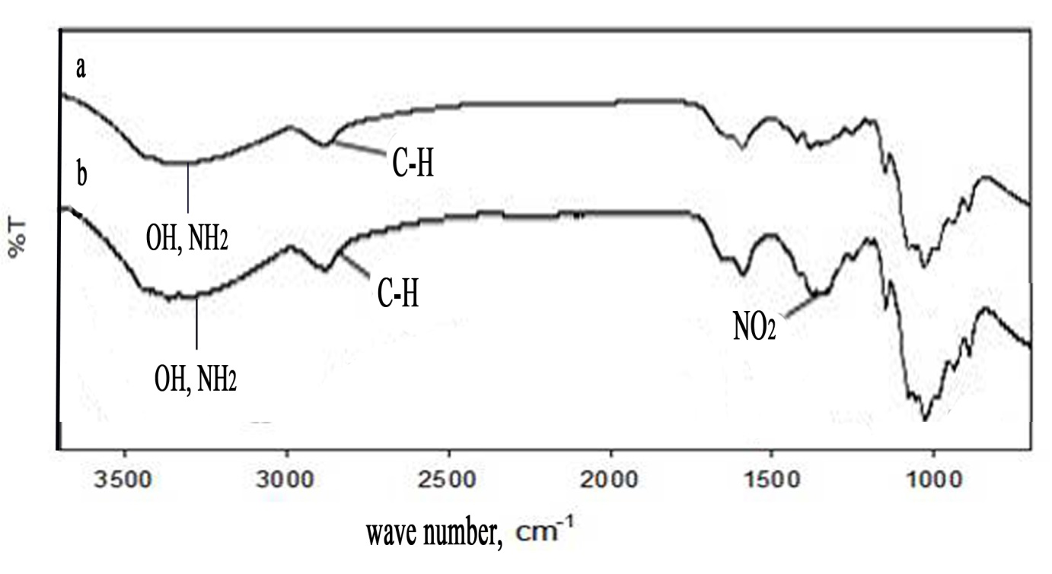

Figure 3. FT-IR spectra of (a) chitosan and (b) ONK

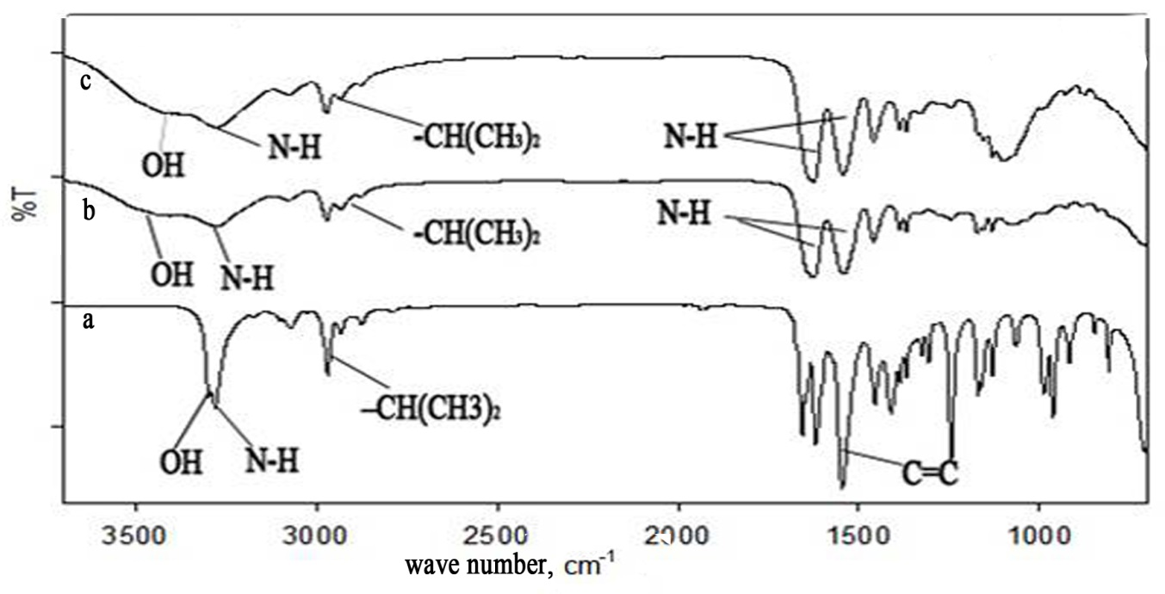
CH₃
N-H
C=C
C-N

Figure 4. FT-IR spectra of (c) poly (NONK82), (d) poly (NONK91) and (e) poly (NIPAAm)

Figure 3 provides the ATR/FTIR spectra for (a) chitosan, (b) ONK while Figure 4 provides the ATR/FTIR spectra for (c) poly (NONK82), (d) poly (NONK91) and (e) poly (NIPAAm). Generally, pure chitosan exhibit absorption bands of amide groups at 1650 cm⁻¹ (amide I, C=O stretching) and 1560 cm⁻¹ (amide II, N-H bending) [5, 7]. After synthesis of the ONK, the primary amine is converted to a secondary amine, which can be observed in the broadening of the amide I (C=O) and amide II (N-H) bands. Stretching of the secondary N-H appears at 1625 and 1542 cm⁻¹ [5, 9; 16]. Unlike chitosan, the ONK exhibits new bands at 1645 and 1348 cm⁻¹ confirming the attachment of nitro groups on chitosan by replacing the hydrogen atoms. The ATR/FTIR spectra of the ONK, poly (NONK82) and poly (NONK91) also exhibit new bands between the C-N and N-H bands that arise from ONK and CH₂ in the NIPAAm at 1154 and 1171 cm⁻¹, respectively, in the spectra in (b) and (c). The C=C band at 1650 cm⁻¹ in poly (NIPAAm), spectra (e) is no longer existed in the interpenetrating polymer network, poly (NIPAAm)/ONK in spectra (c) and (d) thus confirm the polymerization occurred. All samples exhibits one broad band at approximately 3400 cm⁻¹ representing a stretching band of C-H and O-H in all spectra. ONK and chitosan exhibit a type of C-H only which is present in aromatic ring. Poly (NONK82) and poly (NONK91) revealed several bands and exhibited types of C-H at approximately 3000 cm⁻¹ which refer to aliphatic C-H, methyl group (CH₃, at 1458 cm⁻¹) and methylene group (CH₂, at 1376 cm⁻¹ ) at both spectra (c) and (d) [7]. Isopropyl group in poly (NONK82), poly (NONK91) and poly (NIPAAm) can be observed at 2900 cm⁻¹ in spectra (c), (d) and (e) respectively [5, 10].

The confirmation of ONK structure was determined via NMR spectroscopy. The ¹³C-NMR spectra for ONK shows 6 signals attributed to 6 carbon atoms in ONK (Table 1). The total number of carbons of ONK is the same as in pure chitosan because no carbon atoms were added or changed. All spectra signal assignments are reported as in literature [17, 18, and 19]. Figures 4 and 5 show the ¹³C-NMR and ¹H-NMR spectra of ONK. ¹H NMR at δ_{H} 4.65 occurs as a singlet assigning to the anomeric proton on H_{1.} δ_{H} 3.01 (J= 8.7Hz, H₂) occurs as a triplet and δ_{H} 3.55, 3.60, 3.72 - 3.78 occur as multiplet dedicated to H₃ until H₆ owing to the neighbouring hydrogens.

The highest ¹³C-NMR signal at δ_{C} 97.52 (C₁) is assigned to anomeric C which attached to two O atoms. The signal shifts to the left because of the increasing electronegativity from the two O atoms that attached to C₁. The C₃, C₅ and C₆ are also attached to O, as indicated by the peak that appears at more than 50 ppm. The C₂ signal is assigned to C–N at δ_{C} 55.66. The signal at δ_{C} 76.19 indicated to C₄.

Table 1. Chemical shifts for carbon nuclei in O-nitrochitosan determined
by ¹³C NMR spectroscopy
Type of carbon | Position  (δ, ppm) | Original Chitosan  (K.Van de Velde 2004) | Original Chitosan  (Cardenas G.et al 2006)
C₁ | 97.52 | 104.6 | 98.32
C₂ | 55.66 | 55.8 | 56.95
C₃ | 69.99 | 74.2 | 70.92
C₄ | 76.19 | 83.6 | 78.07
C₅ | 74.66 | 76.1 | 75.74
C₆ | 59.78 | 61.4 | 61.43

Table 2. Chemical shifts for proton in (D₂O) nuclei in O-nitrochitosan determined
by ¹H NMR spectroscopy
Type of proton | Position (δ, ppm) | Original Chitosan  (Bhattarai et.al 2006)
H₁ | 4.65 | 4.9-5.2
H₂ | 3.01 | 2.95
H₃-H₆ | 3.55- 3.78 | 3.45–3.90

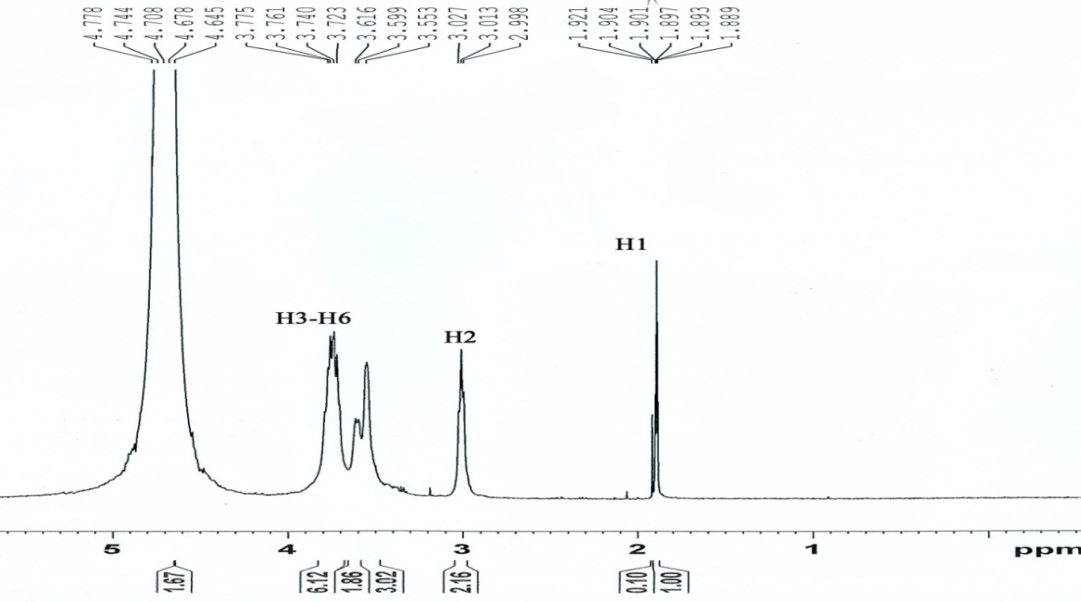
H1
H3-H6

H2

Figure 5. Spectra of ¹H-NMR of ONK

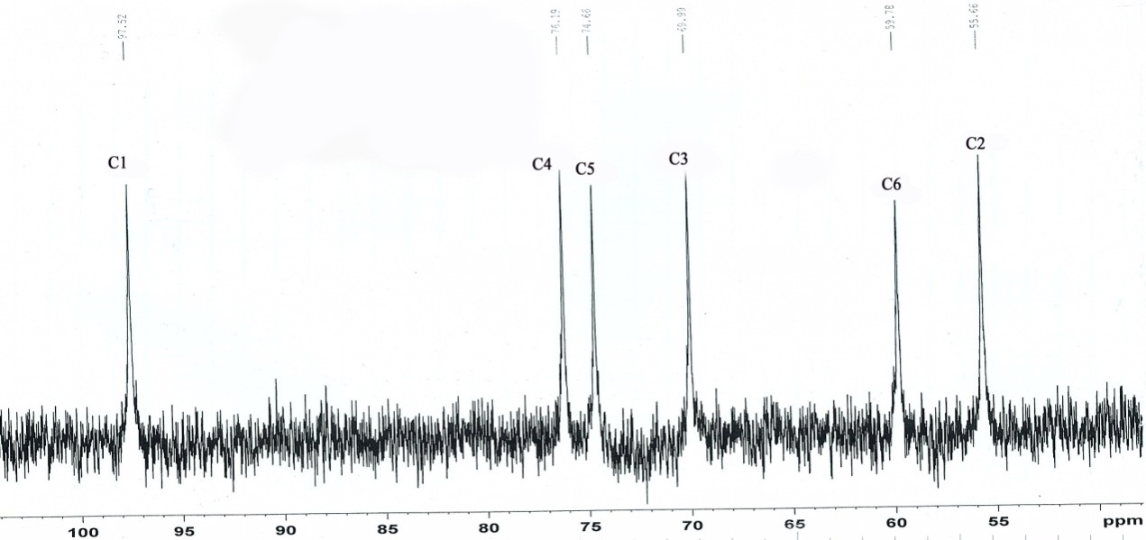

Figure 6. Spectra of ¹³C-NMR of ONK

Hydrogel swelling behavior has been studied with the temperature range between 10 and 60°C. The effect of temperature on the degree of swelling is shown in Figure 7. The swelling percentage of poly (NIPAAm) decreases slightly with increasing temperature. Generally, the swelling degree of hydrogels is affected by repulsive and attractive specific intermolecular interactions such as Van der Waals forces, hydrophobic interactions, hydrogen bonding and electrostatic interactions. The swelling degree of poly (NIPAAm) depends on the hydrophilic (CONH-) and hydrophobic (–CH (CH₃)₂) groups. At the LCST, the hydrophilic group (CONH–) becomes dominant through the formation of H-bonds between water and –OH, –NHCO, and –NH₂ groups in the hydrogel [7]. As the temperature increases, poly (NIPAAm) undergoes deswelling and most of the absorbed water is removed. This result could be due to the collapse of poly (NIPAAm) segments with the increasing temperature. The hydration of the gel is suppressed by interaction of the intermolecular, polymer-water hydrogen bonding with intramolecular hydrogen bonding involving poly (NIPAAm) alone [6]. As ONK was introduced into poly (NIPAAm), these hydrogels poly (NONK91) and poly (NONK82) exhibited a greater swelling capacity than the poly (NIPAAm). For example, poly (NONK82) facilitates water uptake by approximately 1171%, possibly due to additional hydrogen bonding interactions between chitosan and NIPAAm in the interpenetrating polymer networks. In addition, two competitive phenomena appear to determine the behavior of the gel; as the temperature rises, the hydration capacity of chitosan increases, whereas that of poly (NIPAAm) decreases as the segments collapse because of the temperature-controlled conformational transition [6]. The water content of poly (NONK82) also drops sharply when the temperature exceeded 25°C because of the hidrophobic groups (–CH (CH₃)₂) become dominant and break all the formation bonds between water and –OH, –NHCO, and –NH₂ groups in the hydrogel and squezze all the water out of the hydrogel. The same pattern is observed in the water, at the crosslinked chitosan-g-poly (NIPAAm) content when the temperature is greater than 30°C [5].

SEM provides morphological changes and miscibility of poly (NIPAAm)/ONK. The micrograph of the ONK, poly (NONK82) and poly (NONK91) surfaces are presented in Figure 8 at varying 1000× and 10,000× magnifications. According to Nagahama and co-workers, the surface morphology of a chitosan membrane is smooth with no large pores on the surface. This smooth surface is due to the presence of chitosan hydrogels in the membrane. In this study, ONK exhibits a smooth texture with no pores, unlike poly (NONK82) and poly (NONK91), which have pores and smoother textures. Furthermore, poly (NONK82) has more homogeneous morphology than poly (NONK91) with some holes caused by the dispersion of ONK particles in the poly (NIPAAm) networks. This result is due to the increasing of ONK content from 10 to 20 wt% in NIPAAm. Therefore, morphology of poly (NONK82) exhibits dense and hmomogeneous surface. This observation proves the effectiveness of the intermolecular penetration between both ONK and poly (NIPAAm). Poly (NONK91) has a smoother texture and dense with few pores compared to poly (NONK82). As reported by Don and co-workers, A-B crosslinked graft copolymers based on a maleilated chitosan (MA-CS) and NIPAAm are smooth and dense. From these micrographs, we can conclude that both components, ONK and NIPAAm, have good miscibility in polymer networks. The hydrogel show good better miscibility when the ratio of ONK is increase.
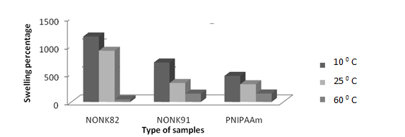

Figure 7. Swelling test of poly (NIPAAM), poly (NONK82) and poly (NONK91) 10 ºC, 25 ºC and 60 ºC in aqueous solution.

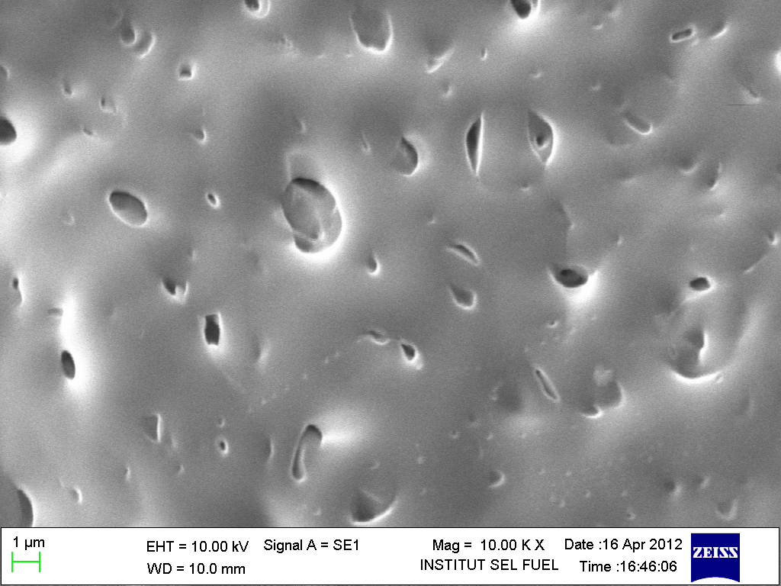
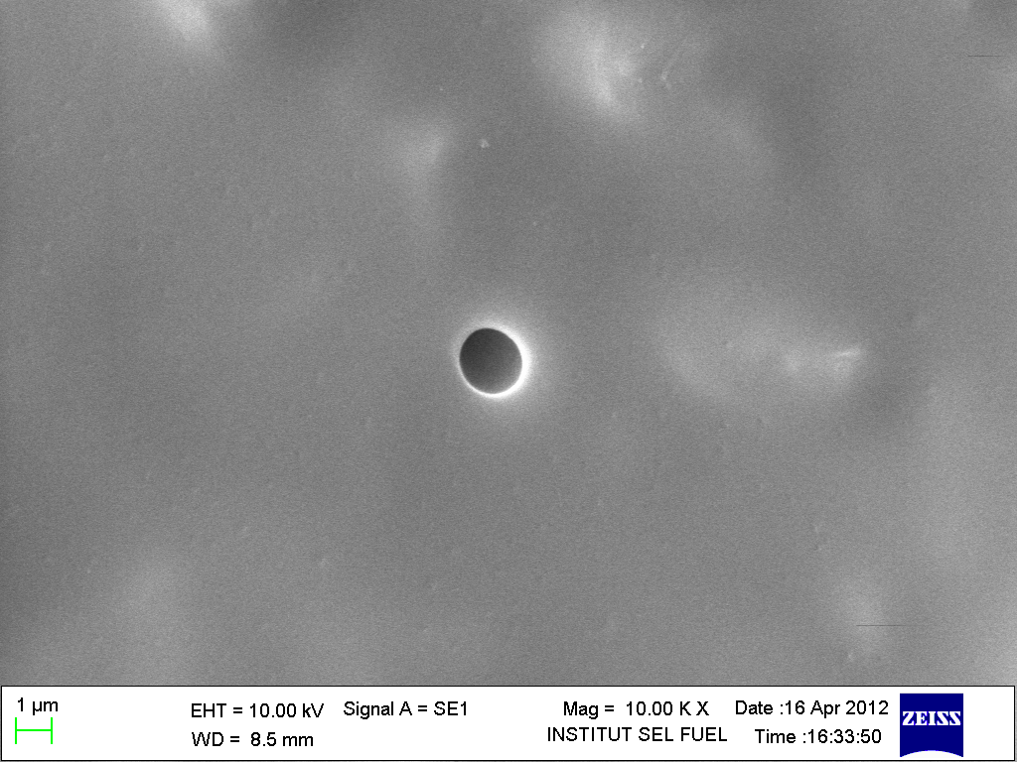
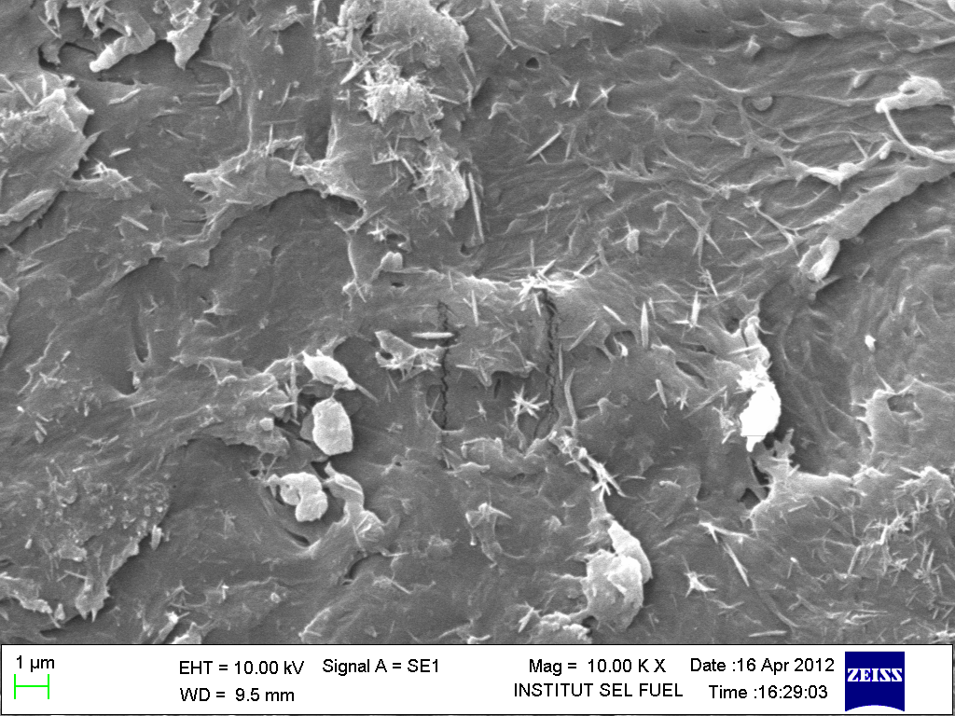
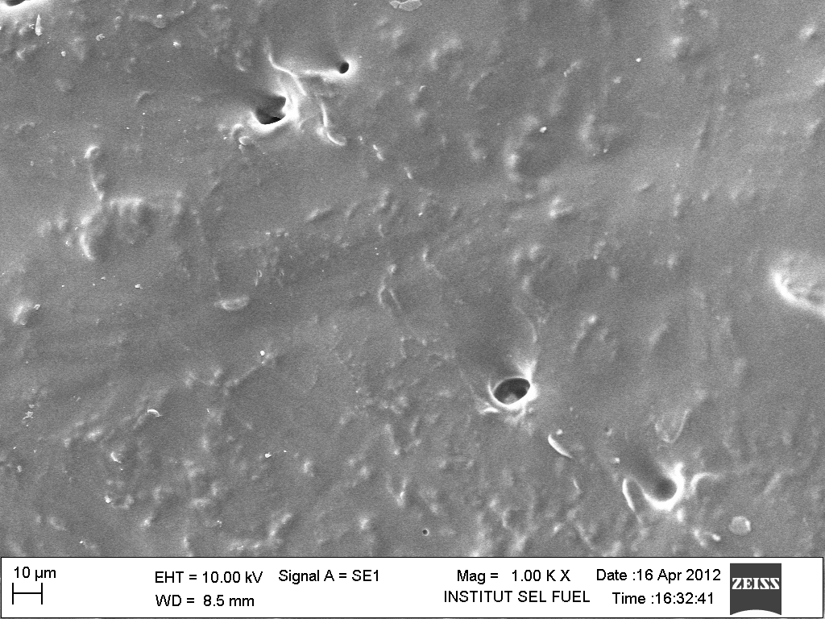
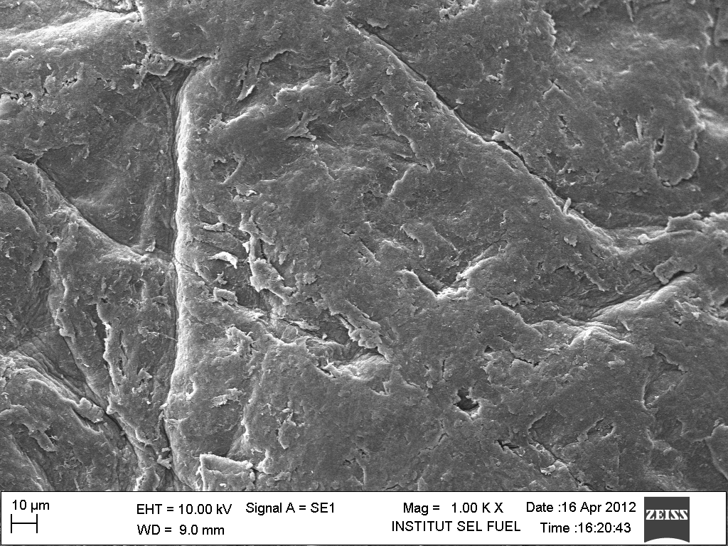
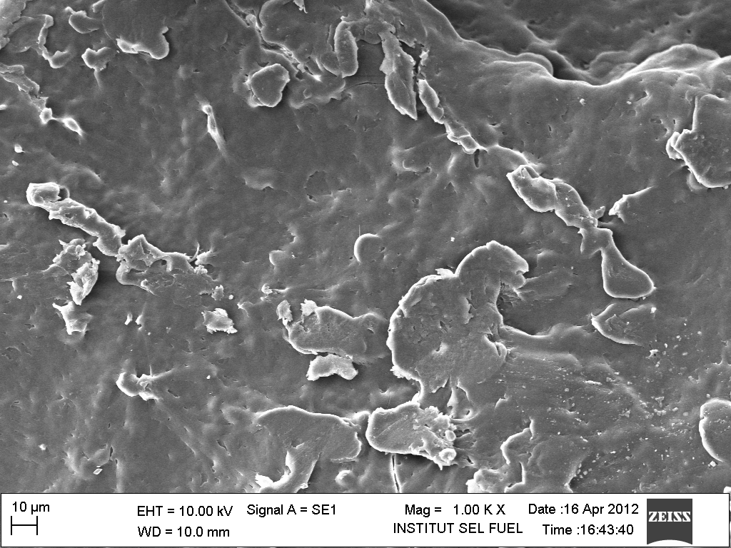
E
C
A

F
D
B

Figure 8. SEM micrographs for ONK surface (A, B), poly (NONK91) (C, D) and poly (NONK82)

Conclusion
In this study, interpenetrating polymer network of poly (N-isopropylacrylamide/O-nitrochitosan) was successfully synthesized using solution polymerization technique and ONK has been confirmed by ¹H and ¹³C NMR analysis. This chitosan derivative improved the properties of poly (NIPAAm) in swelling behaviour compared to poly (NIPAAm) hydrogel. This new IPN of poly (N-isopropylacrylamide/O-nitrochitosan) hydrogels exhibited thermoresponsive characteristic over that of the poly (NIPAAm) hydrogel. Finally ONK and NIPAAm also showed good miscibility as presented from the SEM micrograph.

Acknowledgement
The authors would like to thank to Universiti Kebangsaan Malaysia and Ministry of Education for supporting this research project under grant code FRGS/1/2013/ST01/UKM/02/2 and ICONIC-2013-004. Special thanks also to the School of Chemical Sciences and Food Technology, Faculty of Science and Technology and Fuel Cell Institute, UniversitiKebangsaan Malaysia for facilities.

References
- Kumar M.N.V.R. (2000). A review of chitin and chitosan applications. Reactive Functional Polymer. 46 (1): 1-27.
- Prabaharan, M. & Jayakumar R. (2009). Chitosan-graft-β-cyclodextrin scaffolds with controlled drug release capability for tissue engineering applications. International Journal of Biological Macromolecules 44(4): 320-325.
- Baldrick P. (2010). The safety of chitosan as a pharmaceutical excipient. Regulatory Toxicology and Pharmacology 56 (3): 290-299.
- Dutta, P.K.,Tripathi, S., Mehrotra, G.K. & Dutta, J. (2009). Perspectives for chitosan based antimicrobial films in food applications. Food Chemistry. 114 (4):1173-1182.
- Don, T.M, & Chen, H.R. (2005). Synthesis and characterization of AB-crosslinked graft copolymers based on maleilated chitosan and N-isopropylacrylamide. Carbohydrate Polymers 61 (3): 334- 347.
- Verestiuc, L. Ivanov, C. Barbu, E. & Tsibouklis, J. (2004). Dual-stimuli responsive hydrogels based on poly(N-isopropylacrylamide)/chitosan semi-interpenetrating networks. International Journal of Pharmaceutics 269(1): 185-194.
- Guo, B.L. & Gao, Q.Y. (2007). Preparation and properties of a pH/temperature-responsive carboxymethylchitosan/poly (N-isopropylacrylamide) semi-IPN hydrogel for oral delivery of drugs. Carbohydrate Research 342(16):2416-2422.
- Rinaudo, M. (2006). Chitin and chitosan: Properties and applications.Progress in Polymer Science 31(7): 603-632.
- Alli, A. & Hazer, B. (2008). Poly (N-isopropylacrylamide) thermoresponsive cross-linked conjugates containing polymeric soybean oil and/or polypropylene glycol. European Polymer Journal 44 (6):1701-1713.
- Zhang, H-F. Zhong, H. Zhang, L. Chen, S. Zhao, Y. & Zhu, Y-l. (2009). Synthesis and characterization of thermosensitive graft copolymer of N-isopropylacrylamide with biodegradable carboxymethylchitosan. Carbohydrate Polymers 77(4):785-790.
- Chen, J. Sun, J. Yang, L. Zhang, Q. Zhu, H. Wu, H. Hoffman, A.S. & Kaetsu I. (2007). Preparation and characterization of a novel IPN hydrogel memberane of poly (N -isopropylacrylamide)/carboxymethyl chitosan (PNIPAAM/CMCS). Radiation Physics and Chemistry 76 (8-9): 1425-1429.
- Zeng, M. Zhang, L. & Kennedy, J.F. (2005). Intermolecular interaction and properties of cross-linked materials from poly (ester-urethane) and nitrochitosan. Carbohydrate Polymers 60(3): 399-409.
- Han J. Wang K. Yang D. & Nie J. (2009). Photopolymerization of methacrylated chitosan/PNIPAAm hybrid dual-sensitive hydrogels as carrier for drug delivery. International Journal of Biological Macromolecules 44(3): 229-235.
- Guinesi, L.S. & Cavalheiro, E.T.G. (2004). The use of DSC curves to determine the acetylation degree of chitin/chitosan samples. Thermochimica Acta 444(2): 128-133.
- Lang, G. In: Zakaria, M, Muda W. M. W. & Abdullah, M. P. (1995). Chitin and Chitosan: The Versatile Environmentally Friendly Modern Materials, (ed) Universiti Kebangsaan Malaysia, Bangi,. p. 113.
- Caykara, T. Kiper, S. & Demirel, G. (2006). Thermosensitivepoly(N-isopropylacrylamide-co-acrylamide) hydrogels: Synthesis, swelling and interaction with ionic surfactants. European Polymer Journal 42 (2): 348-355.
- Van de Velde, K & Kiekens, P. (2004). Structure analysis and degree of substitution of chitin, chitosan and dibutyrylchitin by FT-IR spectroscopy and solid state ¹³C NMR Carbohydrate Polymers 58: 409–416.
- Cardenas, G. Cabrera, G. Taboada, E. & Rinaudo, M. (2006). Synthesis and Characterization of Chitosan Alkyl Phosphate. Journal of the Chilean Chemical Society 51(1): 1-8.
- Bhattarai, N. Gunn, J. & Zhang, M. (2010). Chitosan-based hydrogels for controlled, localized drug delivery. Advanced Drug Delivery Reviews 62: 83–99.
- Nagahama, H. Maeda, H. Kashiki, T. Jayakumar, R. Furuike, T. & Tamura, H. (2009). Preparation and characterization of novel chitosan/gelatine membranes using chitosan hydrogel. Carbohydrate Polymers 76 (2): 255-267.

