GYLCEROL CONVERSION OVER NOVEL FLUORINE-DOPED TIN OXIDE SUPPORTED CATALYST: EFFECT OF METAL LOADINGS AND GLYCEROL CONCENTRATION

(Penukaran Gliserol Menggunakan Timah Oksida Terdop Florin sebagai Bahan Sokongan Mangkin: Kajian Kesan Muatan Logam dan Kepekatan Gliserol)
Wan Zurina Samad^{1,2}, Wan Nor Roslam Wan Isahak¹, Norazzizi Nordin¹, Mohd Ambar Yarmo¹, Muhammad Rahimi Yusop¹*

¹School of Chemical Sciences and Food Technology, Faculty of Science and Technology, Universiti Kebangsaan Malaysia, 43600 Bangi, Selangor, Malaysia
²Department of Chemistry, Kulliyah of Science, International Islamic University Malaysia, Jalan Sultan Ahmad Shah, Bandar Indera Mahkota, 25200 Kuantan, Pahang, Malaysia.

*Corresponding author: rahimi@ukm.edu.my
Abstract
The catalytic activity of glycerol conversion to value-added chemicals was attempted using novel fluorine-doped tin oxide (FTO) as support material with ruthenium metal. The effect of metal loadings and glycerol concentration were investigated. Glycerol hydrogenolysis is generally done using a parr reactor with the presence of hydrogen gas. Furthermore, the reaction was carried out under a mild condition (150ºC, 8 hours, and 20 bar of hydrogen pressure). A series of metal loading of (1.5, 3.0, 4.5, 7.5, 9.0, and 11%) were prepared to observe the activity of glycerol conversion and selectivity of 1,2-propanediol as a major product. Meanwhile, glycerol concentrations at (20, 40, 60, and 80 wt%) were proceed to determine the capability of Ru/FTO catalyst to convert glycerol at lower and higher concentration. At the optimized results, metal loading of 7.5% give a better glycerol conversion (99%) and selectivity of 1,2-PDO at 94%. Meanwhile, Ru/FTO catalyst was observed to stabilize the highest glycerol conversion at average mean of 87% for every glycerol concentration.

Keywords: fluorine-doped tin oxide (FTO), glycerol hydrogenolysis, 1,2-Propanediol, metal loadings, heterogeneous catalyst

Abstrak
Aktiviti mangkin untuk penukaran gliserol kepada bahan kimia bernilai tinggi telah menggunakan timah oksida didopkan florin (FTO) sebagai bahan sokongan dengan logam rutenium. Kesan muatan logam dan kepekatan gliserol telah dikaji. Hidrogenolisis gliserol biasanya dilakukan dengan menggunakan reaktor tekanan (Parr) dengan kehadiran gas hidrogen. Tambahan pula, tindak balas ini dilakukan dengan parameter yang mudah iaitu (pada suhu 150ºC, 8 jam, dan 20 bar tekanan gas hidrogen). Satu siri muatan logam (1.5, 3.0, 4.5, 7.5, 9.0, dan 11%) telah disediakan untuk melihat kesan ke atas aktiviti penukaran gliserol dan kepilihan 1,2-propanadiol sebagai produk utama. Sementara itu, kepekatan gliserol pada (20, 40, 60, dan 80% berat) telah digunakan untuk menentukan keupayaan Ru/FTO sebagai mangkin untuk menukarkan gliserol. Analisis optimum yang diperolehi menyatakan, muatan logam sebanyak 7.5% memberikan penukaran gliserol yang lebih baik (99%) dan kepilihan 1,2-PDO pada 94%. Sementara itu, mangkin Ru/FTO diperhatikan boleh menstabilkan penukaran gliserol tertinggi iaitu dalam julat purata sebanyak 87% bagi setiap kepekatan gliserol.

Kata kunci: timah oksida terdop florin (FTO), gliserol hidrogenolisis, 1,2-Propanadiol, muatan logam, mangkin heterogen

Introduction
Glycerol is one of the chemicals abundantly produced from the renewable resources. It was produced by the transesterification reaction of vegetables oils such as palm oil fruits and animals fats to become biodiesel, at which glycerol is a co-product [1]. Glycerol was co-generated for the rate of 1 mol for every 3 mol of alkyl fatty ester synthesized [2]. The rapid development of biodiesel also causes the oversupply of the glycerol in nature [3]. Because of this drawback, it leads us to convert the glycerol to value-added chemicals in order to sustain our society. There are many chemicals can be produced by hydrogenolysis of glycerol such as ethanol, methanol, diols product (1,2-Propanediol (1,2-PDO), 1,3-propanediol (1,3-PDO), ethylene glycol (EG) and propanol (PrOH) [1-4]. 1,2-PDO has been discovered as the most attractive major product that can be produced from glycerol. This chemical is widely used especially as monomer for the polyester resins, in paints, cosmetics products, as an antifreeze agent, foods, and detergent [1, 3, 5].

Many noble heterogeneous catalysts such as monometallic catalysts, noble metal catalyst combined with an acid, noble metal catalyst combines with base, and bi-support catalyst have been applied to the glycerol hydrogenolysis [1]. Besides, the use of various metal such as nickel (Ni), Copper (Cu), Rhenium (Rh), palladium (Pd) and ruthenium (Ru) can also give a better selectivity of 1,2-PDO product [1,5-11]. A new proposed of the fluorine-doped tin oxide (FTO) as a new support catalyst combine with Ru metal was observed to have an extensively activity on glycerol conversion and also 1,2-PDO selectivity. The Ru/FTO catalyst was classified as an amphoteric catalyst which have both acid and basic site naturally. Furthermore, hydrogenolysis of glycerol involved the reduction process which is gain of electron. Thus, the properties of FTO itself as a semiconductor material [14] which have many delocalized electron were concluded as important factor that can leads to an electron transfer and inhibits a better glycerol conversion and selectivity.

Here, we observed the effect of metal loading of Ru/FTO catalysts, and also the glycerol concentration on the glycerol conversion and product selectivity. To the best of our knowledge, there are no others reports on the use of FTO as a support catalyst materials in hydrogenolysis of glycerol.

Materials and Methods
Chemicals
Glycerol (99.2%) and fluorine-doped tin oxide (FTO) were obtained from Fisher Chemicals and Keelings & Walkers. 1,2-PDO, EG, propanol, ethanol, methanol, n-butanol, 1,4-butanediol, ruthenium(IV)oxide (RuO₂) were purchased from Sigma Aldrich. All the chemicals and solvents were used as received without further purification.

Catalyst Preparation
A catalyst of various Ru metal loadings (1.5, 3.0, 4.5, 6.0, 7.5, 9.0, and 11%) was prepared by simple intercalation method. 1.0 g of FTO and 0.1 g of RuO₂ was added to a 28 ml sample bottle. Methanol (15 ml) was then added in the mixture and left under heat and stirring at 80ºC overnight. After stirring, the color of catalyst changed from white to grayish-black which suggested that the Ru metal was successful intercalated inside and around the FTO support. The solvent was removed and the precipitate was dried in oven at 100ºC. After that, the synthesized 7.5% of Ru/FTO catalyst was calcined at 450ºC for 3 hours (for reduction process of Ru⁴⁺ to Ruº).

Catalyst Characterization
The crystallinity and the structure of catalyst were analyzed by X-Ray Diffractogram (XRD), within theta (2θ) = 20 to 80º. The transmission electron microscope (TEM) was used to observe the particle size of the catalyst; meanwhile, the composition study was recorded using electron dispersion X-ray (EDX) and X-ray photoelectron spectroscopy (XPS) respectively. Furthermore, BET instrument was used to determine the specific surface areas which measured by N₂ adsorption-desorption method.

Hydrogenolysis of Glycerol
The glycerol hydrogenolysis was carried out by using 50 ml of Parr reactor setup with a mechanical stirrer, and hot plate with thermocouple wire. The various glycerol concentrations (20, 40, 60, and 80 wt% glycerol) were prepared by simple mixing method. 4.0 g of glycerol was diluted in 20 ml of deionized water (20 wt %) and was sequentially added in the sample holder together with 1.0 g of catalyst. Then, the reactor was sealed and flushed with nitrogen gas to remove the impurities and air. Next, the reactor was heated at 150ºC, pressurized to 20 bar of hydrogen and applied for 8 hours. The resulting products (solution) was collected with separation technique using centrifugation at 4000 rpm for 15 min. SPME technique was carried out to extract the products and ready to be employed for gas chromatography-Flame Ionization Detector (GC-FID) analysis and proceed with the calculation of conversion and selectivity

Results and Discussion
Catalyst Properties
Particles size and surface morphology of the Ru/FTO catalyst and naked FTO were analyzed using TEM and FE-SEM, were shown in Figure 1. The TEM image (inserted 1a) shows clear distribution of Ru/FTO catalyst with significant differences between the cluster of FTO as a support and Ru metal.

FTO cluster was seen to have bigger particle size at range of 20 to 80 nm compared to Ru metal. Ru cluster was observed by the existence of black tiny spot detected around and inside the FTO cluster with particle size ranging at 1 to 3 nm respectively. Meanwhile, the particle shape was determined as having a mixture of sphere and tetragonal forms.

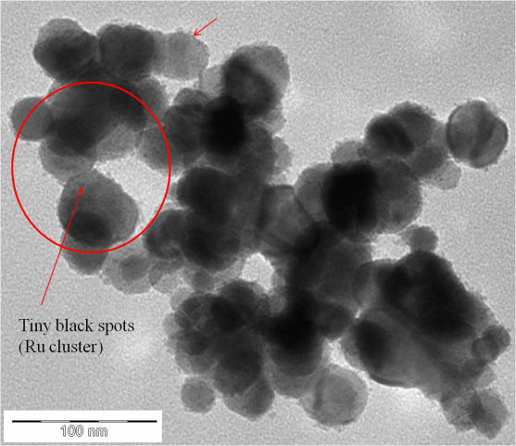
(a)
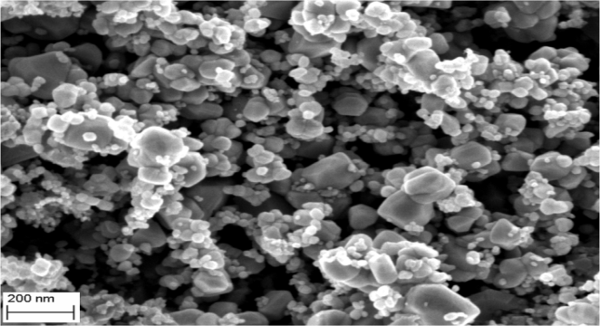
(b)
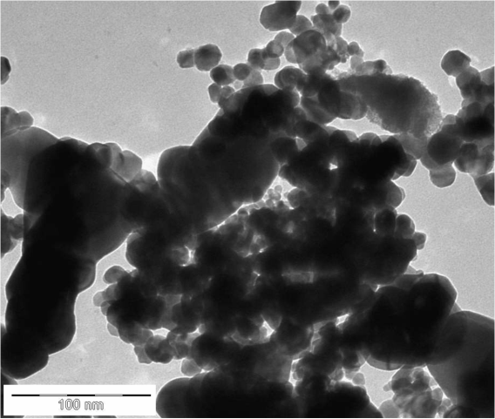
(c)
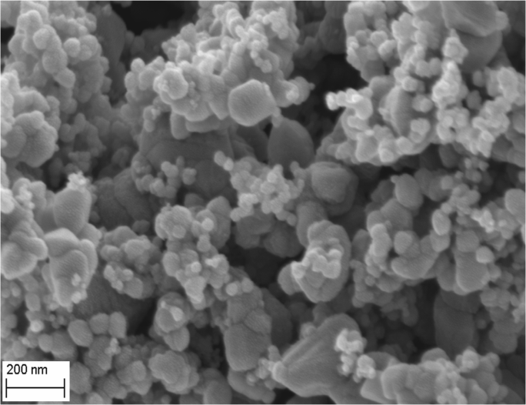
(d)
Figure 1. TEM and FE-SEM morphology of (a,b) Ru/FTO catalyst and (c, d) naked FTO
Besides that, the surface morphology studies also fit well on the catalyst shape with TEM results. Naked FTO (without metal) was done as a comparison study. There are no Ru metal cluster detected on naked FTO and the particle sizes were recorded at range of 30 to 80 nm.
XRD and EDX analyses were used to analyze the crystalline properties and composition of the Ru/FTO catalyst. The XRD study on metal loading was showed in Figure 2. It shows that, with the increasing of metal loading (%), will cause the increasing on diffractogram intensity, which means that the crystallinity properties of the sample is well defined. It is also might be due to the addition of metal cluster in the FTO support which can improve the formation of crystal lattice and also become highly pure. The XRD diffractogram also shows that the diffraction peaks belongs to the FTO phase [JCPDs num: 41-1445/30-1375] and ruthenium oxide (RuO₂) phase [JCPDs num: 87-0726] respectively.
There are no new significant peak appeared when Ru metal was added. It was assumed that the Ru cluster peaks were overlay with FTO cluster and also it is because of the small particle size of Ru cluster in nature. This result has been proved by TEM analysis which it was detected that the size of Ru cluster at range of 1 to 3 nm (inserted figure 1a). Furthermore, it has been proved by the XRD analysis on the RuO₂ itself where the diffractogram shows the amorphous and broader peak at theta range of 30 to 50º (diffractogram not included).
However, there are some of peaks shifting observed which it is attributed to the successful of Ru cluster intercalation in the FTO support. Ru cluster was assuming is well dispersed on the FTO surface [5] and also inside the FTO pores. The peaks shifting were observed at theta of (30 to 40º, 50 to 60º, and 78 to 80º).
Figure 2. XRD patterns of Ru/FTO catalyst with different metal loadings
The composition study of the catalyst was analyzed by using EDX instrument. The result shows the existence of all expected elements such as tin (Sn), Oxygen (O), fluorine (F) and ruthenium (Ru). Figure 3 shows the summary of the elements composition by EDX. Besides that, the mapping analysis using EDX (figure not included) shows that the Ru cluster have well distribution on the FTO support which concluding that FTO can function as a good materials to hold, spreading and stabilized the Ru metal on the surface and in the pores [5]
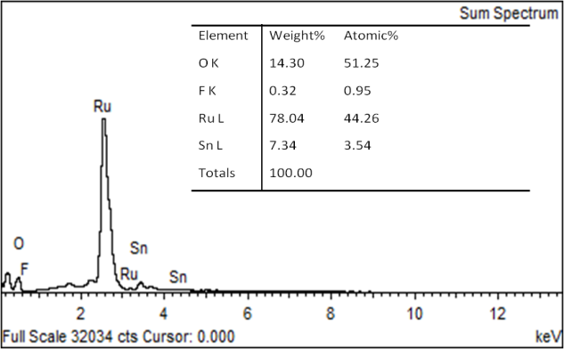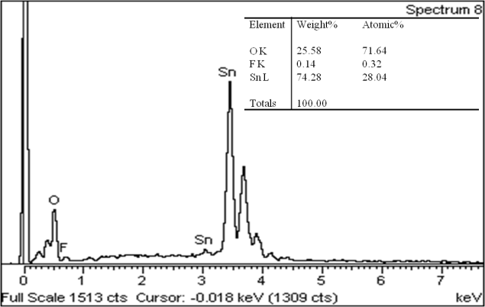
(a)
(b)
Figure 3. EDX spectrum of (a) Ru/FTO catalyst, and (b) naked FTO
Composition of naked FTO was also analyzed as a comparison with Ru/FTO catalyst. As for further research on the Ru/FTO catalyst properties, the surface area analysis was done using BET instrument with N₂ adsorption-desorption method. Table 1 display the summary results on surface area (S_{A}), pore volume (V_{p}) and pore diameter (D_{p}) of the Ru/FTO catalyst.
Table 1. Summarized results on surface area of Ru/FTO catalyst
Sample | S_{A} _{BET}, m²/g⁻¹ | V_{p}, cm³/g⁻¹ | D_{p} , nm
Naked FTO  7.5% Ru/FTO | 9.07  18.23 | 0.04  0.06 | 12.6  11.1

Table 1 shows that the surface areas of the catalyst increased upon Ru addition. Addition of Ru metal can generate the formation of new pores on the support surface. Other than that, it is also determined that the pore volume also increased two times bigger than in naked FTO. It might be due to the more Ru cluster can enter and widen the pores volume, thus produced bigger surface area for reaction to occur. Meanwhile, the pore diameter was slightly decreased from 12.6 to 11.1 nm after the addition of Ru cluster. Figure 4 depicted the diagram of the adsorption and desorption of naked FTO and Ru/FTO catalyst.
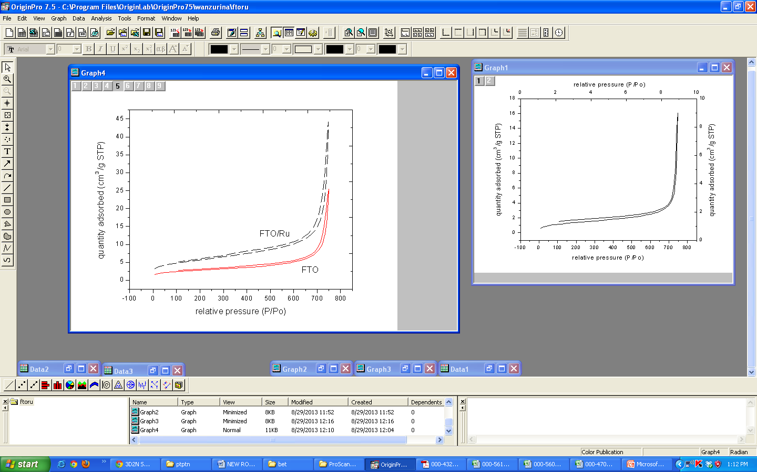

Figure 4. N₂ absorption-desorption isotherm of Ru/FTO and naked FTO

The BET diagram in Figure 4, demonstrated that the Ru/FTO catalyst can be classified as a mesoporous materials. In addition, the thermal stability of the Ru/FTO was done using TGA analysis (thermogram not included). The analysis was done at temperatures from 30 up to 800ºC, and using nitrogen gas. The thermogram shows that Ru/FTO catalyst was very thermal stable as there are no significant weight losses detected. There is only one small decomposition curve with 0.8839% degradation occurs. The main degradation curve was observed at temperature around 400ºC with the starting temperature of degradation was occur at 360ºC and stop at 430ºC. The degradation curve was assumed as loss of water bonding and probably some molecules of oxide and fluorine.
Meanwhile, for the naked FTO, the thermogram shows more thermally stable properties with none of the degradation curve detected. It can be summarized that FTO support is very thermally stable as been quotes by previous researcher [14] At the same time, the thermally stable properties also make FTO as one of the suitable materials for production of heterogeneous catalyst.
Catalyst Performance
The catalytic activity was investigated for hydrogenolysis glycerol under the mild condition of 150ºC, 20 bar, and 8 h. Meanwhile, the effect of metal loading effect (1.5, 3.0, 4.5, 6.0, 7.5, 9.0, and 11 %) and glycerol concentrations (20, 40, 60, and 80 wt %) were studied. There are some of the liquid and gases products produced such as 1,2-PDO (major product), propanol (minor product), EtOH (minor product), Gas products such as CH₄, C₂H₄, and C₃H₈ which formed by the excessive hydrogenolysis of glycerol were also obtained. For clarity, table 2, shows the summary of metal loading effect on glycerol conversion and selectivity of the 1,2-PDO product.
Table 2. Catalytic performance of Ru/FTO on different metal loadings

Metal loading (%) | Conversion (%) | Selectivity (%)
Metal loading (%) | Conversion (%) | 1,2-PDO | EtOH | PrOH
1.5  3.0  4.5  6.0  7.5  9.0  11 | 90.7  100  77  94  100  81.5  78 | 37  11  89.4  95  94  67.1  69 | 63  n.d  5.6  4.6  6.0  n.d  n.d | n.d  89  2.98  n.d  n.d  33  31
The reaction condition: 150ºC, 8 h, 20 bar. N.d = not determined
From the Table 2, it was observed that there are glycerol conversion happened from the lowest metal loading until highest metal loading. Figure 5 shows the diagram influence of metal loading on glycerol conversion and 1,2-PDO selectivity.
The average glycerol conversion was increased as the increases of metal loading. The highest conversion was recorded at 100%. This might be due to the acid sites of the catalyst where it was suggested that the acid support possesses a good ability to dehydrate glycerol [5]. As been reported in this paper, Ru/FTO catalyst is an amphoteric material which contains both acid and basic sites. This advantage was observed can maintain the conversion values.

Figure 5. Time course of glycerol hydrogenolysis by different metal loading
However, there is a decrease of conversion for the higher metal loading used which is at 9.0 and 11% respectively. FTO support itself was found to play a role in giving better conversion and it was proved by our previous work where naked FTO inhibit around 60% of glycerol conversion. It’s concluded that the addition of ru metal only achieved the conversion for 40%. It can be assumed that, support material contributed more on conversion than selectivity.
Meanwhile, the selectivity of 1,2-PDO was also observed to have increasing when the metal loading increased. The production of 1,2-PDO was observed to have lower selectivity at lower amount of metal loading especially at 1.5 and 3.0%. At this stage, the production of ethanol is much larger than 1,2-PDO. It is probably because the Ru cluster was not at optimum stage to convert glycerol to 1,2-PDO. Ru metal was defined as one of the suitable metal to produce 1,2-PDO has been done by previous researcher [10]. Ethanol has been produced as the major product at lower metal loading. After that, the pattern on selectivity change as the production of 1,2-PDO and PrOH increased when metal loading increased. The increasing of metal cluster on the support was assuming can enhance the trace amount of acrolein as intermediate for propanol production [1] (as shown in scheme 1). The optimum metal loading for 1,2-PDO production was detected at 7.5%, then it is declined when reach at 9 and 11% of metal loading.
Scheme 1: Chemical reaction for propanol production
Other than that, the stability of ru metal as a sources of acid sites was observed can increased the production of acetol as one of the precursor to produce 1,2-PDO [1] (as shown in scheme 2). The dispersion of active ru metal over support catalyst have been identified as one of the factor that can enhance the selectivity of 1,2-PDO.
Scheme 2: Chemical reaction for I,1-PDO production

Figure 6, shows the relationship between the glycerol concentration and hydrogenolysis glycerol performance. The amount of Ru/FTO catalyst used was fixed at 1.0 g and the glycerol concentrations were varied from 20 to 80 wt%. It is obvious that the glycerol conversion and 1,2-PDO selectivity decrease with glycerol concentration. Ru/FTO catalyst shows much higher catalytic activity at 20 wt% of glycerol concentration. The higher conversion and selectivity of 1,2-PDO was recorded at 100% and 94% respectively. It shows that every glycerol concentration needs a suitable amount of catalyst to give a better conversion and selectivity.

Higher glycerol concentration (80 wt%) was observed has the lower glycerol conversion (~60%) and 1,2 –PDO selectivity (~63%). This is might due to the lack of catalyst surface area for the reaction occurs. Probably almost ~80% of the catalyst which is supports side and metal site has been consumed in the glycerol bond dissociation process. This implied that the conversion of glycerol was associated with the number of actives sites as been reported by previous works of Ru/CsPW and Cu/ZnO [12-13]. However, this situation could be improved by increased the amount of the catalyst for uses of the higher glycerol concentration.

For comparison with the works done by Zhijie et al. [6], they used the 80 wt% of glycerol and 0.8 g of catalyst. They successfully reported the glycerol conversion and selectivity at 77% and 1,2-PDO at 92% but with different condition with our works. The condition used was a bit higher in temperature which is at 200ºC and 40 bar of hydrogen pressure. This concluded that temperature and hydrogen pressure also influences the glycerol hydrogenolysis. In our case, we would like to maintain the mild conditions which are at 150ºC and 20 bar of hydrogen pressure because Ru/FTO still can be a competent catalyst in the glycerol hydrogenolysis as the Ru/FTO catalyst was defined as an amphoteric catalyst and have better cycle ability.

Figure 6. Time course of glycerol hydrogenolysis by different glycerol concentration
For the recycle ability test, the reaction was done for five times cycle under the same reaction condition and with same Ru/FTO catalyst. The results of five successive reactions were summarized in Figure 7. After every typical run, the catalyst was separated from the liquid product using centrifugal force and filtration techniques. The reused catalyst was first washed with deionized water and dried before used. The recycle result shows that the recovered Ru/FTO catalyst was found to be active for the repeated reaction.
Figure 7. Bar chart of Ru/FTO catalyst cycle ability test
The conversion of glycerol was seen remained high and stable for all retested Ru/FTO catalyst which is at the range of ~90 to 100%. Moreover, the selectivity of 1,2-PDO have faced some decreases but still remained at moderate value which is at range of ~94 to 66%. This suggested that FTO support plays a good role for conversion and Ru metal for selectivity. Furthermore, it is might due to metal activation effect such as in situ reduction process that occurred during the recycle reaction [5, 12-13].
The falling percentage of selectivity was probably due to the less of surface active sites and loss of the catalyst amount respectively. The loss of the catalyst amount was observed from the separated and washed process. It is difficult to maintain the catalyst weight because there is probability where the catalyst powder is not well collected while washing and dried processes. The weight of the catalyst was observed to have a loss at range of 0.02 g for every cycle.
There are reverse observation where when the selectivity of 1,2-PDO decreased, the production of minor product (Propanol) will increased. It was observed that this situation might cause by the metal loading factor and it can be concluded that when the lower metal loading of Ru was used or when the Ru active site was decreasing, the hydrogenation process will have the C-C bond scission to another products and Ru metals was assumed as the major influence to produce the 1,2-PDO products [1,10].
Conclusion
The several of Ru metal loading (%) with FTO support provide a new platform on glycerol conversion and product selectivity. A 7.5% of Ru/FTO metal loading gave a high activity on conversion (100%) and 1,2-PDO selectivity (94%) under mild reaction condition. An assumption can be made where FTO itself was observed to play an important role in conversion process, meanwhile Ru sites for C-C bond dissociation of glycerol to produce 1,2-PDO. The amount of catalyst does affect the conversion of glycerol with different concentration. Higher concentration needs more amount of catalyst without changing the number of catalyst amount.
Acknowledgement
The authors would like to acknowledge the Islamic International University of Malaysia (IIUM) for a PhD scholarship, the ministry of higher education (MOHE) for a SLAB scholarship, and the Universiti Kebangsaan Malaysia for research grant no. AP/2012/017, DLP/2013/002 and FRGS/1/2012/ST01/UKM/02/1. We would also like to express our appreciation to CRIM UKM for their assistance in characterization via the TEM, SEM, XRD, BET, GC-FID, GC-MS, and TGA analyses. Finally, many thanks to all our associates especially Dr. Noraini Hamzah from UITM and laboratory staff for their support of this research.
References
1. Nakagawa, Y., Tomishige, K. (2011). Heterogeneous catalysis of the glycerol hydrogenolysis. Catal. Sci. Technol, 1: 179 – 190.
2. Werpy, T., and Peterson, G. (2004). Top value added chemicals from biomass. Volume I- results of screening for potential candidates from sugars and synthesis gas. U.S. Department of Energy
3. Bharat, N. C., and Raju, K. M. (2013). Development of Rate Expression for Glycerol Hydrogenation Reaction. Procedia Engineering, 51: 443-450.
4. Liu, L., Zhang, Y., Wang, A., and Zhang, T. (2012). Mesoporous WO₃ Supported Pt Catalyst for Hydrogenolysis of Glycerol to 1,3-Propanediol. Chinese Journal of Catalysis. 33 (8): 1257-1261.
5. Noraini, H., Norasikin, M. N., Ainol, H. A. N., Yah, A. N., Mohamad, B. K., and Mohd, A. Y. (2012). Enhanced Activity of Ru/TiO2 Catalyst Using Bisupport, Bentonite-TiO2 for Hydrogenolysis of Glycerol in Aqueous Media. Applied Ctalaysis A : General, 419-420: 133-141.
6. Zhijie, W., Yuzhen, M., Meng, S., Xiaoqian, Y., and Minghui, Z. (2013). Cu/boehmite: A Highly Active Catalyst for Hydrogenolysis of Glycerol to 1,2-Propanediol. Catalysis Communications, 32: 52-57.
7. Xinguo, C., Xicheng, W., Shengxi, Y., and Xindong, M. (2013). Hydrogenolysis of Biomass-Derived Sorbitol to Glycols and Glycerol Over Ni-MgO Catalyst. Catalysis Communication, 39: 86-89.
8. Hu, J., Liu, X., Wang, B., Pei, Y., Qiao, M., Fan, K. (2012). Reforming and Hydrogenolysis of Glycerol Over Ni/ZnO Catalysts Prepared by Different Methods. Chin. J. Catal, 33 (8): 1266-1275.
9. Huang, J., and Chen, J. (2012). Comparison of Ni₂P/SiO₂ and Ni/SiO₂ for Hydrogenolysis of Glycerol: A Consideration of Factors Influencing Catalyst Activity and Product Selectivity. Chin. J. Catal, 33 (5): 790-796.
10. Montassier, C., Menezo, J. C., Hoang, L. C., Renaud, C., and Brabier, J. (1991). Aqueous Polyol Conversion on Ruthenium and on Sulfur-Modified Ruthenium. J. Mol. Catal. 70: 99 – 110.
11. Vasiliadou, E. S., and Lemonidou, A. A. (2013). Kinetic Study of Liquid-Phase Glycerol Hydrogenolysis Over Cu/SiO₂ Catalyst. Chemical Engineering Journal. 231: 103-112.
12. Wang, S., and Liu, H. C. (2007). Selective Hydrogenolysis of Glycerol to Propylene Glycol on Cu/ZnO Catalyst. Catalysis Letters, 117(1-2): 62-67.
13. Ma. L., He, D., and Li, Z. (2008). Promoting Effect of Rhenium on Catalytic Performance of Ru Catalysts in Hydrogenolysis of Glycerol to Propanediol. Catalysis Communications, 9: 2489-2495.
14. Samad, W. Z., M. M. Salleh, A. Shafiee, M. A. Yarmo. (2011). Structural, optical and electrical properties of fluorine doped tin oxide thin films deposited using inkjet printing technique. Sains Malaysiana, 40(3): 251 – 257.

