MODIFICATION OF OIL PALM PLANTATION WASTES AS OIL ADSORBENT FOR PALM OIL MILL EFFLUENT (POME)

(Pengubahsuaian Sisa Kelapa Sawit Sebagai Bahan Penjerap Efluen Kilang Kelapa Sawit (POME))
Noraisah Jahi, Eng Siew Ling, Rizafizah Othaman and Suria Ramli*

School of Chemical Sciences and Food Technology, Faculty of Sciences and Technology, Universiti Kebangsaan Malaysia, 43600 Bangi, Selangor, Malaysia

*Corresponding author: su_ramli@ukm.edu.my
Abstract
This research was conducted to modify oil palm solid wastes chemically to become oil adsorbent for palm oil mill effluent (POME). The purpose of modification on oil palm leaves (OPL) and oil palm frond (OPF) was to change the hydrophilic nature to a more hydrophobic character. This study also exploited the production of sorbent materials with high efficiency in the oil uptake for POME from OPL and OPF. Chemical modification was carried out using 200 mL of 1.0 M lauric acid solution for 6 hrs at room temperature. The modified OPL and OPF were preceded to adsorption test for POME and the capacity of oil adsorbed was compared between them. FTIR analysis supported the modification to occur with the increase in a peak of C−H group and the presence of C=O originated from lauric acid structure chain. The hydrophobicity of modified OPL and OPF samples was supported by XRD and contact angle analysis with modified OPL became more hydrophobic than the modified OPF, which had been 38.15 % and 24.67% respectively. Both the analyses proved that the result from the oil adsorption test on POME showed the presence of a new peak attribute at C=C stretching of aromatics for the oil in POME proved that it was attached on the sorbent materials. Based on SEM analysis, the perforated and rough surface had been observed on modified OPL and OPF samples because oil layers on OPL and OPF surfaces were observed on the modified samples after the adsorption test. All the analyses in the study agreed that the results from oil adsorption test showed that the modified OPL had higher adsorption capacity than the modified OPF with the percentage of oil uptake at 83.74% and 39.84% respectively. The prepared adsorbent showed the potential to be used as a low-cost adsorbent in oil for POME.

Keywords: Oil palm plantation waste, palm oil mill effluent, chemical modification, adsorption material.

Abstrak
Kajian ini adalah untuk mengubahsuai sisa pepejal kelapa sawit secara kimia untuk dijadikan sebagai bahan penjerap sisa minyak dari efluen kilang kelapa sawit (POME). Tujuan modifikasi ke atas OPL dan OPF untuk mengubah sifat hidrofilik kepada sifat yang lebih hidrofobik. Pembangunan bahan penjerap daripada OPL dan OPF yang mempunyai kecekapan menjerap minyak dengan kapasiti yang tinggi adalah tujuan kajian ini. Pengubahsuaian secara kimia menggunakan 200 mL 1.0 M larutan asid laurik dengan masa tindakbalas selama 6 jam pada keadaan suhu bilik. Sampel OPL dan OPF terubahsuai menjalani ujian serapan minyak ke atas POME dan kapasiti minyak yang diserap dibandingkan. Analisis FTIR menyokong bahawa sampel OPL dan OPF berjaya diubahsuai menggunakan asid laurik dengan kehadiran puncak kumpulan C−H dan C=O yang hadir dari rantai struktur asid laurik. Kehidrofobikan sampel OPL dan OPF terubahsuai disokong oleh analisis XRD dan sudut sentuhan dengan memberi keputusan sampel OPL terubahsuai adalah lebih hidrofobik berbanding dengan sampel OPF terubahsuai dengan nilai masing-masing ialah 38.15% dan 24.67%. Kedua-dua analisis membuktikan keputusan ujian serapan miyak ke atas POME menunjukkan kehadiran kumpulan regangan C=C daripada minyak yang terjerap pada sampel OPL dan OPF terubahsuai. Keputusan analisis SEM juga memberi keputusan bahawa permukaan sampel OPL dan OPF terubahsuai kelihatan berliang dan kasar berbanding dengan sampel OPL dan OPF tidak terubahsuai kelihatan mempunyai permukaan yang lebih licin kerana terdapat lapisan minyak yang menyelaputi permukaan sampel OPL dan OPF. Semua analisis yang dikaji adalah sejajar dengan keputusan yang diperoleh daripada ujian serapan minyak mendapati sampel OPL terubahsuai mempunyai kapasiti penjerapan yang lebih tinggi berbanding sampel OPF terubahsuai dengan peratus minyak yang terserap masing-masing ialah 83.74% dan 39.84%. Kajian ini juga memastikan penghasilan bahan penjerap yang murah untuk aplikasi menyingkirkan minyak dalam POME.

Kata kunci: Sisa pepejal kelapa sawit, sisa efluen kilang kelapa sawit, pengubahsuaian kimia, bahan penjerap

Introduction
The plantation of oil palm is known as the second contributor for production of vegetable oil source after soy bean [1]. The production of raw palm oil has been increasing annually and has generated more biomass wastes, such as empty fruit bunch (EFB), mesocarp fiber, and oil palm kernel. The EFB consists of cellulose (40-50%), lignin (15-20%), hemicellulose (20-30%), and extract components [2]. Besides wastes from palm oil processing, wastes from plantation, such as oil palm leaves (OPL) and oil palm frond (OPF), are also increasing. Currently, the wastes are exploited to produce value added products, such as fuel gases, bio-plastics, organic acids, bio-compost, ply-wood, activated carbon, and animal stock [3]. Table 1 shows the chemical components of OPL and OPF.

Table 1. Chemical components in OPL and OPF

 | Palm oil leave (%) | Palm oil frond (%)
Holocellulose | 47.7 | 36.0
Cellulose | 44.5 | 35.0
Lignin | 27.4 | 29.0
Source: Sidik et al. (2012); Ofori-Boateng and Lee (2014)

Palm oil mill effluent (POME) is the wastewater generated from palm oil mill and it is terribly polluted [5]. POME is a concentrated liquid that is brown in color with temperature between 80-90ºC and pH between 4.0−5.0 [6]. It is also a colloid suspension that consists of about 95-96% of water, 0.6-0.7% (4000-6000 mg/L) of oil and grease, and 4.5% of solid sludge. The oil droplets can be detected in phase two, which is as supernatant or flouting on suspension layer. Oil extracted from POME consists of 84% of natural lipid and 16 % wt of complex lipid (6 % wt glycolipid and 10 % wt phospholipid) [4]. Oily wastewater of POME affects the aquatic life and gives problems during wastewater treatment [7].

On the other hand, sorbent material can perform adsorption or absorption [8]. The sorbent material to adsorb oil waste must be oleophilic and hydrophobic in character. Natural sorbent materials for oil sorption that are commonly used are cotton, bagasse, rice husk, barley straw, kapok, and wood waste. Generally, natural sorbent materials have high adsorption capacity and density compatible with synthetic sorbent materials. However, natural sorbent materials are comparatively cheaper because biomass wastes are abundant and have no economic value [9].

In this research, OPL and OPF were chemically modified to produce sorbent materials in treating POME. The sorption capacity of the modified and the unmodified sorbents was compared to evaluate the performance of the sorbents. The significance of the research is that it exploited the wastes (OPL and OPF) from the oil palm plantation to treat the effluent, POME. Furthermore, the OPL and the OPF were directly modified and were not chemically pre-treated.

Materials and Methods
Sample Preparation
Palm oil farm located in Malacca supplied the oil palm leaves (OPL) and oil palm fronds (OPF). Malaysian Palm Oil Board (MPOB) supplied POME. POME sample was collected from a cooling pond that had been an acidification pond. Chemicals that were used in this research included lauric acid (C₁₂H₂₄O₂) and sodium hydroxide (NaOH) from Sigma Aldrich company, and dimethyl sulfoxide (CH₃)₂SO and n-hexane (C₆H₁₄) from Fisher Scientific company. Dried OPL and OPF were grounded and sieved to obtain sample size within the range of 250-500 µm. Then, 200 mL of 1.0 M acid lauric was added with 2 g of OPL and OPF for modification. The mixture was stirred continuously for 6 hrs at room temperature. After that, hydrolase was filtered and was washed with n-hexane solvent. The sample was put in a universal oven at 80 ºC for overnight.

The weight percent gain (WPG) after modifying was calculated based on equation 1.

(1)

Then, 0.2 g of modified OPL and OPF were placed in a beaker containing 4 mL of distilled water and it was shaken for 3 min. Next, equivalent volume of n-hexane was added into the beaker and was continuously shaken for 3 min. After that, the sample was left for 5 min for separation phase to occur. Lastly, the modified OPL and OPF were collected from the solvent phase and were rinsed. The degree of hydrophobicity (DH) or modification was calculated based on equation 2.

(2)

Adsorption Test
The water content in the POME, prior to adsorption test, was determined. 13 mL of POME was dried in the oven at 60 ºC for 4 hrs to remove water content that was found in POME. Oil was extracted from POME using soxhlet extraction and n-hexane as solvent. Then, the solvent was evaporated by rotary vapor. The end product, which was oil residue, was collected and weighed (m_{i}).

The modified OPL and OPF were subjected for POME adsorption test. pH of the POME was adjusted to pH 7 with 0.1 M sodium hydroxide (NaOH). 0.5 g of modified OPL and OPF were added in the beaker containing 13 mL of POME. The sample was stirred at 70 rpm for 30 min at room temperature. After equilibrium was achieved, the sample was filtered and the residue was collected on a petri dish and was dried in oven until a constant weight was achieved. Then, oil adsorbed by OPL and OPF was extracted by n-hexane in soxhlet extractor for several hours until the color of n-hexane solvent was unchanged. Finally, n-hexane was evaporated by using rotary evaporator and the weight of the extracted oil (m_{f}) was measured. Then, the mass and the percent of oil absorbed by the modified OPL and OPF were calculated by using equations 3 and 4, respectively.

(3)
(4)
In order to investigate the change that occurred before and after the modification on OPL and OPF samples, FTIR, XRD, SEM, and contact angle analysis were used in this study. The modified OPL and OPF samples were used as sorbent materials to adsorb oil waste. The success of oil adsorbed by modified OPL and OPF was proven via FTIR, SEM analysis, and the percentage of absorbed oil data.

Results and Discussion
Weight percent gain (WPG)
Table 2 shows the weight percent gain (WPG) that could be accounted for the efficiency of modification on OPL and OPF. The results indicate that modified OPL had higher WPG values than modified OPF. This might be because the OPL sample has more OH active sites that commonly come from the main constituents, which are lignin, hemicelluloses, or holocellulose to be substituted with lauric acid (CH₃(CH₂)₁₀COOH)[10].

Table 2. Weight percent gain (WPG)

Sample | WPG (%)
OPL | 27.8
OPF | 22.4

FTIR Analysis
Figures 1 and 2 show the spectra of unmodified, modified, and after adsorption test of OPL and OPF, respectively. FTIR analysis determined the chemical structures of OPL and OPF before and after modification, and to confirm the presence of oil component that was attached on the OPL and OPF samples after adsorption test. A strong band in an average 3400 cm⁻¹ was attributed to the intra- and inter-molecular hydrogen bonded (O−H) stretching that occurred in cellulose that was found in unmodified, modified and modified sample after oil adsorption test OPL and OPF samples. Two peaks that were observed between 2970 and 2855 cm⁻¹ were assigned to the presence of C−H asymmetry stretching of CH₃ and CH₂ groups [10] for all OPL and OPF samples. The presence of a peak observed at 1750 cm⁻¹ on the modified OPL and OPF is attributed to the stretching of the carbonyl group [11]. The vibration of C=C stretching mode was observed at 1632 cm⁻¹, may be attributed from aromatic structure in modified OPL and OPF sample. The band at 1400 cm⁻¹ may represent the C−H bending vibration mode that found in modified OPL and OPF sample after oil adsorption test[12]. The broad peak at approximately 1103 and 1060 cm⁻¹ showed the C−O−C stretching vibration of lignin and the C−O stretching of cellulose and hemicellulose, respectively [13].

The increase in the peak intensity of CH₃ and CH₂ groups after the modification of OPL and OPF with lauric acid suggested the successful impregnation of lauric acid into the OPL and OPF samples. This hypothesis was confirmed with the presence of a new peak at 1750 cm⁻¹, corresponding to the carbonyl group originated from the lauric acid chain with the deferent intensity. This result is in good agreement with the improvement of the hydrophobicity degree, as shown in Table 3, after the modification. In addition, it supported the increment in the weight of OPL after the treatment with WPG which was about 27.8% and 22.4% for OPL and OPF respectively. Thus, the increase in the hydrophobicity of OPL and OPF after modification with lauric acid increased the affinity of the modified samples to absorb more oil from POME.

A well-pronounced peak at 1632 cm⁻¹ is associated with the presence of C=C stretching of aromatics for the oil adsorption. The adsorption of oil was further evidenced by the presence of a new peak at 1400 cm⁻¹ after the adsorption, which represents the C−H bending of oil [14].

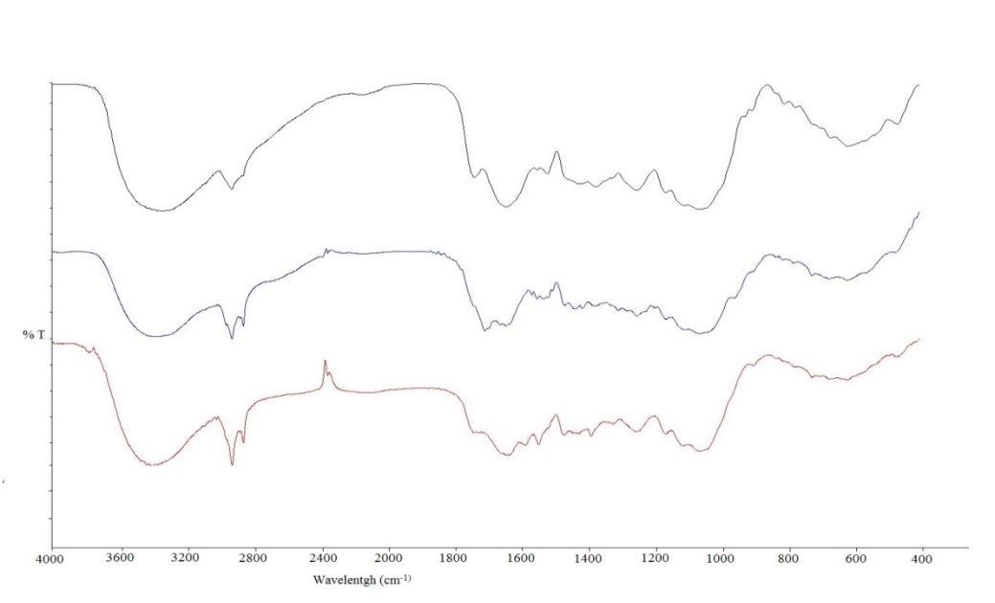
%T
C=H
C=C
C=O
C−H
C=O / N-H
(c)
(b)
(a)
C−O
C−O−C
C=C
C−H
O−H

Figure 1. FTIR spectrum for (a) unmodified OPL, (b) modified OPL, and (c) modified OPL after adsorption test with POME

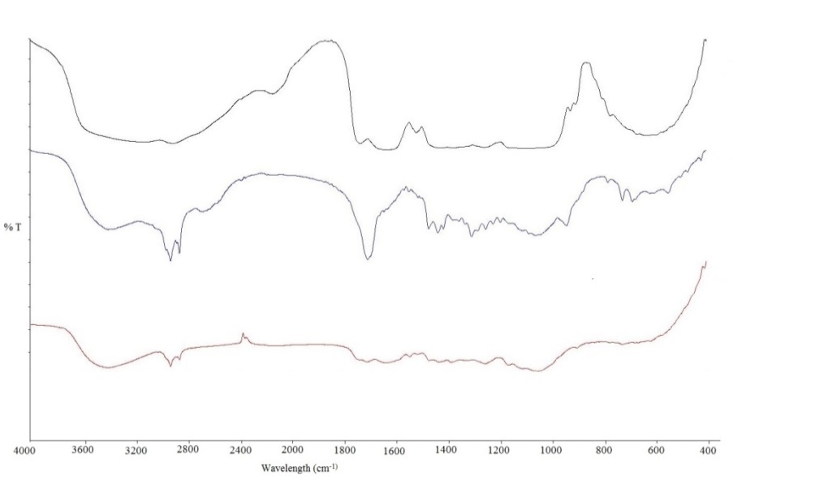
C=H
C=C
(c)
(b)
(a)
C−O
C−O−C
C=C
C=O
C=O/N−H
C−H
C−H
O−H
% T

Figure 2 FTIR spectrum for (a) unmodified OPF, (b) modified OPF, and (c) OPF after adsorption test with POME

X-ray Diffraction Analysis (XRD)

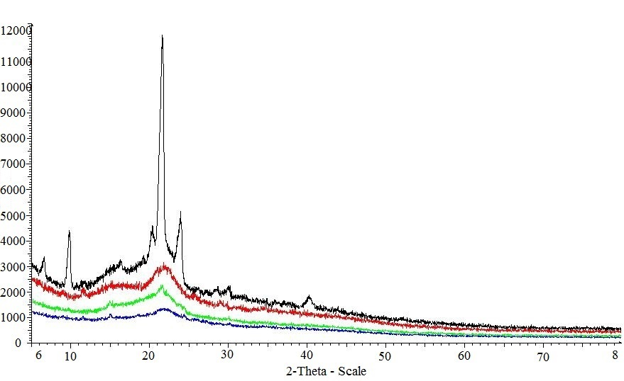
Lin (Count)
Unmodified OPL
Unmodified OPF
Modified OPL
Modified OPL

Figure 3. The intensity of crystallinity for OPL and OPF samples

XRD analysis was used to investigate the effects of chemical treatment on the crystallinity of OPL and OPF samples. Nazir et al. (2013) stated that the crystallinity for extracted cellulose showed high intensity of a peak at the 2$θ=$ 22.5. Based on Figure 3, the crystallinity decreased from 13.63% to 8.27% for unmodified OPL to modified OPL. This is caused by the degradation of cellulose structure during chemical modification [18]. The smaller diameter of cation in the reagent had been used for easier penetration into the cellulose structure [5]. Modification process by chemical treatment that occurs in cellulose chain can affect the cellulose component. It will become easier to dissolve and to be removed by solvent, and this is the reason for the decrease in the percentage of crystallinity after the modification of OPL sample [18]. Meanwhile, the percentage of crystallinity for OPF sample increased to 31.03% after chemical treatment because the cellulose and hemicellulose components in the OPF sample had been less than OPL sample, as the −OH active sites mostly exist on those components [5].

Contact angle

Figure 4. Contact angles for OPL and OPF samples

Figure 4 shows the contact angle of unmodified and modified OPL and OPF, respectively. Unmodified OPL and OPF are very hydrophilic because their contact angle was below 90 º. The hydrophilic property of the samples depends on −OH group found in the lignin and hemicellulose structures [20]. The contact angle for modified OPL and OPF samples is higher than unmodified OPL and OPF samples because more −OH active sites are substituted with lauric acid structure during modification and this affects the high hydrophobic character on the samples. The contact angle for modified OPL was 101.0 º which shows that the sample is hydrophobic. This is due to the substitution of hydrophobic tail from lauric acid at the −OH group on the OPL sample [21]. On the other hand, the contact angle for OPF was 58.5 º and it shows the surface modified OPF is less hydrophobic and is still hydrophilic probably because the modification did not occur completely. It also can be concluded that the active −OH sites on the OPF samples are lower than the OPL samples.

Degree of Hydrophobicity (HD)
Table 3 shows the degree of hydrophobicity calculated based on equation 2. DH is related to the percentage or the degree of substitution of −OH group by CH₃(CH₂)₁₀COOH on OPL and OPF samples. Based on the table, the DH values for both OPL and OPF had increased due to modification. However, modified OPL showed higher DH compared to modified OPF. This means that modification is higher for OPL since there are more active −OH sites on the samples. This result is in agreement with contact angle and XRD analyses. Since modified OPL is more hydrophobic, it is expected that it will absorb more oil and non-polar substituents in POME compared to OPF [22].

Table 3. The degree of hydrophobicity (DH)

Sample | DH (%)
Unmodified OPL | 1.5
Modified OPL | 29.4
Unmodified OPF | 2.7
Modified OPF | 23.2

Morphology Analysis
Scanning Electron Microscope (SEM) was used to investigate surface analysis on the unmodified and modified OPL and OPF samples. Figures 5 and 6 are the micrographs of OPL and OPF samples, respectively. Based on figures 5(b) and 6(b), the surfaces of modified OPL and OPF samples are rough, but comparatively smoother for unmodified OPL and OPF surfaces (figures 5(c) and 6(c)). During modification, the cuticle layer is removed by the chemical treatment process and causes rougher surface and more curvatures are formed on the surface of the sample [14]. The rough surface and perforated structure are the important characters for sorbent materials with high adsorption capacity [23].

After the adsorption test, the SEM micrographs showed wrinkled surface for the modified OPL sample, as shown in Figure 6(c), and covered surface for OPF in Figure 6(c). The wrinkled surface and the covered surface are indications that oil was absorbed by both OPL and OPF [14].

(a) (b)

(c)
Figure 5. Micrograph SEM for (a) Unmodified OPL, (b) Modified OPL, and (c) Modified OPL after adsorption test with POME

(a) (b)
(c)

Figure 6. Micrograph SEM for (a) Unmodified OPF, (b) Modified OPF, and (c) Modified OPF after adsorption test with POME

Oil Sorption Test
Generally, oil adsorption can happen in three steps, which are diffusion of oil molecule on the sorbent surface, trapping of oil molecule in the sorbent structure with capillary interaction, and the agglomeration of oil on the pores and rough sorbent material [23]. Comparison on the efficiency of adsorption for oil waste between modified OPL and OPF samples is shown in Table 4. Based on the result, modified OPL sample had better adsorbent feature compared to modified OPF with the efficiency of adsorption at 83.74%. As expected, the modified OPL sample had successfully absorbed oil at a higher capacity than OPL because it is hydrophobic in nature.

Table 4. The comparison of adsorption efficiency

Sample | Mass of adsorbed oil waste (g) |  | Adsorbed oil waste (%)
Modified OPL | 1.03 | 83.74
Modified OPF | 0.49 | 39.84

This causes more active −OH groups that are available to react with lauric acid CH₃(CH₂)₁₀COOH. Furthermore, high lignin OPF also decreases the efficiency of OPF to adsorb oil waste. Besides, lignin structures are difficult because their structures are very complex, have high molecule weight, and are insoluble [24].

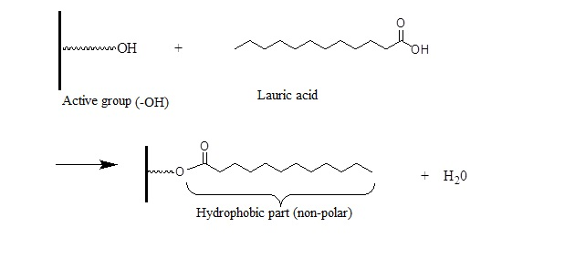

Figure 8. The illustration on the formation of hydrophobic layer

Conclusion
In conclusion, modified OPL showed the potential to be oil adsorbent for POME. The advantage of using OPL as an adsorbent in this study is that it is economical and solves problems due to the abundance of OPL to countries that produce palm oil, such as Malaysia and Indonesia. The successful impregnation of lauric acid into OPL and OPF samples was supported by all the analyses studied. The modification of raw OPL and OPF effectively enhanced their surface hydrophobicity, thus increased the adsorption capacity. The FTIR analysis supported the success of modification with the increase in a peak at C−H group and the presence of C=O that originated from lauric acid structure chain. The presence of a new peak at the modified OPL sample after the adsorption test attributes C=C stretching of aromatics of the oil proved that attachment has taken place on the sorbent materials. The results from XRD and contact angle analyses agreed with the results of oil adsorption test on POME, which showed that the modified OPL possessed more hydrophobicity characteristic than the modified OPF with the percentages of oil adsorbed were 83.74% and 39.84% respectively. Hence, the study showed that the modified OPL had higher efficiency to adsorb oil from POME with high capacity of oil uptake.

Acknowledgement
The author would like to thank the University Kebangsaan Malaysia and the Malaysian Ministry of Science, Technology, & Innovation (MOSTI) for the financial support given through GUP/2012/076 and FRGS/1/2013/SG01/UKM/03/.

References
- Rosalina Tan, R., Mohamed, S., Samaneh, G., Noordin, M., Goh, Y. and Manap, M. (2011). Polyphenol rich oil palm leaves extract reduce hyperglycaemia and lipid oxidation in STZ-rats. International Food Research Journal 18(1):
- Ariffin, H., Hassan, M. A., Shah, U. K. M., Abdullah, N., Ghazali, F. M. and Shirai, Y. (2008). Production of bacterial endoglucanase from pretreated oil palm empty fruit bunch by< i> bacillus pumilus</i> EB3. Journal of bioscience and bioengineering 106(3): 231-236
- Sumathi, S., Chai, S. and Mohamed, A. (2008). Utilization of Oil Palm as a Source of Renewable Energy in Malaysia. Renewable and Sustainable Energy Reviews 12(9): 2404-2421.
- Ahmad, A., Sumathi, S. and Hameed, B. (2005a). Adsorption of residue oil from palm oil mill effluent using powder and flake chitosan: equilibrium and kinetic studies. Water research 39(12): 2483-2494.
- Ngarmkam, W., Sirisathitkul, C. and Phalakornkule, C. (2011). Magnetic composite prepared from palm shell-based carbon and application for recovery of residual oil from POME. Journal of Environmental Management 92(3): 472-479.
- Ahmad, A., Sumathi, S. and Hameed, B. (2005b). Residual oil and suspended solid removal using natural adsorbents chitosan, bentonite and activated carbon: A comparative study. Chemical Engineering Journal 108(1): 179-185.
- Ahmad, A., Sumathi, S. and Hameed, B. (2006). Coagulation of residue oil and suspended solid in palm oil mill effluent by chitosan, alum and PAC. Chemical Engineering Journal 118(1): 99-105.
- Anon. (2012). Technical Information Paper. Impact PR & Design Limited, Canterbury 1-12.
- Wan Ngah, W. and Hanafiah, M. a. K. M. (2008). Removal of heavy metal ions from wastewater by chemically modified plant wastes as adsorbents: a review. Bioresource technology 99(10): 3935-3948.
- Teas, C., Kalligeros, S., Zanikos, F., Stournas, S., Lois, E. and Anastopoulos, G. (2001). Investigation of the Effectiveness of Absorbent Materials in Oil Spills Clean Up. Desalination 140(3): 259-264.
- Marín, A., Ortuño, J., Aguilar, M., Meseguer, V., Saez, J. and Lloréns, M. (2010). Use of Chemical Modification to Determine the Binding of Cd (Ii), Zn (Ii) and Cr (Iii) Ions by Orange Waste. Biochemical Engineering Journal 53(1): 2-6.
- Yang, H., Yan, R., Chen, H., Lee, D. H. and Zheng, C. (2007). Characteristics of Hemicellulose, Cellulose and Lignin Pyrolysis. Fuel 86(12): 1781-1788.
- Pandey, K. and Pitman, A. (2003). Ftir Studies of the Changes in Wood Chemistry Following Decay by Brown-Rot and White-Rot Fungi. International Biodeterioration & Biodegradation 52(3): 151-160.
- Sidik, S., Jalil, A., Triwahyono, S., Adam, S., Satar, M. and Hameed, B. (2012). Modified oil palm leaves adsorbent with enhanced hydrophobicity for crude oil removal. Chemical Engineering Journal 203(9-18.
- Wang, L., Han, G. and Zhang, Y. ( 2007). Comparative study of composition, structure and properties of< i> Apocynum venetum</i>fibers under different pretreatments. Carbohydrate polymers 69(2): 391-397.
- Hashim, R., Nadhari, W. N. a. W., Sulaiman, O., Kawamura, F., Hiziroglu, S., Sato, M., Sugimoto, T., Seng, T. G. and Tanaka, R. (2011). Characterization of raw materials and manufactured binderless particleboard from oil palm biomass. Materials & Design 32(1): 246-254.
- Gan, P. P., Ng, S. H., Huang, Y. and Li, S. F. Y. (2012). Green synthesis of gold nanoparticles using palm oil mill effluent (POME): A low-cost and eco-friendly viable approach. Bioresource technology 113(132-135.
- Ifuku, S., Nogi, M., Abe, K., Handa, K., Nakatsubo, F. and Yano, H. (2007). Surface modification of bacterial cellulose nanofibers for property enhancement of optically transparent composites: dependence on acetyl-group DS. Biomacromolecules 8(6): 1973-1978.
- Nazir, M. S., Wahjoedi, B. A., Yussof, A. W. and Abdullah, M. A. (2013). Eco-Friendly Extraction and Characterization of Cellulose from Oil Palm Empty Fruit Bunches. BioResources 8(2): 2161-2172.
- Anon. 2009. Contact Angle.
- Jonoobi, M., Harun, J., Mathew, A. P., Hussein, M. Z. B. and Oksman, K. (2010). Preparation of cellulose nanofibers with hydrophobic surface characteristics. Cellulose 17(2): 299-307.
- Cunha, A. G., Freire, C. S., Silvestre, A. J., Neto, C. P. and Gandini, A. (2006). Reversible hydrophobization and lipophobization of cellulose fibers via trifluoroacetylation. Journal of colloid and interface science 301(1): 333-336.
- Wahi, R., Ngaini, Z. and Jok, V. U. (2009). Removal of mercury, lead and copper from aqueous solution by activated carbon of palm oil empty fruit bunch. World Appl Sci J 5:84 -91.
- Pérez, J., Munoz-Dorado, J., De La Rubia, T. and Martinez, J. (2002). Biodegradation and biological treatments of cellulose, hemicellulose and lignin: an overview. International Microbiology 5(2): 53-63.
- Teas, C., Kalligeros, S., Zanikos, F., Stournas, S., Lois, E. and Anastopoulos, G. (2001). Investigation of the Effectiveness of Absorbent Materials in Oil Spills Clean Up. Desalination 140(3): 259-264.
- Marín, A., Ortuño, J., Aguilar, M., Meseguer, V., Saez, J. and Lloréns, M. (2010). Use of Chemical Modification to Determine the Binding of Cd (Ii), Zn (Ii) and Cr (Iii) Ions by Orange Waste. Biochemical Engineering Journal 53(1): 2-6.
- Yang, H., Yan, R., Chen, H., Lee, D. H. and Zheng, C. (2007). Characteristics of Hemicellulose, Cellulose and Lignin Pyrolysis. Fuel 86(12): 1781-1788.

