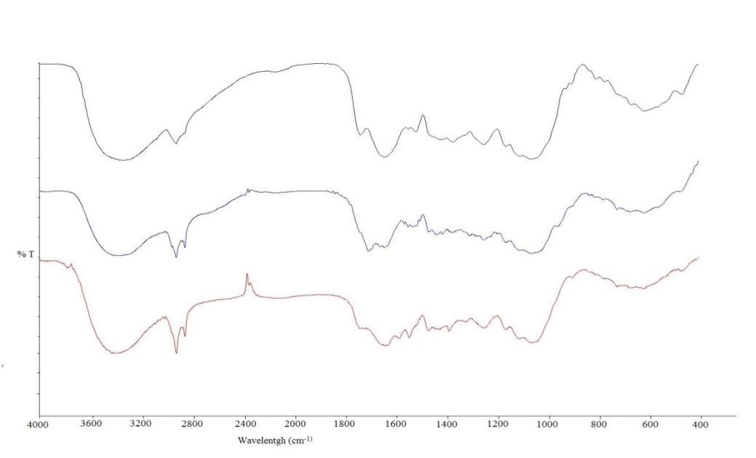
%T
O−H
C−H
C−H
C=O / N-H
C=C
C−O−C
C−O
(a)
(c)
(b)
C=O
C=C
C=H

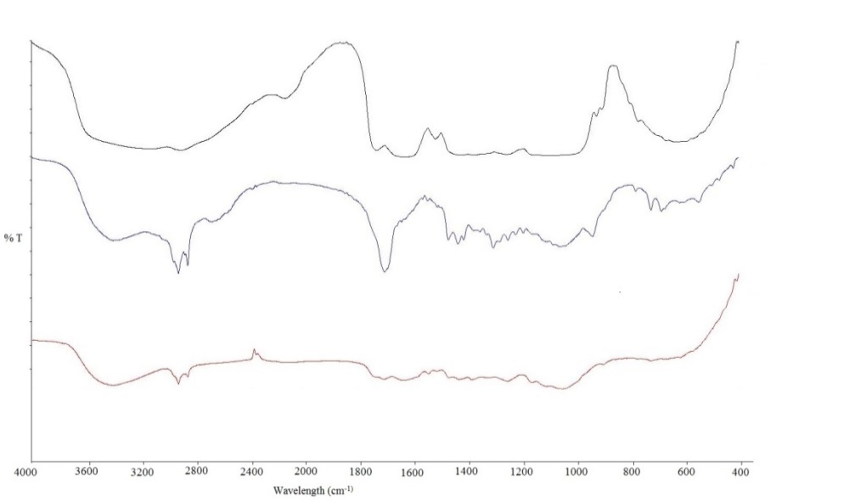
O−H
C−H
C−H
C=O/N−H
C=O
C=C
(a)
(c)
(b)
C−O−C
C−O
C=C
C=H

