PHASE BEHAVIOUR STUDY OF SWIFTLET NEST USING VIRGIN COCONUT OIL WITH NON-IONIC SURFACTANTS

(Penyelidikan Sifat Fasa Sarang Burung Walit Menggunakan Minyak Kelapa Dara dengan Surfaktan Tidak Bercas)
Siti Salwa Abd Gani^{1,2,3*} and Siti Zulaika Adisah¹

¹Department of Chemistry, Faculty of Science,
²Halal Product Research Institute,
³Centre of Foundation Studies for Agricultural Science,
Universiti Putra Malaysia, 43400 Serdang, Selangor, Malaysia

*corresponding author: ssalwaag@upm.edu.my
Abstract
Virgin coconut oil (VCO) is the oil that obtained from fresh and mature kernel of the coconut by mechanical or natural means with or without the application of heat, which does not lead to alteration of the nature of the oil. It have advantages such as strengthens the immune system because of its lauric acid content. It also has medium-chain fatty acids which heighten metabolism and energy, thus stimulating the thyroid. Swiftlet nest as an active ingredient need to be dispersed in a carrier system. Thus, ternary phase diagrams were constructed to find the suitable and stable system for it. The phase behavior of systems has been investigated by constructing ternary phase diagrams consisting of non-ionic surfactants/VCO:bird nest/water. The surfactants used were Sorbitan tri-oleate (Span 85), Sorbitan mono-oleate (Span 80), Sorbitan monolaurate (Span 20), Polyoxyethylene(20) sorbitan tri-oleate (Tween 85) and Polyoxyethylene (20) sorbitan mono-oleate (Tween 80). These systems include several phase regions such as homogeneous, isotropic, two-phase and three-phase regions. Different hydrophilic lipophilic balance (HLB) value of non-ionic surfactants exhibit different ternary diagram characteristics. A lower HLB shows a more oil-soluble and a more water-soluble surfactant (larger homogeneous and isotropic region in ternary phase diagrams) whereas high value of HLB shows the reverse of that result. The results show that the T85/VCO:bird nest/water system gave better performance than the other four individual surfactant systems. As a conclusion, high hydrophilic lipophilic balance (HLB) values of surfactant were found to be a
good surfactant for the formulation of VCO:bird nest emulsion for cosmetic and pharmaceutical purposes.

Keywords: virgin coconut oil, swiftlet nest, surfactant, emulsion

Abstrak
Minyak kelapa dara (VCO) adalah minyak yang diperolehi daripada kernel segar dan matang kelapa dengan cara mekanikal atau semula jadi dengan atau tanpa penggunaan haba, yang tidak membawa kepada pengubahan sifat minyak. Ia mempunyai kelebihan seperti menguatkan sistem imun kerana mempunyai kandungan asid laurik. Ia juga mempunyai rantaian sederhana panjang asid lemak yang meningkatkan metabolisma, tenaga dan merangsang tiroid. Sarang burung walit sebagai bahan aktif perlu dilarutkan dalam sistem pembawa bahan aktif. Oleh itu, gambar rajah fasa tiga segi telah dibina untuk mencari sistem yang sesuai dan stabil. Kelakuan fasa bagi sistem telah diuji dengan membina gambar rajah fasa segi tiga yang terdiri surfaktan bukan ionik / VCO: sarang burung / air. Surfaktan yang digunakan adalah Sorbitan tri-oleat (Span 85), Sorbitan mono-oleat (Span 80), Sorbitan mono-laurat (Span 20), Polioksiethilena (20) sorbitan tri-oleat (Tween 85) dan Polioksiethilena (20) sorbitan mono-oleat (Tween 80). Sistem ini termasuk beberapa kawasan fasa seperti homogen, isotropi, dua fasa dan wilayah tiga fasa. Nilai HLB (Keseimbangan sifat suka air dan minyak) surfaktan bukan ionik yang berbeza memberikan ciri-ciri yang berbeza pada rajah segi tiga. HLB lebih rendah menunjukkan sifat surfaktan larut air yang lebih (wilayah yang lebih besar homogen dan isotropik dalam gambar rajah fasa segi tiga) manakala nilai HLB yang tinggi menunjukkan keputusan sebaliknya. Keputusan menunjukkan bahawa T85/VCO: burung sarang sistem / air memberikan keputusan yang lebih baik berbanding empat sistem surfaktan yang lain. Kesimpulannya, HLB surfaktan yang tinggi baik untuk menyatukan VCO: emulsi sarang burung untuk tujuan kosmetik dan farmaseutikal

Kata kunci: minyak kelapa dara, sarang burung walit, surfaktan, emulsi

Introduction
Recently, there is a trend towards producing coconut oil which does not have to go through RBD (refined, bleached, and deodorized) process. Rather than going to the normal dry process, this oil is obtained by wet processing which entails the extraction of the cream from the fresh coconut milk and consequently breaking the cream emulsion. This process is more desirable as no chemical or high heat treatment is imposed on the oil. The coconut produced through the wet method is known as virgin coconut oil, VCO. The term VCO refers to an oil that is obtained from fresh, mature kernel of the coconut by mechanical or natural means with or without the use of heat and without undergoing chemical refining [1]. Unlike RBD coconut oil which is tailor-made for cooking purposes, VCO is marketed lately as functional oil. VCO is produced from freshly harvested coconut meat that has been and then either wet-milling or drying the residue and pressed to extract the oil [2]. VCO is effective base oil for composition within the lotion, cream, body butter and lip products formulations. It could be combined with hair oil formulations to increase the manageability of the oil. It is suitable for use as non-greasy, non-staining massage oil. VCO is also an excellent super fatting agent in cold process soap making [3].

Fatty acid composition of VCO was analyzed by gas chromatography. Fats were methylated with trimethylsulfonium hydroxide. Table 1 below is the composition of VCO.
Table 1. Fatty acid composition of VCO
Common name | Composition | Percentage (%)
Caproic acid | C 6:0 | 0.10 – 0.95
Caprylic acid | C 8:0 | 4 – 10
Capric acid | C 10:0 | 4 – 10
Lauric acid | C 12:0 | 45 – 56
Myristic acid | C 14:0 | 16 – 21
Palmitic acid | C 16:0 | 7.5 – 10.2
Stearic acid | C 18:0 | 2 – 4
Oleic acid | C 18:1 | 4.5 – 10
Linoleic acid | C 18:2 | 0.7 – 2.5

Source: Nevin, K. G. & Rajamohan, T. (2007) [4]

Other than virgin coconut oil (VCO), swiftlet nest is also one of the natural products used in this emulsion system. Swiftlet nest is obtained purely from saliva secretion. The swiftlet nest is usually found in caves near shoreline cliffs or under eaves of house and is hand-collected. The nests are purified before manufacturing. The swiftlet nest is scientifically named Aerodramus fuciphagus, known as Walet in Southeast Asia especially in Malaysia and Indonesia. From the appearance, swiftlet is about 9 centimeters in body length and has a shorter and rectangular-sharp tail. The average life expectancy of a swiftlet is about 15 to 18 years. Its age influence the quality of its nest. In general, the older the bird is, the higher the quality of the nest is. There are three categories of swiftlet nest. The first is the nests that are harvested from January to April which are the most expensive because they are big and thick, highly swollen and contain fewer impurities. The second category is the nests that are harvested during the dry season. Decreasing in food supply for the swiftlet, makes the swiftlet nest being thin and loose and the nest threads are thick. The shape and the swelling capacity of the nests are poorer than those in the first category. The last category is well within the drought season. During this period of the year the swiftlets are weak. Their secretion of the saliva is low and the feathers detached. The constructed swiftlet nests are smaller in size, containing greater impurities, such as in feathers and having a very poor swelling capacity [5].

A surfactant is a compound that able to lower the surface tension of a liquid, increasing the contact between the oil and water. They are chemical compounds which have parts that are both hydrophilic and hydrophobic. In fact, the word “surfactant” is a shortened form of the phrase “surfactant active agent” that referring to the fact that these substances interact with the surface of a liquid to change its properties [6]. They work through an adsorption process, which means that they stabilize on the surface of a liquid, creating a film that reduces its surface tension. Nonionic surfactants account for a very large percentage of worldwide surfactant use. They have been widely used in domestic and industrial detergents and related products [7]. Most nonionic surfactants are considered to be more effective in cleaning applications at low concentration and in removing oily soil from synthetic fabrics. Nonionic surfactants can be classified into three categories: polyethylene oxide, poly(ethylene/propylene) oxide and polyhydric alcohol, based on their hydrophilic groups. Most of nonionic surfactant analyses were mainly focused on the active ingredients and related products [8]. The examples of nonionic surfactants were Sorbitan tri-oleate (Span 85), Sorbitan mono-oleate (Span 80), Sorbitan monolaurate (Span 20), Polyoxyethylene(20) sorbitan tri-oleate (Tween 85) and Polyoxyethylene(20) sorbitan mono-oleate (Tween 80). All of these nonionic surfactants are in group of fatty acid esters of sorbitan and their ethoxylated deravatives [9]. The HLB value of Span 85 is 1.8, Span 80 is 4.3 and Span 20 is 8.6, while those of Tween 85 and Tween 80 are 11 and 15. The efficiency of a surfactant is not determined solely by the amphilicity; it also depends on the HLB characterictics for this compound [10].

The mixing of oil, water and surfactant in different ratio is able to produce different types of emulsion systems. They depend on the chemical nature, molecular structure and concentration of surfactants and other ingredients [11]. Non-ionic surfactants such as Tween and Span series are safe agents for all biological tissue in general and for skin in specific [12]. These non-ionic emulsifiers are compatible with various ingredients used in the preparation of emulsions and are not affected by pH. They supposed to have an enhancement effect on the skin barrier [13]. Construction of ternary phase diagrams is the best way to study all types of formulation. In this work, formulations of swiftlet nest with VCO using five different nonionic surfactants were constructed using ternary phase diagram in emulsion system.

Materials and Methods
Swiftlet nest was purchased from Habib Enterprise, Kuala Terengganu, West Malaysia. The compositions of swiftlet nest includes lipid (0.14-1.28%), ash (2.1%), carbohydrate (25.62-27.26%) and protein (62-63%) [14]. One of the major glyconutrients in swiftlet nest is sialic acid 9% (Colombo et al., 2003). Sorbitan tri-oleate (Span 85), Polyoxyethylene(20) sorbitan tri-oleate (Tween 85) and Polyoxyethylene(20) sorbitan mono-oleate (Tween 80) were purchased from Fluka Chemie GmbH, USA and Sorbitan mono-oleate (Span 80) from Sigma-Aldrich, Inc., USA,. Meanwhile, for Sorbitan monolaurate (Span 20), it was purchased from Merck Schuchardt OHG, Hohenbrunn, Germany. Virgin Coconut Oil (VCO) was obtained from Wellness Connections Sdn. Bhd., Malaysia. It contained 675.4 kCal of energy, 4.2% carbohydrates, 0.6% proteins and 95.2% fat for every 100mL of serving.

Swiftlet nest/VCO/nonionic surfactant/deionized water were weighed ranging from 0:100 to 100:0 (nest/VCO/nonionic surfactant:water (w/w)). The mixture with a total weight of 0.5g was placed in a 10mL screw-cap glass tube. The samples were then vortexed using vortex mixture for 5 minutes and then centrifuged for 15 minutes at 4000 rpm. The phase behaviors of the samples were examined through cross-polarized light. The experiment was repeated with the addition of deionized water according to its percentage from 0% to 100%. They were vortexed and then centrifuged again regularly after adding deionized water for every cycle. The phase behaviors were determined from visual observation after centrifuging. They were visualized straight away after centrifugation for 15 minutes. Centrifuging the samples are very good method to predict the stability of emulsions in a short time. The not stable emulsions were separated to two or three layer after centrifuging. The stable emulsions maintained their one phase homogenous milky colour or transparent without separation after centrifuging. Ternary phase diagrams were drawn accordingly.

Five nonionic surfactants were selected to construct ternary phase diagram of swiftlet nest and VCO. They were Sorbitan tri-oleate (Span 85), Sorbitan mono-oleate (Span 80), Sorbitan monolaurate (Span 20), Polyoxyethylene(20) sorbitan tri-oleate (Tween 85) and Polyoxyethylene(20) sorbitan mono-oleate (Tween 80). The HLB values of Span 85, Span 80, Span 20, Tween 85 and Tween 80 are 1.8, 4.3, 8.6, 11.0 and 15.0 respectively. Comparison among the ternary phase diagrams were made to see the changes that happened when the different HLB values of the nonionic surfactants were used.

Results and Discussion
In the study of phase behavior of swiftlet nest using VCO with respect to different non-ionic surfactants, five ternary phase diagrams were constructed. Each of the phase diagram is representing the phase diagram of water, VCO:swiftlet nest and surfactant with different HLB values. The changes of phase behavior were observed in the ternary phase diagrams.

Figure 1 shows the ternary phase diagram of Tween80/VCO:swiftlet nest/water. Tween 80 is hydropihilic in nature because the hydroxyl groups on the sorbitan ring are replaced and substituted with bulky polyoxyethylene groups. This substitution makes Tween 80 more soluble in water, so it tends to form O/W emulsion [15]. Figure 1 shows the presence of three regions with different percentage of mixtures, the regions were homogeneous (H), two phase (T) and three phase (T₁) regions. The homogeneous (H) regions were found along the apex line of deionized water from 5% to 92% and also at 25% to 42% T80 (w/w). Two phase region donated as T domain covers most of the T80 and VCO:SN apex line. This showed the instability and incompatibility in the emulsion system. The three phase region appeared at a water-rich corner and at low percentage of Tween 80.

In the ternary phase diagram of the system, the homogeneous region appeared along the apex line and in the area from 58% to 74% of deionized water. This is because Tween 80 formed larged O/W emulsion areas as compared to the other surfactants due to higher HLB value of 15.0 of Tween 80, which promoted the formation of O/W emulsion [16]. The formation of a one phase region suggested that the surfactant mixtures were able to lower the surface tension between the aqueous phase and oil phase, hence facilitate the formation of emulsions having a milky appearance [17]. Even though Tween 80 is the best surfactant to form an O/W emulsion in the system, the formations of two and three phases are still exists. This is due to the addition of swiftlet nest in the mixture of oil and surfactant. The nest might be unsuitable for the formulation of emulsions because of its properties that not allowed it homogenized well with oil and surfactant even though the duration to vortex/mixture was extended.

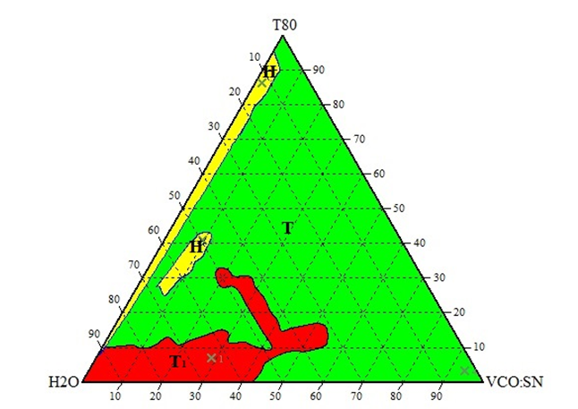

Figure 1. Ternary Phase Diagram of Tween 80/VCO:Swiftlet Nest/Water. (H – Homogenous region; T – Two phase region; T₁ – Three phase region)

The phase diagram of Tween 85/VCO:swiftlet nest/water is shown on Figure 2. Two distinct one-phase regions, L isotropic colorless fluids and H homogeneous were observed. The rest of the region consisted of two phase (T) and three phase (T₁) regions. The formation of two and three phase was due to the mixture being unable to mix well and formed one phase mixture. It might be the properties of the material itself that made it unable to formed one phase mixture. For example, swiftlet nest that used as an additive in the mixture might be unsuitable because of its weight that is considered as heavy when mix with the surfactants, oil and water, that prevents the mixture to mix well or form single phase mixture.

In the homogeneous regions, milky emulsion system appeared in two areas; first at low emulsifier and high water content, second is at the high emulsifier and low water content. The isotropic regions appeared almost along the apex line of Tween 85 from 5% to 53%. The two phase region covers most of the Tween 85 and VCO:SN apex line. The two phase regions domination also appeared when using Tween 80 as an emulsifier. The three phase region was found at the water-rich corner in the system. This was due to the increasing in the percentage of deionized water.

The isotropic region appeared almost along the apex line of Tween 85, meanwhile in Tween 80/VCO:swiftlet nest/water system, there is no isotropic region found. This is due to the stabilization of oil-in-water emulsions, surfactant with HLB value in the range 9-12 are optimal [10] and suitable for emulsification. In Tween 85, two hydroxyl groups of the polyethylene moiety of Tween 80 are substituted by two lipophilic oleate tail groups and form polyoxyethylene sorbitan trioleates. This substitution makes Tween 85 more lipophilic with an HLB of 11.0 as compared with Tween 80, which has an HLB of 15.0 [18]. The maximum amount of oil and nest that could be solubilized was 5 wt %.
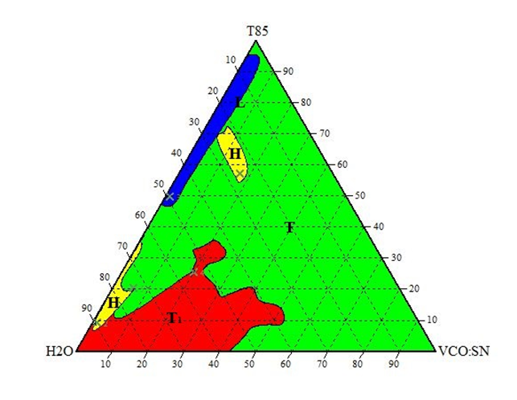

Figure 2: Ternary Phase Diagram of Tween 85/VCO:Swiftlet Nest/Water. (H – Homogenous region; L – Isotropic region; T – Two phase region; T₁ – Three phase region)

From Figure 3, there was no one phase region observed in the ternary phase diagram of Span 20/VCO:swiftlet nest/water system. The HLB value for Span 20 is 8.6 which tend to form water-in-oil emulsions. The regions that appeared in this ternary phase diagram were two phase (T) and three phase (T₁) regions. Two phase regions appeared at two areas; First, along the Span 20 apex line where the percentage of deionized water were low. Second was at the water-rich corner from 78% to 90% deionized water (w/w). Three phase region also appeared at water-rich corner in the ternary phase diagram. It has high percentage of Span 20 and low percentage of VCO:swiftlet nest.

In this system, Span 20 did not play a significant role in facilitating the formation of emulsions as greatly as Tween 80 and Tween 85. The formation of a large two phase region was observed for the ternary phase diagram at low water content and high oil and nest content. The results suggested that the surfactant is not sufficient to solubilize the oil phase. The reason of the inability of the surfactant to facilitate the emulsification process was probably due to no synergistic effect of the surfactant in enhancing the surface activity [9]. The formation of three region could be seen at high percentage of surfactant, which suggested that the surfactant was insufficient to emulsify the aqueous and oil phases. The formation of three phase region is probably due to high hydrophobic character of Span 20 as they contained long carbon chain. This suggested that high lipophilic surfactant should be used to emulsify the oil and swiftlet nest.

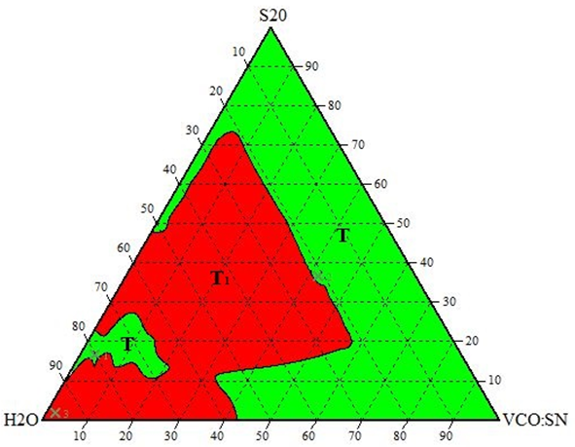

Figure 3: Ternary Phase Diagram of Span 20/VCO:Swiftlet Nest/Water(T – Two phase region; T₁ – Three phase region)

Figure 4 shows the phase diagram of Span 80/VCO:swiftlet nest/water. The surfactant used in this system was Span 80 having the HLB value of 4.3. Span 80 are generally recognized as safe and are approved for use in a number of pharmaceutical, cosmetic and food products because they are non-irritant and have a low potential for toxicity [19]. From the diagram, it was observed that two phase regions were appeared in the system. A dominant two phase region (T) was observed at the surfactant-rich corner and almost water-rich corner of the system. Meanwhile, the three phase region (T₁) was formed at 60% to 100% deionized water (w/w) in the ternary phase phase diagram which is at the water-rich corner and low percentage of VCO:swiftlet nest.

Span 80 is a non-ionic, oil-soluble surfactant with HLB 4.3 and thus, tends to have very little solubility in water [20]. In this system, the addition of water to Span 80 did not lead to useful emulsions. This is due to the lower value of HLB for Span 80, lower HLB values tend to formed W/O emulsions. This explained the formation of two and three phases region in the ternary phase diagram of Span 80/VCO:swiftlet nest/water. The formation of the surfactant phase (or three phase region) caused by the value of HLB is a particular case of phase formation in ternary surfactant-oil/nest-water systems due to the changes in the nature of the oil and nest, the surfactant and addition of water. Therefore, the phase inversion during the formation of a third phase should be considered to be not only the result of the HLB dependence, but in a wider aspect is related to the phase behavior, either to the conditions of the formation and destruction of the micellar phase or three phase region, and their boundaries. It should also be kept in mind that in the region where a three-phase system is observed and in its vicinity, in addition to O/W and W/O emulsions can be distinguished [21].
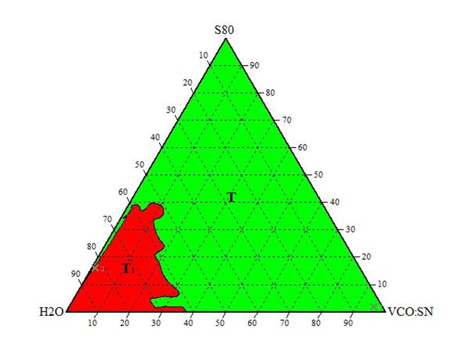

Figure 4. Ternary Phase Diagram of Span 80/VCO:Swiftlet Nest/Water.(T – Two phase region; T₁ – Three phase region)

Figure 5 depicts the ternary phase diagram of Span 85/VCO:swiftlet nest/water. The HLB value of Span 85 is 1.8 which is the lowest among the other surfactants. This emulsion system results in a phase diagram with features similar to those of the Span 20 and Span 80 phase diagram. The two phase region (T) domain covers almost all the apex line in the system; it appeared at surfactant-rich corner. Meanwhile, the three phase region (T₁) was formed at water-rich corner from 59% to 100% deionized water (w/w) almost same as Span 80. Span 80 could not mixed well with water, oil and swiftlet nest due to its properties that is more lipophilic which tends to form a layer when mix with water.

From the observation, the area of O/W emulsion was increased by the lower HLB value of Span 85. Span 85 contains one OH group branched trioleate chain, have decreased the oil and water solubility respectively. Thus, it has proven that the branching and the number of OH groups affected the hydrophobicity and hydrophilicity of the system [22]. This explained the formation of two phase and three phase in the ternary system. This is also due to the lower value of HLB which increased the hydrophobicity induced by trioleate chain of Span 85, as well as decrease the lipophilicity of the surfactant.
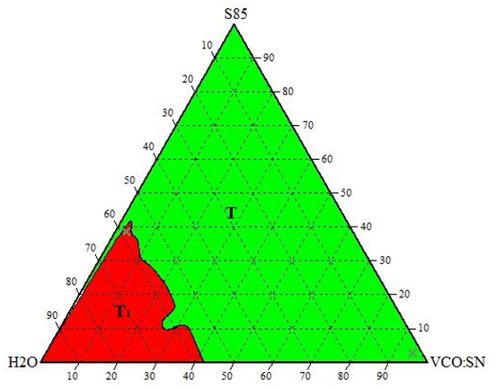

Figure 5. Ternary Phase Diagram of Span 85/VCO:Swiftlet Nest/Water.(T – Two phase region; T₁ – Three phase region)

Results from this study demonstrated the importance of selecting a surfactant with proper HLB for specific oil, as well as the type of surfactant. The HLB number could be used as a reference to determine whether the surfactant is suitable for several types of emulsions or not. In general, surfactants with lower HLB numbers (4-6) are mostly used as emulsifiers (water-in-oil), while those with higher HLB numbers (10-15) are detergents, and surfactants with HLB numbers between 7 and 9 are suitable for wetting agents [21]. According to Griffin’s theory (1954), to select a surfactant properly for any application, one must have the optimal HLB value and the correct chemical group [23]. Thus, the best surfactants used were surfactants with higher HLB numbers (10-15), which in this case the surfactants were Tween 80 and Tween 85.

In the ternary phase diagram of Tween 80/VCO:swiftlet nest/water and Tween 85/VCO:swiftlet nest/water, the presence of one phase region (homogeneous and isotropic) was observed. This show that the increase of HLB values of the non-ionic surfactants used gave larger isotropic and homogeneous regions in the ternary phase diagram [6]. Whereas, surfactants with HLB values 1.8, 4.3 and 8.6 tend to form multiple phase in the ternary phase diagrams. The results also show that the surfactants/VCO:swiftlet nest/water emulsion instability was caused by the properties of the swiftlet nest which has high density and difficult to dissolve in the system. The micelles discussed in this study have potential applications, advantages and usefulness in the pharmaceutical industry as deliver systems by various routes of administration, as well as in cosmetics and personal care products.

Conclusion
Swiftlet nest was successfully purified using deionized water. In this research, five ternary phase diagrams of swiftlet nest using VCO with non-ionic surfactants were successfully constructed. The results show that the Tween 85/VCO:swiftlet nest/water system gave better solubility in water to produce larger isotropic and homogeneous regions. The presence of optimal HLB value of Tween 85 for the stabilization of O/W emulsions contributes to the enlargement of the single phase regions.

References
- Villarino, B.J., Dy, L.M. and Lizada, C.C. (2007). Descriptive Sensory Evaluation Of Virgin Coconut Oil And Refined, Bleached And Deodorized Coconut Oil. LWT-Food Sci Technol, 40:193-199.
- Nevin, K.G. and Rajamohan, T. (2006). Effect Of Topical Application Of Virgin Coconut Oil On Skin Components And Antioxidant Status During Dermal Wound Healing In Young Rat. Skin Pharmacol Physiol, 23: 290-297.
- Marina, A.M., Che Man, Y.B., Nazimah, S.A.H. and Amin, I. (2009). Chemical properties of Virgin Coconut Oil. J Am Oil Chem Soc, 86: 301-307.
- Nevin, K. G., Rajamohan, T. (2007). Virgin Coconut Oil Supplemented Diet Increases The Antioxidant Status In Rats. Food Chem, 99(2): 260-266.
- Aswir, A.R. and Wan Nazaimoon, W.M. (2011). Effect Of Edible Bird’s NestOn Cellproliferation And Tumor Necrosis Factor-Alpha (TNF-A) Release In Vitro. Int Food Res J, 18: 1123–1127.
- Abd Gani, S.S. (2010). Formation and Characteristic Of Engkabang Based Nano-Cosmeceuticals. Ph.D Thesis. University Putra Malaysia.
- Schmitt, T. (2001). Analysis Of Surfactants, Surfactant Science Series. Marcel Dekker, New York, 96.
- Cross J. (1987). Nonionic Surfactants: Chemical Analysis, Surfactant Science Series. Marcel Dekker, New York, 19.
- Tadros T. F. (2005). Applied Surfactants: Principles and Applications. Wiley-VCH, 201.
- Miller, L. D., Wert, S. E. and Whitsett, J. A.(2001). Surfactant Proteins And Cell Markers In The Respiratory Epithelium Of The Amphibian, Ambystoma Mexicanum. Comp Biochem Physiol A, 129: 141–149.
- Lakatos-Szabó , J. and Lakatos I. (1997). Effect Of Non-Ionic Surfactants On Interfacial Rheological Properties Of Crude Oil/Water Systems. Prog Colloid Poly Sci, 105: 302-310.
- Whitehead, K., Karr, N. and Mitragotri, S. (2007). Safe And Effective Permeation Enhancers For Oral Drug Delivery. Inflammopharmacology, 25: 1782-1788.
- Fang, J-Y., Yu, S-Y., Pao-Chuwu, H., Huang, Y-B. and Tsai, Y-H. (2001). In Vitro Skin Permeation Of Estradiol From Various Proniosome Formulations. Int J Pharm, 215: 9199.
- Marcone, M.F (2005). Characterization Of The Edible Bird’s Nest Caviar Of The East. Food Res Int, 38: 1125-1134.
- Jiao, J. and Burgess, D.J. (2006). Multiple Emulsion Stability Pressure Balance and Interfacial Film Strength. In “Multiple Emulsions: Technology and Applications”, Ed. A Aserin, Wiley Series on Surface and Interfacial Chemistry, John Wiley and Sons, Inc. Hoboken, New Jersey. Chapter 1, 1- 27.
- Golemanov, K., Tcholakova, S., Kralchevsky, P.A., Ananthapadmanabhan, K. P. and Lips, A. (2006). Latex-Particle-Stabilized Emulsions of Anti-Bancroft Type. Langmuir, 21: 50-63.
- Mat Hadzir, N., Basri, M., Abdul Rahman, M.B., Salleh, A.B., Raja Abdul Rahman, R.N. and Basri, H. (2013). Phase Behaviour And Formation Of Fatty Acid Esters Nanoemulsions Containing Piroxicam. AAPS Pharm Sci Tech,14(1):456-63.
- Yuan, Y., Li, S.M., Mo, F.K., and Zhong, D.F. (2006). Investigation Of Micro-Emulsion System For Transdermal Delivery Of Meloxicam. Int J Pharm, 321: 117-123.
- Viyoch, J., Klinthong, N. and Siripaisal, W. (2003). Development Of Oil-In-Water Emulsion Containing Tamarind Fruit Pulp Extract I. Physical Characteristics And Stability Of Emulsion. Naresuan Univ J, 11(3): 29-49.
- Karanjkar, P.U., Lee, J.W. and Morris, J. F. (2012). Calorimetric Investigation Of Cyclopentane Hydrate Formation In An Emulsion. Chem Eng Sci, 68: 481-491.
- Schwartz (1949). Surface Active Agents. Interscience, New York. 111-140.
- Witthaya, P., Yanutatsaneejit, U.A., Rangsunvigit, P., Acosta, E.J. and Sabatini, D.A. (2009). Ethylbenzene Removal by Froth Flotation under Conditions of Middle-Phase Microemulsion Formation I: Interfacial Tension, Foamability, and Foam Stability. Separ Sci Technol, 40(7): 1537-1553.
- Griffin, W.C. (1949). Classification of Surface Active Agents by HLB. J Soc Cosmet Chem, 1: 311-326.

