SYNTHESIS AND LUBRICITY PROPERTIES ANALYSIS OF BRANCHED DICARBOXYLATE ESTERS BASED LUBRICANT

(Sintesis dan Analisis Ciri-Ciri Kepelinciran Pelincir Berasaskan Ester Dikarboksilat Bercabang)

Waled Abdo Ahmed, Ambar Yarmo, Nadia Salih, Mohd Darfizzi Derawi, Muhammad Rahimi Yusop and Jumat Salimon*

School of Chemical Sciences and Food Technology, Faculty of Science and Technology, Universiti Kebangsaan Malaysia, 43600 Bangi, Selangor

*Corresponding author: jumat@ukm.edu.my
Abstract
The new dicarboxylate esters offer many of the advantages of lubrication such as high viscosity indices, good low temperature properties and good oxidative stability. In addition, they can be used as additive in lubricant to improve low temperature properties. Six branched dicarboxylate esters with different chemical structures were synthesized and tested in terms of their suitability as lubricants. The esterification reaction was carried out using a Dean Stark distillation method. Fourier transformation infra-red (FTIR); proton and carbon nuclear magnetic resonance (¹H-NMR and ¹³C-NMR), and elemental analysis were used to verify the chemical structure of synthesized dicarboxylate esters. The results showed that the esters of dicarboxylate based on 2-ethyl-1-hexanol had very good low temperature properties with pour point values at -58ºC for di-2-ethyhexyl dodecanedioate (D2EHD) and less than -60 ºC of di-2-ethyhexyl azelate (D2EHAz) and di-2-ethyhexyl suberate (D2EHSub). The viscosity index (VI) of all dicarboxylate esters indicated high values at the range of 178 to 216. The oxidative temperature (OT) of di-2-ethybutyl dodecanedioate (D2EBD) gave the highest value at 216 ºC and di-2-ethyhexyl dodecanedioate (D2EHD) showed the highest flash point value at 200 ºC. The tribological study showed that all dicarboxylate esters were non-Newtonian fluids types and has showed boundary lubrication with low coefficient of friction (COF) at 40 ºC and 100 ºC. In general, the results indicate that all dicarboxylate esters can be used as base oil for biolubricants.

Keywords: pour point, viscosity index, oxidative stability, boundary lubricant

Abstrak
Ester dikarboksilat baru menawarkan banyak kelebihan pelinciran seperti indeks kelikatan yang tinggi, sifat suhu rendah dan kestabilan oksidatif yang baik. Di samping itu ia boleh digunakan sebagai bahan tambah dalam minyak pelincir untuk memperbaiki sifat-sifat suhu rendah. Enam jenis ester dikarboksilat bercabang dengan struktur kimia yang berlainan telah disintesis dan diuji dari segi kesesuaiannya sebagai biopelincir. Proses pengesteran telah dilakukan dengan menggunakan kaedah penyulingan Dean Stark. Spektroskopi inframerah transformasi fourier (FTIR), resonans magnetik nuklear (¹H-NMR dan ¹³C NMR) dan analisis unsur telah digunakan untuk mengesahkan struktur kimia ester dikarboksilat yang disintesis. Hasil kajian menunjukkan bahawa ester asid dikarbosilat dengan 2-etil-1-heksanol mempunyai sifat-sifat suhu rendah yang sangat baik dengan nilai takat tuang pada suhu -58 ºC bagi di-2-etilheksil dodekanedioat (D2EHD) dan kurang daripada suhu -60 ºC bagi di-2-etilheksil azelat (D2EHAz) dan di-2-etilheksil suberat (D2EHSub). Indeks kelikatan (VI) bagi semua ester dikarboksilat menunjukkan nilai yang tinggi pada julat 178 - 216. Suhu oksidatif (OT) di-2-etilbutil dodekanedioat (D2EBD) menunjukkan nilai tertinggi pada 216 ºC sementara di-2-etilheksil dodekanedioat (D2EHD) menunjukkan takat kilat tertinggi pada 200 ºC. Kajian tribologi menunjukkan kesemua ester dikarboksilat adalah cecair bukan Newton dan mempunyai kepelinciran sempadan dengan koefisien geseran (COF) yang rendah pada suhu 40 ºC dan 100 ºC. Secara umum, keputusan kajian menunjukkan bahawa semua ester dikarboksilat tersebut boleh digunakan sebagai minyak asas biopelincir.

Kata kunci: takat tuang, indeks kelikatan, kestabilan oksidatif, kepelinciran sempadan
Introduction
Lubricants can be used in industries depending on their chemical structure. Industrial lubricants contain all kinds of lubricants applied in practice, including gases, various liquid products (mineral oils, animal and vegetable oils, derivatives of fatty acids, synthetic oils and water based fluids), greases (complex soap greases, greases with pigment, minerals and polymers) and solid lubricant (graphite). In many tribological applications, liquid, semi liquid and grease are used to resist friction and wear, but when the conditions of service are very hard (i.e., very high or low temperatures, vacuum, radiation, extreme contact pressure, etc.), solid lubricants are chosen for controlling friction and wear.

Liquid lubricants provide a substantial range of physical and chemical properties. The physical properties are attributable primarily to the structure of the lubricant base stock. Selected properties of interest are: viscosity, surface tension, thermal properties, volatility, oxidative stability, thermal stability, hydrolytic stability, gas solubility, and inflammability [1]. Diesters are currently used in many applications including automotive engine oils, compressor oils, hydraulic fluids, gear oils, and grease formulations [2]. The low toxicity and excellent biodegradability of diester molecules now afford added benefits to those of performance [3]. The linear diacid portion of the diester contributes to the good VI and high pour points, while the branched alcohol portion gives a low pour points. The branching at the end of a linear diester gives an excellent trade-off between VI and pour point due to the free rotation around the ester linkage is good [4]. Long-chain ester with branched or bulky moieties find uses in biodiesel [5], and an alternative diesel fuel derived from vegetable oils or animal fats. Branched esters such as neat isopropyl or isobutyl esters have been applied to improve the low-temperature properties as documented by cloud and pour points [6]. The use of branched esters constitutes one of the possible solutions for improving the low-temperature properties of biodiesel [5], and winterization [7]. Neopentylglycol diesters, as branched compounds are used commercially in lubricants [8], plasticizers and cosmetics [9].

Branches of the carbon chain prevent close chain packing and greatly lower the melting point. Thus, utilization of branched fatty acid can expand the use of stable saturated fatty acid in biodiesel and biolubricants [5]. Branched fatty acid esters derived by replacing the methyl groups in the ester moiety with branched groups such as isopropyl and 2-butyl have lower melting points and their mixtures have lower cloud and pour points [10-13]. Tribological properties show that a good boundary lubricant should have a high degree of interaction between its molecules and the sliding surface. As a general rule, liquids are good lubricants when they are polar and thus able to grip solid surfaces (or be adsorbed) [14]. Polar lubricants contain reactive functional groups with low ionization potential or groups having high polarizability. The boundary lubrication properties of lubricants are also dependent upon the molecular conformation and lubricant spreading.

There is no enough study has been conducted on the lubricity and tribological behaviours of branched diesters with different chemical structure and tests their effect on the lubricity properties. This study included evaluation of the lubricity properties and tribological performance of the various dicarboxylate esters with respect to their application as components of lubricating oils.

Materials and Methods
Chemicals
Dicarboxylic acids such as dodecanedioic acid, sebacic acid, azelaic acid and suberic acid were purchased from Fisher Scientific. All other chemicals and reagents such as 2-ethyl-1-hexanol, 2-ethyl-1-butanol and diethyl ether were obtained from Aldrich Chemical, they were used directly without further purification.
Ester synthesis
A mixture of dicarboxylic acids and alcohol (a mole ratio 1:2) was initially placed into a three-necked round-bottom flask which connected to a Dean Stark distillation. Toluene (40-50 ml) was added as a reaction medium. The reaction mixture was heated with stirring in an oil bath to the desired reaction temperature at 120-130ºC. Concentrated H₂SO₄ (2% wt) was slowly introduced into the reaction vessel. The progress of the reaction was monitored by measuring the quantity of water collected in a dropping funnel. The reaction was run about for 4 h and stopped when no water was further distilled off from the reaction vessel.

Purification of Esters
Toluene was firstly removed and the crude product was allowed to cool to room temperature, then transferred into a separating funnel. Diethyl ether (50 ml) was added to the separating funnel followed by three times of 10 ml of saturated sodium bicarbonate (NaHCO₃) solution to neutralise the catalytic acid used and to remove unreacted diacid. The saturated sodium chloride (NaCl) solution was added to avoid any emulsion formation. The aqueous layer was decanted and the diethyl ether layer was dried over the sufficient anhydrous sodium sulphate (Na₂SO₄), and the hydrated Na₂SO₄ was filtered off. The dried product was passed through a column packed with silica gel 60 to remove any decomposed materials formed during the reaction. The column product was rotary-evaporated to remove diethyl ether. Trace solvent was further removed under nitrogen gas and the excess alcohol in the mixture was removed using the distillation method. The yield percentage of the dicarboxylate ester product was determined. The final product of dicarboxylate ester was identified by its IR, ¹H-NMR, ¹³C- NMR spectral analyses and elemental analysis.

Characterization
Fourier transforms infrared spectroscopy (FTIR) and Nuclear magnetic resonance spectroscopy (NMR) for proton ¹H and ¹³C analysis has been carried out according to Aigbodion and Bakare [15]. A total of 10 mg of sample was dissolved in 0.65 ml of CDCl₃ and were recorded on Bruker 300 NMR spectrophotometer.

Elemental Analysis
Elemental analysis of the synthesized dicarboxylate esters were done according to Aydın [16] they were conducted with Thermo Finnigan Flash EA1112 model analyser which is capable of analysing the carbon, hydrogen and nitrogen (CHNS) content of the samples.
Lubricity Properties
Flash and pour point, kinematic viscosity, viscosity index and oxidative stability of the synthesized dicarboxylate ester were determined according to American Society for Testing and Materials [17] standard procedures.

Tribology and Rheology Analysis
Tribological properties of branched dicarboxylate ester were performed according to ASTM method D4172-94 [18], using Anton Paar rheometer (Anton Paar Physica MCR 301 model, Germany) with one ball geometry. The sliding speed was manipulated between 10⁻¹ – 10³ mm/s at temperature 40 ºC and 100 ºC [19]. The tribological properties were discussed based on their Stribeck curves at 40 ºC and 100 ºC. Rheological properties of branched dicarboxylate esters were observed by the same rheometer with cone and plate geometry [20]. The cone spindle used was CP 25-2 with diameter 0.051 mm. The shear rate was manipulated between 0 – 100 s⁻¹ at temperature 25 ºC.

Results and Discussion

The yield Percentage of Dicarboxylate Ester
This study produced six dicarboxylate esters which are di-2-ethyhexyl dodecanedioate (D2EHD), di-2-ethyhexyl azelate (D2EHAz), di-2-ethyhexyl suberate (D2EHSub), di-2-ethybutyl dodecanedioate (D2EBD), di-2-ethybutyl sebacate (D2EBS) and di-2-ethybutyl suberate (D2EBSub). As example of esterfication reactions Fig. 1 shows the reaction process of dodecanedioic acids with 2-ethyl-1-hexanol to form D2EHD. Based on Fig. 2 D2EBSub has the highest yield percentage (92%) among other dicarboxylate esters. The yield percentage of dicarboxylate esters was different depending on the short and long chain carbon of dicarboxylic acids. The length of the carbon chain (CH₂)_{n} has a negative effect on the acidity of dicarboxylic acids and this cause decrease its electrophilic property, the result decrease the yield percentage of dicarboxylate ester and vice versa, so that the dicarboxylic acids that have short carbon chain gave high yield percentage [21].

Figure 1. The reaction process of dicarboxylic acids and 2-ethyl-1-hexanol to form D2EHD

Note: D2EHD: di-2-ethyhexyl dodecanedioate, D2EHAz: di-2-ethyhexyl azelate, D2EHSub: di-2-ethyhexyl suberate, D2EBD: di-2-ethybutyl dodecanedioate, D2EBS: di-2-ethybutyl sebacate and D2EBSub: di-2-ethybutyl suberate.
Figure 2. The yield percentage (%) of dicarboxylate ester.
Ester Characterisation
The purity of the synthesized dicarboxylate ester was tested after successive purification using FT-IR, ¹H NMR, and ¹³C NMR, and elemental analysis. The FT-IR spectra of the final dicarboxylate ester products are given in Fig 3.
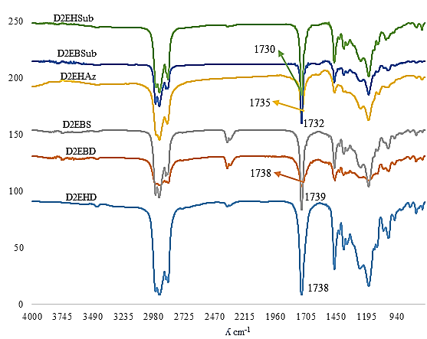
Figure 3. FTIR spectrum synthesized dicarboxylate ester

As it is known that the OH groups of alcohols absorb at 3230–3550 cm⁻¹ while the carbonyl stretching vibrations of saturated acids absorb in the range of 1700–1725 cm⁻¹ [15]. The absence of hydroxyl (OH) stretching vibrations of alcohol and the bonded hydrogen–oxygen stretching of acids in the spectra (Fig 3) suggest that the final products of dicarboxylate ester are free from any unreacted alcohol or acid impurities. The peak of carbonyl stretching vibrations (C=O) of ester was at the range of 1730 cm⁻¹ to 1739 cm⁻¹ Fig 3. Bands representing -CH₃ groups (2850-2980 cm-1), C-O stretching vibrations (1244 -1171 cm⁻¹) and C-O-C (965–1101 cm⁻¹) of synthesized dicarboxylate esters are clearly visible in the spectra. The ester group of all dicarboxylate esters was characterised.
The FTIR spectrum of D2EHD and dodecanedioic acid (DA) Fig. 4 showed that the peak of carbonyl group (C=O) of carboxylic acid at 1700-1710 cm⁻¹ was not appeared at ester spectrum, this mean that the dodecanedioic acid was completely esterified under the conditions of the reaction. The peak of C=O band of ester group of D2EHD was appeared at 1738 cm⁻¹.

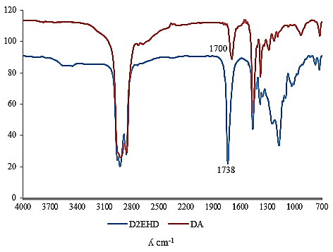
Figure 4. Comparison FTIR spectrum of D2EHD and DA

The ¹H NMR results of tested diester are shown in Table 1, it showed the conformation of assignments signals of ester which is the important signals in the current study. The ¹H chemical shift peaks of D2EHD were appeared at 3.95 ppm for RCOO–CH₂, 2.27 ppm for H₂C–COOR, 1.60 ppm for –CH (3° aliphatic), 1.23- 1.35 ppm for - CH₂ - (saturated alkyl chain) and 0.85ppm for - CH₃ (terminal methyl in alkyl chain). The ¹H chemical shifts peaks of D2EBD and D2EBS are presented in Table 1. ¹³C NMR spectroscopy is more accessible and since all carbon atoms in the organic compounds give distinctive signals, whether or not they are linked to protons, a great deal of structural information can be obtained from the ¹³C NMR spectra. Pavia et al. [22] reported that the peak conformation of carbonyl group is at 170 – 185 ppm. In this study the ¹³C NMR results of tested diester (Table 3) showed the main signals of assignments. The ¹³C chemical shift peaks of D2EHD were appeared at 174.15 ppm for (C=O) ester, 66.67ppm for (O- C) ester, 34.49 ppm for (CH₂-C=O) ester, 38.80 ppm for (– CH (3° aliphatic)), 23.02-30.48 ppm for -CH₂- (saturated alkyl chain), and 11.04 and 14.09 ppm for -CH₃ (terminal methyl in alkyl chain). The ¹³C chemical shifts peaks of D2EBD and D2EBS are presented in Table 2.

Table 1. The ¹H NMR chemical shifts δ (ppm) NMR of D2EHD, D2EBD and D2EBS

The ¹H chemical shifts δ (ppm) |  |  | Signals of assignments
D2EHD | D2EBD | D2EBS | Signals of assignments
2.27, 2.26  3.95, 3.94  1.60  1.23-1.35  0.85 | 2.27, 2.25  3.95, 3.94  1.58  1.23 -1.32  0.86 | 1.99, 1.98  3.69, 3.68  1.33  1.02- 1.10  0.63 | H₂C-C=O (ester)  -O- CH₂ (ester)  -CH (3° aliphatic)  -CH₂  -CH₃ (aliphatic)

Table 2. The ¹³C NMR chemical shifts NMR of D2EHD, D2EBD and D2EBS

The ¹³C chemical shifts δ (ppm) |  |  | Signals of assignments
D2EHD | D2EBD | D2EBS | Signals of assignments
174.15  66.67  34.49  38.80  23.02- 30.48  11.04, 14.09 | 174.14  66.29  34.46  40.35  23.35-29.43  11.05 | 172.71  65.38  33.69  39.96  22.90-28.69  10.48 | C=O (ester)  O- C (ester)  CH₂-C=O (ester)  -CH (3° aliphatic)  -CH₂  -CH₃(aliphatic)

The close similarity between the practical and theoretical elemental analysis data prove the purity of the final dicarboxylate ester products. The comparison of the practical and theoretical elemental analysis data is given below in Table 3 for each dicarboxylate ester. The confirmation of empirical formula of D2EHD as an example was calculated by the mole ratios of C and H. From the practical content of C (74.1 %) and H (12.3%) at Table 4, the calculated mole ratios were 7.26 and 14.36 respectively, and that gave the empirical formula of D2EHD (C_{7.26}H_{14.36}) which was closed to the theoretical empirical formula (C₇H₁₄).

Table 3. The elemental analysis of C and H content of dicarboxylate esters
Dicarboxylate ester | Experimental content of C, H (%) |  | Theoretical content of C, H (%)
Dicarboxylate ester | C | H | C | H
D2EHD  C₂₈H₅₄O₄ | 74.1 | 12.3 | 74.0 | 12.0
D2EHAz  C₂₅H₄₈O₄ | 73.2 | 11.9 | 72.8 | 11.7
D2EHSub  C₂₄H₄₆O₄ | 71.8 | 11.7 | 72.3 | 11.6
D2EBD  C₂₄H₄₆O₄ | 72.4 | 11.5 | 72.3 | 11.6
D2EBS  C₂₂H₄₂O₄ | 71.4 | 11.5 | 71.3 | 11.4
D2EBSub  C₂₀H₃₈O₄ | 69.7 | 11.5 | 70.0 | 11.2

Lubricity Properties of Dicarboxylate Ester
The lubricity properties of dicarboxylate ester such as viscosity index, pour point, flash point, and oxidation stability is showed in Table 4. Lubricant with high viscosity index resists excessive thinning when the engine is hot and thus provides full lubrication and prevents excessive oil consumption. In this study kinematic viscosity at 40 ºC and 100 ºC were obtained from the ratios of the dynamic viscosity to the density of dicarboxylate ester, the results indicated that the values were from 7.93 to 18.95 cSt at 40 ºC and 2.9 to 5.4 cSt at 100 ºC, which made them suitable to be utilized as hydraulic fluids and engine oil, automotive gear and grease oil. The results in Table 4 indicated that the viscosity at 40 ºC and 100 ºC increased with the length of carbon chain of the diacid, while it affected slightly by the branching. The results of this research have shown that the D2EHD gave the highest value of viscosity (19.98 cSt at 40 ºC and 5.4 cSt at 100 ºC). This is due to a high molecular weight of D2EHD, while D2EBSub had the lowest of viscosity (7.98 at 40 ºC and 2.9 cSt at 100 ºC) due to the low in molecular weight.

Table 4. Lubricity properties of dicarboxylate esters
Dicarboxylate ester | Viscosity by cSt at 40 ºC | Viscosity by cSt at 100 ºC | VI | Pour point ºC | Flash point ºC | OT ºC
D2EHD  8:12:8 | 18.95 | 5.4 | 191 | -55±1 | 200±5 | 199±2
D2EHAz  8:9:8 | 11.37 | 3.5 | 186 | ˃ -60 | 185±3 | 184±2
D2EHSub  8:8:8 | 10.86 | 3.3 | 181 | ˃-60 | 170±5 | 183±1
D2EBD  6:12:6 | 13.15 | 4.07 | 216 | -35±5 | 190±5 | 216±3
D2EBS  6:10:6 | 10.93 | 3.3 | 178 | -44±2 | 175±5 | 208±2
D2EBSub  6:8:6 | 7.93 | 2.9 | 216 | -50±3 | 165±4 | 197±2

Note: 8:12:8 means C alcohol: C diacid: C alcohol, VI: Viscosity index, values are mean ± SD of triplicate determinations.
Viscosity index (VI) values reflect the difference in values of viscosity at 40 ºC and 100 ºC, whereas the low difference in the viscosity values at 40 ºC and 100 ºC cause high value of viscosity index and vice versa. The viscosity indexes (VIs) values were in the range of 178 to 216. The esters with good viscosity index values (VIs) can be obtained by controlling of the raw materials selection, which have long chain carbon with branching structures [23]. The flow characteristic of dicarboxylate esters with branching is exceedingly good and this makes them suitable for use in low operating temperatures particularly as automotive engine oils. Nowadays dicarboxylate esters that have very low pour point are used as novel lubricant in many industrial applications, such as a marine engine oils, compressor oils, hydraulic fluids, gear oils, and grease formulations [2]. The pour point values of dicarboxylate esters are summarized in Table 4. All dicarboxylate esters were in the liquid state under -30 ºC temperature. The dicarboxylate esters of 2-ethyl-1-hexanol were the most effective ones in terms of decreasing of the pour point. The low values of pour point in dicarboxylate ester of 2-ethyl-1-hexanol compared to 2-ethyl-1-butanol attributed to the high degree of branching which plays a significant role in decreasing pour points. It can be assumed that the presence of a large branching point in the dicarboxylate ester creates a steric barrier around the individual molecules and inhibits crystallization. D2EHAz and D2EHSub gave very low pour point less than -60 ºC; this refers to the low molecular weight and high degree of branching. Previous studies showed that the branched dicarboxylate esters gave very low pour points compared with those with straight carbon chain [24] and [25]. Fig 5 shows to the chemical structure of D2EHD and D2EBD. The result showed that despite the high molecular weight of D2EHD it gave lower pour point (-44 ºC) than D2EBD (-35 ºC) and this is due to the increase degree of branching in D2EHD.
Figure 5. Chemical structure of D2EHD and D2EBD
The flash point values of dicarboxylate esters are presented in Table 5, it was increased with long-chain of dicarboxylic acid used. D2EHD had the highest flash point at 200 ºC among all dicarboxylate esters due to the high molecular weight. The flash points were slightly affected by the branching. The high flash points (e.g. D2EHD of 200 ºC, D2EBD of 190 ºC), with other properties such as low pour point and high viscosity index makes the dicarboxylate ester appropriate greatly to be used as a good lubricant at both of high and low temperatures. Buenemann et al. [23] and Shubkin, 1993 [26] reported that the low volatility of dicarboxylate ester is needed to eliminate the need to replenish the lost ester and increase in viscosity during use and also the negative effect of evaporating in the environment. Oxidative stability is very important property for lubricant’s quality, especially for long-time use. The rate of oxidation depends on the chemical compositions of esters [27]. The high value of oxidative stability is an indicator for a greater stability of lubricant [28]. Determination of oxidative temperature (OT) of dicarboxylate ester in this study, were done using Pressure differential scanning calorimetry (PDSC). The OT scans were conducted on at least three fresh samples. Fig 6 indicates the PDSC exotherm curve of oxidation temperature as the oxidative temperature (OT) for D2EBD, it showed high oxidative stability at 216°C. The OT was observed by extrapolating the tangent drawn on the steepest slope of reaction exotherm to the baseline. The repeating scans of OT conducted on at least three fresh samples of D2EBD.
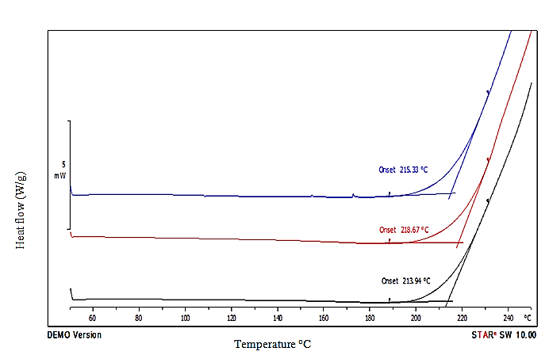
Figure 6. The PDSC exotherm curves of D2EBD as (OT).
The results in Table 4 showed that, the dicarboxylate esters of 2-ethyl-1-butanol had a high stability to oxidation compared to those of 2-ethyl-1-hexanol. This was predicted due to the low degree of branching. The branching form of esters play a significant effect on the rates of oxidation [27]. Kubouchi et al [29] showed in their study that the oxidative stability decreases with the increase of branched carbon in the esterified acid and alcohol. The results in Table 4 indicate that the values of OT decreased with increase of branched carbon of dicarboxylate esters. Despite the molecular weight of D2EHD was higher than that of D2EBD, however D2EBD showed higher value (216 ºC) compared to D2EHD (199 ºC). The OT of D2EBS and D2EBSub recorded at 208 ºC and 197 ºC while for D2EHAz and D2EHSub was at 184 ºC and 183 ºC respectively.
Tribological and Rheological Properties of Dicarboxylate esters
The tribological properties study is very important to identify the type of lubricant. The presence of polar groups in the ester structure makes it amphiphilic in nature, therefore allowing it to be used as boundary lubricants. The polarity of the lubricant also causes increased its efficiency by reducing wear [30]. The extracted oil from plant showed good lubricity because they have straight-chain carbon with polar end groups. These polar end groups adsorb on a metallic surface, which decreases the surface energy and causes a reduction of the coefficient of friction (COF) [31].

Tribological properties of dicarboxylate esters as COF in the current study are shown in Table 5. It was noted that the molecular weight and viscosity (shown in Table 4) had an impact on the values ​​of the COF, where those values were decreased with the high molecular weight and viscosity of dicarboxylate esters.

Table 5. The COF of dicarboxylate esters at 40 and 100 °C

Dicarboxylate ester | COF
Dicarboxylate ester | 40 ºC | 100 ºC
D2EHD (8:12:8) | 0.11± 0.01 | 0.17 ± 0.00
D2EHAz (8:9:8) | 0.20 ± 0.02 | 0.25±0.01
D2EHSub( 8:8:8) | 0.24±0.01 | 0.29±0.01
D2EBD (6:12:6) | 0.18± 0.02 | 0.22± 0.01
D2EBS (6:10:6) | 0.19±0.02 | 0.26±0.02
D2EBSub (6:8:6) | 0.26±0.01 | 0.30±0.01
Values are mean ± SD of triplicate determinations.
The results indicated that the COF for dicarboxylate esters of 2-ethyl-1-hexanol was lower than dicarboxylate esters of 2-ethyl-1-butanol at 40 ºC and 100 ºC and that attributed to the high in molecular weight as well as the viscosity of dicarboxylate esters of 2-ethyl-1-hexanol. D2EHD gave the lowest value of COF at 0.11 and 0.17 at 40 ºC and 100 ºC respectively. The viscosity of dicarboxylate esters at 100 ºC was decreased and this caused an increase in the COF [32]. Generally, despite the low molecular weight of dicarboxylate esters, the results showed a decrease in the COF and this is due to the high polarity of dicarboxylate esters. All dicarboxylate esters recorded low COF below 0.35 at 40 ºC and 100 ºC. Those results indicated a good quality of their tribological properties even in the high temperature. The results concluded that all diesters were boundary lubricants with low COF at 40 ºC and 100 ºC. The rheological properties are useful to understand the processing, handling, storage and for the design of hydraulic systems of oils and lubricants [33] and [34]. The rheological tests in this study were performed using an Anton Paar rheometer with one ball geometry according to Coussot, [20]. The cone spindle used was CP 25-2 with diameter 0.051 mm. The shear rate was manipulated between 0 – 100 s⁻¹ at constant temperature (25 ± 0.1 ºC). The flow curves at Fig 7.

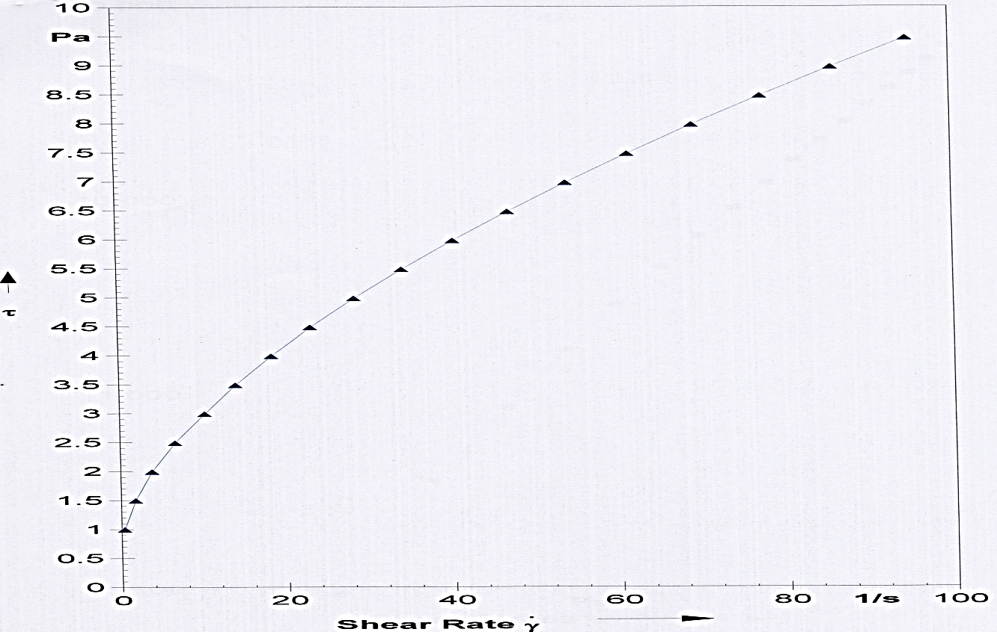
Figure 7. Shear stress vs. shear rate plots of D2EHD at 25 ºC

Shear stress versus shear rate present the rheological behavior of D2EHD. From the curves, a fluid can be classified as Newtonian or non-Newtonian fluid. Newtonian fluid is a fluid that has a constant viscosity by increasing shear rate, while non-Newtonian fluid is a fluid that does not have a constant viscosity although the shear rate is increased [35]. Based on Fig 7 D2EHD was classified as non-Newtonian fluid. All others dicarboxylate esters in this study, namely D2EHAz, D2EHSub, D2EBD, D2EBS, and D2EBSub were also non-Newtonian fluids.

Conclusion
This study concluded that the esters resulting from the reaction of dicarboxylic acid with 2-ethyl-1-hexanol and 2-ethyl-1-butanol gave low pour points and this underlines the importance of selecting the raw materials for esterification reactions. Generally the branched configuration of dicarboxylate ester prevents alignment of carbon chains during crystallization, which lowers the pour point. Moreover, the high degree of branching of 2-ethyl hexanol gave very low pour points (less than -60 °C) of its corresponding ester compared to 2-ethyl-1-butanol. Based on the results, it is possible to use the branched dicarboxylate ester as lubricant without any additives.
Acknowledgements
We would like to thank to UKM for the project funding under university research grants no UKM-AP-2011-17, DPP-2014-058, GGPM-2014-033 and the School of Chemical Sciences and Food Technology, Faculty of Science and Technology, Universiti Kebangsaan Malaysia for their support and encouragement.

References
- Bhushan, B. (2013). Boundary Lubrication and Lubricants. In Principles and Applications of Tribology: John Wiley & Sons, Ltd.
- Gryglewicz, S. and Oko, F.A (2005). Industrial Lubrication and Tribology, 57 (3):128-132.
- Havet, L. Blouet J, Robbe V. F, Brasseur, E. and Slomka, D. (2001). Tribological characteristics of some environmentally friendly lubricants. Wear, 248 (1): 140-146.
- Maria, C., Bazile, JP, Baylaucq A., and Boned, C. (2008). Density of Diethyl Adipate using a New Vibrating Tube Densimeter from (293.15 to 403.15) K and up to 140 MPa. Calibration and Measurements.Journal of Chemical & Engineering Data, 53 (4): 986-994.
- Knothe, G., Dunn R.O., and Bagby M.O. (1997). Biodiesel: The Use of Vegetable Oils and Their Derivatives as Alternative Diesel Fuels, in ACS Symp. Ser. 666 (Fuels and Chemicals from Biomass), American Chemical Society, Washington, DC, pp. 172–208.
- Lee, I., Johnson L.A and Hammond, E.G. (1996). Reducing the Crystallization Temperature of Biodiesel by Winterizing Methyl Soyate. Ibid, 73:631–636.
- Dunn, R.O., Shockley, M.W. and Bagby, M.O. (1997). Winterized Methyl Esters from Soybean Oil: An Alternative Fuel with Improved Low-Temperature Flow Properties, SAE Techn. Pap. Ser. 971682, published in State of Alternative Fuel Technologies SP-1274, SAE, Warrendale, PA, pp. 133–142.
- Fujii, K., Izumi, M. and Nakahara, M. (1992). Lubricating Oils for Refrigerators Using Tetrafluoroethane as Refrigerant, Japanese Patent 4,183,789.
- Uehara, K. & Katsura, H. (1980). Cosmetic Neopentyl Glycol Esters. Japanese Patent 80 02,648.
- Lee, I., Johnson, L.A., and Hammond, E.G. (1995). Use of Branched- Chain Esters to Reduce the Crystallization Temperature of Biodiesel, Journal of American Oil Chemical Society, 72:1155–1160.
- Foglia T.A., Nelson, L.A, Dunn R.O, Marmer W.N. (1997). Low- Temperature Properties of Alkyl Esters of Tallow and Grease. Ibid, 74:951–955.
- Zhang Y, Van Gerpen JH. (1996). Combustion analysis of esters of soybean oil in a diesel engine. Performance of alternative fuels for SI and CI engines, SAE technical paper series 960765, SP-1160. Society Automotive Engineers; [Special Publication] SP, 1–15.
- Dunn RO, Bagby MO. (1995). Low-temperature properties of triglyceride based diesel fuels; transesterified methyl esters and petroleum middle distillate/ester blends. Journal of the American Oil Chemists' Society, 72(8):895–904.
- Bhushan, B. and Zhao, Z. (1999). Macro- and Microscale Tribological Studies of Molecularly-Thick Boundary Layers of Perfluoropolyether Lubricants for Magnetic Thin-Film Rigid Disks. Journal of information and processing, systems, 1: 1–21.
- Aigbodion, A.I. & Bakare, I.O. (2005). Rubber seed oil quality assessment and authentication. Journal of American Oil Chemical Society, 82: 465-469.
- Aydın, Ahmet Alper. (2012). Diesters of high-chain dicarboxylic acids with 1-tetradecanol as novel organic phase change materials for thermal energy storage. Solar Energy Materials and Solar Cells, 104 (0): 102-108.
- ASTM D 2270-93. (2005). Standard practice for calculating viscosity index from kinematic viscosity at 40 and 100 ˚ C. ASTM, West Conshohocken, PA (USA).
- ASTM. (2011). Standard test method for wear preventive characteristics of lubricating fluid (four-ball method). ASTM, West Conshohocken, PA (USA).
- Kalin, M., Velkavrh, I., Vizintin, J. (2009). The Stribeck curve and lubrication design for non-fully wetted surfaces. Wear, 267: 1232-1240.
- Coussot, P., Tocquer, L., Lanos, C., Ovarlez, G. (2009). Macroscopic vs local rheology of yield stress fluids. J. Non-Newtonian Fluid Mech, 158: 85-90.
- Romero, M.D, Gomez, J.M. and Diaz-suelto, B.G. (2011). A Study of the Inﬂuence of Alcohols in the Synthesis of Short Chain Esters. Chemical Engineering Transactions, 24: 37-42.
- Pavia, D.L., Lampman, G.M. & Kriz, G.S. (2010). Introduction to spectroscopy. 4th ED. USA: Thomson Learning, Inc.
- Buenemann, T.F., Boyde,S., Randles, S. & Thompson, I. (2003). Synthetic Lubricants Non Aqueous,” Fuels and Lubricants Handbook: Technology, Properties, Performance, and Testing, ASTM International, West Conshohocken, PA, Chapter 10, pp. 249–266.
- Nagendramma P, Savita K. (2012). Development of ecofriendly/biodegradable lubricants: An overview. Renewable and Sustainable Energy Reviews, 16(1): 764-774.
- Cermak S.C, Kendra B.B, Terry A.I. (2006). Synthesis and physical properties of estolides from lesquerella and castor fatty acid esters. Industrial Crops and Products, 23 (1): 54-64.
- Shubkin, R.L. (1993). Polyalphaolefins, CRC Handbook of Lubrication, Theory and Practice in Tribology, Vol. III, Monitoring, Materials, Synthetic Lubricants, and Applications, Booser, R.E. CRC Press, Boca Raton, pp. 219–235.
- Murrenhoff, H.R.A. (2003). “Environmentally Friendly Oils,” Fuels and Lubricants Handbook: Technology, Properties, Performance, and Testing, G. E. Totten Ed., ASTM International, West Conshohocken, PA. Chapter 11, pp. 267–295.
- Adhvaryu, A., Erhan, S.Z., Liu Z.S. & Perez, J.M. (2000). Oxidation kinetics studies of unmodified and genetically modified vegetable oils using pressurised differential scanning calorimetry and nuclear magnetic resonance spectroscopy. Thermochim Acta, 364(1): 87–97.
- Kubouchi, H., Kai, H., Miyashita K. & Matsuda, K. (2002). Effects of Emulsifiers on the Oxidative Stability of Soybean Oil TAG in Emulsions. Journal of American Oil Chemical Society, 79: 567-570.
- Salimon, J., Salih, N. & Yousif, E. (2012). Triester derivatives of oleic acid: The effect of chemical structure on low temperature, thermo-oxidation and tribological properties. Industrial Crops and Products, 38: 107-114.
- Durak, E., Çetinkaya, M., Yeinigün, B. & Karaosmanoǧlu, F. (2004). Effects of sunflower oil added to base oil on the friction coefficient of statically loaded journal bearings. Journal of Synthetic Lubrication, 21 (3): 207-222.
- Rudnick, L.R. (2006). Synthetics, Mineral Oils and Bio-based Lubricants: Chemistry and Technology. C RC/Taylor Francis Group, New York. (Ch. 21) pp. 22–31.
- Igwe, Isaac O. (2004). The effects of temperature on the viscosity of vegetable oils in solution. Industrial Crops and Products, 19 (2): 185-190.
- Kerschbaum, S., & G. Rinke. (2004). Measurement of the temperature dependent viscosity of biodiesel fuels. Fuel, 83 (3):287-291.
- Batchelor, G. (2000). An Introduction to Fluid Mechanics. Cambridge University Press,UK.

