ENHANCEMENT OF PALM OIL EXTRACTION USING CELL WALL DEGRADING ENZYME FORMULATION

(Peningkatan Pengekstrakan Minyak Kelapa Sawit Melalui Penggunaan Enzim Degradasi Dinding Sel)
Hemavathi Silvamany and Jamaliah Md Jahim*

Department of Chemical and Process Engineering, Faculty of Engineering and Built Environment, Universiti Kebangsaan Malaysia, 43600 Bangi, Selangor, Malaysia

*Corresponding author: jamal@eng.ukm.my
Abstract
In this recent work, application of aqueous enzymatic process to enhance recovery of palm oil was studied. Experiments were carried out to investigate the structural carbohydrate composition of oil palm mesocarp (Elaeis guineensis) and to analyze the effect of different combination of enzymes on the palm oil recovery and degree of digestibility and the respective correlation. The optimum combination of enzymes comprising of Cellic CTec2 (X₁), Cellic HTec2 (X₂) and Pectinex Ultra SP-L (X₃) for Aqueous Enzymatic Oil Extraction Process (AEOEP), were determined using Simplex Lattice mixture design under fixed parameters. Maximum oil recovery of 88% was achieved with ratio of enzymes at 0.46: 0.34: 0.2 (X₁:X₂:X₃), at enzyme loading of 30 mg_{protein} /10 g_{substrate}, substrate loading of 50 %w/v, pH 4.8, and 2 hours of incubation at 50 ºC. The conversion of reducing sugar at corresponding condition was measured to evaluate the effectiveness of enzymes in degrading fruit cell wall releasing trapped oil. Moreover, transmission electron microscopy (TEM) was utilized to indicate the increase in cell wall disintegration leading to higher release of oil with enzymatic treatment.

Keywords: Aqueous enzymatic process, Elaeis guineensis, palm oil extraction, Cellic CTec2, Cellic HTec2, Pectinex Ultra SPL

Abstrak
Kajian ini bertujuan untuk menganalisis penggunaan proses enzimatik akueus dalam meningkatkan pemulihan minyak sawit. Eksperimen telah dijalankan untuk menentukan komposisi struktur karbohidrat dalam mesokarpa kelapa sawit (Elaeis guineensis) dan menganalisis kesan gabungan enzim berbeza ke atas pemulihan minyak sawit dan tahap penghadaman serta korelasi masing-masing. Gabungan enzim yang optimum terdiri daripada Cellic Ctec2 (X₁), Cellic Htec2 (X₂) dan Pectinex Ultra SPL (X₃) untuk AEOEP ditentukan menggunakan reka bentuk campuran Simplex Lattice pada keadaan terkawal. Pemulihan minyak maksimum sebanyak 88% telah dicapai dengan nisbah enzim pada 0.46: 0.34: 0.2 (X₁:X₂:X₃), pada pemuatan enzim 30 mg_{protein} /10 g_{substrat}, pemuatan substrat 50% w/v, pH 4.8, dan pengeraman selama 2 jam pada suhu 50ºC. Penukaran gula penurun dikaji untuk menilai keberkesanan enzim dalam mengdegradasi dinding sel mesokarpa kelapa sawit untuk melepaskan minyak terperangkap. Selain itu, imbasan mikroskop transmisi (TEM) digunakan untuk menunjukkan peningkatan dalam perpecahan dinding sel yang membawa kepada pengeluaran minyak yang lebih tinggi dengan rawatan enzim.

Kata kunci: Proses enzimatik akueus, Elaeis guineensis, minyak kelapa sawit, Cellic Ctec2, Cellic Htec2, Pectinex Ultra SPL

Introduction
Today, the oil palm industry in Malaysia has grown rapidly and has shown massive contribution to economic growth. Having the most suitable climatic conditions for oil palm growth, the full potential of this crop has been exploited, that Malaysia is now able to supply a total of 12.7% (18.91 million tonnes) of global vegetable oils and fats output in 2011 and also accounting for 26.2% (17.99 million tonnes) of the total global trade of oils and fats [1]. Economic transformation program has identified that the palm oil industry will increase the gross national income from RM52.7 billion to RM178 billion in 2020 [2].
Palm oil has the richest known content of natural tocotrienols and carotenoids which is a good supply of vitamin A and E. Palm oil is cholesterol and trans fat free. It is composed mainly of triglycerides of fatty acid with a balanced composition between saturated and unsaturated fatty acids. The latter comprises of 40% monounsaturated and 10% polyunsaturated fat. Palm oil is used in a wide variety of food products such as cooking oil, shortenings, spreads, ice cream, dairy products and margarines [3]. Palm oil has a unique chemical composition that provides longer shelf life as it does not easily become rancid. Unlike other vegetable oils, palm oil is naturally semi-solid and does not need to undergo hydrogenation process to make it suitable for solid application [4].
The ideal composition of palm fruit bunch is usually as such; kernel per fruit: 5-8%, mesocarp per fruit: 85-92%, oil per mesocarp: 20-50%, oil per bunch: 23-25%. In the palm oil industry, the complete process of extraction of edible oil from oil palm involves mechanical processing at temperatures ranging from 90ºC to 140ºC [5, 6]. Generally, fresh fruit bunches undergo sterilization process at 140 ºC for about 75 to 90 minutes to deactivate hydrolytic enzyme responsible for the breakdown of oil to free fatty acid (FFA) and also to loosen the fruits on the bunch to facilitate stripping. Separated fruits are then heated in a digester aided with rotating paddle impeller at a temperature of 85 to 90ºC to mash the fruit which results in release of 20 to 30 % of free oil from fruit mesocarp. The crude palm oil is extracted with a screw press under high pressure and then clariﬁed to remove dirt, ﬁbres or gums. The crude palm oil is further processed to remove among others, a signiﬁcant quantity of FFA and to obtain reﬁned, bleached, and deodorized oil (RBDO). The oil that was not extracted remains in the solid residue and ends up as waste oil. However, aqueous enzymatic oil extraction can be employed in our palm oil industry due its potential as an environmentally cleaner alternative technology for oil extraction and also producing significant increase in the yield. The release of oil facilitated by cell wall degrading enzyme is able to exhibit greater than 90% oil extraction efficiency [7].
This concept has been well explored in the olive oil industry and commercialized with significant output. Many researches have been conducted on the aqueous enzymatic extraction of vegetable oils such as rapeseed [8], grape seed [9], soybean [10], borage seed [11], peanut [12], olive [13, 14], coconut [15, 16] and sunflower [17]. Texeira et al. (2013) [5], have reported maximum oil recovery (90-93% total oil) using 4% of enzyme preparation (w/w) as 80 U of tannase, 240 U of cellulase and 178 U of pectinase, pH 4, ratio of solution to pulp of 2:1 and 30 min incubation at 50 ºC. The aqueous enzymatic extraction process eliminates phospholipids, which eliminates the degumming step from the process and in return reduces the overall cost of the final product [18]. The most common hydrolytic enzymes employed in aqueous enzymatic process are cellulases, hemicellulases and pectinases which functions to break the structure of cotyledon cell walls making the structure more permeable. Apart from that, Cheah (1990) [19] extracted 57 % of the palm oil in an aqueous process after treating the palm mesocarp with a cellulase preparation. Recently, Rathi et al. (2012) [20] presented an invention on extraction of oil from oil palm fruit mesocarp using enzyme composition comprising enzymes having exocellulolytic, pectinolytic, mannanolytic and glucanolytic activity with improved efficiency and increased yield of 90%. A better understanding of the complex arrangements of polysaccharides in the cell wall of the oil bearing material is essential prior to deriving an appropriate enzyme combination for oil extraction. In oil palm fruits, the storage lipid bodies are usually in excess of 20 µm and normally the mesocarp tissue accumulates most of storage lipid [7]. Nevertheless, structural characteristics of oil palm fruit are yet to be studied and enzyme composition with minimal number of enzymes for higher performance of aqueous enzymatic oil extraction is yet to be determined. This study aims to characterize oil palm fruit mesocarp and formulate best enzyme mixture for aqueous enzymatic oil extraction.

Materials and Methods
Materials
The fresh oil palm fruits (Elaeis guineensis) and mass passing to digester (MPD) samples were kindly provided by Sime Darby East Palm Oil Mill, Carey Island, Selangor and were kept frozen prior to use. The MPD samples consisting of total fruit, calyx leaves, spikelet and undeveloped fruit were collected at the thresher conveyor before fruit elevator to digester. Three different types of hydrolytic enzymes were employed in this enzymatic reaction targeting structural carbohydrate composition of palm fruit mesocarp (Novozymes A/S, Denmark). They were Cellic CTec2 (616.67 FPU/mL with protein concentration of 80.2 mg/ml), Cellic HTec2 (740 FPU/mL with protein concentration of 93.5 mg/mL) and Pectinex Ultra SPL (3800 U/mL of PG activity with protein concentration of 11.2 mg/mL). One FPU unit is claimed as the amount of enzyme required to release a fixed amount of glucose equivalent from 50 mg Whatman no.1 filter paper in 1 min. The protein concentration was determined by dye-binding assay of Bradford using bovine serum albumin (BSA) as standard and the absorbance of solution was measured at wavelength of 595 nm using spectrophotometer [21]. Analytical grade reagents were used as received for all analyses.
Sample Preparation
Palm fruits of uniform size and with no visible defects were segregated and crushed using mortar/pestle to manually separate kernel seeds and further blended using a food mixer to form palm pulp. Moisture content of the palm pulp was determined prior to every experiments and compositional analysis. Structural carbohydrate of both samples was determined by two-stage hydrolysis with sulfuric acid [22]. Prior to this, samples were solidified by lyophilization method using a freeze dryer, model Martin Christ Alpha 1-4LSC at -40ºC and vacuum condition to get well distribution of particle size to ensure complete hydrolysis of polymeric sugar to monomeric sugar.
Organic solvent extraction of palm oil
Conventional procedure of oil extraction using organic solvent was carried out to compare the performances of aqueous enzymatic oil extraction. Palm pulp of 10 g was extracted using n-hexane in a Soxhlet apparatus of 100 mL capacity for 24 hours. The extract was then filtrated and the n-hexane contained in the filtrate was removed using rotary evaporator at 70 ºC.

Aqueous enzymatic treatment
Ten grams of palm pulp with known moisture content value was dissolved in 10 ml of 0.1 M citrate buffer solution (pH 4.8). Homogenous mixture of three enzymes at different ratios of total 30 mg protein value according to experimental design and appropriate amount of buffer solution was added to account for 20 ml (substrate loading of 50 %w/v). The extraction was carried out in a 100 ml conical flask placed in incubator shaker operating at 50 ºC for 2 h at constant shaking of 200 rpm. After incubation, the conical flasks were placed in waterbath at 100 ºC for 10 min to deactivate the enzymes. The oil, liquid and solid residues obtained from the reaction were separated by 3 times serial centrifugation at 6500 rpm for 30 min, followed by washing with hexane and filtration. The hexane content in the oil was removed using rotary evaporator and the amount of oil was weighed. The oil recovery percentage was expressed as mass of palm oil extracted by AEOEP over mass of total oil obtained through solvent extraction.

Monosaccharide
Reducing sugars in the liquid residue were analyzed using HPLC (Agilent Technologies, USA) equipped with refractive index detector and column of Rezex (ROA Organic acids H+ (8%) 4E, 7.8 mm × 300 mm). The HPLC was operated at 60 ºC using mobile phase of 0.005 N sulphuric acid with flow rate of 0.6 mL/min.

Transmission Electron Microscope (TEM) analyses
With the aim of investigating the influence of enzyme on the cell wall degradation, the mesocarp fibers of raw fruit, MPD sample, and remaining mesocarp fiber after AEP were used for TEM analysis. Samples were prepared by standard method and analyzed using transmission electron microscope Model CM 12, Philips 120 KV at several magnifications [23].
Experimental design
The AEP was conducted with different composition of enzymes, thus Simplex Lattice mixture design was used to identify the optimum enzyme ratio to maximize oil extraction yield. Effect of Cellic CTec2 (X₁), Cellic HTec2 (X₂), Pectinex Ultra SP-L (X₃) on the oil extraction and production of reducing sugars were evaluated. Table 1 shows enzyme combination ratios for 13 mixtures. This design demonstrates 4 three-enzyme mixture reactions (1 center point and 3 six-quarter points), 3 two-enzyme mixture reactions (half-way points) and 6 single enzyme reactions (vertex points with duplication). Oil extraction yield %, which is the amount of oil extracted per total oil in palm mesocarp, was taken as responding variable. Verification test was performed to evaluate the validity of expected optimum point from the model. Experimental result within 95% confidence interval from expected value was considered valid. Design Expert 6.0.10 software was used to analyze the result obtained to yield analysis of variance (ANOVA) and regression coefficient. P-values <0.01 and <0.005 were considered as significant and very significant respectively. Finally, the numerical optimization was performed by multiple optimization procedure using specific goals and desirability functions.

Table 1. Composition of enzyme mixture in simplex lattice mixture design
Run | Ratio (%)
Run | CTec2 (X₁) | HTec2 (X₂) | Pectinex (X₃)
1 | 0.67 | 0.17 | 0.17
2 | 0 | 0.50 | 0.50
3 | 0 | 1.00 | 0
4 | 0 | 0 | 1.00
5 | 1.00 | 0 | 0
6 | 0.50 | 0.50 | 0
7 | 0.50 | 0 | 0.50
8 | 0 | 0 | 1.00
9 | 1.00 | 0 | 0
10 | 0 | 1.00 | 0
11 | 0.17 | 0.17 | 0.67
12 | 0.17 | 0.67 | 0.17
13 | 0.33 | 0.33 | 0.33

Results and Discussion
The composition of structural carbohydrate and other major components in MPD are shown in Table 2. The total oil content of MPD mesocarp was 56.67% and this value is taken as the basis to determine oil extraction efficiency. Besides this, solvent extraction (hexane) was also performed on fresh palm fruit and the total oil content was 49.77%. This shows that the sterilization process acting as pretreatment prior to AEOEP had disintegrated the cell wall materials to some extent and further enzymatic treatment could be more effective. From the results, it can be seen that cellulose (glucan) and hemicellulose (xylan & arabinan) contributes largely to the cell wall polysaccharides constituents followed by soluble lignin. Lignin coating on the mesocarp fibre could act as physical barrier preventing accessibility towards cellulose and hemicellulose [24]. Besides that, arabinan, as present in cell-wall pectic-substances are structural components responsible for the integrity and coherence of plant tissue [17]. Thus, to facilitate release of oil located in vacuoles and cytoplasmic membranes, it is essential to degrade and rupture the cellular wall of fruit mesocarp. Therefore, the Cellic CTec2, being a blend of aggressive cellulases, high level of beta-glucosidases and hemicellulase, Cellic HTec2, an endoxylanase with high specificity toward soluble hemicellulose and Pectinex Ultra SP-L rich in pectolytic activities were used in the aqueous enzymatic reaction. An optimized combination of the three enzymes was obtained through simplex lattice mixture. Simplex lattice mixture design is a wiser alternative over conventional process in formulating and optimizing dosage ratios as it requires fewer experiments and shorter time providing a more cost effective technique. According to Lamsal (2006) [25], the oil extraction efficiency and the quality it acquires depend on the combination of the enzymes utilized.

Table 2. Main composition of MPD sample
Structural characteristics | MPD sample
Total lipid content % | 56.68
Soluble sugars % | 2.89
Total structural carbohydrate % | 13.76
Glucan % | 8.27
Xylan % | 4.52
Arabinan % | 0.97
Soluble lignin % | 3.58
Insoluble lignin % | 0.038
Water extractives % | 17.16
Ethanol extractives % | 17.98

The oil extraction yield % obtained from 13 experimental runs and respective predicted values was summarized in Table 3. The reported oil recovery percentages are the average of three values. Aqueous enzymatic oil extraction process was conducted similar to any other hydrolysis process. As for the variable studied, enzyme formulation was manipulated at constant condition of enzyme and substrate loading, pH, temperature, reaction time and agitation. All the experiments were conducted strictly at constant conditions to avoid any fluctuations as enzymatic hydrolysis is highly influential by the other process conditions [26].

Table 3. Oil extraction yield % and reducing sugar extraction yield (g/L) after 2 h aqueous enzymatic reaction with 0.3% enzyme loading
Run | Oil extraction yield (%) |  |  | Reducing Sugar extraction yield (g/L)
Run | Experimental value | Predicted value |  | Reducing Sugar extraction yield (g/L)
1 | 87.30 |  | 88.41 | 14.41
2 | 71.62 |  | 71.25 | 14.88
3 | 77.54 |  | 79.23 | 9.74
4 | 71.18 |  | 71.20 | 11.16
5 | 73.05 |  | 72.73 | 16.17
6 | 74.91 |  | 74.54 | 15.33
7 | 79.85 |  | 79.48 | 17.61
8 | 71.41 |  | 70.15 | 10.95
9 | 72.59 |  | 72.73 | 19.61
10 | 81.10 |  | 79.23 | 9.88
11 | 72.45 |  | 73.56 | 16.59
12 | 82.28 |  | 83.38 | 17.83
13 | 90.38 |  | 88.71 | 19.27

Sequential Model Fitting of the response data showed that the mixture reduced special cubic model is the most appropriate model and the polynomial equation was:

Y=72.726X₁ + 79.228X₂ + 71.204X₃ – 5.768 X₁X₂ + 30.057 X₁X₃ – 15.8642 X₂X₃ + 361.567 X₁X₂X₃ – 26.099 X₁X₂(X₁ - X₂) + 132.277 X₁X₃(X₁ - X₃)

where Y, X₁, X₂, and X₃ were oil extraction yield %, CTec2, HTec2 and Pectinex respectively. The extraction efficiency of enzyme mixture with equal ratios of each enzyme (0.33) was superior to those of other enzyme mixtures with maximum yield of 90.38 %. An aqueous extraction with no addition of enzyme (yield of 53.79%) was also carried out to compare single enzyme efficiency and significant individual performance were noted in the order of CTec2 > HTec2 > Pectinex. This finding contradicts the previous reported research and it could be due to the different structural behavior of oil bearing materials that is made up of complex matrix of cellulose, hemicellulose, pectin and lignin conferring non-identical mechanical strength [27].

ANOVA data for the mixture reduced special cubic model is presented in Table 4. The model F-value of 17.82 implies the significance of the mixture reduced special cubic model and indicates that there is only 0.70% chance that this model F-value can occur due to noise. Besides that, P-value of 0.0070 revealed the significance of the model. Adequacy of the model is additionally supported by the non-significant lack-of-fit with P-value of 0.1710. Thus, it can be summarized that the model was highly reliable. Linear mixture components, X₁X₃, X₁X₂X₃, and X₁X₃(X₁ – X₃) contributed significant effects to the oil extraction yield with a probability value (Prob > F) less than 0.05. This reveals the existence of interaction between these enzymes in combination. On the contrary, the term X₁X₂ and X₂X₃ are insignificant, however these terms were required in the model equation to support hierarchy. Both X₁ (CTec2) and X₃ (Pectinex) exhibited most signiﬁcant effect on oil extraction.

Table 4. ANOVA for mixture reduced cubic model of the composition of enzyme mixture
Sources of variation | Sum of squares | Degree of freedom | Mean square | F value | P-value
Model | 477.24 | 8 | 59.65 | 17.82 | 0.0070 | significant
Linear mixture | 70.56 | 2 | 35.28 | 10.54 | 0.0254
X₁X₂ | 1.68 | 1 | 1.68 | 0.50 | 0.5180
X₁X₃ | 45.58 | 1 | 45.58 | 13.62 | 0.0210
X₂X₃ | 12.70 | 1 | 12.70 | 3.79 | 0.1233
X₁X₂X₃ | 127.87 | 1 | 127.87 | 38.20 | 0.0035
X₁X₂(X₁ – X₂) | 2.70 | 1 | 2.70 | 0.81 | 0.4197
X₁X₃(X₁ – X₃) | 69.44 | 1 | 69.44 | 20.74 | 0.0104
Residual | 13.39 | 4 | 3.35
Lack of Fit | 6.92 | 1 | 6.92 | 3.21 | 0.1710 | Not significant

Through enzymatic treatment, the trapped oil is released together with valuables components such as antioxidants and taste-flavor determining compounds due to degradation of cell wall. Lipophobicity nature of cellulase, hemicellulase and pectinase leaves no traces of solubility of these enzymes in the oil promising to preservation of the oil quality. Hence, we can conclude that synergetic action of several enzymes on cell wall is necessary to maximize the release of oil. HTec2 had shown a non-significant effect on AEOEP with P-value of >0.01. However, it was still effective for enhancing the oil extraction yield. From the statistical properties of the response surface model, the R-square value is 0.9727 and adequate precision of the model is 11.502. Referring to adequate precision, measure of the signal-to-noise ratio with desirability value greater than 4, this model can be utilized to navigate the design space.

Lipid bodies are intracellular organelles for storing neutral lipids, mainly triacylglycerol (TAG) and sterol esters, and they are often termed as oil bodies, lipid droplets, oil globules, oleosomes, and spherosomes [28, 29]. As depicted in Fig. 1(a), a very rigid and organized cell structure can be observed in the microstructure of fresh palm fruit tissue along with MPD sample as illustrated in Fig. 1(b). The mesocarp parenchyma cells of oil palm are observed to be completely contented with oil globules and few small protein bodies among the globules. Oil globules were well enveloped by the cell wall and larger part of cell corner middle lamella can be seen. Effect of processing conditions on the structure of oil-bearing material can be easily identified by analyzing the retention degree of the normal features of structure involved [30]. Pectin architecture in the middle lamella plays a vital role as intercellular glue and cell adhesive besides considered for determination of porosity of cell wall and growth of the cell [31].

Cell masses were easily decomposed by pectinase to smaller disintegrated cells favoring degradation of cell wall by cellulase and hemicellulase. As a result, middle lamella became less dense and irregular as depicted in Fig. 2. It could be observed that the cell wall still retained the geometrically shape with partial melting of oil globules. Thus, cellulose degradation is further needed to facilitate the complete rupture of cell wall to release all of the trapped oil globules. Fig. 3 shows micrograph of fibre after enzymatic treatment using CTec2, HTec2 and Pectinex with maximum oil extraction yield of 90.38%. It could be observed that cellular architecture of cell wall is completely lost with absolute melting of oil globules while leaving only some traces of cell wall. The structural modification of the fibre clearly demonstrates the effect of enzymes on the mesocarp tissue of oil palm.

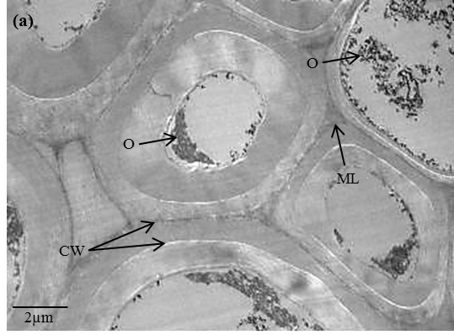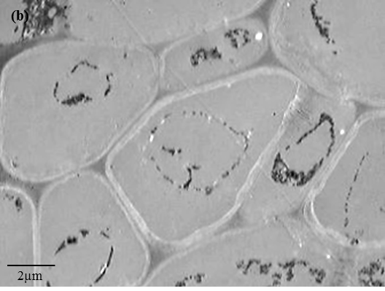
Figure 1. TEM images of a section through (a) fresh palm fruit and (b) MPD sample.
O - oil globules; CW - cell wall; ML - middle lamella. Magnification: (a) 1400; (b) 1800

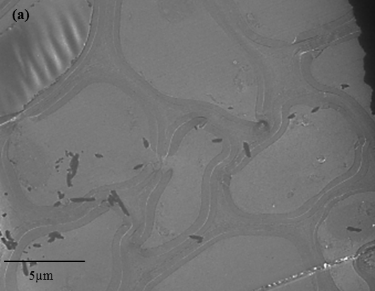

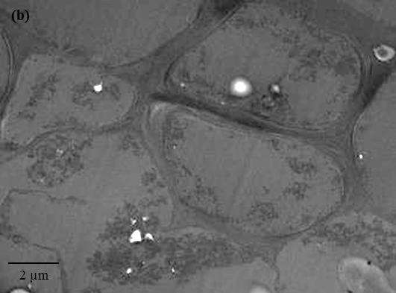

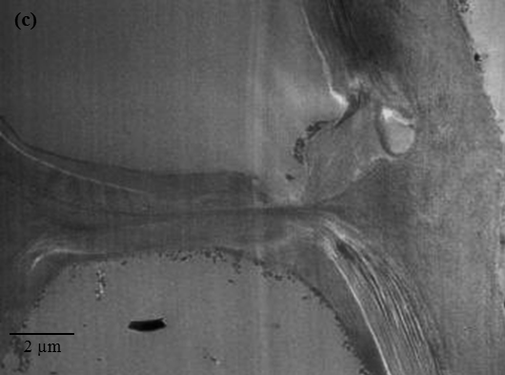

Figure 2. TEM images of a section through palm fruit fibre after enzymatic treatment using Pectinex only with minimum oil extraction yield of 71.18%. Magnification: (a) 800; (b) 1000

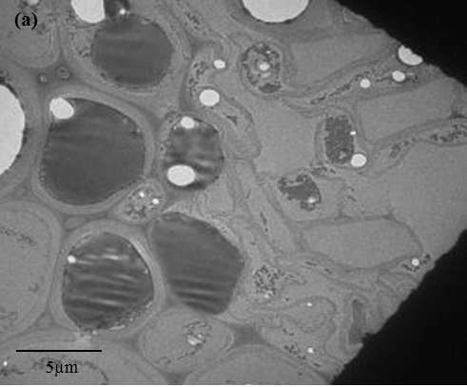

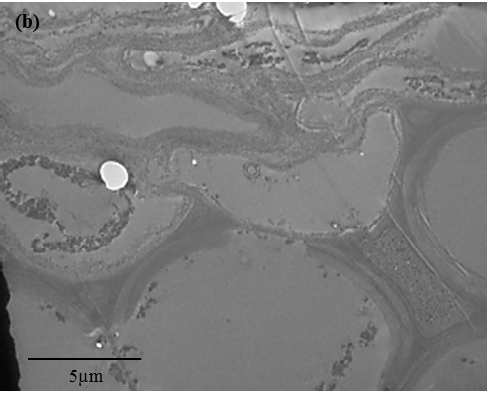

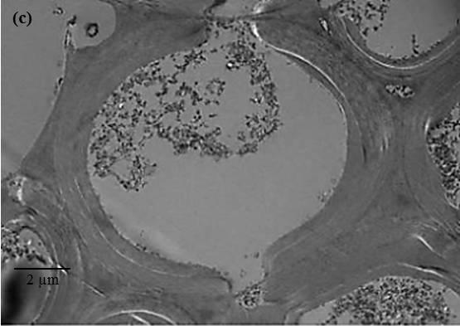

Fig. 3. TEM images of a section through palm fruit fibre after enzymatic treatment using enzyme combination of CTec2, HTec2 and Pectinex with maximum oil extraction yield of 90.38%. Magnification: (a) 450; (b) 1400

Figure 4. Oil extraction yield % and reducing sugar extraction yield (g/L) for aqueous enzymatic process and control

Measurement of reducing sugar generated by synergetic action of enzyme mixture on cell was performed to investigate the correlation between degree of hydrolysis and oil extracted. Fig. 4 displays the overlaying of sugar extraction yield over oil extraction yield to distinguish the interference between these two variables. It can be observed that oil extraction trend is not similar to that of reducing sugar yield. In control experiment, the sugar yield was 2.97 g/L and the highest sugar yield was 19.27 g/L (obtained through run 13) which showed 85% increment. This proves tremendous degradation effect of enzyme mixture corresponding to highest oil extraction yield. On the other hand, run 3 using HTec2 only resulted in the lowest reducing sugar yield which was 9.74 g/L but higher oil extraction yield compared to run 4 (lowest oil extraction yield). It can be deduced that higher degree of hydrolysis represented by higher level of reducing sugar yield does not necessarily give greater oil yield. Thus, an optimum condition has to be derived.

Lastly, numerical optimization was performed by setting goal of each criteria with regard to single response to generate optimal conditions. Ctec2 and Htec2 were chosen to be at minimum value while Pectinex in the range of zero to 0.2 targeting maximum oil yield %. Processes involving enzymes are always questionable in industries due to its high costing, thus usage of enzymes at minimum to yield maximum oil is more feasible and acceptable. Optimal mixture of CTec2, HTec2 and Pectinex obtained were 0.46, 0.34 and 0.2 respectively to yield 89.39 % of oil with desirability value of 0.7. Predicted optimum enzyme mixture was verified at 98% confidence interval of predicted value (experimental value of 88.36% oil extraction and 16.55 g/L sugar extraction yield). As quoted earlier, a maximum palm oil recovery of 90-93% was achieved with enzyme mixture of tannase, cellulase and pectinase at optimized hydrolysis conditions. Findings of this study is remarkably close to previous research but by optimizing other process conditions such as temperature, pH, substrate and enzyme loading, a much higher recovery could be expected.

The sensitivity of the response with respect to the three enzymes was analyzed referring to trace plot of oil yield given in Fig. 5. As illustrated in the figure, oil recovery has high sensitivity with the 3 enzymes (CTec2, HTec2, and Pectinex). Yield of oil decreases when HTec2 is increased, meanwhile enzymes CTec2 and Pectinex are characterized by a curve that is concave downward (with relative maximum point). With the other variable being held constant, the oil recovery increases when the concentration of CTec2 and Pectinex increases. However, at a deviation range before 0.171 with respect to the optimum enzyme combination, the oil recovery begins to decline.
Figure 5. Trace Plot (Piepel) for oil yield % as a function of component mix of three enzymes (A: CTec2, B: HTec2, C: Pectinex) in reference to the optimum enzyme mixture
Conclusion
In the present study, a new blend of enzymes, CTe2, HTec2 and Pectinex Ultra SP-L, was tested on aqueous enzymatic oil extraction process to achieve high performance extraction of palm oil from palm mesocarp. AEOEP is certainly an alternative way for palm oil extraction being an environmentally friendly process. The microscopic characteristics of AEOEP fibre studied using TEM shown an obvious enzyme degradation on mesocarp cell wall. The oil extraction yield can be further increased by optimizing other process conditions and oil quality parameters could be tested to support the efficiency of this enzymatic treatment.

References
- Teoh, Y. P. and Mashitah, M. D. (2010). Cellulase Production by Pycnoporus Sanguineus on Oil Palm Residues through Pretreatment and Optimization Study. Journal of Applied Sciences, 10 (12): 1036-1043.
- Ng, F. Y., Yew, F. K., Basiron, Y. and Sundram, K. (2011). A Renewable Future Driven with Malaysian Palm Oil Based Green Technology. Journal of Oil Palm & The Environment, 2:1-7.
- Kok, S., Ong-Abdullah, M., Ee, G.C., Namasivayam, P. (2011). Comparison of nutrient composition in kernel of tenera and clonal materials of oil palm (Elaeis guineensis Jacq.). Food Chem., 129 (4): 1343-1347.
- Sime Darby Plantation (2014), Palm Oil Facts and Figures, accessible at : http://www.simedarby.com/upload/Palm_Oil_Facts_and_Figures.pdf, accessed in October 2014
- Teixeira, C. B., Macedo, G. A., Macedo, J. A., Silva, L. H. M. and Rodrigues, A. M. C. (2013). Simultaneous extraction of oil and antioxidant compounds from oil palm fruit (Elaeis guineensis) by an aqueous enzymatic process. Bioresources Technology, 129: 575-581.
- Tan, C. H., Ghazali, H. M., Kuntom, A., Tan, C. P. and Ariffin, A. A. (2009). Extraction and physicochemical properties of low free fatty acid crude palm oil. Food Chemistry, 113: 645-650.
- Rosenthal, A., Pyle, D. L. and Niranjan, K. (1996). Aqueous and enzymatic processes for edible oil extraction. Enzyme Microb. Technol., 19 (6): 402–420.
- Deng, Y., Pyle, D. L. and Niranjan, K. (1992). Studies of aqueous enzymatic extraction of oil from rapeseed. Agri. Eng. Rural Dev. I Conf Proc. International Academic Publishers, Beijing 1: 190-195.
- Passos, C. P., Yilmaz, S., Silva, C. M. and Coimbra, M. A. (2008). Enhancement of grape seed oil extraction using a cell wall degrading enzyme cocktail. Journal of Food Chemistry, 115: 48-53.
- Rovaris, A. A., Balsamo, G. M., Costa, A. C. O., Arisi, A. C. M., Micke, G. A., Piovezan, M., Petkowicz, C. L. O. and Amante, E. R. (2013). Chemical characterization of liquid residues from aqueous enzymatic extraction of soybean oil. Journal of Food Science and Technology, 51: 51-58.
- Soto, C., Chamy, R. and Zuniga, M. E. (2007). Enzymatic hydrolysis and pressing conditions effect on borage oil extraction by cold pressing. Journal of Food Chemistry, 102: 834-840.
- Jiang, L., Hua, D., Wang, Z. and Xu, S. (2010). Aqueous enzymatic extraction of peanut oil and protein hydrolysates. Journal of Food and Bioproducts Processing, 88: 233-238.
- Aliakbarian, B., Faveri, D. D., Converti, A. and Perego, P. (2008). Optimisation of olive oil extraction by means of enzyme processing aids using response surface methodology. Biochemical Engineering Journal, 42: 34-40.
- Najafian, L., Ghodsvali, A., Khodaparast, M. H. H. and Diosady, L. L. (2009). Aqueous extraction of virgin olive oil using industrial enzymes. Journal of Food Research International, 42: 171-175.
- Barrios, V. A., Olmos, D. A., Noyola, R. A. and Lopez-Munguia, C. A. (1990). Optimization of an enzymatic process for coconut oil extraction. Oleagineux, 45 (1): 35-42.
- McGlone, O. C., Lopez-Munguia, C. A. and Carter, J. V. (2006). Coconut oil extraction by a new enzymatic process. Journal of Food Science, 51 (3): 695-697.
- Perez, E.E, Fernadez, M.B., Nolasco, S. M. and Crapiste, G. H. (2013). Effect of pectinase on the oil solvent extraction from different genotypes of sunflower (Helianthus annuus L.) Journal of Food Engineering, 117: 393-398.
- Sineiro, J., Dominguez, H., Nunez, M. J. and Lema, J. M. (1997). Optimization of the enzymatic treatment during aqueous oil extraction from sunflower seed. Journal of Food Chemistry, 61 (4): 467-474.
- Cheah, S. C., Augustin, M. A. and Ooi, L C. L. (1990). Enzymatic extraction of palm oil. Palm Oil Res. Bull. Malaysia 20: 30-36.
- Rathi, C. L., Pradhan, S., Javvadi, S. and Wani, A. (2012). An enzyme composition and process for extracting oil from palm oil fruits. WO2012011130 A3.
- Bradford, M. M. (1976). A Rapid and Sensitive Method for the Quantitation of Microgram Quantities of Protein Utilizing the Principle of Protein-Dye Binding. Analytical Biochemistry, 72 (1–2): 248-254.
- Sluiter, A., Hames, B., Ruiz, R., Scarlata, C., Sluiter, J., Templeton, D. and Crocker, D. (2011). Determination of Structural Carbohydrates and Lignin in Biomass. Golden, CO:U.S. Department of Energy National Renewable Energy Laboratory.
- Yoshida, M., Ichinose, H., Liu, Y., Kaneko, S., Uchida, S., and Kawarada, K. (2008). Effect of cellulose crystallinity, hemicellulose and lignin on the enzymatic hydrolysis of Miscanthus sinensis to monosaccharides. Biosci. Biotechnol. Biochem., 72 (3): 805-10.
- Glauet, A. M. (1980). Fixation, Dehydration and Embedding of Biology Specimens, in Practical methods in electron microscopy, A M Glauet, ed (North-Holland, Amsterdam).
- Lamsal, B. P., Murphy, P. A., and Johnson, L. A. (2006). Flaking and extrusion as mechanical treatments for enzyme-assisted aqueous extraction of oil from soybeans. J.Am. Oil Chem. Soc., 83 (11): 973-979.
- Ricochon, G. and Muniglia, L. 2010. Influence of enzymes on the oil extraction processes in aqueous media. Journal of Technology-Innovation, 17(6): 356-359.
- Li, J., Zu, Y. G., Luo, M., Gu, C. B., Zhao, C. J., Efferth, T. and Fu, Y. J. (2012). Aqueous enzymatic process assisted by microwave extraction of oil from yellow horn (Xanthoceras sorbifolia Bunge.) seed kernels and is quality evaluation. Journal of Food Chemistry, 138: 2152-2158.
- Ho, L.S., Nair, A.,Yusof, H.M., Kulaveerasingam, H.and Jangi, M.S. (2014). Morphometry of Lipid Bodies in Embryo, Kernel and Mesocarp of Oil Palm: Its Relationship to Yield. American Journal of Plant Sciences, 5: 1163- 1173.
- Tzen, J.T.C. (2012) Integral Proteins in Plant Oil Bodies. ISRN Botany, 2012: 16.
- Owolarafe, O. K., and Faborode, M. O. (2007). Micro-structural characterization of palm fruit at sterilization and digestion stages in relation to oil expression. Journal of Food Engineering, 85: 598-605.
- Wi, S. G., Singh, A. P., Lee, K. H., and Kim, Y. S. (2005). The pattern of distribution of pectin, peroxidase and Lignin in the Middle Lamella of Secondary xylem fibres in Alfalfa (Medicago sativa). Annals of Botany, 95: 863-868.

