

OPTIMIZATION STUDY FOR BUTANOL EXTRACTION FROM BUTANOL-WATER USING FATTY ACID METHYL ESTER (FAME) AS SOLVENT

(Kajian Pengoptimuman Pengekstrakan Butanol Daripada Campuran Butanol-Air Menggunakan Asid Lemak Metil Ester (FAME) Sebagai Pelarut)

Nurul Izzati Ab Rahim , Mohd Irfan Hatim Mohamed Dzahir*, Wan Nurul Hidayah Wan Othman

School of Bioprocess Engineering,
Universiti Malaysia Perlis, Kompleks Pengajian Jejawi 3, 02600 Arau, Perlis, Malaysia

*Corresponding author: irfan@unimap.edu.my

Abstract
The oil crisis, warned the humanity’s depends on oil was not sustainable and recently, there are plenty of renewable resources had been developed. Much attention has been given to the solvent extraction process to separate butanol from butanol-water mixture using fatty acid methyl ester (FAME) as a solvent. In this respect, the use of FAME as a green solvent which are locally available has greater potential for butanol extraction process. Therefore, an experimental work has been carried out to study its feasibility as a potential solvent. A single stage extraction process as performed to evaluate the ability to achieve optimal extract butanol. The extraction process was carried out to evaluate the distribution coefficient of butanol with the effects of other parameters such as reaction temperature (50-70 ºC) and butanol-water mixture to solvent ratio (1:1, 1:1.5, 1:2). The constant parameter is the stirring speed (300 rpm). Response Surface Methodology (RSM) in conjunction with the Central Composition Design (CCD) as employed to statistically evaluate and optimize the butanol extraction process. It was found that the distribution coefficient has achieved an optimum level of 1.92% at the following conditions: (i) butanol-water mixtures to solvent ratio (1:1.48) and (ii) reaction temperature (62.75 ºC).

Keywords: liquid-liquid extraction, butanol separation, green solvent, FAME

Abstrak
Krisis pengurangan minyak, memberi amaran kebergantungan kepada minyak tidak akan berkekalan dan kini terdapat banyak sumber yang boleh diperbaharui telah dibangunkan. Tumpuan yang khusus diberikan kepada proses pengekstrakan pelarut untuk memisahkan butanol dari campuran butanol-air menggunakan metil ester asid lemak (FAME) sebagai satu pelarut. Oleh yang demikian, penggunaan FAME sebagai satu pelarut semula jadi dan mudah didapati di sini mempunyai lebih banyak potensi untuk proses pengekstrakan butanol. Lantaran itu, satu eksperimen telah dijalankan untuk mengkaji potensi FAME sebagai satu bahan pelarut. Satu proses pengekstrakan peringkat dijalankan untuk mengkaji keupayaan optimum pengunaan butanol. Proses pengekstrakan dijalankan untuk menilai pekali taburan butanol dengan kesan parameter seperti suhu tindak balas dan campuran butanol-air kepada nisbah pelarut (1:1, 1:1.5, 1:2). Parameter yang dimalarkan adalah kelajuan kacauan. Kaedah Tindakbalas Permukaan (RSM) bersama-sama dengan ‘Central Composition Design‘(CCD) dilaksanakan untuk menilai dan mengoptimumkan proses pengekstrakan butanol. Hasil kajian menunjukkan pekali taburan telah mencapai satu tahap optimum iaitu 1.92% di syarat-syarat berikut: (i) campuran butanol-air kepada nisbah pelarut (1:1.48) dan (ii)suhu tindak balas (62.75 ºC).

Kata kunci: pengekstrakan Cecair-cecair tunggal, pemisahan butanol, pelarut semulajadi, FAME

Introduction
Recently, bio-fuel offers the technology by fermentation process such as bio-ethanol and bio-butanol. However, this has attracted renewed attention lately due to the expended of oil price and depletion of fossil fuels. The climate issues had become higher priorities in modern times and searching the alternative sustainable energy sources was highly worked out [1]. Compare to ethanol, butanol offers several advantages as a biofuel such as higher energy content, lower vapour pressure and lower hygroscopy which can be worked as a transport fuel. Currently, butanol is considered as an alternative biofuel [2]. Preparation butanol by anaerobic fermentation is one of the most senior industrial. Production of butanol through fermentation experiences intense product induced inhibition [1]. Among all biofuel alternatives, butanol obtained through the acetone-butanol-ethanol (ABE) process through a biological approach, is considered one of the replacement fuels with the most potential [3]. The solvent can be removed easily from the fermentation broth by using the liquid-liquid extraction process. In this process, the water-insoluble organic solvent is mixed with the fermentation broth. Butanol can be selectively concentrated in the organic phase due to it more soluble in organic (extractant) phase than in the aqueous (fermentation broth) phase. As extractant and fermentation are immiscible, the solvent can easily be separated from the fermentation broth after butanol extraction [4]. Various separation techniques have been studied on the butanol-water mixtures separation; one of the techniques is single stage liquid-liquid extraction.

The purity of butanol is influenced by the addition of solvent. A number of solvents have been studied on the basis of butanol selectivity, partition coefficient, their toxicity and the biocompatibility. These solvents include methyl ester, ionic liquid and 2-ethyl-1-hexanol. Preliminary research from the previous journals has been studied to identify the screening of potential solvents for separation of butanol-water mixture. For this purpose the factors such as locality and environment-friendly types of solvent is considered. These solvents include 2-ethyl-1-hexanol, methyl ester and ionic liquid. Among these, ionic liquid attracted considerable attention as the clean designable solvents. Ionic liquid is a type of green solvent for butanol separation because its low toxicity to butanol. Whereas, 2-ethyl-1-hexanol was considered as the best solvent for extract butanol due to an increase of contact surface area. Methyl ester on the other hand is an interesting solvent since it can be produced from agricultural product that is available in Malaysia [5,6]

In this study, methyl ester has been used as a solvent because of its partition coefficient (up to 3), low viscosity and low toxicity [7]. Although, methyl ester cannot perform a higher butanol production, but it was selectively preferred due to its characteristics as a green solvent and locality factor. In addition, methyl ester is an interesting solvent since it can be produced from agricultural product. Therefore, in this study the solvent ratio to butanol-water mixture and the temperature are investigated to separate the butanol using single stage liquid-liquid extraction process.

Materials and Methods
Materials
All the chemicals were directly used as received without further purification. Methyl ester is produced by transesterification of vegetable cooking oil with constant speed rate (300 rpm). The vegetable cooking oil was dissolved along with the mixture of sodium hydroxide, NaOH (HmbG) and methanol, CH₃OH (reagent grade AR), which made up to a different total volume data in DOE at the different reaction time [7]. The butanol, n-butanol (reagent grade AR)–water, deionized water mixture used represent the mixture butanol-water from ABE fermentation broth.

Experimental procedure
This study consisted of two parts: the first part is liquid-liquid extraction process. In this part the mixture of butanol-water is mixing with fatty acid methyl ester (FAME) to separate the butanol from by-product, glycerol and other impurities by a single stage liquid liquid extraction process. Butanol-water mixtures were prepared before mixed with FAME by diluting with deionized water. The process will perform in a double-necked flask with equipped with a reflux condenser, temperature sensor, and agitation. Time taken for each session was 30 minutes with the different butanol-water mixtures to solvent ratio and reaction temperature. The stirring speed was kept constant at 300 rpm. After that the mixtures were poured into a separator funnel and allow cooling until it’s separated into two layers. The upper layer is known as extractant while the bottom layer known as raffinate [5,8]. The second part of this research is quality analysis of butanol products from its distribution coefficient. Each layer was analysed using gas chromatography (GC) before calculation was made to obtain distribution coefficient.

Results and Discussion
The complete design matrix corresponding to central composite design (CCD) design terms of real and coded independent variable and the results are given in Table 1. The experiments were run randomly in order to minimize errors from the systematic trends in the variables.
Experimental data obtained from central CCD were analyzed using response surface methodology (RSM). The second-order polynomial equation model for prediction of the optimal point between the response variable (butanol yield) and the independent variables of transesterification reaction is expressed by Equation 1, where Y is the predicted response; β₀, β_{i}, β_{j}, β_{ii}, β_{jj}, β_{ij} are the constant coefficients; x_{i} and x_{j} are the coded independent variables or factors, while ξ is random error:

Y = β₀ + ∑^{k}_{j = 1} βixi + ∑ ∑_{kj}βijxij + ∑^{k}_{j} = ₁ βjjx²_{j}+ ξ (1)
The quality of fit for the model was evaluated by the coefficients of determination (R²) and its regression coefficient significant analysis of variances (ANOVA) was checked with the Fisher’s test F-test. Response surfaces and contour plots were developed using the quadratic polynomial equation obtained from regression analysis of experimental data by keeping of the independent variables at a constant value while changing the other variables.

Table 1. Central composite design for response surface methodology (extraction process)
Run Order | Reaction  Temperature (ºC) | BM to solvent ratio (ml) | Distribution Coefficient (%) | Predicted Distribution Coefficient (%)
1 | 70 | 100 | 1.24 | 1.19
2 | 50 | 100 | 0.42 | 0.47
3 | 50 | 50 | 0.92 | 0.89
4 | 70 | 50 | 1.25 | 1.10
5 | 60 | 75 | 1.98 | 1.94
6 | 60 | 100 | 1.25 | 1.24
7 | 50 | 75 | 1.32 | 1.29
8 | 60 | 50 | 1.24 | 1.41
9 | 70 | 75 | 1.56 | 1.76
10 | 60 | 75 | 1.81 | 1.94
11 | 60 | 75 | 2.44 | 1.94
12 | 60 | 75 | 1.96 | 1.94
13 | 60 | 75 | 1.67 | 1.94

Among the models that fitted to the response (linear, two factor interaction (2FI), quadratic and cubic polynomial), the quadratic vs. 2FI model was selected as a best model due to its highest order polynomial with the signification of additional terms and the model was not aliased. This quadratic vs. 2FI model was suggested by the RSM software as shown in Table 2. The model equation based on the coded values (A and B as reaction temperature and butanol-water mixtures to solvent ratio, respectively) for the distribution coefficient was expressed by Equation 2. Positive sign in front of the terms indicates a synergistic effect in increase butanol production, whereas negative sign indicates antagonistic effect.

The model in Equation 2 shows the significant coefficients of A, B, AB, A², and B² indicated a linear effect to increase the distribution coefficient. The result of statistical ANOVA, which was carried out to determine the significance and the fitness of the quadratic model as well the effect of significant individual terms and their interaction on choosing responses was presented in Table 3.

Y= 1.94 + 0.23x_{i} – 0.084x_{j} + 0.12x_{i}x_{j} – 0.41x²_{i} – 0.61x²_{j} (2)

Table 2. Sequential model sum of squares
Source | Sum | df | Mean | F value | Prob. > F
 | Squares |  | square
Mean vs Total | 27.89 | 1 | 27.89
Linear vs Mean | 0.37 | 2 | 0.18 | 0.64 | 0.5497
2FI vs Linear | 0.062 | 1 | 0.062 | 0.20 | 0.6671
Quadratic vs 2FI | 2.38 | 2 | 1.19 | 18.91 | 0.0015
Cubic vs Quadratic | 0.062 | 2 | 0.031 | 0.41 | 0.6852
Residual | 0.38 | 5 | 0.076
Total | 31.15 | 13 | 2.40

Table 3. Analysis of variance (ANOVA) for model regression.
 | Source | Sum of | Df | Mean | F Value | p-value
 |  | Squares |  | Square |  | Prob > F
 | Model | 2.81 | 5 | 0.56 | 8.92 | 0.0060 | Significant
 | A-Reaction | 032 | 1 | 0.32 | 5.15 | 0.0575
 | Temperature
 | B- BW to | 0.042 | 1 | 0.042 | 0.67 | 0.4398
 | solvent ratio
 | AB | 0.062 | 1 | 0.062 | 0.98 | 0.3542
 | A² | 0.47 | 1 | 0.47 | 7.48 | 0.0291
 | B² | 1.03 | 1 | 1.03 | 16.41 | 0.0049
 | Residual | 0.44 | 7 | 0.063
 | Lack of Fit | 0.10 | 3 | 0.034 | 0.40 | 0.7608 | Not significant
 | Pure Error | 0.34 | 4 | 0.085
 | Cor Total | 3.25 | 12 | R-Squared | 0.8644
 | Std. Dev. | 0.25 |  | Adj R- | 0.7675
 |  |  |  | Squared
 | Mean | 1.46 |  | Pred R- | 0.5701
 |  |  |  | Squared
 |  |  |  | Adeq | 8.596
 |  |  |  | Precision

The regressors or terms incorporated in the Model F-value of 8.92 with p-value 0.0060 implies that the model is significant at 95% confidence level. The p-value (probability of error value) is used as a tool to check the significance of each regression coefficient, which also indicates the interaction effect of each across products. The smaller the p-value, the bigger the significance of the corresponding coefficient [1].

In the case of model terms, the p-values less than 0.05 indicated that the particular model terms were statistically significant. From the ANOVA results, the main model terms suggested that variables with significant influence on the distribution coefficient response were reaction temperature (A) and butanol-water mixtures to solvent ratio (B) and the interaction terms were found to exist between the main factors (AB, A², B²) while there were no significant quadratic terms exist.

The predicted values versus actual values of the distribution coefficient with adjusted-R² value was 0.8644 indicate the model with 86.44% of variability as Figure 1. The predicted values and experimental values were reasonable agreement, where the R² value closed to unity, mean that the data fit with the model and given a convincingly good estimate of the response for the system in the range studied.

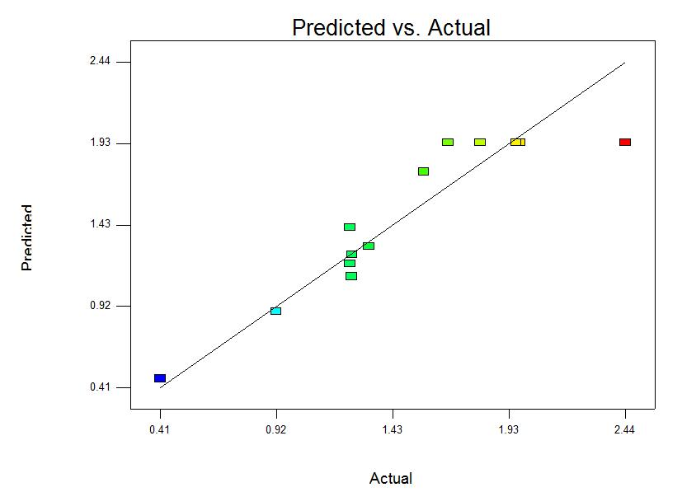

Figure 1. Predicted versus actual distribution coefficient of butanol.

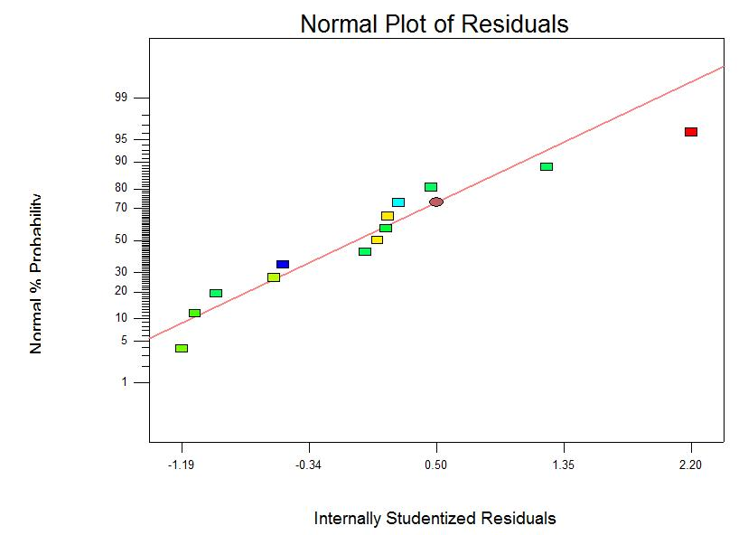

Figure 2. Normal probability plot of residuals

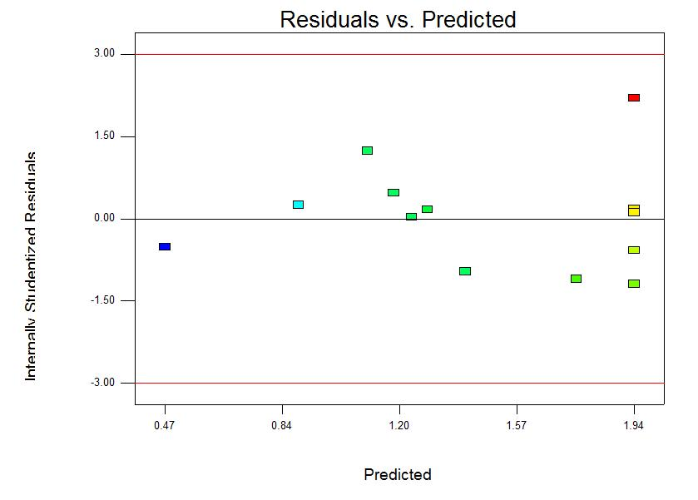

Figure 3. Plot of the residuals versus the predicted response

The optimization of the single stage liquid-liquid extraction process was performed to seek for an optimum combination of operating conditions at which the highest distribution coefficient is achieved. The variables (reaction temperature and butanol-water mixtures to solvent ratio) were set in a range between low and high levels, which coded -1 and +1 to achieve maximum response for the distribution coefficient as in Table 4. The solutions with these two variables were generated by the software for the desired response of the system based on the model obtained and the experiment data input criteria. The overall optimized conditions for biodiesel yield were obtained as follows; reaction temperature 62.75, and butanol-water mixtures to solvent ratio 1:1.48 or 50 mL: 73.98 mL (Table 5).

Table 4. Optimization criteria for highest distribution coefficient
 | Name | Goal | Lower Limit |  | Upper Limit
 | Reaction Temperature | Is in range | 50 (-1) | 70 (+)
 | Butanol-water mixtures to solvent ratio | Is in range | 50 (-1) | 100 (+)
 | Distribution Coefficient | Maximize | 0.412 | 2.44

The optimization of distribution coefficient has been done and the suggested parameter values can be seen in Table 5. Based on the table, all the suggested parameters will be fixed and use of single stage liquid-liquid extraction process before undergoing a separation step. The theoretical distribution coefficient was 1.97%, while the value of the experimental distribution coefficient was 1.92%.
Table 5. Results of model validation at the optimum condition
 | Number | Reaction | BW | Predicted | Experimental | Desirability
 |  | Temperature | Mixtures to | Distribution | Distribution
 |  |  | Solvent | Coefficient | Coefficient
 |  |  | Ratio | (%) | (%)
 | 1 | 62.75 | 1:1.48 or | 1.97 | 1.92 | 0.77
 |  |  | 50:73.98 mL

Conclusion
Optimization of butanol-water mixtures contributes to 1.97% Of predicted butanol yield, while 1.92% of experimental distribution coefficient of butanol by manipulating reaction parameters, which are reaction temperature and butanol-water mixtures to solvent ratio. A response of 13 experiments had been analyzed and evaluated on their interaction between those parameters and its effects towards distribution coefficient. Single stage liquid-liquid extraction process was done using the optimized parameters and undergoes a separation process for the removal of impurities.

Despite the performance and efficiency of Fatty acid methyl esters (FAME) as an extraction solvent gave lower butanol distribution coefficient compared to other commercial solvents, but it is a potential solvent since it can be produced from agricultural product that is available in Malaysia. Moreover, the cost of production of FAME is lower compared to other solvent. The optimum temperature used for the extraction process between 60 to 62ºC.

Acknowledgement
The authors would like to thank the Ministry of Higher Education, Malaysia for supporting this work through the Fundamental Research Grant Scheme (FRGS 9003-00389).

References
- Liu, H., Wang, G., and Zhang, J. (2013). The Promising Fuel-Biobutanol, InTech. , Chapter 6
- Shapovalov, O. I. and Ashkinazi, L. A. (2008). Biobutanol: biofuel of second generation, Springer. 81: 2232-2236
- Garcia, L.Y, Garsia C.M, Schuur, B., Abeqseq, D. (2012) Biobutanol Recovery Using Nonfluorinated Task-Specific Ionic Liquids. Ind Eng Chem Res. 51(24): 8293-8301.
- Nasibuddin, Q. and Addox, S. (1995) Continuous Production of Ketone-Butanol-Ethanol Using Immobilized Cells of Clostridium acetobutylium and Integration with Production Removal by Liquid-Liquid Extraction, Journal of Bioscience and Bioengineering 80 (2): 185-189
- Chuichulcherm, S. and J. Chutmanop (2000). Butanol separation from ABE model fermentation broth by liquid-liquid extraction, Elsevier. 1-6.
- Plechkova, N.V. and Seddon, K.R. (2007). Applications of ionic liquids in the chemical industry, Chem. Soc. Rev. 37: 123-150.
- Canaki, M., Gerpen, J. V. (2001). Biodiesel production from oils and fats with high free fatty acids, Trans. ASAE, 44: 1429-1436.
- Ishizaki, A., Michiwaki, S., Crabbe, E., Kobayashi, G., Sonomoto, K. and Yoshino, S. (1999). Extractive Acetone-Butanol-Ethanol Fermentation in Batch Culture of Clostridium saccharoperbutylacetonicum N1-4 (ATCC 13564), Journal of Bioscience and Bioengineering 87 (3):352-356.

