

PHOTOGRAFTING OF POLYACRYLAMIDE HYDROGEL COATING ONTO VARIOUS POLYETHYLENE TEREPHTHALATE TEXTILES

(Pencantuman Melalui Pencahayaan Salutan Hidrogel Poliakrilamida ke atas Pelbagai Jenis Tekstil Polietilena Tereftalat)
Nurul Hazlina Naemuddin¹, Siti Samahani Suradi¹, Jamarosliza Jamaluddin^{1,2}, Nadia Adrus^{1,2}*

¹Department of Polymer Engineering,
²Biopolymer Research Group, Department of Polymer Engineering,
Faculty of Chemical Engineering,
Universiti Teknologi Malaysia, 81000 Skudai, Johor, Malaysia

*Corresponding author: nadia@cheme.utm.my

Abstract
In this paper, polyacrylamide (PAAm) hydrogels grafted via photopolymerization onto various types of polyethylene terephthalate (PET) as matrix were designed and synthesized. The investigation was carried out based on thickness (0.02 -0.07 mm) of nonwoven PET textiles from various resources as well as commercial PET membrane. In this study, PET matrices with a disk shape of 4.5 cm in diameter were coated with thin hydrogel using UVA photopolymerization system. The resulting grafted PAAm-g-PET was examined through degree of grafting (DG) and characterized by using Fourier Transformed Infrared Spectroscopy (FTIR). The DG above 50 % results showed the ability of PAAm hydrogel to be grafted onto PET. The various range of thickness and surface of PET also gave an impact onto the performance of grafting of PAAm onto PET. FTIR results also confirmed the addition of amide group after grafting process (1720 cm⁻¹, 1100 cm⁻¹, 850 cm⁻¹). The hydrophilicity of hydrogels was reported to impart oil fouling resistance. We expect that grafted hydrogel layer has fascinating future for oil/water separation.

Keywords: polyacrylamide (PAAm), hydrogel, polyethylene terephthalate (PET), Fourier Transformed Infrared Spectroscopy (FTIR)

Abstrak
Dalam kertas ini, hidrogel poliakrilamida (PAAm) dicantumkan pada beberapa jenis polietilena tereftalat (PET) sebagai matriks dengan menggunakan teknik pempolimeran cahaya telah direka dan disintesis. Kajian ini telah dilaksanakan berdasarkan ketebalan (0.02-0.07 mm) tekstil PET bukan tenunan daripada pelbagai sumber yang berbeza dan juga membran PET komersial. Melalui kajian ini, tekstil PET dipotong dalam bentuk cakera yang berdiameter 4.5 cm telah disaluti dengan lapisan hidrogel yang nipis menggunakan sistem pempolimeran cahaya UVA. Hasil cantuman PAAm-g-PET dianalisis melalui darjah cantuman (DG) dan dicirikan menggunakan spektroskopi inframerah transformasi Fourier (FTIR). Hasil 50 % DG dan ke atas dapat membuktikan keupayaan sifat hidrogel PAAm yang dicantumkan dengan PET. Ketebalan dan permukaan PET yang berbeza turut memberi kesan terhadap kebolehupayaan cantuman antara PAAm dan PET. Keputusan FTIR juga mengesahkan penambahan kumpulan amida selepas proses cantuman (1720 cm⁻¹, 1100 cm⁻¹, 850 cm⁻¹). Sifat hidrofilik hidrogel dilaporkan memberikan rintangan terhadap kotoran minyak. Kami menjangkakan bahawa lapisan hidrogel yang dicantumkan mempunyai masa depan yang baik dan menarik untuk pengasingan minyak/air.

Kata kunci: poliakrilamida (PAAm), hidrogel, polietilena tereftalat (PET), Spektroskopi Inframerah Transformasi Fourier (FTIR)

Introduction
There are tremendous attention upon hydrogel and its application nowadays especially in separation and membrane processes field [1-3]. This is evidenced by the contribution of many biomaterial science researchers on the preparation, structure, properties and application of hydrogel in catalysis, photonics, optics, pharmaceutics and biomedicine [4].

Hydrogels are highly hydrated polymers that built up of three-dimensional polymer network [5]. The net repulsion between a polymer network and solvent can cause a phase transition and a change in the swelling degree. Hydrogels can be specifically categorized according to their structures or crosslinking; either physically or chemically. According to Yang et al. [3] hydrogel can be classified as conventional or stimuli-responsive hydrogels (SRH). SRH has similarity with conventional hydrogels except that it exhibit sudden volume change in response to pH, light and temperature. Due to their hydrophilicity, hydrogels have the ability to retain high water content and minimize the foulant contact such as adsorption of protein [6], adhesion of cells or bacteria [7] as well as oil-repellent property [8].

Polyacrylamide (PAAm) hydrogel networks are formed in an aqueous medium and mainly used in electrophoresis application [9]. Polyacrylamide gel electrophoresis (PAGE) is a popular method for protein and DNA characterization [9]. It has been shown that PAAm are non-toxic even though acrylic acid monomer indicated the toxicity characteristic [10]. The hydrophilic and semipermeable nature of PAAm is valuable for mimicking the extracellular matrix (ECM) surrounding cells and tissues [11-16]. Commercial applications of PAAm included its use in drag reduction agents, thickening agents, cutting fluids, soil stabilizers, soap, textiles and enhanced recovery oil [17].

Some reports showed polyethylene terephthalate (PET) has been used in wide range of applications [18]. Those include automotive and aerospace industries, construction, filtration and many more. To some extent, engineering PET and metals possess comparable properties in terms of mechanical properties. On top of that, PET polymer is much cheaper and easy to handle.

Most of polymeric materials including PET have low surface energies. Despite their outstanding chemical and mechanical properties, the applied fibres made from PET have limitations with regard to their surface properties. According to Ilaria et al [19] due to the intrinsic hydrophobic nature, PET textile has suffered some drawbacks. These hydrophobic nature leads to the occurrences of fouling like bio-fouling [20-22] (deposition and growth microorganism on surfaces), oil-fouling [23] and etc. Therefore, the hydrophilicity of PET textiles can be improved by grafting with hydrophilic polymer such as hydrogels. Surface modification of grafted polymer based hydrogel is convenient process in producing the polymers with better physicochemical properties at minimum cost.

UV light can be claimed to be an important tool for attaching hydrogel layers onto PET surfaces [3]. UV light source produces free-radicals by decomposing the photoinitiator in order to initiate the polymerization. In recent years, the UV-initiated grafting or co-polymerization is progressively proposed for an effective surface modification as it offers unique ability to tune and to manipulate surface properties without damaging the bulk materials [24-25]. Absorbed photons and the generation of free radicals is a photo-chemical surface modification based on bond breaking.

Therefore, the aims of this work were to synthesize PAAm hydrogels via UV photografting and to characterize the grafted PET (PET-g-PAAm) network from degree of grafting (DG) and Fourier Transformed Infrared Spectroscopy (FTIR) measurement. The hydrogel grafted PET textiles are envisioned to have oil-repelling properties due to the synergistic of combining hydrophilic hydrogel onto PET surfaces.

Materials and Methods
Materials
Acrylamide (AAm), N,N-methylenebiscarylamide (MBAAm), bezophenone (BP; “type II” photoinitiator), sodium hydroxide (NaOH), acetic acid (CH₃COOH) and ethanol (C₂H₅OH) were purchased from Acros Organic (Belgium), Sigma Aldrich (USA), Rahn AG (Germany) and Fisher Scientific (M) Sdn Bhd (Malaysia) respectively. All chemicals are of analytical grade. AAm was recrystallized from n-hexane while other chemicals were used as received without further purification. Various types of commercial PET textiles termed as PET_W, PET_BE, PET_N and PET_G, and Technical PET (cut into 4.5 cm diameter) were purchased from local supplier, Md Interactive Enterprise. PET track-etched membranes were purchased from Oxyphen GmbH, Germany. Distilled water was used throughout all the experiment.

Preparation of PET Textiles
The PET textiles were cut into a diameter of 4.5 cm, washed with distilled water to remove the impurities and undergone alkali treatment by immersing the textiles into NaOH solution at ambient temperature for 30 minutes. Then, the textiles were rinsed with abundant water to remove any traces of alkali on the surface of the textiles. After the treatment, the textiles were neutralized with a dilute CH₃COOH solution and were washed again with distilled water. Finally, the treated textiles are dried at the room temperature for 48 hours.

Photografting of PET Textile using Polyacrylamide Hydrogels
Next, photoinitiator type II solution was prepared using 50 mM of BP in 10 mL of C₂H₅OH. PET textiles were immersed in the photoinitiator solution for about 1 hour. Meanwhile, for typical PAAm pre-gel reaction mixture, purified AAm (15 %) were added to 5 mL of distilled water, followed by the addition of MBAAm (cross-linker, 5 %) and stirred until completely dissolved. The textiles were immersed in pre-gel solution and exposed to UV Mercury devices (UVACUBE 400, Honle UV Technology, Germany) for 45 minutes.

Degree of Grafting
After irradiation, the fabric samples were equilibrated with distilled water for 8 hours to elute all the unreacted monomer, BP and homo-polymer. Then, the fabric samples were dried in oven at 45 °C for about 2 hours and weighted again. The degrees of PET-g-PAAm were calculated using the formula equation 1 stated by Hassan et al. [26].

DG = $\frac{W_{2}- W_{1}}{W_{1}} x 100\%$ (1)

where W₁ is initial textile sample weight and W₂ is the textile weight after modification.

Characterization of functional group on the surface
The surfaces of unmodified and grafted PET were characterized by using FTIR (Perkin Elmer Spectrum One). The FTIR spectra were recorded in the wavenumber range of 4000-400 cm⁻¹ with a resolution of 4 cm⁻¹ over 32 scans and by the potassium bromide (KBr) pellet technique.

Results and Discussion
Degree of Grafting Evaluation
The DG was determined from various hydrogel grafted PET surfaces (PET textiles and PET membrane) textiles and membrane as a function of its thickness and porosity. Hydrogel has an ability to swell and retain a large amount of water while it remained insoluble [27]. Table 1 shows the appearance of the sample before and after grafting. After grafting, the overall thickness of the PET increased (Figure 1) and a thin layer of hydrogel was noticeable from visual observation. From Table 1, PET_G has undergone a significant change in appearance as compared to other PET textiles and membrane; it became transparent after grafting with the hydrogel. Presumably, hydrogel grafted to a larger extent within the PET_G pores rather than their outer surfaces as it has higher porosity.

The DG is an indication of the hydrogels capability to be grafted onto various PET surfaces. Figure 1 exhibits the variation of DG versus original and grafted thickness of various PET textiles and membrane surfaces. Obviously, the values of DG are depending upon the types of PET and its thickness. Based on Figure 1, the two region of DG can be observed; i.e., below and above 200 %. According to the previous studies [5], the DG that exceeds 500 % indicates as a pore-filling and less than 200 % indicates a surface grafting.

Table 1. Appearance of Grafted Hydrogel onto Various Types of PET Textiles Before and After Grafting
with the Degree of Grafting
Samples | DG (%) | Appearance
Samples | DG (%) | Before Grafting | After Grafting
PET_W | 167.82 | 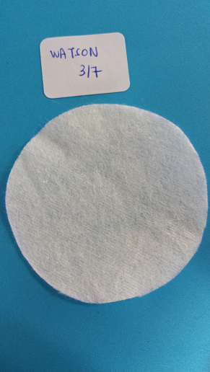 | 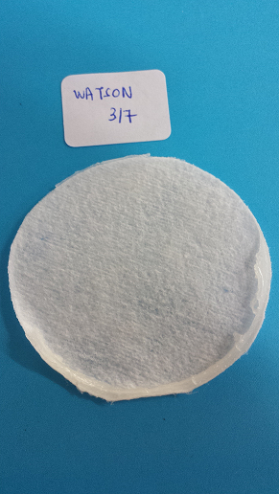
PET_B | 517.29 | 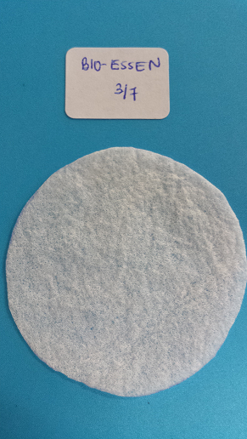 | 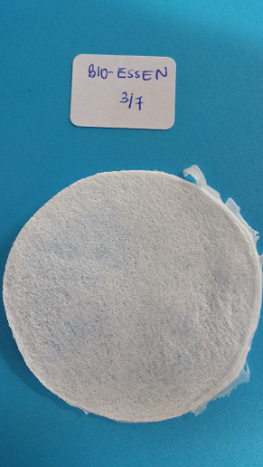
PET_N | 395.16 | 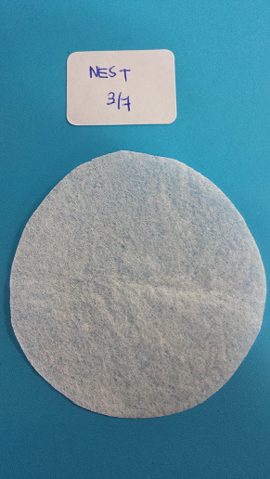 | 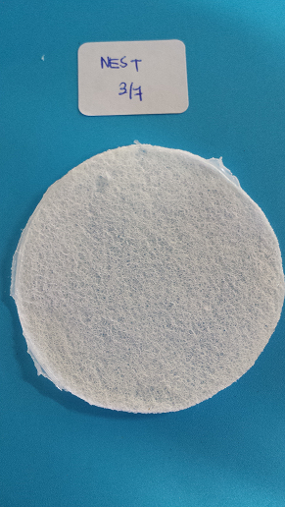
PET_G | 233.71 | 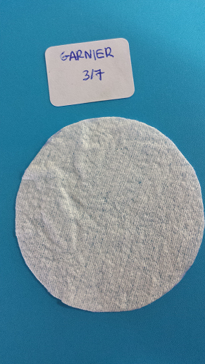 | 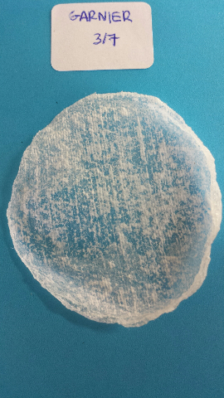
Technical PET | 49. 86 | 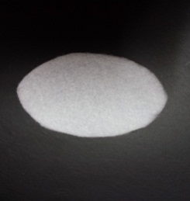 | 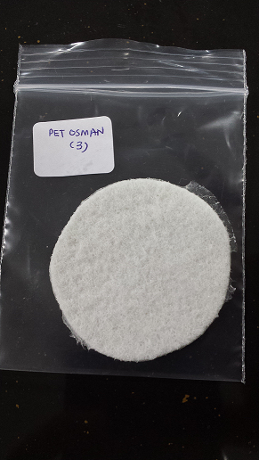
PET Membrane | 94.43 | 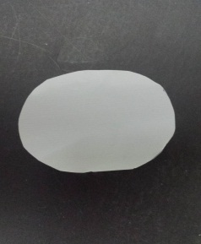 | 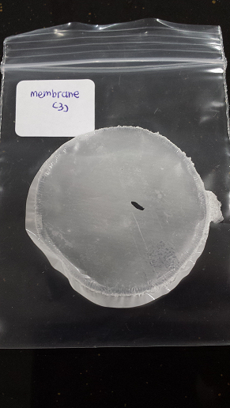
Note: Degree of grafting calculated based hydrogel coated on the surface of textile ONLY.

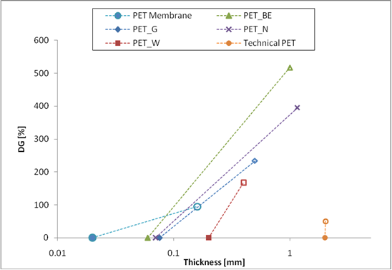

Figure 1. Degree of grafting versus original thickness (filled symbol) and the thickness after grafting (unfilled symbol) of various PET textiles and membrane.

Among five grafted PET textiles samples, PET_BE shows the highest DG (517.29 %) and technical PET recorded the lowest DG with 49.86 %. PET membrane has the lowest original thickness which was 0.02 mm. In case of PET textiles, the PET_BE has the lowest thickness (0.063 mm) and technical PET has the highest original thickness (2 mm) followed by PET_W (0.19 mm). This clearly indicates that the DG is also influenced by the thickness of the textiles. Since PET_BE has lowest thickness, it undergone pore-filling rather than only surface grafting.

Fourier Transform Infrared Spectroscopy Evaluation
Figure 2, 3, 4, 5 and 6 show IR spectra of unmodified and modified PET samples by grafting. The IR absorptions bands of various unmodified PET textiles were illustrated in Figures 2. Among unmodified PET textiles, technical PET textile has higher thickness tend to indicate higher absorption intensity, followed by PET_W textile and the rest of unmodified PET are possess almost similar intensity.

From Figure 3, absorption bands of PET for unmodified technical PET textiles can be seen in a range around 1742.98 – 1688 cm⁻¹, 1612.98- 1451.21 cm⁻¹ and 1299.02- 1161 cm⁻¹ which corresponding to C=O stretching, benzene stretching and C-O-C stretching, respectively. The band 1262.55cm⁻¹ is mainly due to vibrations of the ester group. Also, an absorption bands at range 3760.28- 3580.25 cm⁻¹ indicated to the hydroxyl (O-H) aliphatic group [28].

Meanwhile, the grafting of PAAm hydrogel onto PET outer surface could be confirmed based on the significant difference between spectra before and after modification. The results were firstly compared using technical PET as examples (Figure 3). It can be seen that technical PET-g-PAAm textile has significant additional feature of absorption bands in the range 3100-3500 cm⁻¹ resulting from N-H stretching oscillation and intensive peak at around 1700-1650 cm⁻¹ corresponding to the C=O stretching oscillation of amide moiety of the grafted acrylamide chain [29-30]. Not only that, the broader peak in range 3500-3700 cm⁻¹ may due to higher extent of H bonding of carboxylic acid group [31]. These data convincingly support the evidence of grafted reaction of PAAm with PET textiles surface.

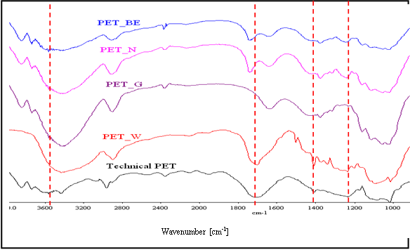

Figure 2. FTIR spectra of unmodified PET textiles.

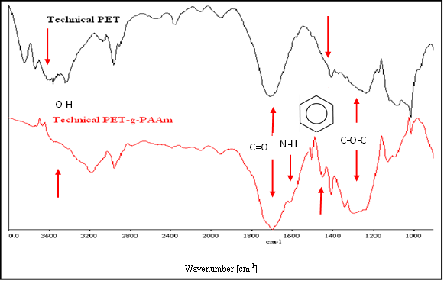

Figure 3. FTIR spectra of unmodified and grafted PET textiles (technical PET).

IR spectra of several PET textiles before and after modification are shown in Figures 3, 4 dan 5. PET_BE and PET_ G were amongst the thinnest textiles. PET_BE-g-PAAm and PET_G-g-PAAm have higher absorption peak corresponding to amide functional group as compared to technical PET-g-PAAm textiles. This observation can thus be attributed due to the grafting capability of hydrogel onto the PET textiles as a function of its thickness. Correspondingly, these trends are also in a good agreement with the DG obtained. These results proved that thickness of PET textiles may also have influence on the DG; the thicker PET textile has led to decrease in intensity of absorption in FTIR spectrum.

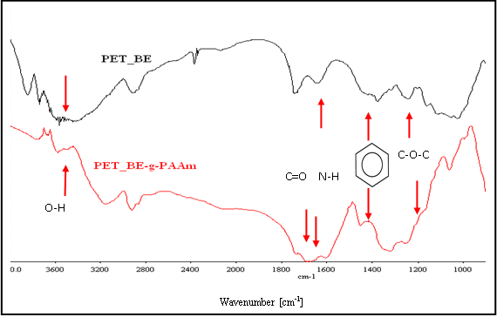

Figure 4. FTIR spectra of unmodified and grafted PET textiles (PET_BE).

In addition, the FTIR results were also compared among various types of PET (commercial membrane, commercial textile (PET_W) and technical textile) The FTIR data of various types of PET are shown in Figure 6. Based on this figure, the spectra revealed a comparable intensity. These patterns were obtained due to the physical properties of PET itself. Basically, the PET membrane showed robust fine surfaces, high penetration, and good mechanical properties. On the other hand, PET_W and technical PET also showed good mechanical properties similar to PET membrane but limited penetration and the stiffness depending on its thickness. Indeed, the DG is influenced by the thickness of PET. Remarkably, these results are in good agreement with the above observation.

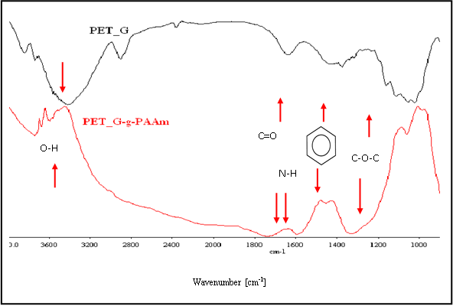

Figure 5. FTIR spectra of unmodified and grafted PET textiles (PET_G)

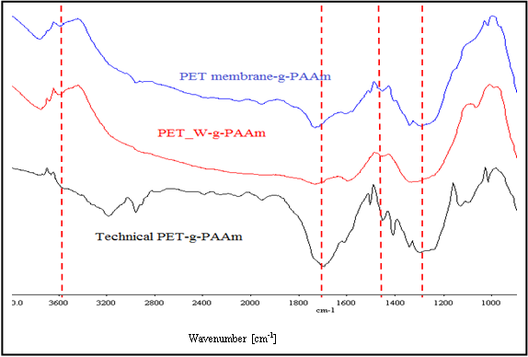

Figure 6. FTIR spectra of modified PET membrane, PET_W and technical PET.

Conclusion
Polyacrylamide (PAAm) hydrogel were successfully grafted onto various PET textiles and commercial PET membrane by UV initiated photopolymerization. The DGs are strongly dependent on the thickness of PET and also porosity; where most likely pore-filling occurred at high DG. Not only that, through FTIR spectra evaluation, it is proven that the thickness of types of PET textiles play a significant in influencing the DGs. Therefore, owing to the hydrophilicity modification of PET surfaces using hydrogel; this unique feature has fascinating future for oil/water separation.

Acknowledgement
Authors would like to thanks the Ministry of Higher Education Malaysia for supporting this work through the Exploratory Research Grant (ERGS Vot. No: 4L142) and also Universiti Teknologi Malaysia.

References
- Kumar, A. Srivastava, I. Galaev and B. Mattiasson. (2007). Adjuvant properties of a biocompatible thermo-responsive polymer of N-isopropylacrylamide in autoimmunity and arthritis. Program Polymer Science, 32: 1205-1237.
- D. Wandera, S. R. Wickramasinghe and S. M. Husson. (2010). Stimuli-responsive membrane. Journal Membrane Science, 357: 6-35.
- Q. Yang, N. Adrus, F. Tomicki, M. Ulbricht. (2011). Composites of functional polymeric hydrogels and porous membranes. Journal of Material Chemistry, 21: 2783-2811.
- Z. Jovanović, A. Krklješ, J. Stojkovska, S. Tomić, B. Obradović, V. Miškorić-Stanković, Z. Kačarević-Popović. (2011). Synthesis and characterization of silver/poly (N-vinyl-2-pyrrolidone) hydrogel nanocomposites obtained by in situ radiolytic method. Radiation Physics and Chemistry, 80: 1208-1215.
- N. Adrus. (2012). Stimuli-Responsive Hydrogels and Hydrogel Pore-Filled Composite Membranes. Department of Chemistry, Universitat Duisburg-Essen, Germany: 1-148.
- P. T. Charles, V. R. Stubbs, C. M. Soto, B. D. Martin, B. J. White, C. R. Taitt. (2009). Reduction of non-specific protein adsorption using Poly(ethylene) glycol (PEG) modified Polyacrylate hydrogels in immunoassays for Staphlococcal Enterotoxin B Detection. Sensor, 9: 645-655.
- R. Kunz, C. Anders, L. Heinrich. (1999). Investigation into the mechanism of bacterial adhesion to hydrogel-coated surfaces. Journal of Material Science Material Medicine, 10: 649-652.
- R. Yoshida, and T. Okano. (2010). Stimuli-Responsive Hydrogels and Their Application to Functional Material, in R.M. Ottenbrite, K. Park, T. Okano (Eds.) Biomedical Applications of Hydrogel Handbook, Springer New York: 19-43.
- D. C. Lin, B. Yurke, N. A. Langrana. (2004). Mechanical Properties of a Reversible, DNA-Crosslinked Polyarcylamide Hydrogel. Biomechanical, 126: 104-110.
- L. Yu, S. Zhang, W. Liu, X. Zhu, X. Chen. (2010). Improving the flame retardancy of PET fabrics by photo-induced grafting. Polymer Degradation and Stability, 95: 1934-1942.
- R. J. Pelham, Y. L. Wang. (1997). Proc Natl Acad Sci USA, 94:13661-13665
- Y. L Wang, R. J. Pelham. (1998). Preparation of a ﬂexible, porous polyacrylamide substrate for mechanical studies of cultured cells. In: Vallee RB, editor Molecular motors and the cytoskeleton part B. San Diego: Academic Press: 489-496.
- D. S. Gray, J. Tien, C. S. Chen. (2003). Repositioning of cells by mechanotaxis on surfaces with micropatterned Young’s modulus. Journal of Biomedical Material Resources, 66: 605-614.
- H. B. Wang, M. Dembo, Y. L. Wang. (2000). Substrate flexibility regulates growth and apoptosis of normal but not transformed cells. Am J Physiol Cell Physiol, 279:1345-1350.
- E. J. Semler, P. A. Lancin, A. Dasgupta, P. V. Moghe. (2005). Engineering hepatocellular morphogenesis and function via ligand-presenting hydrogels with graded mechanical compliance. Biotechnology Bioengineering, 89: 296-307.
- C. A. Reinhart-King, M. Dembo, D. A. Hammer (2003). Endothelial Cell Traction Forces on RGD-Derivatized Polyacrylamide Substrata. Langmuir, 19:1573-1579.
- D. Hunkeler, A. E. Hamielic (1991). Water-Soluble Polymers: Synthesis, Solution Properties and Application. American Chemical Society, Washington DC: 82-104.
- T. Tkavc, I. Petrinic, T. Luxbacher, A. Vesel, T. Ristic, L. F. Zemljic (2014). Influence of O₂ and CO₂ plasma treatment on the deposition of chitosan onto polyethylene terephthalate (PET) surfaces. International Journal of Adhesion and Adhesive, 48: 168-176.
- D. Ilaria, T. Paola, F. S Philippe, P. Dirk, A. N Vicent, F. Guiliano (2009). Enzymatic surface modification and functionalization of PET: a water contact angle, FTIR and Fluorescence Spectroscopy Study. Biotechnology and Bioengineering, 103: 845-856.
- C. M. Magin, J. A. Finlay, G. Clay, M. E. Callow, J. A. Callow, A. B. Brennan (2011). Antifouling performance of cross-linked hydrogels: Refinement of an Attachment Model. Biomacromolecules, 12: 915-922.
- J. Lei, C. Mayer, V. Freger, M. Ulbricht (2013). Synthesis and Characterization of Poly (ethylene glycol) Methacrylate Based Hydrogel Networks for Anti-Biofouling Applications. Macromolecules Materials and Engineering, 298: 967-980.
- D. M. Yebra, S. Kiil, K. D- Johansen (2004). Antifouling technology- past, present and future steps towards efficient and environmentally friendly antifouling coating. Progress in Organic Coating, 50: 75-104.
- Z. Xue, S. Wang, L. Lin, L. Chen, M. Liu, L. Feng, L. Jiang (2011). A Novel Superhydrophilic and Underwater Superoleophobic Hydrogel-Coated Mesh for Oil/Water Separation. Advanced Material, 23: 4270-4273.
- D. Praschak, T. Bahners, E. Schollmeyer (2004). Excimer UV lamp irradiation induced grafting on synthetic polymers. Journal of Applied Science, 71: 577-581.
- T. Bahners, T. Textor, E. Schollmeyer (2004), in: K. L. Mittal (Ed.), Polymer Surface Modification: Relevance to adhesion, vol 3, VSP, Utrecht, pp. 97-124.
- N. Hassan, T. Bahners, A. Wego, J. S. Gutmann, M. Ulbricht (2012). Surface modification of poly(ethylene terephthalate) fabric via photo-chemical reaction of dimethylaminopropyl methacrylamide. Applied Surface Science, 259: 261-269.
- M. Pandey, M. C. I. Mohd Amin, N. Ahmad, M.M Abeer (2013). Rapid Syhnthesis of Superabsorbent Smart-Swelling Bacterial Cellulose/Acrylamide Based Hydrogel for Drug Delivery. Journal of Polymer Science, Hindawi: 1-10.
- M. Diebara, J. P. Stoguert, M. Abdesselam, D. Muller, A. C. Chami (2012). FTIR analysis of polyethylene terephthalate by Me V He+. Nuclear Instrument and methods in Physics Research Section B: Beam Interactions with Materials and Atoms, 274: 70-77.
- S. Varvarenko a, A. Voronov b, V. Samaryk a, I. Tamavchyka, N. Nosovaa, A. Kohut, S. Voronov (2010). Covalent grafting of polyacrylamide-based hydrogels to a polypropylene surface active with functional polyperoxide. Reactive and Functional Polymer, 70: 647-655.
- K. S. Soppirmath, T. M. Aminabbavi (2002). Water transport and drug release study from cross-linked polyacrylamide grafted microspheres for the controlled release application. European Journal of Pharmaceutical and Biopharmaceutics, 53: 87-98.
- B. Gupta, C. Plummer, I. Bisson, P. Frey, J. Hilborn (2002). Plasma-induced graft polymerization of acrylic acid onto poly (ethylene terephthalate) films: characterization and human smooth muscle cell growth on grafted films. Biomaterials, 23: 863-871.

