

EFFECT OF TEMPERATURE IN CALCINATION PROCESS OF SEASHELLS

(Kesan Suhu Dalam Proses Pengkalsinan Kulit Kerang)

Nurfatirah Nordin^{1,2}, Zainab Hamzah¹*, Othman Hashim¹, Farizul Hafiz Kasim², Rozaini Abdullah¹

¹Faculty of Engineering Technology (FETech),
Universiti Malaysia Perlis,
Aras 1 Blok S2, Kampus UniCITI Alam, Sungai Chuchuh, Padang Besar 02100 Perlis, Malaysia
²School of Bioprocess Engineering,
Universiti Malaysia Perlis,
Kompleks Pengajian Jejawi 3, 02600 Arau, Perlis, Malaysia.

*Corresponding author: zainab@unimap.edu.my

Abstract
Catalyst affects the rate of chemical reactions but emerges from the process unchanged. In this study calcium oxide (CaO) from seashell is used as catalyst in altering the products obtained from pyrolysis. CaO can be synthesized from natural calcium carbonate (CaCO₃) source, such as seashell, through the calcination process. The objective of this study is to investigate the effect of temperature in the calcination process of seashell. Calcinated CaO from seashell were analysed using thermogravimetric analysis (TGA), X-ray fluorescence (XRF), scanning electron microscopy (SEM) and energy dispersive X-ray analyser (EDX). There was a significant relationship observed between structural properties of calcinated CaO and temperature. It was also found that by increasing the temperature in the calcination process resulted in an increase in weight of CaO. Seashell calcined at 800˚C gave a higher amount of CaO compared to a calcination temperature of 700˚C and 900˚C. Therefore, 800˚C seems to be an optimum temperature for calcination of seashell. The presence of a CaO catalyst increased the bio-oil production in the pyrolysis of empty fruit bunches (EFB) from 33.4% to 45.6%.

Keywords: seashell, calcination, calcium oxide (CaO), and calcium carbonate (CaCO₃)

Abstrak
Kalsium oksida (CaO) adalah pemangkin yang berkesan dalam mengubah produk daripada pirolisis. CaO boleh disintesis daripada sumber kalsium karbonat semula jadi (CaCO3), seperti kerang, melalui proses pengkalsinan. Objektif kajian ini adalah untuk mengkaji kesan suhu dalam proses pengkalsinan bagi kerang. CaO yang telah dikalsinkan daripada kerang telah dianalisis dengan menggunakan mikroskop imbasan elektron (SEM), tenaga serakan X-ray analyzer (EDX), termo analisis gravimetrik (TGA) dan sinar-X pendarfluor (XRF). Terdapat hubungan yang signifikan diperhatikan di antara sifat-sifat struktur calcinated CaO dan suhu. Ia juga mendapati bahawa dengan meningkatkan suhu dalam proses pengkalsinan akan menyebabkan peningkatan berat peratusan CaO. Ini menunjukkan bahawa dengan peningkatan suhu semasa proses pengkalsinan kesan pemangkin kerang akan lebih cekap semasa proses pirolisis. Kerang yang dikalsinkan pada 800˚C memberikan jumlah yang lebih tinggi berbanding suhu 700˚C dan 900˚C. Oleh itu, suhu 800˚C adalah suhu optimum untuk pembentukan CaO. Kehadiran pemangkin CaO meningkatkan pengeluaran bio minyak pirolisis buah tandan kosong (EFB) daripada 33.4% sehingga 45.6%.

Kata kunci: kulit kerang, pengkalsinan, kalsium oksida and kalsium karbonat

Introduction
Marine source material can be found abundantly in Malaysia, considering the country is surrounded by sea. One of the marine sources in the coastal area is seashell. The usage of seashell is well documented and researched. The utilization of seashell for medical, domestic and agriculture use can be found in the literature [1]. Seashell was also reported to be used as a catalyst in the production of biodiesel and also as a source of raw material for production of calcium oxide [2]. Seashell needs to undergo a calcination process before it can be used as a catalyst in the form of calcium oxide. One of the main factors influencing the calcination process is temperature [3]. Mohamed et al. (2012) in his study on calcinations of cockle shell found that the calcium oxide production was highly dependent on variables such as temperature and time [4]. Calcium oxide is usually formed at high calcination temperature. A study by Rashidi et al, (2011) reported that apart from temperature of the furnace, the particle size and heating rate also played important roles in the production of calcium oxide [5]. Their results were concluded based on the analysis using thermogravimetric analysis (TGA). Further analysis of calcined shell by X-ray fluorescence (XRF), scanning electron microscopy (SEM), and energy dispersive X-ray analyser (EDX) confirmed the change of calcium carbonate in the shells to calcium oxide after calcination process. The findings from this study prove that seashells are rich in calcium, which acts as a source of calcium oxide [6].

Materials and Methods
Sample preparation
CaO used in this study was obtained by calcination of seashells (CaCO₃) in a muffle furnace. Calcium oxide (CaO) was prepared from seashells collected from a local beach at Kuala Perlis, Malaysia. The seashells were washed with distilled water and then dried in an oven (Binder, ED53) for 2 hours at 110˚C.The seashells were finely ground using a commercial blender (Pensonic).The shell powder were sieved using stainless steel laboratory test sieve (Retsch, AS200). The CaO was prepared by calcinations at three different temperatures, namely 700, 800, and 900˚C in the furnace (Carbolite,CWF 11/13) for 2 hours. After cooling, the resultant solid product was ground in a grinder. The powder were sieved and stored in air tight sample bottles.

Catalyst characterization
The thermal decomposition patterns of seashell particles were studied using thermogravimetric analyzer (Mettler Toledo, TGA/DSC). Approximately, 10.5 mg of seashell powder were placed in a crucible and weighed. The sample was then placed inside the furnace and programmed for continuous heating from room temperature to 1300˚C at a heating rate of 20 ˚C/min under nitrogen flow at the rate of 100 mL/min. The chemical compositition of calcined seashells were estimated using Panalytical Minipal 4. The surface morphologies and elemental analyses were performed using scanning electron microscope SEM and EDX (Hitachi TM 3000). The powder was mounted onto the SEM stubs layer (layer with sticky tape). The stub was then placed in sputter coater (Auto line cutter, JEOL: JFC-1600) for five minutes for coating with platinum to provide high reflectivity during the scanning process.

Bio- oil production
The empty fruit bunch (EFB) was obtained from Fong Wee Sawiminyak Sdn. Bhd. located at Sungai Siput, Perak. The sample was washed and chopped into smaller size and dried at 105˚C for 24 hours in an oven. The biomass is sieved for screening to obtain a sample of <710 µm. 100 g of biomass was mixed 10 g CaO catalyst. The sample was placed in a pyrolysis reactor. Pyrolysis was conducted at a temperature of 550˚C under nitrogen gas flow rate of 500 ml/minute. The pyrolysis vapour products passed through the condenser and the liquid collector. The pyrolyzate was collected in a conical flask at 0°C. After pyrolysis the products obtained were biochar and bio-oil. Biochar and bio-oil yields were estimated on a weight basis according to Equation (1)-(3).

Biochar yield (%) = (char product (g)) / (EFB sample (g)) x100% (1)

Bio oil yield (%) = (liquid product (g)) / (EFB sample (g)) x100% (2)

Gas yield (%) =100% - (Biochar yield (%) +Bio oil yield (%)) (3)

Results and Discussion
To evaluate the thermal decomposition process of raw seashell, thermal analysis was conducted in a simultaneous TGA analyser. Figure 1 shows that the temperature curve peaked at 780˚C. Islam et al., (2013) studied the decomposition of calcium carbonate (CaCO₃) and found two distinct phases in the decomposition pattern of CaCO₃ [7]. The first phase initial process started with a very small weight loss which is due to the removal of water and alkyl group. The second phase started at 580˚C and ended at 815˚C. As the temperature increased between 700-900˚C, a rapid weight changes occur as the volatile matter in the sample was removed, and the CaCO_{3,} contained in seashell was transformed as CaO. However, the sample weight was constant until the temperature reached 900 ˚C. This shows that the process was completed and the sample left as residue.

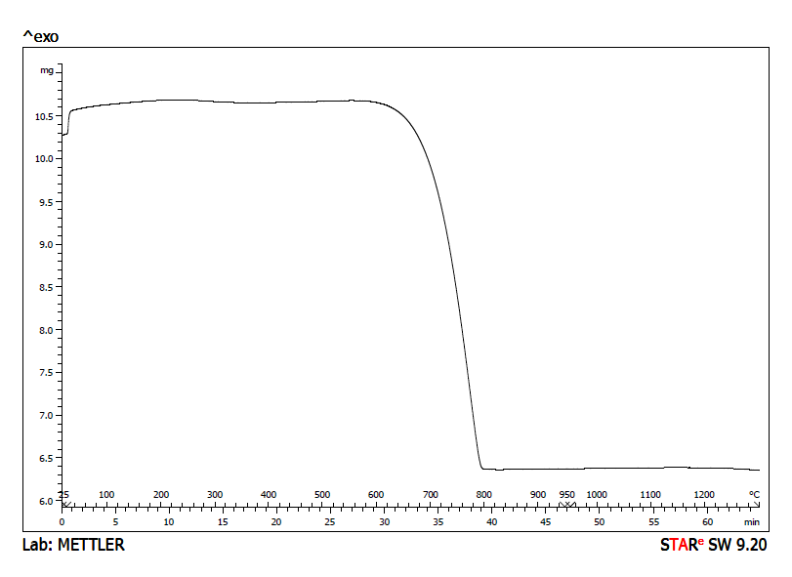
Figure 1. TGA curve of raw seashell

The chemical composition of the calcined seashells determined using XRF is shown in Table 1. The main composition of calcined seashell is CaO followed by low levels of undesirable impurities, such as Na₂O, SrO, RuO_{2,} Fe₂O_{3,} and CuO. As shown in Table 1, the chemical composition analysis indicated that the CaO contents of calcined seashells at 700˚C and calcined seashell at 900˚C were comparable, whereas in the case of calcined seashells at 800˚C the contents were relatively higher.

Table 1. Chemical compound of calcined seashells at different temperatures
Compound |  | Calcined seashell at 700˚C (wt %) | Calcined seashell at 800˚C (wt %) | Calcined  seashell at  900˚C (wt %)
 | Na₂O | 2.800 | - | 2.600
 | CaO | 95.620 | 98.490 | 96.260
 | TiO₂ | 0.0064 | - | -
 | Fe₂O₃ | 0.170 | 0.083 | 0.120
 | CuO | 0.007 | 0.044 | 0.037
 | SrO | 0.414 | 0.448 | 0.388
 | RuO₂ | 0.340 | 0.370 | 0.250
 | CeO₂ | 0.120 | - | -
 | Tm₂O₃ | 0.250 | - | -
 | Lu₂O₃ | 0.038 | - | 0.072
 | Co₃O₄ | - | 0.084 | -
 | BaO | - | 0.260 | -
 | Al₂O₃ | - | 0.200 | -
 | Cr₂O₃ | - | - | 0.025

Changes in the shell’s structure at different temperatures after calcination was observed by SEM analysis. Figure 2 shows the seashell structure before calcinations process. Figure 2a shows the seashell structure before calcinations process. Although the structures change after 700˚C, the structures were not uniform (Figure 2b). At a higher calcination temperature of 800˚C and 900˚C the curves were showing smoother and more uniform surface as shown in Figure 3c and Figure 3d, respectively.
Based on the Figure 2, the raw seashells showed a rough and disordered surface with low porosity grains, whereas the surface of calcined seashells show clusters of tidy and porous grains, confirming the thermal decomposition process.

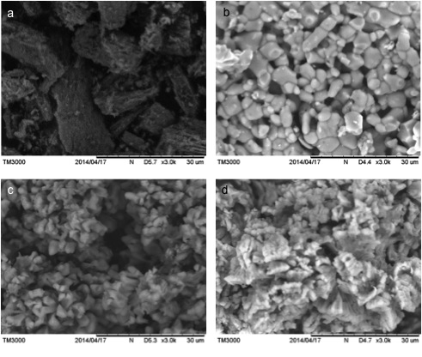
Figure 2. (a) SEM image of raw seashel and changes in shell structure at different calcined temperature using SEM, (a) 700˚C, (b) 800˚C and (c) 900˚C

EDX analysis result indicates that CaCO₃ was present but the proportion changed after calcination. Calcination increased the amounts of calcium (Ca) from 44.7% to 56.9% and reduced the weight percent of carbon (C) from 17.7% to 3.0% (Table 2).

Table 2. EDX analysis of raw seashells and calcined seashells
Element | Raw seashells (wt %) | Calcined seashells (wt %)
C  O  Ca | 17.7  37.6  44.7 | 3.0  40.1  56.9

Effect of catalyst CaO and yield of bio-oil

Figure 3. The product yield at 550 ˚C in non-catalytic and catalytic pyrolysis of biomass

The catalytic effects of CaO on the products of EFB pyrolysis were studied experimentally. The pyrolysis processes were carried out using 100 g of biomass was mixed to 10 g CaO catalyst at 550 ˚C. Figure 3 shows product yield at 550 ˚C in presence and absence of catalyst. The presence of catalyst enhanced the yield of bio-oil and biochar and reduced the yield of gas product. The bio-oil and biochar increased from 33.5% to 45.6% and 20.9% to 32.2% respectively and the gas product decreased from 51.7% to 22.2%. The addition of catalyst to the biomass enhanced the production of bio-oil. The result obtained is in agreement with date reported by Feldmann et al. (1981). He reported that mixing of wood ash with CaO increased the yield of liquid products.

Conclusion
Temperature has a significant effect on the calcination process of seashells. Seashell calcined at 800˚C gave a higher amount of CaO compared to that at 700˚C and 900˚C. Therefore, 800˚C seems to be an optimum CaO temperature for calcinations of seashell for formation of CaO catalyst. The thermal decomposition occurred at 580˚C. The XRF and TGA analysis confirmed the structural transformation of natural seashell to calcium oxide. High temperature plays an important role in the formation of calcium oxide catalyst from the seashell. The oil yield increased from 33.4% to 45.6%. CaO enhanced the production of pyrolysis oil. The natural seashell, after thermal treatment at a higher temperature of 800˚C produced activated seashell, which could be used as a cracking catalyst in the biomass pyrolysis.

Acknowledgement
The authors would like to thank the Malaysia Technical University Network (MTUN CoE Grant 9016-00005) for funding this research project and School of Bioprocess Engineering, University Malaysia Perlis (UniMAP) for technical support.

References
- Barros, M. C., Bello, P. M., Bao, M. and Torrado, J. J. (2009). From waste to commodity: transforming shells into high purity calcium carbonate. Journal of Cleaner Production, 17(3), 400–407.
- Rezaei, R., Mohadesi, M. and Moradi, G. R. (2013).Optimization of biodiesel production using waste mussel shell catalyst.Fuel, 534-541.
- Borgwardt, R.H. (1989). Calcium oxide sintering in atmosphere containing water and carbon dioxide. Industrial& Engineering Chemistry Research, 493-500.
- Boro, J., Thakur, A. J. and Deka, D. (2011). Solid oxide derived from waste shells of Turbonilla striatula as a renewable catalyst for biodiesel production. Fuel Processing Technology, 92(10), 2061–2067.
- Rashidi, N.A, Mohamed M. and Yusup S. (2011). A study of calcination and carbonation of cockle shell. Engineering and Technology, 818-823.
- Islam, K. N., Bakar, M. Z. B. A., Ali, M. E., Hussein, M. Z. Bin, Noordin, M. M., Loqman, M. Y. and Hashim, U. (2013). A novel method for the synthesis of calcium carbonate (aragonite) nanoparticles from cockle shells. Powder Technology, 235, 70–75.
- Mohamed, M., Rashidi, N. A., Yusup, S., Teong, L. K., Rashid, U. and Ali, R. M. (2012). Effects of experimental variables on conversion of cockle shell to calcium oxide using thermal gravimetric analysis. Journal of Cleaner Production, 37, 394–397.
- Mohammed, M. A. A., Salmiaton, A., Wan Azlina, W. A. K. G., Mohamad Amran, M. S. and Taufiq-Yap, Y. H. (2013). Preparation and Characterization of Malaysian Dolomites as a Tar Cracking Catalyst in Biomass Gasification Process. Journal of Energy, 1–8.
- Feldmann, H. F., Chol, P. S., Conkle, H. N. and Charhan, S. P. (1981) In 'Biomass as a Non Fossil Fuel Source' (Ed. D. L. Klass), Symposium Series No. 144, American Chemical Society,Washington.

