

EFFECT OF TITANIUM DIOXIDE NANOPARTICLE ADDITION TO THE SURFACE CHARGE AND STRUCTURE OF DPPC VESICLES

(Kesan Penambahan Nanozarah Titanium Oksida ke atas Cas Permukaan dan Struktur Vesikel DPPC)
Hur Munawar Kabir Mohd, Irman Abdul Rahman*, Ainee Fatimah Ahmad, Shahidan Radiman, Faizal Mohamed, Muhamad Samudi Yasir

School of Applied Physics,
Faculty of Science and Technology,
Universiti Kebangsaan Malaysia, 43600 Bangi, Selangor, Malaysia

*Corresponding author: irman@ukm.edu.my

Abstract
Titanium dioxide nanoparticle dispersions interaction with 1,2-dipalmitoyl-sn-glycero-3-phosphocholine (DPPC) vesicles is reported in this paper. DPPC- TiO₂ interactions were investigated using dynamic light scattering (DLS) and transmission electron microscopy (TEM) by focusing on the effect of the interactions on the surface charge, size and localisation of TiO₂ in DPPC- TiO₂ vesicles. It was observed that surface charge of DPPC- TiO₂ vesicles were increased from -26.0 to 12.1 mV as the TiO₂ nanoparticle concentrations increased from 0.01 to 100 mg/ml. The binding of positively charged TiO₂ nanoparticle to the zwitterionic DPPC vesicles caused the surface charge to become more positive. The size distribution, localisation and positioning of TiO₂ nanoparticles in DPPC vesicles were confirmed through TEM analysis.

Keywords: DPPC, vesicles, titanium dioxide, DLS, TEM

Abstrak
Interaksi penyerakan nanozarah titanium oksida keatas vesikel 1,2-dipalmitoyl-sn-glycero-3-phosphokolina (DPPC) dilaporkan di dalam jurnal ini. Interaksi DPPC- TiO₂ telah dikaji menggunakan kaedah penyerakan cahaya dinamik (DLS) dan mikroskop transmisi electron (TEM) dengan menumpukan kepada kesan interaksi keatas cas permukaan, saiz dan penempatan nanozarah TiO₂ di dalam vesikel DPPC- TiO_{2.} Didapati bahawa cas permukaan vesikel DPPC- TiO₂ meningkat daripada -26.0 kepada 12.1 mV apabila kepekatan nanozarah TiO₂ meningkat daripada 0.01 kepada 100 mg/ml. Ikatan antara nanozarah TiO₂ yang bercas positif keatas vesikel DPPC yang bersifat zwiterionik menyebabkan cas permukaan menjadi lebih positif. Taburan saiz, penempatan dan kedudukan nanozarah TiO₂ di dalam vesikel DPPC telah disahkan menngunakan kaedah analisis TEM.

Kata kunci: DPPC, vesikel, titanium oksida, DLS, TEM

Introduction
Vesicles (liposomes) are artificially constructed spherical lipid with controllable size which comprises compartments that can encapsulate or store various molecules such as proteins, DNA and drug molecules [1,2]. However, there is a limitation in manufacturing and storage of lipid vesicles. Fusion occurs when vesicles encounter one another in suspension and leads to aggregation which destabilises vesicles and limiting vesicles as effective drugs carrier. Considering that, several formulation methods have been developed to overcome this problem. Zhang and Granick used carboxyl-modified polystyrene nanoparticles to stabilise liposomes with respect to liposome concentration. They found that the liposomes repel and do not fuse up to 50 days [3]. Currently, there were few works done to understand the interaction between zwitterionic lipid and positively charged nanoparticle. Therefore we intend to investigate the effect of positively charged titanium dioxide (TiO₂) nanoparticles addition to the 1,2-dipalmitoyl-sn-glycero-3-phosphocholine (DPPC) vesicles.

The effect of nanoparticle addition to biological system is a growing interest in relation to the increasing utilization of nanomaterials. TiO₂ nanoparticles exhibits many admirable features such as biocompatibility, environmentally benign and used in medical fields [4,5]. Incorporation of titanium dioxide nanoparticles could not only improve lipid vesicles stability but also help to provide multipurpose functionality in single stable vesicle [6]. The important aspect investigated in this work is the effect of TiO₂ nanoparticles interaction on the surface charge (zeta potential) and the morphology of DPPC vesicles. As observed in the previous works on the similar systems, nanoparticles might have significant effect on the vesicles zeta potential, size and structure as the nanoparticles concentration increases [7].

Materials and Methods
Materials
1,2-dipalmitoyl-sn-glycero-3-phosphocholine (DPPC) supplied from Avanti Polar Lipids (USA) was dissolved in chloroform to get a concentration of 10 mg/ml. TiO₂ (P25) nanoparticle was obtained from Sigma Aldrich (USA) with an estimated particle size of 21 nm and phase composition of 80% anatase and 20% rutile. These nanoparticles were dispersed in Milli-Q water.

Methods
Lipid vesicles were prepared in deionised water at 10 mg/ml DPPC using the conventional gentle hydration method. The DPPC lipid was dried in an oven overnight at 45ºC to form a thin lipid film. The thin film was then prehydrated with deionised water and 0.1M of sucrose and left at room temperature. A bulky white suspension formed in the solution was vesicles and were extruded through 100 nm polycarbonate membranes to obtain homogeneous vesicles. These vesicles were mixed by vortex with TiO₂ nanoparticles of various concentrations which varied from 0.01 to 100 mg/ml. The mixed DPPC- TiO₂ vesicles were left overnight to reach adsorption equilibrium of TiO₂ onto the surface of vesicles.

Analysis
The size distribution and zeta potential of both TiO₂ nanoparticles (positively charged; +25 mV) and DPPC-TiO₂ vesicles were determined by dynamic light scattering (DLS) using Zetasizer (Malvern Instruments, UK). The morphology and structure of TiO₂ nanoparticles and DPPC-TiO₂ vesicles were characterised using transmission electron microscopy, TEM (FEI Tecnai G2 Spirit Biotwin). Based on Figure 1, the size range of TiO₂ nanoparticles dispersion was 15-35 nm in diameter.

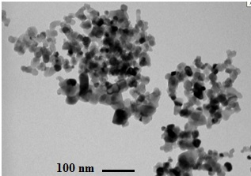
(a)
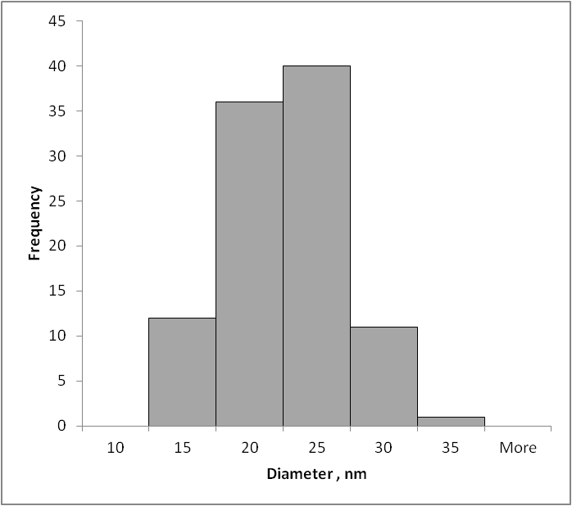
(b)

Figure 1. TEM observation (a) and particle size distribution (b) of titanium dioxide nanoparticles.

Results and Discussion
Different concentrations of TiO₂ nanoparticles dispersion were found to have a significant effect on the zeta potential values of the DPPC vesicles as presented in Figure 2. The zeta potential of DPPC vesicles increases from -26 to 12.1 mV with slight decrease towards negative values at 0.01 till 1 mg/ml TiO2 nanoparticles concentrations. The value decrease may due to the addition of sucrose during the DPPC vesicles preparation which gives a good isotonic medium (in terms of electrostatic stability) for negatively charged nanoparticles. However, for positively charged TiO₂ nanoparticles these sucrose additions slightly decrease the DPPC zeta potential to more negative values [8]. Furthermore, adsorption of charged nanoparticles to the neutral (zwitterionic) charged surface of DPPC vesicles causes the movement of the slip plane away from the surface causing a decrease of zeta potential value [9]. It is also known that in the gel phase, positively charged nanoparticles reduce the tilt angle below the angle of 30º to ~65º causing reduce in lipid density [10]. When the zwitterionic headgroup is exposed to positively charged (cationic) nanoparticle, the electrostatic binding are not as strong as the binding between zwitterionic headgroup and negatively charge (anionic) nanoparticle [11]. In agreement with our results, concentration dependent effect in nanoparticle addition to lipid vesicle was also reported by several other studies. Mohanraj et al. used DPPC with silica nanoparticles and reported that lipid size and zeta potential depends on the concentration and charge ratio of vesicles and nanoparticles [7].

Table 1. Composition of DPPC-TiO₂ vesicles and the effects on the particle size and zeta potential
Sample | Nanoparticle concentration (mg/ml) | Titanium dioxide:  lipid mass ratio | Mean particle size  (nm) | Zetapotential  (mV)
Uncoated | 0 | 0 | 280 | -26
Lipid 1 | 0.01 | 1000:1 | 996 | -6.35
Lipid 2 | 0.1 | 100:1 | 1071 | -14.1
Lipid 3 | 1 | 10:1 | 513 | -20.1
Lipid 4 | 10 | 1:1 | 2384 | +6.93
Lipid 5 | 50 | 1:5 | 2605 | +12.1
Lipid 6 | 100 | 1:10 | 155 | +0.392

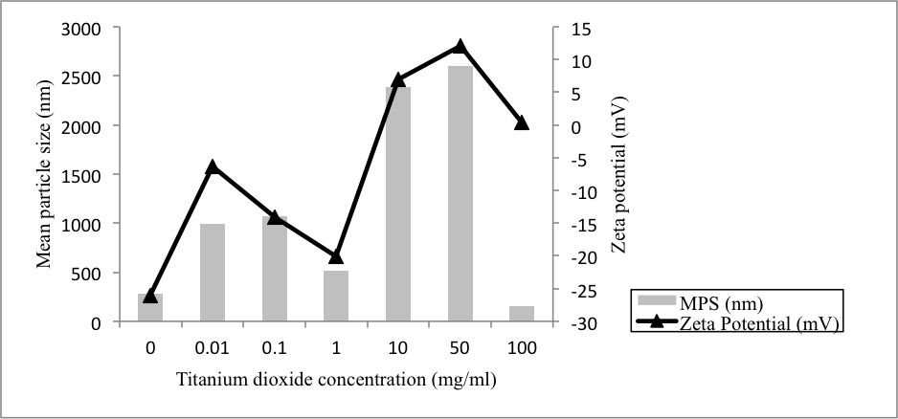
Figure 2. Effect of titanium dioxide nanoparticle concentration on the zeta potential and mean particle size of DPPC vesicles

The presence of nanoparticle caused the diameter of DPPC-TiO₂ vesicles to increase from around 280 nm (absence of TiO₂ nanoparticles) to >2600 nm at a TiO₂ nanoparticles concentration of 50 mg/ml. This indicates formation of large aggregates which is due to an increase in density and a decrease in interparticle repulsion. Meanwhile at high TiO₂ nanoparticles concentration (100 mg/ml), vesicle size decreased to 155 nm, suggesting TiO₂ fully covered DPPC vesicle surface thereby overcome the attractive forces. Based on TEM images, incorporated TiO₂ nanoparticles have been found attached on the vesicle walls resulting in the appearance of dark images surrounding the vesicles (Figure 3b) compare to normal vesicles without nanoparticles (Figure 3a). There is also possibility that the nanoparticle partially embedded inside the lipid vesicles instead of only attached on the vesicles surface.

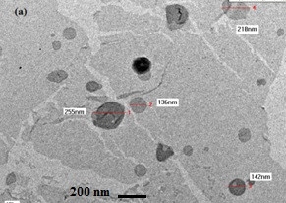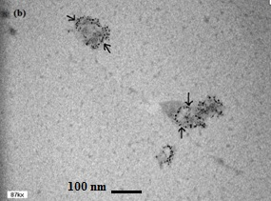

Figure 3. TEM observations of (a) DPPC vesicles and (b) DPPC vesicles after addition of TiO₂. The arrow depicts the localization of the TiO₂ nanoparticles on the lipid vesicle walls.

Conclusion
The results obtained based on the zeta potential suggest that the DPPC-TiO₂ vesicles formed was facilitated via electrostatic interaction. The interaction/binding strength is determined by the geometrical relation between P⁻-N⁺ dipole of the headgroup and the charge of the adsorbing nanoparticle. By dynamic light scattering measurement, it was found that TiO₂ nanoparticles increased the zeta potential value of DPPC vesicles with slight decrease at 0.01 till 1 mg/ml TiO₂ nanoparticles concentrations. TEM provided confirmation about the localisation of TiO₂ nanoparticles on DPPC vesicles and structure of DPPC-TiO₂ vesicles. The present findings demonstrate the importance use of zeta potential value especially in designing drug delivery systems since it allows determining the sign of the charge of particles and to predict the stability of the vesicles conditions. However, new approach and integration with other analysis method such as differential scanning calorimetry might provide further information on nanoparticle embedded lipid vesicle.

Acknowledgement
The authors wish to acknowledge funding from UKM in this work through research grants DLP-2013-037 and ERGS/1/2012/STG02/UKM/02/1.

References
- Pantos, A., Tsiourvas, D., Paleos, C.M. and Nounesis, G. (2005). Enhanced drug transport from unilamellar to multilamellar liposomes induced by molecular recognition of their lipid membranes. Langmuir 21:6696.
- Sharma, A. and Sharma U.S. (1997). Liposomes in drug delivery: progress and limitations. International Journal of Pharmaceutics. 154(2):123-140.
- Zhang, L. and Granick, S. (2006). How to stabilize phospholipid liposomes (using nanoparticles). Nano Letters. 6(4): 694-698.
- Fujishima, A., Zhang, X. and Chimie, C.R. (2005). Titanium dioxide photocatalysis: present situation and future approaches. Comptes Rendus Chimie. 9: 750-760.
- Song, M., Pan, C., Li, J.Y., Wang, X.M. and Gu, Z.Z. (2006). Electrochemical study on synergistic effect of the blending of nano TiO2 and PLA polymer on the interaction of antitumor drug with DNA. Electroanalysis. 18: 1995-2000.
- Sanvicens, N. and Marco, M.P. (2008). Multifunctional nanoparticles-properties and prospects for their use in human medicine. Trends in Biotechnology. 26(8):425-433.
- Mohanraj, V.J., Barnes, T.J. and Prestidge, C.A. (2010). Silica nanoparticle coated liposomes: a new type of hybrid nanocapsule for proteins. International Journal of Pharmaceutics. 392: 285-293.
- Kaasalainen, M., Makila, E., Riikonen, J., Kovalainen, M., Jarvinen, K., Herzig, K., Lehto, V. and Salonen, J. (2012). Effect of isotonic solutions and peptide adsorption on zeta potential of porous silicon nanoparticle drug delivery formulations. International Journal of Pharmaceutics. 431: 230-236.
- Koopal, L., Hlady, V. and Lyklema, J. (1988). Electrophoretic study of polymer adsorption: dextran, polyethylene oxide and polyvinyl alcohol on silver iodide. J. Colloid Interface Sci. 121:49-62.
- Somerharju, P., Virtanen, J.A. and Cheng, K.H. (1999). Lateral organization of membrane lipids- The superlattice view. Biochim Biophys Acta Mol Cell Biol Lipids. 1440: 32-48.
- Yu, Y., Anthony, S.M., Zhang, L., Bae, S.C. and Granick, S. (2007). Cationic nanoparticles stabilize zwitterionic liposomes better than anionic ones. Journal of Physical Chemistry C. 111: 8233-8236.

