

PHOTOSTABILIZING EFFICIENCY OF PVC BASED ON EPOXIDIZED OLEIC ACID

(Kecekapan Kestabilanfoto Filem PVC berasaskan Asid Oleik Terepoksida)
Emad Yousif¹ , Rahimi M. Yusop^{2,3}*, Ahmed Ahmed¹, Jumat Salimon², Nadia Salih²

¹Department of Chemistry, College of Science,
Al-Nahrain University, Baghdad, Iraq
²School of Chemical Sciences and Food Technology, Faculty of Science and Technology,
Universiti Kebangsaan Malaysia, 43600 Bangi, Selangor, Malaysia
³Regenerative Advanced Medical & Dental Institute,
Universiti Sains Malaysia, 13200 Bertam Kepala Batas, Pulau Pinang, Malaysia

*Corresponding author: rahimi@ukm.edu.my

Abstract
The photostabilization of poly (vinyl chloride) (PVC) films by epoxidized oleic acid compounds was investigated. The PVC films containing concentration of complexes 0.5% by weight were produced by the casting method from tetrahydrofuran (THF) solvent. The photostabilization activities of these compounds were determined by monitoring the carbonyl, polyene and hydroxyl indices with irradiation time. The changes in viscosity average molecular weight of PVC with irradiation time were also tracked (using THF as a solvent). The quantum yield of the chain scission (Φcs) of these complexes in PVC films was evaluated and found to range between 4.98´10⁻⁸ and 8.72´10⁻⁸. According to the experimental results obtained, mechanisms were suggested depending on the structure of the additive (oleic acid).

Keywords: photostabilizer, PVC, oleic acid

Abstrak
Proses kestabilanfoto filem poli(vinil klorida) (PVC) dengan asid oleik terepoksida telah dikaji. Filem PVC yang mengandungi kompleks berkepekatan 0.5% berat telah dihasilkan dengan kaedah acuan yang sama daripada pelarut tetrahidrofuran (THF). Aktiviti kestabilanfoto sebatian-sebatian ini ditentukan dengan pengawasan indeks karbonil, poliena dan hidroksi dengan masa penyinaran. Perubahan dalam kelikatan berat molekul purata bagi PVC dengan masa penyinaran turut dikesan (menggunakan THF sebagai pelarut). Hasil kuantum rantai guntingan (Φcs) kompleks-kompleks ini di dalam filem-filem PVC telah dikira dan di dapati berada dalam julat 4.98´10-8 and 8.72´10-8. Berdasarkan keputusan eksperimen yang diperolehi, beberapa mekanisme telah dicadangkan bergantung kepada struktur bahan tambah yang digunakan (asid oleic).

Kata kunci: kestabilanfoto, PVC, asid oleik

Introduction
Poly(vinyl chloride) is second only to polyethylene among five kinds of general plastic materials, which was widely used in the industries including architecture, electronics, chemical engineering, packaging, transportation, etc. However, low photostability of PVC leads to hydrogen chloride loss, discoloration, and finally serious corrosion phenomena, accompanied by changes of physical and chemical properties of PVC [1]. Poly(vinyl chloride), better known by its abbreviation PVC, is one of the most versatile plastics. It is the second largest manufactured resin by volume worldwide [2]; currently, its production per annum exceeds 31 million tons. The most remarkable milestones in PVC history, their importance to the development of macromolecular chemistry, and some PVC research and industrial applications, with respect to polymerization, stabilization, bulk property modification, and chemical and material recycling of PVC waste [3].

The low cost and the good performance of poly(vinyl chloride) products have increased the utilization of this polymer in building, mainly in exterior applications, such as window profiles, cladding structure and siding [1]. However, ultimate user acceptance of the PVC products for outdoor building applications will depend on their ability to resist photodegradation over long periods of sunlight exposure [4]. To ensure weather ability, the PVC resin needs to be compounded and processed properly, using suitable additives, leading to a complex material whose behaviour and properties are quite different from the PVC resin by itself [5]. On the other hand, it is important to perform reliable accelerated weathering test methods. In this regard, factors that influence the degradation of PVC based materials on the service condition, like light and temperature are accelerated.

Almost all synthetic polymers require stabilization against the adverse effect with the development of synthetic resins it became necessary to look for ways and means to prevent, or at least reduce, the damage caused by the environmental parameters such as light, air and heat. This can be achieved through the addition of special chemicals, light stabilizers or UV stabilizers, that have to be adjusted to the nature of the resin and the specific application considered. The photostabilization of polymers may be achieved in many ways. The following stabilizing systems have been developed, which depend on the action of stabilizer: (a) light screeners, (b) UV absorbers, (c) excited state quenchers, (d) peroxide decomposers and (e) free radical scavengers, of these it is generally believed that types (c)–(e) are the most effective. Most of stabilizers are believed to be multifunctional in their mode of operation. This view is complicated by the fact that mechanisms involved in photo-oxidation and these, in turn depend on the polymer structure and other variables, such as manufacturing, operation, processing and conditions [6].

As part of our on-going research in the photostabilization of poly(vinyl chloride), the photostabilization of PVC was studied using epoxidized oleic acid as additive.

Materials and Methods

Materials

The following complexes in Fig. 1 were prepared by the method has been previously described [7].

Experimental techniques
Films preparation
Commercial poly(vinyl chloride) supplied by Petkim company (Turkey) was re-precipitated from THF solution by alcohol several times and finally dried under vacuum at room temperature for 24 hours. Fixed concentrations of poly(vinyl chloride) solution (5 g/100 ml) in tetrahydrofuran was used to prepare polymer films with 30 µm thicknesses (measured by a micrometer type 2610 A, Germany). The prepared complexes (0.5% concentrations) were added to the films starting at 0 concentrations (blank). The films were prepared by evaporation technique at room temperature for 24 hours. To remove the possible residual tetrahydrofuran solvent, film samples were further dried at room temperature for three hours under reduced pressure. The films were fixed on stands, especially used for irradiation. The stand is provided with an aluminium plate (0.6 mm in thickness) supplied by Q-panel company.

Irradiation experiments
Accelerated testing technique
Accelerated weatherometer Q.U.V. tester (Q. panel, company, USA), was used for irradiation of polymers films. The accelerated weathering tester contains stainless steel plate, which has two holes in the front side and a third one behind. Each side contains a lamp (type Fluorescent Ultraviolet Lights) 40 Watt each. These lamps are of the type UV-B 313 giving spectrum range between 290-360 nm with a maximum at wavelength 313 nm. The polymer film samples were vertically fixed parallel to the lamps to make sure that the UV incident radiation is perpendicular on the samples. The irradiated samples were rotated manually from time to time to ensure that the intensity of light incident on all samples is the same.

Figure 1. Triester formation RCOOH, A1 = Lauric , A2= nonanoic and A3=octanoic

Photodegradation measuring methods
Measuring the photodegradation rate of polymer films using infrared spectrophotometery
The degree of photodegradation of polymer film samples was followed by monitoring FTIR spectra in the range 4000-400 cm⁻¹ using FTIR 8300 Shimadzu Spectrophotometer. The position of carbonyl absorption is specified at 1722 cm⁻¹, polyene group at 1602 cm⁻¹ and the hydroxyl group at 3500 cm⁻¹. The progress of photodegradation during different irradiation times was followed by observing the changes in carbonyl and polyene peaks. Then carbonyl (I_{co}), polyene (I_{po}) and hydroxyl (I_{OH}) indices were calculated by comparison of the FTIR absorption peak at 1722, 1602 and 3500 cm⁻¹ with reference peak at 1328 cm⁻¹ attributed to oscissoring and bending of CH₂ group, respectively. This method is called band index method [8,9].

(1)

where As = Absorbance of peak under study, Ar = Absorbance of reference peak and Is = Index of group under study. Actual absorbance, the difference between the absorbance of top peak and base line (a Top Peak – a baseline) is calculated using the baseline method.

Determination of average molecular weight using viscometry method:
The viscosity property was used to determine the average molecular weight of polymer at room temperature, using the Mark- Houwink relation [10].

(2)

where as the intrinsic viscosity and K, α = are constants depend upon the polymer-solvent system at a particular temperature.

The intrinsic viscosity of a polymer solution was measured with an Ostwald U-tube viscometer. Solutions were made by dissolving the polymer in a solvent (g/100 ml) and the flow times of polymer solution and pure solvent are t and t₀ respectively. Specific viscosity (η_{sp}) was calculated as follows:

(3)

η_{re} = Relative viscosity

η_{sp} = η_{re} – 1 (4)

The single – point measurements were converted to intrinsic viscosities by the relation 2.

(5)

where c = concentration of polymer solution (g /100 ml).

By applying equation 5, the molecular weight of degraded and the virgin polymer can be calculated. Molecular weights of PVC with and without additives were calculated from intrinsic viscosities measured in THF solution using the following equation 6:

=4.17x10⁻⁴Mv^{0.6} (6)

The quantum yield of main chain scission (ф_{cs}) [11] was calculated from viscosity measurement using the following relation 7.
(7)

where: C = concentration; A = Avogadro’s number; = the initial viscosity–average molecular weight; [η_{o}] = Intrinsic viscosity of PVC before irradiation; I_{o} = Incident intensity and t = Irradiation time in second.

Results and Discussion
The epoxidized oleic acids were used as additives for the photostabilization of PVC films. In order to study the photochemical activity of these additives for the photostabilization of PVC films, the carbonyl and polyene indices were monitored with irradiation time using IR spectrophotometry. The irradiation of PVC films with UV light of wavelength, λ = 313 nm led to a clear change in the FTIR spectrum. Appearance of bands in 1772 cm⁻¹ and 1724 cm⁻¹, were attributed to the formation of carbonyl groups related to chloroketone and to aliphatic ketone, respectively. A third band was observed at 1604 cm⁻¹, related to polyene group. The hydroxyl band appeared at 3500 cm⁻¹ was annotated to the hydroxyl group [12].

The absorption of the carbonyl, polyene and hydroxyl groups was used to follow the extent of polymer degradation during irradiation. This absorption was calculated as carbonyl index (I_{co}), polyene index (I_{PO}) and hydroxyl index (I_{OH}). It is reasonable to assume that the growth of carbonyl index is a measure of the extent of degradation. However, in Figure 2, the I_{co} of A3, A2 and A1 showed a lower growth rate with irradiation time with respect to the PVC blank film without additives. Since the growth of carbonyl index by irradiation time is lower than PVC blank, as seen in Figure 3, it is suitable to conclude that these additives might be considered as photostabilizers of PVC polymer. Efficient photostabilizer shows a longer induction period. Therefore, the A1 is the most active photostabilizer, followed by A2 and A3 which is the least active. Just like carbonyl, polyene compounds are also produced during photodegradation of PVC. Therefore, polyene index (I_{Po}) could also be monitored by irradiation time in the presence and absence of these additives. Results are shown in Figure 2.

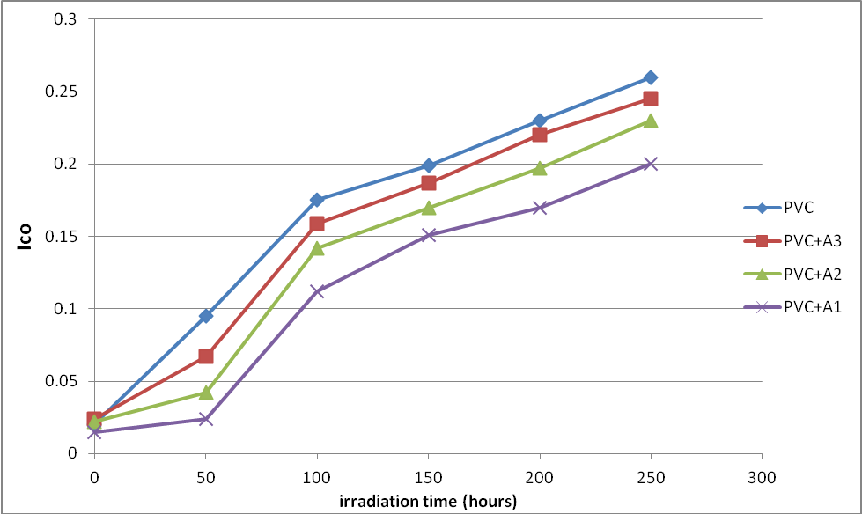
Figure 2. The relationship between the carbonyl index and irradiation time for PVC films (30 μm thickness) containing different additives. Concentration of additives is fixed at 0.5% by weight.

Figure 3. The relationship between the polyene index and irradiation time for PVC films (30 μm thickness). Containing different additives, concentration of additives are fixed at 0.5% by weight.

Hydroxyl species were produced during photodegradation of PVC. Therefore, hydroxyl index (I_{OH}) was monitored with irradiation time for PVC and with additives. From Figure 4, the A3, A2 and A1 showed lower growth rate of hydroxyl index with irradiation time compare to PVC film without modification.

Figure 4. The relationship between the hydroxyl index and irradiation time for PVC films (30 μm thickness). Containing different additives, concentration of additives are fixed at 0.5% by weight.

Variation of PVC molecular weight during photolysis in the presence of epoxidized oleic acid as additive
Analysis of the relative changes in viscosity average molecular weight, has been shown to provide a versatile test for random chain scission. Figure 5 shows the plot of versus irradiation time for PVC film with and without 0.5% (w/w) of the selected additives, with absorbed light intensity of 1.052 x 10⁻⁸ ein. dm⁻³. s⁻¹ . is measured using equation 4 with THF as a solvent at 25 ºC .

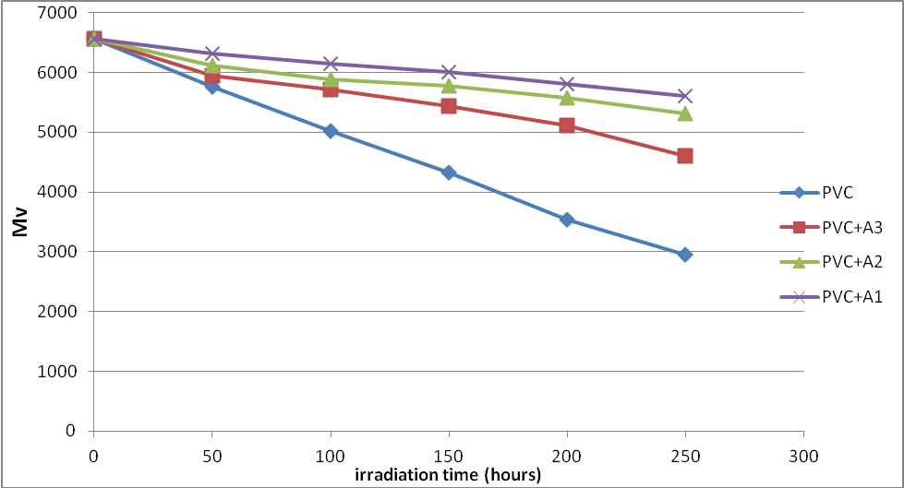
Figure 5. Changes in the viscosity-average molecular weight during irradiation of PVC films (30 μm) (blank) and with 0.5 wt% of additives.

Another way of degradation reaction characterization is the measurement of the quantum yield of the chain scission (Φ_{cs}). The quantum yield for chain scission was calculated for PVC films with and without 0.5% (wt/wt) of additive mentioned above using relation 5. The Φ_{cs} values for complexes are tabulated in Table 1.

Table 1. Quantum yield (Φcs) for the chain scission for PVC films (30μm) thickness
with and without 0.5 (wt/wt) additive after 250 hrs. irradiation time.
Additive (0.5%wt) | Quantum yield of main chain scission (Φ_{cs})
PVC+A1 | 5.77E-08
PVC+A2 | 6.26E-08
PVC+A3 | 7.26E-08
PVC(blank) | 8.56E-05

The Φcs values for PVC films in the presence of additive are less than that of additive free PVC (blank), which increase in the order C1, C2, C3 and PVC.

It is well established that the quantum yield (Φ_{cs.}) increases with increasing temperature [15, 17, 18] around the glass transition temperature, (Tg) of the amorphous polymer, and around the melting temperature of crystalline polymers. In the study presented in this work, the photolysis of PVC film is carried out at a temperature 35 – 45 °C well below the glass transition temperature (Tg of PVC = 80 °C). Therefore, the Φ_{cs} dependency on temperature is not expected to be observed.

Conclusion
In the work described in this paper, the photostabilization of poly(vinyl chloride) films using epoxidized oleic acid as additive were studied. These additives behave successfully as photostabilizer for PVC films. The additives take the following order in photostabilization activity, according to their decrease in carbonyl, pollen and hydroxyl indices for PVC films (A1 > A2 > A3). The epoxidized oleic acid as additive were found to be the more efficient in photostabilization process according to the photostability and mechanisms mentioned above. These mechanisms support the idea of using tin complexes as a commercial stabilizer for PVC.

Acknowledgement
The authors thank Al-Nahrain University and Universiti Kebangsaan Malaysia for the funding (Codes AP-2011 17, DPP-2013-054, UKM-MI-OUP- 2011, AP-2012-017 and DLP 2013-002).

References
- Yousif, E. and Haddad, R. (2013). Photodegradation and photostabilization of polymers, especially polystyrene: review, Springer plus 2: 1-32.
- Moulay, S., (2010). Chemical modification of poly(vinyl chloride)-Still on the run. Progress in Polymer Science. 35: 303-331.
- Braun, D. (2004). Poly(vinyl chloride) on the way from the 19th century to the 21st century. J. Polym. Sci. A Polym. Chem. 42: 578–586.
- Yousif, E., Salimon, J. and Salih, N. (2012). Improvement of the photostabilization of PMMA films in the presence 2N-salicylidene-5-(substituted)-1,3,4-thiadiazole, J. King Saud University (Science). 24: 11-17.
- Gardette, J. Gaumet, S. and Philippart, J. (1993). Influence of the experimental conditions on the photooxidation of poly(vinyl chloride). Journal of Applied Polymer Science. 48(11): 1885-1895.
- Harper, D., McKellar, N. and Turner, P. (1974). Photostabilizing effect of Ni(II) chelates in polymers II. Effect of diamagnetic chelates on polypropylene phosphorescence. Journal of Applied Polymer Science. 311 (1974) 2802-2805.
- Salimon, J., Salih, N. and Yousif, E. (2011). Chemically modified biolubricant basestocks from epoxidized oleic acid: Improved low temperature properties and oxidative stability. Journal of Saudi Chemical Society 15: 195-201.
- Yousif, E. (2013). Triorganotin(IV) complexes photo-stabilizers for rigid PVC against photodegradationJournal of Taibah University for Science, 7: 79-87.
- Yousif, E., Salimon, J., Salih, N. 2014. Mechanism of photostabilization of poly(methy methacrylate) films by 2-thioacetic acid benzothiazol complexes, Arabian Journal of Chemistry, 7: 306-311.
- Mark, J. 2007. Physical properties of polymers handbook. Springer, New York.
- Yousif, E., Salih, N., Salimon, J. (2011). Improvement of the " Improvement of the Photostabilization of PVC Films in the Presence of 2N-Salicylidene-5-(Substituted)-1,3,4-Thiadiazole. Journal of Applied Polymer Science. 120: 2207–2214.
- Andrady, A., Hamid, S., Hu, X. and Torikai, A. (1998). Effects of increased solar ultraviolet radiation on materials. Journal of Photochemistry and photobiology B-Biology. 46: 96-103.
- Rabek, J. & Ranby, B. (1975). Photodegradation, photooxidation and photostabilization of Polymers, John Wiley, New York.
- Shyichuk, A., White, J. (2000). Analysis of chain-scission and crosslinking rates in the photo-oxidation of polystyrene. Journal of Applied Polymer Science, 77(13): 3015-3023.
- Yousif, E., Hameed, A., Rasheed, R., Mansoor, H., Farina, Y., Graisa, A., Salih, N., Salimon, J. (2010). Synthesis and Photostability Study of Some Modified Poly(vinyl chloride) Containing Pendant Benzothiazole and Benzimidozole Ring. International Journal of Chemistry, 2(1): 65-80.
- Yousif, E., Aliwi, S., Ameer, A. (2009). Improved photostability of PVC films in the presence of 2-thioacetic acid -5-phenyl-1,3,4-oxadiazole complexes. Turkish J.Chem. 33: 399-410.
- Harun, N. S., Talip, N. N. M., Hong, L. K., Jamil, M. S. M., & Yusop, R. M. (2013). Phase Behaviour of Fatty Alcohol Sulphate and Fatty Alcohol Ether Sulphate from Palm Based. Malaysian Journal of Analytical Sciences, 17(1), 139-145..
- Hong, L. K., Harun, N. S., Jamil, M. S. M., & Yusop, R. M. (2013). Phase Behavior and Rheology of Fatty Alcohol Sulphate, Fatty Alcohol Ether Sulphate from Palm based and Mixtures with other Surfactants. Malaysian Journal of Analytical Sciences, 17(1), 101-108.

