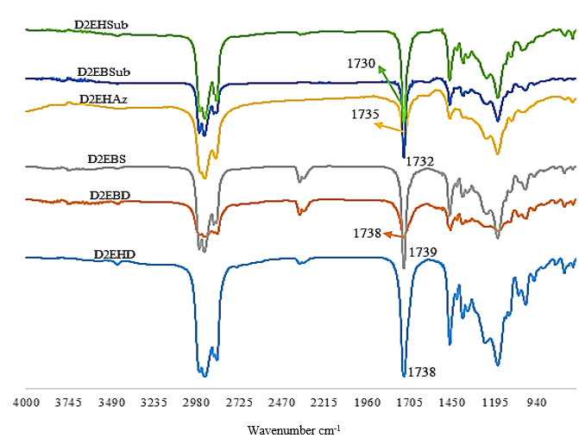
Figure 3. FTIR spectrum for the synthesized dicarboxylate esters

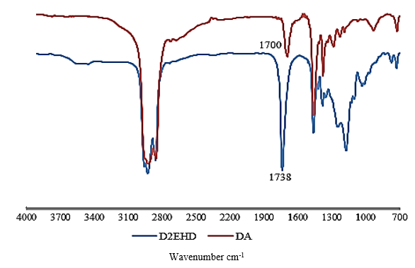
Figure 4. Comparison FTIR spectrum of D2EHD and DA

