EFFECTS OF USING DIFFERENT HEALING AGENTS ON HEALING EFFICIENCY IN SOLID STATE SELF-HEALING SYSTEM

(Kesan menggunakan Agen Pemulihan Berbeza ke atas Keberkesanan Pemulihan Sistem Swa-Pemulihan Keadaan Pepejal)

N. N Muhamad¹*, S. M. Makenan¹, M. J. Mohd Suzeren¹, S. Abdullah², M.A.S Mat Lazim¹

¹School of Chemical Science and Food Technology, Faculty of Science and Technology

Universiti Kebangsaan Malaysia, 43600 Bangi

² Department of Mechanical & Materials, Faculty of Engineering and Architecture Engineering,

Universiti Kebangsaan Malaysia, 43600 Bangi

*Corresponding author: msuzeren@gmail.com
Abstract
Self-healing polymers possess the ability to heal in response to damage using resources inherently available to the system. The solid-state self-healing system was obtained by blending thermoplastic polymers into epoxy resin matrix. This study aimed to investigate the effect of polymer healing efficiency by using different thermoplastic polymers as healing agents which were poly (bisphenol-A-co-epichlorohydrin) (PDGEBA), polypropylene (PP) and polyethylene (PE). The bonding formed in the epoxy resins were characterized by means of Fourier transform infrared spectroscopy (FTIR). Healing was achieved by heating the fractured specimen to a specific temperature, above their glass transition temperature (Tg) to mobilize the polymeric chains of the healing agent. The Tg for each specimen was obtained from dynamic mechanical analysis (DMA). From the Izod impact test it was found that healable resin with PDGEBA has the highest healing efficiency followed by PP and PE, with 63%, 31% and 24% of average percentage healing efficiencies, respectively. These results were due to the different solubility parameters of the thermoset/network and thermoplastic polymer which led to the phase separation. The morphological properties and the fracture-healing process of the resins were then observed using optical microscope.
Keywords: Solid state self-healing; different healing agent; healing efficiency; impact test
Abstrak
Swa-pemulihan polimer memiliki keupayaan untuk memulihkan kerosakan menggunakan sumber yang telah tersedia di dalam sistem tersebut. Sistem swa-pemulihan keadaan pepejal disediakan dengan mengadunkan polimer termoplastik ke dalam matriks resin epoksi. Dalam kajian ini, kesan keberkesanan pemulihan telah dikaji dengan menggunakan polimer termoplastik yang berbeza sebagai agen pemulihan iaitu poli(bisfenol-A-ko-epiklorohidrin) (PDGEBA), polipropilena (PP) dan polietilena (PE). Pencirian ikatan yang terbentuk dalam resin epoksi telah dijalankan menggunakan spektroskopi inframerah (FTIR) Pemulihan telah dicapai dengan memanaskan spesimen yang patah menggunakan suhu spesifik, iaitu suhu di atas suhu peralihan kaca (Tg) matriks resin bagi membolehkan rantai polimer agen pemulihan bergerak. Suhu peralihan kaca bagi setiap spesimen telah diperolehi dari analisis mekanikal dinamik (DMA) Hasil daripada ujian hentaman Izod, resin pemulihan dengan agen pemulihan PDGEBA menunjukkan keberkesanan pemulihan yang tertinggi diikuti dengan agen pemulihan PP dan PE, dengan masing-masing memiliki purata peratusan keberkesanan pemulihan 63%, 31% dan 24%. Hasil ini adalah disebabkan oleh perbezaan parameter kelarutan polimer termoset dan termoplastik yang membawa kepada pemisahan fasa. Pencirian morfologi dan proses patah-pemulihan kemudiannnya dikaji menggunakan mikroskop optik.

Kata kunci: Swa-pemulihan keadaan pepejal; agen pemulihan berbeza; keberkesanan pemulihan; ujian impak

Introduction
Polymers and structural composites are used in a variety of applications, which include transport vehicles, civil engineering, and electronics [1]. However, these polymeric materials are susceptible to damage in the form of cracking or micro cracking deep within the structure where detection and external intervention are difficult or impossible, resulting in a signiﬁcant shortening of the service lifetime [1].

In response, the concept of self-healing polymeric materials was proposed in 1980s by [2] as a mean of healing invisible micro cracks. This self-healing concept is taken to be where the concept or basic mechanism of self-healing has been inspired by mimicking the biological systems [3]. A number of self-healing techniques have been employed to prepare self-healing materials. In early work by Dry [4], hollow ﬁbers ﬁlled with reactive liquids were embedded in concrete. The concrete ruptured on failure and ﬁlled cracks to cause strength recovery. In different technique, White, Sottos [5] developed polymer composites that heal autonomously. In these systems, microcapsules ﬁlled with monomers are dispersed within a catalyst-containing matrix. Upon failure, the microcapsules rupture, releasing monomers that ﬁll the crack site and react when exposed to the catalyst particles. Both mentioned techniques have demonstrated the design of systems that can heal autonomously at least once. However, the need to develop materials that can heal multiple times without substantial loss in strength is proven because once the ﬁlled inclusions are ruptured, the healing agent is depleted, leading to only a singular local healing event.

To date, new approaches have been demonstrated show promise as continuously rehealable material systems; intrinsic healing polymers [6, 7]. For intrinsic systems, the matrix is inherently self-healing, and sequestration of healing agents is no longer required, avoiding many of the problems with integration and healing-agent compatibility that arise in vascular and capsule-based self-healing materials [8]. However this system need an external stimulus; heat for healing occurred [1]. These systems rely on chain mobility and entanglement, reversible polymerizations, melting of thermoplastic phases, hydrogen bonding, or ionic interactions to initiate self-healing because each of these reactions is reversible, multiple healing events are possible. A solid-state healable system via the incorporation of linear polymer chains [9] was identified as an alternative technology for intrinsic system. This system employs a thermosetting resin as a matrix of which a thermoplastic is dissolved. In this system a linear polymer should be bonded into epoxy matrix through hydrogen bonding. Upon giving a stimulus, the hydrogen bonding would break allowed the linear polymer material mobilize and diﬀuse through the thermosetting matrix, with some chains bridging closing the cracks and thereby facilitating healing. Kim and Wool [10] also proposed a microscopic theory on the basis of the “Reptation model”; proposed by de Gennes [11] that describes the diffusion and randomization in polymer-polymer crack interfaces for strength recovery (Figure 1).


(a)
(b)
(c)
(d)

Figure 1. Schematic illustration of mechanisms involved in self-healing via molecular interdiffusion based on (a) Rearrangement of surface approach; (b) Wetting of the surface; (c) Low level diffusion between surface; and (d) Diffusion, equilibration and randomization process [1]

The work reported herein represents the crack-healing study of new linear polymers as healing agents in solid state self-healing using standard epoxy. The efficiency for healing damage of the healable resin of each linear polymer was examined.

Materials and Methods
Material and Sample Preparation
The matrix system was produced using a base thermosetting resin consisting of diglycidyl ether of bisphenol-A (DGEBA) with Mw of 384.36g/mol, cured with nadic methylene anhydride (NMA) and benzyldimethylamine (BDMA), purchased from Sigma–Aldrich. The proportions of each component are given in Table 1. Once blended, the resin was cured at 90˚C for 4h followed by a postcure at 140˚C for 1h.

The healable resin was prepared by adding a thermoplastic material to this blend that was selected to be closely compatible with the main constituent, diglycidyl ether of bisphenol-A based resin. The selected thermoplastic was poly(bisphenol-A-co-epichlorohydrin) (PDGEBA) with average Mw of 44,000 g/mol, polypropylene with average Mw 12,000 and polyethylene with average Mw 15,000 from Sigma Aldrich Ltd. 8 wt% of these thermoplastics was added to the resin. Mixing of the thermoplastic was done using an overhead stirrer and the resin was heated to 90˚C until the mixture was obtained (at least 24 h). The mixture was a viscous liquid which could be degassed at 90˚C. NMA and BDMA were blended in the mixture at 90˚C before being degassed again. The degassed resin blend was poured into pre-heated silicone rubber bar moulds to produce Izod impact specimens. The resin was then cured at 90˚C for 4 h, followed by a post-cure of 140˚C for 1 h.

Table 1. Formulation of the epoxy resin

Component | Ratio by weight
DGEBA | 100.0
NMA | 81.2
BDMA | 2.0

Assessment of Matrix Healing Through Impact Testing
Testing of the ability of the matrix to heal was carried out using Izod impact testing machine, manual clamping vice with a specimen adapter for ASTM D256 (Standard Test Method for Determining the Izod Pendulum Impact Resistance of Plastics). Specimens have being prepared with the dimensions 64 mm x 13 mm x 4 mm. The specimens were lightly polished ensuring a regular rectangular shape. A notch was introduced using a motorized notching cutter (Ray-Ran). This cuts a ASTM standard notch (3 mm) in a single pass which was sharp and reproducible. Room temperature Izod impact test was performed using an impact test of Ray-Ran Test Equipment RR/IMT (RR/MT/100).
force applied to keep it flat
broken specimen
screw to keep specimen in intimate contact
platform

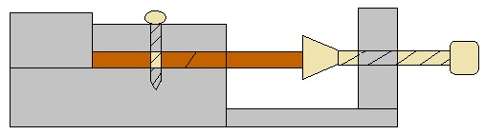
Figure 2. Schematic of the healing platform for the fractured Izod impact specimens
Under test, these specimens were fully fractured, with the two halves being immediately relocated and lightly clamped together using the healing platform shown in Figure 2. Gentle pressure was applied to ensure that the faces of the two halves were kept in alignment and intimate contact. The samples were healed at 160˚C for 6 hours. Samples were repeatedly healed and tested throughout the study, to examine the effect of repeated healings on the efficiency of impact strength recovery. Each sample was tested 3 times, making a total of 9 tests at each healing temperature. Considering the qualitative nature of the Izod impact test, the efficiency of impact strength recovery was calculated from the relative impact energies, Equation 1 [12],

. (1)
where E_{healed} and E_{initial} are the post-healing and initial impact energies, respectively. R_{E} is the percentage recovery in impact strength. The resin healing efficiency (H_{E}) has been re-estimated from Equation 2, [12], where R_{E} and R˚_{E} are the recovery percentage of healable resin and residual healing effect of reference resin (containing no healing agent) respectively.

(2)

Characterization
FTIR spectra were recorded with Spectrum ASCII PEDS 400 ATR Spectrometer to determine the functional group in the resin system. All spectra were recorded at room temperature with the infrared spectra range of 4000 - 650 cm¹. Dynamical mechanical thermal analysis (DMTA) was performed on a TA Instruments Thermal Analysis DMA 2980 Dynamic Mechanical Analyzer operating in the single cantilever-bending mode at an oscillation frequency of 1Hz. Data were collected from room temperature to 180ºC at a scanning rate of 2ºC/min. The sample specimens were made in the form of rectangular bars of a nominal 35 mm x 15 mm x 5 mm. The morphology of the sample crack surfaces from Izod impact test were observed using optical range microscopy (Axiolab A45090 Image Analyzer) with Zeiss camera.

Results and Discussion
Infrared Analysis
Interaction between functional group in epoxy resin was determined by infrared spectrum as shown in Figure 3. Throughout all resin system, there were peaks for hydroxyl (–OH) functional group in the range of 3300-3600 cm⁻¹ in the spectrum of reference resin (Figure 3b) and healable resins (Figure 3 c, d, e). The peaks are quite broad and clear for almost cases, indicates the presence of hydroxyl group. For Figure 3a, the -OH stretching groups observed at 3500 cm⁻¹ for DGEBA spectrum is due to the the presence of dimers or high molecular weight species [13]. The existence of hydroxyl groups in healable resins are very importance to introduce the self-healing mechanism at crack surface through hydrogen bonding physically. The reaction between anhydride and epoxy group was found in reference and healable resins. This reaction produced ester group with clear peak at 1730cm⁻¹. Due to the opening of epoxy ring from curing process, the reduction in the intensity of the epoxy ring band at 910cm⁻¹ was observed. The band at 915cm⁻¹ is assigned to the asymmetric stretching vibration of C-O-C (epoxy ring).

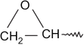
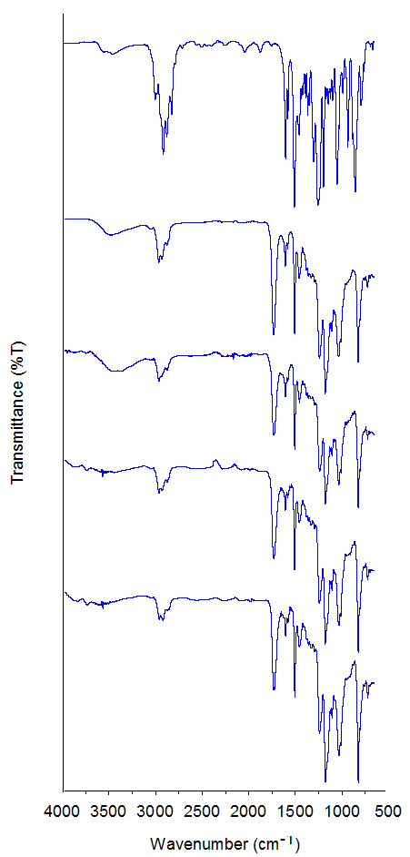
1730cm⁻¹
^{Ester group}
910cm⁻¹
3511cm⁻¹
O-H group

(a)
(e)
(d)
(c)
(b)
Figure 3. FTIR spectra of (a) DGEBA (b) reference resin, (c) healable resin containing PDGEBA, (d) healable resin containing polypropylene and (e)healable resin containing polyethylene

Glass Transition Temperature (Tg)
The glass transition temperature (Tg) of reference and healable resins were determined by dynamic mechanical thermal analysis (DMTA). Figure 4 shows the DMTA curves for the reference and healable resins. The Tg for reference resin (DGEBA resin) appeared at 139˚C while for healable resins containing PDGEBA, PP and PE are 137˚C, 126˚C and 125˚C respectively. Determination of Tg for each sample are important so the minimal healing temperature can be determined. Solubility parameter of the network and thermoplastic polymer is the main factor for optimal repairing damage, which it provides directly indications of their solubility behaviors in the mixture. The solubility parameter of the healing agents and a model of the NMA-cured diglycidylether of bisphenol A were calculated using the group contribution methodology of Hoy [14] from The Hoy Solubility Parameter Software (from Computer Chemistry Consultancy, Germany). The values for polymeric matrix resin with repeat unit is 21.88 (J/cm³)^{1/2}. This value is close to the solubility parameter value of 21.25 (J/cm³)^{1/2} for healing agent PDGEBA. The traces for reference and healable resins in addition of PDGEBA (Figure 4) are essentially identical demonstrating the solubility of the healing agent thus conﬁrms that by closely matching the linear molecule to the cross-linked network, diffusional healing can be achieved [9]. While for healable resins containing PP and PE, the solubility parameter values are 16.69 (J/cm³)^{1/2} and 18.01 (J/cm³)^{1/2} respectively, which these values are slightly different compared to the polymeric matrix resin. The traces for both healable resins evident the incompability of PP and PE as healing agents in matrix. Therefore, linear polymer of PDGEBA has the potential to be soluble in the cured epoxy resins compared to PP and PE.

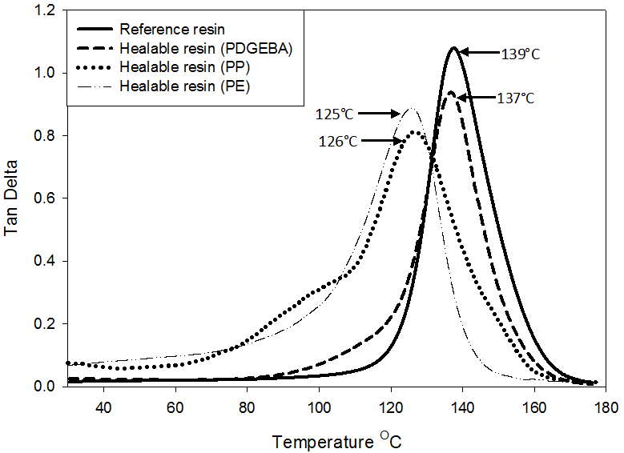
Figure 4. Dynamical mechanical thermal analysis (DMTA) traces for the NMA-cured bisphenol A epoxy resin of reference resin, healable resin containing PDGEBA, healable resin containing PP, and healable resin containing PE

Healing Efficiency
The healing efficiency of the resins matrix was investigated using Izod impact testing. Figure 5 shows the percentage recovery (R_{E}) and percentage of healing efficiency (H_{E}) in Izod impact strength after fracture as a function of the varying healing agent calculated from Equation 1 and 2. Data for three impact/heal cycles are shown to reveal the effect of multiple healing events on the healing performance.

Figure 5 (a) shows that the reference resin can be thermally healed to a limited extent after 6 h at 160˚C. The graph shows a 19.5% recovery in impact strength for the reference resin after one healing event. The implication is that there is some post-cure of the samples in the curing schedule. To compensate for this, the healing efficiency (H_{E}) of healable resins was calculated using Equation 2. Thus, H_{E} contribution to healing from the addition of the healing agent can be examined.

Figure 5 (b) shows the healing efﬁciency across the range of varying healing agent. From this graph, it was found that healable resin with PDGEBA has higher healing efficiency followed by PP and PE, with 63%, 31% and 24% of average percentage healing efficiencies, which taken from the average of all three healing cycle. All three healing agents shows maximum healing efficiency of 38-65% with PDGEBA the highest in the first healing cycle followed by PP and PE. Subsequent healing cycles lead to signiﬁcant healing efficiency in impact strength although at a lower level than for the ﬁrst cycle, with 63, 23 and 20% for a second healing and with 60, 14 and 13% for the third cycle for each of healable resin. For the second and third healing cycles, it was observed that PDGEBA still achieved the highest healing efficiency followed by PP and PE. However, there are a reduction in the healing efficiency for all specimens especially healable resins of PP and PE after first healing event. These reductions are possibly due to physical ageing effect. Physical ageing effect of epoxy resin can be explained by the molecular relaxation in which the epoxy network loses the mobility and the free volume during its approach towards the equilibrium glassy state [15, 16]. This effect in self-healing system was also reported by [12], Peterson, Kotthapalli [17]. The full detail study on the physical ageing effect will be explored in the future.

(a)
(b)
Figure 5. (a) The percentage recovery in Izod impact strength (R_{E}) of epoxy resin (b) The percentage of healing efficiency in Izod impact strength (H_{E}) of epoxy resin

Both Figures 5 (a) and (b) shows that PP and PE have a limited effect on healing efficiency compared to PDGEBA. An explanation could be that the healing agent is not completely dissolved in the thermosetting DGEBA matrix because the solubility parameter value of healing agents are not closely matched to the solubility parameter value of matrix. The solubility parameters are need to be matched so that the ‘healing agent’ remains uniformly dissolved in the matrix, without phase separation [9].

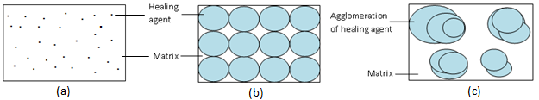
Figure 6. Visualisation of (a) miscible healing agent in matrix, (b) partially dissolved of healing agent in matrix and (c) agglomeration of healing agent in matrix

Healable resin containing PDGEBA as a healing agent shows a miscible system (Figure 6a) where all the PDGEBA dissolved in the resin, while for healable resin containing PP and PE show an immiscible systems where PP and PE were partially dissolved in the matrix. Using Hoy software, it was shown that the solubility parameter value of PP and PE are not matched to the solubility parameter value of the network. The surface morphology obtained (Figure 7 g-l), evident that these healable resins are phase separated as the PP and PE are not miscible to the matrix. Thus it can be postulated that the reduced healing efficiency appears to be due to its immobilization of linear polymer which is attributed from the phase separation.

The difference in solubility parameter also lead to the formation of agglomeration (Figure 6c). Since the mechanism of the healing is believed to be the diffusion of the soluble linear healing agent, it can be postulated that the less thermoplastics miscible with the epoxy, such that there is reduced capacity for molecular scale migration through unoccupied or free volume within the matrix resin for crack closure.

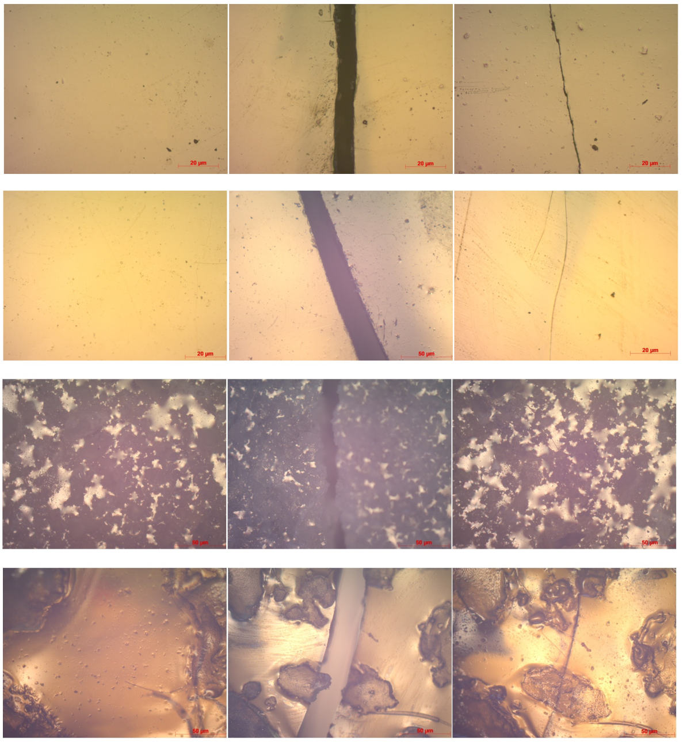
Healing agent (Agglomeration)
Matrix
Healing agent (Agglomeration)
Matrix
DGEBA
+
PDGEBA
DGEBA
+
PP
DGEBA
+
PE
DGEBA

(i)
(h)
(g)
(j)
(k)
(l)
(a)
(b)
(d)
(e)
(f)
(c)
Crack occured
Crack closed

Figure 7. Visualization of the fracture-healing process for reference (a, b, c) and healable resin with PDGEBA (d, e, f), PP (g ,h ,i) and PE (j, k, l). Optical microscopy images of (a, d, g, j) the surface of the sample before fracture, (b, e, h, k) the crack on a completely fractured samples, (c, f, i, l) the cracked surface after thermal mending

The healing capability and the visualization of the fracture-healing process for healable resins were observed through the surface morphology using optical microscopy (Figure 7). The crack in the sample after fracture can be clearly seen in Figure 7 (b, e, h, k) with the magnification of 5x. After healing at 160⁰C for 6h, this crack is apparently healed as shown in Figure 7 (c, f, i, l). This phenomenon can be clearly observed in which the crack has been filled and the two fracture surfaces have been bonded together. The agglomeration and phase separation effect in healable resins of PP and PE also can be clearly verified in Figure 7 (g, h, i, j, k, l).

Conclusion
The healing efficiency in a matrix resins by using different healing agents, which are PDGEBA, PP and PE is attempted. The addition of the three healing agents to a thermosetting epoxy resin has been shown to be a means of inducing self-healing but at different efficiency. From this study it was shown that PDGEBA is the most effective healing agent compared to PP and PE with 63%, 31% and 24% of average percentage healing efficiencies. The poor healing efficiencies of healable resins containing PP and PE are due to the existence of phase separation which can be clearly seen through the surface morphology study. Since the mechanism of the healing is believed to be the diffusion of the soluble linear healing agent, it can be concluded that there was a definite correlation between the solubility parameter value of the network and the healing agent with the kinetics of diffusion.

Acknowledgment
The authors acknowledge the financial support of this study by Government of Malaysia through grant number of FRGS/1/2012/SE07/UKM/03/1, GGPM-2012-014 and ERGS/1/2012/TK04/UKM/03/3. The authors also wish to thank the National University of Malaysia for the support of this project.

References

- Wu, D. Y., Meure, S., & Solomon, D. (2008). Self-healing polymeric materials: A review of recent developments. Progress in Polymer Science, 33 (5): 479-522.
- Jud, K., Kausch, H. H., & Williams, J. G. (1981). Fracture mechanics studies of crack healing and welding of polymers. Journal of Materials Science, 16 (1): 204-210.
- Trask, R. S., Williams, H. R., & Bond, I. P. (2007). Self-healing polymer composites: mimicking nature to enhance performance. Bioinspiration & Biomimetics, 2 (1): 1-12.
- Dry, C. (1994). Matrix cracking repair and filling using active and passive modes for smart timed release of chemicals from fibers into cement matrices. Smart Materials and Structures, 3 (2): 118.
- White, S. R., Sottos, N. R., Geubelle, P. H., Moore, J. S., Kessler, M. R., Sriram, S. R., Brown, E. N., & Viswanathan, S. (2001). Autonomic healing of polymer composites. Nature, 409 (6822): 794-797.
- Kalista, S. J. & Ward, T. C. (2007). Thermal characteristics of the self-healing response in poly(ethylene-co-methacrylic acid) copolymers. Journal of The Royal Society Interface, 4 (13): 405-411.
- Murphy, E. B. & Wudl, F. (2010). The world of smart healable materials. Progress in Polymer Science, 35 (1–2): 223-251.
- Blaiszik, B. J., Kramer, S. L. B., Olugebefola, S. C., Moore, J. S., Sottos, N. R., & White, S. R. (2010). Self-Healing Polymers and Composites. Annual Review of Materials Research, 40: 179 - 211.
- Hayes, S. A., Jones, F. R., Marshiya, K., & Zhang, W. (2007 a). A self-healing thermosetting composite material. Composites Part A: Applied Science and Manufacturing, 38 (4): 1116-1120.
- Kim, Y. H. & Wool, R. P. (1983). A theory of healing at a polymer-polymer interface. Macromolecules, 16 (7): 1115-1120.
- De Gennes, P. G., Scaling concepts in polymer physics. 1979: Cornell university press.
- Hayes, S. A., Zhang, W., Branthwaite, M., & Jones, F. R. (2007 b). Self-healing of damage in fibre-reinforced polymer-matrix composites. Journal of The Royal Society Interface, 4 (13): 381-387.
- González, M. G., Cabanelas, J. C., & Baselga, J. (2012). Applications of FTIR on Epoxy Resins–Identification, Monitoring the Curing Process, Phase Separation and Water Uptake. Infrared Spectroscopy–Materials Science, Engineering and Technology.
- Hoy, K. (1970). New values of the solubility parameters from vapor pressure data. Journal of Paint Technology, 42 (541): 76-118.
- Hutchinson, J. M. (1995). Physical aging of polymers. Progress in Polymer Science, 20 (4): 703-760.
- Kong, E. S.-W.(1986) Physical aging in epoxy matrices and composites, in Epoxy Resins and Composites IV Springer:125-171.
- Peterson, A. M., Kotthapalli, H., Rahmathullah, M. A. M., & Palmese, G. R. (2012). Investigation of interpenetrating polymer networks for self-healing applications. Composites Science and Technology, 72 (2): 330-336.

