EFFECT OF REINFORCED HYBRID PALM SHELLS ON MECHANICAL PROPERTIES OF POLYURETHANE-JUTE WOVEN/VINYL ESTER SANDWICH BOARD

(Kesan tenunan hibrid biji kering kelapa sawit terhadap sifat-sifat mekanikal Poliuretana-Jute Wooven/Ester vinil papan sandwic)

Teo Siew Cheng, Nurul Ain Binti Nanyan, Du Ngoc Uy Lan*, and Teh Pei Leng

School of Materials Engineering,
Universiti Malaysia Perlis,Taman Muhibah, Jejawi, 02600 Arau, Perlis,Malaysia

*Corresponding author: uylan@unimap.edu.my

Abstract
A natural fiber sandwich was constructed from palm shells/polyurethane core and jute woven/vinyl ester facesheets by the in-situ sandwich process (core and panel prepared simultaneously). The polyurethane sandwich core was reinforced by hybrid shell systems of dried palm shell (DPS) and palm kernel shell (PKS) (50P-50D, 25P-75D), and single shell system of PKS (100P) as well as 20phr empty fruit bunch (EFB) based on hundred part of polyurethane. The sandwich facesheets are prepared by using two jute woven layers and impregnated by vinyl ester. Interlocking between DPS and polyurethane matrix was formed, which hence enhanced the mechanical properties. The interfacial adhesion between DPS, PKS, and EFB with the polyurethane binder played the important role to achieve high mechanical properties. It was found that hybrid shells exhibited high reinforcement for sandwich’s performance resulting better compression (50P-50D) and flexural (25P-75D) properties. The single shell 100P showed only improvement on flexural modulus.The fracture surface morphology of sandwich under mechanical test was performed by using optical microscopy.

Keywords: Interlocking, sandwich, palm shell, empty fruit bunch, jute woven

Abstrak
Sandwic serat semula jadi telah dibina dari biji kering kelapa sawit/ poliuretana teras dan jute anyaman /ester vinil melalui proses sandwic in-situ (bahagian teras dan lapisan luar disediakan pada masa yang sama). Sandwich teras poliuretana telah diperkukuhkan oleh sistem biji hibrid biji kering kelapa sawit (DPS) dan biji kelapa sawit (PKS) (50P-50D, 25P-75D), dan sistem biji tunggal PKS (100P) serta tandan buah kosong kelapa sawit (EFB) sebanyak 20phr berdasarkan bahagian per seratus poliuretena . The panel sandwich disediakan dengan menggunakan dua lapisan jute anyaman dan diimpregnat oleh vinil ester. Saling cantum antara DPS dan matriks poliuretana telah dibentuk, dimana sifat-sifat mekanikal telah dipertingkatkan. Pelekatan antaramuka antara DPS, PKS, dan EFB dengan pengikat poliuretana memainkan peranan penting untuk mencapai sifat-sifat mekanikal yang tinggi. Didapati bahawa hibrid biji menunjukkan pengukuhan yang tinggi bagi prestasi sandwich yang mengakibatkan sifat mampatan yang lebih baik (50P-50D) dan juga peningkatan dalam sifat-sifat kelenturan (25P-75D). 100P biji tunggal hanya menunjukkan peningkatan pada modulus kelenturan. Morfologi permukaan patah sandwic selepas ujian mekanikal telah dilakukan dengan menggunakan mikroskop optik.

Kata kunci: Interlocking, sandwic, biji kering kelapa sawit, tandan buah kosong kelapa sawit, jute wooven

Introduction
Composite sandwiches fabricated from two thin and stiff surface facesheets with a lightweight and thick core have been widely used in the automotive, aerospace, land transport, marine and civil construction industrial applications. Their advantages from such applications are high specific bending stiffness, strength under distributed loads and good energy-absorbing capacity [1,2]. The behavior of sandwich board depends on the properties of core material, especially under mechanical loading. The flexibility of sandwich construction allows innovative structural developments and it is important to choose high-quality core material in the optimal design of sandwich board [2-4]. The sandwich core must provide the structure stiffness in the transverse direction in order to prevent the delamination of facesheets over each other. Honeycomb core architectures have been widely used in aerospace application and the major disadvantage is the water trapping in the hexagonal cells of the honeycomb, which corrodes the core material [5]. Besides, defection can be occurred easily during manufacturing or in-service conditions due to debonding atthe small adhesive area between honeycomb cells andfacesheets [6].Balsa core is another type of sandwich wood core, which can provide good mechanical properties andcan be processed with a lot of sandwich manufacturing techniques. However, balsa wood experience problems in water ingress which is important for penetrationsthrough tank bulkheads or outer shells in marine application.In present,palm oil mills produce crude palm oil as their main product, and some residue such as mesocarp fibre, PKS and empty fruit bunch (EFB) [7]. The palm oil industry has to dispose of approximately 1.1 tons of EFB per every ton of palm oil produced [8]. This biomass is traditionally used as a thermal energy sources for boilers to provide process steam and to produce electricity [9]. Problems are associated with the burning of these solid fuels, about 5% by weight of ash was collected and stockpiled in open field have caused light particles of ash are easily carried away by the wind, resulting in smog and thus it had negative impact on environment [10].
Palm fruit loosens naturally off the bunches and falls on the palm fields, after drying naturally and then the mesocarp is peeled off, with the resulting waste product referred to as dried palm shell (DPS), which is considered as a natural macro-cenosphere due to elliptical shape and empty core (as seen in Figure 1a). The shell has high potential to be used as reinforcement shell for sandwich core. Moreover, binder could flow into DPS’s core and form a macro interlock, which results in high mechanical properties. This research also chooses jute fibres to reinforce the panel of the sandwich, because it has 64.4%cellulose content and possess superior mechanical properties [11]. The potential to use recycled jute fibers is made possible by the rapid expansion of coffee industry with a 7% annual growth rate in restaurant industry [12]. This preliminary study centered on the effect of different contour of palm shell (spherical and flaky) on the mechanical properties (flatwise compression and three point bending).The economic utilization oil palm waste material as reinforced filler in sandwich core not only can reduce the environmental issue but exploit the possible value of palm shells for sandwich industry.
Materials and Methods

Materials
Polyol (PEG 400) and 4, 4 methylenebis (phenyl isocyanate) were obtained from Maskimi Polyol Sdn. Bhd, Selangor, Malaysia. Dried palm shell (DPS) from the Kepala Batas plantation in Penang with a diameter from 15 mm to 20 mm and a bulk density of 0.85 gcm⁻³ (The shells are sealed their surface hold and measured byElectronic Densimeter MD-300S). Relative density of DPS is 1.4345 gcm⁻³obtained by using Pynometer (Micromeritics Ltd, AccuPyc 1330). Empty fruit bunch (EFB) with a length ranging from 600 µm to 2.98 mm and palm kernel shells (PKS) with a density of 0.65 gcm⁻³ were obtained from DST Technology Sdn. Bhd., These materials were used for core preparation. The vinyl ester jute woven (VEJW) panel was prepared using vinyl ester and methyl ethyl ketone peroxide (MEKP), which were obtained from PT. Kawaguchi Kimia Indonesia. Jute woven (JW) obtained from waste jute bags used for vegetable packaging and was washed and dried before use.

Sandwich preparation
A wooden mould with dimensions of 260 mm × 220 mm × 25 mm was used, and was covered with a polypropylene film for demoulding. Two ply jute woven (JW) were placed inquasi isotropic arrangement in the mould.The mixture of DPS/PKS and EFB fibre was arranged into the mould. Polyol and MDI (1:1) were mixed at 250 rpm for 1 min using a stirrer and then cast into the palm shells and EFB. Lastly, the other two ply JW were placedon the topof palm shell-EFB mixture. The mould was closed with a polypropylene film covered-steel plate and pressed at room temperature for 24 hours. The board was demoulded and the overflow of PU foam was trimmed.For facesheets finishing, mixture of vinyl ester resin and MEKP in the ratio 100:3 (stirring at 400 rpm for 1 min) wasimpregnated to the JW surfaceby hand lay-up method. The sandwich boards were allowed to cure at room temperature for 24hours before testing. Table 1 represents the composition sandwich core; single shell system 100P was compared to hybrid palm shell system, 50P-50D and 25P-75D. It is noted that the volume fraction of hybrid system was below 50% compared to single system. This was due to the different size and density of PKS and DPS. Flaky PKS is the by-products after oil extraction using compression method, hence, PKS has smaller size, thinner wall, and lower density compared to DPS, which was used directly without any prior processing.

Table 1. Composition palm shell/polyurethane sandwich core

Palm shells blend ratio | PKS  (% by weight) | DPS  (% by weight) | Palm shell volume fraction, vol % | Palm shells content | PU content | Core Density
100P | 100 | 0 | 48.55 | 75wt% | 25wt% | 0.4295
50P-50D | 50 | 50 | 42.84 | 75wt% | 25wt% | 0.4272
25P-75D | 25 | 75 | 40.00 | 75wt% | 25wt% | 0.4213
*EFB was used 20 phr for all recipes, which is part per hundred weights of PU and MDI
*wt%=weight percent based on total weight of sandwich core

Mechanical characterization
A three point bending test was performed in accordance with ASTM C 393. Flexural specimens of sandwich (26 mm in thickness) were cut with bandsaw to the dimensions of 220 mm × 50 mm. A flat compression test was conducted according to ASTM C 365-11a with sandwich specimens of 50 mm × 50 mm × 26 mm. Five replicate specimens were tested in each test with a displacement rate of 5 mm/min.

Results and Discussion

Interlocking observation
The interlocking between DPS and PU binder were formed in the sandwich system as depicted in Figure 1 (b). The cenospherical shape of DPS induces the formation of PU inside the DPS empty core so interlockingwas obtained. There are two shell systems, sandwich 100P composed of single type of shell and hybrid shell DPS and PKS such as 50P-50D and 25P-50D. The cross surface of 50P-50D sandwichwas shown in Figure 1 (c), which presented the distribution of palm kernel shells in sandwich core. Shell structure and volume have a significant influence onsandwich mechanical properties. In term of same weight percent, PKS has higher volume compared to DPS due to low density.In comparison, a single shell of DPS is stronger than PKS due to the cenospherical structure as well as the interlocking formation.

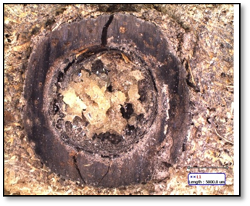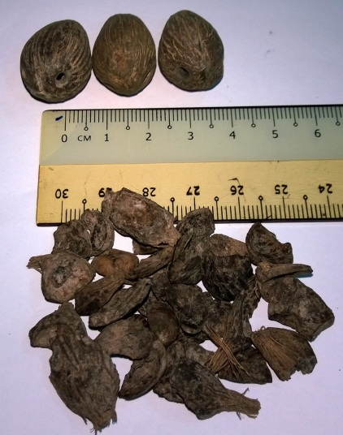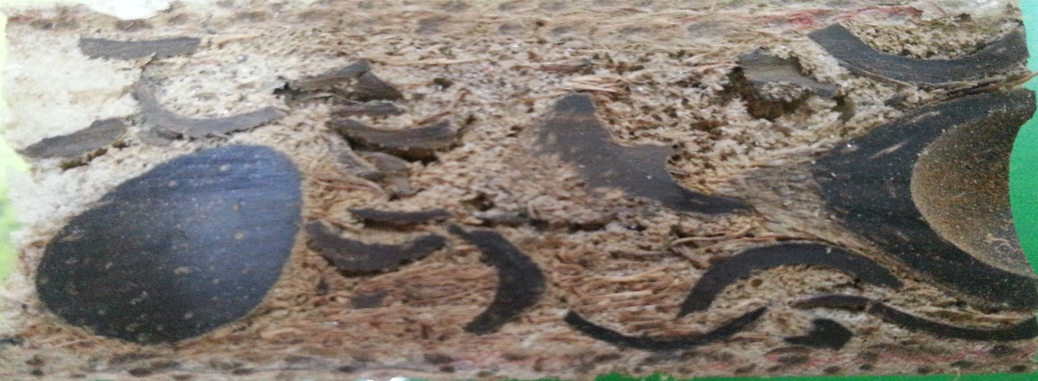
DPS
PKS
(a)
(c)
(b)
DPS wall
PKS
DPS
PU Interlocking

Figure 1. (a)Thenatural spherical shape of DPS and the flaky irregularly shape of PKS, (b) the cross section of interlocking between DPS and PU, (c) cross surface50P-50Dsandwich [13].

Flexural properties of PU sandwich board
Flexural strength and modulus of the sandwich are shown in Table 2 and depicted in Figure 2. Theflexural strength of sandwich was enhanced by theincrease of DPS ratio in DPS/PKS hybrid. Besides, singleshell system of 100P exhibited quite similar flexural strength to 25P-75D. During flexural loading, the upper VEJW panel of the PU sandwich sampleis undercompression, the lower VEJW panel is under tension and the palm shell-EFB core is under shear. Therefore, it could be said that one of the most important properties of a reinforced core are shear strength and stiffness. The VEJWfacesheets are subjected to compression/tension and are largely responsible for the strength of the PU sandwich board [14]. Three points bending test more focus on localized load at roller transferring throughout the specimen [15]. Therefore, the interfacial adhesion between PU binder and palms shells (DPS/PKS) in sandwich system is a main factor imparts on flexural.

Table 2. Mechanical properties of PU sandwich board with 20phr EFB

PU  Sandwich | Flexural strength, Mpa | Flexural modulus, Mpa | Compression strength, MPa | Compression modulus, MPa
100P | 2.826 | 97.907 | 5.580 | 28.360
50P-50D | 2.195 | 29.827 | 12.839 | 68.013
25P-75D | 2.865 | 24.517 | 9.654 | 45.353

Figure 2. The effect of palm shell blend ratio on flexural properties of PU sandwich

Flexural modulusdepends not only on the hybrid composition, but also inpalm shell positions of in the core. A spherical shell of DPS could cause the sandwich be initially bent easier compared to the irregular shape of PKS under the localized load applied from the flexural rollers. More PKS dispersed throughout the samples due to its higher volume of the lighter density compared to DPS was also produced larger interface area so that the modulus of sandwich 100P was enhanced. A similar result was also founded in the modulus of50P-50Doverthat of 25P-75D in hybrid shell system but with a slight effect.

In sandwich 100P, the large quantities of PKS allowed well connected with each other so that the bending load could transfer well. The arrangement of PKS with across each other entrapping PU binder between themselves has also imparted to the flexural strength. PKS in sandwich core are important in reflection of the crack path from its original path to increase the flexural strength as shown in Figure 3(a).In addition, high shear stresses are given across the core of the sandwich 100P and once the sandwich board failed by core shear, all the forces transfer to the bottom panel. The bottom panel carried the built up load and deflection and finally, it was failed, leading debonding occurred at the bottom panel as shown in Figure 3(b) [16,17].

In hybrid shell sandwich board, considerable interlocking formed between PU binder and DPS could enhance the strength of sandwich. This explains the higher flexural strength of sandwich 25P-75D than that of sandwich 50D50P. However, both sandwiches25P-75D and 50P-50D have common failure that is tensile crack occurred middle of the bottom VEJW panel as shown in Figure 3(c), (d) and Figure 3(e), (f) respectively. This is because of the applied stress exceeds the yield strength or buckling strength, the tensile panel or compressive panel will fail proving a good bond between facesheets and core in the sandwich [3].

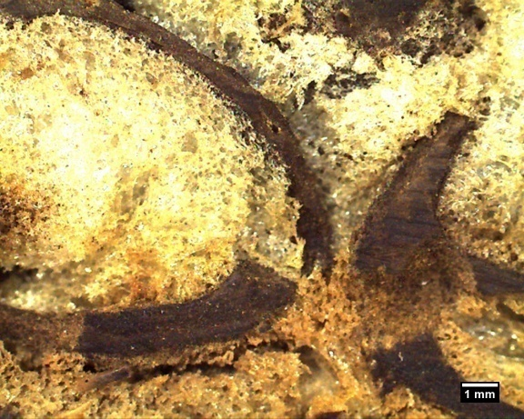  Crack path  (a) | 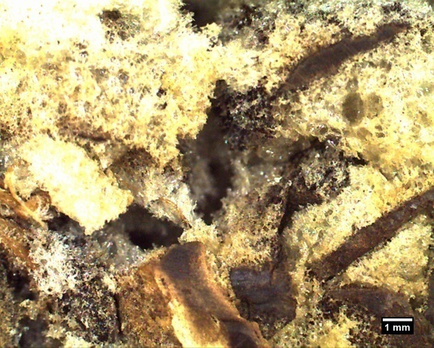  Cohesive failure  (b)
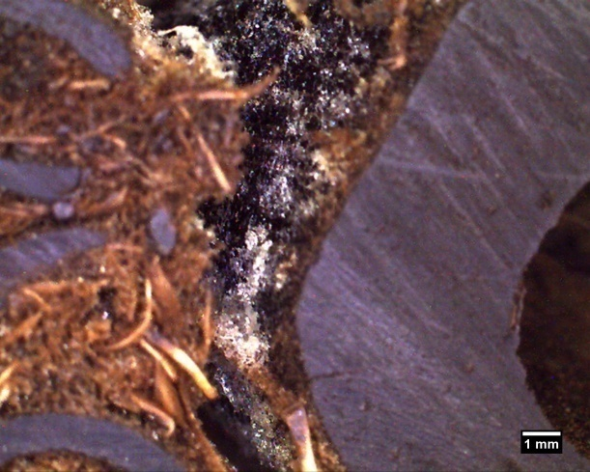  (c)  DPS  Crack path | 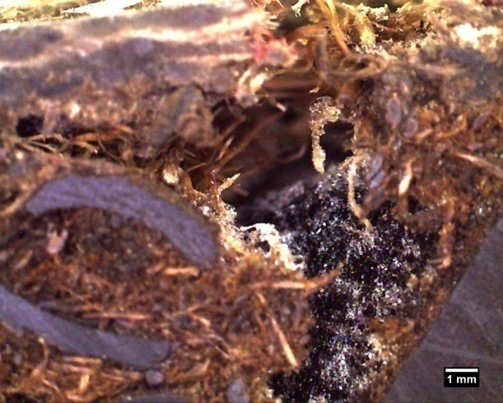  (d)  Sandwich panel  Tensile crack
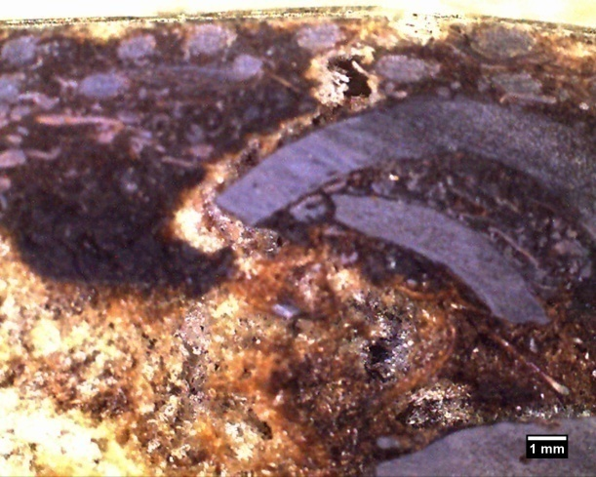  (e)  Sandwich panel  Tensile crack | 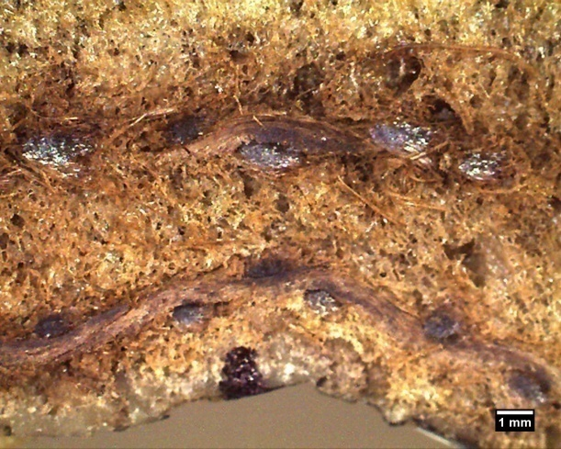  (f)  Sandwich panel  Panel wrinkle

Figure 3. Fracture deformations of PU sandwiches after flexural test (a) Sandwich 100P: Crack path deflects by PKS; (b) Sandwich 100P: Shear core failure; (c) Sandwich 50P-50D: Crack path deflects by DPS caused cohesive failure; (d) Sandwich 50P-50D: Fractured of JWVE panel due to tensile crack; (e) Sandwich 25P-75D: Crack path from tensile crack deflect by PKS; (f) Sandwich 25P-75D: Panel wrinkle at loading roller; ⇑ : Flexure load direction

Compression properties of PU sandwich board
In terms of axial compressive load applied on PU sandwiches, sandwich 100P exhibited lower compressive strength compared to hybrid shell sandwiches 50P-50D and 25P-75D as depicted in Figure4. These results are different from flexural results. The behaviour of sandwich 100P may be attributed to the intrinsic properties of PKS under compressive load. PKS was obtained after kernel extraction. Since PKS underwent mechanical pressing and crushed into irregular semi-ellipse shape, so PKS are weak compared to DPS, which does not bear any mechanical process before proven by DPS crystal structure morphology as shown in Figure 5. Furthermore, weak PU binder imparts common cohesive failure (Figure 6(a)) and bulking of sandwich core at the edge of sandwich are common failure in sandwich 100P. Significant improvement in compression strength was found in hybrid shell sandwich system. Theenhancement was contributed from the intrinsically cenospherical structure of DPS. Naturally ellipse morphology is considered as the perfect shape in compressive resistance.However, more DPS does not enhance the compression resistance, where sandwich50P-50D performed better compressive strength than sandwich 25P-75D. The reason could be originated from better shell arrangement based on the equivalent blend ratio of DPS and PKS, which is important in compression resistance as shown in Figure 6(b). DPS with presence of PU interlocking cracked under compression load at the edge ofsandwich as shown in Figure 6(c). PU interlocking formed in DPS is damaged by the crack propagated while the DPS shell wall was ruptured by compression load. Sandwich with 25P-75D with large amounts of DPS contents confer crushed down of the DPS and the pullout of DPS shell at the cutting edge of 25P-75Dsample as shown in Figure 6(d).

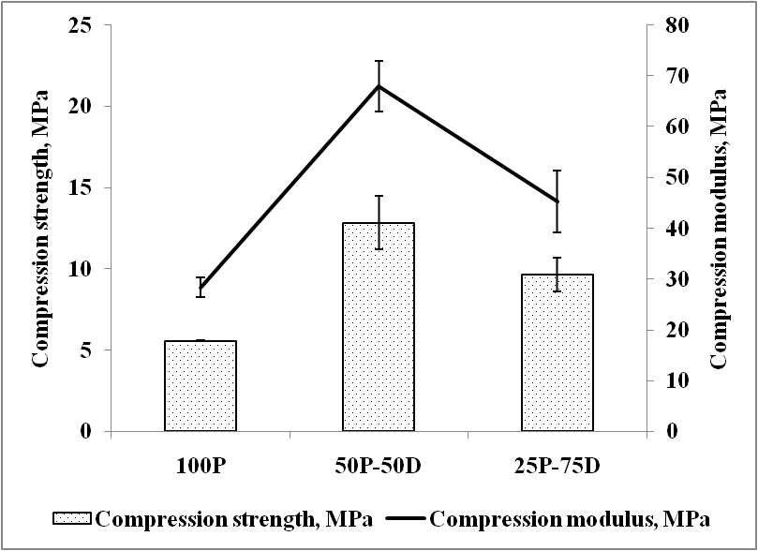

Figure 4. The compression strength and modulus of PU sandwich boards with different palm shell blend ratio

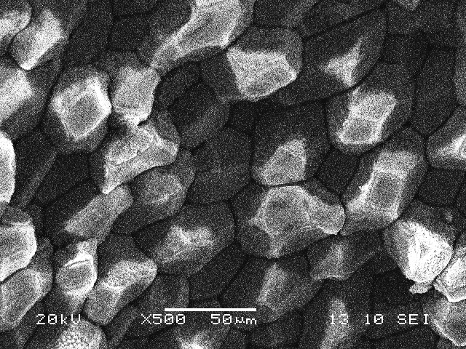
Figure 5. The crystalline arrangement morphologyof DPS wall exhibits strong mechanical properties

Correspondingly, compression modulus can be related to the stiffness of PU sandwich. Sandwich 50P-50D has highest compression modulus;this can be attributed to the equivalent blend ratio of DPS and PKS in sandwich core. The result is in agreement with flexural modulus. Based on the volume fraction of palm shell as tabulated in Table 1, sandwich 50P-50D has a large interfacial area than sandwich 25P-75D due to PKS content in sandwich core, which played important role in load transfer to strong DPS. Large quantitiesof PKS in sandwich 100P could cause inadequate of wetting of PKS and EFB by PU binder in sandwich core, thus100P sandwich performed a poor modulus compared tothat of hybrid sandwich.

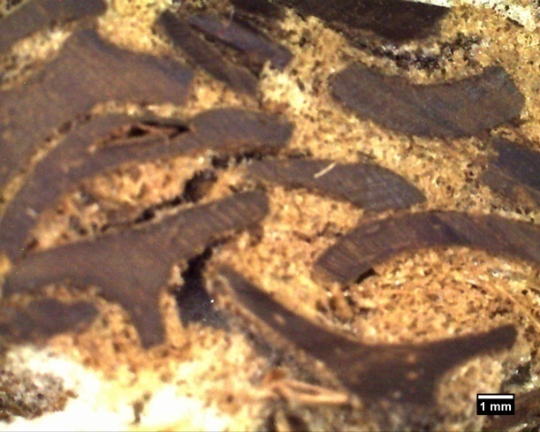  (a)  Crack path | 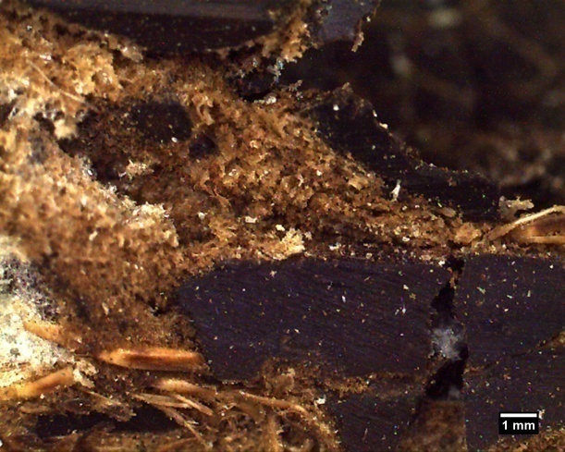  Cracked PKS  (b)  Cracked DPS
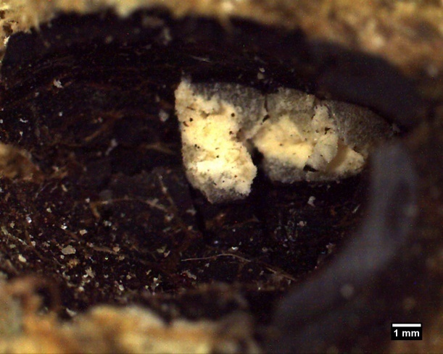  (c)  Cracked DPS  DamagedPU interlocking | 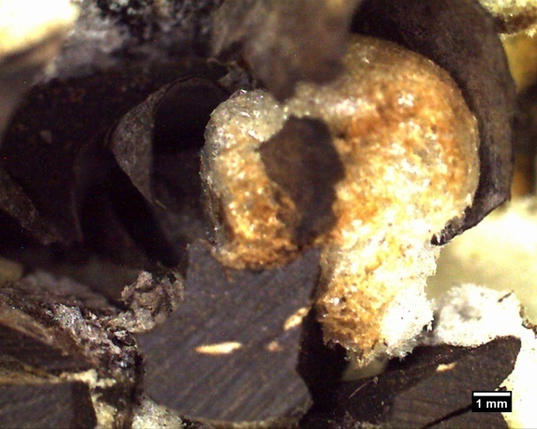  (d)  Crushed DPS  DamagedPU interlocking

Figure 6. Fracture surfaces of PU sandwiches after compression test (a) Sandwich 100P: cohesive failure; (b) Sandwich 50P-50D: Crushed DPS and PKS; (c) Sandwich 50P-50D: PU Interlocking formed inside DPS; (d) Sandwich 25P-75D: Damaged PU interlocking in crushed DPS; ⇓ : Compression load direction

Conclusion
Hybrid shell system imparts higher mechanical properties than a single shellsystem proven by the results of flexural strength of sandwich 25P-75D and compression strength of sandwich 50D50P. In the hybrid system, the blend ratio of DPS and PKS showed a significant effect on the stiffness of sandwich board due to the interlocking, crystal structure of the DPS’s shell wall and the volume fraction of palm shell. Different deformation patterns are also observed depending on the interaction of PU binder with DPS, PKS and EFB. In details, the crack propagation occurred through the PU binder and caused cohesive failure between palm shells, while interlocking formation deflect the crack path was also observed. PKS was crushed under flexural and compression load. DPS tends to be cracked and crushed down under axial compression load, but maintain the sandwich’s strength, which is considered as densification.

Acknowledgement
The researchers would like to thank the Minister of Higher Education, Malaysia for providing the Fundamental Research Grant Scheme (FRGS) 9003-00326 that made this work possible.

References
- Fleck, N.A. and Sridhar, I. (2002). End compression of sandwich columns. Compos. Part A. Appl. Sci. Manuf. 33: 353-359.
- Yu, J.L., Wang, E.H., Li, J.R. and Zheng, Z.J. (2008). Static and low-velocity impact behavior of sandwich beams with closed-cell aluminum-foam core in three-point bending. Int. J. Impact. Eng. 35: 885–894.
- Manalo, A.C., Aravinthan, T. and Karunasena, W. (2010). Flexural behaviour of glue-laminated fibre composite sandwich beams. Compos. Struct. 92: 2703–2711.
- Daniel, I. M. (2009). Influence of core properties on the failure of composite sandwich beams J. Mech. Mater. Struct. 4(7-8): 1271-128.
- Belouettar, S., Abbadi, A., Azari, Z., Belouettar, P. and Freres, P. (2009). Experimental Investigation of Static and Fatigue Behaviour of Composites Honeycomb Materials Using Four Point Bending Tests. Compos. Struct. 87(3): 265-273.
- Burlayenko, N.V., Sadowski, T. (2009). Analysis of structural performance of aluminum sandwich plates with foam-filled hexagonal honeycomb core. Comput. Mater. Sci. 45(3): 658–662.
- Husain, Z., Zainac, Z. and Abdullah Z. (2002). Briquetting of palm fibre and shell from the processing of palm nuts to palm oil. Biomass. Bioener.22: 505-509.
- Karina, M., Onggo, H., Dawam Abudullah, A.H. and Syampurwadi, A. (2008). Effect of oil palm empty fruit bunch fiber on the physical and mechanical properties of fiber glass reinforced polyester resin composites. J. Biol Sci, 8(1):101-106.
- Konsomboon, S., Pipatmanomai, S., Madhiyanon, T. and Tia, S. (2011). Effect of kaolin addition on ash characteristics of palm empty fruit bunch (EFB) upon combustion. Appl. Energy. 88(1): 298–305.
- Tay, J.-H. (1991). Complete reclamation of oil palm wastes. Resour. Conserv. Recy. 5:383-392.
- Bledzki, A.K. and Gassan, J. (1999). Composites reinforced with cellulose based fibres.Prog. Polym. Sci. 24: 221–274.
- Du, Y., Yan, N. and Kortschot, M.T. 2012. Light-weight honeycomb core sandwich panels containing biofiber-reinforced thermoset polymer composite skins: Fabrication and evaluation.Compos. Part B. Eng. 43(7): 2875–2882.
- Du, N.U.L. (2014). Malaysia Patent No.PI 2014700124. Selangor, Pintas IP Group Sdn.Bhd.
- Jawid, M., Abdul Khalil, H.P.S. and Abu Bakar, A.( 2010). Mechanical performance of oil palm empty fruit bunches/jute fibres reinforced epoxy hybrid composites. J. Mater. Sci. Eng. A. 527: 7944-7949.
- Feraboli, F. and Keyward, K.T. (2003). Four-point bend interlaminar shear testing of uni- and multi-directional carbon/epoxy composite systems. Compos. Part A. Appl. Sci. Manuf. 34(12): 1265-1271.
- McCormack, T.M., Miller, R., Kesler, O. and Gibson, L.J. (2001). Failure of sandwich beams with metallic foam cores. Int. J. Solids. Struct. 38, 4901-4920
- Awad, Z.K., Aravinthan, T. and Manalo, A. (2012). Geometry effect on the behaviour of single and glue-laminated glass fibre reinforced polymer composite sandwich beams loaded in four-point bending Mater. Des. 39: 93-103.

