IMPROVING FILLER DISPERSION AND PHYSICAL PROPERTIES OF EPOXIDISED NATURAL RUBBER/SILICA COMPOUND BY USING DUAL FILLERS AND COUPLING AGENT IN MIXING PROCESS

(Meningkatkan Penyerakan Pengisi dan Sifat Sifat Fizikal Sebatian Getah Asli Terepoksida/Silika dengan Menggunakan Dual Pengisi dan Ejen Gandingan di dalam Proses Pencampuran)

Teku Zakwan Zaeimoedin*, Ahmad Kifli Che Aziz and Mazlina Mustafa Kamal

Malaysian Rubber Board, RRIM Research Station, 47000 Sungai Buloh, Selangor

* Corresponding author: zakwan@lgm.gov.my

Abstract
Since the introduction of Green Tyre concept, in the early 90ies, the use of silica as reinforcing fillers has spread and grown worldwide. The general advantages of silica as reinforcing filler over carbon black filler are better rolling resistance by achieving at least equal wet traction while tread wear should not be adversely affected. In general, high filler loading in ENR attributes poor dispersion and lack of adhesion to the rubber matrix which in turn affect the processability and physical properties of the rubber compounds. In this work, effect of dual fillers (silica and carbon black) and coupling agent in ENR/silica compound was studied respectively. The mixing was done in a Banbury® BR 1600 internal mixer and the filler dispersion and physical properties were analysed. The carbon black filler was varied from 5 phr to 20 phr, where the total filler was fixed at 60 phr for truck tyre tread compound. The coupling agent was mixed in the mixing at two different stages which is first stage and finalizing stage of mixing. The rheological properties test was conducted by using Mooney Viscometer. The hardness, abrasion and tensile strength for physical properties evaluation were also conducted in this study. In addition, the filler dispersion property was determined by using disperGrader._{TM} The results showed that some of ENR/silica compound properties such as tensile, hardness, filler dispersion and abrasion resistance were slightly improved as compared to control compound.

Keywords: ENR, Silica, carbon black, coupling agent, filler dispersion, physical properties

Abstrak
Sejak pengenalan konsep Tayar Hijau, dalam awal 90an, penggunaan silika sebagai pengisi pengukuh telah merebak dan berkembang di seluruh dunia. Kelebihan umum silika sebagai pengisi pengukuh terhadap pengisi karbon hitam ialah rintangan gulingan yang lebih baik dengan mencapai sekurang-kurangnya cengkaman basah yang sama manakala kehausan telapak tayar tidak akan terjejas. Secara umum, muatan pengisi yang tinggi dalam ENR menyebabkan sifat penyelerakan yang lemah dan kurangnya lekatan terhadap matriks getah yang seterusnya memberi kesan kepada sifat pemprosesan dan sifat fizikal sebatian getah. Dalam karya ini, kesan dual pengisi (silika dan karbon hitam) dan ejen gandingan dalam sebatian ENR/silika masing-masing dikaji. Pencampuran dilakukan dalam pencampur dalaman Banbury® BR 1600 dan penyerakan pengisi dan sifat sifat fizikal dianalisis. Pengisi karbon hitam telah dilpelbagaikan dari 5 hingga 20 phr, di mana jumlah semua pengisi ditetapkan pada 60phr untuk sebatian telapak tayar trak. Ejen gandingan dicampurkan di dalam pencampuran di dua peringkat yang berbeza iaitu peringkat pertama dan peringkat akhir pencampuran. Ujian sifat-sifat reologi telah dijalankan dengan menggunakan Mooney viscometer. Kekerasan, lelasan dan kekuatan tegangan untuk penilaian sifat sifat fizikal juga dijalankan dalam kajian ini. Di samping itu, penyerakan pengisi telah ditentukan dengan menggunakan disperGrader.TM Hasil kajian menunjukkan bahawa beberapa sifat sebatian ENR / silika seperti tegangan, kekerasan, serakan pengisi dan rintangan lelasan telah meningkat sedikit berbanding dengan sebatian kawalan.

Kata kunci: ENR, Silika, karbon hitam, ejen gandingan, serakan pengisi, sifat sifat fizikal

Introduction
The general advantages of silica as reinforcing filler over carbon black filler are reduced rolling resistance with at least equal wet traction while tear and wear should not be adversely affected. ENR-25 which is a polar rubber interacts strongly with silica (silanol group) hence therefore could eliminate or reduce the use of coupling agent. In contrast to carbon black, the surface of precipitated silica is highly polar and hydrophilic due to the presence of numerous silanol groups. The strong intermolecular hydrogen bonds between hydroxyl groups and relative high surface area, agglomeration and flocculation tend to occur during storage and vulcanization process. The processing becomes more crucial under the tropical climate with its high relative humidity and moisture prevalent. Under such ambient conditions, silica filler would easily pick up additional moisture which would have detrimental effects on processing and mixed compound properties. In order to improve the compatibility of silica in rubber and ensure its good coupling to the polymer matrix, the addition of coupling agents are necessary [1]. The use of silanes coupling agent allow modification of the polar silica surface, which makes the silica more compatible with the rubber matrix [2].

Meanwhile the addition of carbon black filler in rubber matrix as a reinforcement is to modify the mechanical properties of the finished product and also to control the viscoelastic behavior of the compound properties. To date, scarce information can be obtained on filler blend particularly in ENR compound. In this work, study on the filler blend dispersion, rheological and physical properties will be discussed. The filler dispersion and rheological properties of a polymer are very important in processing but are complicated by a number of factors such as flow rate, pressure and temperature [3-4].

Materials and Methods
Material
In this experiment, the ENR/silica compounds were prepared in Banbury 1600 (Tangential Rotor) internal mixer based on truck tyre tread formulation. The formulations and materials used in this study are given in Table 1 and Table 2. For dual fillers study, the carbon black filler pphr was varied from 5 pphr to 20 pphr while the total fillers used were fixed at 60pphr. The addition of Si69 coupling agent was mixed in the mixing at two different conditions which is first stage and finalizing stage of mixing in internal mixer. The effect of dual fillers (silica and carbon black) and addition of coupling agent on the rheological, dispersion and physical properties of ENR/silica compound were investigated.

Table 1. Formulations of filled ENR-25 compound with dual fillers

Ingredients Truck Tyre Tread (pphr)

 | Mix 1 | Mix 2 | Mix 3 | Mix 4
ENR-25 | 100 | 100 | 100 | 100
Silica Zeosil 1165MP | 55 | 50 | 45 | 40
C.Black | 5 | 10 | 15 | 20
Process oil | 5 | 5 | 5 | 5
Zinc oxide | 3 | 3 | 3 | 3
Stearic acid | 3 | 3 | 3 | 3
Calcium stearate | 2 | 2 | 2 | 2
Antioxidants | 2 | 2 | 2 | 2
Sulphur | 1.25 | 1.25 | 1.25 | 1.25
Accelerators | 1.5 | 1.5 | 1.5 | 1.5

Table 2. Formulations of filled ENR-25 compound with Si69 coupling agent

Ingredients | Truck Tyre Tread (pphr)
 | Control | Mix 1  (Final stage) | Mix 2  (First stage)
ENR-25 | 100 | 100 | 100
Silica Zeosil 1165MP | 55 | 55 | 55
C.Black | 5 | 5 | 5
Process oil | 5 | 5 | 5
Zinc oxide | 3 | 3 | 3
Stearic acid | 3 | 3 | 3
Calcium stearate | 2 | 2 | 2
Antioxidants | 2 | 2 | 2
Silane Si69 | - | 1 | 1
Sulphur | 1.25 | 1.25 | 1.25
Accelerators | 1.5 | 1.5 | 1.5

Mixing
In this work, the mixing of the compound was carried out in three stages. The silica, carbon black and oil were pre-blended prior weighing into the different portions. The silica was kept in air- conditioned room in order to avoid moisture absorption. In the first stage mixing, 0.7 fill factor, 100 rpm of rotor speed, with starting temperature of 50°C was employed. The dumping temperature was set at (150 to 160°C) with a maximum mixing time 7 minutes. Later the master batches were sheet out on warm two-roll mill with minimal passes. In the second stage, the mixing was done in within 3 minutes with a rotor speed of 110 rpm at a temperature of 70°C. Finally, the mixing was completed in 2 minutes when the curatives agents were added in the mixer with a temperature and rotor speed of 40°C and 50 rpm.

Mooney Viscosity Determination
Mooney viscosity measurements were carried out using the MV2000 Viscometer (large rotor) at 100oC. The sample weights were in the range of 25-30g. The testing was conducted based on ISO 289-1[5].

Cure Characteristic
The cure characteristics were performed on 5 grams of compound at 150oC and 30 minutes with oscillation amplitude of 0.5o using a Monsanto MDR 2000P based on ISO 6502 standard.

Filler Dispersion
Filler dispersion study was conducted by using DisperGraderTM based on ISO 11345 on cured compounds. Sample preparation involved cutting of hardness test piece sample to generate a‘fresh face’ for analysis and observed using DisperGraderTM optical light microscope.

Physical Properties
The physical properties test was conducted according to Standard Methods as tabulated in Table 3.

Table 3. Standard method of physical properties test

Physical Properties Test Standard Method

Tensile Strength Hardness MS ISO 37:1998
IRHD MS ISO 48:2002
Abrasion Resistant Index ISO 4649:2002

Results and Discussion
Mooney Viscosity
The Mooney viscosity of masterbatches and compounds of ENR/silica mixes with different loading level of carbon black (vary from 5 phr to 20 phr) and addition of Si69 coupling agent at two different conditions which is first stage and finalizing stage are shown in Table 4 and Table 5 respectively . For dual fillers mixes, it was found that compound containing 15 phr of carbon black gave the highest value of Mooney viscosity while, compound containing 5 phr of carbon black showed the least value as compared to the other compounds. As for ENR compounds with addition of coupling agent, there is no significant difference between adding coupling agent in first stage mixing and final stage mixing was found but however both viscosity values are slightly higher as compared to control. In general, a lower Mooney viscosity is an indirect indication of good process ability and flow properties due to lower elastic property of rubber mix.

Table 4. Mooney viscosity of master batch and compound of ENR mixes with dual fillers

Internal Mixer BR1600

Mooney  Viscosity | Mix 1  (5 phr C.Black) | Mix 2  (10 phr C.Black) | Mix 3  (15 phr C.Black) | Mix 4  (20 phr C.Black)
Masterbatch  Viscosity  Compound | 83.7  72.2 | 83.8  74.0 | 89.4  78.7 | 86.9  74.7
viscosity

Table 5. Mooney viscosity of masterbatch and compound of ENR mixes with coupling agent

Mooney |  | Internal Mixer BR1600
Viscosity | Control | Mix 1(Final stage) | Mix 2 (First stage)
Masterbatch viscosity | 114.3 | 130.1 | 125
Compound viscosity | 77.6 | 84.9 | 83.9

Filler Dispersion
Usually dispersion involves reduction of the size of filler aggregates to their ultimate size [6]. In general good dispersion and distribution of filler aggregates is important for the full reinforcing potential of fillers to be reached. In this study, the filler dispersion was determined by disperGraderTM. Results of ENR compounds with dual fillers showed that dispersion increased with carbon black loading and gradually decreased after reaching 10 pphr (Mix 2) as shown in Table 6 and Figure 1. Indeed, smallest average aggregates size was observed with Mix 2 as compared to other mixes. Hence result indicates that the optimum dispersion can be obtained with 10pphr of carbon black loading. For ENR/silica compounds with coupling agent as shown in Table 7 and Figure 2, the results showed that there is no significant differences between Mix 1 and Mix 2 with both compounds dispersion are slightly higher than control mix. However, all the vulcanizates still did not achieved desirable filler dispersion up to 95 percent.

Table 6. Filler dispersion properties of filled ENR compounds with dual fillers

Parameter Vulcanizates
 | 1 (5phr) | 2 (10phr) | 3 (15phr) | 4 (20phr)
Avg. Ag. Size, micron | 14.0 ± 0.3 | 13.0 ± 0.3 | 13.9 ± 0.2 | 13.7 ± 0.2
Dispersion, % | 78.1 ± 1.4 | 85.0 ± 3.4 | 74.3 ± 3.0 | 70.6 ± 0.9

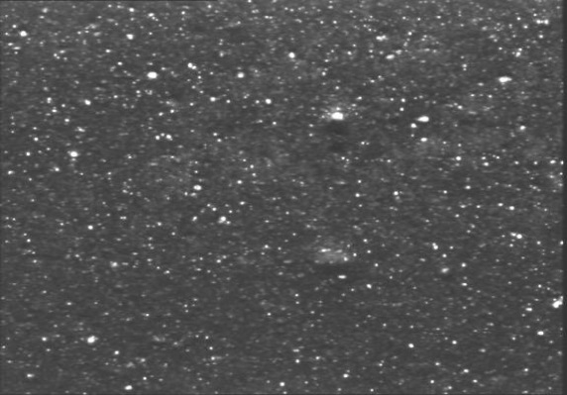  1 | 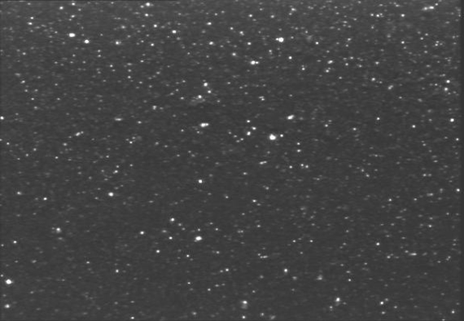  2
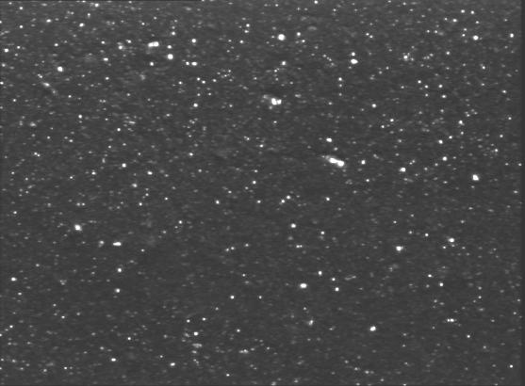  3 | 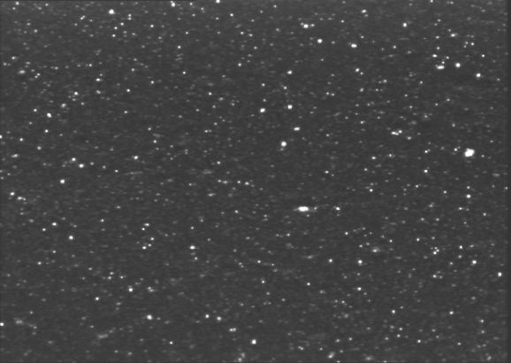  4

Figure 1. Filler dispersion image of filled ENR vulcanizates with dual fillers

Table 7: Filler dispersion properties of ENR/Silica compounds with coupling agent

Parameter |  | Vulcanizates
 | Control | Mix 1(Final stage) | Mix 2 (First stage)
Avg. Ag. Size, micron | 13.0 ± 0.3 | 13.5 ± 0.5 | 13.1 ± 0.4
Dispersion, % | 83.3 ± 0.5 | 84.3 ± 1.7 | 85.8 ± 2.6

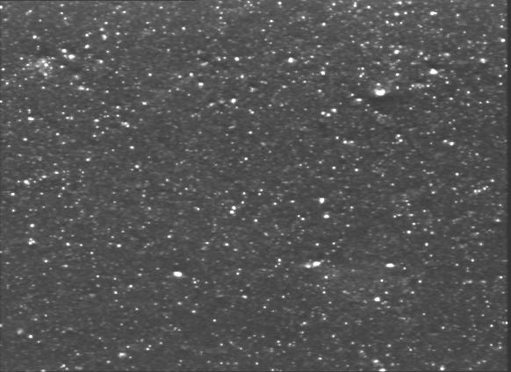  Control | 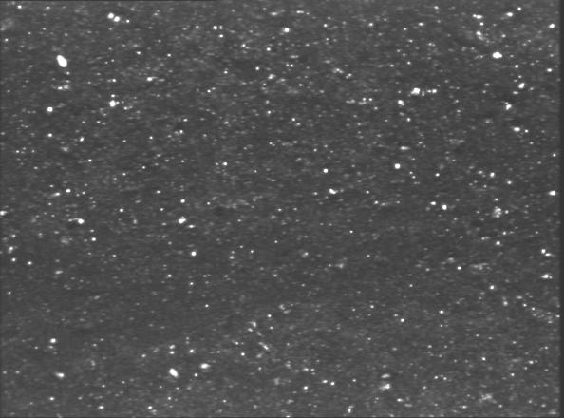  1
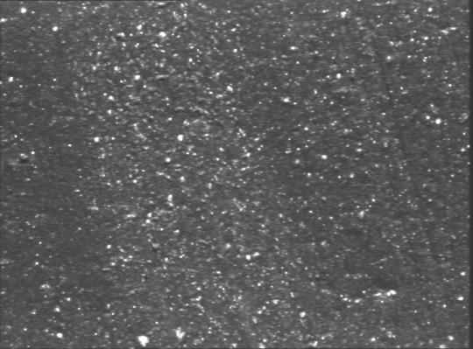
2

Figure 2. Filler dispersion image of ENR/silica vulcanizates with coupling agent

Physical Properties
The physical properties of filled ENR vulcanizates with dual fillers and ENR vulcanizates with coupling agent are shown Table 8 and Table 9 respectively. The results of ENR vulcanizates with dual fillers indicate that the properties are affected by the carbon black filler loading. In general, the tensile strength, hardness and abrasion resistance increased and improved with black loading [7]. Hence greater rubber filler interaction was possible responsible for this phenomenon as silica and carbon black posses different type of surface activity. The extremely high dispersive component in carbon black means that carbon black exhibit stronger interaction with non polar or low polar segment in ENR backbone. On the other hand, the very high specific surface energy for silica indicates there will be a strong interaction with polar segments of ENR [8]. Hence a mixed filler system is possible to enhance the rubber filler interaction and adhesion. As for ENR compounds with Si69 coupling agent, the results showed that tensile strength, hardness and abrasion resistance slightly improved with addition of coupling agent with Mix 1 which the mixing of Si69 was done in final stage of mixing gave the best physical properties as compared to control mix (without coupling agent). This silane coupling agent leads to a reduction of the silica-silica network during mixing and hence improved process ability and filler dispersion which could be the reason of this better physical properties result.
Table 8. Physical properties of filled ENR compounds with dual fillers

Properties Vulcanizates
 | 1 (5phr) | 2 (10phr) | 3 (15phr) | 4 (20phr)
Tensile Strength, MPa | 21.5 ± 2.0 | 22.8 ± 1.7 | 23.8 ± 2.1 | 25.8 ± 1.0
Hardness (IRHD) | 62.0 ± 0.8 | 63.0± 0.9 | 66.0± 0.4 | 67.0 ± 0.4
Abrasion Resistant Index , % | 86.7 | 91.8 | 91.7 | 90.8

Table 9. Physical properties of filled ENR/silica compounds with coupling agent

Properties Vulcanizates

 | Control | Mix 1(Final stage) | Mix 2 (First stage)
Tensile Strength, MPa | 20.3 ± 2.5 | 22.7 ± 1.7 | 18.5 ± 0.7
Hardness (IRHD) | 62.0 ± 0.8 | 65.0 ± 0.7 | 68.0 ± 0.8
DIN Abrasion Resistant Index , % | 79.3 | 104.6 | 104.9

Conclusion
From the observations and results obtained in this study, it can be deduced that the tensile strength, hardness and Mooney viscosity of ENR compound with dual fillers improved with increasing carbon black filler loading. However the abrasion and filler dispersion properties, an optimum value was found at 10phr of carbon black loading. For ENR/silica compound with addition of Si69 coupling agent, the tensile strength, hardness and Mooney viscosity was slightly improved and mixing coupling agent in the final stage gave the best physical properties as compared to control mix.

Acknowledgement
The author would like to thank the management of the Malaysian Rubber Board (MRB) for the permission to carry out this study. The assistance from Advanced Rubber Technology Unit officers and staff are gratefully acknowledged.

References

- Gerster, M, Fagouri, C. and Peregi, E. (2010). Novel Coupling Agents For Silica-filled Rubbers with Superior Processing Safety and Improved Hysteresis of the Vulcanizates. Tire Science and Technology 38(1): 80-98.
- Ou Y.-C., Yu Z.-Z., Vidal A., Donnet J.B., (1994). Effect of Alkylation of Silica Filler and Rubber Reinforcement. Rubber Chem. Technol. 67: 834 – 844.
- Brydson, J. A. (1981). Flow Properties of Polymer Melts, 2nd Ed., London: George Godwin.
- Wood, A. K., Read, A. G. G. and Lovegrove, J. G. A. (1989). Effect of Rheometer Design on the Measurement of the Flow Properties of Polymer Melts. Rubber Process Appl 12(1): 15-20.
- ISO 289-1.(2005).Determinations Using a Shearing Disc Viscometer-Part 1: Determination of Mooney Viscosity, International Organisation for Standardisation.
- Azemi Samsuri. (2009) An Introduction to Polymer Science and Technology, UPENA UiTM.:166-169.
- Meng-Jiao W., Phing Z. and Khalid M. (2000). Carbon-Silica Dual Phase Filler, A New Generation Reinforcing Agent for Rubber Part IX, Application to Truck Tire Tread Compound. Rubber Division, ACS, Dallas, Texas; April 4 – 6.
- Chanvoot K. and White J. L. (2000). Comparison of Intermeshing Rotor and Traditional Rotors of Internal Mixers in Dispersing Silica and Other Fillers. Journal of Applied Polymer Science.78: 1551–1554.

