SYNTHESIS AND CHARACTERIZATION OF 5,5,7,12,12,14-HEXAMETHYL-1,4,8,11-TETRAAZACYCLOTETRADECA-7,14-DIENIUM DIPERCHLORATE COPPER(II) COMPLEX

(Sintesis dan Pencirian Kompleks Di(Perklorat) 5,5,7,12,12,14-Heksametil-1,4,8,11-Tetraazasiklotetradeka-7,14-Dienium Kuprum(II))

Nur Hasyareeda Hassan*, Noorhanani M Ali, Bohari M Yamin, Nurul Huda Abd Karim, Noor Azlina Abd Ghani

School of Chemical Sciences and Food Technology,
Faculty of Science and Technology,
Universiti Kebangsaan Malaysia, 43600 UKM Bangi, Selangor Darul Ehsan.

*Corresponding author: syareeda@ukm.edu.my

Abstract
In this study, 5,5,7,12,12,14-hexamethyl-1,4,8,11-tetraazacyclotetradeca-7,14-dienium diperchlorate copper(II) complex was successfully synthesized by reacting macrocyclic tetraaza perchlorate with copper(II) acetate monohydrate in 1:1 ratio. The metal complex was characterized by variety of physicochemical techniques such as melting point, CHN elemental analysis, metal content, ultraviolet-visible spectroscopy, infrared spectroscopy, single crystal X-ray diffraction, thermogravimetric analysis, mass spectrometry and magnetic susceptibility. The infrared spectrum of complex showed four main peaks for v(N-H), ν(C-H), v(C=N) and ν(C-N) bands that appeared in the region of 3432, 2975, 1670 and 1088 cm⁻¹ respectively. X-ray single crystal structure showed a four-coordination geometry around the copper atom adopting a monoclinic system with a space group P/2c, unit cell dimension with a = 26.8271(17) Å, b = 7.8778(5) Å and c = 17.9908(12) Å; α = 90º, β = 99.05º and γ = 90º. The value of μ_{eff} (B.M) for copper (II) complex in the range of 1.23-2.21 B revealed that the complex was square planar geometry.

Keywords: one-pot synthesis, tetraaza macrocycles, copper (II) complex

Abstrak
Dalam kajian ini, kompleks 5,5,7,12,12,14-heksametil-1,4,8,11-tetraazasiklotetradeka-7,14-dienium diperklorat kuprum(II) telah berjaya disintesis hasil tindak balas makrosiklik tetraaza perklorat dengan kuprum(II) asetat monohidrat dengan nisbah 1:1. Kompleks yang terhasil dicirikan dengan pelbagai teknik fizikokimia seperti takat lebur, analisis unsur CHN, kandungan logam, spektroskopi ultra lembayung boleh nampak, spektroskopi inframerah, kristalografi sinar-X, analisis termogravimetri, spektrometri jisim dan penetapan kerentanan magnet. Spektrum inframerah kompleks menunjukkan terdapat empat jalur ν(N-H), ν(C=N), ν(C-H) dan ν(C-N) yang masing-masing wujud pada julat 3483-3151, 1668-1648, 2984-2917 dan 1292-1025 cm⁻¹. Struktur hablur tunggal sinar-X menunjukkan atom pusat kuprum berkoordinat empat dan hablur mempunyai sistem monoklinik dengan kumpulan ruang P/2c, dengan dimensi a = 26.8271(17) Å, b = 7.8778(5) Å dan c = 17.9908(12) Å; α = 90º, β = 99.05º dan γ = 90º. Nilai μ_{eff} (B) untuk kompleks kuprum(II) berada pada julat 1.7-2.2 B.M menunjukkan bahawa kompleks ini mempunyai geometri satah persegi empat.

Kata kunci: sintesis satu bikar, makrosiklik tetraaza, kompleks kuprum (II)

Introduction
Synthesis of tetraaza macrocyclic ligands developed by Curtis in the 1960s opened a field with great possibilities in preparative chemistry [1]. There is a great interest in the area of synthesis and characterization of transition metal complexes with tetraaza macrocyclic ligands in recent years. However, metal template reactions have been employed in the preparation of various tetraaza macrocyclic complexes where the transition metal ion was used as a templating agent to yield the metal complexes directly [2,3]. In this study, we aimed to synthesize the 5,5,7,12,12,14-hexamethyl-1,4,8,11-tetraazacyclotetradeca-7,14-dienium salt as ligand before its conversion to transition metal complex. The success of finding a new method for synthesizing the ligand provide an opportunity to apply the same reaction using a variety of different metal ions and could yield a higher yield
compared to the metal template reaction. Cu (II) is the most studied metal ion among all the transition metal ions [4,5]. Therefore, we decided to synthesis copper(II) complex from 5,5,7,12,12,14-hexamethyl-1,4,8,11-tetraazacyclotetradeca-7,14-dienium diperchlorate salt as ligand in 1:1 ratio. The reaction is simple, cheap and also high yielding. In this paper, we report the synthesis, characterization and properties of 5,5,7,12,12,14-hexamethyl-1,4,8,11-tetraazacyclotetradeca-7,14-dienium diperchlorate ligand and 5,5,7,12,12,14-hexamethyl-1,4,8,11-tetraazacyclotetradeca-7,14-dienium diperchlorate copper(II) complex. The structure of ligand and its complex have been characterized by elemental analysis (CHN), Fourier transform infrared (FTIR), ultraviolet-visible spectroscopy, thermogravimetric analysis, single crystal X-ray diffraction, mass spectrometry, melting point and room temperature magnetic moment.

Materials and Methods
Chemicals
Ammonium perchlorate, ethylenediamine, copper (II) acetate monohydrate and all other reagents were purchased from Sigma-Aldrich and Friendemann Schmidt. All chemicals were of the analytical reagent grade (AR) and used without purification.

Physical measurement
Microelemental analyses were conducted using Thermo-Finnigan Flash EA 1112 Elemental Analyzer. IR spectra were recorded on KBr discs using FTIR Perkin-Elmer GX model in the spectral range of 4000-400 cm⁻¹. The metal content of the copper (II) complex was determined by atomic absorption technique using Perkin-Elmer AAnalyst 800 AA spectrometer. Magnetic susceptibility was measured using Sherwood Magnetic Susceptibility Balance (Auto) at room temperature. Melting point was measured by using Barnsted Electrothermal Melting Point IA9100 series. A single-crystal X-ray diffraction investigation was performed on Bruker D8 QUEST ECO with CMOS detector. The electronic spectrum of the complex in water was recorded on Shimadzu UV-2450 and mass spectrometry was carried out using Bruker MicroTof Q Mass Spectrometer. Thermogram was obtained by using a Matter Toledo TGA/SDTA 851 instrument under N₂ atmosphere with a flow rate of 20 mL min⁻¹, in the temperature range of 0 to 600 ºC, at the heating rate of 10 ºC min⁻¹.

Synthesis of macrocyclic tetraaza perchlorate, C₁₆H₃₄N₄(ClO₄)₂
Ethylenediamine (0.01 mol) was added drop wise to a stirring acetone solution (40 mL) of ammonium perchlorate (0.01 mol). The solution mixture was stirred for 20 minutes. The solution was allowed to slowly evaporate at room temperature, upon which a precipitate was obtained. The resulting precipitate was collected by filtration, washed several times with acetone and dried overnight in a desiccator. Schematic representation of the reaction for synthesis of macrocyclic ligand, C₁₆H₃₂N₄(ClO₄)₂ is shown in scheme 1.

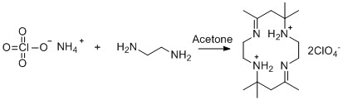

Scheme 1. Synthetic route of macrocyclic ligand

Synthesis of 5,5,7,12,12,14-hexamethyl-1,4,8,11-tetraazacyclotetradeca-7,14-dienium diperchlorate copper(II) complex, C₁₆H₃₂N₄OCu(ClO₄)₂
The ligand, (0.001 mol, 0.48 g) was dissolved in acetonitrile (10 mL). Copper (II) acetate monohydrate (0.001 mol, 0.20 g) was dissolved separately in acetonitrile (10 mL) and was then added into the beaker containing the ligand solution. The mixture was stirred for 30 minutes at 45 ºC and filtered. The solution was allowed to slowly evaporate at room temperature, upon which a precipitate was obtained. The solid product was filtered off, washed several times with ethanol and dried overnight in a desiccator. Schematic representation of the reaction for synthesis of copper (II) complex, C₁₆H₃₄N₄OCu(ClO₄)₂ is shown in Scheme 2.

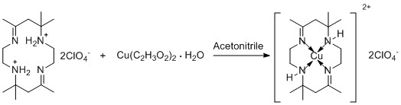

Scheme 2. Synthetic route of copper(II) complex

Result and Discussion
Physical and Elemental Analysis (C, H, N)
The ligand was obtained as white solid in 77.60% yield while the complex was synthesized in the form of a purple solid in 71.02% yield and is soluble in water and most of organic solvents. Micro elemental analysis of carbon, hydrogen and nitrogen were carried out in order to determine the elemental content of the synthesized compounds. Based on Table 1, the difference in percentage value of each element’s content in the complex obtained with the theoretical value is within ±2 percent. These small differences proved that the complex is pure. The result of this analysis also proved that the stoichiometric ratio of metal to ligand for the complex is 1:1. The melting point of ligand was below 200 °C while for the complex was above 200 °C. This suggested that the compound were stable in air and moisture.

Table 1. Analytical data and physical properties of macrocyclic ligand and its complex

Compound | Colour | Yield (%) | Melting Point (ºC) | Elemental Analysis
 |  |  |  | C | H | N | Cu
C₁₆H₃₄N₄(ClO₄)₂ | White | 77.60 | 165.9-166.4 | 39.84  39.92 | 8.23  7.07 | 13.42  11.64 | -
C₁₆H₃₂N₄OCu(ClO₄)₂ | Purple | 71.02 | 290.2-290.4 | 33.82  34.26 | 8.49  6.83 | 9.95  9.99 | 12.46  11.34

Mass Spectrometry
The Electrospray ionization mass spectrometry (ESI-MS) was carried out in order to confirm the composition and the purity of the complex under investigation. Besides that, ESI-MS can provide important information concerning the structure, stoichiometry, and metal oxidation state of dissolved metal complexes which are otherwise hardly obtained by electrochemical or spectroscopic techniques [6]. Figure 1 shows representative mass spectra of a solution containing copper (II) complex measured by ESI-MS. In the ESI mass spectrum, two groups of peaks corresponding to [CuL - 2H + ClO₄]⁺ and [CuL - 2H]⁺ fragments are observed at m/z 442.14 and 342.18, respectively. These assignments are based on ⁶³Cu.

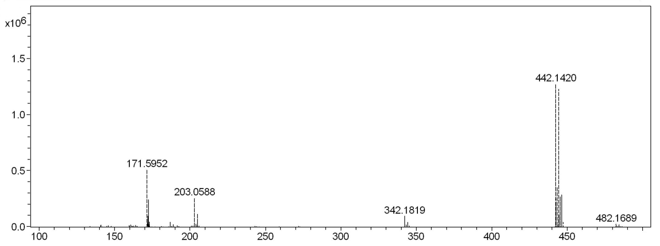
500
m/z
Intensity

Figure 1. ESI mass spectrum of copper (II) complex

Infrared Spectroscopy
Infrared spectroanalysis was carried out in order to determine the functional group of the synthesized compounds. Figure 2 shows FTIR spectra of macrocyclic ligand and its complex. IR spectra of macrocyclic ligand and its complex exhibited absorption bands due to stretching vibrations of some functional groups such as amine, N-H; alkanes, C-H; azomethine, C=N and imine, C-N. The IR spectra of macrocyclic ligand and its copper (II) complex confirmed the expected C=N band at 1667 cm⁻¹ and 1670 cm⁻¹ respectively. The expected frequency of ν(C-H) and ν(C-N) were observed at 2981-2975 cm⁻¹ and 1088-1079 cm⁻¹, respectively. There was also the presence of perchlorate ion peak, ClO₄⁻ for both spectra at 624-623 cm⁻¹. The free ligand spectrum exhibit a characteristic splitted band in the 3466-3407 cm⁻¹ range which is assigned to ν(NH₂). The appearance of a single band at a lower frequency, 3432 cm⁻¹ in the copper (II) complex spectrum indicated the complexation of the macrocyclic ligand. Futhermore, the formation of copper (II) complex can be confirmed by the presence of new band in the low frequency at 446 cm⁻¹ which assignable to ν(Cu-N) band [7]. The comparison infrared spectroscopy data for the macrocyclic ligand and its complex is shown in Table 2.

Table 2. IR absorption peaks of macrocyclic ligand and copper(II) complex

Compound | FTIR - wavenumbers (cm⁻¹)
Compound | ν (N-H) | ν (C-H) | ν (C=N) | ν (C-N) | ν (ClO₄⁻) | ν (Cu-N)
C₁₆H₃₄N₄(ClO₄)₂ | 3466-3407 | 2981 | 1667 | 1079 | 623 | -
C₁₆H₃₂N₄OCu(ClO₄)₂ | 3432 | 2975 | 1670 | 1088 | 624 | 446

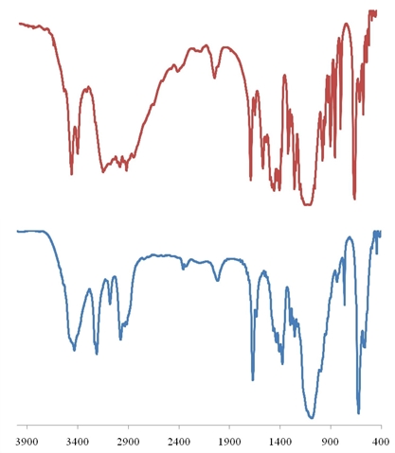
}
C-N
M-N
ClO₄⁻

C-H
ClO₄⁻
C-N
C=N
C-H
N-H

C=N
N-H
(b)
Transmittence / a.u.
(a)
Wavenumber / cm⁻¹

Figure 2. The FTIR spectra of (a) macrocyclic ligand and (b) copper(II) complex

Electronic Spectral Anaysis
The UV-Vis spectra of macrocyclic ligand and its complex are depicted in Figure 3 and 4. The characteristic absorption peak of macrocyclic ligand occurred at 241.5 nm (Fig. 3) is associated with high energy π → π* transition of the ligand [8]. The UV-Vis for the copper II) complex was repeated at higher concentration because of a great difference in molar absorptivity. Therefore, the copper (II) complex showed a broad and very strong band in the visible region at 505 nm (Fig. 4) corresponding to a d–d transition. This band may be assigned to ²B_{1g} → ²B_{2g} transition which indicated the square planar geometry around the Cu (II) ion [9]. Spectroscopic data for macrocyclic ligand and copper (II) complex is shown in Table 3.

Table 3. Spectroscopic data for macrocyclic ligand and copper (II) complex

Compound | Concentration (mol.L⁻¹) | λ_{max} (nm) | Wavenumber (cm⁻¹) | ԑ
C₁₆H₃₄N₄(ClO₄)₂ | 0.001 | 241.5 | 4.14x10⁴ | 1068.0
C₁₆H₃₂N₄OCu(ClO₄)₂ | 0.010 | 505.0 | 1.98x10⁴ | 117.9

Figure 3. Absorption spectra of macrocyclic ligand at 0.001 mol.L⁻¹

b) 505.0 nm
a) 505.5 nm

Figure 4. Absorption spectra of copper (II) complex (a) at 0.001 mol.L⁻¹, (b) at 0.01 mol.L⁻¹
Magnetic Susceptibility Determination
The magnetic moment data has been found to be helpful for identifying the number of unpaired electron and determining the geometry of the complexes. The effective magnetic moment is calculated from the molar susceptibility, χ_{m} since the magnetic moment cannot be measured directly. The molar susceptibility of copper (II) complex is measured in order to determine the spin properties of the complex [10].

The magnetic moment of the copper (II) complex was found to be in the range of 1.23-2.21 B.M, which is 1.92 B.M and it’s corresponded to the one unpaired electron [11]. The complex is paramagnetic, as expected for complex of metal ion with a d⁹ configuration and agrees with the square planar geometry around the copper (II) ion.

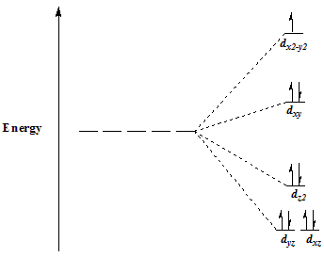

Figure 5. Crystal field diagram of square planar copper (II) complex

Thermal Analysis
The thermogravimetric analysis of the macrocyclic ligand and copper (II) complex were recorded under nitrogen atmosphere at the heating rate of 10 °C/min. Figure 6 shows thermograms for both compounds. Both macrocyclic ligand and the copper (II) complex decomposed in a single step but in a different way. The macrocyclic ligand was stable up to 150 °C and showed a slow weight loss up to 240 °C. A major step of decomposition occurred from 245 °C to 255 °C. On the other hand, the thermogram of copper (II) complex suggested that the metal complex was more stable than the macrocyclic ligand since it started to decompose at 290 °C. It showed only a single major decomposition curve in the region 280 °C to 300 °C corresponding to the loss of organic moiety. In term of stability, both compounds are stable for analytical test done at room temperature since their decomposition occurs at a temperature around 150 °C to 550 ºC. Thermogravimetric analysis data of macrocyclic ligand and copper (II) complex are given in Table 4.

Table 4. Thermogravimetric analysis data of macrocyclic ligand and copper (II) complex

Compound | Temperature (ºC) | Final residue (%)
C₁₆H₃₄N₄(ClO₄)₂ | 150-245, 245-255 | 10.0
C₁₆H₃₂N₄OCu(ClO₄)₂ | 280-300 | 5.8

(b)
(a)

Figure 6. TGA curve for (a) macrocyclic ligand and (b) copper (II) complex

X-ray Crystallography
Crystal structure of copper (II) complex, C₁₆H₃₂N₄OCu(ClO₄) (Fig. 7) agreed with the data obtained from elemental analysis, infrared spectroscopy, ultraviolet spectroscopy, magnetic susceptibility and thermogravimetric analysis. The structure of copper (II) complex was determined in a single crystal X-ray diffraction study. Copper atom formed a tetradentate coordination with macrocyclic C₁₆H₃₄N₄(ClO₄)₂ through four nitrogen atoms. This dicationic complex is offset by two perchlorate anions. X-ray single crystal structure showed a square planar geometry and monoclinic system with a space group P/2c, unit cell dimension with a = 26.8271(17) Å, b = 7.8778(5) Å and c = 17.9908(12) Å; α = 90º, β = 99.05º and γ = 90º. The crystallographic data and some features of the structure refinements are listed in Table 5.

Table 5. Details of crystallographic data collection and structure refinement parameters

State | Data
Empirical formula | C16 H32 Cl2 Cu N4 O9
Formula weight | 1145.84
Temperature | 296(2) K
Wavelength | 0.71073 Å
Crystal system, space group | Monoclinic
Unit cell dimensions | a = 26.8271(17) Å α = 90º  b = 7.8778 (5) Å β = 99.049(2)º  c = 17.9908(12) Å γ = 90º
Volume | 3754.8(4) Å³
Z, calculated density | 3, 1.520 Mg/m³
Absorption coefficient | 1.140 mm⁻¹
F(000) | 1798
Crystal size | 0.20 x 0.20 x 0.06 mm³
Theta range for data collection | 3.008 to 25.500º
Limiting indices | -32<=h<=32, -9<=k<=9, -21<=l<=21
Reflections collected / unique | 111547 / 6974 [R(int) = 0.2366]
Completeness to theta = 25.242 | 99.8%
Refinement method | Full-matrix least-squares on F²
Data / restraints / parameters | 6974 / 10 / 489
Goodness-of-fit on F^2 | 1.061
Final R indices [I>2sigma(I)] | R1 = 0.0689, wR2 = 0.1547
R indices (all data) | R1 = 0.1325, wR2 = 0.1914
Largest diff. peak and hole | 0.968 and -0.609 e.Å⁻³

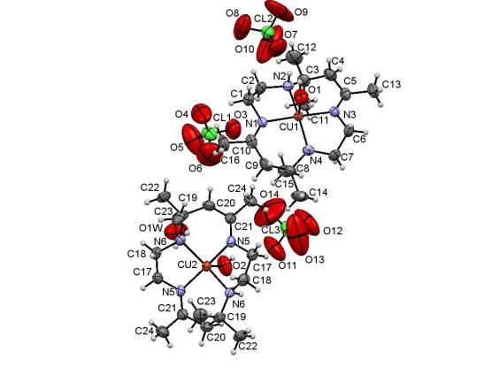

Figure 7. ORTEP plot of C₁₆H₃₂N₄OCu(ClO₄)₂

Conclusion
To conclude, we have successfully synthesized and fully characterized copper (II) complex containing macrocyclic tetraaza, C₁₆H₃₄N₄(ClO₄)_{2.} Mass spectrum under ESI-condition was in agreement with the elemental analysis, confirming the composition and purity of the Cu (II) complex. Based on the magnetic moment and electronic spectral studies, we assumed that the copper (II) complex exhibits a square planar geometry. X-ray crystallography showed macrocyclic ligand behaves as a bidentate chelating ligand which binds with the metal ion through azomethine and imine nitrogen.

Acknowledgement
The authors would like to thank Faculty of Science and Technology, Universiti Kebangsaan Malaysia for the provision of laboratory facilities and lab assistance are equally helpful in making this work. The authors also gratefully acknowledge the research grant from GGPM2013-038 and ETP2013-027.

References
- Curtis, N. F., House, D. A. (1961). Chemistry and Industry, 1708.
- Farha, F., Kaneez, F., Mohammad, A., Shahper, N. K., Asad, U. K., Mohammad, S. (2009). Template synthesis and physico-chemical characterization of 14-membered tetraimmine macrocyclic complexes, [MLX₂][M=Co(II), Ni(II), Cu(II) and Zn(II)]. DNA binding study on [CoLCl₂] complex. Spectrochimica Acta, 72(3), 591-596.
- Mohammad, S., Hamida, T. N. C., Poonam, C. (2006). Metal ion-directed synthesis of 16-membered tetraazamacrocyclic complexes and their physico-chemical studies. Spectrochimica Acta, 64, 512-517.
- Ajibade P.A., Zulu N.H. (2011). Metal complexes of diisopropylthiourea : Synthesis, characterization and antibacterial studies. Int. J. Mol. Sci, 12, 7186-7198.
- Reddy P.M., Prasad A.V.S.S., Ravinder V. (2007). Synthesis, spectral characterization, catalytic and antibacterial activity of macrocyclic CuII compounds. Transit. Met. Chem, 32, 507–513.
- Atsushi M., Takao F., Hiroshi A., Hitoshi W. (1999). Electrospray ionization mass spectrometry of metal complexes. Gas phase formation of a binuclear copper (II)–5-Br-PADAP complex. Analytical Chimica Acta, 390(1-3), 193-199.
- Abdalla M. K., Hadi M.M. (2012). Synthesis, spectral, thermal analyses and molecular modeling of bioactive Cu(II)-complexes with 1,3,4-thiadiazole Schiff base derivatives. Their catalytic effect on the cathodic reduction of oxygen. International Journal of Electrochemical Science, 7, 10074 – 10093.
- Raziyeh A.A., Farshideh H., Giuseppe B., Hadi A.R. and Saeid A. (2013). Synthesis, spectroscopy, and magnetic characterization of copper (II) and cobalt(II) complexes with 2-Amino-5-bromopyridine as ligand. ISRN Inorganic Chemistry.
- Reddy P.M., Rohini R., Krishna E.R., Hu A. and Ravinder V. (2012). Synthesis, spectral and antibacterial studies of copper (II) tetraaza macrocyclic complexes. Int. J. Mol. Sci, 13(4), 4982–4992.
- Manan M.F., Kassim K. and Manan A.F. (2012). Synthesis, characterization and conductivity studies of Schiff base ligand derived from isatin and O-Phenylenediamine with cobalt (II) metal complex and lithium-Schiff base compound. The Malaysian Journal of Analytical Sciences, 16(3), 318 – 324.
- Halim N.I., Kassim K., Fadzil A.H., Yamin B. (2012). Synthesis, characterization and antibacterial studies of Cu (II) complexes hiourea. The Malaysian Journal of Analytical Sciences, 16(1), 56-61.

