EFFECT OF GAMMA RADIATION ON AMINO ACID BASED VESICLE CARRYING RADIOSENSITIZER

(Kesan Sinaran Gama ke atas Vesikel berasaskan Asid Amino yang membawa Pemeka Sinaran)

Nur Ratasha Alia Md. Rosli, Faizal Mohamed*, Muhammad Amir Syafiq Md. Sah, Irman Abdul Rahman

School of Applied Physics, Faculty of Science and Technology

Universiti Kebangsaan Malaysia, 43600 Bangi

*Corresponding author: faizalm@ukm.edu.my

Abstract

Vesicles has been developed and studied to be used as a medium to transport radiosensitizer in treating cancer cells by increasing its sensitivity effectively towards the radiation given during radiotherapy. This study was conducted to investigate the effect of gamma radiation on amino acid-based vesicle carrying radiosensitizer. Amino acid based vesicles carrying radiosensitizer were synthesized using sonication method with sodium N-lauroylsarcosinate hydrate and decanol being the primary surfactant, while hydrogen peroxide and sodium hyaluronate as the encapsulated radiosensitizer. The synthesized vesicle was then irradiated at radiation doses equilvalent to those given during radiotherapy. Irradiated vesicle carrying radiosensitizer were then characterized using Transmission Electron Microscopy (TEM), Fourier Transform Infrared Spectroscopy (FTIR) and Polarized Light Microscope. Results obtained shows that there were no significant changes in morphology and molecular conformation of the synthesized vesicle after irradiation. Even at higher radiation dose of 100 Gray and 200 Gray , the results remained unchanged. This indicates that the synthesized vesicle carrying radiosensitizer is morphologically and spectroscopically stable even at high radiation doses.

Keyword: Amino acid based Vesicle, Radiosensitizer, Radiation, Radiotherapy, Cancer

Abstrak

Vesikel telah dihasilkan dan dikaji sebagai medium untuk membawa pemeka sinaran dalam merawat kanser secara berkesan dengan meningkatkan kesensitifan sel kanser terhadap sinaran yang diberi ketika rawatan radioterapi. Kajian ini dijalankan untuk mengkaji kesan sinaran gama ke atas vesikel berasaskan asid amino yang membawa pemeka sinaran. Vesikel berasaskan asid amino yang membawa pemeka sinaran telah disintesis menggunakan kaedah sonikasi dengan natrium N-lauroylsarcosinat hidrat dan dekanol sebagai sufaktan utama, manakala hidrogen peroksida dan natrium hialuronat sebagai pemeka radio yang dikapsulkan. Vesikel yang disintesis telah disinarkan dengan dos sinaran yang setara dengan dos yang diberi ketika rawatan radioterapi. Pencirian telah dilakukan ke atas vesikel membawa pemeka sinaran yang disinarkan menggunakan Mikroskopi Elektron Transmisi (TEM), Spektroskopi Inframerah Transformasi Fourier (FTIR) dan Mikroskop Cahaya Polarisasi. Hasil kajian menunjukkan bahawa tiada perubahan yang signifikan dari segi morfologi dan konformasi molekul vesikel membawa pemeka sinaran setelah disinar. Walaupun disinarkan pada dos sinaran 100 Gray dan 200 Gray, hasilnya tetap sama. Ini menunjukkan bahawa vesikel membawa pemeka sinaran yang disintesis adalah stabil dari segi morfologi dan spektroskopi terhadap sinaran walaupun dos sinaran yang tinggi telah diberikan.

Kata kunci: Vesikel berasaskan Asid Amino, Pemeka Sinaran, Sinaran, Radioterapi, Kanser

Introduction

Non ionic surfactant vesicle, also known as niosomes, are closed bilayer structures formed from the self-assembly of non ionic amphiphiles in aqueous medium [1]. Through its bilayer structure, vesicles has the ability to encapsulate hydrophilic drugs in its aqueous core and hydrophobic drugs in its membrane [2, 3]. Niosomes possess several advantages in the form of chemical stability, lower cost and availability of material in comparison with conventional liposome vesicles [4]. Thus there has been an increase of interest in studying and developing niosomes as a tool for drug delivery [5]. Recently, a biodegradable and biocompatible niosome was developed from an amino acid based biosurfactant Sodium N-lauroylsarcosinate Hydrate [6]. The vesicle was proven to have good characteristics and potential as a drug deliverer or carrier [6]. Due to this, studies on the ability of this niosome to encapsulate radiosensitizer was conducted.

Radiosensitizer are chemotherapeutic agents that have been developed to increase the therapeutic effect of radiation treatment by increasing the sensitivity of cancer cells towards radiation [7-10]. In 2011, a combination of radiosensitizers, Hydrogen Peroxide and Sodium Hyaluronate, has been developed and proven clinically to give promising results in treating cancer patients who undergoes radiotherapy. These radiosensitizer not only inactivates anti-oxidative enzymes but also produces oxygen from the degradation mechanism of hydrogen peroxide, resulting hypoxic tumor being reoxygenated [11-12]. Thus cancer cells becomes more sensitive towards radiation. But because of the rapid degradation of Hydrogen Peroxide, the delivery of the radiosensitizers via intratumoral injection causes patient to experience local pain at the injection site [11-12] and may also cause complications such as pulmonary embolism [11]. Thus, studies on the ability of amino acid based vesicle loaded with these radiosensitizers was conducted so that the drug therapeutic index could be increased while reducing the toxicity of the drug. In line with this study, the effect of gamma radiation on amino acid based vesicle carrying radiosensitizers was also studied

Materials and Methods

Materials

Sodium N-lauroylsarcosinate Hydrate and Sodium Hyaluronate with 95% purity were purchased from Acros Organics (New Jersey, United States of America), 1-decanol with 97% purity was purchased from Fluka-Chemical (Switzerland) and Hydrogen Peroxide with 30% purity was purchased from Friendemann Schmidt Chemical (Germany). Deionised water was used to prepare all of the samples.

Synthesis of Radiosensitizer

The radiosensitizing agent used in this study was synthesized according to the method previously reported by Ogawa and Tokuhiro [11-12] with several modifications. Stock solutions of 1% w/v Sodium Hyaluronate and 3% w/v Hydrogen Peroxide were prepared with deionised water. The radiosensitizing agent was synthesized by mixing 3% w/v Hydrogen Peroxide solution with 1% w/v Sodium Hyaluronate at a mixing ratio of 1:5. The mixed agent was then vortex for 3 minutes to achieve homogeneity. Hydrogen Peroxide was added just before in use in order to avoid the degradation of Sodium Hyaluronate by the oxidative effect of Hydrogen Peroxide [11].

Synthesis of Amino Acid based Vesicles

Amino acid based vesicles (AABV) were prepared according to the sonication method as previously reported by Akter [6] with several modifications. Sodium N-lauorylsarcosinate Hydrate and 1-decanol was added in a test tube at a molar ratio of 1:2. Then 92 wt% of deionised water was added in the test tube and the resulting suspension was sonicated at 60°C for 10 minutes using a bath sonicator. The mixture was then vortex for 5 minutes to obtain microemulsion. The mixture is centrifuged for 4000 rpm for 10 minutes to obtain phase separation.

Preparation of Amino Acid based Vesicles carrying Radiosensitizer

Amino acid based vesicles carrying radiosensitizers (AABVRS) were prepared in the same protocol as in the control vesicles. However, prior to the additon of sodium n-lauroylsarcosinate hydrate and 1-decanol in the test tube, the prepared radiosensitizers was mixed with 1-decanol at a ratio of 1:1 and vortex for 3 minutes. This allows the radiosensitizer to form a complex with 1-decanol and thus physically be encapsulated in the vesicle.

Irradiation of Amino Acid based Vesicles carrying Radiosensitizer

The synthesized amino acid based vesicle carrying radiosensitizer samples were then irradiated using a GammaCell 220 Excel (MDS Nordion). Radiation doses of 4 Gy, 8 Gy, 12 Gy, 16 Gy and 20 Gy, equivalent to those given during fractionated radiotherapy , were exposed to samples individually.

Characterization

The formation of vesicles were characterized using polarised light microscope (PLM, Leica DM100), while Transmission Electron Microscopy (TEM, FEI Tecnai G2 Spirit BioTwin) was used to characterize the size distribution and morphology of the control and irradiated vesicles. The infrared spectra of the samples were recorded for wavenumbers ranging from 400-4000 cm⁻¹ using a Perkin Elmer Spectrometer 400 FT-IR & Spotlight 400 Imaging System.

Result and Discussion

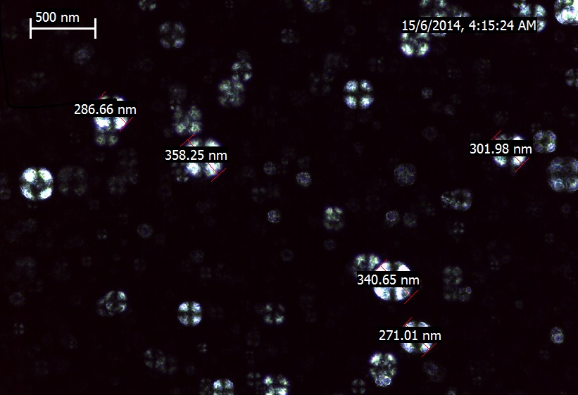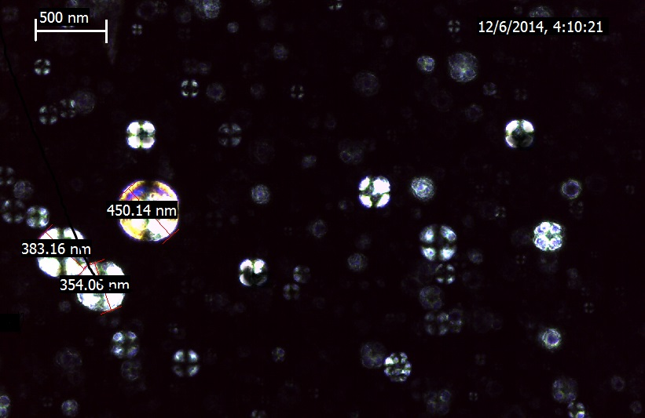
a)
b)
Figure 1. Polarized light microscope images of a) Amino Acid based Vesicles (AABV) and b) Amino Acid based Vesicles carrying Radiosensitizer (AABVRS) indicating vesicle formation through X cross formation
Formation of bilayer vesicle from the self-assembly of non ionic surfactants is characterized by an X cross formation under light polarization microscopy [14]. Based on Figure 1, X cross formation corresponding to the bilayer of the vesicle could be observed for both AABV and AABVRS, confirming the formation of vesicles. Through the use of LAS EZ polarized light microscopy software, AABV has a range of size from 250-360 nm, while AABVRS has a range of size from 350-450 nm. The slight increase of size for AABVRS is attributed by the entrapment of radiosensitizing agent. The physico chemical properties of encapsulated drug influences the charge and rigidity of the niosome bilayer. The drug interacts with surfactant head group and develop the charge that creates mutual repulsion between surfactant bilayers and hence increase the vesicle size. Entrapment of drug in niosomes increases vesicle size due to interaction of drug with surfactant head group, increasing the charge of the surfactant bilayers, thereby increasing the vesicle size [15]. Thus this confirms that the radiosensitizers are entrapped in the vesicles. Due to the fact the radiosensitizers are hydrophilic [16], thus it is presumed that the drug are encapsulated in the aqueous core of the vesicles [2, 3].

b)
a)
c)
e)
f)
d)
Figure 2. TEM images of Amino Acid based Vesicles carrying Radiosensitizer (AABVRS) irradiated at a) 0 Gy, b) 4 Gy, c) 8 Gy, d) 12 Gy, e) 16 Gy and f) 20 Gy.
The morphology of control and irradiated AABVRS could be observed in the TEM images in Figure 2. It could be seen that the vesicle has a spherical morphology which is represented by a bright border surrounding an internal cavity [6]. Even though the AABVRS were irradiated up to 20 Gy, the morphology of the vesicle remained unchanged with no deformation observed. IMAGE J software was used to estimate the average size of control and irradiated AABVRS based on the TEM images. Based on Figure 3, the average size of control and irradiated AABVRS is in the range of 73.05-77.30 nm. The average size of AABVRS viewed by TEM is different with the size of those viewed under PLM. This is due to the fact that PLM has a resolution of 200 nm, whereas TEM with a higher resolution approximately 0.2 nm [17] has the ability to visualize smaller constructs [18] and surpasses vesicles which are larger in size. Through Figure 3, based on the average size of irradiated vesicle with the control, it could be deducted that there is no significant changes in the vesicle size after irradiation.

Figure 3. The average size of Amino Acid based Vesicles carrying Radiosensitizer (AABVRS) after being irradiated at 0 Gy, 4 Gy, 8 Gy, 12 Gy, 16 Gy and 20 Gy.

Figure 4. FTIR spectra of Amino Acid based Vesicles carrying Radiosensitizer (AABVRS) after being irradiated at 0 Gy, 4 Gy, 8 Gy, 12 Gy, 16 Gy, 20 Gy, 100 Gy and 200 Gy.
Figure 4 shows the FTIR spectra of the vesicle in deionised water. Maxima were found at 1656cm⁻¹ which is shifted from a split peak in the surfactant originally at 1640cm⁻¹ and 1648 cm⁻¹ [6]. The shift is attributed by the hydrogen bonding between C=O at the amide group and the alcoholic hydroxyl group. Bound water also contributed to this bonding. This is due to the reduction of hydration due to the addition of decanol [6]. Theoretically, the chemical changes that occur when polymer were irradiated includes cross linking where inter or intra molecular bond is formed, bond scission, formation of carbon carbon double bonds or formation of hydrogen and methane [19]. However based on Figure 4, it could be seen that there is no significant changes on the chemical conformation of the vesicle encapsulating radiosensitizer. Even at higher radiation dose of 100 Gray and 200 Gray, no spectroscopic changes were observed. This suggest that radiation does not affect the chemical property of amino acid based vesicle carrying radiosensitizer.

Conclusion

Through this study, it could be concluded that gamma radiation does not affect the morphology, size and molecular conformation of amino acid based vesicle carrying radiosensitizer. This demonstrates that the vesicle is physically and chemically stable towards ionizing radiation. With this property, the vesicle could be potentially used to encapsulate radiosensitizing drugs delivered during radiation therapy.

Acknowledgement

The authors would like to acknowledge the financial support from UKM in this study, through grant FRGS/1/SG02/UKM/02/1.

References

- Manosroi, A., Chutoprapat, R., Abe, M. & Manosroi J. (2008). Characteristics of niosomes prepared by supercritical carbon dioxide (scCO2) fluid. Int J Pharm, 352 (2):248-255.
- Chu, C., Tong, S.S., Xu, Y., Wang, L., Fu, M., Ge, Y.R., Yu, J.N. & Xu, X.M. (2011). Proliposomes for delivery of dehydrosilymarin: preparation and evaluarion in vitro and in vivo. Acta Pharmacol.Sin. 32(7):973-980.
- Yang, T., Cui, F.D, Choi, M.K., Cho, J.W., Chung, S.J., Shim, C.K. & Kim D.D. (2007). Enhanced solubility and stability of PEGylated liposomal paclitaxel: in vitro and in vivo evaluation. Int. J. Pharm. 338(1-2):317-326.
- Carafa, M., Santucci, E. & Lucania, G. (2002). Lidocaine loaded non ionic surfactant vesicles: characterization and in vitro permeation studies. Int. J. Pharm. 231(1):21-32.
- Nasir, A., Harikumar, S.L. & Amanpreet, K. (2012). Niosome: an excellent tool for drug delivery. International Journal of Research in Pharmacy and Chemistry. 2(2) 479-487.
- Akter, N., Radiman, S., Mohamed, F., Rahman, I.A. & Reza, M.I.H. (2011). Ternary phase behaviour and vesicle formation of a sodium N-lauroylsarcosinate hydrate/1-decanol/water system. Sci. Rep. 1:71
- Wardman, P. (2007). Chemical Radiosensitizers for Use in Radiotherapy. J Clin Oncol. 19(6), 397-417.
- Lawrence, T.S., Blackstock, A.W. & McGinn, C. 2003. The mechanism of action of radiosensitizer of conventionalchemotherapeutic agents. Semin Radiat Oncol, 13(1):13-21.
- Bohm, L., Roos, W.P. & Serafin, A.M. (2003). Inhibition of DNA repair by pentoxifylline and related methylxanthine derivatives. J Toxicol. 193(1-2):153-160.
- Milas, L. (2001). Cyclooxygenase-2 (COX-2) enzyme inhibitors as potential enhancers of tumour radio response. Semin Radiat Oncol. 11(4): 290-299.
- Ogawa, Y., Kubota, K., Ue, H., Kataoka, Y., Tadokoro, M., Miyatake, K., Tsuzuki, T., Yamanishi, T., Itoh, S., Hitomi, J., Hamada, N., Kariya, S., Fukumoto, M., Nishioka, A. & Inomata, T. (2009). Phase I study of a new radiosensitizer containing hydrogen peroxide and sodium hyaluronate for topical tumour injection: A new enzyme-targeting radiosensitization treatment, Kochi Oxydol Radiation Therapy for Unresectable Carcinomas Type II (KORTUC II), Int J Oncol. 34(3), 609-618.
- Tokuhiro, S., Ogawa, Y., Tsuzuki, K., Akima, R., Ue, H., Kariya, S. & Nishioka, A. (2010). Development of a Novel Enzyme-targeting Radiosensitizer (KORTUC) Containing Hydrogen Peroxide for Intratumoral Injection for Patients with Low Linear Energy Transfer-radioresistant Neoplasms, Oncol Lett. 1(6):1025-1028.
- Pollack, A. & Ahmed, M. (2011). Hypofractionation: Scientific Concepts and Clinical Experiences. 1st. Ellicot City: LimiText Publishing.
- Manosroi, A., Wongtrakul, P., Manosroi, J., Sakai, H., Sugawara, F., Yuasa, M. & Abe, M. (2003). Characterisation of vesicles prepared with various non ionic surfactants mixed with cholesterol. Colloids Surf B. 30(1-2):129-135.
- Biswal, S., Murthy, P.N., Sahu, J., Sahoo, P., Amir, F. Vesicles of non ionic surfactants (niosomes) and Drug Delivery Potential. Int J Pharm Sci Nanotech. 1:1-8.
- Necas, J., Bartosikova, L. Brauner, P. & Kolar, J. (2008). Hyaluronic acid (Hyaluronan): a review. Veterinarni Medicina. 8: 397-411.
- Kane J. & Steinheim, M. (1978). Physics. John Wiley and Sons: New York.
- Bibi, S., Kaur, R., Lacey, M.H., McNeil, S.E., Wilkhu, J., Lattaman, E., Christensen, D., Mohammed, A.R. & Perrie, Y. (2011). Microscopy imaging liposomes: From coverslips to environmental SEM. Int. J. Pharm. 417:138-150.
- Utracki, L.A. (2002). Polymer Blends Handbook. Kluwer Academic Publishers: The Netherlands.

