THE CHARACTERIZATION STUDY OF FERRITES (MAGNESIUM AND MANGANESE) USING SOL GEL METHOD
(Kajian Pencirian untuk Ferit (Magnesium dan Mangan) Menggunakan Kaedah Sol Gel)
Rita Sundari¹, Tang Ing Hua², Madzlan Aziz³, Umar Kalmar Nizar⁴
Department of Chemistry, Faculty of Science, University of Technology Malaysia, 81310 Skudai, Johor, Malaysia
*Corresponding author: ritsun2003@yahoo.com
Abstract
A sol gel method with citric acid as an anionic surfactant was used to fabricate nano magnesium ferrites (MgFe₂O₄) and manganese ferrites (MnFeO₃) under different calcination temperatures (300°C, 600°C and 800°C) for 2h, respectively. The Fourier Transformation Infrared (FTIR) spectra of magnesium ferrites showed the formation of tetrahedral and octahedral peaks of the metal oxides, which are getting remarkable after calcination at 300°C because of the volatile matters removal (H₂O, CO₂, NO₂, etc.). The results of the single point Brunauer, Emmett and Teller (BET) method showed a substantial decrease of surface area for both the magnesium and manganese ferrites as the calcinated temperatures getting increased from 300°C to 800°C. The SEM micrograph of the magnesium ferrite showed flake structures at 800°C, and that of manganese ferrite showed granule structures at the same temperature. The results of X-Ray Diffraction (XRD) analysis of magnesium ferrite obtained a range of crystalline sizes from 11 nm to 60 nm, and those of manganese ferrite from 27 nm to 38 nm as the temperatures of both ferrites (magnesium and manganese) increased from 300°C to 800°C. The results of this study are useful for further applications, such as semiconductors, heterogeneous and photo catalysts, magnetic materials and sensors.

Keywords: magnesium and manganese ferrites; calcinations; characterizations.

Abstrak
Kaedah sol gel dengan asid sitrik sebagai anionik surfaktan telah digunakan untuk menghasilkan nano ferit magnesium (MgFe₂O₄) dan ferit mangan (MnFeO₃), di bawah suhu pengkalsinan yang berbeza (300°C, 600°C dan 800°C) untuk 2 jam. Inframerah Transformasi Fourier (FTIR) spektrum bagi ferit magnesium menunjukkan pembentukan puncak tetrahedral dan oktahedral oksida logam yang semakin menonjol selepas proses pengkalsinan pada 300°C, disebabkan penyingkiran jirim mudah meruap (H₂O, CO₂, NO₂, dll). Keputusan kaedah titik tunggal Brunauer, Emmett dan Teller (BET) menunjukkan apabila suhu pengkalsinan semakin meningkat daripada 300°C ke 800°C, luas permukaan turun dengan ketara untuk kedua- dua ferit magnesium dan mangan. Mikrograf SEM ferit magnesium pada 800°C menunjukkan struktur serpihan, dan pada suhu yang sama ferit mangan menunjukkan struktur granul. Keputusan analisis pembelauan X-Ray (XRD) bagi ferit magnesium menunjukkan julat saiz kristal daripada 11 nm hingga 60 nm, dan ferit mangan daripada 27 nm hingga 38 nm, apabila suhu bagi kedua-dua ferit (magnesium dan mangan) meningkat dari 300°C ke 800°C. Keputusan kajian ini amat berguna untuk aplikasi lanjut, seperti semikonduktor, pemangkin heterogen dan foto, bahan magnet dan sensor.

Kata kunci: Magnesium dan mangan ferit, pengkalsinan, pencirian.

Introduction
Magnesium ferrites (MgFe₂O₄) are classified as spinel ferrites, which the Mg²⁺ and Fe³⁺ ions can occupy either the tetrahedral or octahedral interstitial sites, and the oxygen atoms form the close-packed face-centered cubics. Manganese ferrites (MnFeO₃) have perovskite structure, which is capable of forming 12-fold coordination with oxygen atoms and therefore, it is suitable for octahedral coordination [1]. Many perovskite ferrites have cubic or nearly cubic structures, and they are likely to have more transitional phases at low temperatures [2].

Previous publications reported that ferrites were used for many applications, such as composites, catalysts, magnetic materials, sensors and conductors [3]. The fabrication of nano ferrites has attracted much greater interest because of their large surface-to-volume ratio yielding remarkable material properties. A number of methods have been developed to fabricate ferrites including electrospinning [3,4], coprecipitation [1,5], high energy ball milling [6], solid state reaction [7], and oxidative thermal decomposition [8]. Among the various methods, the sol–gel method yields more promising results in the fabrication of ferrites particularly at a fairly low temperature [9]. The sol gel method for preparing ferrites has many advantages with respect to good stoichiometric control and particle size distribution at a lower temperature [5].

The study of characterizations on ferrites would provide a meaningful correlation of their structures and effective changes in the environs of ions related to different calcination temperatures. To our knowledge, only a few published reports about the comparative study of metal ferrites with respect to characterizations exist in the current literatures. Therefore, a comparative study of magnesium and manganese ferrites by a sol gel method using a solution of citric acid as an anionic surfactant, which was stirred and heated up to 100°C for 24 h was investigated. Different calcination temperatures (300°C, 600°C and 800°C) were carried out in a furnace for respective 2h after heating the gel at 100°C. The effects of calcination temperature on morphology, structure, and properties of the fabricated ferrites were the subject to be studied.

Materials and Methods
The fabrication of magnesium and manganese ferrites by a sol gel method using a solution of citric acid as an anionic surfactant included several steps: (i) a solution of ferric nitrate, magnesium nitrate or manganese (IV) oxide, and citric acid was mixed; (ii) the mixture was constantly stirred and heated up to 100 °C for 24h to form the gel; (iii) the brown, fluffy gel was calcinated at different temperatures (300°C, 600°C and 800°C) for respective 2h; (iv) the calcination products were examined by BET (Brunauer, Emmett and Teller), UVDR (Ultra Violet Diffuse Reflectance), FTIR (Fourier Transformation Infrared), XRD (X-Ray Diffraction) and SEM-EDX (Scanning Electron Microcope-Energy Dispersive X-ray) for characterizations.

A micrometrics PulseChemiSorb 2705 using 30% N2: 70% O2 was used to run the analysis of BET. A Lambda 90 Diffused Reflectance Spectrometer was used to perform the UV-Vis spectra. The FTIR analysis was carried out by a Perkin Elmer instrument using a KBr pelletizer with a scanning region of 400 cm-1 to 4000 cm-1, and the XRD analysis was conducted by a Siemens Diffractometer D5000 using CuKα radiation at 30 mA and 40 kV to examine the structure of ferrites. Furthermore, the SEM mappings of the fabricated ferrites accomplished by the Energy Dispersive X-ray (EDX) spectra were investigated by a Philips XL instrument using 25.0 kV.

Results and Discussion
The results of BET analysis showed the reductions of the surface area of magnesium and manganese ferrites of 106 to 4 m²/g and 35 to 7 m²/g, respectively, which was related to the calcination temperatures from 300°C to 800°C. The reduction in surface area of the ferrites was caused by particles’ agglomeration; thus, optimization is important to produce better quality. The difference of the surface area reduction with respect to magnesium and manganese ferrites is that manganese element has several oxidation numbers and could be able to form more various crystalline structures. The UV-Vis spectra (not shown here) of magnesium ferrite showed a broadband absorption to 400 nm. One of the requirements for a promising photocatalyst is a catalyst that can be used for a photocatalytic reaction in visible region that has lower energy.

The absorption peaks of the FTIR spectra at 3393 cm⁻¹, 1624 cm⁻¹ and 1384 cm⁻¹ of the fabricated magnesium ferrites were disappeared as the calcinations increased from 300°C to 800°C indicated the removal of the -OH, -CO and -NO groups from the material of interest, which is shown in Fig. 1. The absorption peak of the FTIR spectra (400 cm⁻¹ to 800 cm⁻¹) was more obviously shown as the calcination temperatures getting increased (from 300°C to 800°C) that indicated the formation of tetrahedral – octahedral structures of the metals oxide after octahedral structures of metal complexes at 561 cm⁻¹ and 437 cm⁻¹ of the FTIR spectra of magnesium ferrite that attributed to the shorter bond length of tetrahedral complex producing more stable structure. At the same time, the FTIR spectra (400 – 800 cm⁻¹) of manganese ferrite did not show remarkable peaks as that in magnesium ferrite since manganese ferrite possesses its transition metal properties and more valence oxidation numbers that performs more flexible structure.

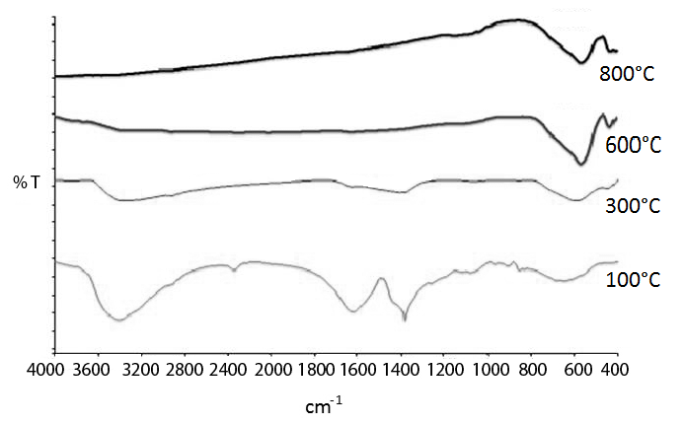

Figure 1. The FTIR spectra of magnesium ferrites at 100°C, 300°C, 600°C and 800°C. (Sol gel method using citric acid).

Fig.2 showed the XRD spectra of manganese ferrites and other compound from 100°C to 800°C. The XRD spectra indicated the alteration of amorphous phase to crystalline structure as the calcination temperature increased. At the 300°C calcination, despite the formation of manganese ferrite (MnFeO₃), the Fe₃O₄ was produced in minority corresponding to planes (3 1 1) and (4 4 0). However, the only manganese ferrite (MnFeO₃) was produced corresponding to planes (2 1 1), (2 2 2), (4 4 0), and (6 2 2) at 600°C and 800°C, because the Fe₃O₄ was not detected in the XRD spectra attributed to planes (2 2 0), (3 1 1), (5 1 1) and (4 4 0). Furthermore, the plane (4 4 0) of manganese ferrite was sited 2θ = 55°, while the plane (4 4 0) of Fe3O4 was sited at different position (2θ = 63°). Therefore, the formation of manganese ferrites (MnFeO₃) in this conditions (600°C and 800°C) were more possible. The particle sizes at different calcinations (300°C, 600°C, and 800°C) were found to be 16.8 nm, 36.9 nm, and 44.8 nm, using the Debye–Scherrer’s equation based on the full width at half maximum (FWHM). The results of XRD were in good agreement with that of BET. Based on the particle sizes, there is an indication that the present method can be able to produce nano ferrites. Naseri et al. [10] reported the average particle sizes of manganese ferrite of 12 nm to 22 nm at calcination temperatures of 450 °C to 600°C using a polyvinyl pyrrolidone (PVP) as a capping agent to control the agglomeration process. It was apparent that PVP prevented the formation of larger particle size.

Figure 2. The XRD spectra of manganese ferrites at 100°C, 300°C, 600°C and 800°C. (Sol gel method using citric acid).
Figure 3 showed the SEM micrographs of both magnesium and manganese ferrites at 800°C. The micrograph of magnesium ferrite at 800°C showed flake particles (Fig.3a), and the manganese ferrite showed granulated particles (Fig.3b) at the same temperature. The different in particle shape of both ferrites (magnesium and manganese) at 800°C is because both elements have different crystalline characterizations associated to the relationship between oxidation state and electronic configuration of the atomic element. Flake particles were shown by the SEM image of magnesium ferrite prepared by the sol gel method at 600°C calcinations using citric acid, but granulated forms were produced using the co-precipitation method [4]. Furthermore, granulated particles were shown by the SEM image of magnesium ferrite fabricated by co-precipitation and sintered methods using polyvinyl alcohol (PVA) binder [11]. It was suggested that the co-precipitation method induced the formation of granulated particles. Granulated particles were shown by the SEM micrograph of manganese ferrites fabrication using co-precipitation and thermal methods at 1000°C [12].
a)  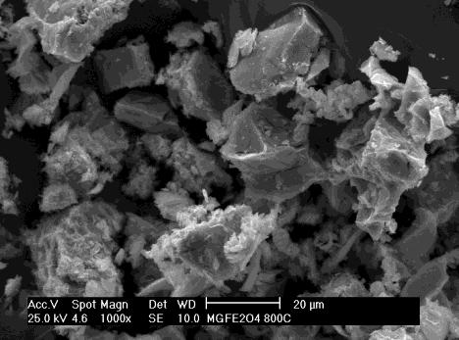 | b)  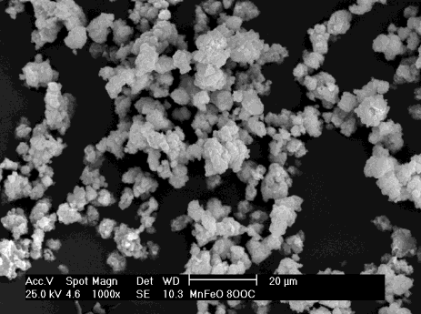

Figure 3. The SEM micrographs of (a) magnesium ferrite and (b) manganese ferrite, both at 600°C. (Sol gel method using citric acid); (1000 x magnification).
The SEM mappings of magnesium ferrite at 600°C are shown in Fig. 4 in relation to the distribution of magnesium (Fig.4a), iron (Fig.4b) and oxygen (Fig.4c). The EDX analysis of magnesium ferrites at 600°C showed the element distribution of magnesium (≈ 6%), iron (≈ 50%,) and oxygen (≈ 17%), while the EDX spectra is shown in Fig. 4d. Similar EDX analysis was shown by the fabricated magnesium ferrite using co- precipitation and thermal methods at 900°C with PVA binder [11]. The EDX analysis showed that the NaOH used in the co-precipitation method did not take part in the reaction [11]. This study reported that the XRD analysis of magnesium ferrites (MgFe₂O₄) showed the formation of Fe₂O₃ besides the magnesium ferrite at 600°C. The higher concentration of iron as shown in the SEM mapping of iron and EDX analysis (≈ 50%) was caused by the formation of MgFe₂O₄ and Fe₂O₃ at 600°C. Besides, this study used a mol ratio of 2:1 of Fe(NO₃)₃ and Mg(NO₃)₂ as precursors. According to Naseri et al. (2011), there is a possibility of the transfer of Fe³⁺ ions from B site to A site in the spinel structure of MgFe₂O₄ at calcinations of 600°C.
a)   | b)  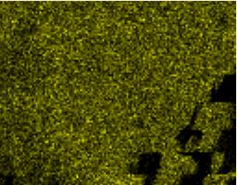
c)   | d)  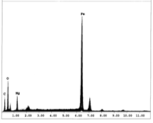

Figure 4. The SEM mappings of magnesium ferrite at 600°C for the distribution of (a) magnesium, (b) iron, (c) oxygen, and (d) the associated EDX spectra. (Sol gel method using citric acid).
The present study in relation to the effects of calcinations on the structures and properties of ferrites (magnesium and manganese) is useful for future applications particularly focused on the fabrication of ferrites for the purpose of catalyst and semiconductors.
Conclusion
The present study shows that the crystal structure and morphology of the fabricated ferrites were influenced by the calcination temperatures. The FTIR spectra of magnesium ferrite showed the remarkable peak (400 cm⁻¹ –
600 cm⁻¹) both at the 600°C and 800°C, because the tetrahedral and octahedral structures were obviously formed after all volatile matters removed at both the temperatures of interest. The XRD spectra of manganese ferrite showed the formation of pure manganese ferrites at 600°C and 800°C in the crystalline structure compared to the semi-amorphous structure of the related ferrite at 300°C. The SEM micrograph of magnesium ferrite showed a flake-form structure and that of manganese ferrite showed a granule structure, which they were calcinated at 800°C. This study provides meaningful correlation of the effects of calcination temperature on the crystalline structure of the ferrites of interest.
Acknowledgement
This research was financially supported by a Research University Grant of Universiti Teknologi Malaysia (Vote
No 77545, Sub Project No 77263D046 and Vote No 02J02, Sub Project No 712602J02), which is gratefully acknowledged.

References

- Siemons, M., Weirich, Th., Mayer, J. & Simon, U. (2004). Preparation of nanosized perovskite-type oxide via polyol method. Journal of Inorganic & General Chemistry 630(12): 2083-2089.
- Wolfram, T. & Elliatioglu, S. (2006). Electronic and Optical Properties of D-Band Perovskites. United Kingdom, University Press, Cambridge. 1-24.
- Maensiri, S., Sangmanee, M. & Wiengmoon, A. (2008). Magnesium ferrite (MgFe₂O₄) nanostructure fabricated by electrospinning. Nanoscale Research Letters, 4(3): 221-228.
- Liu, C.P., Li, M.W., Zhong, C., Huang, J.R., Tian, Y.L., Tong, L. & Mi, W.B. (2007). Comparative study of magnesium ferrite nanocrystallites prepared by sol-gel and co-precipitation methods. Journal of Material Science, 42: 6133-6138.
- Pradeep, A. & Chandrasekaran, G. (2005). FTIR study of Ni, Cu and Zn substituted nano-particles of MgFe₂O₄. Material Letters, 60(3): 371-374.
- Pradhan, S.K., Bidb, S., Gateshki, M. & Petkov, V. (2005). Microstructure characterization and cation distribution of nanocrystalline magnesium ferrite prepared by ball milling. Journal of Material Chemistry & Physics, 93(1): 224-230.
- Mishra, S., Kundu, T.K., Barick, K.C., Bahadur, D. & Chakravorty, D. (2006). Preparation of nanocrystalline MnFe₂O₄ by doping with Ti⁴⁺ ions using solid state reaction route. Journal of Magnetism & Magnetic Materials, 307(2): 222-226.
- Lick, L.D. & Soria, D.B. (2009). The synthesis of MnFeO₃ from the oxidative thermal decomposition of Mn[Fe(CN)₅NO].2H₂O. Journal of Argentine Chemical Society, 97(1): 102-108.
- Pradeep, A., Priyadharsini, P. & Chandrasekaran, G. (2008). Sol gel route of synthesis of nanoparticles of MgFe₂O₄ and XRD, FTIR and VSM study. Journal of Magnetism & Magnetic Materials, 320(21): 2774-2779.
- Naseri, M.G., Saion, E.B., Ahangar, H.A., Hashim, M. & Shaari, A.H. (2011). Synthesis and characterization ofmanganese ferrite nanoparticles by thermal treatment method. Journal of Magnetism & Magnetic Materials, 323(13): 1745-1749.
- Hankare, P.P., Vader, V.T., Patil, N.M., Jadhav, S.D., Sankpal, U.B., Kadama, M.R., Chouguleb, B.K. & Gajbhiye, N.S. (2009). Synthesis, characterization and studies on magnetic and electrical properties of Mg ferrite with Cr substitution. Journal of Material Chemistry & Physics, 113(1): 233-238.
- Rashad, M.M. (2006). Synthesis and magnetic properties of manganese ferrite from low grade manganese ore. Material Science & Engineering B, 127(2-3): 123-129.

