

HYDROTHERMAL OXIDATIVE DEGRADATION OF ORGANIC COMPOUNDS DERIVED FROM PRODUCED WATER

(Penguraian Secara Pengoksidaan Hidrotermal Bahan Organik daripada Air Hasilan)

Ahmad Rafizan Mohamad Daud*, Mohd Zahid Marzuki, Mohd Muslim Abu Hassan

Faculty of Chemical Engineering,
Universiti Teknologi Mara (UiTM), 40450 Shah Alam, Selangor, Malaysia

*Corresponding author: ahmad2057@salam.uitm.edu.my

Abstract
Produced water contains various hazardous organic compounds such as BTEX (benzene, toluene, ethyl benzene and xylene), phenolics and polycyclic aromatic hydrocarbons (PAHs). These compounds are stable and difficult to degrade by conventional wastewater treatment method. Aqueous based hydrothermal oxidative method is viewed as a promising approach for produced water treatment. The experiment was conducted in a micro-bomb reactor at subcritical water condition (200-300 ºC) and 30 minute reaction time. Hydrogen peroxide was used as an oxidant. The reaction products were analyzed using a Fourier Transform Infra-Red (FTIR) and a Gas Chromatography-Mass Spectroscopy (GC-MS). The hydrothermal treatment in the absence of an oxidant showed minimal degradation of organics for the temperature range investigated. With the presence of an oxidant, the organics degradation increased drastically to near completion within the 30 minute reaction time at 300 ºC. The results indicated that most of the organic compounds found in the produced water were successfully degraded using hydrothermal oxidative method.

Keywords: Produced water, organic, degradation, hydrothermal, oxidation

Abstrak
Air hasilan mengandungi pelbagai bahan organik berbahaya seperti BTEX (benzena, toluena, etil benzena dan xylene), fenol dan hidrokarbon polisiklik aromatik (PAHs). Bahan-bahan ini adalah stabil dan sukar untuk diuraikan dengan menggunakan kaedah rawatan air sisa buangan konvensional. Kaedah rawatan berasaskan air seperti pengoksidaan hidrotermal dilihat sebagai satu kaedah yang berpotensi untuk rawatan air hasilan. Eksperimen telah dijalankan menggunakan reaktor bom mikro pada keadaan air dibawah paras kritikal (200-300 ºC) dan masa tindakbalas 30 minit. Hidrogen peroksida telah digunakan sebagai ejen pengoksidaan. Hasil tindakbalas telah dianalisa menggunakan peralatan Fourier Transform Infra-Red (FTIR) dan Gas Chromatography-Mass Spectroscopy (GC-MS). Hasil kajian pada keadaan air dibawah paras kritikal mendapati rawatan secara hidrotermal tanpa sokongan ejen pengoksidaan tidak berupaya untuk menguraikan bahan organik. Penggunaan ejen pengoksida seperti hydrogen peroksida telah meningkatkan tahap penguraian bahan organic secara drastic menghampiri tahap penguraian sepenuhnya dalam jangkamasa 30 minit pada suhu 300 ºC. Hasil kajian juga menunjukkan kebanyakan bahan organik yang terdapat didalam air hasilan telah berjaya diuraikan menggunakan kaedah pengoksidaan hidrotermal.

Kata kunci: Air hasilan, penguraian, organik, hidrotermal, pengoksidaan

Introduction
Increasing water production over oil is now a major environmental and economic challenge for the downstream and upstream industries. Lee et al. [1] reported that oil wells in the United States produced an average of more than 7 bbl of water for each barrel of oil. For crude oil wells nearing the end of their production life span, water can comprise as much as 98% of the material brought to the surface. Wells elsewhere in the world averages at 3 bbl of water for each barrel of oil produced [2].

Produced water (PW) is hazardous and requires specific disposal and handling care. It contains a broad range of organic as well as inorganic compounds including carboxylic acids, benzene, toluene, ethyl benzene, and xylene (BTEX), polycyclic aromatic hydrocarbons (PAHs), inorganic nutrient such as ammonia, and heavy metals. Soluble organic compounds in PW or oily refinery waste discharges represent treatment problems for the industry. The organic components frequently recognized as high chain alkenes, phenolic categories, aromatic acids and also polycyclic aromatics are difficult to be eliminated with the conventional treatment processes. For instance, the organic compounds dissolved in the PW are simply not possible to be eliminated by physical separation alone. On the other hand, an aeration method usually resulted in massive amount of solid toxic sludge which requires further costly treatment such as incineration.

Considering that PW is highly aqueous in nature, hydrothermal oxidative treatment (oxidation in water at high pressure and temperature) is viewed as a promising alternative treatment approach. An oxidant such as hydrogen peroxide (H₂O₂) has been showed to enhance the degradation of organics under subcritical and critical condition [3]. This study aims to investigate the effect of hydrothermal oxidative reaction temperature on the degradation of organic compounds.

Materials and Methods
Material
The PW sample was obtained from a local oil refinery. Hydrogen peroxide, H₂O₂ (30% w/v) purchased from Merck Sdn. Bhd. was used as the oxidation agent. Dichloromethane (DCM) was used as a solvent for liquid-liquid extraction step.

Experimental Procedure
Experiments were conducted in a micro-bomb reactor constructed by using a ½ inch stainless steel tubing. The volume of the reactor is 8 mL. The micro bomb reactor tubing is closed at both ends using stainless steel end caps whereby one of the ends was used for loading and unloading of reactants and reaction products. Typically, 5mL of liquid PW sample was filtered and loaded into the reactor. The reactor was heat up to the desired temperature using an electrical furnace and kept at the reaction temperature for 30 minutes. Next, the micro bomb reactor was quenched to a room temperature in a cold water bath to minimize the secondary reaction. The liquid organic product was extracted with the DCM solvent. The experiment was repeated with the addition of H₂O₂.

Extracted product was analyzed using a Perkin Elmer Spectrum One FTIR and an Agilent 7890A GC-MS. The GC-MS was equipped with a 30m x 0.25 mm ID fused silica capillary column bonded with 5 % methyl silicone (HP-5). The film thickness is 0.25-µm. The oven temperature program was set as follows: 40°C for 1 min, then heating at a 5°C min⁻¹ heating rate up to 260°C. The oven temperature was kept at the final temperature for 10 minutes.

Results and Discussion
The fresh PW sample was analyzed with FTIR to determine the major organic classes present. Figure 1 shows the FTIR spectrum for the fresh PW sample. Three distinctive peaks at 3308, 2107 and 1635 cm⁻¹ wavenumber were observed. The 3308 cm⁻¹ is most likely corresponded to the alcohols or phenolic groups. Typically the 3400-3300 cm⁻¹ wavenumber represents the O-H bond [4]. The FTIR results also indicated the presence of alkynes or carboxylic acid (2250-2100 cm⁻¹) as well as alkenes group (1680-1600 cm⁻¹) in the fresh PW.

The PW sample was also analyzed using a GC-MS to identify the organic components present (Figure 2). Major compounds identified using the NIST library matching is presented in Table 1. They include hydroxyl, phenolic and carboxylic group compounds. Overall, the results were in agreement with the FTIR analysis.

Hydrothermal treatment of the fresh PW without an oxidant at 200, 250 and 300ºC resulted in small degradation of its initial organics composition. Figure 3 indicates the various organics present in the hydrothermally treated PW at 300 ºC as observed by the GC-MS analysis. Water at elevated temperature and pressure alone could not bring much effect on the degradation of organic compounds in the PW. This result is in line with the findings of Daud et al.[3] which found that minimum degradation of organics such as phenanthrene was observed under subcritical water condition. In this case, the role of the subcritical water is thought to be limited to being a reaction medium rather than a reactant or a catalyst for the reaction.

Wave number (cm⁻¹)
% Transmission

Figure 1. FTIR spectrum of fresh PW.

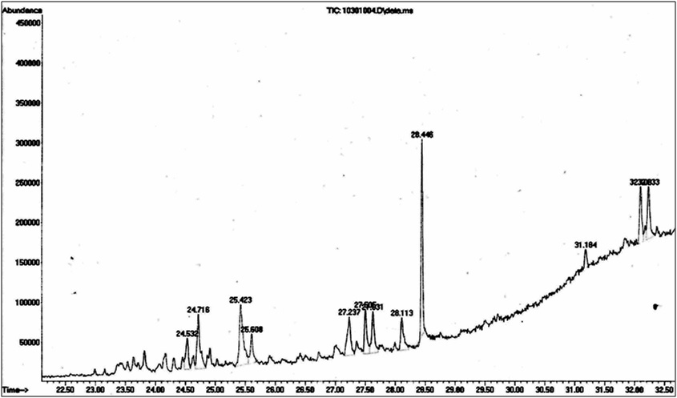

Figure 2. GC-MS chromatogram of fresh PW

Table 1. Major organic compounds present in the PW identified by GC-MS analysis
Retention Times (min) | Major Compound Detected
25.442 | Xaanthen-9-one,1-hydroxy-3,5,8-tri methoxy
 | Decanamide-
 | Hexadecanamide
27.628 | 2,4-bis (1-phenyethyl)-phenol
28.110 | 1,2-benzenedicarboxylic acid, diis ooctyl ester
 | 9-Octadecenamide
28.442 | 1,2-benzenedicarboxylic acid, mono (2-ethylhexyl) ester
 | 2,4-bis (1-phenylethyl)-phenol

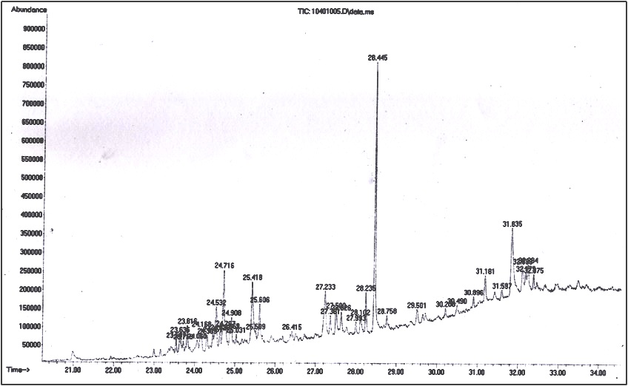

Figure 3. GC-MS chromatogram showing the organics distribution after hydrothermal treatment without an oxidant at 300ºC for 30 min reaction time.

The fresh PW was also subjected to hydrothermal oxidation treatment at 200, 250 and 300 ºC. With the addition of the H₂O₂ oxidant, the organics degradation was increased as the reaction temperature was raised from 200 to 300 ºC. Figure 4 shows the GC-MS result for the hydrothermal oxidation treatment at 300 ºC. It can be clearly observed that the addition of H₂O₂ has enhanced the degradation of the organics whereby major organic components such as phenolic, carboxylic acids and alkenes were fully decomposed into mostly water and carbon dioxide. Previous studies [3,5] have observed similar organics degradation pattern under subcritical and supercritical water conditions. The enhanced degradation of organics is most likely due to the presence of active radicals as a result of the H₂O₂ decomposition [6]. The dissociation pathways of H₂O₂ involved the formation of highly reactive OH● and HO₂● radicals. These radicals could in fact affect the organics degradation rate.

Figure 4. GC-MS chromatogram showing the destruction of organics under hydrothermal oxidation treatment at 300ºC and 30 min reaction time

Conclusion
The fresh PW was found to contain mostly carboxylic, alkenes, phenolic and aromatics groups. These compounds were resistant to hydrothermal treatment alone whereby minimum degradation was observed up to 300˚C reaction temperature. However, with the presence of the H₂O₂ oxidant, the degradation of these compounds has proceeded to near completion largely due to the availability of OH● and HO₂● active radicals. It was found that almost all of the organics present in the sample were successfully degraded into mostly water and carbon dioxide at 300 ºC. This study established the influence of temperature and an oxidant in the degradation of organics derived from the PW under subcritical water conditions.

Acknowledgement
The authors would like to thank the Ministry of Education Malaysia and Universiti Teknologi MARA for the financial support provided through research funds 600-RMI/FRGS 5/3(25/2013) and 600-RMI/DANA 5/3 RIF (131/2012) that has made this work possible.

References
- Lee, R., Seright, R., Hightower, M., Sattler, A., Cather, M., McPherson, B., Wrotenbery, L.,Martin, D. and Whitworth, M. (2002). Strategies for Produced Water Handling in NewMexico, Ground Water Protection Council Produced WaterConference, Colorado Springs, Oct. 16-17.
- Khatib, Z.and Verbeek, P.(2003).Water to Value - Produced water management forfield development of mature and green fields,Journal of PetroleumTechnology.55(1):26-28.
- Daud, A. R. M., Millan-Agorio, M., Hellgardt, K. And Kandiyoti, R. (2011). Partial Oxidative Cracking of Polycyclic Aromatic Compounds under Supercritical Water Conditions for Heavy Hydrocarbons Upgrading, Ph.D. Thesis,Imperial College London.
- Lampman, G. M., Pavia, D. L., Kriz, G. S. and Vyvyan, J. R. (2009). Introduction to Spectroscopy. Fourth Edition, Brooks/Cole, Belmont, CA.
- Onwudili, J. A. and Williams,P. T.(2007). Reaction mechanisms for the decomposition of phenanthrene and naphthalene under hydrothermal conditions,The Journal of Supercritical Fluids.39(3): 399-408.
- Croiset, E., Rice, S.F. and. Hanush, R. G.(1997).Hydrogen peroxide decomposition in supercritical water, AIChE Journal 43(9): 2343-2352.

