

IMPROVEMENT OF MECHANICAL PROPERTIES OF POLY(LACTIC ACID) BY ELASTOMER

(Penambahbaikkan Sifat Mekanikal Poli(Asid Laktik) Oleh Elastomer)

Penwarat Sennan and Jantrawan Pumchusak*

Department of Industrial Chemistry, Faculty of Science
Chiang Mai University Chiang Mai 50200, Thailand

*Corresponding author: jantrawan@gmail.com

Abstract
Poly(lactic acid), PLA is a biodegradable thermoplastic that has a limited application due to its brittleness. This study has tried to overcome this weakness by blending polybutadiene (BR) into PLA. In the beginning period of the investigation, the preparation of PLA film with the thickness of less than 0.2 mm was prepared using the solvent casting method. The BR contents of 3, 5, 10 and 20 wt% were investigated. Vibracell sonicator was applied to disperse and lessen the rubber particle size in the PLA matrix. It was found that the elongation at break of the samples improved from 11 % for neat PLA to 39 % by blending with 10 wt%BR. However, tensile strength decreased as the BR contents was increased. SEM imaging revealed that the rubber has played an important role in the increase of sample toughness.

Keywords: polylactic acid, polybutadiene, biodegradable

Abstrak

Poli(asid laktik) (PLA) merupakan termoplastik biourai yang mempunyai aplikasi yang terhad kerana sifat kerapuhannya. Kajian ini cuba untuk mengatasi kelemahan tersebut dengan mengadunkan polibutadiena (BR) bersama PLA. Pada peringkat awal, penyediaan filem PLA dengan ketebalan kurang daripada 0.2 mm telah disediakan dengan menggunakan kaedah percampuran pelarut. Kandungan BR sebanyak 3, 5, 10 dan 20% berat telah dikaji. Sonikator Vibracell telah digunakan untuk menyebarkan dan seterusnya mengurangkansaiz zarah getah dalam matriks PLA. Kajian mendapati bahawa pemanjangan pada takat putus meningkat daripada 11% untuk matriks PLA kepada 39% untuk adunan yang ditambahkan 10% berat BR. Walau bagaimanapun, kekuatan tensil menurun dengan peningkatan kandungan BR dalam adunan. Pemeriksaan SEM membuktikan bahawa kehadirangetah telah memainkan peranan penting dalam peningkatan keliatan sampel.

Kata kunci: poli(asid laktik), polibutadiena, biourai

Introduction
It is known that environmental problems could cause by plastic bags made from petroleum. As a result, in recent years bioplastics or biopolymer have been of interest to be used to replace plastic. PLA is both bio-based and biocompostable, high strength and stiffness at room temperature that make it promising as a substitute for conventional petroleum-based polymers. However, there are serious limitations, notably brittleness and a low heat distortion temperature [1,2,3]. Several studies have reported to improve the physical and mechanical properties of PLA by blending with other polymers, such as low density poly (ethylene) [4]. poly(propylene glycol) and poly(ethylene glycol). [5,6]. However, most of these blends are incompatible; therefore, compatibilizers are required in order to attain the desired properties. Furthermore, there were some researches focused on the addition of rubber into PLA [7]. Rubber matrices have commonly been used as a second phase polymer to improve the toughness of brittle thermoplastic materials. The rubber particles behave as stress concentrators enhancing the fracture energy absorption of brittle polymers and ultimately result in a material with improved toughness. In order to improve the toughness of polymers, several criteria must be met: the rubber must be distributed as small domains in the polymer matrix; the rubber must have good interfacial adhesion to the polymer [8,9]. Liu reported that small rubber particles lead to increase in the impact strength of the polypropylene (PP) / ethylene-propylene rubber (EPR) blend. They showed the toughening efficiency of very fine rubber particles [10]. This research aims to prepare PLA film blended with different amount of polybutadiene rubber and Vibracell sonicator was applied to lessen the size of rubber phase in PLA matrix. Mechanical properties especially elongation at break were investigated.

Materials and Methods
The PLA resin was supplied by NatureWorks®, USA. The selected grade, PLA 2003D (MI = 5-7 g/10 min), is an extrusion grade. Polybutadiene was kindly supplied by Thai Hashi Corporation Co., Ltd. under the trade name of BR-AA or BR-BB (raw Mooney viscosity: ML (1+4) 100 °C). PLA film was prepared in the thickness of less than 0.2 mm by solvent casting method. The PLA resin was dried in a vacuum oven at 80 °C for 4 h to remove moisture before casting. PLA/BR was dissolved in chloroform to obtain a polymer blend solution. The mixtures were stirred at room temperature for 3 h. Moreover, the dispersion of rubber by Vibra-cell sonicator electric power between 150-750 watts was applied for about 1-5 minutes after the mechanical stirring. The blend solution was then casted on the glass plates. The films were dried for about 4 h at room temperature and 4 h at 80 °C in a vacuum dryer to remove the remain solvent. The BR content in the range of 0-20 wt% was studied. The tensile strength, elongation at break and Young’s modulus of the PLA films were measured using a Lloyd Instruments LRX testing machine according to the ASTM standard method D882-88. Specimen samples were cut to the size of 10 cm×2.54 cm. Samples were conditioned for 48 h at 23±0.5 ◦C and 50% RH in a constant temperature and humidity chamber before the measurement. Initial grip separation and cross-head speed were set at 5 cm and 12.5 mm/min, respectively. The values presented were the average of five measurements. The surface morphology of the materials was observed using an optical microscope (OM) and scanning electron microscope (SEM). The specimen surfaces for the SEM were sputter coated with gold to avoid charging. The element analyzer was done by energy dispersive x-ray spectrometer (EDS).

Results and Discussion

Morphological Properties
The morphologies of the film surfaces were investigated by OM as presented in Figure 1. Neat PLA showed a smooth and uniform surface (Figure 1(a)). Figure 1(b) – (e) show the OM images of PLA/BR blends with 3, 5 10 and 20 wt% of BR, respectively. For these blends, the blend solutions were mechanical stirred at 400 rpm. The rubber droplets were well dispersed in all blends. The image J program was used to analyze the rubber droplet size and found that the rubber droplets were in the average size of 4.80, 4.45, 5.74, and 6.94 micrometer for the 3, 5, 10 and 20 wt% BR blends, respectively (Table 1). The higher rubber content gave the bigger rubber droplets.

Table 1. The rubber droplet size analysis of PLA/BR blends by image J program.
Time  Watt | Particle size (µm)
Time  Watt | 0 | 1 | 3 | 5
3%BR** | 4.80 | - | - | -
5%BR** | 4.45 | - | - | -
10%BR** | 5.74 | - | - | -
20%BR** | 6.94 | - | - | -
5%BR 150 watt | - | 6.06 | 4.35 | 2.77
5%BR 350 watt | - | 3.29 | 2.51 | 6.34
5%BR 650 watt | - | 1.40 | 1.21 | 1.33



(a)

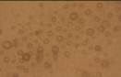
(c)
(b)

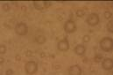
(e)
(d)
Figure 1. OM images of (a) neat PLA and PLA/BR blends at (b) 3 wt% (c) 5 wt% (d) 10 wt% (e) 20 wt%. The blend solutions were mechanical stirred at 400 rpm.

There was a greater tendency to form some rubber agglomerates when higher content of rubber was used [11]. Furthermore, Vibracell sonication was applied to the blend solution after mechanical stirring in order to reduce the size of rubber droplets. Figure 2 (a-d) show the OM images of the PLA/5 wt% BR blends which were sonicated by Vibracell sonicator at different watts and times. Table 1 shows the rubber droplet size of the blends. It can be seen that the higher watt provide the smaller droplet size, and 3 minutes application gave the smallest droplet size. The higher watt provided the higher vibration; therefore, small rubber droplets were obtained. However, during the sonication high amount of heat could be created (solution was warmer after sonication). This caused the solvent lost, which resulted the re-combination of the rubber particles, so the bigger particles were obtained when longer sonication was applied.


(b)
(a)


(d)
(c)


(f)
(e)


(h)
(g)

Figure 2. OM images of PLA/5 wt% BR blends at different watts and times of Vibracell sonicator application (a) 150 watt 1 min (b) 150 watt 3 mins (c) 150 watt 5 mins (d) 350 watt 1 min (e) 350 watt 3 mins (f) 350 watt 5 mins (g) 650 watt 1 min (h) 650 watt 3 mins.

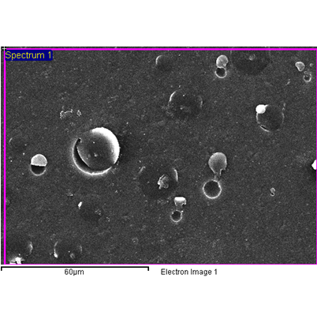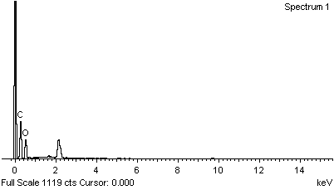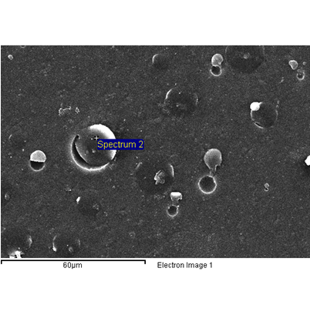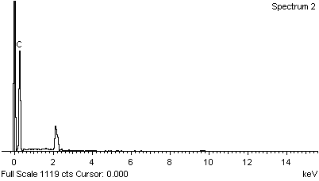
(b)
(a)
Small droplet
Smooth surface

Figure 3. LV-SEM micrographs and EDS results of PLA/ 3 wt% BR blend. (a) smooth surface site (b) small droplet site.

Table 2.Tensile properties of PLA and PLA/BR blends
 | Young’s modulus  (MPa) | Tensile strength  (MPa) | Elongation at break  (%)
PLA neat  3 wt.%BR  5 wt.%BR  10 wt.%BR  20 wt.%BR  5%BR 650 watt 3 min. | 421 + 55  452 + 29  441 + 51  354 + 34  317+ 55  384+ 72 | 48+ 10  40 + 2  36 + 1  32 + 1  20 + 3  33 + 2 | 11+ 1  21 + 1  21+ 2  39+ 3  30 + 4  49+ 4

Mechanical Properties of PLA/BR Films
Young’s modulus, tensile strength and elongation at break are the important factors for studying mechanical properties of PLA film. Figure 4 compares the stress-strain curves of the neat PLA to the PLA/5 wt% BR (non-sonication) and PLA/5 wt % BR (with sonication). It is clearly stated that the addition of BR gave more ductile and tougher materials. Moreover, the utilization of Vibracell sonicator, which provided the smaller rubber droplets, gave the tougher blends with the same rubber content. Table 2 exhibits the tensile properties of the neat PLA and PLA/BR blends. The elongation at break increased as the content of BR increased. PLA with 5 wt% BR and dispersion by Vibracell sonicator showed the highest elongation at break. However, the 20 wt% of BR blend revealed a lower elongation at break. In addition, the addition of BR decreased the strength of samples, and the high content of rubber decreased the Young’s modulus of samples. This is because of the low tensile strength and Young’s modulus of rubber. So the rigidity of PLA was lessen, which is good for the packaging application.

(a)
(b)
(c)

(a)
(b)
(c)

Figure 4. Stress-strain curves of the (a) PLA neat (b) PLA/ 5 wt.%BR non-sonication and (c) PLA/5 wt.%BR with sonication.

Conclusion
The PLA/BR blends were prepared by solvent casting method. The higher content of BR provided the higher elongation at break and lower the strength and Young’s modulus. The Vibra-cell sonicator was applied and found that it could lessen the rubber droplet size and provided the tougher materials.

Acknowledgement
This research was financially supported by National Research University (NRU) and the Graduated School, Chiang Mai University.

References
- Kim, J. K., Park, D. J., Lee, M. S. & Ihn, K. J. (2001). Synthesis and crystallization behavior of poly (L-lactide)-block-poly (e-caprolactone) copolymer. Polymer, 42(17): 7429–41.
- Martin, O. & Avérous, L. (2001). Poly (lactic acid): plasticization and properties of biodegradable multiphase systems. Polymer, 42(14): 6209–19.
- Rasal, R. M., Janorkar, A. V. & Hirt, D. E. (2010). Poly(lactic acid) modifications. Progress Polymer Science, 35(3): 338–56.
- Anderson, K.S., Lim, S.H. & Hillmyer, M.A. (2003). Toughening of polylactide by melt blending with linear low-density polyethylene. Polymer Science, 89: 3757–3768.
- Piorkowska, E., Kulinski, Z., Galeski, A. & Masirek, R. (2006). Plasticization of semicrystalline poly(L-lactide) with poly(propylene glycol). Polymer, 47: 7178–7188.
- Hu, Y., Topolkaraev, V., Hiltner, A. & Baer, E. (2003). Crystallization and phase separation in blends of high stereoregular poly (lactide) with poly (ethylene glycol). Polymer, 44: 5681–5689.
- Ma, P., Hristova-Bogaerds, D.G., Goossens, J.G.P., Spoe;stra A.B., Zhang Y. & Lemstra P.J. (2012). Toughening of poly(lactic acid) by ethylene-co-vinyl acetate copolymer with different vinyl acetate contents. European Polymer, 48: 146-154.
- Wu, S.H. (1985). Phase structure and adhesion in polymer blends: A criterion for rubber toughening. Polymer, 26: 1855–1863.
- Kim, G.M. & Michler, G.H. (1998). Micromechanical deformation processes toughened and particle-filled semicrystalline polymers-Part 1- Characterization of deformation processes in dependence on phase morphology. Polymer, 39: 5689–5697.
- Liu, Y., Zhang, X., Gao, J., Huang, F., Tan, B., Wei, G. & Qiao, J. (2004). Toughening of polypropylene by combined rubber system of ultrafine full-vulcanized powdered rubber and SBS. Polymer, 45: 275-286.
- Petchwattana, N., Covavisaruch, S. & Euapanthasate, N. (2012). Utilization of ultrafine acrylate rubber particle as a toughening agent for poly(lactic acid). Material Science and Engineering: 64-70.

