

THE INFLUENCE OF MODIFIED SODIUM MONTMORILLONITE AS FILLER ON THE PERFORMANCE OF GLASS POLYALKENOATE CEMENT

(Kesan Natrium Montmorilonit Terubahsuai Sebagai Bahan Pengisi Dalam Meningkatkan Prestasi Simen Kaca Polialkenoat)

Nur’Izzah Md Nasir¹, Norhazlin Zainuddin¹*, Wan Md Zin Wan Yunus², and Khamirul Amin Matori³

¹Department of Chemistry, Faculty of Science,
Universiti Putra Malaysia, 43300 Serdang, Selangor, Malaysia
²Department of Chemistry, Centre for Defense Foundation Studies,
National Defence Universiti Malaysia, Sungai Besi Camp, Kuala Lumpur, Malaysia
³Department of Physics, Faculty of Science,
Universiti Putra Malaysia, 43300 Serdang, Selangor, Malaysia.

*Corresponding author: norhazlin@upm.edu.my

Abstract
Modification of sodium montmorillonite(Na-MMT) to aluminium montmorillonite(Al-MMT) and octadecylamine montmorillonite(ODA-MMT) was done by ion exchange process. These MMTs were added as filler to glass polyalkenoate cement(GPC) formulation. The compressive strength and setting reaction of the GPCs were studied. Aluminosilicate glass powder with polyacrylic acid, water and MMT were mixed together with weight ratio of 5:1:1:(1.5wt% powder). The setting reaction was studied from FTIR by monitoring the conversion of COOH in polyacrylic acid to crosslink with metal ions from the glass to form COO⁻M⁺ at different aging time. The addition of Al-MMT slightly sped up the setting reaction of GPCs as early as 3 minutes and recorded significant increment in compressive strength at early aging time. While GPC+ODA-MMT only showed increment in compressive strength at early aging time. However, GPC+Na-MMT had shown the slowest performance in GPCs setting reaction and lowest value of the compressive strength. Although the compressive strength for these GPCs was different at early aging time, all cements recorded almost similar compressive strength at day 28. The study highlighted the potential of modified Na-MMT as filler to enhance the performance of GPCs as posterior filling material.

Keywords: sodium montmorillonite, montmorillonite, glass polyalkenoate cement, aluminosilicate glass, compressive strength

Abstrak
Pengubahsuaian terhadap natrium montmorilonit Na-MMT kepada aluminium montmorilonit, Al-MMT dan oktadesilamin montmorilonit, ODA-MMT dilakukan melalui proses pertukaran ion. MMT ini ditambahkan sebagai pengisi kepada formulasi simen kaca polialkenoat (GPC). Kekuatan mampatan dan tindak balas pengesetan bagi GPC dikaji. Serbuk kaca aluminosilikat dengan asid poliakrilik, air dan MMT dicampur dengan nisbah berat 5:1:1:(1.5 wt% serbuk). Tindak balas pengesetan dikaji melalui FTIR dengan memerhatikan penukaran COOH dalam asid poliakrilik untuk rangkai silang dengan ion logam daripada kaca untuk menghasilkan COO-M+ pada masa penuaan yang berbeza. Penambahan Al-MMT meningkatkan sedikit tindak balas pengesetan GPCs seawal 3 minit dan merekodkan peningkatan yang ketara dalam kekuatan mampatan pada awal masa penuaan. Manakala GPC+ODA-MMT hanya menunjukkan kesan pada ujian kekuatan mampatan di mana ia juga menunjukan peningkatan yang ketara pada awal masa penuaan. Walau bagaimanapun, GPC+Na-MMT telah menunjukkan prestasi paling perlahan dalam tindak balas pengesetan GPCs dan kekuatan mampatan. Walaupun kekuatan mampatan bagi semua jenis GPC sedikit berbeza pada awal masa penuaan, semua simen merekodkan kekuatan mampatan yang hampir sama pada hari ke 28. Kajian ini menumpukan kepada potensi Na-MMT terubahsuai sebagai pengisi untuk meningkatkan prestasi GPC sebagai bahan penampal gigi.

Kata kunci: natrium montmorilonit, montmorilonit, simen kaca polialkenoat, kaca aluminosilikat, kekuatan mampatan

Introduction
Glass polyalkenoate cement, GPC is water based cement, which is formed by the acid base reaction between aqueous polyacid and fluroaluminosilicate glass. The reaction releasing ion such as Al³⁺, F⁻, Ca²⁺ for polyacid linking with the surface of the aluminosilicate glass[1]. Hydrolysis reaction takes place on the surface of glass, where the polyacid in the presence of water attacks the glass network, which causes the leaching of metal cations such as Al³⁺, Ca²⁺ and F⁻ from the glass. These metal cations then ionically cross link with polyacid chain to form polysalt matrix resulting hard ceramic-like cement. While, the surface of the glass developed into silica gel layer, Si(OH)₄.

GPC is a great candidate to replace the function of amalgam as it has ability to chemically bond to the tooth structure, biocompatible, low shrinkage and can release fluoride to protect the tooth from secondary caries. Although amalgam is successfully material as a universal tooth filling for over century, controversy still exists mainly because of the presence of mercury in amalgam. Other than that, amalgam also able to tarnish the tooth applied and can form micro-leakage on the tooth.

Various fillers have been applied to conventional glass polyalkenoate restoratives to improve their mechanical properties and enable posterior use clinically, including alumina-silicate[2], fused fibre[3], hydroxyapatite[4], zirconia[5] and montmorillonite clay, MMT[6]. MMT is trilayer smectice clay consisting of stacked platelets constructed of an alumina octahedral layer sandwiched between two silica tetrahedral layers. MMT clay is easy to obtain and modified. MMT can be modified by ion-exchanging organic cationic surfactants (intercalants). The presence of Al, Si, H, and O ions in the MMT structure made it favorable to be used as filler in dental cement. MMT is a special material which has been applied widely such as filler in polymer, nylon 6[7] and acrylic [6], treatment in waste water [8], and absorbent of benzene derivative [9-11].

The modifications on the GPC in order to improve the mechanical properties were widely done previously. However, no one had repeated or improved the work done by Dowling and his co-worker [6, 12]. Dowling [6, 12] had used organo MMT as filler in GPC application and the study only focus on the compressive strength, working characteristic, volumetric wear and wear depth. Up to date, there is no study had been published on the setting reaction of the GPC with addition of modified MMT. In addition, Dowling et al. [6,12] used commercial glass, which might make the study on the setting reaction of the GPC hardly to explain. Therefore, in this study, the glass that we used was experimentally synthesized in our laboratory. Furthermore, we applied larger interlayer spacing of MMT called d spacing compared to the modified MMT used by Dowling et al. [6] to study the effect of MMT’s d spacing on the mechanical properties of GPC. The hypothesis proposed in this study was that the addition of MMT would improve the compressive strength and influence the setting reaction of the GPCs. Therefore, in this study, the compressive strength of the GPC with addition of modified Na-MMT would be determined and the setting reaction of GPC with addition of MMT would be understood using FTIR spectroscopy.

Materials and Methods
Preparation of Aluminosilicate Glass
Aluminosilicate glass was produced using high temperature melting technique with composition of 4.5SiO₂. 3CaO. 3Al₂O₃. 2CaF₂. 1.5P₂O₅. . The reagents were melted in alumina crucible at 1450°C for 3 hours. Then, the resulting melts were rapidly poured into water to prevent phase separation and crystallization. The frit was collected and dried overnight in an oven at 60°C. The glass frit produced was ground by using ball grinding mill and sieved to a fine particle size of less than 45 µm for preparation of GPCs.

Modification of sodium montmorillonite, Na-MMT.
Na-MMT was used as a starting material. Aluminium montmorillonite (Al-MMT) and octadecylamine montmorillonite (ODA-MMT) were prepared by ion exchange process where Na⁺ in the MMT was exchanged with Al³⁺ in AlCl₃ or alkyl ammonium ion in octadecylamine, ODA aqueous solution.

For Al-MMT, ~20 g of the Na-MMT was mixed with 800 mL of water and stirred for two days. After decantation, 200 mL of 0.1 M AlCl₃ solution was added. The suspension was stirred for two days and then washed several times with distilled water until negative result for chlorides (using Ag⁺ ions) was achieved.

For ODA-MMT, ~20 g of Na-MMT was stirred vigorously in 600 mL of hot distilled water at approximately 80 °C for 1 hour to form a clay suspension. Subsequently, 13.5 g of surfactant (octadecylamine, ODA) which had been dissolved in 400 mL of hot water and 4.81 mL of concentrated hydrochloric acid (HCl) was added into the clay suspension of (ODA). After stirred vigorously for 1 hour at 80 °C, the ODA-MMT suspension was filtered and washed with distilled water until no chloride was detected with 1.0 M silver nitrate solution. It was then dried at 60°C for 48 hours. The dried Al-MMT and ODA-MMT were ground and sieved with particle size less than 45 μm.

Preparation of glass polyalkenoate cement
GPCs were prepared by thoroughly mixing the glass powder with polyacrylic acid, PAA (Mw~30,000) and water at weight ratio of 5:1:1 was chosen according to Griffin and Hill [13] which is suitable for restorative cements. While the weight ratio for addition of MMTs in GPC were 5:1:1:(0.5 to 2.0 wt%). Three types of GPCs with addition of MMT were prepared: GPC added with Na-MMT (GPC+Na-MMT), GPC added with Al-MMT (GPC+Al-MMT) and GPC added with ODA-MMT (GPC+ODA-MMT). The specimens that less than 1 hour aging time were quenched with liquid nitrogen to terminate the reaction and dehydrated using ethanol. For aging time greater than 1 hour, the specimens were placed in oven at 37 °C and were immersed and stored in deionized water prior to termination of the reaction by the above method. The immersion was done to prevent the dehydration for samples up to 28 days.

X-ray diffraction
X-ray diffraction analysis for Na-MMT, Al-MMT and ODA-MMT was done to determine the interlayer spacing from the position of the d₀₀₁ peak in the XRD pattern using Bragg’s law. XRD analysis was conducted using Shimadzu XRD 6000 diffractometer with Cu-K α radiation (λ = 0, 15406 nm). The diffractogram was scanned in the range of 2θ angle from 2 to 10° at a scan rate of 2° min⁻¹.

Fourier Transform Infrared (FT-IR) analysis
The functional group, bond formation, and setting reaction of samples were analyzed using Perkin Elmer Spectrum 1000 series FT-IR spectrophotometer equipped with attenuated total reflectance (ATR). The infrared spectra were recorded at wave number 1000 – 4000 cm⁻¹.

Compressive strength test
GPCs prepared were shaped in cylindrical mould with dimension of 4 mm $×6$ mm following the ISO7489:1986 specifications [14–15]. Identical cylindrical standard specimens were produced using the PTFE split-mould. The specimens were test under INSTRON tensile machine at a cross head speed 1 mm/min and maximum load 5 kN.

Results and Discussion
XRD analysis
The XRD patterns for the Na-MMT and modified Na-MMT are given in Figure 1. The peaks at 2θ appeared at 7.52, 5.54 and 2.98 for Na-MMT, Al-MMT, and ODA-MMT, respectively. The basal spacing was calculated and listed in Table 1.

Table 1. The interlayer spacing calculated using Bragg’s law for unmodified Na-MMT, cationic clay Al-MMT,
and organically modified treated ODA-MMT
Montmorillonite, MMT | Wavelength, λ | Angle, 2Ɵ | Interlayer spacing,  d₀₀₁ (nm) | Expansion of interlayer spacing (nm)
Na-MMT | 1.59 | 7.52 | 1.21 | -
Al-MMT | 1.59 | 5.54 | 1.64 | 0.43
ODA-MMT | 1.54 | 2.98 | 2.96 | 1.75
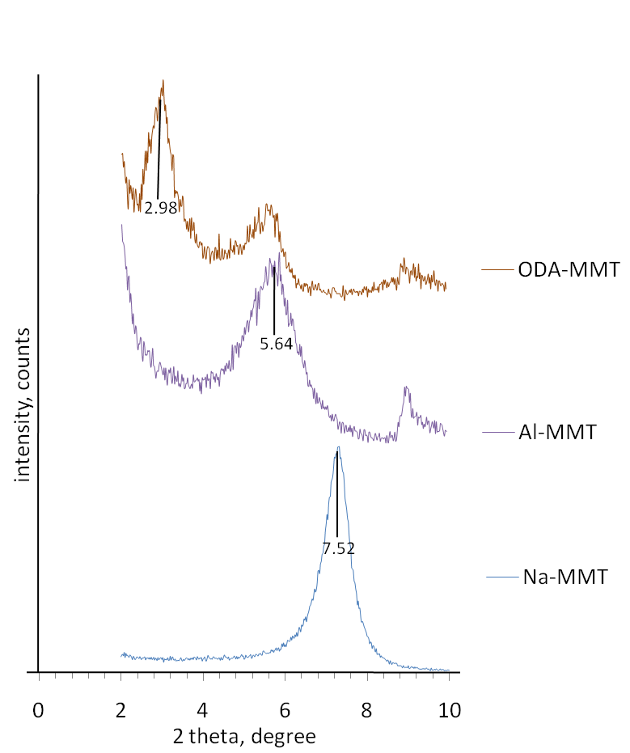

Figure 1. XRD patterns of Na-MMT and modified Na-MMTs (Al-MMT, and ODA-MMT)

Na-MMT gave the lowest spacing with 1.21 nm, followed by Al-MMT with 1.64 nm, and ODA-MMT with 2.96 nm. The expansion of interlayer spacing of 0.43 nm and 1.75 nm for Al -MMT and ODA -MMT, respectively, suggested that modification was successfully done. The d-spacing of Al-MMT was smaller compared to the ODA-MMT. This is due to the structure of ODA is bigger and the molecular weight is higher compares to Al, which gives a greater distance layer. The increase in the interlayer d-spacings (d₀₀₁) for ODA-MMT and Al-MMT clays demonstrated that the modified MMT clays have expanded layers, which may increase the opportunity for the polyacrylic acid chains of the GPC restorative to diffuse into the MMT galleries during manipulation. This finding is supported by Dowling et al. [6].

Compressive strength
Optimization of amount of MMTs in GPC
The optimum amount of MMT in the GPCs was determined in order to get the highest compressive strength of GPC. Figure 2 shows the compressive strength for GPCs with addition of Na-MMT, ODA-MMT, and Al-MMT from 0.5 – 2.0 wt% at 1 day aging time.

The addition of 0.5 – 2.0 wt% of MMT in GPC was investigated by the author in order to determine the optimum amount of MMT as filler in GPC. It was found that more than 2.0 wt% of MMT, namely 2.5 and 3.0 wt%, resulted in difficulty to mix and easily rupture cement. Therefore, the authors exclude these wt% from the study. From figure 2, as we increased the amount of clay from 0.5 to 1.5wt%, the compressive strength was also increased. This may be due to high amount of MMTs can react with PAA in the cement to form crosslinkages. However, above 1.5wt%, a reduction in compressive strength for all types of GPCs was observed. Dowling et al. [6] suggested that excess MMT in GPC causes the clays agglomerate into disorganised structures of stacked clay platelets, which decreases the overall surface area available for reaction thereby minimising any potential reinforcing effect. Therefore, 1.5 wt% of MMTs was chosen as optimum amount of MMT in this study.

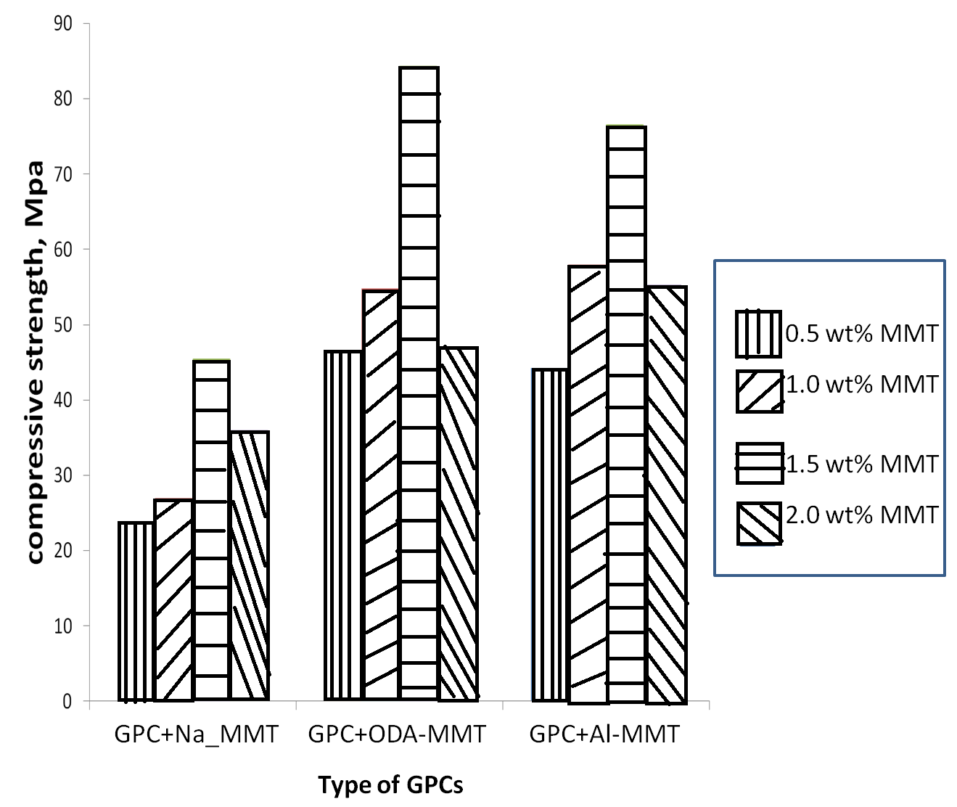

Figure 2. Compressive strength of GPC+Na-MMT, GPC+Al_MMT and GPC+ODA-MMT with 0-2 wt% of MMT at 1 day aging time

FTIR analysis for GPC
Figure 3 shows the FTIR spectra of GPCs from 3 minutes to 28 days aging time. The FTIR spectra of PAA and glass were also included as comparison. The IR spectra absorption peaks of GPC without MMT are listed in Table 2.

Table 2: FTIR absorption for GPC without MMT
Wave number (cm⁻¹) | Assignment and Remarks
1695 | COOH bending
1544 | COO⁻M⁺ (cross linking)
1454 | -CH₂ bending
1425 | CH-C=O bending
1070 | Si-O-Si bridging
920 | Si-OH stretching (NBO)

The major peaks observed in this GPC were bridging Si-O-Si (cement) at 1070 cm⁻¹ and shoulder peak at 920 cm⁻¹ (Si-OH deformation vibration) , scissor and bending vibrations of -CH₂ and CH-C=O at 1410-1450 cm⁻¹, COOH bend at 1695 cm⁻¹ and lastly new peak at 1544 cm⁻¹ due to COO⁻M⁺ (crosslinking).

As early as 3 minutes aging time, the cross linking peak at 1544 cm⁻¹ was already clearly observed and COOH peak at 1695 cm⁻¹ had become a shoulder peak. After 10 minutes aging time, the intensity of COOH peak decreased and hardly to be observed. Other peak at 970 cm⁻¹ in the alumina silicate glass was assigned Si–O–Si stretching with non bridging oxygen. While in the GPCs, there were two new peaks appeared as early as 3 minutes aging time, which corresponded to Si–O–H (920 cm⁻¹) and Si – O – Si in the cement (1070 cm⁻¹), respectively. The Si–O–Si stretching peak slightly shifted from low to high wave number due to the hardening reaction. This finding is in good agreement with previous studies done by Matsuya et al.[16] and De Maeyer et al.[17]. Matsuya et al.[16] suggested that the shifting of wave number shows the degree of polymerization in the silicate network kept increasing during hardening of the cement.

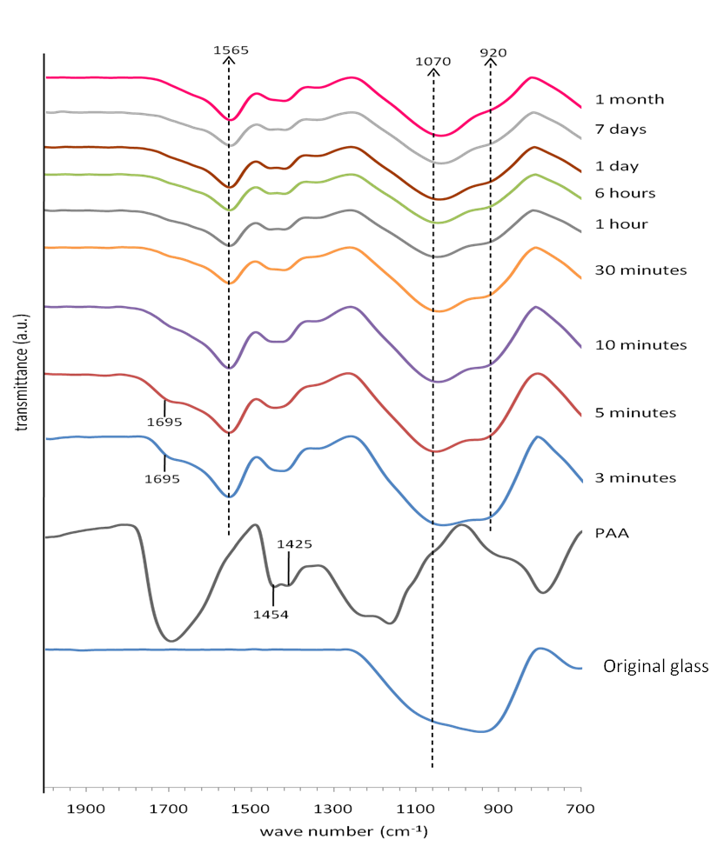

Figure 3. FTIR spectra of GPC without MMTs at wave number 700 cm⁻¹ – 2000 cm⁻¹ from 3 minutes to 28 days aging time, PAA, and original glass.

The FTIR result also indicated the change in structure of the silicate network of the cement during the setting reaction. The intensity of the shoulder peak, Si-O-H at 920 cm⁻¹ decreased with the aging time. It may be due to the condensation reaction by the elimination of water to form Si-O-Si. Matsuya et al.[16] reconstructed the silicate network in the glass starting with the breakage of the Si-O-Al bond by proton attack with releasing Al³⁺ ion. Then, Si-O-H, formed by the hardening reaction were condensed by the elimination of water.

Figure 4 shows interesting peaks of the FTIR spectra cut from Figure 3 for GPCs. There were two weak peaks associated with scissor and bending vibrations of -CH₂ and CH-C=O groups appeared at 1440 and 1415 cm⁻¹, respectively for PAA backbone.

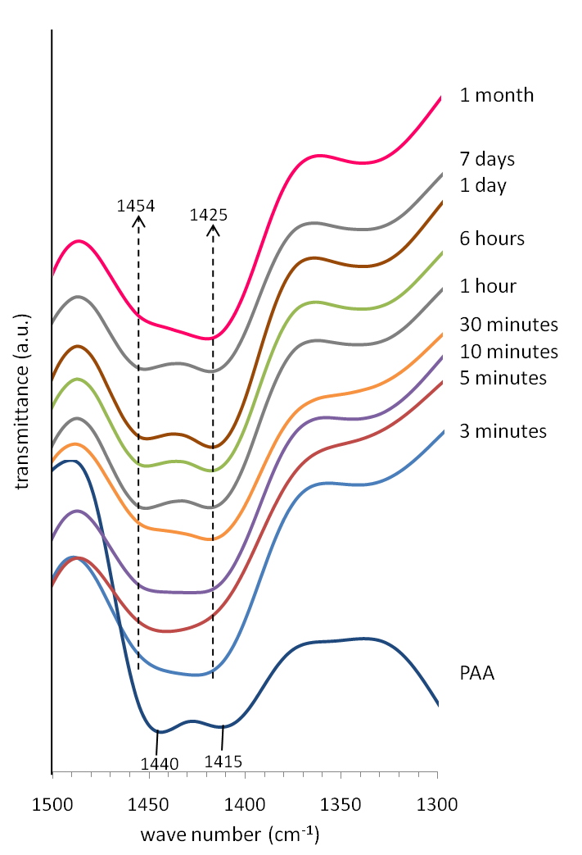

Figure 4. FTIR spectra of GPCs at 1300 – 1500 cm⁻¹ for scissor and bending vibrations of -CH₂ and CH-C=O groups at 3 minutes to 28 days aging time compared with PAA

During the setting reaction of GPCs, both peaks slightly shifted to the high wave number. This may be due to the cross linking reaction where the angle of C-C=O bond was disturbed to allow Al³⁺/Ca²⁺ cross link with the polyacid at the surface of glass as shown in Figure 5.

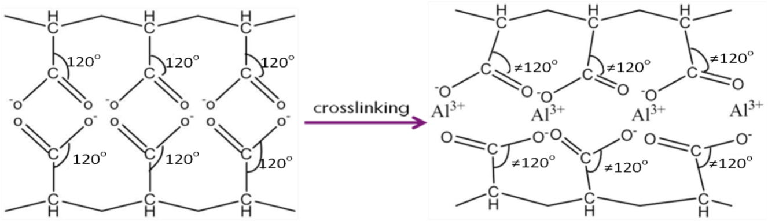

Figure 5. Cross linking reaction at the surface of the glass network

This causes the -CH₂ bond near the CH-C=O vibrates and thus disturbs the position of -CH₂ bending. Both peaks shifted slightly to a higher wave number in cements, which may be due to higher energy needed to vibrate these two bonds. The wave number for -CH₂ bending shifted from 1440 to 1454 cm⁻¹ while CH-C=O shifted from 1415 to 1425 cm⁻¹.

Figure 6, 7, and 8 show the FTIR spectra of GPCs with Na-MMT, GPC+ODA-MMT, and GPC+Al-MMT, respectively at wave number from 700 – 2000 cm⁻¹. Similar observation for the cross linking formation with the appearance of COO⁻M⁺ (1565 cm⁻¹) peak and reduction in the intensity of COOH peak (1695 cm⁻¹). There were also hardening reaction with the formation of Si-O-H (920 cm⁻¹) and Si-O-Si (1070 cm⁻¹) in cement, and shifting of -CH₂ and CH-C=O bending peaks (1440 and 1415 cm⁻¹). The peaks were similar to GPCs without MMTs but only different on the intensity of the transmittance at different aging time.

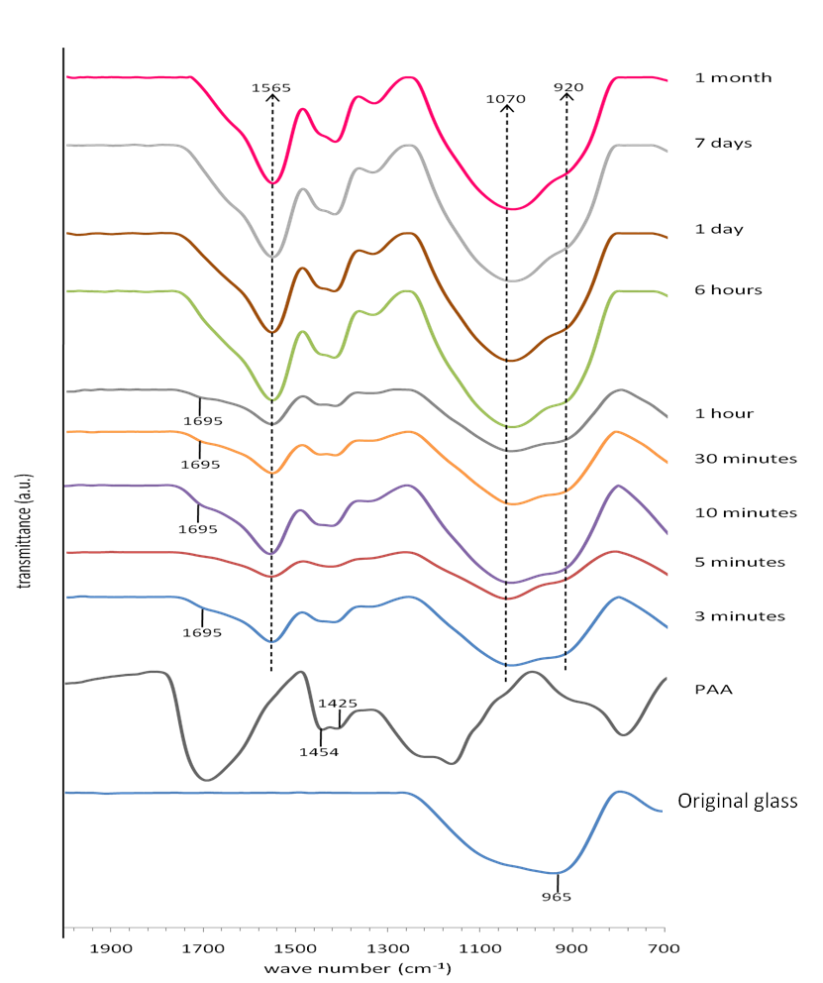

Figure 6. FTIR spectra of GPC+Na-MMT at wave number 700 cm⁻¹ – 2000 cm⁻¹ from 3 minutes to 28 days aging time, PAA, and original glass

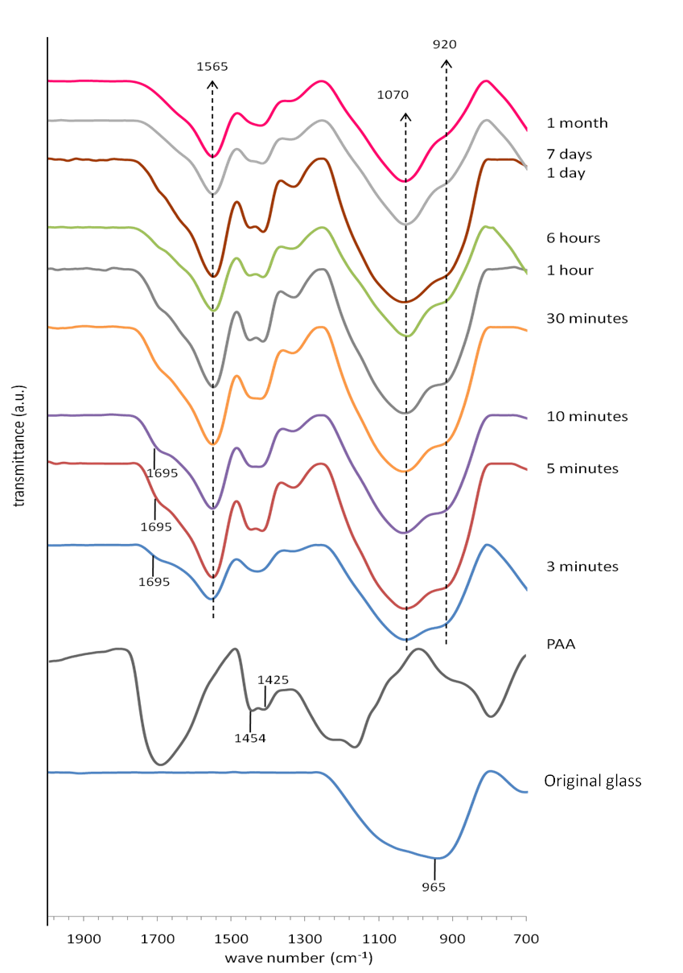

Figure 7. FTIR spectra of GPC+ODA-MMT at wave number 700 cm⁻¹ – 2000 cm⁻¹ from 3 minutes to 28 days aging time, PAA, and original glass
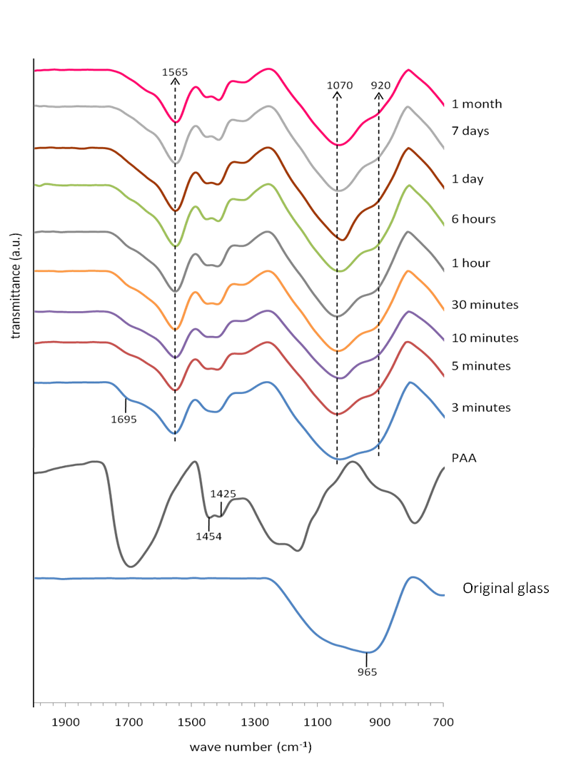

Figure 8. FTIR spectra of GPC+Al-MMT at wave number 700 cm⁻¹ – 2000 cm⁻¹ from 3 minutes to 28 days aging time, PAA, and original glass

The FTIR spectra of GPC were compared with FTIR spectra of GPC+Na-MMT, GPC+ODA-MMT and GPC+Al-MMT. Similar trend was observed where COOH peak converted to COO⁻ M⁺ as crosslinking proceed with aging time, and changes in silicate network as the hardening reaction took place simultaneously. The addition of Na-MMT in GPC (Figure 6) showed that the conversion of COOH to COO⁻M⁺ is not constant up to 1 day aging time. The intensity of COO⁻M⁺ peak appeared as early as 3 minutes aging time but after 10 minutes the COOH peak reappeared and then the intensity of both peaks became constant after 1 hour aging time. De Barra and Hill[18] explained that the presence of sodium ions prevent the COOH in PAA to take part in the crosslinking reaction by forming sodium polyacrylate salt. In our study, Na ions in Na-MMT can form Na-PAA salt at the early aging time and thus delayed the formation of crosslink in the cement. However, at longer aging time, this Na ions from Na-PAA salt were released to water and COO⁻ became available for crosslinking with metal ions from the glass.

For GPC+ODA-MMT (Figure 7), the peak of -NH₂ group from ODA-MMT was not detected from FTIR spectroscopy because very small amount of ODA-MMT has been used in this study (1.5 % of total weight powder). In addition, the peak for -NH₂ might be overlapped with the COO⁻M⁺ peak at 1529 cm⁻¹. Both GPC and GPC+ODA-MMT showed similar trend on the crosslinking, where the disappearance of COOH peak was found at 10 minutes aging time. It is suggested that the presence of ODA-MMT in the cement did not change the crosslinking reaction of the cement. The presence of amine group is believed to form hydrogen bond with the PAA and thus can only contribute in increasing the compressive strength of GPCs but not the setting reaction.

For GPC+Al-MMT, the IR (Figure 8) spectra showed that the intensity of COOH and COO⁻M⁺ peaks became constant after 5 minutes aging time, which is the fastest, compared to other cements in this study. This might be due to the presence of free aluminium in Al-MMT that can contribute in cross linking reaction and thus speed up the setting reaction of the GPC+Al-MMT. Al³⁺ in the modified MMT is assumed to move freely at ion exchangeable site in MMTs galleries layer. This free ion is believed to diffuse out easily and join the cross linking reaction together with the metal ions that leach out from the glass and speed up the setting reaction of the GPCs.

Compressive strength for GPC, GPC+ Na-MMT, and GPC+modified Na-MMT (GPC+Al-MMT/ GPC+ODA-MMT)
The compressive strength for GPC, GPC+Na-MMT, GPC+Al-MMT, and GPC+ODA-MMT were measured at 1, 7, 14, 21, and 28 days (Table 3).

Table 3. Mean compressive strength (MPa) of GPC, GPC+Al-MMT, GPC+ODA-MMT, and GPC+Na-MMT
at different aging time
 | Compressive strength, MPa (SD)
Day | GPC | GPC+Na-MMT | GPC+Al-MMT | GPC+ODA-MMT
1 | 61.7(3.5) | 45.5(4.1) | 84.4(4.7) | 76.6(8.9)
7 | 78.1(5.3) | 62.2(5.7) | 84.4(1.6) | 90.4(3.6)
14 | 88.7(8.5) | 72.5(8.2) | 91.4(7.5) | 89.4(9.2)
21 | 90.7(5.6) | 74.5(3.8) | 86.3(8.8) | 86.5(1.7)
28 | 93.4(4.6) | 80.4(10.5) | 92.5(8.8) | 86.4(4.7)
SD = standard deviation

At 1 day aging time, GPCs with addition of modified Na-MMT (ODA-MMT and Al-MMT) gave highest compressive strength compared with GPC without MMT and GPC+Na-MMT. The compressive strength value for GPC+ODA-MMT and GPC+Al-MMT were 76.6 and 84.4 MPa, respectively. While for GPC and GPC+Na-MMT, the compressive strengths were 61.7 and 45.5 MPa, respectively. The compressive strength for all GPCs increased with aging time and reached similar value in the range of 80 to 95 MPa after 28 days aging time.

The high value of compressive strength for GPCs with modified Na-MMT at the early aging time suggested that the addition of modified Na-MMT may contribute to the cross linking reaction during the formation of GPCs. The presence of octadecylamine in montmorillonite brings about the formation of intercalated compound with bilayers of organic molecules in the interlayer spaces. Intercalation is accompanied with water desorption and partial protonisation of NH groups [19]. Thus, there is possibility to form hydrogen bonding between the carboxylic acid groups of PAA and the polar amine groups, NH³⁺ of the ODA-MMT [6]. The formation of hydrogen bond may contribute in increasing the compressive strength of the GPCs.

For GPC+Al-MMT, the modification of Na-MMT to Al-MMT caused excess of free Al³⁺ in the MMT structure. The Al³⁺ was assumed to be moved freely in the layer of MMTs and because Al³⁺ was easily to diffuse out, it contributed in the cross linking reaction by forming COO⁻Al⁺, hence sped up the setting reaction of GPCs. Thus, gave higher compressive strength at 1 day aging time compared to GPC without MMT and GPC+ Na-MMT.

The addition of modified Na-MMT in GPC network had slightly increase the mechanical properties in early aging time as shown in the table, however, different situation happen to GPC+Na-MMT. The addition of Na-MMT had decreases the compressive strength of the GPC at 1 day aging time. The presence of Na in the MMT may delay the cross linking reaction by forming Na-polyacrylate salt. Thus, prevent the COOH from PAA from taking part in the cross linking reaction. This situation causes the poor compressive strength result at early stage of reaction.

The d spacing of the MMT itself may affect the strength of the GPC at the early aging time. Na-MMT has the smallest d spacing compared with Al-MMT and ODA-MMT with only 1.21 nm. The size of d spacing for Al-MMT and ODA-MMT were 1.64 and 2.96 nm, respectively. Dowling et al. [6] suggested that the increase in interlayer spacing may allow the movement of polyacid chains between the layered montmorillonite platelets and possibly the formation of hydrogen bonds between the carboxylic acid groups of polyacid and the amine groups of the ODA-MMT.

All types of GPCs except GPC + Na-MMT started to reach constant value of compressive strength at 14 to 28 days aging time. The compressive strength of all types of GPCs regardless the addition of MMT increased time.

For GPC+Na-MMT, the compressive strength increased with aging time from 45.5 MPa at 1 day and reached 80.4 MPa at 28 days aging time. Although the compressive strength of GPC+Na-MMT was the lowest at 1 day aging time, it increased and reached almost similar value as in GPC, GPC+Al-MMT and GPC+ODA-MMT at 28 days aging time. As discussed above, the presence of Na ions interrupt the cross linking reaction at the beginning of setting reaction. However, as the aging time increased, the sodium ions from sodium polyacrylate released to water and thus the carboxyl group from PAA became available again for cross linking. This finding is in good agreement with previous study done by Francis et al.[20]. In addition, although the compressive strength of these GPCs was different at 1 day aging time, it reached to a similar value after 28 days aging time regardless the type of MMT added to the GPCs. The reason for the similarity may be due to the same amount of PAA used in all types of the GPCs as well as the same glass composition was used throughout this study. PAA in the GPCs contributed in the cross linking reaction and therefore same amount of cross linking could be formed in the GPCs of all types of MMTs.

Conclusion
The expansion in d-spacing for Al-MMT and ODA-MMT may enhance the opportunity for the polyacrylic acid chains of the GPC to diffuse into the MMT galleries. Hence, it increased the compressive strength of the GPCs at early aging time. The existence of Al ions in Al-MMT may involve in the crosslinking reaction of GPC. While for ODA-MMT, there was possibility to form hydrogen bond between COOH from PAA and NH₂ group from ODA. However, the presence of Na-MMT gave low compressive strength at early aging time and delayed the setting reaction because of the formation of sodium polyacrylate. This study suggested that both modified Na-MMT (Al-MMT and ODA-MMT) increased the compressive strength of GPCs at early aging time.

Acknowledgement
The authors would like to thank Universiti Putra Malaysia for providing research grant under RUGS (No:9199846).

References
- Nicholson, J. W. (1998). Chemistry of Glass-Ionomer Cements: a review. Biomaterials, 19: 485–494.
- Kobayashi, M., Kon, M., Miyai, K. & Asaoka, K. (2000). Strengthening of Glass-Ionomer Cement by compounding Short Fibres with CaO-P₂O₅-SiO₂-Al₂O₃ Glass. Biomaterials, 21: 2051–2058.
- Ruddell, D.E., Maloney, M.M., & Thompson, J.Y. (2002). Effect of Novel Filler Particles on the Mechanical and Wear Properties of Dental Composites. Dental Materials , 18: 72–80.
- Lucas, M.E., Arita, K. & Nishino, M. (2003). Toughness, Bonding and Fluoride-Release Properties of Hydroxyapatite-added Glass Ionomer Cement. Biomaterials , 24: 3787–3794.
- Gu, Y.W., Yap, A.U.J., Cheang, P., Koh, Y.L. & Khor, K.A. (2005). Development of Zirconia-Glass Ionomer Cement Composites. Journal of Non Crystalline Solids , 351: 508–514.
- Dowling, A.H., Stamboulis, A. & Fleming, G.J.P. (2006). The Influence of Montmorillonite Clay Reinforcement on the Performance of a Glass Ionomer Restorative. Journal of Dentistry , 34: 802–810.
- Fornes, T.D. & Paul, D.R. (2003). Formation and Properties of Nylon 6 Nanocomposite. Polimeros, 13:212-217. Available from: http://www.redalyc.org/pdf/470/47013403.pdf [Accessed 21 February 2010]
- Zhu, J., Wang, T., Zhu, R., Ge, F., Wei, J., Yuan, P. & He, H.P. (2011). Novel Polymer/Surfactant Modified Montmorillonite Hybrids and the Implications for the Treatment of Hydrophobic Organic Compounds in Wastewaters. Applied Clay Science, 51: 317–322.
- Zhou, Q., He, H.P., Ray, L.F. & Yunfei, (2007). Adsorption of p-Nitrophenol on Mono-, Di-, and Trialkyl Surfactant-Intercalated Organoclays: A Comparative Study. Journal Physical Chemistry, 111: 7487–7493.
- Zaghouane-Boudiaf, H. & Boutahala, M. (2011). Preparation and Characterization of Organo-Montmorillonites. Application in Adsorption of the 2,4,5-Trichlorophenol from Aqueous Solution. Advanced Powder Technology, 22: 735–740.
- Moaaz, K.S., Komarneni, S., Cho, Y., Lim, T., Shahien, M.G., Khalil, A.A. & Abd El-Gaid, I.M. (2011). Organosilicas and Organo-Clay Minerals as Sorbents for Toluene. Applied Clay Science, 52: 184–189.
- Dowling, A.H. & Fleming, G.J.P. (2007). The Impact of Montmorillonite Clay Addition on the In Vitro Wear Resistance of a Glass-Ionomer Restorative. Journal of Dentistry, 35: 309–317.
- Griffin, S.G. & Hill, R.G. (2000). Influence of glass composition on the Properties of Glass Polyalkenoate Cements. Part II: Influence of Phosphate Content. Biomaterials , 21: 400.
- Genebra, (1986). International Organization for Standardization. ISO7489. Dental glass polyalkenoate cements.
- Mallmann, A., Ataíde, J.C.O., Amoedo, R., Rocha, P.V. & Jacques, L.B. (2007). Compressive Strength of Glass Ionomer Cements using Different Specimen Dimensions. Brazillian Oral Restorative, 21: 204-208. Available from: http://dx.doi.org/10.1590/S1806-83242007000300003, [Accessed 18 july 2014]
- Matsuya, S., Maeda, T. & Ohta, M. (1996). IR and NMR Analyses of Hardening and Maturation of Glass-ionomer Cement. Journal of Dentistry Restorative, 75(12): 1920–1927.
- De Maeyer, E.A.P., Verbeeck, R.M.H. & Vercruysse, C.W.J. (1998). Reactivity of Fluoride-containing Calcium Aluminosilicate Glasses used in Dental Glass-ionomer Cements. Journal of Dentistry Restorative, 77 (12): 2005–2011.
- De Barra, E. & Hill, R.G. (1998). Influence of Alkali Metal Ions on the Fracture Properties of Glass Polyalkenoate (Ionomer) Cements. Biomaterials , 19: 495–502.
- Bujdák, J. and Slosiariková, H. (1992). The Reaction of Montmorillonite with Octadecylamine in Solid and Melted State. Applied Clay Science , 7: 263–269.
- Francis Thoo, V. W., Zainuddin, N., Matori, K. A. & Abdullah, S. A. (2013). Studies on the Potential of Waste Soda Lime Silica Glass in Glass Ionomer Cement Production. Advances in Materials Science and Engineering, 2013: 1-6.

