

CONSTRUCTION OF RADON CHAMBER FOR DETERMINATION OF RADON EMANATION USING CONTINUOUS RADON MONITOR

(Pembinaan Kebuk Radon untuk Penentuan Emanasi Radon Menggunakan Alat Permonitoran Radon)

Norafatin Khalid*, Amran Ab Majid, Redzuwan Yahaya, Muhammad Samudi Yasir, Faizal Mohamed

School of Applied Physics, Faculty of Science and Technology,
Universiti Kebangsaan Malaysia, 43600 Bangi, Selangor, Malaysia

*Corresponding author: nora.fatin@ymail.com

Abstract
An airtight chamber was designed and constructed in order to determine the emanation and the activity concentration of radon and to optimize measurement of radon emanation in terms of temperature, pressure and humidity. In this study, an airtight chamber in size of 0.50 m (width) x 0.40 m (depth) x 0.35 m (height) with total chamber volume of about 0.07 m³ was built by using a perspex material with 6 x 10⁻³ m of thicknesses. A Continuous Radon Monitor (CRM) Sun Nuclear model 1029 was used to measure the emanation of radon in the chamber. This homemade chamber has a rectangular opening with two key systems to insert and remove samples and continuous radon monitor to prevent any of disturbances to the flow of air in the chamber.An efficiency and leakage tests were carried out before radon activity was measured. Xenotime mineral was inserted into the chamber as a source of radon (²²²Rn). Radon measurements were done for each hour over 96 hours counting time. The results indicated that the background of radon concentration in an empty chamber was 21.0 ± 4.8 Bq m⁻³. The usage of 0.15 kg, 0.25 kg and 0.50 kg of xenotime mineral recorded 249.6 ± 119.1 Bq m⁻³, 400.0 ± 187.6 Bq m⁻³, 2236.6 ± 213.8 Bq m⁻³ of radon activities respectively.The effect of volume of the homemade radon chamber, the mass of xenotime, temperature, pressure and humidity to the radon emanation will be discussed in this paper.

Keywords: radon, radon monitor, radon chamber, xenotime

Abstrak
Kebuk kedap udara telah direka dan dibina bagi menentukan emanasi dan kepekatan aktiviti radon dan mengoptimumkan pengukuran emanasi radon dari sudut suhu, tekanan dan kelembapan. Dalam kajian ini, kebuk kedap udara bersaiz 0.5 m (lebar) x 0.4 m (panjang) x 0.35 m (tinggi) dengan jumlah isipadu kebuk 0.07 m³ telah dibina menggunakan bahan perspek dengan ketebalan 6 x 10⁻³ m. Alat permonitoran radon secara berterusan (CRM) model Sun Nuklear 1029 digunakan untuk mengukur emanasi gas radon di dalam kebuk. Kebuk yang direka bina ini mempunyai pembukaan bersaiz segi empat tepat dengan dua system kekunci untuk memasukkan dan mengeluarkan sampel dan juga alat permonitoran radon bagi menghalang berlaku gangguan terhadap aliran udara di dalam kebuk tersebut. Ujian ketahanan dan kebocoran kebuk dilakukan sebelum pengukuran radon dijalankan. Mineral xenotim dimasukkan ke dalam kebuk sebagai sumber radon, (²²²Rn). Pengukuran radon telah dilakukan bagi setiap jam untuk selama 96 jam masa pembilangan. Hasil kajian menunjukkan kepekatan radon latar belakang dalam kebuk kosong adalah 21.0 ± 4.8 Bq m⁻³. Penggunaan sumber radon xenotim dengan jisim 0.15 kg, 0.25 kg, 0.5 kg masing-masing mencatatkan bacaan kepekatan radon iaitu 249.6 ± 119.1 Bq m⁻³, 400.0 ± 187.6 Bq m⁻³, 2236.6 ± 213.8 Bq m⁻³. Perubahan kadar emanasi radon terhadap isipadu kebuk radon, jisim xenotim, suhu, tekanan dan kelembapan menggunakan kebuk buatan sendiri ini dibincangkan dalam kertas ini.

Kata kunci: radon, permonitoran radon, kebuk radon, xenotim

Introduction
It has been known for longer years that radon, a radioactive gas, is present naturally. Radon is an inert radioactive gas hence it does not react chemically with other elements. Since radon is an inert gas, when it is inhaled, the gas is mostly exhaled then the radon will decay to other radioactive decay products, such as polonium-212, bismuth and lead. These are solid fine radioactive particles that can be inhaled and subsequently reside in the lung. In recent years, the measurement of radon in air continues become an interest subject because radon can potentially contribute for lung cancer caused by the combination effects of radon gas, air pollution and smoking [1]. Radon has been classified as carcinogenic to humans [2] and studies of the activity concentration of radon and its progenies are performed worldwide either at work places (e.g. mines) or at home.

The environmental radon concentration is a function of time and climate conditions. To monitor radon, both active and passive techniques have been developed. Active methods are usually used for short-term measurements of radon while passive methods are more suitable for the assessment long term radon exposure. The active method usually used an advanced radon monitor to determine the emanation of radon. For passive method, practically used for examples activated charcoal to collect the radon gas and the concentration need to process to get the actual radon contration. The parameters involve during the radon measurement are temperature, humidity, pressure and aerosol distribution.

Most radon emanation measurements are based on the accumulation technique. The sample material is placed in a closed container; some days after sealing, e.g. about 4 days by Moore et al. [3], 2 weeks for Moore et al. [4], and 1 month for Greeman et al. [5], a sample of a gas is drawn into an evacuated scintillation cell to measures radon activity. Radon chamber technique also have been developed to produce consistent radon levels under specific ambient conditions and to test the performance of radon monitoring equipment. Radon chambers are designed in various sizes ranging from small chamber at 0.01 m⁻³ to very large chamber.

In this study, a homemade chamber made from Perspex material has been constructed and tested to determine the emanation rate of samples using radon monitoring system. The accumulated radon concentration in the closed airtight homemade chamber containing the sample is continuously monitored without any disturbance induced by outdoor gas.

Materials and Methods
Radon chamber design
The chamber was made from a clear perspex material of thickness 6 x 10⁻³ m. The total volume of the chamber was 0.07 m³ with 0.5 m (length) x 0.4 m (width) x 0.35 m (height) of size. Silicone glue was used to join the pieces of perspex to ensure the chamber is airtight. The door was built with metal handle to pull the door out. To keep the door of chamber to be airtight, the plasticine was applied at the edge of the door and two metallic gasket keys acts as a lock keys to close the door to be tight. The setup of radon chamber is as shown in Figure 1.

Measurement of the radon emanation and activity concentration
Radon measurements were performed using two diffused junction photodiode continuous radon monitor (Sun Nuclear: Model 1029). The measurement accuracy is + 25 % pr 1 pCi/l and the sensitivity of radon monitor is 5 cph/pCi/l. This instrument has recognised by Environmental Protection Energy (EPA) and calibrated yearly by the manufacturer. The measurement range of the detection is between 1 Bq/m³ – 100 kBq/m³. The radon concentration in the chamber is monitored at one hour interval for 96 hours. The continuous radon monitor can only detect the radon gas not the radon progenies gaseous hence the radon progenies are negligible. The sensitivity of radon monitor is dependent on the material and volume of homemade chamber, the position of continuous radon monitor in the radon chamber.

Experiments were performed to measure the emanation of radon gas in the homemade chamber as a function of time. To do this, a background counting is done by opening the chamber’s door and allowing the chamber air to reach equilibrium with the ambient room air naturally [3]. The chamber’s door then was closed with radon monitor inside; begin to allow the radon monitor to collect the data. Next, this step was used to count the Xenotime sample until one hour intervals for 96 hours measurements.

The leakage tests for homemade chamber were carried out before radon concentration was measured. The test was done by using the tap water added with blue dye. After that the blue dye of water was filled in the homemade chamber. Tissue was used to cover the outer walls of radon chamber to observe whether the condition of tissue. After the test was done, the finding showed that all the tissue was not wet and still in a good condition. Even though water had larger molecule of particle compared with gaseous but it can be notified that there was no leakage showed when this practiced made.

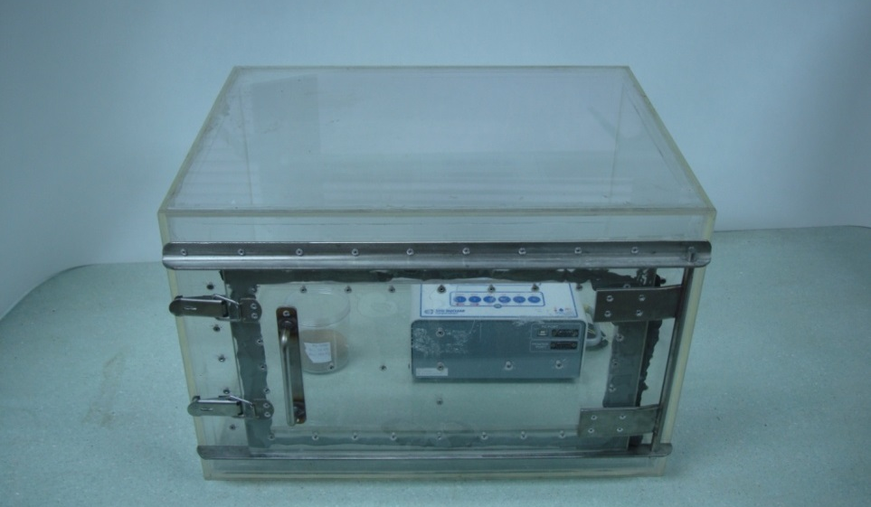
Handle
Metallic gasket
0.4 m
0.5 m
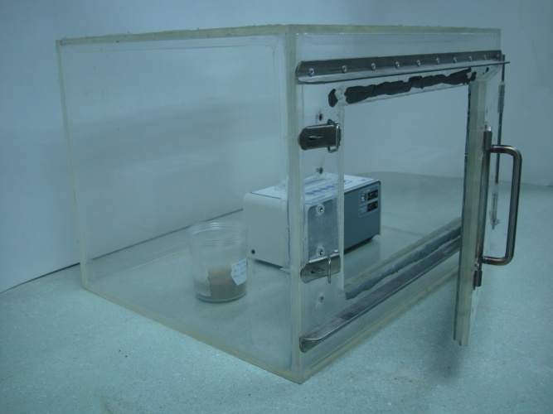
Sample
0.35 m
Door
CRM
Plasticine
Figure 1. The radon chamber with radon monitor and samples

Measurement of the radon emanation and activity concentration
Radon measurements were performed using two diffused junction photodiode continuous radon monitor (Sun Nuclear: Model 1029) as shown in Figure 2. The measurement accuracy is + 25 % pr 1 pCi/l and the sensitivity of radon monitor is 5 cph/pCi/l. This instrument has recognised by Environmental Protection Energy (EPA) and calibrated yearly by the manufacturer. The measurement range of the detection is between 1 Bq/m³ – 100 kBq/m³. The radon concentration in the chamber is monitored at one hour interval for 96 hours. The continuous radon monitor can only detect the radon gas not the radon progenies gaseous hence the radon progenies are negligible. The sensitivity of radon monitor is dependent on the material and volume of homemade chamber, the position of continuous radon monitor in the radon chamber.

Experiments were performed to measure the emanation of radon gas in the homemade chamber as a function of time. To do this, a background counting is done by opening the chamber’s door and allowing the chamber air to reach equilibrium with the ambient room air naturally [3]. The chamber’s door then was closed with radon monitor inside; begin to allow the radon monitor to collect the data. Next, this step was used to count the Xenotime sample until one hour intervals for 96 hours measurements.

The leakage tests for homemade chamber were carried out before radon concentration was measured. The test was done by using the tap water added with blue dye. After that the blue dye of water was filled in the homemade chamber. Tissue was used to cover the outer walls of radon chamber to observe whether the condition of tissue. After the test was done, the finding showed that all the tissue was not wet and still in a good condition. Even though water had larger molecule of particle compared with gaseous but it can be notified that there was no leakage showed when this practiced made.

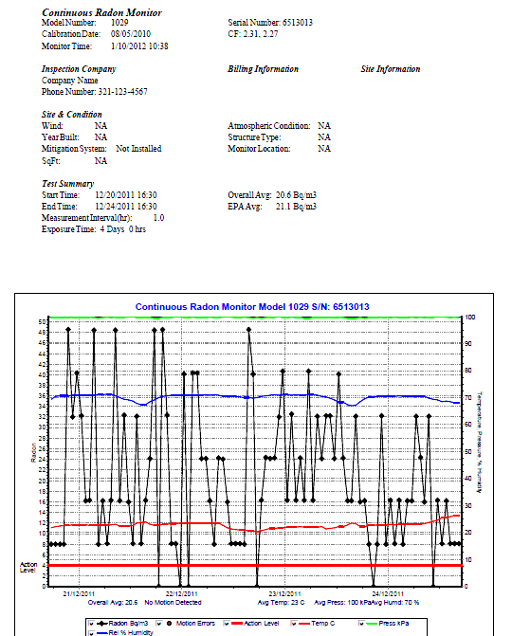

Figure 2. The report of radon concentration using radon monitor Sun Nuclear 1029

Study sample
Xenotime mineral has greater production of radon gas compared to the other minerals such as Ilmenite, Monazite, Struverite and Zircon. This is because the activity of radium-226 (²²⁶Ra) in Xenotime mineral is higher than others and it is known that ²²⁶Ra is the parent of radon gas. That is why Xenotime mineral is chose to become the source of radon in this study. Xenotime mineral is collected from an amang processing plant located in Factory of Hup Lee Sdn. Bhd., Kampar, Perak, Malaysia with GPS coordinate 4º 39”N 100º 98” E .

Treatment of samples
The samples were oven dried at temperature of 105ºC for 24 hours until constant mass, then xenotime was sieved through > 500 µm mesh sieve and their bulk densities determined. All the samples had nearly the same densities (i.e. 1.0593 g cm⁻³).

Each sample were weighed according to the selected portion of 150 g, 250 g and 500 g and put into counting container. Each prepared samples were labelled according to the code used in Table 1 below.

Table 1. Classification of samples and its code
Code | Mass (g)
XE 1 | 150
XE 2 | 250
XE 3 | 500

Concentration of radon
Radon concentration for each samples studied, were measured using a radon monitor that was left for 96 hours at the homemade chamber. The reading of radon concentration (Bq m⁻³) was obtained, recorded and classified according to study sample. The values were calculated by subtracting the average reading of first three readings since they were considered unstable and to permits the test environment to stabilize. The average reading at each sample were classified into a set of 24 hours, which the average concentration of radon readings taken accordingly in the range of 1-24 hours, 25-48 hours, 49-72 hours and 73-96 hours with a standard deviation calculated for each interval of 24 hours. The average radon concentration was determined using the following equation suggested by EPA [6]:

Total reading 96 hours – 3 first reading
(Bq m⁻³ h⁻¹)
Average Reading = (Eq. 1) 93 hours

Results and Discussion
Data analysis for background chamber
Analysis for background counting was done by measuring the empty chamber using radon monitor for 96 hours. The results of radon concentration showed by the radon monitor system were deducted with the background radon concentration collected in empty radon chamber.

Table 2 showed the result of radon concentration for background counting in blank chamber. The average of radon concentration recorded for each interval for 1 to 24 hours showed 23.4 Bq m⁻³, 24 to 48 hours showed 21.8 Bq m⁻³, 48-72 hours showed 24.9 Bq m⁻³ and 72-96 hours showed 14.1 Bq m⁻³. The total radon concentration recorded was 21.0 ± 4.8 Bq m⁻³ meanwhile EPA average showed 21.1 Bq m⁻³. The total radon concentration were called as measured radon emanation while for EPA average was radon emanation that calculated automatically based on the system configuration of radon monitor and it appeared with the result of radon concentration. The EPA average was the average of total reading radon concentration without deducting the three first reading of radon concentration. The EPA was a guideline data for radon concentration’s action level. The result of background counting was due to air that contained in the chamber.

Data comparisons between Xenotime sample
In this research, Xenotime sample were used to observe the radon emanation patterns in the radon chamber. The comparisons were made between the background counting and the different masses i.e 150 g, 250 g and 500 g of Xenotime as a manipulated variable. The results showed that increasing the sample, the higher concentration of radon will get. Table 3 indicated the radon concentration for each hour until 96 hours for XE 1 (150 g), XE 2 (250 g) and XE 3 (500 g).

Table 2. Background radon concentration
Hour | Blank (Bq m⁻³)
Hour | 1-24 | 24-48 | 48-72 | 72-96
1 | 8.0 | 48.4 | 0.0 | 16.0
2 | 8.0 | 0.0 | 16.3 | 16.1
3 | 8.0 | 48.5 | 24.4 | 8.0
4 | 8.0 | 32.4 | 24.1 | 0.0
5 | 48.5 | 8.1 | 24.3 | 8.0
6 | 32.0 | 8.1 | 32.0 | 32.3
7 | 40.3 | 0.0 | 40.7 | 8.0
8 | 32.3 | 40.2 | 16.3 | 16.3
9 | 16.1 | 0.0 | 32.5 | 8.1
10 | 16.3 | 40.3 | 16.3 | 16.3
11 | 48.4 | 40.3 | 24.3 | 8.0
12 | 8.0 | 24.1 | 16.3 | 16.0
13 | 16.1 | 24.1 | 40.7 | 16.1
14 | 8.1 | 16.1 | 16.3 | 32.1
15 | 16.3 | 8.0 | 32.1 | 24.4
16 | 48.4 | 24.3 | 24.1 | 16.0
17 | 16.1 | 24.0 | 32.3 | 32.1
18 | 32.4 | 16.0 | 32.3 | 0.0
19 | 16.0 | 8.1 | 24.1 | 16.3
20 | 8.1 | 8.1 | 40.2 | 8.1
21 | 32.1 | 8.1 | 24.3 | 16.1
22 | 8.1 | 8.0 | 16.1 | 8.1
23 | 16.3 | 48.5 | 16.1 | 8.1
24 | 24.1 | 40.2 | 32.1 | 8.1
Total | 492.0 | 523.9 | 598.2 | 338.6
Average | 23.4 | 21.8 | 24.9 | 14.1
Radon concentration | 21.0 ± 4.8
EPA average 21.1 Bq m⁻³

Table 3 showed that the measured radon concentration for XE 1, XE 2 and XE 3 are 249.6 ± 119.1 Bq m⁻³, 402.0 ± 187.6 Bq m⁻³ and 2236.6 ± 213.8 Bq m⁻³ respectively. EPA average are 252.1 Bq m⁻³, 403.6 Bq m⁻³ and 2239.0 Bq m⁻³ respectively. The results determined the highest radon concentration was XE 3 while the lowest was XE 1. Furthermore, the radon activity also indicated that XE 3 showed the highest contribution on radon activity but XE 2 showed the lowest radon activity. The reasons why Xenotime sample were used in this research due to the high natural radioactivity of radium contained that produced radon as its decay product. Xenotime is one of tin tailing that contained high radioactivity. Other tin tailing are Monozite and Ilmenite were high natural radioactivity of thorium which not produced radon but thoron. In this case, the measured radon concentration from Xenotime samples were assumed to be the maximum radon gas collected in this chamber. The chamber was airtight, sealed and not affected by the outdoor air. It was only from the sample that emanated the radon gas.

Table 3. Radon concentration for Xenotime sample at 150 g, 250 g and 500 g
Sample | Radon concentration  (Bq m⁻³) | EPA Average  (Bq m⁻³)
XE 1 | 249.6 ± 119.1 | 252.1
XE 2 | 402.0 ± 187.6 | 403.6
XE 3 | 2236.6 ± 213.8 | 2239.0

Parameters studied
There were three parameters to be studied in this research. The temperature, humidity and pressure were the parameters that give effects to radon concentration in the radon chamber. When the temperature cold, the radon gas will became inactive and due to their physical property which is radon is a heavy gas, it will assemble together closely [7]. Humidity gives effects on radon concentration by the presence of moist air. Pressure plays an important role to the production of radon concentration. When the pressure is high, the pressure may depress the radon flux from the Xenotime samples and the radon concentration may be decreased [8]. The EPA did not mention the standard range for temperature, humidity and pressure in radon studies to use it as a comparison reference value.

Table 4 showed the average true reading of radon concentration, temperature, humidity and pressure. The true reading was calculated based on measured radon concentration by the radon monitor. The value of temperature, humidity and pressure were measured automatically by the radon monitor 1029. This monitor was able to detect the parameters due to special specifications built in the monitor. With these parameters, the patterns of radon emanation can be observed and studied.

Table 4. The average true reading of radon concentration and all the parameters
Samples | Radon concentration (Bq m⁻³) | Temperature (ºC) | Humidity (%) | Pressure (Pa)
Empty chamber | 21.0 ± 4.8 | 23.0 | 69.0 | 996.5
XE 1 | 249.6 ± 119.1 | 27.0 | 57.0 | 997.5
XE 2 | 400.0 ± 187.6 | 29.0 | 59.0 | 998.0
XE 3 | 2236.6 ± 213.8 | 22.5 | 60.0 | 998.5

Figure 3, 4 and 5 showed the graph of temperature, pressure and humidity against radon concentration for empty chamber, XE 1, XE 2 and XE 3. From the results, the temperature for empty chamber and for each xenotime sample showed in the range from 20 ºC to 34 ºC. For pressure, the results showed in the range from 993 Pa to 1002 Pa and for humidity the results showed in the range from 54 % to 71 %. In this studied, all those parameters should be constant because the measurement was done in enclosed chamber without any disturbance from the outside surrounding. From this result, it showed that there is a variation occurred on temperature, pressure and humidity for each measurement but the deviation is still in a range.

Temperature

a) b)
c) d)

Figure 3. Variation of temperature against radon concentration for a) empty chamber b) XE1 c) XE2 d) XE3

Pressure

a)  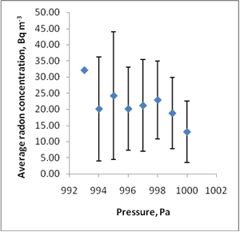 | b)  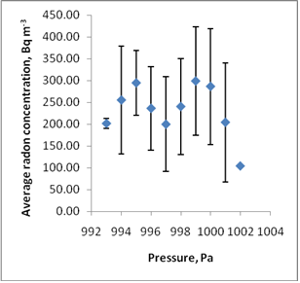
c) | d)

Figure 4. Variation of pressure against radon concentration for a) empty chamber b) XE1 c) XE2 d) XE3

Humidity

a) | b)
c) | d)

Figure 5. Variation of humidity against radon concentration for a) empty chamber b) XE1 c) XE2 d) XE3

Conclusion
This chamber designed is unique because of its size, Perspex material, and airtight design. This paper describes an experimental method for determining radon concentration in homemade radon chamber using Xenotime sample as studied sample. The method proposed here is based on 96 hours accumulation technique. The radon concentration is measures using radon monitor Sun Nuclear Model 1029 directly in the chamber. This configuration allows the radon concentration increase to be monitored hourly without any disturbance induced by outdoor air. The effects of parameters on the radon concentration measurement are taken into account. Results showed that this homemade chamber can be used to determine the radon concentration, EPA average and radon activity using radon monitor.

Acknowledgement
The authors would like to thank to Universiti Kebangsaan Malaysia for the project grant with reference number UKM-AP-PLW-04-2009/1 and UKM-GUP-2011-152 and to Nuclear Science Programme of UKM for their technical support throughout the research.

References
- NRC. 1999. Health Effects of Exposure to Radon. National Research Council, Biological Effects of Ionizing Radiation (BEIR) VI Report.
- IARC. 2001. IARC Monographs on the Evaluation of Carcinogenic Risks to Humans 78, Part 2: Some Internally Deposited Radionuclides.
- Moore, J.A. and Kearfott, K.J. 2005. A Simple Radon Chamber for Educational Use. The Radiation Safety Journal 89 (5):78-84
- Moore, R. and Moore W.S. 1984. Mechanism of transport of U-Th series radioisotopes from solids into ground water. Geochim.Cosmochim.Acta 48: 395-399.
- Greeman, D. J. and Rose, A.W. 1996. Factoscontrolling the emenation of radon and thoron in soils of the eastern U.S.A Chem. Geol. 129: 1-14.
- EPA. Environmental Protection Agency. 2003. EPA Assessment of Risks from Radon in Homes. PA 402-R03-003. U.S.
- Al-Ahmady, K. and Hintenlang, D.1994. Assessment of Temperature-Driven Pressure Differences with regard to Radon Entry and Indoor Radon Concentration. AARST International Radon Symposium
- Nazaroff, W.W. and Sextro, R.G. 1989. Technique for Measuring the Indoor Rn 222 Source Potential of Soil. Environmental Science and Technology 23 (4): 451-458.

