

PRODUCTION OF BIOCHAR WITH HIGH MINERAL CONTENT FROM OIL PALM BIOMASS

(Pengeluaran Biochar dengan Kandungan Mineral yang Tinggi dari Biomas Kelapa Sawit)

Juferi Idris^{1,2,3}, Yoshihito Shirai¹ , Yoshito Ando¹ , Ahmad Amiruddin Mohd Ali¹ , Mohd Ridzuan Othman⁴ , Izzudin Ibrahim⁴, Mohd Ali Hassan^{4,5}*

¹Department of Biological Functions and Engineering, Graduate School of Life Science and Systems Engineering,
Kyushu Institute of Technology, 2-4 Hibikino, Wakamatsu-ku, Kitakyushu, Fukuoka 808-0196, Japan.
²Faculty of Chemical Engineering,
Universiti Teknologi MARA (UiTM) Sarawak, 94300, Kota Samarahan, Sarawak, Malaysia
³Faculty of Chemical Engineering,
Universiti Teknologi MARA (UiTM) Malaysia, 40450, Shah Alam, Selangor, Malaysia.
⁴Department of Bioprocess Technology, Faculty of Biotechnology and Bimolecular Sciences,
⁵Department of Process and Food Engineering, Faculty of Engineering,
Universiti Putra Malaysia, 43400 UPM Serdang, Selangor, Malaysia

*Corresponding author: alihas@upm.edu.my

Abstract
Carbonization of oil palm empty fruit bunch (OPEFB) biomass for the production of high mineral content biochar under an uncontrolled carbonization temperature and controlled air flow rate was studied using a pilot-scale brick carbonization reactor. The maximum temperature during the carbonization process was found to be in the range of 543 to 564 ºC at exhaust gas flow rate of 36 m³/hr. All minerals (i.e P, K ,Mg, Ca, Na, Mn, Fe, Cr, AI) showed an increased from the feedstock concentration up to 300 %. The concentration of heavy metal extracted from OPEFB biochar was lower than listed ceiling permitted levels. This proposed system without electrical control and heating source is preferable to the industry due to its simplicity, ease of operation and low energy requirement making it suitable for OPEFB biochar production for mulching purposes with more than double the mineral content compared to raw OPEFB biomass.

Keywords: biochar, elemental, carbonization; oil palm empty fruit bunch; oil palm biomass

Abstrak
Karbonisasi kelapa sawit tandan kosong biomas untuk pengeluaran kandungan mineral yang tinggi biochar di bawah suhu karbonisasi yang tidak terkawal dan dikawal kadar aliran keluar asap telah dikaji menggunakan skala-pilot reaktor bata karbonisasi. Suhu maksimum semasa proses karbonisasi yang didapati dalam julat 543-564ºC pada kadar aliran asap pada 36 m³/jam. Semua mineral (iaitu P, K, Mg, Ca, Na, Mn, Fe, Cr, AI) menunjukkan peningkatan dari kepekatan bahan mentah sehingga 300%. Kepekatan logam berat yang diekstrak daripada biochar adalah lebih rendah daripada paras siling dibenarkan disenaraikan. Sistem yang dicadangkan tanpa kawalan elektrik dan sumber pemanasan adalah lebih baik untuk industri karena kesederhanaan, kemudahan operasi dan keperluan tenaga yang rendah menjadikan ia sesuai untuk pengeluaran biochar kelapa sawit untuk tujuan mulsa dengan lebih daripada dua kali ganda kandungan mineral berbanding kelapa biomas mentah.

Kata kunci : biochar, unsur mineral, karbonisasi; kelapa sawit buah tandan kosong; biomas kelapa sawit

Introduction
Biochar is a carbon-rich substance produced when biomass is heated at a certain temperature without any oxygen in a closed system [1]. The utilization of biochar give better improvement for soil fertility and reduce the use of chemical fertilizers as compared to raw biomass for the same purpose [2]. In addition, biochar from biomass can be used to prevent erosion and maintain soil moisture while reducing pollution to the environment [3]. Being one of the largest producer and exporter of palm oil, Malaysia palm oil industry is currently expanding rapidly and yields large amount of poorly utilized waste biomass [4]. Malaysia has 362 palm oil mills, processing 71.3 million tons of fresh fruit bunch per year and producing an estimated 19 million tons of crop residues annually in the form of OPEFB, fibre and shell [5]. About 69,000 dry tons of OPEFB can be produced per year at a typical palm oil mill [6]. Currently, only mesocarp fibers and palm kernel shell are used as fuel to generate steam and electricity for palm oil mills requirement [7], while raw OPEFB is partly sold for mulching purpose [6].

Utilization of biomass-derived combustion fly ash comprises both char and inorganic ash component generated by biomass-based power plant for soil amendment are of recent interest [8]. The ash obtained from combustion with high inorganic content is useful for increasing the pH and providing nutrient [9]. Moreover, gaseous emission generated from power plant or incinerator has created pollution to the environment. In this study, we propose an uncontrolled carbonization to produce biochar with high mineral content and low heavy metal using biomass feedstock. Under uncontrolled carbonization, a sustained combustion process without an electrical control source is more preferable to the industry due to its simplicity, ease of operation and low energy requirement.

Materials and Methods
Pressed-shredded OPEFB biomass particle size range 100-150 mm was obtained from Seri Ulu Langat Palm Oil Mill, Dengkil, Selangor, Malaysia. The carbonization was carried out in the 1m x 1m clay brick reactor with 30 kg capacity using portable propane burner where initial burning on top of the reactor for about 5-10 minutes before being completely closed with no oxygen entrance. The temperatures inside the reactor were monitored using three k-type thermocouples positioned at different heights from top to bottom of the reactor. The exhaust gas flow rate discharged from the reactor was set at 36 m³/hr to ensure the circulation of hot air distributed uniformly from top to the bottom before being discharged through 3 meter chimney. The experiments were repeated at least two times to ensure reproducibility.

The main elements obtained from raw OPEFB biomass and OPEFB biochar samples was analyzed using inductive coupled plasma-optical effluent spectrophotometer (ICP-AES, model: Perkin Elmer 2100). About 1-2 gram of the samples was first placed in the furnace at temperature gradually to 300 ºC until smoke ceased and was raised up to 500 ºC and continued at this temperature until a white or greyish-white ash was obtained. The sample was then digested using concentrated hydrochloric acid (37% v/v) and nitric acid (20% v/v) [10].

Results and Discussion
Raw OPEFB elemental characteristic
Table 1 shows the main elementals obtained from the raw OPEFB biomass. All elemental found in this study is according to Wan Razali et al. [11] where the source of raw OPEFB biomass collected was from the same place (Seri Ulu Langat Palm Oil Mill, Dengkil, Selangor, Malaysia). High concentrations of potassium (K) and phosphorus (P) is due to usage of fertilizers which contain potassium nitrate (KNO₃) and phosphoric acid (H₃PO₄) [12].

Effect of the OPEFB biomass on the carbonization temperature profile under uncontrolled temperatures
Figure 1 shows the average temperature profiles measured during carbonization of OPEFB biomass under uncontrolled carbonization temperatures. The experiment was repeated at least twice to ensure reproducibility of the process. The temperature in the reactor gradually increased moments after the fire was introduced from the top shown in Figure 1. The carbonization start time measured when the temperature reached 300 ºC, The maximum temperature for experiment 1 and 2 were found to be 564 and 543 ºC respectively and were found maintained above 300 ºC at average retention time 630 min for long period of carbonization process which was suitable for targeting char production [13]. Generally the temperatures increased as combustion moved from top towards the bottom of the reactor.

Table 1. Elemental analysis of EFB samples carried out by ICP-OES
Concentration ppm (%)
Elements | This study | Wan Razali et al [11]
Phosphorus, P | 470 ±180 (0.05%) | 0.1%
Calcium, Ca | 1330 ±410 (0.13%) | 0.2%
Sulphur, S | 1730±210 (0.17%) | 0.1%
Iron, Fe | 561.57 ±131.64 (0.06%) | 0.1%
Potassium, K | 12200 ±2600 (1.22%) | 1.4%
Magnesium, Mg | 870 ±270 (0.09%) | 0.1%
Sodium, Na | 71.97 ±8.23 | -
Chromium, Cr | 2.03 ±0.12 | 39.1 ppm
Manganese, Mn | 21.47 ±4.18 | 26.4 ppm
Boron, B | 11.9 ±1.42 | 1.8 ppm
Cadmium, Cd | 0.2 ±0.14 | ND
Copper, Cu | 17.3 ±5.09 | 19.6 ppm
Nickel, Ni | 1.8 | ND
Lead, Pb | 1.13 ±0.21 | 0.2 ppm
Zinc, Zn | 16 ±5.9 | 22.4 ppm
Silicon, Si | 304.1 ±90.25 | -
ND=Not detected

Figure 1. Temperature profiles of during carbonization of OPEFB biomass under uncontrolled carbonization temperatures and controlled air flow rates.
Elemental content of OPEFB biochar at different particle size under uncontrolled carbonization temperature and controlled air flow rates
Carbonization concentrated minerals of OPEFB biochar is shown in Figure 2. Being rich in minerals, OPEFB biochar may be better suited as alternative chemical fertilizer or at least reduced the usage of them. For example, P-content in OPEFB biochar increased tremendously from the raw OPEFB biomass concentration by 310 %. K-content also has high effect on the soil fertility increased by 286 %. Other mineral (i.e Mg, Ca, Na, Mn, Fe, Cr, AI) also showed increased from the feedstock concentration by 142-376 %. Although all minerals reported in this study were lower than fly ash but P and K content which were 1.46 and 34.85 g/kg respectively was comparable to Pan and Eberhardt (2011) which found in the range 2.44 and 20.33 g/kg respectively.
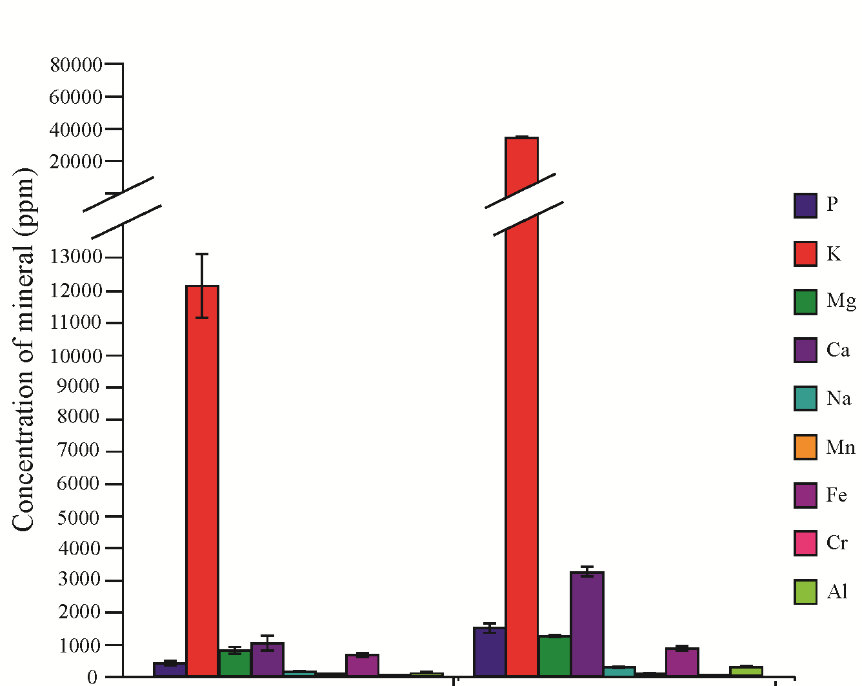
⁴⁷⁰
¹²²⁰⁰
⁸⁷⁰
¹³³⁰
⁷²
²¹
⁵⁶¹
^{2.0}
¹⁵⁰
²⁰²
^{2.9}
⁷⁷³
⁶¹
²⁷¹
³²⁵⁸
¹²⁴¹
³⁴⁸⁵⁵⁵
¹⁴⁵⁶

Raw OPEFB OPEFB biochar
Figure 2. Comparison of mineral concentration between raw OPEFB and OPEFB biochar

Table 2. Heavy metal concentration of OPEFB biochar
Heavy metal | Concentration (ppm)
Heavy metal | This study |  | Pan and Eberhardt [8]
Cu | 28.53 | (±4.27) | 37.25(3.64)
Zn | 55.93 | (±8.80) | 345.45(5.05)
Cd | 0.40 | (±0.20) | 4.39(0.09)
Pb | 23.7 | (±2.97) | 11.83(0.17)
Ni | 2.53 | (±1.17) | 47.29(3.27)
Mo | 8.27 | (±3.63) | -
As | 71.4 | (±23.19) | 10.06(10.90)
The concentration of heavy metal (Table 2) extracted from OPEFB biochar were lower than standards for the use or disposal of sewage sludge listed ceiling concentration under 40 C.F.R §503 [14]. Lower concentration of Cd due to lost in gas oil phase at carbonization up to 400 ºC which was within temperature of this study however in contrast, Cd, Zn, and Cu did not exhibit losses to the same phase [15]. As compared to ash fly heavy metal reported by Pan and Eberhardt (2011), the concentration of heavy metal in this study were much lower, thus effect on the plant growth can be minimized.

Conclusion
The application of uncontrolled carbonization in a pilot scale for the production of high mineral content biochar from OPEFB biomass successfully increased from the feedstock concentration by 300 % and phosphorus and potassium were comparable with other studies. Meanwhile heavy metals were found lower than listed ceiling concentration. This proposed system without electrical control and heating source is preferable to the industry due to its simplicity, ease of operation and low energy requirement.

Acknowledgement
The authors would like to thank Kyushu Institute of Technology (Kyutech), Japan, Universiti Putra Malaysia (UPM), Malaysia, Universiti Teknologi MARA (UiTM), Malaysia and Universiti Teknologi MARA (UiTM) Sarawak for their financial and technical support towards this research.

References
- Gaunt, J. L. and Lehmann, J. (2008). Energy balance and emissions associated with biochar sequestration and pyrolysis bioenergy production. Environ Sci Technol 42: 4152–4158.
- Abu Bakar, R., Darus, S. Z. and Kulaseharan, S. (2010). Jamaluddin N. Effects of ten year application of empty fruit bunches in an oil palm plantation on soil chemical properties. Nutr Cycl Agroecosystems 89:341–349.
- Lim, K. C. and Zaharah, A. R. (2000). Decomposition and n & k release by oil palm empty fruit bunches applied under mature palms. J Oil Palm Res 12:55–62.
- Malaysian palm oil council (MPOC). Oil palm plantation (2014). Oil palm plantation .http://www.mpoc.org.my/Overview.aspx. [aceessed 20.4.2014]
- Sumathi, S., Chai, S. P. and Mohamed, A. R. (2008). Utilization of oil palm as a source of renewable energy in Malaysia. Renew Sustain Energy Rev 12: 2404–2421.
- Yoshizaki, T., Shirai, Y., Hassan, M. A., Baharuddin, A. S., Raja Abdullah, N. M. and Sulaiman, A. (2013). Improved economic viability of integrated biogas energy and compost production for sustainable palm oil mill management. J Clean Prod 44:1–7.
- Yusoff, S. (2006). Renewable energy from palm oil – innovation on effective utilization of waste. J Clean Prod, 14:87–93.
- Pan, H. and Eberhardt, T.L. (2011). Characterization of the fly ash from the gasification of wood and assessment for its application as a soil amendment. Bioresources 6:3987–4004.
- Odlare, M. and Pell, M. (2009). Effect of wood fly ash and compost on nitrification and denitrification in agricultural soil. Appl Energy 86:74–80.
- Idris, J., Musa, M., Yin, C. Y. and Hamid, K. H. K. (2010). Recovery of nickel from spent catalyst from palm oil hydrogenation process using acidic solutions. J Ind Eng Chem 16:251–255.
- Razali, W. A. W., Baharuddin, A. S., Talib, A. T., Sulaiman, A., Naim, M. N. and Hassan, M.A. (2012). Degradation of oil palm empty fruit bunches (OPEFB) fibre during composting process using in-vessel composter. BioResources 7:4786–805.
- Razuan, R., Chen, Q., Finney, K. N., Russell, N. V., Sharifi, V. N. and Swithenbank, J. (2011). Combustion of oil palm stone in a pilot-scale fluidised bed reactor. Fuel Process Technol 92:2219–2225.
- Spokas, K. A., Cantrell, K. B., Novak, J. M., Archer, D. W., Ippolito, J. A. and Collins, H. P. (2012). Biochar: a synthesis of its agronomic impact beyond carbon sequestration. J Environ Qual 41:973–89.
- EPA. (2005). Title 40-Protection of environment. Standards for the use or disposal of sewage sludge. Code of federal regulations. Washington, D.C.
- Lievens, C., Yperman, J., Vangronsveld, J. and Carleer, R. (2008). Study of the potential valorisation of heavy metal contaminated biomass via phytoremediation by fast pyrolysis: Part I. Influence of temperature, biomass species and solid heat carrier on the behaviour of heavy metals. Fuel, 87:1894–905.

