

PREPARATION OF EPOXIDIZED PALM OLEIN AS RENEWABLE MATERIAL BY USING PEROXY ACIDS

(Penyediaan Minyak Sawit Olein Terepoksida Sebagai Bahan Keterbaharuan Menggunakan Asid Peroksi)

Darfizzi Derawi*, Jumat Salimon, Waled Abdo Ahmed

Oleochemistry Research Laboratory, School of Chemical Sciences and Food Technology,
Faculty of Science and Technology,
Universiti Kebangsaan Malaysia, 43600 UKM Bangi, Selangor Darul Ehsan, Malaysia

*Corresponding author: darfizzi@ukm.edu.my

Abstract
Epoxidized palm olein (EPO_{o}) was prepared through generated in situ of performic acid (HCOOOH), and peracetic acid (CH₃COOOH) as epoxidation agent with the presence of sulphuric acid (H₂SO₄) 3 % v/wt as catalyst. Formic acid (HCOOH) or acetic acid (CH₃COOH) as oxygen carrier and hydrogen peroxide (H₂O₂) as oxygen donor in the reaction system. Highly conversion (95.5 %) of oxirane ringwas obtained by usingperformicacid as epoxidation agent at 150 minutes of reaction time. The reaction yield was 90 % by weight. EPO_{o} has showed good physicochemical properties as renewable material for industrial applications. Carbon (¹³C-NMR) and proton (¹H-NMR) spectra showed the present of epoxy profile at 54 ppm and 2.9 ppm. Epoxy group was detected on 844 cm⁻¹ byfourier transformation infra-red (FTIR) spectra.

Keywords: epoxidation, palm olein, in-situ, peroxy acid, renewable material

Abstrak
Minyak sawit olein terepoksida (EPO_{o}) disediakan melalui proses pengepoksidaan secara in situ menggunakan asid performik (HCOOOH), asid perasetik (CH₃COOOH) sebagai agen pengepoksidaan dengan kehadiran mangkin asid sulfurik (H₂SO₄) 3 % v/wt. Asid formik (HCOOH) atau asid asetik (CH₃COOH) sebagai pembawa oksigen dan hydrogen peroksida (H₂O₂) sebagai penderma oksigen dalam sistem tindak balas. Peratus penukaran gelang oksirana yang tinggi (95.5 %) diperolehi dengan menggunakan asid performik pada 150 minit tindak balas. Peratus hasil tindak balas adalah sebanyak 90 % berdasarkan berat. EPO_{o} telah menunjukan sifat fiziko kimia yang baik sebagai bahan keterbaharuan untuk aplikasi industri. Spektrum karbon (¹³C-NMR) dan proton (¹H-NMR) menunjukan kehadiran profil epoksi pada 54 ppm dan 2.9 ppm. Kumpulan epoksi dikesan pada nombor gelombang 844 cm⁻¹ dengan merujuk spektrum transformasi fourier inframerah (FTIR).

Kata kunci: pengepoksidaan, minyak sawit olein, in-situ, asid peroksi, bahan keterbaharuan

Introduction
Over the last decade, world concern about utilizing of renewable sources in product synthesis. Fats and oils are renewable resources that can be chemically or enzymatically treated to produce materials that can often act as a replacement for materials derived from petroleum [1]. Among of chemical modifications of polyolefins, epoxidation is a simple and efficient method for introducing a new reactive group and useful properties and wide use in a variety of applications [2]. Epoxidized oils have a high commercial importance and are widely utilized in plastics manufacture, lubricants, detergents, and as intermediates in chemical reactions [1 - 6]. Epoxidized oil has been used widely as stabilizer and plasticizer in polyvinylchloride (PVC). Epoxidized ester can be used as solvent to replace the volatile organic solvent in paints. It also has been studied actively for lubricant production through the reaction of the epoxy group with linear or branching chain [7]. Epoxidized oil with higher oxirane oxygen value and lower iodine value is considered to be of better quality [8, 9]. There are four known technologies to produce epoxides from olefinic type of molecules[1]: (a) epoxidation with per carboxylic acids [10], the most widely used in industry, can be catalyzed by acids or by enzymes [11,12]; (b) epoxidation with organic and inorganic peroxides which includes alkaline and nitrile hydrogen peroxides epoxidation as well as transition metal catalysedepoxidation [13]; (c) epoxidation with halohydrins using hypochalous acids (HOX) and their salts as reagents for the epoxidation of olefins with electron deficient double bonds [10]; and (d) epoxidation with molecular oxygen [10]. Epoxidation methods vary from case to case depending on the nature of reactants and catalyst used for epoxidation[14].

Palm olein (PO_{o}) is a vegetable oil and liquid fraction of palm oil (the largest renewable resources in Malaysia), consists of mainly mono-unsaturated triacylglycerol (TAG), POP (42.8 %) and di-unsaturated TAG, POO (35.7 %). The iodine value of PO_{o} is about 51.0 – 61.0 [15]. The present of 40.0 % oleic acid in the PO_{o} [16] is widely open for further reaction such as epoxidation process. Despite the development of many new oxidation procedures, the use of peroxy acids still constitutes a useful synthetic procedure for the epoxidation of alkenes on a laboratory scale. In the laboratory, epoxides are prepared by treatment of an alkene with a peroxy acid (RCO₃H). Commonly epoxidation reactions are carried out using a peroxy acid such as performic and peracetic, either preformed or formed in situ, by reacting a carboxylic acid as oxygen carrier with concentrated hydrogen peroxide (H₂O₂) as oxygen donor. Formic acid is preferred than acetic acid as oxygen carrier since, owing to its high reactivity, no catalyst is required in the formation of performic acid, but the production costs increase because formic acid’s price is frequently higher than acetic acid’s price [17].

Comparison between performic and peracetic acid as epoxidation agent on PO_{o} are not yet been studied. Kinetic study on the epoxidation and oxirane cleavage of methyl ester palm olein (MEPO) by using performic acid generated in situ as catalyst has been reported [5]. Performic acid has been used in the epoxidation process on fatty acid methyl ester (FAME) of soybean [18]. High epoxidation yield was obtained at 40 ºC with using high concentration of hydrogen peroxide (60 wt. %). A study on partial and fully epoxidation of plant oils with perhydrolysis lipase as catalyst has been reported [19]. Epoxidation of unsaturated plant oils conducted in industrial process by Prileshajev-epoxidation using short chain peroxy acid generated in situ. Novozym ® 435 and hydrogen peroxide have been used to epoxidize the unsaturated plant oils and over than 90 % of conversion was obtained [19].

In this paper, we discuss the preparation of epoxidized palm olein (EPO_{o}) by using three different approaches and the physicochemical properties of the product.

Materials and Methods
Raw Materials
Palm olein (Seri Murni brand, FFM Marketing Sdn. Bhd.) was used as raw material. Formic acid (HCOOH) (99 %) and glacial acetic acid (CH₃COOH) (100 %)were purchased from Univar and Bendosen. While, hydrogen peroxide (H₂O₂) (30 %) from J. T. Baker.

Production of Epoxidized Palm Olein
Epoxidized Palm Olein (EPO_{o}) was produced by using generated in situ peroxy acid with a constant molar ratioof PO_{o}:HCOOH/CH₃COOH:H₂O₂ (1:5:4 mole/mole) under continuous magnetic stirring at constant temperature (45 ºC) [20].The reaction was carried out in a three necked glass (250 ml capacity) flask equipped with thermometer and reflux condenser. Generated in situ peroxy acid is produced by mixing formic acid (HCOOH) or acetic acid (CH₃COOH) with H₂O₂ simultaneously. Hydrogen peroxide was slowly added drop wise into the acidic media. Fast introduction to this reagent will cause an excessive development of oxygen due to the decomposition of H₂O₂ at high temperature and is not recommended [2]. After the reaction finished, samples of reaction mixture were taken out and thoroughly washed with sodium bicarbonate (5 wt%), distilled water and sodium chloride (5 wt%) to separate the organic layer from the mixture. The sample was then analyzed for oxirane oxygen content (OOC) value and the percentage of oxirane conversion was calculated.

Determination of oxirane oxygen content
Oxirane oxygen content (OOC) value was determined by direct method using hydrobromic acid solution in glacialaceic acid (AOCS Cd 9-57) [21,22]. The percentage of conversion can be calculated based on the theoretical OOC value of PO_{o} [1,16]. From the oxirane content values, the relative percentage conversion to oxirane was calculated using the Equation 1:

Relative percentage conversion to oxirane = (OOC_{exp} / OOC_{the}) x 100 (Eq .1)

where OOC_{exp} (g/100 g sample) is the experimentally obtained oxirane oxygen and OO_{the} is the theoretically obtainable maximum oxirane oxygen, which was determined from the Eq. 2:

OO_{t} = {(IV₀/A_{i}) / [100 + (IV₀/2A_{i}) A0]} x A₀ x 100 (Eq. 2)

where A_{i} (126.9) and A_{o} (16.0) are the atomic weights of iodineand oxygen respectively and IV₀ is the initial iodine value of oil sample.

Detection tests
FTIR spectrometer (GX model) was used to detect the present of epoxide group by using the NaCl salt window method. Epoxide group can be detected at wavenumber 750 - 880 cm⁻¹ and 815 - 950 cm⁻¹ [23]. Proton and carbon analysis was performed by using FT-NMR spectrometer 600 MHz Cryo-Probe (Advance 111 600MHz model). Sample was prepared by using chloroform (CDCl₃) as a solvent [11].

Characterisation tests
Physicochemical tests were carried out to analyze the iodine value, oxidative stability [4], flash and fire point, pour point (ASTM D 97-66) [15], kinematic viscosity at 40 ºC and 100 ºC (ASTM D 445- 79) [15] and viscosity index (ASTM D2270) [13].

Results and Discussion
Epoxidation of palm olein (PO_{o}) was carried out by using generated in situ performic acid (HCOOOH) and a peracetic acid (CH₃COOOH). They prepared by mixing of formic acid (HCOOH) and acetic acid as oxygen carrier and hydrogen peroxide (H₂O₂) as oxygen donor [24]. Generation reaction of peracid are given in Figure 1.

Figure 1. Generation reaction of performic acid (HCOOOH) and a peracetic acid (CH₃COOOH)

Preparation HCOOOH and CH₃COOOH as epoxidation agents were carried out as in situ since the reaction condition is highly exothermic and not stable. The epoxidation process involved of electrophilic addition mechanism as Figure 2. Unsaturated bond at triacylglycerol (TAG) PO_{o} was converted to oxirane ring to produce epoxidized palm olein (EPO_{o}) [24]. Peroxy-acids are commonly used epoxidizing agents. They have an extra oxygen atom between the carbonyl group and their acidic hydrogen, and are electrophilic at oxygen. Attack at this position by a nucleophile displaces carboxylate, which is a good leaving group. An example of one such reaction is shown below involving ethylene and peroxyformic acid. The mechanism is essentially an electrophilic attack, with a proton being transferred from the epoxide oxygen to the carboxylic acid by-product. Firstly the nucleophilic π bond donates its electrons to the oxygen, breaking the O-O bond to form the new carbonyl bond. The electrons from the old O-H bond make up the second new C-O bond, and the original carbonyl group uses its electrons to pick up the proton. The transition state for the reaction makes the bond-forming and bond-breaking processes much clearer.

Figure 2. Mechanism for oxirane formation

Based on Figure 3, by introducing acid catalyst in the epoxidation system, it seems to give a high OOC value in a short period (30 minutes) but at the same time, the oxirane cleavage rapidly occur, then, the OOC value will decrease along with the reaction time. The epoxidation process was exothermic and high concentration of peroxy acid must be avoided [7]. Besides, the epoxidation process by using peracetic acid just only gave OOC value below 1.00 %. CH₃COOOH is not an effective epoxidation agent compared to the HCOOOH. HCOOH is better than CH₃COOH for this work because, when reacted with H₂O₂, HCOOOH forms at a much faster rate than CH₃COOOH [25,26,4]. The optimum oxirane oxygen content (OOC) value obtained was 3.57 % (± 2.8) compared to the theoretical OOC value was 3.74 % [13]. The optimum oxirane conversion was 95.5 % with 90.0 % yield. Table 1 shows the physicochemical properties of EPO_{o}. It has good properties on oxidative stability (193.9 ºC), flash and fire points (> 320 ºC), and kinematic viscosity.

Figure 3. Relative conversion of EPO_{o}

Table 1. Physicochemical properties of EPO_{o}
Characterization | Unit | EPO_{o}
Oxidative stability | ºC | 193.9
Flash point | ºC | ˃ 320
Fire point | ºC | ˃ 320
Pour point | ºC | 16
Kinematic viscosity, 40 ºC | cSt | 158.6
Kinematic viscosity, 100 ºC | cSt | 19.8
Viscosity index | - | 144
Physical state (Room temperature) | - | Semi solid
Percentage of conversion | % | 95.5
Yield | % | 90

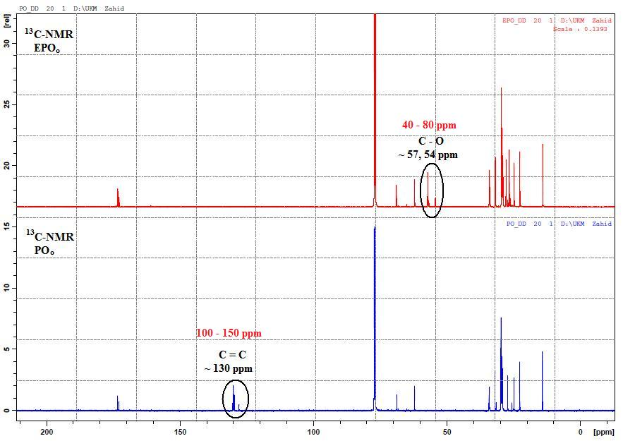

Figure 4. Comparison ¹³C-NMR spectra between PO_{o} and EPO_{o}

The present of oxirane ring of EPO_{o} proved by ¹³C-NMR and ¹H-NMR spectra. Based on Figures 4 and 5, the presents of oxirane ring can be confirmed with the theoretical ¹³C and ¹H chemical shift ranges (ppm). ¹³C chemical shift ranges for unsaturated bond was 100 - 150 ppm while for C - O was 40 - 80 ppm. ¹H chemical shift ranges for vinyl hydrogen (C=C–H) was 4.5 - 6.5 ppm and for allyic hydrogen (C=C–C–H) was 1.6 - 2.6 ppm while for epoxide ring appeared in the range 5 - 3.5 ppm [23]. Based on comparison between PO_{o} and EPO_{o} FTIR (Figure 6), the spectrum of PO_{o} showed an overtone streching vibration peak of C=O for ester at wavenumber 3473 cm⁻¹, streching vibration peak of =CH (3003 cm⁻¹) and unsaturation peak of HC=CH (cis) at wavenumber 1651 cm⁻¹. While, for the FTIR spectrum of EPO_{o}, the unsaturation peak and streching vibration peak of =CH for PO_{o} have been disappeared. But the presents of oxirane ring peak was detected at wavenumber 844 cm⁻¹. Theoretical [27] explained that oxirane ring can be detected at wavenumber 750 – 880 cm⁻¹ and 815 – 950 cm⁻¹, while overtone streching vibration peak of C=O for ester at wavenumber ~3450 cm⁻¹, streching vibration peak of =CH can be detected at wavenumber 3050 – 3000 cm⁻¹ and bonding peak of HC=CH (cis) at wavenumber 1650 – 1600 cm⁻¹. Based on Figure6, FTIR spectrum of PO_{o} showed an overtone streching vibration peak of C=O for ester at wavenumber 3473 cm⁻¹, streching vibration peak of =CH (3003 cm⁻¹) and unsaturation peak of HC=CH (cis) at wavenumber 1651 cm⁻¹. While, for the FTIR spectrum of EPO_{o}, the unsaturation peak and streching vibration peak of =CH for PO_{o} have been disappeared. But the presents of oxirane ring peak was detected at wavenumber 844 cm⁻¹.

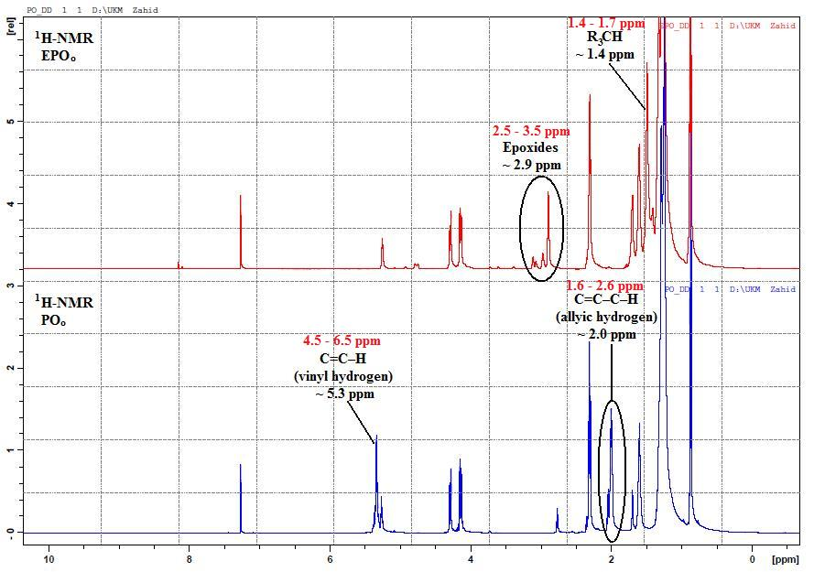

Figure 5. Comparison ¹H-NMR spectra between PO_{o} and EPO_{o}

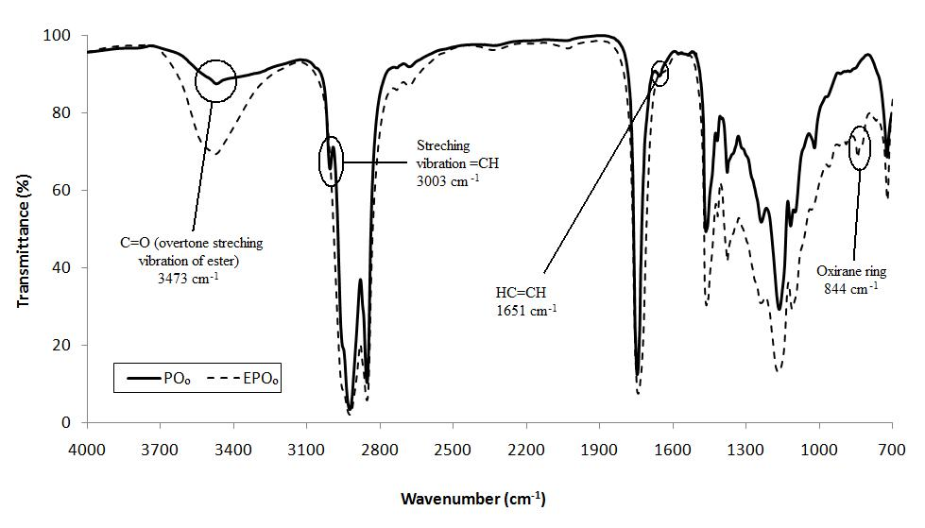

Figure 6. Comparison FTIR spectra between PO_{o} and EPO_{o}

Conclusion
Epoxidized palm olein is successfully produced by using peroxy acids. Performic acid is the best epoxidation agent for epoxidation process on palm olein. The presence of epoxide was proved by ¹³C, ¹H-NMR and FTIR spectra. EPO_{o} is potentially to be used as renewable material in synthesis process, coating, biolubricant, plasticizer and polymer industry.

Acknowledgement
Authors would like to acknowledge Mr. Mohd Zahid Md. Yusoff (UKM’s Science Officer) and Mr. Hasanudin Salleh for technical supports in this project. Thanks to the Universiti Kebangsaan Malaysia for the financial support through research grant no. GGPM-2014-033 and DPP-2014-058.

References
- Goud, V. V., Patwardhan, A. V., & Pradhan, N. C. (2006). Studies on the epoxidation of mahua oil by hydrogen peroxide. Bioresource technology, 97 (12), 1365 – 1371.
- Wang, X., Zhang, H., Wang, Z., & Jiang, B. (1997). In situ epoxidation of ethylene propylene diene rubber by performic acid. Polymer, 38 (21), 5407 – 5410.
- Rangarajan, B., Havey, A., Grulke, E. A., & Culnan, P. D. (1995). Kinetic parameters of a two-phase model for in situ epoxidation of soybean oil. J. Am. Oil. Chem. Soc., 72 (10), 1161 – 1169.
- Scala, J. L. and Wool, R. P. (2002). Effect of FA composition on epoxidation kinetic of TAG. J. Am. Oil. Chem. Soc., 79 (4), 373 – 378.
- Gan, L. H., Goh, S. H. & Ooi, K. S. (1992). Kinetic studies of epoxidation and oxirane cleavage of palm olein methyl esters. J. Am. Oil. Chem. Soc., 69 (4), 347 – 351.
- Goud, V. V., Pradhan, N. C., & Patwardhan, A. V. (2006). Epoxidation of karanja (Pongamiaglabra) oil by H₂O₂. J. Am. Oil. Chem. Soc., 83 (7), 635 – 640.
- Gunstone, F. D. (2004). “The Chemistry of Oils and Fats: Sources, Composition, Properties and Uses” Blackwell Publishing Ltd., UK.
- Carlson, K. D. & Chang, S. P. (1985). Epoxidation of a Natural Unsaturated Epoxy Seed Oil from Vernoniagalamensis and a Look at Epoxy Oil Markets, J. Am. Oil. Chem. Soc., 62, 934 – 939.
- Hang, X., & Yang, H. (1999). Model for a cascade continuous epoxidation process. J. Am. Oil. Chem. Soc., 76 (1), 89 – 92.
- Guenter, S., Rieth, R., Rowbottom, K. T. (2003). “Ullmann’s Encyclopedia of Industrial Chemistry” Wiley-VCH, 6th Edition.
- Rios, L. A., Weckes, P., Schuster, H.. & Hoelderich, W. F. (2005). Mesoporous and amorphous Ti–silicas on the epoxidation of vegetable oils J. Catal., 232, 19 – 26.
- Warwel, S. & Klaas, M. R. (1995). Chemo-enzymatic epoxidation of unsaturated carboxylic acids. J. Mol. Cat. B: Enzym, 1, 29 – 35.
- Sharpless, K. B., Woodard, S. S. & Finn, M. G. (1983). On the mechanism of titanium-tartrate catalyzed asymmetric epoxidation. Pure Applied Chemistry. 55 (4), 1823 – 1836.
- Dinda, S., Patwardhan, A. V, Goud, V. V. & Pradhan, N.C. (2008). Epoxidation of cottonseed oil by aqueous hydrogen peroxide catalysed by liquid inorganic acids. Bioresource Technology, 99, 3737 – 3744.
- O’Brien, R. D. (1998). “Fats and Oils; Formulating and Processing for Applications”, Technomic Publishing AG, Switzerland.
- Scrimgeour, C. (2005). “Chemistry of Fatty Acids” John Wiley & Sons Inc., Scotland, 6th Edition.
- Campanella, A., Fontanini, C. & Baltanás, M. A. (2005). Catalysis Today, 107-108, 208-214.
- Campanella, A., Fontanini, C. & Baltanás, M. A., (2008), High yield epoxidation of fatty acid methyl esters with performic acid generated in-situ, Chemical EngineeringJournal, 144, 466 – 475.
- Klaas, M. R. & Warwel, S. (1999). Complete and partial epoxidation of plant oil by lipase-catalysed perhydrolysis. Ind. Crops Prod., 9 (2), 125 – 132.
- Derawi, D. & Salimon, J. (2010). Optimization on epoxidation of palm olein by using performic acid. E-Journal of Chemistry, 7 (4), 1440 – 1448.
- A.O.C.S. (1998). Official Metthods and Recommended Practices of AOCS, AOCS, Illionis.
- Paquot, C. (1979). “Standards Methods for the Analysis of Oils, Fats and Derivatives Part-1” Pergamon Press, Germany, 5th Edition
- Pavia, D. L. (2001). “Introduction to Spectroscopy” Thomson Learning, Inc., United States
- Derawi, D. & Salimon, J. (2013). Palm olein based biolubricant basestocks: synthesis, characterisation, tribological and rheological analysis. Malaysian Journal of Analytical Sciences, 17 (1), 153 – 163.
- Findley, T. W., Swern, D. & Scanlan, J. T. (1945). Epoxidation of unsaturated fatty materials with peracetic acid in glacial acetic acid solution. J. Am. Oil. Chem. Soc., 67(3), 412 – 414.
- Greenspan, F. P. (1946). The convenient preparation of per-acids. J. Am. Oil. Chem. Soc., 68(5), 907 – 907.
- Socrates, G. (2001). “Infrared and Raman Characteristic Group Frequencies” John Wiley & Sons Ltd., England, 3rd Edition.

