

THERMAL CHARACTERIZATION OF MODIFIED TACCA LEONTOPETALOIDES STARCH AND NATURAL RUBBER BASED THERMOPLASTIC ELASTOMER

(Pencirian Termal antara Modifikasi Kanji Tacca leontopetaloides dan Getah Semulajadi berasaskan Termoplastik Elastomer)

Ainatul Mardhiah Mohd Amin*, Nur Shahidah Ab Aziz, Nurul Shuhada Mohd Makhtar,
Miradatul Najwa Mohd Rodhi, Suhaila Mohd Sauid

Faculty of Chemical Engineering,
Universiti Teknologi MARA, 40450 Shah Alam, Selangor Darul Ehsan, Malaysia

*Corresponding author: mardhiah.amin@yahoo.com

Abstract
The purpose of this study is to identify the potential of Tacca leontopetaloides starch as bio-based thermoplastic elastomers, TPEs. Starch based polymer had been recognized to have highly potential in replace existing source of conventional elastomeric polymer. The modification process of blending starch with natural rubber, plasticizers, additives, and filler contribute to the enhancement and improvement for the properties of starch in order to produce biopolymers by approaching the properties of TPEs. Thermal properties of starch based thermoplastic was studied to evaluate the decomposition and degradation of the samples by using Thermogravimetric Analysis, TGA while the properties of endothermic reactions of the samples were thermally analyzed via Differential Scanning Calorimetry, DSC. From the analysis, it was found that the thermal properties of samples were revealed by recognizing GM-2 (green materials, GM) has high thermal resistance towards high temperature up to 480.06°C with higher amount of residue which is 4.97 mg compared to other samples. This indicates GM-2 comprises of superior combination of ratio between natural rubbers and glycerol (plasticizer) in purpose of approaching the properties of Thermoplastic Elastomers, TPEs.

Keywords: biopolymer, green material, Tacca leontopetaloides, thermal characterization

Abstrak
Kajian ini dijalankan bertujuan mengenal pasti potensi kanji Tacca leontopetaloides untuk dijadikan sebagai bahan asas bio yang akan digunapakai dalam pembuatan termoplastik elastomer, TPE. Kanji Tacca ini dikenalpasti mempunyai potensi yang tinggi dalam menggantikan sumber yang ada bagi pembuatan konvensional elastomerik polimer. Proses modifikasi antara adunan kanji, getah semulajadi, pemplastik, aditif dan bahan pengisi mampu menyumbang kepada penambahbaikan dan peningkatan ciri-ciri bahan asas bio untuk menghasilkan biopolimer sekaligus menepati sifat-sifat termoplastik elastomer, TPE. Sifat termal bagi sample modifikasi Tacca sebagai bahan asas bio dalam pembuatan termoplastik dikaji adalah untuk menilai kesan penghuraian dan degradasi dengan menggunakan Analisis Termogravimetri (TGA). Manakala alat Kalorimetri Imbasan Diferensial (DSC) digunakan untuk menganalisis tindak balas sample terhadap reaksi endotermik. Daripada analisa dan kajian yang dijalankan, sample GM-2 (bahan hijau, GM) didapati menepati ciri-ciri termal dalam menolak rintangan haba terhadap suhu yang tinggi sehingga mencecah 480.06 ° C dan meninggalkan jumlah sisa yang lebih tinggi iaitu sebanyak 4.97 mg berbanding sample-sample lain. Hal ini menunjukkan bahawa sample GM-2 memiliki kombinasi yang unggul antara nisbah getah asli dan gliserol (pemplastik) dalam menepati sifat-sifat termoplastik elastomer, TPEs.

Kata kunci: biopolymer, bahan hijau, Tacca leontopetaloides, pencirian termal

Introduction
In the years ago, plastics are made from petrochemical polymer for various applications such as packaging, automobile, construction and consumer goods. The extensively used for these applications make plastics be demanding in market trade which gives high gross profit to the polymer industries. In the previous study, the development of plastic was contributed by the involvement factor of the chemical structure and physical structure. Hence, this factor was led to the formation of differential and classification of plastics. The classification of plastics can be differentiated into thermoplastics, elastomers and thermosets [1]. Among these classes, elastomeric plastics or known as thermoplastic (TPE) shows highly importance in any production which could contributes to the higher total production capacity per year since in 30 years last decades starting from 1 million tons to more than 150 million tons per year [2]. Thermoplastic elastomers has superior characteristic because the characterization of elastomeric that present in TPE production has brought to the similar characteristic likes a rubber but it is durable [3]. TPE possess of elastomeric properties is because of the presence of amorphous and crystalline regions makes the product tends to be rubbery [4]. The production of thermoplastic elastomers, TPEs is relatively simple because the finishing period of TPEs is shorter and economical. TPEs is also creates the good mechanical properties in resist towards heat and humidity.

However, there is disadvantage appeared behind the favor of TPEs, much of end-use of TPE serves adverse effect to the ecological system as it is not easily degrade in nature [5]. Due to this drawback factor, bio-based polymer from selected starch, Tacca blended with several additives material has potentially being recognized to produce a potent thermoplastic starch, TPS. Hence, Tacca starch will be used as a main “tools” to produce bio-polymer because it has two major compositions needed to make a good thermoplastic in order to approach the characteristic similar with TPE. These two major compositions are amylose and amylopectin which can serve a good mechanical inherent similar with existing TPE. Although, Tacca starch should be mixed with other substituents or additives in order to enhance the properties of TPS [6]. TPS made from Tacca starch offers an excellent initiative to be a good biopolymer [7] because the composition of the starch contains about 28% of amylose [8]. In this study will identified either Tacca leontopetaloides starch has potentially can be one of the reliable raw material to be use in TPS making through blending or grafting process or vice versa [9]. In the meantime, the thermal properties of starch based TPS will be studied to evaluate the decomposition and degradation of samples using Thermogravimetric Analysis (TGA) and study the endothermic reaction using Differential Scanning Calorimetry (DSC).

Materials and Methods
Raw Materials
Tacca leontopetaloides starch used was collected from the East-Cost of Peninsular Malaysia; latex natural rubber was supplied by Malaysia Rubber Board (MRB); rice husks were collected from Bernas Rice Mill Tanjung Karang, Selangor and glycerol was purchased from Merck (M) Sdn Bhd. Other materials used were Calcium Chloride (CaCl₂), stearic acid and sulphur.

Preparation of Green Materials
Green materials, GMs were produced by the use of Tacca starch and natural rubber was prepared by melt blending using a beaker and hot plate. 10 g of Tacca starch was added to 150 mL of distilled water in beaker with temperature range between 150 °C to 200 °C. Tacca starch solution was thoroughly mixed while 1 g of treated silica was added into blending solution. Glycerol with varies volume of 6%, 10%, 20% and 30% was added respectively into solution after 10 minutes blending by constantly stirred using magnetic stirrer at 150 rpm. At ambient temperature, natural rubber was mixed into blending solution by varying the volume from 40% to 60% while adding with CaCl₂ to stabilize the composition of GM. The composition of material was dried at 110˚C about 24 hours in an air-circulated oven to remove the moisture. The dried sample of GM was rolled at temperature of 50°C to 60°C by using two roll-mills. During compounding process, 0.2 mg of sulphur and stearic acid were mixed with sample until shape of GM form as a sheet with thickness of 3 mm. The sheet of GM was cut into smaller size for thermal analysis. The preparation composition of GMs was stated in Table 1.

Fourier Transform Infrared (FT-IR)

Fourier Transform Infrared Spectrophotometer (FT-IR) (Perkin Elmer, Spectrum GX, UK) was used to analyze the functional group exhibit in the GMs formulated from varies range of natural rubber and glycerol between 400 cm-1 to 4000 cm-1 of infrared wave length by thermally compressing the samples into a thin film.

Thermogravimetric Analysis (TGA)

The thermal stability and decomposition of GMs were measured by using thermogravimetric analyzer. The samples of GMs with different ranges of natural rubber ranging from 40% to 60% and plasticizer in range of 6% to30% were analyzed. About ≤5 mg samples were placed in aluminium pans and were heated from room temperature to 600 ˚C at heating rate 10 °C/min under air flow condition. The mass loss and percent residue leaved for each GM samples were determined based on ASTM E 967.

Table 1. Compositions of green materials
Sample | NR (%) | Glycerol (%) | Starch (g) | dH₂O (ml) | RHS (g) | CaCl₂ (g)
GM1 | 40 | 30 | 10 | 150 | 1 | 1
GM2 | 50 | 6 | 10 | 150 | 1 | 1
GM3 | 60 | 30 | 10 | 150 | 1 | 1
GM4 | 40 | 10 | 10 | 150 | 1 | 1
GM5 | 50 | 20 | 10 | 150 | 1 | 1

Differential Scanning Calorimetry (DSC)
Differential Scanning Calorimetry (DSC) analysis of GMs with different range of natural rubber which ranging from 40%, 50% and 60% and plasticizer in range of 6%, 10%, 20% to 30% were carried out under 10˚C/min of nitrogen flow by following the American Standard Method, ASTM D 3418-03. The samples of ≤ 5 mg were heated from 25°C to 500°C. The enthalpy of reaction (J/g) and the residual reaction heat were measured at point of under the DSC peaks. The mid-point temperature of the peak was considered as the melting temperature, T_{m}.

Results and Discussion

Fourier Transform Infrared (FTIR) Analysis

The absorption peaks of GM1, GM2,GM3 GM4 and GM5 were detected at functional group of hydroxyl group, methyl group, C-H stretch, nitro group, ether stretch, and vinyl group, C-C=C asymmetric stretch [10].The assignment of each functional group present in sample of GM can be shown as Table 2.

Table 2. FTIR assignment of green material samples
Wavenumber (cm⁻¹) | Functional Group
3400-3450 | Hydroxyl group (O-H bond)
2800-3000 | Methyl group (C-H stretch)
1450-1600 | Nitro group
1400-1500 | Vinyl group (C-C=C asymmetric stretch)
1000-1300 | Ether stretch

The absorbance bands in range 3400 – 3450 cm⁻¹ indicates the hydroxyl group due to covalent bond present between oxygen and hydrogen atom. After addition of starch into the composition of GMs, the absorbance band changes into 2800-3000 cm⁻¹ indicate the methyl group. The present of nitro group with absorbance band between 1450-1600 cm⁻¹ makes the sample more stable due to the present of natural rubber which causes H-bond directly increases proportionally with molecular weight and yield more rubbery effect to the sample. The addition of glycerol causes the functional group ester present in range of absorbance band between 1400-1500 cm⁻¹. As high amount of glycerol added to the samples, the molecular weight increases as well as the bonding of ether increases which causes GMs samples more unstable become narrow and lower [11].

Thermogravimetric Analysis (TGA)
Figure 1 shows the TGA profile to investigate the effect of decomposition onto GM samples. According to the graph, there were two major steps of weight loss as temperature arose. The first neat of GM start to degrade at 260 °C to 390 °C to show the degradation of glycerol present while the second region of weight loss shows the natural rubber decomposed effect occurred at temperature range of 400 °C before completely end the degradation process at temperature 600°C [12]. As GMs composition contains lower blending of plasticizer, the higher decomposition temperature would require to thermally decompose of materials [13]. According to Table 3, the sample which has higher temperature of early and final stage of degradation was GM2 at temperature of 308.46 °C and 480.06 °C respectively. Meanwhile, when low blending of glycerol was added to material, lower temperature was required to increase the decomposition rate [14]. For example, GM2 has low amount of glycerol and require high decomposition rate at 2.09 mgmin⁻¹ with the highest residue, 4.97 mg compared to others.

Derivative Thermogravimetric (DTG) curves of GM samples as illustrated in Figure 2 shows three major peaks present during the thermal degradation. The first peak occurs at temperature range between 150 °C to 250 °C which indicates the degradation of glycerol. According to Susan et al., the temperature range of 250 °C to 400 °C is stages where most of plasticizer and oil contain in TPS were degraded. Meanwhile, the second peak was present at temperature range 250 °C to 270 °C to show the thermal degradation of Tacca starch in five samples while temperature range between 370 °C to 400 °C represent the decomposition phase of natural rubber [15]. Hence, the characteristic of thermal degradation and decomposition prove the sample of GM2 has superior bonding compared to other sample due to higher amount of natural rubber and small amount of plasticizer remarked GM2 toughen the green material from decomposed and degraded at elevated temperature.

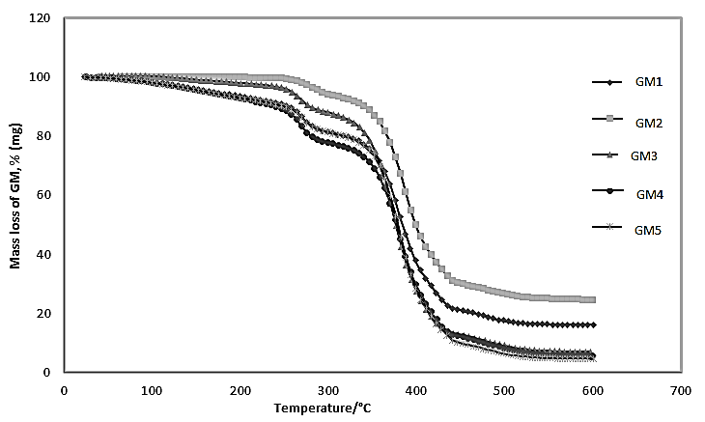
Figure 1. Thermogravimetric Analysis of GM1, GM2, GM3, GM4, and GM5

Table 3. Results of Thermogravimetric Analysis, TGA and DTG data of Green Materials
Sample  GM | Early stage of Decomposition Temperature  (ºC) | Final stage of  Decomposition temperature,  T_{d} (ºC) | Decomposition rate, T_{d} (mgmin⁻¹) | Residue of GM (mg)
GM1 | 307.06 | 466.06 | 3.65 | 3.26
GM2 | 308.46 | 480.06 | 2.09 | 4.97
GM3 | 304.88 | 479.53 | 1.42 | 1.42
GM4 | 304.65 | 472.06 | 1.19 | 1.19
GM5 | 306.02 | 473.02 | 0.97 | 0.97

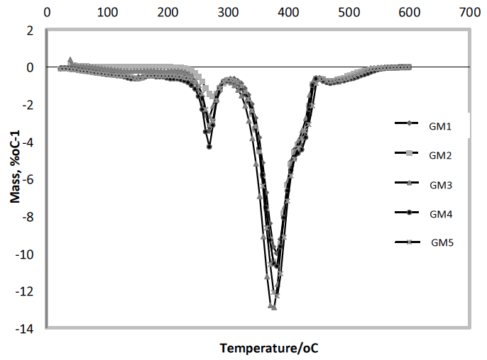
Figure 2. Derivative Thermogravimetric Analysis of GM1, GM2, GM3, GM4 and GM5

Differential Scanning Calorimetry (DSC) Analysis
The profile of thermal degradation by DSC to trace GM samples contain of Tacca starch, glycerol and natural rubber were illustrated as Fig. 3. The melting temperature, T_{m} and the enthalpy involved during the process of thermal degradation was presented in Table 4. In this experiment, the temperature of glass transition, T_{g} is initially considered in order to recognize the changes of calorific capacity during transition process of sample which started in solid form to shift into liquid phase. However, the temperature of T_{g} was not detected due to difficulty to identify the midpoint temperature during the testing.

Based on thermal degradation, GMs reflect an endothermic slope due to increases of heat capacity with the increases of temperature [16]. According to Fig.3, the first curve shows on the degradation of glycerol in each sample. Through the result, the melting temperature was occurred between 100°C to 150°C which indicates the presence of plasticizer in the sample. For Tacca starch, the indication of the material occur when the melting temperature, T_{m} was started at a range of 250°C to 300°C while temperature of 300°C to 500°C was corresponded to T_{m}for natural rubber content in GM samples. As in Table 4, it shows the sample of GM2 has high enthalpy, 76.74 J/g due to the present of low amount of plasticizer which about 6% in sample while GM5 has lowest enthalpy, 45.03 J/g due to high amount of plasticizer, 20%. This cause the T_{m} of GM5 lower compared to GM2. As a result, the degradation process was easier for GM5 due to small amount heat absorb needed to degrade the sample [17]. Therefore, it was proven GM2 has high degree of degradability as it undergoes amorphous phase which made the sample was harden to degrade [18].

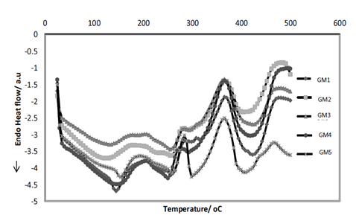
Figure 3. Differential Scanning Calorimetry Analysis of GM1, GM2, GM3, GM4 and GM5

Table 4. Data of Differential Scanning Calorimetry analysis.
Sample  GM | Enthalpy,$∆H_{f}, (J/g)$ | Melting temperature, T_{m} of glycerol,  (ºC) | Melting temperature, T_{m} of Tacca starch, (ºC) | Melting temperature, T_{m} of natural rubber, (ºC)
GM1 | 112.36 | 144.47 | 260.76 | 423.06
GM2 | 76.74 | 118.52 | 258.62 | 417.16
GM3 | 80.66 | 131.87 | 256.13 | 422.13
GM4 | 104.53 | 141.31 | 251.42 | 423.27
GM5 | 45.03 | 153.81 | 260.92 | 404.53

Conclusion
Blends of thermoplastic starch and natural rubber were obtained directly from the latex and granular Tacca leontopetaloides starch. The natural rubber was homogenously distributed with the aids of glycerol plasticizer. The complementation between natural rubber, Tacca starch and glycerol as a green material was responsible for a great improvement in the thermal properties of the biopolymer. Thermally, the sample requires low plasticizer and high natural rubber to be sustain in high temperature which are not easily degraded and decomposed. Thus, GM2 shows high resistance towards the higher temperature with the presence of high natural rubber content with low glycerol content.

Acknowledgement
The authors are thankful and grateful to Research Management Institute (600-RMI/RAGS5/3 (84/2013)) of Universiti Teknologi MARA Shah Alam, Malaysia for supporting and providing funds for the paper.

References
- Chaudhary, P. T. (2009). Amylose content and chemical modification effects on thermoplastic starch from maize, Processing and characterisation using conventional polymer equipment. Carbohydrates Polymer, 917–925.
- Bourtoom, T. (2008). Plasticizer effect on the properties of biodegradable blend film from rice starch-chitosan. Science and Technology, 149-165.
- Mahallati, P., Arefazar, A., and Naderi, Gh. (2011). Thermal and morphological properties of thermoplastic elastomer nanocomposites based on PA6 / NBR. Iranian Journal of Chemical Engineering 8: 1 (Winter).
- Long Yu, K. D. (2006). Polymer blends and composites from renewable resources. Progress in Polymer Science, 576–602.
- Mondragón, M., Hernández, E. M., Rivera-Armenta, J. L., and Rodríguez-González, F. J. (2009). Injection molded thermoplastic starch/natural rubber/clay nanocomposites: morphology and mechanical properties. Carbohydrate Polymers, 77(1), 80-86.
- Maurizio Avella, A. B. (2009). Eco-Challenges of Bio-Based Polymer Composites. Materials, 911-925.
- Richard J. and Spontak, N. P. (2000). Thermoplastic elastomers: fundamentals and applications. Colloids and Interface Science 5(5): 334-340
- Spennemann, D. H. (1992). Notes on the occurrence, utilisation and importance of Polynesian Arrowroot (Taccaleontopetaloides) in the Marshall Islands.
- Prachayawarakorn, J., Sangnitidej, P. and Boonpasith, P. (2010). Properties of thermoplastic rice starch composites reinforced by cotton fiber or low-density polyethylene. Carbohydrate Polymers, 81(2): 425-433.
- Curvelo, A. A. S., De Carvalho, A. J. F., and Agnelli, J. A. M. (2001). Thermoplastic starch–cellulosic fibers composites: preliminary results. Carbohydrate Polymers, 45(2): 183-188.
- Alessandra L, D. R., Márcia, D. Z., Antonio, A.S.C., & Antonio J.F, C. (2011). Thermoplastic starch modified during melt processing with organic acids: The effect of molar mass on thermal and mechanical properties. Industrial Crops and Products, 33(1): 152-157.
- Mohd Makhtar, N, S., Muhd Rodhi., M, N., Musa, M., & Ku Hamid, K, H. (2013). Thermal Behavior of Tacca leontopetaloides Starch-Based Biopolymer. International Journal of Polymer Science 3: 1-7.
- Zhang F., Zhang J. and Sun D. (2009). Study on Thermal Decomposition of Intumescent Fire-Retardant Polypropylene by TG/Fourier Transform Infrared. Thermoplastic Composite Materials, 22: 681.
- Taghizadeh, A., Sazarin, P., & Favis, B. D. (2013). High molecular weight plasticizers in thermoplastic starch/polyethylene blends. Journal of Materials Science, 48: 1799-1811.
- Saikrasun, S., & Amornsakchai, T. (2012). Thermal decomposition behavior and mechanical properties of elastomeric composites based on polyolefinic thermoplastic elastomer and organomontmorillonite. Journal of Polymer Research, 19(1), 1-13.
- Rodriguez, G. F. J., Ramsay, B. A., and Favis, B. D. (2004). Rheological and thermal properties of thermoplastic starch with high glycerol content. Carbohydrate Polymers, 58(2): 139-147.
- Montoya, M., Tomba, J. P., Carella, J. M. and Gobernado-Mitre, M. I. (2004). Physical characterization of commercial polyolefinic thermoplastic elastomers. European polymer journal, 40(12), 2757-2766. Differential Scanning Calorimetry (DSC). (n.d.). Retrieved from www1.chm.colostate.edu/Files/CIFDSC/dsc2000.pdf

