EFFECT OF DIFFERENT HEALING TEMPERATURE ON SOLID STATE SELF-HEALING SYSTEM

(Kesan Suhu Pemulihan Yang Berbeza Terhadap Sistem Swa-Pemulihan Dalam Keadaan Pepejal)
S. M. Makenan, N. N. Muhamad, M. J. Mohd Suzeren*, S. Salihan, M.A.S. Mat Lazim

School of Chemical Science and Food Technology, Faculty of Science and Technology

Universiti Kebangsaan Malaysia, 43600 Bangi

*Corresponding author: suzeren@ukm.edu.my

Abstract
The aim of this study is to identify the effect of using various healing temperatures ranging from 120ºC to 180ºC with temperature interval of 10⁰C on self-healing resin system containing diglycidyl ether of bisphenol-A (DGEBA), the hardener nadic methyl anhydride (NMA), the catalyst benzylmethylamine (BDMA) and poly(bisphenol-A-co-epichlorohydrin) (PDGEBA) as healing agent. The effects of different healing temperatures on the resin systems were investigated by means of Fourier-transform Infrared Spectrometer (FTIR), Dynamic Mechanical Thermal Analysis (DMTA), and izod test. Optical image of the sample morphology was observed using optical microscope. Healing efﬁciencies (H_{E}) were evaluated using izod test and the optimum healing temperature of 160ºC was obtained within the third healing cycles with H_{E} 37%. The results indicate that the healing temperature affected the physical aging and the chemical reaction between the secondary hydroxyl group and carboxyl group occurred at high temperature of ≥180ºC.

Keywords: Self-healing; healing temperature; epoxy resin
Abstrak
Tujuan kajian ini adalah untuk mengenalpasti kesan menggunakan suhu pemulihan yang berbeza iaitu 120ºC, 140ºC, 150ºC, 160ºC, 170ºC dan 180ºC terhadap sistem swa-pemulihan resin yang mengandungi diglisidil eter bisfenol-A (DGEBA), pengeras nadik metil anhidrida (NMA), pemangkin benzilmetilamina (BDMA) dan poli(bisfenol-A-ko-epiklorohidrin) (PDGEBA) sebagai agen pemulihan. Kesan penggunaan suhu pemulihan yang berbeza terhadap sistem resin dikaji menggunakan Spektrometer Infra Merah Fourier-transform (FTIR), Analisis Terma Mekanikal Analisis (DMTA), ujian izod dan mikroskop optik. Keberkesanan pemulihan (H_{E}) diukur menggunakan ujian izod dan suhu pemulihan terbaik pada 160ºC didapati di kitaran pemulihan yang ketiga dengan nilai H_{E} sebanyak 37% . Keputusan ini menunjukkan bahawa suhu pemulihan menyebabkan berlaku penuaan fizikal dan tindak balas kimia antara kumpulan hidroksil sekunder dan kumpulan karboksil berlaku pada suhu yang tinggi sekitar ≥180ºC.

Kata kunci: Swa-pemulihan; suhu pemulihan; resin epoksi

Introduction
Throughout their lifetime, polymeric materials are susceptible to mechanical damages such as matrix cracking and delamination. These damages reduce the mechanical properties of these materials [1-4]. To overcome these limitations, a rapidly emerging ﬁeld of research has resulted in the material itself is capable of repairing the crack and restoring the functionality of the material, thus expanding the lifetime of the material, which is referred as self-healing material. The self-healing system can be divided into two types, namely, extrinsic; without any external intervention (autonomously) [5, 6] and intrinsic; required external stimulus [7, 8].

Solid-state healable system; one of the types of intrinsic self-healing system, is the thermoplastic-thermosetting semi-interpenetrating network. This employs a thermosetting resin, in to which a thermoplastic is dissolved. In miscible mixing, Hayes and colleagues (co-workers) [9, 10] studied the incorporation of a soluble linear polymer; poly(bisphenol-A-co-epichlorohydrin) (PDGEBA), which is highly compatible with the thermosetting resin; diglycidyl bisphenol A. Upon curing, the thermoplastic material remains dissolved in the thermosetting matrix. Although requiring additional external activation, this system is repeatable over a number of healing events.

The recovery occurs by heating the systems above the minimum healing temperature (glass transition temperatures, T_{g}). At this temperature, the linear polymer of healing agent would mobilize and diffuse through the thermosetting matrix, to the cracked surfaces with some chains bridging to close the cracks and thereby facilitating healing. After healing the damage PDGEBA will return to its immobilize state [9, 11]. Wool [12] elaborated a microscopic theory on the basic of the “Reptation model”, that originally proposed by de Gennes [13], that described the diffusion and randomization in polymer-polymer crack interphase for strength recovery. These crack healing systems are time and temperature dependent; and occur via void closure of “free volume”, surface interaction, and molecular entanglement between the damage faces [14, 15].

Ideally, solid state system exhibits the ability to undergo multiple healing cycles. However, Hayes et al. [10] reported a reduction in the percentage of healing efficiency within the second and third healing cycles. The diffusion through reptation of healing agent is related to the free volume within the thermosetting resin which can be affected by physical aging which has been well documented [16-18]. The objective of this study is to examine the effect of healing efficiency when using different healing temperatures which are 120ºC, 140ºC, 150ºC, 160ºC, 170ºC and 180ºC.

Materials and Method
Materials
The materials used to produce epoxy resin were diglycidyl ether of bisphenol-A (DGEBA) with Mw of 384.36g/mol, the hardener nadic methyl anhydride (NMA) (MW of 178.18g/mol) and the catalyst benzylmethylamine (BDMA) (MW of 135.21g/mol) and all were purchased from Sigma–Aldrich. Unreactive Poly(bisphenol-A-co-epichlorohydrin) or PDGEBA with average Mw of 4400 g/mol obtained from Sigma -Aldrich, was used as healing agent.

The control (or non-healable) resin was prepared by heating the DGEBA at 90ºC for 5 minutes under the mechanical stirrer. NMA hardener was added and stirred for 1 minute until it was completely dissolved and was followed by BDMA with further stiring for 30 seconds. The ratios by weight of 100.0, 81.2 and 2.0 for the epoxy-hardener-catalyst mixture were used [9]. The resin mixture was degassed in the vacuum oven at 90ºC to eliminate any gas bubbles generated during the mixing process. After degassing, the mixture was poured into the silicon mould. Then the mould was placed into the air convection oven at 90ºC to cure for 4 hours followed by 1 hour post-cure at 140⁰C, to ensure the resin was fully cured.

For the self-healing (or healable) resin, the healing agent; PDGEBA was dissolved in DGEBA under mechanical stirring at 120ºC for approximately 24 hours to form a homogenous solution [9]. After this point, the method for sample preparation was following the same procedures as in the control resin with the addition of NMA and BDMA for curing (Figure 1).

Whereas :
Figure 1: The chemical structure of repeating unit of resin produced from the curing of the anhydride (NMA) and the epoxy (DGEBA) under catalyst (tertiary amine)

Assessment of Healing
The impact machine was using a manual clamping of a manual clamping vice with a specimen adapter according to ASTM D256 (Standard Test for Izod Pendulum Impact Resistance of Plastics) The dimension of the specimen was 64 mm x 13 mm x 4 mm with 3 mm notch (Figure 2a). The sample was correctly positioned in the vice with a centering device adapted for notched specimens. Izod impact tests were performed at room temperature with on notched specimens cut by motorized notching cutter (Ray-Ran) using a Ray-Ran Test Equipment RR/IMT (RR/MT/100)

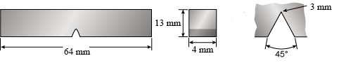
(a)
Force applied
to keep it flat
Broken
specimen
Screw to keep specimen
In intimate contact
Platform

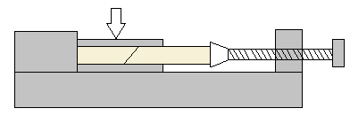
(b)
Figure 2 a) Dimension of the izod test specimen (in mm) and b) the alignment machine for healing process [10]

At least five specimens were tested for each set of data. By following the initial fracture, all samples including control resin and healable resin, were immediately healed using the alignment machine (Figure 2b) at different healing temperatures (120ºC, 140ºC, 150ºC, 160ºC, 170ºC and 180ºC) for 6 hrs before cooling back to 25ºC at 2ºC/min in each healing cycle. The percentage of recovery efficiency (R_{E}) was be calculated by using Equation 1;
(1)
Where E_{healed} and E_{initial} are the impact energy after healing and the impact energy at initial crack respectively [19].
Fourier-Transform Infrared Spectrometer (FTIR)
FTIR observation was made with a Perkin Elmer Spectrum (BX200) to determine the functional group in resin system. 1-2 mg of the solid sample was mixed with potassium bromide and grounded into fine powder before being pressed into thin discs for FTIR measurement. All spectra are recorded at room temperature with the infrared spectra range of 4000 - 400 cm⁻¹.

Dynamic Mechanical Thermal Analyzer (DMTA)
DMTA was performed on a TA Instruments Thermal Analysis (DMA 2980) operating in the single cantilever-bending mode at an oscillation frequency of 1Hz. Data were collected from room temperature to 180 ºC at a scanning rate of 2ºC/min. The sample specimens were made in the form of rectangular bars of a nominal 35 mm x 15 mm x 5 mm.
Optical Microscopy
Optical images of the morphology of the crack surface of samples from izod test specimens were taken using an Axiolab A450909 Image Analyzer with camera lens model Zeiss.
Results and Discussion

Solid state self-healing system involves the process of diffusion of linear polymer within the epoxy resin when heat is applied. Matrix resin was prepared based on DGEBA matrix.

Preparation of Matrix DGEBA Epoxy Resin
The curing reaction in epoxy resin was observed by infrared spectrum through the determination of interactions between the functional groups. An epoxy group intensity was monitored at a wavelength of 915 cm⁻¹ (Figure 3). FTIR spectra of healable and control resin possessed O-H peaks in the region of 3300-3600 cm⁻¹ (Figures 3b and 3c) that can be attributed to the self-associated hydroxyl. The formation of that covalent bonding was seen at the appearance of a new peak at 1730cm⁻¹ (Figures 3b and 3c) that can be attributed to the formation of an ester. It is possible that this peak resulted/originated from anhydride-epoxy reaction. The reduction of epoxy peak intensities of control resin compared to the healable resin (Figure 3) indicates that more epoxy rings (915cm⁻¹) have been opened during curing process.

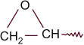
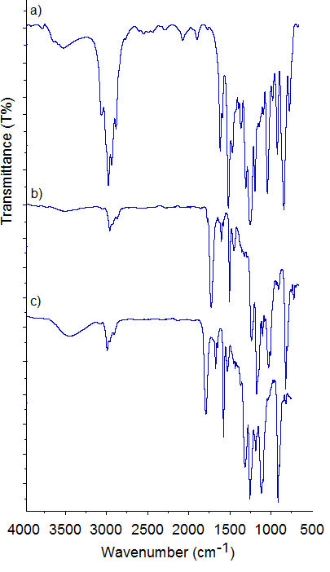
3511 cm⁻¹
915 cm⁻¹
Ester
1730 cm⁻¹
Figure 3: FTIR spectra recorded at room temperature of a) DGEBA b) healable resin and c) control resin
Meanwhile, the dynamic mechanical thermal analysis was used to determine the minimum healing temperature (T_{g}) of epoxy resin. At this point, the linear polymer starts to mobilize and diffuse to the crack plane [22]. Glass transition temperature (T_{g}) is defined as the maximum in tan δ. Tan δ versus temperature data for control and healable resin are shown in Figure 4.

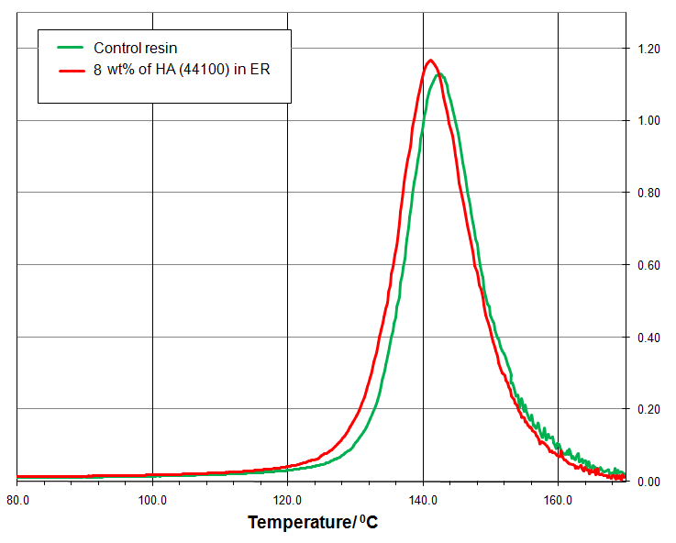
Figure 4: Dynamic mechanical thermal analysis curves for the control resin and healable resin between the temperature ranges from 80⁰C to 180ºC

Clearly, only single peak around 140ºC existed in both epoxy systems, indicating a homogenous phase structure [20]. There was no significant change in T_{g} with the addition of healing agent into control resin system.

Healing Efficiency at Different Healing Temperature
In this study, the samples of control and healable resin were subjected to repeating impact/heal cycles. Each sample was subjected to a 2.706 J impact energy followed by a healing cycle of 6 hrs at various healing temperatures. This procedure was repeated for a total of three impact/heal cycles. Impact energy values, the change of energy per area unit from notch (kJ/m²) were obtained from the FractaTM software. It is clearly indicated that the healing effects of healable resin specimens are much greater than that of control resin (Figure 5).

Figure 5: Impact energies (kJ/m²) of control and healable resin (with 8% of healing agent) on healing temperature 160˚C for 6 hrs with three healing cycle

The control resin can be thermally healed to a limited extent after 6 hrs at 160˚C (Figure 5). The healing effect on the control resin can be explained by two possibilities; dangling chains (or chain slippage) at healing temperature above T_{g} and through interaction of excess epoxy group in the epoxy resin [12]. The recovery effeciency (R_{E}) was calculated (Equation 1) from the average of impact energy obtained from the izod test. The actual “Healing effeciency” (Equation 2) ; to compensate for the residual healing effect in the control resin system, was obtained by correcting for healing in the control system from Equation 1.

(2)
Where R_{E} is the percentage recovery efficiency and R_{E}⁰ is recovery effeciency of control resin [19]. Whereas, the healing effect on healable resin was reasoned by the diffusion of PDGEBA to the crack surface when the heat was introduced to the system (above T_{g} temperature) [7]. The polymer matrix is actually healed by bringing two pieces of identical samples into contact due to molecular diffusion along the polymer/polymer interface [15]. Figure 6 shows the mechanism of the solid state healing resin in order to understand the phenomena of self-healing, proposed by Wool and O’Connor [12] which involving five steps of surface rearrangement.

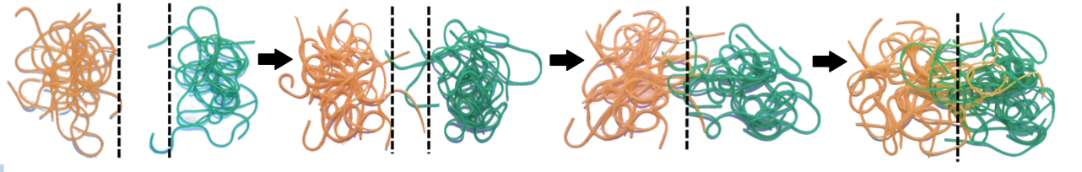
- surface rearrangement c) wetting d) diffusion e) randomization
- surface approach

Figure 6: Schematic of self-healing mechanism of the solid state healing resin [15]

Figure 7: Graph showing a) the recovery effeciency (R_{E}) and b) healing effeciency (H_{E}) percentage of the control and healable resin vs healing cycle for healing resin at healing temperature 160ºC

Based on the concept of diffusion of healing agent, different healing temperature has been studied. Figure 7(a) and Figure 7(b) show the recovery effeciency, R_{E} (Equation 1) and healing effeciency, H_{E} (Equation 2) respectively for the healing cycle of healable resin (healing temperature of 160ºC). The percentage of healing effeciency, H_{E} in the range 48% to 37% were achieved for three healing cycles (Figure 7b).

By using T_{g} value (minimum healing temperature for resin epoxy) from DMTA results (Figure 4) as a reference, various healing temperature which were from 120ºC (below T_{g} value) to 180ºC have been used. The comparison of healing efficiency, H_{E} of resin epoxy usingdifferent healing temperatures showed that the healable resin with healing temperature of 120ºC has the lowest healing efficiency (Figure 7). This resulted from less movement of healing agent within the matrix resin at the healing temperature below the T_{g} (T_{g} = 140ºC) [9].

On the contrary, samples with healing temperature range from 140-180˚C showed high percentages of healing efficiencies. This resulted from the heat stimulus that cause the diffusion process and the movement of molecular chain of healing agent into the matrix resin [7, 21]. Healing efﬁciencies are higher with higher healing temperature and these values are in agreement with the literature [22].

On average, it has been demonstrated from figure 8a that there was a drop in the percentage of healing efficiency, H_{E} at the second and the third healing cycle of resin under all conditions (from 120-180˚C). This is possibly due to physical aging effect. Physical aging of resin epoxy can be explained by the molecular relaxation in which the epoxy network loses the mobility and the free volume during its approach towards the equilibrium glassy state [16, 23]. This behaviour was reported previously by other authors [10, 11]. The full detailed study on the healing cycle and the physical aging will be explored in the future.

The highest degree of healing effeciencies at about 48%, 43% and 37% from the first, second and third healing cycles wereachieved at 160ºC of healing temperature. However, the obvious reduction of H_{E} percentage value can be seen at the healing temperature of 180˚C (Figures 8a and 8b) at the second healing cycles. The reaction between the secondary hydroxyl and carboxyl group can occur at high temperature will restrict the movement of healing agent due to the chemical reaction between matrix resin and healing polymer. It can be concluded that high healing temperature (>180˚C) would decrease the percentage oh healing effeciency of the resin.

Figure 8: Graph showing the results for healing efficiency, H_{E} of; a) healable resin at different healing temperature as a function of healing event and b) the healing cycle as a function of healing temperature

Reaction of Secondary Hydroxyl
To monitor changes in the functional group of epoxy resin, further heating at temperature of 160ºC for up to 3 healing events (18 hrs) has been done. FTIR was used to compare the intensity of epoxide and hydroxyl functional groups. The comparison of FTIR spectra of healable resin and 3rd healing cycle healable resin at healing temperature 160ºC (Figure 9) shows there was no significant change between the peaks. It was considered that there was no change in chemical structure in the system. However, the comparison of spectra of healable resin at low (160ºC) and high healing temperature (180ºC) (Figure 10) showed that the peak for O-H group (3700-3100 cm⁻¹) for high healing temperature resin has been shifted to the lower wavenumber (shifted to the right) compared to low healing temperature resin.

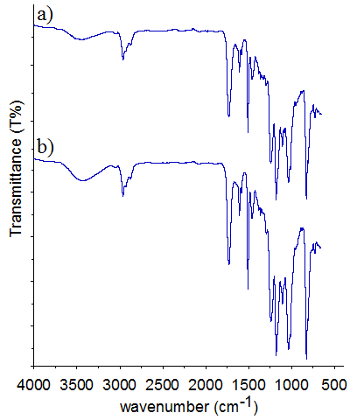
Figure 9: FTIR spectra in region 4000-500cm⁻¹ recorded at room temperature of a) healable resin and b) 3rd healing cycle of healable resin
(b)
(a)
(b)
(a)
(i)
(ii)

Figure 10: FTIR spectra in region 4000-500cm⁻¹ for healable resin with healing process at a) low and b) high temperature. (ii) : A magnification of FTIR spectra in range from 3700 to 3100cm⁻¹

This result suggests that healing at low temperature (below 160ºC) occurs via physical processes (diffusion of polymer) rather than chemical reactions [9]. On the other hand, healing at high temperature (180ºC) causes chemical interaction between the functional group in the system. Painter et al. [24] showed that absorption bands of OH-$π$ bonds at ~3516cm⁻¹ and self-associated OH groups at ~3400cm⁻¹. It is more likely that this transition in hydroxyl group peak might be due to the chemical interaction of the carboxyl group and secondary hydroxyl group (Figure 11) [24].

Figure 11: Curing reaction mechanism of the anhydride (NMA) and epoxy resin (DGEBA) in the present of a catalyst [28]

In healing process, post-reaction between curing agent and hydroxyl group in epoxy resin can occur until the limited stage as shown in Figure 11. There are two possible reactions to open the epoxy ring; reaction between anhydride group and secondary hydroxyl group and reaction between epoxide group and carboxyl group. Whereas, the third reaction is between carboxyl group and secondary hydroxyl group that can occur at high temperature (≥180ºC). Two different products are formed in the ring opening reaction of the epoxy group with a carboxyl group; i) the ester of the primary hydroxyl group and ii) the ester of the secondary hydroxyl group (if the temperatures > 180 ⁰C) (Figure 11). The reaction between the secondary hydroxyl and carboxyl at high healing temperature will restrict the movement of healing agent in system and resulted in low healing efficiency.

To further explore the impact of healing temperature upon the epoxy network, dynamic mechanical thermal analysis was performed on healable resin at various healing temperatures for up to 3 healing events (18 hrs). Comparison of T_{g} values (maximum in the tan δ) with healing temperature of 120˚C (at 140.2˚C), 140˚C (at 141.6˚C), 160˚C (at 145.8˚C) and 180˚C (at 153.4˚C) was shown in Figure 12.

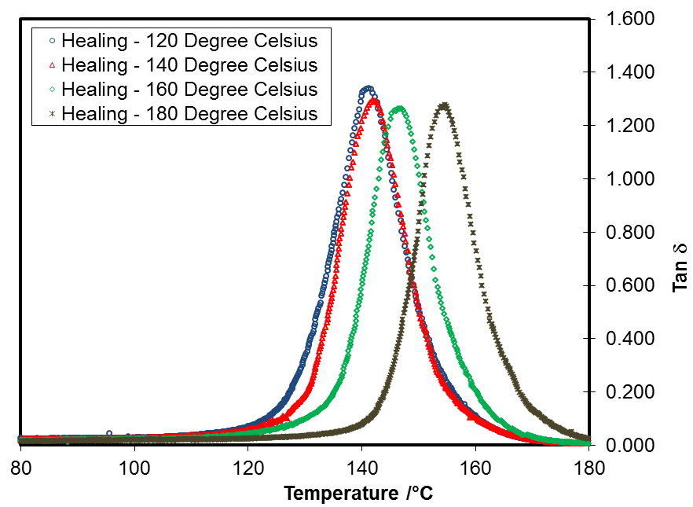
Figure 12: DMTA scan of tan δ for healable resin (with 8 wt% of HA) that subjected to different healing temperature
There was a slightly increase of T_{g} value at healing temperature 140˚C and 160˚C compared to 120˚C. These differences suggest that further curing process of epoxy at varied degrees occured in the systems [25]. However, the increasing of T_{g} value at 180˚C was more significant. As discussed elsewhere [26, 27], T_{g} increases with increased cross-linking due to the restriction on molecular mobility. In relation to this, the increasing of T_{g} could be due to futher curing of epoxy and also chemical interaction of the carboxyl group and secondary hydroxyl group, thus more highly crosslinked polymers have been found.
Microscopy Analysis
Optical microscope was used to investigate the surface morphology of the healable resin. A typical healing process of a damage resin as viewed through optical microscope as shown in Figures 13b and 13c. By comparing the two images of epoxy resins, the crack can be seen clearly in resin epoxy that was introducing crack (Figure 13b) and heating for 6 hrs causes the crack to virtually disappear (Figure 13c).

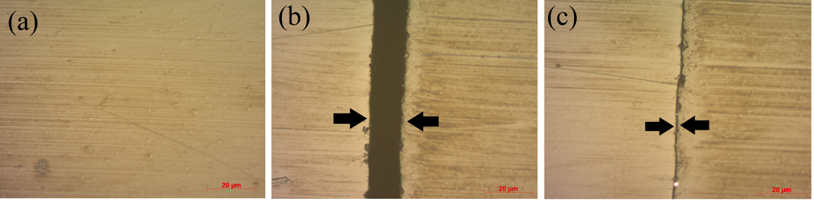
Figure 13: Optical micrograph of a test specimen izod test cross-section from the resin containing 8.0 wt% of healing agent with the magnification of 10x ; a) before introducing crack, b) after introducing crack and c) after healing process
Further, the surface morphology also demonstrated that the healable resin washomogenous without signs of phase separation. These results are accordance with DMTA analysis as discussed above.

Conclusion
A solid state self-healing system can be prepared by mixing the thermoset polymer; DGEBA and the thermoplastic polymer; PDGEBA and the effects of using various healing temperatures; from 120ºC to 180ºC have been studied. The resin systems used in this study was able to self-healing at healing temperature above the minimum healing temperature (>T_{g}). Healing efﬁciencies (H_{E}) were evaluated using izod test and the optimum healing temperature at 160ºC within the third healing cycles with H_{E} 37% was achieved. The healing process at low healing temperature (140ºC to 160ºC) occurred by diffusion of healing agent (physically process). Meanwhile, the healing process at high temperature (180ºC) occurred by the physically and the chemically processess. It is demonstrated that there was a reduction in the percentage of healing efficiency, H_{E} at the second and the third healing cycles of resin under all conditions. The results indicate that the healing temperature affected the physical aging and the chemical reaction between the secondary hydroxyl group and carboxyl group occurred at high temperature (≥180ºC).
Acknowledgement
The authors acknowledge the financial support of this study by Government of Malaysia through FRGS/1/2012/SE07/UKM/03/1, GGPM-2012-014 and ERGS/1/2012/TK04/UKM/03/3 grants. The authors also wish to thank the School of Chemical Sciences and Food Technology of the National University of Malaysia for the continuous support of this project.
References
- Dry, C. (1996). Procedures developed for self-repair of polymer matrix composite materials. Composite Structures, 35(3): 263-269.
- Kim, V. T. & Nele, D. B. (2013). Self-Healing in Cementitious Materials—A Review Materials, 6: 2182-2217.
- Colquhoun, H. & Klumperman, B. (2013). Self-healing polymers. Polymer Chemistry, 4(18): 4832-4833.
- Tyagi, P., Deratani, A., & Quemener, D. (2013). Self-Healing Dynamic Polymeric Systems. Israel Journal of Chemistry, 53(1-2): 53-60.
- Billiet, S., Van Camp, W., Hillewaere, X. K. D., Rahier, H., & Du Prez, F. E. (2012). Development of optimized autonomous self-healing systems for epoxy materials based on maleimide chemistry. Polymer, 53(12): 2320-2326.
- White, S. R., Sottos, N. R., Geubelle, P. H., J.S.Moore, Kessler, M. R., Sriram, S. R., Brown, E. N., & Viswanathan, S. (2001). Autonomic healing of polymer composites. Nature, 409: 794-797.
- Blaiszik, B. J., Kramer, S. L. B., Olugebefola, S. C., Moore, J. S., Sottos, N. R., & White, S. R. (2010). Self-Healing Polymers and Composites. Annual Review of Materials Research, 40(1): 179-211.
- Williams, K. A., Dreyer, D. R., & Bielawski, C. W. (2008). The Underlying Chemistry of Self-Healing Materials. MRS Bulletin, 33: 759-765.
- Hayes, S. A., Jones, F. R., Marshiya, K., & zhang, W. (2007). A self-healing thermosetting composite material. Composites Part A: Applied Science and Manufacturing, 38(4): 1116-1120.
- Hayes, S. A., Zhang, W., Branthwaite, M., & Jones, F. R. (2007b). Self-healing of damage in fibre-reinforced polymer-matrix composites. Journal of The Royal Society Interface, 4(13): 381-387.
- Peterson, A. M., Kotthapalli, H., Rahmathullah, M. A. M., & Palmese, G. R. (2012). Investigation of interpenetrating polymer networks for self-healing applications. Composites Science and Technology, 72(2): 330-336.
- Wool, R. P. & O'Connor, K. M. (1981). A theory crack healing in polymers. Journal of Applied Physics, 52(10): 5953-5963.
- de Gennes, P. G., Scaling Concepts in Polymer Physics. 1979, Ithaca, New York: Cornell Univ. Press.
- Jud, K. & Kausch, H. H. (1979). Load transfer through chain molecules after interpenetration at interfaces. Polymer Bulletin, 1: 697-707.
- Diana, D., philipp, M., & Wolfgang, B., eds. Principles of Self-Healing Polymers, In: Self Healing Polymers : From Principles to Applications Self-Healing Polymers. 2013, Wiley-VCH Verlag GmbH & Co. KGaA.: USA. 5-60.
- Kong, E.,(1986). Physical aging in epoxy matrices and composites Epoxy Resins and Composites IV, Dušek, K., Editor, Springer Berlin / Heidelberg. p. 125-171.
- Lévêque, D., Schieffer, A., Mavel, A., & Maire, J.-F. (2005). Analysis of how thermal aging affects the long-term mechanical behavior and strength of polymer–matrix composites. Composites Science and Technology, 65(3–4): 395-401.
- Hu, H. & Sun, C. T. (2000). The characterization of physical aging in polymeric composites. Composites Science and Technology, 60(14): 2693-2698.
- Brown, E. N., White, S. R., & Sottos, N. R. (2005). Retardation and repair of fatigue cracks in a microcapsule toughened epoxy composite – Part I: Manual infiltration. Composites Science and Technology, 65(15–16): 2466-2473.
- Fox, T. G. & Flory, P. J. (1950). Second-order transition temperatures and related properties of polystyrene. I. Inﬂuence of molecular weight. Journal of Applied Physics, 21(6): 581.
- Jones, F. R., Zhang, W., & Hayes, S. A. ( 2007). Thermally induced self healing of thermosetting resins and matrices in smart composites. Self Healing Materials, 100: 69-93.
- Rahmathullah, M. A. M. & Giuseppe, R. P. (2009). Crack-healing behavior of epoxy-amine thermosets. Applied Polymer Science, 113(4): 2191-2201.
- Hutchinson, J. M. (1995). Physical aging of polymers. Progress in Polymer Science, 20(4): 703-760.
- Miura, K. (1998). A new method to estimate hydrogen bondings in coal by utilizing FTIR and DSC. Fuel and Energy Abstracts, 39(3): 167-167.
- Kausch, H. H. & Tirrell, M. (1989). Polymer interdiffusion. Annual Review of Materials Science, 19(1): 341-77.
- Cook, W., Mehrabi, M., & Edward, G. (1999). Ageing and yielding in model epoxy thermosets. Polymer, 40(5): 1209-1218.
- Barral, L., Cano, J., Lopez, J., Lopez-Bueno, I., Nogueira, P., Abad, M. J., & Ramirez, C. (1999). Physical aging of an epoxy/cycloaliphatic amine resin. European Polymer Journal, 35(3): 403-411.
- Thomas, R., Durix, S., Sinturel, C., Omonov, T., Goossens, S., Groeninckx, G., Moldenaers, P., & Thomas, S. (2007). Cure kinetics, morphology and miscibility of modified DGEBA-based epoxy resin – Effects of a liquid rubber inclusion. Polymer, 48(6): 1695-1710.

