SYNTHESIS OF CHITOSAN-GRAFTED-POLY(METHYL METHACRYLATE) WITH FENTON’S REAGENT (Fe²⁺ - H₂O₂) AS A REDOX INITIATOR

(Sintesis Kitosan-Cangkuk-Poli(Metil Metakrilat) Dengan Reagen Fenton (Fe² ⁺ - H₂O₂) Sebagai Pemula Redoks)

Nur Azmyra Abdul Aziz *, Aznizam Abu Bakar, Azman Hassan and Nurulhusna Azmi

Enhanced Polymer Research Group (ENPRO),
Department of Polymer Engineering, Faculty of Chemical Engineering,
Universiti Teknologi Malaysia, 81310 UTM Skudai, Johor, Malaysia.
*Corresponding author: azmyra_aziz@yahoo.com

Abstract
Graft copolymerization of poly(methyl methacrylate)(PMMA) onto chitosan fiber has been successfully carried out using Fenton’s Reagent which is consisted of hydrogen peroxide(H₂O₂) as initiator and ferrous ammonium sulphate(FAS) as co-catalyst under inert atmosphere in an aqueous medium. The PMMA homopolymer formed during the reaction was removed from the grafted copolymer by Soxhlet extraction using acetone as the solvent. The grafting percentage and efficiency obtained were 449.16% and 85.94%, respectively. The maximum grafting percentage and efficiency were achieved when 0.3 g chitosan copolymerized with 3 mL monomer at 70ºC for 120 minutes with [FAS] = 6 x 10⁻⁵ M, [H₂O₂] = 6 x 10⁻³ M and 8 mL water. The grafted copolymers were characterized by using FTIR, DSC, TGA and SEM analysis. The presence of absorbance band at 1724 cm⁻¹ provided strong evidence of grafting.

Keyword: graft copolymers, chitosan, monomers, radical polymerization

Abstrak
Pengkopolimeran cangkuk poli(metil metakrilat)(PMMA) terhadap gentian kitosan telah berjaya dilakukan dengan menggunakan Reagen Fenton yang terdiri daripada hidrogen peroksida (H₂O₂) sebagai pemula dan ferus ammonium sulfat (FAS) sebagai ko-mangkin pada persekitaran atmosfera lengai dalam medium berair. Homopolimer PMMA terbentuk semasa tindakbalas telah disingkirkan daripada kopolimer cangkuk melalui kaedah pengekstrakan Soxhlet dengan menggunakan aseton sebagai pelarut. Peratusan pencangkukan dan peratusan kecekapan pencangkukan yang diperolehi masing-masing ialah 449.16% dan 85.94%. Peratusan maksima pencangkukan dan kecekapan pencangkukan diperolehi apabila 0.3 g kitosan dikopolimer dengan 3 mL monomer pada 70ºC selama 120 minit dengan mengunakan [FAS] = 6 x 10⁻⁵ M, [H₂O₂] = 6 x 10⁻³ M dan 8 ml air. Kopolimer tercangkuk telah dicirikan dengan menggunakan analisis FTIR, DSC, TGA dan SEM. Kehadiran kumpulan penyerapan pada 1724 cm⁻¹ menunjukkan bukti kukuh berlakunya pencangkukan.

Kata kunci: kopolimer cangkuk, kitosan, monomer, radikal pempolimeran

Introduction
With growing worldwide ecological awareness, there has been a trend to produce low cost, biodegradable materials with improved properties. Lately, there has been a great interest to produce thermoplastic composites reinforced with natural products. Chitosan is a deacetylated derivative of chitin which is a polymer second abundance polysaccharide natural polymer on earth after cellulose [1], biodegradable, non-toxic and biocompatible [2]. It is a unique basic polysaccharide with high molecular weight [3]. In particular, chitosan are becoming popular because it has lower cost, lower density and exhibit better processing ability. Nowadays, chitosan is no longer a waste by-product from the seafood processing industry because currently this material is being used by biomedical and pharmaceutical industry.

Graft copolymerization is a well-established technique for modification of the chemical and physical characteristic of polymer. Grafting various vinyl monomers onto an existing polymer backbone is a promising method for the preparation of new materials. This is because the potential and multiple applications of this versatile material can be increased and its chemical and physical properties can be improved greatly [1]. Grafting technique is used to enhance the compatibility of lignocellulosic fibres with thermoplastic material [4]. This is because the thermoplastics are hydrophobic, and thus they are incompatible with lignocellulosic fibres. The modification of chitosan via grafting of vinyl monomers is one of the most effective methods to incorporate desirable properties into chitosan without sacrificing its biodegradable nature [5]. In addition, graft copolymers had been used as stabilizers between grafted and ungrafted polymer. The properties of cellulose obtained by blending synthetic polymers do not last long due to the separation of blended synthetic polymers, whereas cellulose obtained by grafting of monomer gives rise to everlasting properties [6].

There are a few reports on grafting of poly(methyl methacrylate)(PMMA) onto chitosan. Lagos and Reyes [7], studied on the graft copolymerization of methyl methacrylate onto chitosan with Fenton’s reagent as a redox initiator in the presence of atmospheric oxygen. Harish Prashanth [8] studied the graft copolymerization of chitosan with poly(methyl methacrylate)(PMMA) and polyacrylonitrile(PAN) using potassium persulfate as an initiator. They found that, the percentage grafting of chitosan-g-PMMA was higher than chitosan-g-PAN because of bulky methyl groups of PMMA. Harish Prashanth [9] also studied on the biodegradation of chitosan-graft-polymethyl methacrylate film.

According to Liu et al. [1] chitosan-g-polymethyl acrylate (PMA) may improve the compatibility of two phases of chitosan and PVC. With this in mind, the grafting technique was used to modify the chitosan for being used as filler in polymer composites. In this study, chitosan fiber was grafted with methyl methacrylate (MMA) to improve the compatibility of hydrophilic chitosan fiber with a hydrophobic polymer matrix, particularly for PVC composites application.

Therefore, the aims of this work are to synthesize graft copolymer of chitosan onto methyl methacrylate using H₂O₂/Fe²⁺ as a redox initiator in aqueous medium and under nitrogen atmosphere. The resulting chitosan grafted methyl methacrylate was characterized by using Fourier-Transform Infrared Spectroscopy, Differential Scanning Calorimeter, Thermogravimetry Analysis and Scanning Electron Microscopy.

Materials and Methods
Materials
Chitosan from shrimp shell with medium molecular weight and degree deacetylation (75%- 85%) in a powder form and yellow in colour were purchased from Sigma Aldrich (Malaysia). The methyl methacrylate (MMA) monomer used is manufactured by Merck Schuhardt (Hohenburnn, Germany) was used for grafting onto chitosan. The MMA was chosen because it is widely used in the grafting of synthetic polymers and cellulosic fibers [10]. Analytical-grade hydrogen peroxide (H₂O₂) was purchased from QRec (Malaysia) as an initiator, while ammonium ferrous sulfate, obtained from BDH Sigma Aldrich Chemie Gmbh (Steinheim, Germany) was used as catalyst. All solvents and other analytical-grade chemicals were used as received from the manufacturers without further purification.

Removal of the inhibitor from the monomer
MMA was purified by passing through a column packed with an activated alumina to remove its inhibitor (hydroquinone). The reagent bottle was immersed in an ice bath. A burette was filled with glass wool and followed by activated alumina. The burette was attached to the retort stand. MMA was poured into burette through a conical funnel and allow to flow through the burette. The activated alumina changed in colour from white to pink when the inhibitor was trapped. Finally, the purified MMA was collected in a reagent bottle, sealed in a refrigerator below 10ºC.

Preparation of Chitosan -grafted- poly (methyl methacrylate)
To prepare the chitosan/PMMA copolymer, 0.3 g chitosan was placed in 250 mL three-necked flasks equipped with a magnetic stirrer. A 250 mL three necked flask was properly arranged and immersed in a thermostated water bath. 0.3 g of chitosan and 8 mL of distilled water was transferred into the flask. After that, the flask was placed into a water bath at a desired temperature. Nitrogen was purged into the flask for 30 minutes to remove the presence of oxygen during the reaction. Then, followed by adding the required volume of hydrogen peroxide and required amount of ammonium ferrous sulphate. The reaction mixture was mixed for 5 min and then the required amounts of monomer (MMA) were added into the mixture. The reaction mixture was stirred under nitrogen at the chosen temperature and reaction period. Immediately, after the reaction period was over, the reaction flask was exposed to the ambient atmosphere and the product was filtered. The crude product was washed thoroughly with distilled water and kept in an oven at 60ºC for 24 hours until a constant weight was achieved. The grafted product was further treated with the Soxhlet extraction techniques to removed PMMA homopolymer that was formed during the reaction.

Removal of homopolymer and determination of graft level
Initially, the three necked- flask was filled with acetone. A thimble used for the extraction process was preheated in an oven before its application in the Soxhlet extractor. The preheated thimble was then kept in a desiccator to remove moisture. Firstly, the initial weight of the empty thimble was determined. The grafting product was took out from the oven and allowed to cool down to room temperature. Later, this grafting product was added into thimble and the weight of thimble with grafting product (including homopolymer of PMMA) was taken. The thimble is then was inserted into Soxhlet extractor and the extraction was ran for 24 hours to remove homopolymer of PMMA. Afterwards, the thimble was dried in an oven at 60ºC for another 24 hours until constant weight was achieved. The thimble was removed from the oven and immediately transferred to desiccators to avoid thimble from absorbing the moisture. The thimble was allowed to cool down to room temperature. Finally, the weight of thimble and grafting product without homopolymer of PMMA was determined. The grafting percentage, %G and grafting efficiency, %E was determined using Equations 1 and 2, respectively.

% G = [(w₃ – w₁)/ (w₁)] x 100% (1)
% E = [(w₃ -w₁) / (w₂ – w₁)] x 100% (2)

% G is the grafting percentage, % E is the efficiency percentage, w₁ is the weight of the original chitosan, w₂ is the weight of the grafted product after copolymerization, and w₃ is the weight of the grafted product after copolymerization and purification (extraction) [10].

FTIR spectroscopy
Infrared (IR) spectra of the chitosan, PMMA and chitosan-g-PMMA were recorded on a Fourier transform – IR spectrometer (Pelkin Elmer Spectrum 2000) using a KBr disk pellet to identify the functional groups present in the chitosan, PMMA and chitosan-g-PMMA.

Differential scanning calorimeter (DSC)
A DSC study was carried out with a Perkin-Elmer DSC2 according to ASTM D 3418-2 at heating rate of 10ºC/min from 30ºC to 450ºC. Liquid nitrogen was used at a steady state of 50 ml/min. a sample was placed in a sealed aluminium pan, and an empty pas was used as the reference. This analysis is used to obtain the melting temperature of chitosan and chitosan-g-PMMA.

Thermogravimetry analysis (TGA)
Thermogravimetry experiments were carried out using a Perkin-Elmer Thermal Analyzer. This analysis was carried out in nitrogen atmosphere from 35ºC to 1000ºC at heating rate 10ºCmin⁻¹ with nitrogen flow rate of 50ml min⁻¹. Thermograms were obtained by plotting percentage residual weight against temperature. This study is used to identify the degradation temperature of chitosan and chitosan-g-PMMA.

Scanning electron microscopy (SEM)
Studies on the surface morphologies of grafted chitosan and original chitosan were performed with a Philips ZL 40 scanning electron microscopy. Samples were mounted on the stub and sputter-coated with a thin layer of gold to avoid electrostatic charging during examination.

Results and Discussion
Graft copolymerization reaction analysis
The parameters of the grafting reaction used to produce chitosan-g-PMMA were obtained from Lagos and Reyes [7] with some modification on the grafting method. The grafting method used was based on our previous study [10]. In this study, the grafting percentage and grafting efficiency were found to be about 449.16% and 85.94% respectively. Based on previous study [7] the grafting percentage was 332% with 3 mL monomer at 70ºC for 120 minutes with [FAS] = 6 x 10⁻⁵ M, [H₂O₂] = 6 x 10⁻³ M and 8 mL water in the presence of atmospheric oxygen. In contrast, in this work chitosan-grafted-poly(methyl methacrylate) were done under nitrogen. The grafting percentage and efficiency showed that MMA monomer was grafted successfully onto the chitosan surface. The postulated mechanism is shown in Figure 1.

FTIR spectroscopy
Infrared spectroscopy is the best tool to confirm the grafting reaction. The FTIR spectra of pure PMMA,grafted and ungrafted chitosan in the frequency range 4000 – 370 cm⁻¹ are shown in Figure 2. All spectra show a characteristic absorption band of hydroxyl group around 3500-3100 cm⁻¹. This is attributed to OH stretching vibrations of cellulose and absorbed water of chitosan. The absorption band within this range changed with the amount of grafting [11]. The FTIR spectrum of chitosan shows some characteristic extension vibration of N-H and intermolecular hydrogen bonds of polysaccharides at 1645 cm⁻¹ due to N-H bending vibrations indicating the presence of NH₂ groups on C2 of the glucosamine unit and at 1066 cm⁻¹ corresponding to stretching vibrations of –C –O –C bond. The amide I and amide II absorptions were seen around 1645 and 1584 cm⁻¹, and with increase in percent grafting a progressive weakening of amide II band was observed [8].

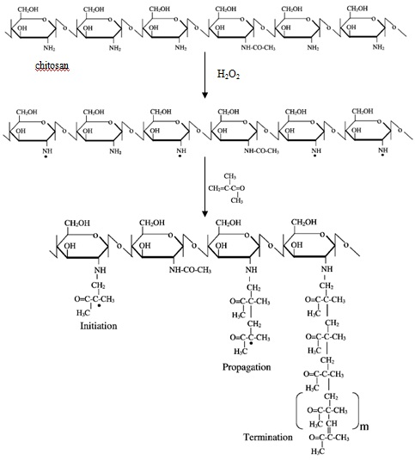
Figure 1: Schematic representation of graft-copolymerization of chitosan

The appearance in chitosan-g-PMMA at absorption 1723 cm⁻¹ is due to –C = O (carbonyl) absorption and methyl and methylene asymmetric stretching vibrations at 2991 and 2946 cm⁻¹ respectively. With increase in percent grafting, the intensity of these grafting also increase [5]. A broad peak around 3363 cm⁻¹ due to stretching vibration of N-H and O-H bonds and a peak around 1649 cm⁻¹ (N-H bending vibration) are observedindicating the existence of chitosan in the grafted copolymers. The vibrations peak corresponding to the out-of plane C-H bending, rocking C-H₂ and the stretching vibration of C-N are observed at 752, 842 and 986 cm⁻¹, respectively in the chitosan-g-PMMA. The presence of the characteristic peaks clearly proves that PMMA has been successfully grafted onto the chitosan surface.

Figure 2: FTIR spectra of (a) chitosan (b) PMMA (c) chitosan-g-PMMA

DSC analysis
Figure 3 and Table 1 show the DSC results of pure chitosan and chitosan-grafted-PMMA. The chitosan shows melting temperature at around 300ºC while the grafted chitosan exhibits melting temperature at 402ºC, is similar to those reported by [8]. The increase in melting temperature is probably caused by the restricted mobility of the PMMA grafted to the cellulose. DSC analysis also shows that the PMMA was successfully grafted onto chitosan surface.

Table 1: Melting temperature of pure chitosan and chitosan-g-PMMA

Material | Melting Temperature(T_{m})
Chitosan | 300.00ºC
Chitosan-g-PMMA | 402.00ºC

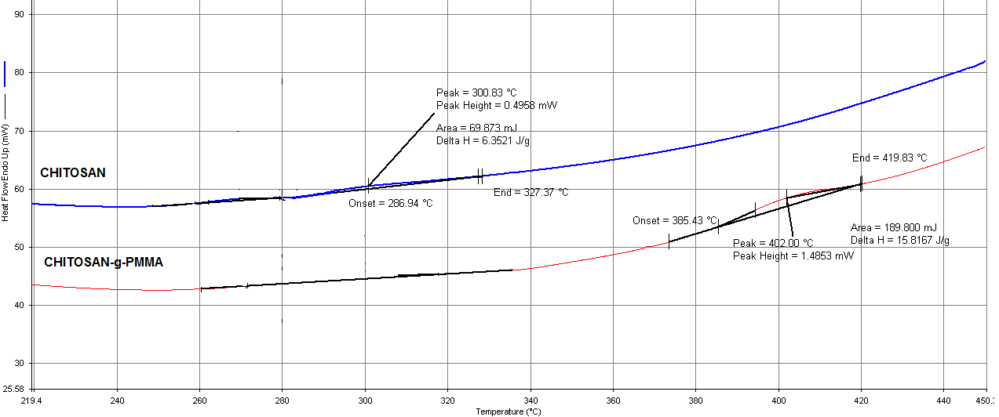
Figure 3: DSC thermograms of chitosan and chitosan-g-PMMA

Thermogravimetric analysis
TGA is the simplest accurate method for analysing the thermal stability of polymers. TGA thermogram of pure chitosan and the grafted chitosan is shown in Figure 4. The TGA of pure chitosan shows a two stages weight loss. The first stage occurs in the temperature range of 30ºC - 231ºC with a weight loss of 4.25%. This may be attributed to the loss of adsorbed and bound water. The second stage of weight loss starts at 401ºC and continues up to 571ºC during which there is 88.41% of weight loss due to the degradation of chitosan.

Figure 4: TG curves of chitosan and chitosan-grafted-PMMA (grafting percentage = 449.16%)

The TGA curve of chitosan-grafted-PMMA (Figure 4) also shows two stages of degradation. The first stage occurs in the temperature range of 31ºC- 111ºC with a weight loss of 12.38%.This may be due to the devolatilization of moisture. The second stage weight loss starts at 231ºC to 361ºC with weight loss of 54.51%.

Table 2 compares the degradation temperature at 20% and 65% weight loss for the grafted and ungrafted chitosan. The thermal stability at 65% weight loss of chitosan-grafted-PMMA increases drastically compared to pure chitosan. The increase in thermal stability at 611ºC in chitosan-grafted-PMMA may be due to the PMMA enveloping the chitosan surface, thus increasing the overall thermal stability of the grafted chitosan. In addition, the grafted polymers entangle and form a physical crosslinked type of network, which when heated forms an insulative carbonaceous char barrier on the surface, thus inhibiting degradation [11]. Thus, the grafting chitosan onto PMMA enhances the stability of pure chitosan at elevated temperature.

Table 2:Thermal degradation analysis at 20% and 65% weight loss

Material | T₂₀ | T₆₅ | Char Residue
Chitosan | 301ºC | 381ºC | 0.755%
Chitosan-g-PMMA | 281ºC | 611ºC | 21.46%

Scanning Electron Microscopy
Graft copolymerization considerably modifies chitosan morphology. It also alters the chemical, physical and biodegradable characteristics, which varies with respect to the nature of the synthetic side chains incorporated [8]. Figure 5 shows the SEM micrographs of ungrafted chitosan and grafted chitosan respectively. The difference can be observed on the surface of ungrafted and grafted chitosan. On Figure 5 (B) and (D) the surface of the grafted chitosan was almost covered by PMMA after the grafting process. It is believed that the PMMA is strongly attached onto the chitosan surface.

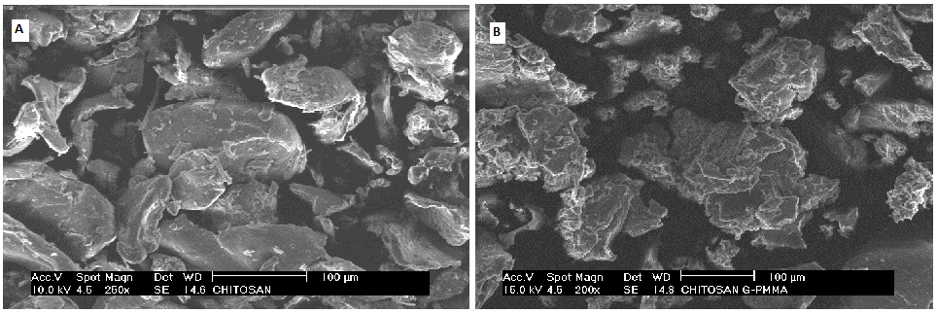
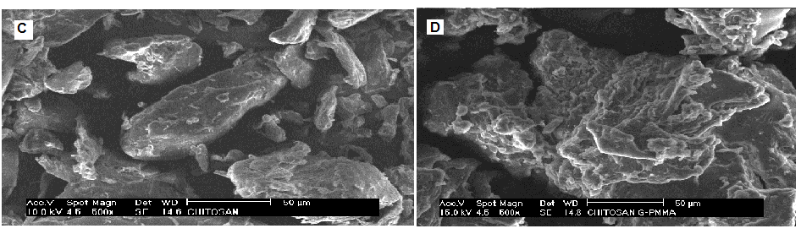
Figure 5. SEM photographs (A) chitosan (x 250), (B) chitosan-g-PMMA(x 200), (C) chitosan (x500),
(D) chitosan-g-PMMA(x 500)

Conclusions
The graft coplymerization of hydrophobic monomer (MMA) onto chitosan was successfully carried out by free radicals using hydrogen peroxide and ferrous ion as initiator/co-catalyst system. The parameters used for the grafting process were 0.3 g chitosan copolymerized with 3 mL monomer at 70ºC for 120 minutes with [FAS] = 6 x 10⁻⁵ M, [H₂O₂] = 6 x 10⁻³ M and 8 mL water. These parameters produced 449.16% and 85.94% of grafting percentage and efficiency respectively. The presence of PMMA on the chitosan surface was confirmed by FTIR spectra, TGA, DSC and SEM analysis. The chitosan-grafted-PMMA exhibited better thermal resistance than pure chitosan.
Acknowledgement
The authors gratefully acknowledged the Ministry of Higher Education (MOHE), Malaysia under the Exploratory Research Grant Scheme (ERGS Project No. 4L028) for financial support, and the Polymer Processing Laboratory, Faculty of Chemical Engineering, Universiti Teknologi Malaysia for technical assistance.

References

- Liu, Z., Wu, G. & Liu, Y. (2006). Graft copolymerization of methyl acrylate onto chitosan initiated by potassium diperiodatoargentate (III). Journal of Applied Polymer Science. 101 (1): 799-804.
- Flores-Ramirez, N., Luna-Barcenas, G., Vasquez-Garcia, S., Munoz-Saldana, J., Elizalde-Pena, E., Gupta, R., Sanchez, I., Gonzalez-Hernandez, J., Garcia-Gaitan, B. & Villasenor-Ortega, F. (2008). Hybrid natural-synthetic chitosan resin: thermal and mechanical behavior. Journal of Biomaterials Science, Polymer Edition. 19 (2): 259-273.
- Radhakumary, C., Nair, P. D., Mathew, S. & Nair, C. P. R. (2005). Biopolymer composite of chitosan and methyl methacrylate for medical applications. Trends Biomater. Artif. Organs. 18 (2): 117-124.
- Bledzki, A. K., Reihmane, S. & Gassan, J. (1996). Properties and modification methods for vegetable fibers for natural fiber composites. Journal of Applied Polymer Science. 59 (8): 1329-1336.
- Prashanth, K. V. H. & Tharanathan, R. N. (2003). Studies on graft copolymerization of chitosan with synthetic monomers. Carbohydrate Polymers. 54 (3): 343-351.
- Gupta, K., Sahoo, S. & Khandekar, K. (2002). Graft copolymerization of ethyl acrylate onto cellulose using ceric ammonium nitrate as initiator in aqueous medium. Biomacromolecules. 3 (5): 1087-1094.
- Lagos, A. & Reyes, J. (1988). Grafting onto chitosan. I. Graft copolymerization of methyl methacrylate onto chitosan with Fenton's reagent (Fe²⁺−H₂O₂) as a redox initiator. Journal of Polymer Science Part A: Polymer Chemistry. 26 (4): 985-991.
- Prashanth, K. & Tharanathan, R. (2003). Studies on graft copolymerization of chitosan with synthetic monomers. Carbohydrate Polymers. 54 (3): 343-351.
- Harish Prashanth, K., Lakshman, K., Shamala, T. & Tharanathan, R. (2005). Biodegradation of chitosan-graft-polymethylmethacrylate films. International Biodeterioration & Biodegradation. 56 (2): 115-120.
- Abu Bakar, A., Nik Mat, N. S. & Isnin, M. K. (2008). Optimized conditions for the grafting reaction of poly (methyl methacrylate) onto oil-palm empty fruit bunch fibers. Journal of Applied Polymer Science. 110 (2): 847-855.
- Das, R. K., Basu, D. & Banerjee, A. (1999). Study of methyl-methacrylate-viscose fiber graft copolymerization and the effect of grafting on thermal properties. Journal of Applied Polymer Science. 72 (1): 135-140.

