EFFECT OF REAGENTS CONCENTRATION AND RATIO ON DEGRADATION OF NATURAL RUBBER LATEX IN ACIDIC MEDIUM
(Kesan Kepekatan dan Nisbah Reagen ke Atas Pendegradasian Lateks Getah Asli dalam Media Berasid)
Suhawati Ibrahim*, Asrul Mustafa

Fine Chemicals and Biomaterials Programme, Bahagian Teknologi dan Kejuruteraan,
Lembaga Getah Malaysia, 47000 Sungai Buloh, Selangor, Malaysia.

*Corresponding author: suhawati@lgm.gov.my

Abstract
The molecular weight of natural rubber (NR) was reduced via degradation to liquid natural rubber (LNR) using hydrogen peroxide and sodium nitrite as reagents in latex solution. In this study, the reaction was carried out in an acidic medium at 70ºC at various ratio and concentration of reagents. Results showed that the properties of degraded product i.e. LNR depends on the concentration and ratio of the reagents added into reaction mixtures. Increasing the concentration of hydrogen peroxide and sodium nitrite as reagents at 1 to 1 ratio efficiently reduced the molecular weight of LNR, but the gel content increased when reagents were added more than 0.2 mol. Hydrogen peroxide was found to have greater effect on degradation reaction compared to sodium nitrite when excessive amount of hydrogen peroxide showed further reduction in molecular weight of LNR. The degradation reaction also resulted in the formation of certain functional groups such as hydroxyl and carbonyl as shown from spectroscopy microstructure analysis.
Keyword: Liquid natural rubber (LNR), OH radical, redox reaction

Abstrak
Berat molekul getah asli (NR) telah diturunkan secara pendegradasian kepada getah asli cecair (LNR) menggunakan hidrogen peroksida dan natrium nitrit sebagai reagen-reagen dalam lateks. Dalam kajian ini, tindak balas dilakukan dalam media berasid pada suhu 70ºC pada nisbah dan kepekatan reagen yang berbeza. Keputusan menunjukkan bahawa sifat hasil pendegradasian iaitu LNR bergantung kepada kepekatan dan nisbah reagen yang digunakan semasa tindak balas. Penambahan kepekatan reagen pada nisbah 1:1 menurunkan berat molekul LNR dengan berkesan, tetapi kandungan gel meningkat bila kepekatan reagen lebih dari 0.2 mol digunakan. Hidrogen peroksida didapati memberikan pengaruh yang lebih besar ke atas tindak balas pendegradasian berbanding natrium nitrit bila berat molekul LNR terus menunjukkan penurunan bila jumlah berlebihan digunakan. Tindak balas pendegradasian juga menghasilkan kumpulan berfungsi yang tertentu seperti hidroksi dan karbonil seperti ditunjukkan dari analisa spektroskopi.
Kata kunci: Getah asli cecair (LNR), radikal OH, tindak balas redoks

Introduction
Degraded natural rubber (NR) in the form of liquid namely liquid natural rubber (LNR) can be considered as a type of oligomer (Scheme 1). Functionalized oligomer having certain functional groups are attracting interests as they can be used in various applications such as surface coating [1], adhesives [2, 3], compatibilizer [4-7] and precursor to synthesize advanced materials [8-13].
In NR degradation, the rubber chains are cleaved and the chain length is reduced, hence leaving different end groups depending on the methods used. This end groups mostly are reactive groups such as carbonyl [14], hydroxyl [15], phenylhydrazone [16] etc. Ravindran [15] reported a novel route in preparing hydroxyl telechelic liquid natural rubber (HTLNR) using photochemical degradation process. This toluene-based reaction later was used by some workers in their works to produce LNR as soft segment in polyurethane [17-19].

Mw ≤ 50K g/mol
Mw ≥ 400K g/mol
Scheme 1. Degradation of NR to LNR.
LNR can be obtained from various methods of degradation of NR either using mechanical, chemical or photodegradation. The degradation reaction is feasible in solution such as toluene [14], yielding degraded rubber with low molecular weight (MW) and narrow molecular weight distribution (MWD). Due to environmental concern, degradation of NR in latex state has been explored and developed. The degradations of NR latex were successfully carried out using chemicals such as phenylhydrazine/ferrous chloride [20] phenylhydrazine/oxygen [16], peroxide/metal nitrite or chlorite [21], periodic acid [22], kalium persulfat/propanal [23], ammonium persulfate/propanal and ozone/hydrogen peroxide [24].
In our recent work, it is found that LNR with hydroxyl and carbonyl functionalities can be prepared via degradation reaction using hydrogen peroxide and sodium nitrite in an acidic medium [25]. Determination of LNR structure and possible routes of reactions in NR degradation is important in order to have a better control on the product properties and also for further modifications of the LNR produced. This paper discusses the effect of concentration and ratio of the reagents on the chemical structure of LNR.

Materials and Methods

Materials
Latex used in this study was low ammonia NR latex (LATZ) (Mn 657 kDa, MWD 7.8) supplied by Lee Rubber. The ammonia of latex was removed by stirring the latex at room temperature for at least 3 hours. Hydrogen peroxide (30%), sodium nitrite, methanol, sodium dodecyl sulfate (emulsifier), tetrahydroforun (THF), CDCl₃ and formic acid were purchased from Merck, USA and used as received.

Degradation of NR latex
Firstly, dilution with emulsifier and water at judicious amount was carried to prepare NR latex with 20% of dry rubber content (DRC). The NR latex was then stirred continuously until a homogeneous mixture is obtained. The NR latex mixture was further acidified with formic acid to achieve the required pH for reaction. The solution was poured into a five necked reaction flask equipped with an overhead stirrer, condenser and thermometer. Hydrogen peroxide and sodium nitrite were added simultaneously into the solution at temperature of 70ºC. The reaction was then allowed to occur for 8 hours. The degraded natural rubber or LNR obtained was coagulated and washed with methanol, then dried in a vacuum oven at 60ºC. Further purification by dissolving LNR in toluene and re-precipitated in methanol followed by drying until a constant weight was achieved.

Characterizations
Fourier Transform Infrared (FTIR) spectrum was recorded on Thermo Nicolet 6700 spectrometer using attenuated total reflection (ATR) accessory at a wave number range of 4000 to 500 cm⁻¹. The ¹H NMR was measured using Bruker 500 Hz using deuterated chloroform as solvent. Tetramethyl silane (TMS) was used as the internal standard for zero axis calibration. Number average molecular weight of the LNR was determined using Viscotex multi-detector Gel Permeation Chromatography (GPC) using THF as a solvent and also as an eluent. The molecular weight was determined from an internal standardized molecular weights curve which was prior obtained using polyisoprene molecular weights standard.

Results and Discussion
It is known that the concentration of chemicals involved in a reaction is one of main factors affecting the final result or reaction yield. In a degradation reaction, the concentration of reagents used will determine the degree of reaction to a certain extend. In this work, hydrogen peroxide and sodium nitrite were used to degrade the NR chain. Both reagents were varied in their concentration ranging from 0.1 mol to 0.4 mol at different ratios. The LNR samples obtained were examined for their molecular weight and chemical structure.
The molecular weight of the LNR samples prepared is tabulated in Table 1. Degradation of NR was observed where the molecular weight of the NR was reduced from 657 ×10³ g/mol to less than 10⁴ g/mol. At the ratio of 1:1 hydrogen peroxide to sodium nitrite, greater degradation was found to occur at higher reagents concentration where Mn was reduced from 64.64 ×10³ g/mol to 24.13×10³ g/mol when the concentrations of reagents increased from 0.1 mol to 0.4 mol. However, polydispersity of all samples were not markedly changed or influenced by the increasing of concentrations of reagents. The gel content of LNR samples prepared at the concentration 0.1 and 0.2 mol reagents were found to be very low and slightly increased when the concentration of reagents increased. This suggested that the presence of side reaction or crosslink is most possible to occur at higher reagent concentrations.
When the concentration of hydrogen peroxide was fixed at 0.2 mol, the LNR sampels prepared with varying concentrations of sodium nitrite revealed that the lowest Mn was obtained when 0.2 and 0.3 mol of the sodium nitrite was used, but 0.3 mol exhibited higher polydispersity. The result suggested that both reagents are required in an equal concentration to perform the degradation reaction effectively. Excessive amount of sodium nitrite slightly increased the Mn and polydispersity of LNR, probably due to an interference of reagent during chain breaking reaction.
Alternatively, when sodium nitrite was fixed at 0.2 mol, increasing the concentrations of the hydrogen peroxide slightly reduced the Mn of LNRs obtained.

Table 1. Mn, Mw and polydispersity of LNRs
Reagents concentration  (mol) |  | Mn ×10³  (g/mol) | Mw ×10³  (g/mol) | Polydispersity | Gel content (%)
H₂O₂ | NaNO₂
NR latex (Control) |  | 657.00 | 5120 | 7.800 | 11.73
0.1 | 0.1 | 64.64 | 168.00 | 2.606 | 0.05
0.2 | 0.2 | 36.77 | 81.45 | 2.215 | 0.01
0.3 | 0.3 | 34.31 | 89.27 | 2.602 | 0.79
0.4 | 0.4 | 24.13 | 57.35 | 2.376 | 3.75
0.2 | 0.1 | 56.41 | 160.00 | 2.836 | -
0.2 | 0.3 | 35.43 | 112.67 | 3.180 | -
0.2 | 0.4 | 44.56 | 139.50 | 2.933 | -
0.1 | 0.2 | 62.12 | 166.10 | 2.674 | -
0.3 | 0.2 | 35.90 | 101.85 | 2.837 | -
0.4 | 0.2 | 30.62 | 74.13 | 2.422 | -

Figure 1 show the ¹H-NMR spectra of LNRs prepared at 1:1 ratio of hydrogen peroxide and sodium nitrite with the concentrations ranging from 0.1 to 0.4 mol. The spectra obtained showed similar pattern to that of NR spectrum except a small peak appeared at $δ$=3.75 ppm. This peak corresponds to the proton of α carbon and was used as an indication of the presence of hydroxyl groups on LNR chains [11, 26, 27]. However, no proton peak for the hydroxyl group itself was observed. This may due to highly variable chemical shift of the protons of the hydroxyl group as they rapidly exchanges and their position depends largely on concentration, solvent and temperature [28]. The intensity of this peak increased as the concentration of hydrogen peroxide and sodium nitrite increased from 0.1 to 0.3 mol reflected the increase in the amount of hydroxyl group produced in the reaction. However, a reduction in peak intensity was observed for further increment of hydrogen peroxide and sodium nitrite at 0.4 mol.
Figure 2 illustrates ¹H NMR spectra of LNRs prepared at 0.1, 0.2, 0.3 and 0.4 mol of sodium nitrite to a fixed 0.2 mol of hydrogen peroxide. It is noticed that methylene proton of adjacent carbon of hydroxyl group appeared at chemical shift $δ$=3.75 ppm for all LNR samples. The ¹H NMR spectra for LNR samples prepared at various concentrations of hydrogen peroxide with a fixed concentration of sodium nitrite of 0.2 mol are shown in Figure 3. Very weak peak at 3.75 ppm was observed when hydrogen peroxide concentration exceeded 0.2 mol and was not observable when the level reached 0.4 mol. Any presence of aldehyde peak at 9-10 ppm was not observed. This may due to very low amount or the carbonyl groups observed in the FTIR spectrum are attributed to ketone.
The presence of OH groups on the LNR chain was confirmed by ¹³C NMR spectrum as shown in Figure 4. There are two small peaks located at chemical shifts 69.79 ppm and 74.98 ppm corresponded to the methylene and methine carbons of hydroxyl groups respectively.

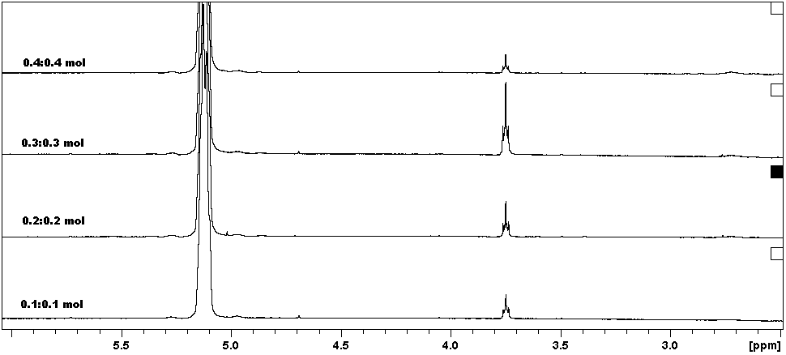
Figure 1: ¹H-NMR spectra of LNRs prepared at same ratio of hydrogen peroxide and sodium nitrite

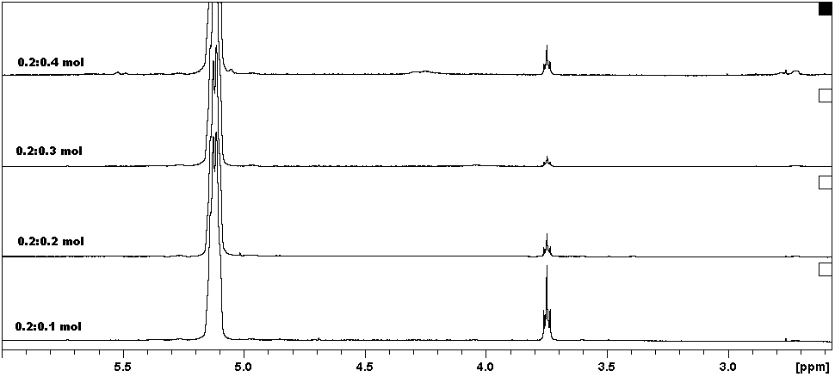
Figure 2: ¹H NMR spectra of LNRs prepared at 0.2 mol of hydrogen peroxide and various concentration of sodium nitrite

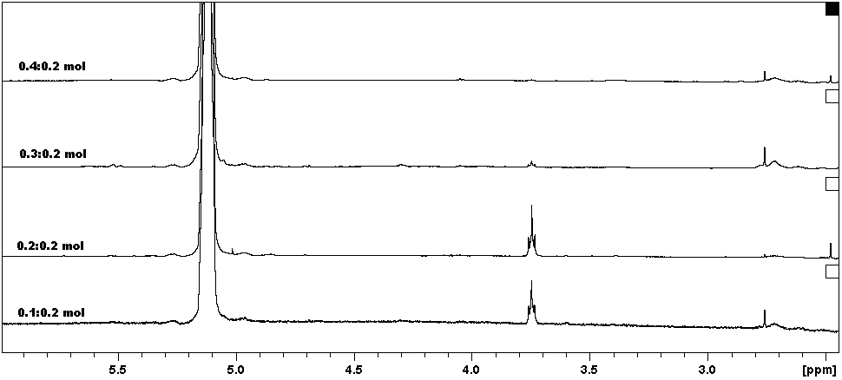
Figure 3: ¹H NMR spectra of LNRs prepared at various concentration of hydrogen peroxide and 0.2 mol of sodium nitrite

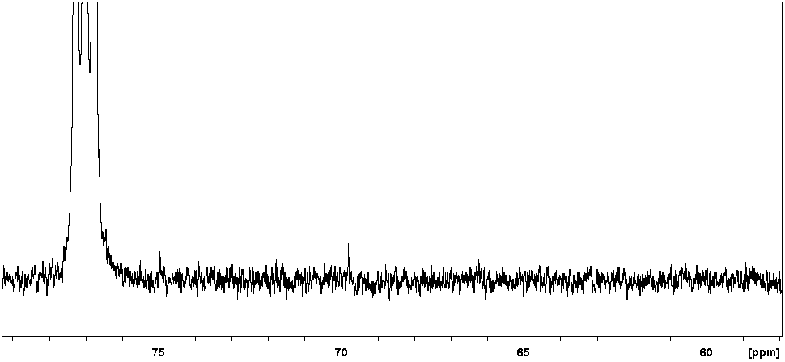
Figure 4: ¹³C NMR spectrum of LNR prepared with 0.2:0.2 mol reagents
The microstructure of LNR samples obtained was determined using FTIR. The spectra of LNR samples showed similar pattern to that of NR spectrum, but with few different peaks and intensity (Figure 5). The absorption peaks of C=C bond, C-C bond and =C-H at 1667, 1446 and 835cm⁻¹ respectively were found to decrease when NR was degraded to LNR. The presence of other groups on the LNR chains can be attributed to the appearance of carbonyl peak at 1720 cm⁻¹ and a broad peak at 3400 cm⁻¹ for O-H groups. Similar observation was seen in the NMR analysis as mentioned in the earlier section.
Figure 6 is shows the spectra of LNR samples prepared at reagents ratio of 1:1. The intensity of the broad peak at 3400 cm⁻¹ was the highest when reagents concentration used was at 0.2 mol. The peak intensity then decreased with increasing reagents concentrations. The decrease of the peak intensity is compromised by an increase in carbonyl peak at 1720 cm⁻¹.
IR spectra of LNR samples prepared at various concentrations of sodium nitrite to a fixed amount of 0.2 mol hydrogen peroxide are shown in Figure 7. When sodium nitrite concentration was less than hydrogen peroxide (0.1 mol of sodium nitrite to 0.2 mol of hydrogen peroxide), the intensity of 3400 cm⁻¹ broad peak that indicates hydroxyl group is negligible, but increased considerably when both the reagents were of same concentration (0.2 mol of sodium nitrite to 0.2 mol of hydrogen peroxide). This peak remained when the concentration of sodium nitrite was further increased to 0.3 and 0.4 mol. At the same time, no significant change was observed for carbonyl groups as the intensity of peak at 1715 cm⁻¹ remains unchanged.
The LNR samples prepared at various concentrations of hydrogen peroxide with a fixed amount of 0.2 mol sodium nitrite is shown in Figure 8. It was found that the intensity of peak at 1715 cm⁻¹ that corresponded to carbonyl groups, which increased when the concentration of hydrogen peroxide was higher than sodium nitrite.
Figure 5: IR spectra of NR and LNR

Figure 6: IR spectra of LNRs prepared at same ratio of hydrogen peroxide and sodium nitrite

Figure 7: IR spectra of LNRs prepared at various concentration of sodium nitrite and 0.2 mol hydrogen peroxide

Figure 8: IR spectra of LNRs prepared at various concentration of hydrogen peroxide and 0.2 mol sodium nitrite
Radical initiated reaction in NR modification causes by radical species leading to chain rupture can be contributed by unbalanced structure and weakened CH₂-CH₂ bond, [15]. This is also induced by the steric hindrance occurring at cis position of NR chain. The C=C in the chain is a nucleophilic site which becomes favorable for cleavage by redox reaction. Thus, the reduction of C=C and C-C bonds as shown in FTIR spectrum of LNR indicated that the degradation of NR had occurred at both C=C and C-C bonds and suggested the possibility that more than one cleavage sites occurred concurrently in the degradation reaction.
The C=C bond was cleaved by the redox reaction induced by hydrogen peroxide and sodium nitrite, whilst C-C bond cleavage as a result of hydroxyl radical activity. Hydrogen peroxide and sodium nitrite are known to react chemically in acidic medium to produce peroxynitrite acid, which then can undergo homolytic decay to release hydroxyl radical [29]. This hydroxyl radical is highly reactive species that can break the C-C bond of NR chain [15].
Carbonyl and OH groups were present in the LNR chain as indicated by both FTIR and NMR spectra. The formation of these groups came from cleavage of C=C by redox reaction that leave carbonyl as terminal groups, while C-C bond that broken by hydroxyl radical would produce LNR with hydroxyl end chain [25, 30].
Highest amount of hydroxyl group was observed when the LNR prepared with 0.2 mol of hydrogen peroxide to sodium nitrite at a ratio of 1:1. This suggested that the degradation reaction was predominantly affected by OH radical in the bond cleavage when the ratio of reagents used was 0.2 mol. On the other hand, redox reaction predominated if the concentration of reagents used was higher than 0.2 mol as indicated by the increasing of carbonyl group.
The reactions conducted with excessive amount of sodium nitrite compared to hydrogen peroxide showed the presence of higher hydroxyl groups on LNR chain, whilst the reactions added with excessive amount of hydrogen peroxide showed the presence of higher carbonyl group. This suggested that the primary reaction either by redox or hydroxyl radical is strongly influenced by the concentrations and ratios of reagents.

Conclusions
Degradation of NR latex by using sodium nitrite and hydrogen peroxide was successfully conducted and yielding LNR having Mn of less than 50 x 10³ g/mol. One to one ratio of 0.2:0.2 mol of hydrogen peroxide and sodium nitrite reagents concentrations was found to be the best ratio to produce LNR that having low Mn, gel content and polydispersity. It is found that increasing the concentrations of sodium nitrite resulted in the increase of Mn and the chains attached with OH groups. Meanwhile, excessive concentrations of hydrogen peroxide reduced the Mn and increased the number of carbonyl groups attached on the chains, while the hydroxyl groups was almost negligible.The degradation reaction is suggested to occur at both C=C and C-C bonds by redox reaction and hydroxyl radical respectively.

Acknowledgments
The authors would like to extend gratitude to Malaysian Rubber Board for approval of funding for this research under grant no. SN12NM0408.

References

- Mathew V. S, Sinturel C, George S. C, & Thomas S (2010). Epoxy resin/liquid natural rubber system: Secondary phase separation and its impact on mechanical properties. J Mater Sci 45: 1769-1781.
- Wayakron Phetphaisit C, Bumee R, Namahoot J, Ruamcharoen J, & Ruamcharoen P (2012). Polyurethane polyester elastomer: Innovative environmental friendly wood adhesive from modified PETs and hydroxyl liquid natural rubber polyols. Int J Adhes Adhes 41: 127-131.
- Dileep U, & Avirah S. A (2003). Studies on carboxy-terminated natural rubber in filled NR and NR latex vulcanizates. Iranian Polymer Journal (English Edition) 12: 441-448.
- Abdullah I. (1992). Liquid natural rubber as a compatibilizer in the blending of natural rubber with polypropylene. Mater Forum 16: 353-357.
- Ahmad S, Abdullah I, Sulaiman C. S, Kohjiya S, & Yoon J. R (1994). Natural rubber -HDPE blends with liquid natural rubber as a compatibilizer. I. Thermal and mechanical properties. J Appl Polym Sci 51: 1357-1363.
- Srilathakutty R, Noushad V, Joseph R, & George K. E (1996). Studies on the properties of microcellular soles based on NBR/PVC blends. Polymer - Plastics Technology and Engineering 35: 97-119.
- Dahlan H. M, Zaman M..D..K, & Ibrahim A. (2002). Liquid natural rubber (LNR) as a compatibiliser in NR/LLDPE blends - II: The effects of electron-beam (EB) irradiation. Radiat Phys Chem 64: 429-436.
- Paul C. J, Gopinathan Nair M. R, Neelakantan N. R, Koshy P, Idage B. B, & Bhelhekar A. A (1998). Segmented block copolymers of natural rubber and 1, 3-butanediol-toluene diisocyanate oligomers. Polymer 39: 6861-6874.
- Gopakumar S, & Gopinathan Nair M. R (2006). Natural rubber-polyurethane block copolymers: Nonlinear structural variations with NCO/OH ratio. Polym Eng Sci 46: 1812-1821.
- Nair M. N. R, Sukumar P., Jayashree V, & Nair M. R. G (2010). Mechanical properties and fractography of block copolymers based on NR and MDI-based polyurethanes. Polymer Bulletin 65: 83-96.
- Kébir N, Campistron I, Laguerre A, Pilard J, & Bunel C. (2011). New crosslinked polyurethane elastomers with various physical properties from natural rubber derivatives. J Appl Polym Sci 122: 1677-1687.
- Saetung A, Kaenhin L, Klinpituksa P, Rungvichaniwat A, Tulyapitak T, Munleh S, Campistron I, & Pilard J (2012). Synthesis, characteristic, and properties of waterborne polyurethane based on natural rubber. J Appl Polym Sci 124: 2742-2752.
- Kaenhin L, Klinpituksa P, Rungvichaniwat A, & Pilard J. F (2012). Waterborne polyurethane: Effect of functional groups in aromatic isocyanate and the chain length of hydroxyl terminated natural rubber. Advanced Materials Research 415-417: 2032-2035
- Saetung A, Rungvichaniwat A, Campistron I, Klinpituksa P, Laguerre A, Phinyocheep P, & Pilard J. F (2010) Controlled degradation of natural rubber and modification of the obtained telechelic oligoisoprenes: Preliminary study of their potentiality as polyurethane foam precursors. J Appl Polym Sci 117: 1279-1289.
- Ravindran T, Nayar M..R..G, & Francis D. J (1988). Production of hydroxyl-terminated liquid natural rubber mechanism of photochemical depolymerization and hydroxylation. J Appl Polym Sci 35: 1227-1239.
- Lemoine A. J (1988) Production of Liquid Natural Rubber on a Pilot Scale. Proceedings of International Rubber Technology Conference Kuala Lumpur
- Gopakumar S, Paul C. J, & Gopinathan Nair M. R (2005) Segmented block copolymers of natural rubber and 1,4-butanediol-toluene diisocyanate oligomers. Materials Science- Poland 23: 227-245.
- Maier G, Knopfova V, Voit B, Ly P. H, Dung B. T, & Thanh D. B (2004). Synthesis and characterization of segmented block copolymers based on hydroxyl-terminated liquid natural rubber and α,ω-diisocyanato telechelics. Macromolecular Materials and Engineering 289: 927-932.
- Paul C. J, Nair M. R. G, Koshy P, & Idage B. B (1999). Segmented block copolymers of natural rubber and bisphenol A-toluene diisocyanate oligomers. J Appl Polym Sci 74: 706-721.
- Ha T. H, Nguyen T. N, Le Q. H, & Chu N. S (1996). Depolymerization of Natural Rubber Latex using Phenylhydrazine-FeCl₂ System. Pure Applied Chemistry: 1923-1930.
- Gazeley K. F, & Mente P. G (1990). Method for reducing the molecular weight of rubber latex. Malaysian Patent 1,00304-A
- Phinyocheep P, Phetphaisit C. W, Derouet D, Campistron I, & Brosse J. C (2005) Chemical degradation of epoxidized natural rubber using periodic acid: Preparation of epoxidized liquid natural rubber. J Appl Polym Sci 95: 6-15.
- Phetphaisit C. W, & Phinyocheep P (2003). Kinetics and Parameters Affecting Degradation of Purified Natural Rubber. J Appl Polym Sci 90: 3546-3555
- Kodama S, Nishi K, & Furukawa M (2003). Preparation of low molecular weight natural rubber by ozonolysis of high ammonia latex. Journal of Rubber Research 6: 153-163
- Suhawati I (2012). Preparation of Liquid natural rubber via chemical degradation of natural rubber latex and preparation of LNR-based polyurethane. MSc Thesis
- Kébir N, Campistron I, Laguerre A, Pilard J, Bunel C, Couvercelle J-, & Gondard C (2005). Use of hydroxytelechelic cis-1,4-polyisoprene (HTPI) in the synthesis of polyurethanes (PUs). Part 1. Influence of molecular weight and chemical modification of HTPI on the mechanical and thermal properties of PUs. Polymer 46: 6869-6877
- Sakdapipanich J. T, Suksawad P, Insom K, Kawahara S (2005). Preparation of functionalized low molecular weight natural rubber latex using solid nanometric TiO2 film as a photocatalyst. Rubber Chemistry and Technology 78: 597-605.
- Pavia D. L, Lampman G. M, Kriz G. S, & Vyvyan J. A (2009) Introduction to Spectroscopy, 4th edn. Cengage Learning, Brooks/Cole
- Halfpenny E, & Robinson P. L (1952) Pernitrous acid. The reaction between hydrogen peroxide and nitrous acid, and the properties of an intermediate product. Journal of the Chemical Society (Resumed): 928-938
- Solanky S. S, & Singh R (2003) Functional and group determination in photo-degraded liquid rubbers. . Journal of Rubber Research 6: 1-11

