GRAFT COPOLYMERIZATION OF METHYL METHACRYLATE ONTO AGAVE CELLULOSE

(Pengkopolimeran Cangkukan Metil Metakrilat ke atas Selulosa Agave)

Noor Afizah Rosli, Ishak Ahmad*, Ibrahim Abdullah, Farah Hannan Anuar

School of Chemical Science and Food Technology, Faculty of Science and Technology

Universiti Kebangsaan Malaysia, 43600 Bangi

*Corresponding author: gading@ukm.edu.my

Abstract

The grafting polymerization of methyl methacrylate (MMA) and Agave cellulose was prepared and the grafting reaction conditions were optimized by varying the reaction time and temperature, and ratio of monomer to cellulose. The resulting graft copolymers were characterized by Fourier transform infrared, X-ray diffraction analysis, thermogravimetric analysis, and scanning electron microscopy (SEM). The experimental results showed that the optimal conditions were at a temperature of 45 ºC for 90 min with ratio monomer to cellulose at 1:1 (g/g). An additional peak at 1738 cm⁻¹ which was attributed to the C=O of ester stretching vibration of poly(methyl methacrylate), appeared in the spectrum of grafted Agave cellulose. A slight decrease of crystallinity index upon grafting was found from 0.74 to 0.68 for cellulose and grafted cellulose, respectively. Grafting of MMA onto cellulose enhanced its thermal stability and SEM observation further furnished evidence of grafting MMA onto Agave cellulose with increasing cellulose diameter and surface roughness.

Keyword: Agave, Cellulose, Graft copolymerization, Methyl methacrylate

Abstrak

Pempolimeran cangkukan metil metakrilat (MMA) dan selulosa Agave telah disediakan dan keadaan tindak balas cangkukan dioptimumkan dengan mempelbagaikan masa dan suhu tindak balas, dan nisbah monomer kepada selulosa. Kopolimer cangkukan yang terhasil dicirikan oleh spektroskopi jelmaan Fourier inframerah (FTIR), belauan sinar-x (XRD), analisis termogravimetri, dan mikroskopi elektron pengimbasan (SEM). Keputusan eksperimen menunjukkan bahawa keadaan optimum adalah pada suhu 45°C selama 90 minit dengan nisbah monomer kepada selulosa pada 1:1 (g/g). Satu puncak tambahan pada 1738 cm⁻¹ yang menunjukkan kepada getaran regangan C=O daripada poli(metil metakrilat) muncul pada spektrum selulosa cangkukan. Indeks penghabluran menurun sedikit melalui cangkukan dari 0.74 ke 0.68, masing-masing bagi selulosa dan selulosa cangkukan. Cangkukan MMA ke atas selulosa meningkatkan kestabilan terma dan pemerhatian SEM melengkapkan lagi bukti cangkukan MMA ke atas selulosa dengan peningkatan diameter dan permukaan kasar selulosa.

Kata kunci: Agave, Selulosa, Pengkopolimeran cangkukan, Metil metakrilat

Introduction

Cellulose is a unique polymeric material which is the most abundant on earth. It possesses several good properties such as a fine cross-section, high durability and thermal stability, good biocompatibility, and good mechanical properties. Cellulose is a semicrystalline polysaccharide with a large number of hydroxyl groups. It is generated from repeating β-D-anhydroglucopyranose units that are covalently joined together through acetal functions between the equatorial group of the C4 and C1 carbon atom [1]. The sensitivity of the β-1,4-glycosidic linkages between the glucose repeating units towards hydrolytic attack determined the chemical stability of the cellulose molecule [1]. Agave angustifolia is a promising reinforcement element for polymer composites because of its high cellulose content (67%) [2]. However, there are some limitations in cellulose applications due to its poor solubility in common solvent, poor dimensional stability, lack of thermoplasticity, and high hydrophilicity [3]. To overcome these major drawbacks, physical and chemical modification such as graft copolymerization of the cellulose structure is necessary.

Graft copolymerization permits one to combine the best properties of two or more polymers by taking advantages of synergy effects of the graft copolymer. It can be classified into three major groups: (i) free radical polymerization, (ii) ionic and ring opening polymerization, and (iii) living radical polymerization. Among these three methods, free radical polymerization has received greatest amount attention due to its many characteristics, such as mild reaction conditions, wide temperature range, simple to implement and inexpensive [3]. The grafting of MMA onto natural polymers like Saccharum spontaneum L. fiber [4], wood fiber [5], etc. with different redox systems has been reported. However, no work has been directed towards grafting of MMA monomer onto cellulose isolated from Agave angustifolia.

Keeping the view to promote an ecologic through value added application, cellulose was isolated from the Agave angustifolia fibre followed by grafting of MMA onto cellulose to develop a commercially viable product. The work of graft copolymerization of MMA onto cellulose was investigated in the presence of ceric ammonium nitrate as redox initiator with a view that grafted cellulose may find better applications than native cellulose.

Materials and Methods

Materials

Agave leaves used in this study were harvested in Kajang, Selangor (Malaysia). The chemical reagents used were sodium chlorite (NaClO₂), and nitric acid from Sigma-Aldrich, acetic acid glacial (99%), acetone, methanol, and sodium hydroxide (NaOH) purchased from Systerm and ceric ammonium nitrate (CAN) from E. Merck. All of these chemical reagents were used without further purification. Methyl methacrylate (MMA) (stabilised) for synthesis was purchased from E. Merck. The MMA was passed through a column of basic alumina oxide (Al₂O₃) to remove the stabilizer.

Extraction of cellulose

The ground Agave fibres were treated with 4% NaOH at 70 to 80 ºC for two hours, after which bleaching treatment was carried out using 1.7 w/v% NaClO₂ at 70 to 80 ºC for four hours. The ratio of the fibres to liquor was 1:25 (g/mL). Each fibre treatment was done twice and the fibres were washed with distilled water after each treatment.

Graft copolymerization

The grafting reaction was carried out under nitrogen atmosphere in 250 ml three-necked flask equipped with a reflux condenser, dropping funnel and a gas inlet system immersed in a water bath. 1 g of cellulose was dispersed in a 50 ml of water with constant stirring and bubbling of nitrogen for one hour at 45 ºC. Then, a freshly prepared 10 ml solution of CAN (0.91 x 10⁻³ mol) in nitric acid 0.3 N was added and stirred for 15 min. MMA monomer was added gradually over a period of 30 min and the mixture was stirred for a further 90 min. The ratio of cellulose to monomer was kept constant to 1:1 (g/g). After the reaction, the grafted cellulose was washed with 750 ml of distilled water followed by 250 ml of methanol and dried to a constant weight in an oven at 40 ºC. The dried product was extracted with acetone in a Soxhlet apparatus to remove the homopolymer. The suspension was filtered and the filtrate was washed with acetone and dried to a constant weight. The grafting reaction conditions were optimized by varying the reaction time, temperature, and monomer to cellulose ratios.

The grafting efficiency is defined as the ratio between the amounts of grafted monomer and the total polymerized monomer [6].

Infrared (IR) spectral analysis

The Fourier transform infrared (FTIR) spectra of the cellulose and grafted cellulose were recorded on a Perkin-Elmer spectrometer (SpectrumGX) in the range of 500-4000 cm⁻¹ with a scanning resolution of 1 cm⁻¹. The cellulose and grafted cellulose were ground into powder, mixed with KBr, and pressed into an ultra-thin pellet.

X-ray diffraction study

X-ray diffraction (XRD) analyses were performed with a Bruker AXS D8 Advance diffractometer at 40 kV, 40 mA with Cu-Kα radiation ( λ=0.1541 nm). The data were acquired in a 2θ range from 10 to 60º. The percent crystallinity was calculated using the following equation 1 [7].

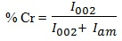 (1)

where I₀₀₂ is the maximum intensity of diffraction of the (002) lattice peak between 22º to 23º, and I_{am} the intensity of diffraction of the amorphous material between 18º to 19º where the intensity is minimum.

Thermogravimetric analysis

A Mettler Toledo model TGA/SDTA851e thermogravimetric analyzer was used to characterize the thermal stability of the cellulose and grafted cellulose. Approximately 2 to 12 mg of each sample was heated from 30 ºC to 600 ºC at a heating rate of 10 ºC/min. All the measurement was performed under nitrogen atmosphere.

Scanning electron microscopy

The scanning electron microscopy (SEM) micrographs of the cellulose and grafted cellulose were recorded on a Leo 1450VP microscope at a voltage of 15 kV. The samples were coated with gold to avoid charging.

Results and Discussion

Effects of reaction time

Figure 1 shows the results of grafting MMA onto cellulose as a function of time. It can be seen that the percent grafting efficiency (%GE) increases with increase reaction time up to 90 min. Increase in the %GE with time is due to more contact time of the monomer molecules with the cellulose macroradical sites. Depletion of monomer concentration with the progress of reaction explained in the decrement of %GE after 90 min.

Figure 1: The effect of time on the percentage of graft efficiency of the grafting polymerization of 1:1 (MMA:cellulose) at 45 °C

Effects of temperature

Figure 2 shows the results of graft copolymerization of MMA onto cellulose as a function of temperature. The %GE increases with the initial increased in temperature, reaches the optimum at 45ºC, and then decreases with further increased in temperature. As the kinetic energy of the molecules increases with temperature, more radicals drifted at faster rate onto the cellulose backbone, hence, increase in the %GE. Further increase in temperature leads to termination processes and thermally initiate the monomer resulted in the formation of a homopolymer, thereby decreasing the %GE.

Figure 2: The effect of temperature on the percentage of graft efficiency of the grafting polymerization of 1:1 (MMA:cellulose) for 90 min

Effects of monomer to cellulose ratios

Figure 3 shows the effect of monomer:cellulose ratios on the %GE. The %GE decrease with increase monomer to cellulose ratios. The %GE decrease with increasing the MMA to cellulose ratios is due to the formation of homopolymer over the cellulose macroradicals [8]. The formation of homopolymer at high MMA to cellulose ratios is due to formation of a three-component complex which comprise of a substrate, monomer, and water. These three-component complex rearranges to provide a requisite free radical site with liberation of atomic hydrogen and thus initiates the homopolymerisation.

Figure 3: The effect of MMA:cellulose ratios on the percentage of graft efficiency of the grafting polymerization at 45 °C for 90 min

Infrared spectroscopy analysis

The FTIR spectroscopy analysis of the cellulose and grafted cellulose are shown in Figure 4. It reveals that compositional changes occurred upon grafting. Both of the spectra exhibited a broad band in the region 3400-3300 cm⁻¹ which indicates the free O-H stretching vibration of the OH group. Moreover, the vibration peak detected at 2910 cm⁻¹ in both samples is related to stretching vibration of C-H. In addition, both of the spectra showed the characteristic of C-H and C-O bending vibration bond in the polysaccharide aromatic rings around 1360-1375 cm⁻¹. An additional peak at 1732 cm⁻¹ was observed in the grafted cellulose spectra. This peak is attributed to the stretching vibrations of C=O of the PMMA chains. Furthermore, there is another one characteristic peaks of PMMA in the grafted cellulose spectra which appeared at 843 cm⁻¹. This peak is attributed to the C-O-C bending vibration of PMMA. Note that the absorbance peak at 1640 cm⁻¹ was slightly decreased for the grafted cellulose spectra. This peak is attributed to the O-H bending of the absorbed water [9]. Improved of hydrophobicity with grafting leads to reduce the amount of absorbed water.

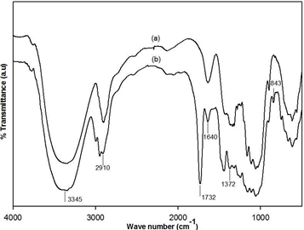

Figure 4: FTIR spectra of (a) cellulose, and (b) cellulose-g-PMMA

X-ray diffraction study

Figure 5 shows X-ray diffraction patterns of cellulose and grafted cellulose. The crystallinity of Agave cellulose and grafted cellulose were determined to see the changes in the fine structure of cellulose as a results of grafting MMA onto the cellulose backbone. The result in Table 1 clearly showed that the percent crystallinity slightly decreased upon grafting from 80.14% to 75.48% for cellulose and grafted cellulose, respectively. Crystallinity decrease with grafting, indicates that the grafted chain occurred in the ordered and amorphous region of cellulose [10].

Table 1: Percent crystallinity of cellulose and cell-g-PMMA

Sample | % Crystallinity
Cellulose  Cellulose-g-PMMA | 80.14  75.48

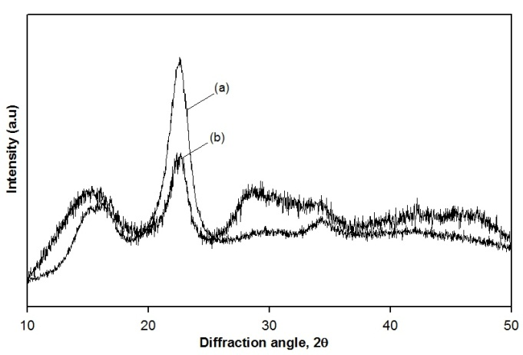

Figure 5: X-ray diffraction patterns for (a) cellulose, and (b) cellulose-g-PMMA

Thermogravimetric analysis

Figure 6 shows the thermal behaviour of cellulose and grafted cellulose as a function of % weight loss with temperature. Cellulose samples shows two degradation steps related to: (i) moisture evaporation, and (ii) cellulose degradation while grafted cellulose only shows one degradation step which related to cellulose degradation. The absence of the first step in grafted cellulose is due to the improved hydrophobicity on the grafted cellulose. The second step decomposition of the cellulose (260 to 370 °C) shifts to higher temperature in comparison with the grafted cellulose (289 to 416 °C). The shift can be explained by assuming that the presence of PMMA improved the thermal stability. At the end of the test at 600°C, the residue of 13, and 8 wt% of the original mass remains for the cellulose, and grafted cellulose, respectively.

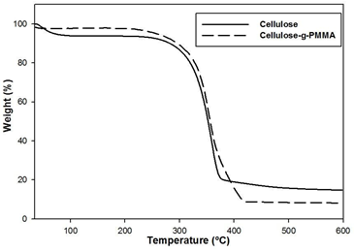

Figure 6: TGA thermograms of cellulose, and cellulose-g-PMMA

Morphological analysis

The evidence of grafting on the surface morphology was examined with SEM. Microscopic examinations on the cellulose and grafted cellulose were depicted in Figures 7(a) and 7(b), respectively. The cellulose appears completely fibrous. The cellulose surface was very smooth and covered with the thin PMMA layer as seen in grafted cellulose micrograph. The diameter also increased from 5.8 ± 1.2 µm to 8.9 ± 0.6 µm for cellulose and grafted cellulose, respectively.

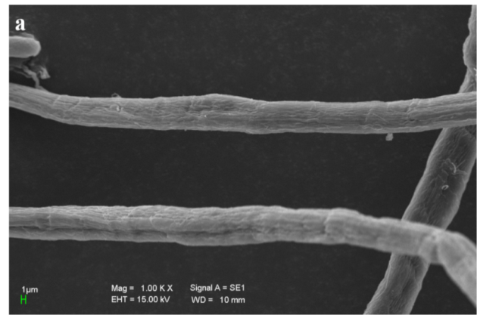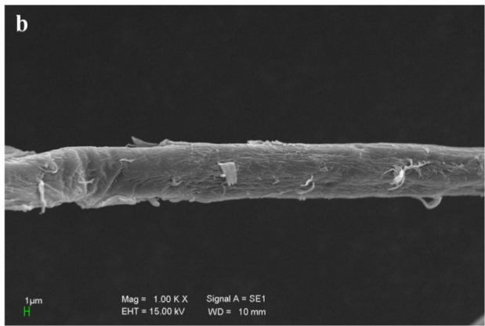

Figure 7: SEM micrographs of (a) cellulose, and (b) cellulose-g-PMMA

Conclusion

The graft copolymerization of PMMA onto Agave cellulose was successfully carried out using CAN as redox initiator. The optimized conditions for grafting obtained are as follows: MMA:cellulose ratio, 1:1 (g/g); reaction time, 90 min; temperature of 45 ºC. The characterization of the grafted cellulose by means of FTIR , and SEM elucidated the structure changes in comparison with the ungrafted cellulose. Although the crystallinity and crystallinity index decreased, the incorporation of PMMA chains onto the cellulose backbone slightly improved the thermal stability of grafted cellulose.

Acknowledgements

This work was supported by research grants from the Ministry of Higher Education (MOHE) and Universiti Kebangsaan Malaysia under research grant ERGS/1/2012/STG01/UKM/02/4. The authors would also like to thank Dr. Md. Akhir Hamid from Malaysian Agriculture Research & Development Institute (MARDI) for the processing of raw Agave fibres.

References

- Krassig, H.A. Cellulose and Its Derivatives: Chemistry, Biochemistry and Applications. Kennedy, J. pg 3 – 25.
- Rosli, N. A., Ahmad, I., & Abdullah, I. (2013). Isolation and characterization of cellulose nanocrystals from Agave angustifolia fibre. Bioresources, 8 (2): 1893–1908.
- Roy, D., Semsarilar, M., Guthrie, J.T., & Perrier, S. (2009). Cellulose Modification by Polymer Grafting: A Review. Chemical Society Reviews, 38: 2046-2064.
- Kaith, B.S., Jindal, R., & Maiti, M. (2009). Induction of Chemical and Moisture Resistance in Saccharum spontaneum L Fiber through Graft Copolymerization with Methyl Methacrylate and Study of Morphological Changes. Journal of Applied Polymer Science, 113 (3): 1781-1791.
- Román-Aguirre, M., Márquez-Lucero, A., & Zaragoza-Contreras, A. (2004). Elucidating the graft copolymerization of methyl methacrylate onto wood-fiber. Carbohydrate Polymers 55 (2): 201-210.
- Princi, E., Vicini, S., Pedemonte, E., Mulas, A., Franceschi, E., Luciano, G., & Trefiletti, V. (2005). Thermal Analysis and Characterisation of Cellulose Grafted with Acrylic Monomers. Thermochimica Act, 42 (1-2): 173-179.
- Mwaikambo, L.Y., & Ansell, M.P. (2002). Chemical Modification of Hemp, Sisal, Jute, and Kapok Fibres by Alkalization. Journal of Applied Polymer Science, 84 (12): 2222–2234.
- Kumar, V., Naithani, S., & Pandey, D. (2011). Optimization of Reaction Conditions for Grafting of α-Cellulose Isolated from Lantana camara with Acrylamide. Carbohydrate Polymers, 8 (2): 760–768.
- Troedec, M., Sedan, D., Peyratout, C., Bonnet, J., Smith, A., & Guinebretiere, R. (2008). Influence of Various Chemical Treatments on The Composition and Structure of Hemp Fibres. Composites Part A-Applied Science and Manufacturing, 39 (3): 514-522.
- Jain, V., Xiao, H., & Ni, Y. (2007). Grafting of Poly(methyl acrylate) onto Sulfite Pulp Fibers and Its Effect on Water Absorbance. Journal of Applied Polymer Science 105 (6): 3195-3203.

