MECHANICAL AND MORPHOLOGY PROPERTIES OF FEATHER FIBER COMPOSITE FOR DENTAL POST APPLICATION

(Sifat- Sifat Mekanikal dan Morfologi Komposit Serat Bulu Untuk Aplikasi Pos Pergigian)

Siti Maizatul Farhain Salehuddin¹, Mat Uzir Wahit^{2*}, Mohammed Rafiq Abdul Kadir³, Eshamsul Sulaiman⁴, Noor Hayaty Abu Kasim⁴

¹Department of Polymer Engineering, Faculty of Chemical Engineering,
²Center of Composite, Faculty of Mechanical Engineering,
³Medical Implant Technology Group, Faculty of Biosciences & Medical Engineering,
Universiti Teknologi Malaysia (UTM),
81310, UTM Skudai, Johor Bahru, Malaysia
⁴Department of Restorative Dentistry, Faculty of Dentistry Building,
Universiti Malaya (UM), Kuala Lumpur, Malaysia

*Corresponding author:mat.uzir@cheme.utm.my

Abstract

Feather/plastic composite material was fabricated from polymethyl methacrylate (PMMA), feather fiber (FF) and montmorillonite (MMT) using brabender internal mixer. PMMA based composites were produced with 1, 3, 5, 7 and 10 phr composite of mass feather fiber with and without 4 % of montmorillonite (MMT). Alkali treatment was used to improve the interfacial adhesion among the feather fiber (FF) and the PMMA. Flexural properties of FF/PMMA and FF/PMMA/MMT composites were investigated. Composites were analyzed by Scanning Electron (SEM) and Fourier Transform Infra Red (FTIR) spectroscopy techniques. The result showed that, the addition of FF significantly increased the flexural strength of the composites. The hydrophobic nature of feather fiber displayed an excellent compatibility among fibers and PMMA matrix.

Keywords: PMMA, Feather Fiber, Alkali treatment

Abstrak
Dalam kajian ini, bulu / bahan komposit plastik telah diperbuat daripada polimetil metakrilat (PMMA), serat bulu (FF) montmorilonit (MMT) menggunakan brabender percampuran dalaman. PMMA komposit dihasilkan berasaskan dengan 1, 3, 5, 7 dan 10 phr komposit berat serat bulu dengan dan tanpa 4% daripada MMT. Kaedah rawatan alkali telah digunakan untuk meningkatkan lekatan antara muka antara serat bulu dan PMMA. Sifat mekanik FF/PMMA dan FF /PMMA/ MMT komposit kekuatan lenturan itu telah disiasat. Spesimen yang diperolehi dianalisis dengan mikroskop imbasan elektron (SEM) dan teknik spektroskopi FTIR. Keputusan menunjukkan bahawa penambahan FF meningkatkan kekuatan lenturan bahan komposit ini. Sifat hidrofobik serat menunjukkan satu keserasian yang baik antara gentian dan matrik PMMA.

Kata Kunci: PMMA, Serat Bulu, Rawatan Alkali
Introduction
An endodontically treated tooth often requires an endodontic post as an additional retention element for buildup with crown restoration. Dental post which will act as an anchor for the placement of crown is used to reinforce the remaining tooth structure when the amount of coronal tooth structure remaining is small. The current existing posts which are metal based post and zirconia based posts have drawbacks. Metal post has high rigidity and corrosive while ceramic post made from zirconium oxide has risk in the occurrence stress peaks. Thus, fiber reinforced composite (FRC) posts have recently become the center of interest for dentists and scientist. The reason this occurs is because the dentin-like modulus of elasticity of the FRC post allows better distribution of forces along the length of the root.

The goose feather is made up of keratin which contains ordered α-helix or β-sheet structure and some disordered structure and approximately 91 % protein (acid amino), 1 % lipids and 8 % water [1]. Feather is a special protein. It has a high content of cysteine, which may vary between 2 to 18 wt % in the acid amino sequence and cystine has –SH groups cause the sulfur-sulfur (disulfide) chemical bonds which link adjacent keratin protein network as shown in Figure 1. These strong covalent bonds stabilized the three-dimensional protein structure and are very difficult to break [2].

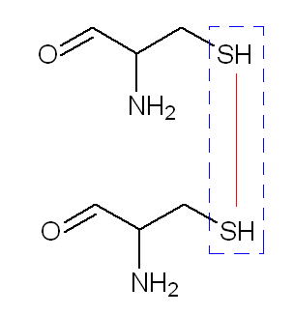
Figure 1: Two cysteines connect to each other by disulfide bonds [2].

The use of feather fiber as reinforcement materials for polymer matrix has drawn considerable interest from the engineering industry in recent years. A few studies have investigated feather fibers for biocomposite material applications, and it was found that materials which derived from feathers can be used advantageously as reinforcing materials in polymer matrix composites [3]. This is due to the considerations of developing an environmental friendly material and partly replacing currently used glass or carbon fibers in fiber reinforced composites. Some of the advantages of the FF are high specific strength and modulus materials, low priced and recyclable [4]. FF inclusion in a composite would potentially lower the overall density, compared with the density in a composite of synthetic reinforcement.

Nondegradable polymers as polymethyl methacrylate (PMMA) were widely used in various biomedical applications from the beginning of biometric development and have been an essential material in medicine and dentistry [5]. The popularity of PMMA is associated with its favorable working characteristics, processing ease, accurate fit, stability in the oral environment, superior esthetics, and the ability to be used with inexpensive equipment [6]. In this study, an exploration will be made on the use of feather fiber (FF) filled polymethyl methacrylate (PMMA) composite in the development of bio composite dental posts.

Materials and Methods
Materials
Commercial Goose Feather Fiber (FF) was purchased from the Shuttlecock (Malaysia). Polymethyl methacrylate (PMMA) pellets were supplied by Chi Mei Corporation (Taiwan) and trade name is PMMA Acryrex CM-205. MMT was obtained from Nanocor Inc., Arlington Heights, IL, USA (Nanomer 1.30 P) organically modiﬁed with octadecylamine with mean dry particle size of 16 – 22 µm. PMMA/FF based composites were produced in range 1 to 10 phr of FF fiber loading with and without 4 wt % of MMT.

Alkali Treatment Method
The feathers were cleaned using a constant pH of water, then treated by immersion in a 0.5 M sodium hydroxide (NaOH) aqueous solution for two hours at 25 ºC followed by washing with distilled water. The feathers were then, dried in a vacuum oven at 60 ˚C for 12 hours. The treated feather was crushed using a laboratory mixer, National Blender MX-491N. Only particles that pass through a sieve of mesh 20 (841 µm) were used in this study.

Fabrication of Composites
The mixing of each composite was prepared via Brabender plastograph EC (C. Melchers GmbH & Co Malaysia) set at a temperature of 180 °C which is an intermediary temperature between matrix and fiber and the mixing speed of 50 rpm is used to homogenize the composition. The mixing time for each composite formulation is 10 minutes for PMMA to melt. The hot melt composites were allowed to cool at room temperature. Each of the composites was compressed via Motor Hydrolic Lab Press (Gutrie Malaysia) to produce the composites in film form. The hot press machine was set at 180 ˚C for both top and bottom platens. The composites were put into the mold, preheated partially for 8 minutes, followed by full compression for 4 minutes at the same temperature and subsequently cooled under pressure for 4 minutes. This results in film approximately 1 mm and 2 mm in size. The composite in film form was used to prepare test specimens for testing analysis according to standard.

Characterization: Flexural Testing
The three point bending flexural test was performed on a Tensile Tester EZ 20 kN Lloyd at a crosshead speed of 1 mm min⁻¹ and span length of 40 mm under an ambient condition according to ISO 14125: 1998 specifications.

Morphological Analysis
The morphology of the SEM fractured surface of composites was observed by a scanning electron microscope (JEOL JSM-6390LV). The sample was mounted on an aluminium stub and sputtered coating with thin layers of gold about 12 µm thickness by using a JEOL JFC-1600 Auto-Fine coater in order to prevent any electrical discharge during testing.

Characterization Analysis
The nature of bonding of the fiber was characterized using a Perkin Elmer spectrum 2000 Fourier Transform Infrared spectroscopy (FTIR) at a spectral resolution of 4 cm⁻¹ over the spectral range of 4000-650 cm⁻¹.

Result and Discussion
Flexural Properties
Figure 2 and Figure 3 shows the flexural strength and modulus of FF/PMMA composites with and without MMT. Both types of composite showed increase in flexural strength and modulus with addition of FF. The flexural strength of the FF/PMMA/MMT composites is greater than FF/PMMA composites. The flexural strength values of FF/PMMA composites increased slowly from 57.08 MPa to 72.31 MPa while the flexural strength values of FF/PMMA/MMT composites increased linearly from 58.53 MPa to 78.82 MPa as shown in Figure 2. From Figure 3, it can be seen that flexural modulus also showed a similar trend as flexural strength, where increasing FF contents will increase the flexural modulus of the composites.

Figure 2: Flexural Strength of FF/PMMA and FF/PMMA/MMT composites.

Figure 3: Flexural Modulus of FF/PMMA and FF/PMMA/MMT composites.

Overall, it was observed that the flexural strength and flexural modulus of the composite improved with increasing FF contents into the FF/PMMA and FF/PMMA/MMT composites. The significant improvement in strength of the composites is possibly due to the role of NaOH treatment played as fiber surface modifier as shown in Figure 4 which enhance the bonding between the FF surface and PMMA matrix. The fiber is expected to act as a bridge to prolong the fracture process of composites. The presence of FF also restricts the mobility and deformability of the matrix, thus increased the modulus of FF/PMMA and FF/PMMA/MMT composites. Ramaniah et al. studied the effect of fiber loading on the mechanical properties of Borassus seed shoot fiber reinforced polyester composite [7]. They reported that by increasing the fiber content in the polyester matrix, the tensile strength and flexural properties also increased. They attributed this to the fact that the polyester resin transmitted and distributed the applied stress to Borassus fiber resulting in higher strength.

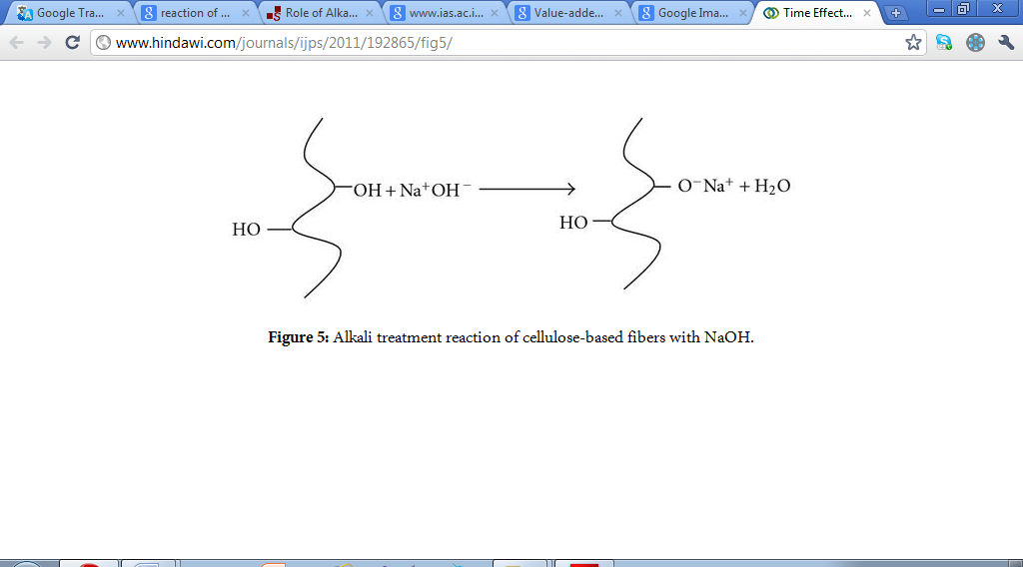
Figure 4: Alkali Treatment Reaction of Fiber with NaOH.

Besides, the incorporation of MMT led to substantial improvement in strength and exhibited the desirable reinforcement effect in modulus. This is probably due to the nanoscale structure, large aspect ratio and the corresponding strong interaction between polymer molecule chains and silicate surface. The formation of supramolecular assemblies obtained by the presence of dispersed anisotropic laminated nanoparticles.

Fourier Transform Infra Red Spectroscopy (FTIR) Analysis
The FTIR spectra of feather fiber (FF) and the FTIR spectra of FF/PMMA-10 and FF/PMMA/MMT-10 are shown in Figure 5 and Figure 6 respectively. Examining the three spectra in Figure 5 and Figure 6, a number of change can be distinguishable peaks.

Figure 5 shows infrared spectroscopy spectrum of the FF. The peak at 3280.63 cm⁻¹ was due to N–H (amine) group from an amino acid from FF. The peak at 2923.89 cm⁻¹ shows the C–H stretch. The characteristic peak of nitrile C–N stretch at 2360.26 cm⁻¹ and the peak at 1647.36 cm⁻¹ shows the C=C stretch. The peak at 1537.46 cm⁻¹ shows the C=C bending. On the other hand, the peak at 1235.37 cm⁻¹ related to C-O (carboxylic acid) originating mainly from amino acid of the feather fiber. Mishra et al. studied bio-waste reinforced epoxy composites [8] and found that, when the feather was treated with an alkali solution before mixing with resin, the chemical reaction between the matrix and reinforcement takes place which give rise to the formation of ester and amine.

Figure 5: FTIR spectrograph of the feather fiber (FF).

Figure 6 shows the FTIR spectra of FF/PMMA-10 and FF/PMMA/MMT-10 composites with fiber loading of 10 phr. Both spectra show similar characteristic peak patterns indicate OH groups from water of the feather fiber, sodium hydroxide solution and MMT at a frequency around 2947.55 cm⁻¹. The characteristic peaks of a C=O stretch are at 1724.06 cm⁻¹ and have been observed in both spectrums of FF/PMMA-10 and FF/PMMA/MMT-10 composites. The peaks which appeared around 1434.89 cm⁻¹ region in both spectra show C–H bending formation occurs. The peak at 1238.55 cm⁻¹ related to C-O (carboxylic acid) originating mainly from amino acid of the feather fiber respectively. The peak at 1142.49 cm⁻¹ indicated that nitrile C–N stretch in both composites. A previous study by Madejova (2003) revealed that the band appeared near 3620 cm⁻¹ is due to the stretching vibrations of structural O-H groups and a broad band near 3440 cm⁻¹ on the other hand is due to the O-H stretching vibrations of H₂O present in the clay [9].

Figure 6: FTIR spectrograph of FF/PMMA-10 and FF/PMMA/MMT-10 composites.

Scanning Electron Microscopy (SEM) Analysis
Morphological information of a composite after a mechanically induced break of composite with different composition was studied using SEM micrographs. Feather fiber (FF) and Polymethyl methacrylate (PMMA) are two kinds of materials with different physical properties and microstructures. The micrographs of fractured surfaces of FF containing 1, 5 and 10 phr FF composition are shown in Figure 7 (a - c) respectively. It can be observed that the FF distribution is uniform throughout the PMMA matrix. Better dispersion of FF results in strength enhancements, which allow stress to be fairly distributed. The FF particles were found embedded in a PMMA matrix with possibly through a certain degree of mechanical bonding between two phases and it is believed that only mechanical bonding exists between the FF and PMMA matrix. The presence of void on the matrix surface is believed as a result from deboned FF fiber and was bended during mechanical testing.

The keratin feather fiber should be compatible with hydrophobic polymers to some degree [10]. The amino acid sequence of feather keratin shows that the protein has 40 % hydrophilic and 60 % hydrophobic groups [11]. Castano et al. found that the FF keratin biofibers allows an even distribution within and adherence to polymers due to their hydrophobic nature [12]. Martínez-Hernández et al. studied the mechanical properties evaluation of new composites with protein biofibers reinforcing poly (methyl methacrylate)[13]. They reported the possibility of observing the keratin fiber-PMMA composites because of the good compatibility between these materials.

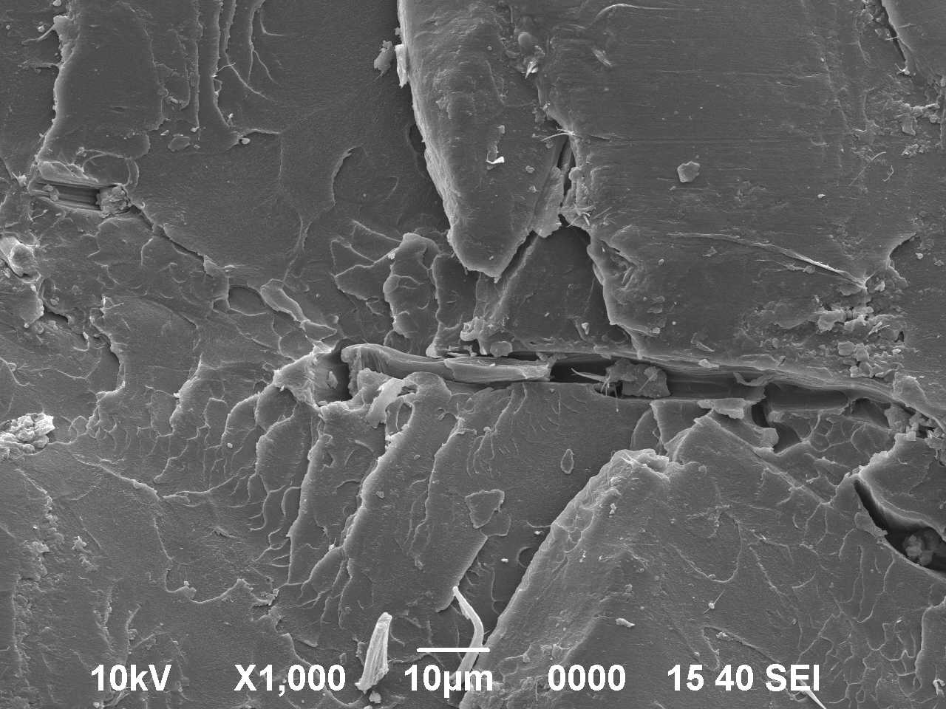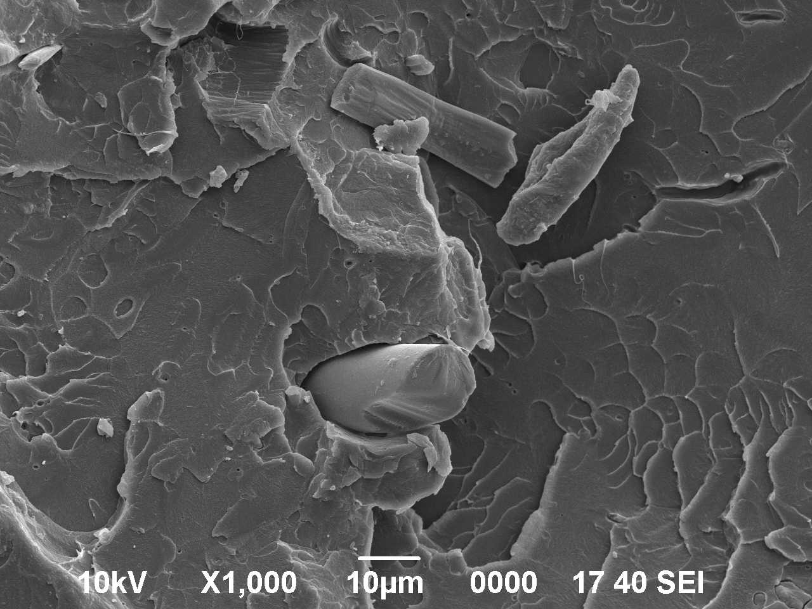
b
a
void
void
fiber
fiber
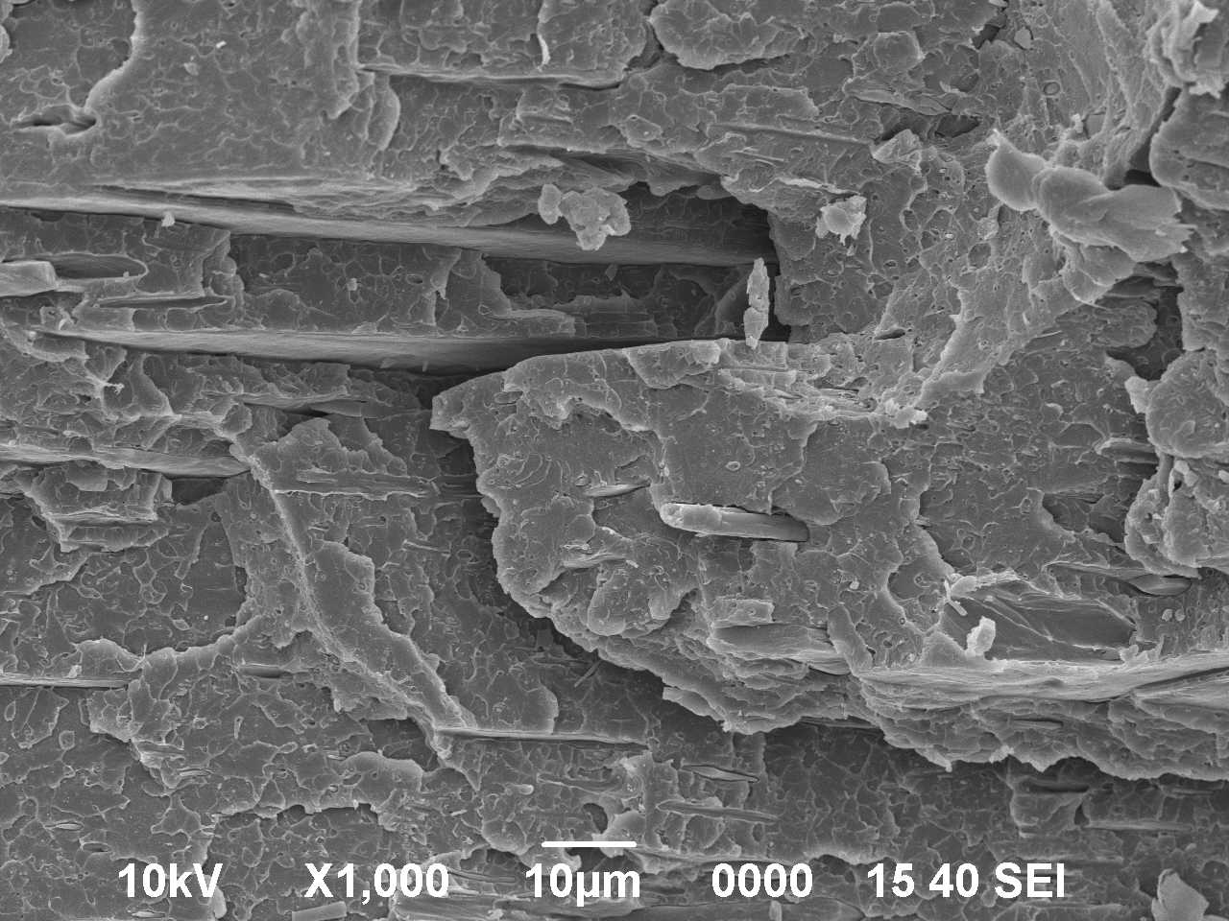
void
c
fiber
Figure 7: Morphology SEM micrographs fractured surfaces of FF containing 1, 5, and 10 phr composition. (a) FF/PMMA-1 (b) FF/PMMA-5 and (c) FF/PMMA-10 composites at 1000 X magnification.

Conclusion
The effect of FF loadings on the morphological and mechanical properties of FF/PMMA and FF/PMMA/MMT composites on were studied. The improvement in strength indicated an improvement in mechanical bonding between FF and PMMA matrix due to the homogenous distribution of FF in the polymer matrix. Incorporation of FF restricting the mobility and deformability of the matrix, thus increased the modulus. A substantial improvement observed in strength and modulus of FF/PMMA/MMT composites with the inclusion of MMT. SEM results revealed that only mechanical bonding between exist between FF and PMMA. The morphological characterization composites showed a relatively uniform distribution of the fiber in the polymer matrix.

Acknowledgements
This project was supported financially by the Ministry of Science, Technology & Innovation Malaysia, and the Ministry of Higher Education Malaysia (Vote No: 4L021). We would like to express our gratitude and deepest thanks to the Research Management Centre, Universiti Teknologi Malaysia (UTM), for managing the project.

References
- Kock J. W. (2006). Physical and Mechanical Properties of Chicken Feather Materials. Master School of Civil and Environmental Engineering, Georgia Institute of Technology.
- Alberts, B., Bray, D., Lewis, J., Raff, M., Robert, K., & Watson, J. D. (1994). Molecular Biology of the Cell. 3 ^{rd} edition. Garland Press. New York.
- Jeffrey, W. K. (2006). Physical and Mechanical Properties of Chicken Feather Material. Master of Science. Georgia Institute of Technology.
- Ananda R.V., Alok, S., & Mirsha, S. C. (2007). Polymer Composites Reinforced with Short Fibers Obtained from Poultry Feathers. Proceedings of International and INCCOM-6 Conference.
- Unemori, M., Matsuya, Y., Matsuya, S., Akashi, A., & Akamine, A. (2003). Water Absorption of Poly(methyl methacrylate) Containing 4-methacryloxyethyl Trimellitic Anhydride. Biomaterials. 24(8): 1381-1387.
- Nidal, W. E. (2006). Mechanical and Enviroment Properties of Denture Base Poly(methylmethacrylate) Filled by Brium Titanate. Master of Science. Universiti Sains Malaysia (USM).
- Ramanaiah. K, Ratna Prasad. A. V., & Hema Chandra Reddy, K. (2012). Effect of Fiber Loading on Mechanical Properties of Borassus Seed Shoot Fiber Reinforced Polyester Composites. Journal of Material Environment Science. 3(3): 374-378.
- Mishra, S. C., Nayak, N. B., & Satapathy, A. (2010). Investigation on Bio-waste Reinforced Epoxy Composites. Journal of Reinforced Plastics and Composites. 29(19): 3016-3020.
- Madejova, J. (2003). FTIR Techniques in clay Mineral studies. Vibrational Spectroscopy 31: 1-10.
- Barone, J. R., & Schmidt, W. F. (2005). Polyethylene Reinforced with Keratin Fibers Obtained from Chicken Feathers. Composites Science and Technology. 65(2): 173-181.
- Murayama-Arai K., Takahashi R., Yokote Y., Akahane K. (1983). Amino acid sequence of feather keratin from fowl. European Journal of Biochemistry. 132: 501 - 507.
- Castano V.M., Martinez-Harnandez A. L., Velasco-Santos C., & De-Icaza M. (2007). Dynamical- mechanical and thermal analysis of polymeric composites reinforced with keratin biofibers from chicken feathers, Composites B. 38(3): 405-410.
- Martínez-Hernández, A. L., Velasco-Santos, C., Icaza, M. d., & Castaño, V. M. (2005). Mechanical Properties Evaluation of New Composites with Protein Biofibers Reinforcing Poly(methyl methacrylate). Polymer. 46(19): 8233-8238.

