THE EFFECT OF BLEND RATIO ON PROPERTIES OF RECYCLED POLYPROPYLENE/RECYCLED HIGH DENSITY
POLYETHYLENE GEO- COMPOSITES

(Kesan Nisbah Adunan Ke Atas Sifat-Sifat Geo-Komposit Polipropilena Kitar Semula/Polietilena Ketumpatan Tinggi Kitar Semula)

A.A.S Mariam Atiqah¹, H.Salmah^{1*}, Z. Firuz¹, D.N.U. Lan¹

1School of Materials Engineering,
Universiti Malaysia Perlis,Taman Muhibah, Jejawi,
02600 Arau, Perlis,Malaysia.

*Corresponding author: irsalmah@unimap.edu.my

Abstract
The effect of blends ratio of Recycled Polypropylene (rPP) and Recycled High Density Polyethylene (rHDPE) on tensile properties of rPP/rHDPE geo-composites were studied. The increasing of rHDPE ratios has decreased the tensile strength and elongation at break of rPP/rHDPE geo-composites, but the modulus of elasticity increased. The effects of rPP ratios have enhance the tensile strength and modulus of elasticity of geo-composites. The elongation of break of rPP/rHDPE was decreased with increasing the rPP content. At similar blends ratio, the rPP/rHDPE geo-composites higher tensile strength and modulus of elasticity compared to rHDPE/rPP geo-composites. The MFI value of rPP/rHDPE higher than rHDPE/rPP blends. The SEM micrograph showed that rPP/rHDPE has smooth failure surface.

Keywords: recycled polypropylene, recycled high density polyethylene, tensile properties, blends, geo-composites.
Abstrak
Kesan nisbah adunan ke atas sifat- sifat tegangan geo komposit polipropilena kitar semula (rPP)/ polietilena ketumpatan tinggi kitar semula (rHDPE) telah dikaji. Peningkatan nisbah rHDPE telah mengurangkan kekuatan tegangan dan rPP/rHDPE tetapi meningkatkan ketegangan modulus. Kesan nisbah rPP telah meningkatkan kekuatan tegangan dan pemanjangan geo- komposit. Pemanjagan rPP/rHDPE telah menurun dengan peningkatan kandungan rPP. Pada campuran nisbah yang sama, rPP/rHDPE geo-komposit kekuatan tegangan modulus tinggi berbanding rHDPE/rPP geo-komposit. Nilai MFI adunan rPP/rHDPE lebih tinggi berbanding adunan rHDPE/rPP. Mikrograf SEM menunjukkan rPP/rHDPE mempunyai permukaan yang licin.

Kata kunci: polipropilena kitar semula, polietilena ketumpatan tinggi kitar semula, sifat-sifat tegangan, adunan, geo-komposit

Introduction
For the past ten years, total consumption of plastics and the range of their practical application had demonstrated significant increase [1]. This development is caused by the properties of the plastic materials, also with their adaptability and lower manufacturing cost [2]. Once plastics become waste at the end of their functional usage, they could lead to a serious environmental problem [3]. These plastic wastes are almost non-degraded in the natural environment even after being exposed to extreme weather [4]. Hence, recycling of plastics has become an alternative method in reducing the plastic wastes [4].
Recycled high density polyethylene (rHDPE) and recycled polypropelene (rPP) were used in this study to accomplish solid waste reduction and to achieve advance development of sustainable materials [5]. High Density Polyethylene (HDPE) and PP are nearly not degraded in the natural environment although had been in a long period of exposure [6]. The slow degradation properties of these plastics give off worthful properties as construction material [6, 7]. In today’s construction, the presence of weak layers consists of soft soil has led to applications of various types of ground improvement techniques [8]. Common types of geosynthetics used for soft soil reinforcement are geotextiles (particularly woven geotextiles), geogrids and geocells [8-9]. The main aim of developing construction geo-composites from recycled plastic are to reduce resource consumption, direct or indirect harmful emissions and to produce environmentally-friendly product that meet functional criteria as the conventional product [7]. The development of construction materials from recycled plastics is important to both construction and plastic recycling industries.
This study is aim to investigate effect of blend composition of Recycled Polyproylene (rPP) and Recycled High density polyethylene (rHDPE) blends geo-composite on tensile properties.
Materials and Methods
Materials
The recycled HDPE and recycled PP were obtained from SLT. Plastic Sdn. Bhd., Penang, Malaysia. The density of rHDPE and rPP were 0.92 g/cm3 and 0.9 g/cm3. Melt flow index (MFI) of rHDPE and rPP were 0.93 g/10min and 4.03 g/10min at 230°C, respectively.

Preparations of rHDPE/rPP blends
The rHDPE/rPP blends were prepared using co-rotating twin screw extruder. The temperatures in all three zones of the extruder and die exit were set to 180⁰C, and the speed was set at 180 rpm. The extrudates were fed directly into the pelletizer. The samples were compress with compression molding. The compression procedure involve preheat at 3 minutes, compress at 2 minutes and followed by cooling at 4 minutes. Table 1 shows the formulation of rPP/rHDPE blends.

Table 1. Formulation of rPP/rHDPE blend
Materials | Blends 1 | Blends 2
rPP (php) | 100, 80, 70, 60, 50 | 0, 20, 30, 40, 50
rHDPE (php) | 0, 20, 30, 40, 50 | 100, 80, 70, 60, 50
*php= part per hundred polymer
Tensile testing
Tensile test was done according to ASTM D638. Testing was done at room temperature by using a crosshead speed of 20 mm/min. The mean value of five specimens of each sample was taken. The value of tensile strength, elongation at break and modulus of elasticity were calculated from software.

Melt flow index
Melt flow index measurement was carried out according to ASTM 1238 using GoTech MFI machine. The die diameter and length were 8 mm and 2095 mm, respectively. The entry angle was 180°. The testing temperature was set at 230°C with load 2.16 kg. Melt flow index (MFI) values of the blends were measured and recorded.

Morphology
The morphology of tensile fracture surfaces of blends were examined with scanning electron microscope (SEM) model JEOL 6460 LA. The fracture surfaces of the samples were sputter coated with thin layer of palladium before analyzed to avoid electrostatic charging during examination.

Results and discussion
Figure 1 show the results from tensile strength of rPP/rHDPE and rHDPE/rPP with different blend ratios. The tensile strength of rPP/rHDPE blends decreased with increasing rHDPE content. The reduced value of tensile strength of blend was due to the addition of rHDPE that influenced the strength of the blends. The tensile strength of rHDPE/rPP blends increased with rPP content increase. This is due to the increasing content of rPP that has a rigid short methyl group attached to every second carbon atom of the polymer chain. The restriction of the chain rotation produce a stronger but less flexible material compared to rHDPE. The tensile strength for pure HDPE is 24 MPa and theoretically as recycled plastics rHDPE tensile strength is in the range of 20.9 - 34.2 MPa [4, 10]. In this study, the tensile strength of rHDPE is 21.5 MPa. However, the tensile strength of rPP is almost the same as virgin PP which is 30.2 -35.0 MPa [4, 11].

Figure 2 shows the value of elongation at break of rPP/rHDPE blend increased with increasing rHDPE content. This due to the elongation at break of virgin rHDPE is higher than virgin rPP. Hence, the addition of rHDPE gives significant increment to the elongation at break of rPP/rHDPE blends. . At different blend ratios of the rHDPE/rPP, the elongation at break decreased. This is due to the presence of additives in the rPP that give rigid behavior to the recycled thermoplastic. It was found that the rPP/rHDPE blends show lower elongation at break compared to rHDPE/rPP.

Figure 1. Effect of different blend ratios on tensile strength of rPP/rHDPE and rHDPE/rPP

Figure 2. Effect of different blend ratios on elongation at break of rPP/rHDPE and rHDPE/rPP.
As the rHDPE content increased, there was signifcant reduction in tensile strength and modulus of elasticity. This result clearly indicates that the addition of rHDPE can influenced the tensile properties. The modulus of elasticity rPP/rHDPE and rHDPE/rPP blends is shown in Figure 3. The results show that increasing of rHDPE content in rPP/rHDPE blends has decreased the modulus of elasticity of the blends. The lower value of modulus of elasticity of rPP/rHDPE blends attributed to the addition of rHDPE that reduced the stiffness of the blends. Modulus of elasticity of virgin rHDPE is lower than modulus of elasticity of virgin rPP which shows that virgin rHDPE has lower stiffness than rPP. At similar blend ratios the modulus of elasticity of rHDPE/rPP blend increased with blend ratios.

Figure 3. Effect of different blend ratios on modulus of elasticity of rPP/rHDPE and rHDPE/rPP.
Melt flow index is described as weight of polymer in grams flowing in 10 minutes through a capillary of specific diameter and length by a pressure applied by prescribed alternative gravimetric weight under prescribed temperature [12-13]. Figure 4 shows the MFI value of the of rPP/rHDPE and rHDPE/rPP blends. From Figure 4, it shows that the increasing of rPP content from 20 to 50 php had change the melt behavior of the blends. The MFI values of rPP/rHDPE blends decreased with increasing rHDPE content. This is due to the rHDPE structure that consist of little branching which restrict the mobility of the short part of the chain or side groups of the blends and lead to small changes of the melt flow. At different blend ratios, the MFI values of rHDPE/rPP blends increased with rPP content increases. This is due to the incorporation of rPP that have high melt flow index compared to rHDPE and ease the flowability of blends.

Figure 4. Effect of different blend ratios on melt flow index of rPP/rHDPE and rHDPE/rPP blends.

Figures 5 - 8 showed the scanning electron micrograph of tensile fractured surfaces of the rPP/rHDPE and rHDPE/rPP blends at different blend ratios, respectively. Figure 5 and 6 present the homogenous surface of rPP and rHDPE which exhibit rHDPE showed ductile tearing mode and rPP showed rough tearing. SEM micrograph of rPP/rHDPE at 80/20 blend ratio xhibit the smooth fracture surface as shown in Figure 7, meanwhile the SEM morphology of rHDPE/rPP at 80/20 blend ratio indicated the rough surface.

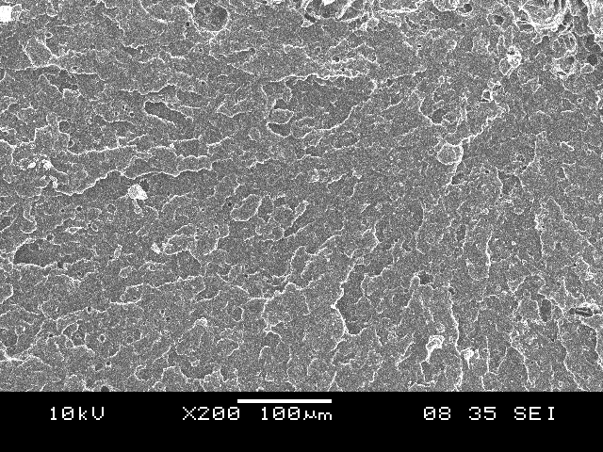
Figure 5. Scanning electron micrograph of tensile fracture surface of rPP.

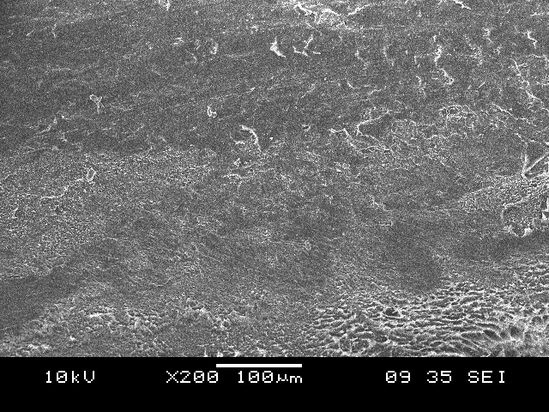
Figure 6. Scanning electron micrograph of tensile fracture surface of rHDPE.

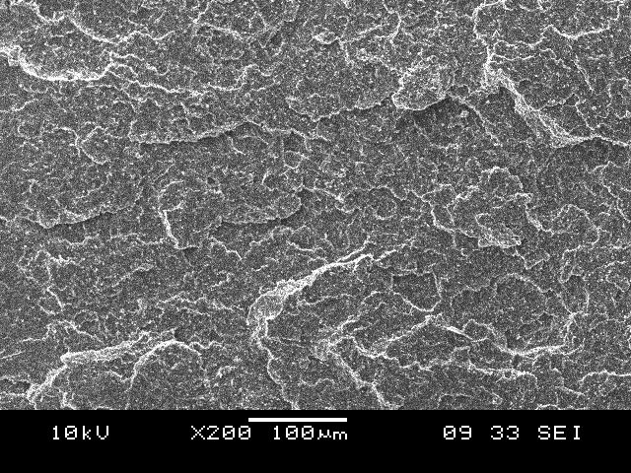
Figure 7. Scanning electron micrograph of tensile fracture surface of rPP/rHDPE blends at 80/20 composition.

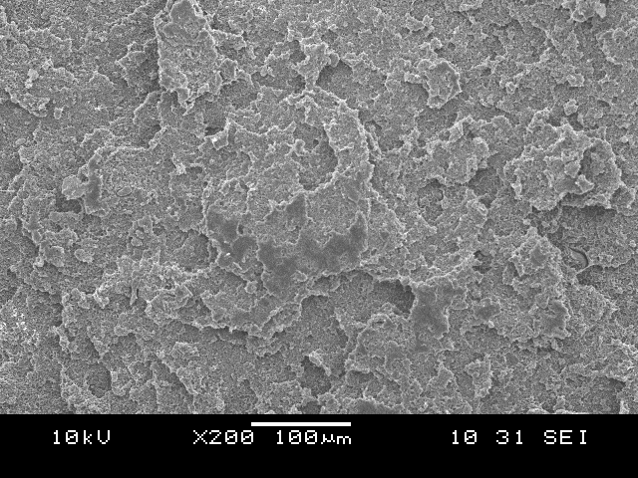

Figure 10. Scanning electron micrograph of tensile fracture surface of rHDPE/rPP blends at 80/20 composition.
Conclusion
The effect of rPP content has increase the tensile strength and the modulus of elasticity but reduced elongation at break. The addition of rHDPE has decreased the tensile strength and also modulus of elasticity but increased the elongation at break. The MFI values of rPP/rHDPE blends decreased with increasing rHDPE content. The presence of rPP in the blends of rHDPE/rPP blends had increased the flowability of the blends. The SEM study proved that the morphology of rPP/rHDPE blends showed the smooth failure surface, whereas rHDPE/rPP has rough failure surface.
Acknowledgement
This research was supported by Ministry of Higher Education (MOHE) for providing MTUN CEO Grant No. 9016-00001.
References
- Rahman M.M., Islam M.A., Ahmed M. (2012). Recycling of Waste Polymeric Materials as a Partial Replacement for Aggregate in Concrete. International Conference on Chemical, Environmental and Biological Sciences (ICCEBS’2012), Penang, Malaysia.
- Sukunya C. A study of compatibilization and properties of recycled high densitypolyethylene/polyethylene teraphthalate blends. Institute of Engineering, Polymer Engineering, Suranaree University of Technology, (2007) MSc Thesis.
- Albano L. & Sanchez G. (1999). Study of the Mechanical, Thermal and Thermodegradative Properties of Virgin PP with Recycled and Non Recycled HDPE. PolymerEngineering and Science. 39(8): 1456-1462.
- La Mantia F. (2002). Handbook of Plastic Recycling. Rapra Technology Ltd., Shropshire,UK, London. pg.132-167
- Oza S.,Wang R., Lu N. (2011). Thermal and Mechanical Properties of Recycled High Density Polyethylene/hemp Fiber Composites. International Journal of Applied Science and Technology,1 (5), 31-36.
- Batayney M., Marie I., Asi I. (2007). Use of selected waste materials in concrete mixes. Faculty of Engineering, Civil Engineering Department, The Hashemite Univeristy, Jordan. Waste Management, 27: 1870-1876.
- Siddique R., Khatib J., Kaur I. (2008). Use of Recycled plastic in concrete: A review. Waste Management, 28: 1835-1852.
- Fasanella E.L., Jackson E.K., Kellas S. (2007). Soft Soil Impact testing and Simulation of Aerospace Structures. NASA langley Research Center, Hampton, Virginia, US.
- Palmeira E.M., Tatsuoka F., Bathurst R.J., Stevenson P.E., Zornberg J.G. (2008). Advances in Geosynthesis Materials and Applications for Soil Reinforcement and Environmental Protection Works. Electronic Journal of Geothecnical Engineering: 1 - 38.
- Vijay C., John S.K.,Thomas J., George J.N. (2010). World’s First Thermoplastic Bridges. Parsons Brinckerhoff Inc. New York.
- Pan B., Ning N., Liu J.,Bai L., Fu Q. (2009). Mechanical Properties of SMC Whisker Reinforced High Density Polyethylene Composites. Chinese Journal of Polymer Science, 27 (2), 267 – 274.
- Lei Y.,Wu Q.,Yao F.,Xu Y. (2007). Preparation and Properties of recycled HDPE/natural fiber composites. Composites: Part A, 38, 1664-1674.
- Shenoy A.V., Saini D.R., Nadkarni V.M. (1984). Melt rheology of polymer blends from melt flow index. International Journal of Polymeric Materials and Polymeric Biomaterials, 10,231-235.
- Utracki L.A. (1983). Melt flow of polymer blends. Polymer Engineering and Sciences: Polymer Blends. 23(11), 602-609.

