DETERMINATION OF MODAFINIL IN TABLET FORMULATION USING THREE NEW VALIDATED SPECTROPHOTOMETRIC METHODS

(Penentuan Modafinil Dalam Formulasi Tablet Menggunakan Tiga Kaedah Spektofotometrik Ditentusahkan)

Pawan Kumar Basniwal^{1,2}* and Deepti Jain¹
¹School of Pharmaceutical Sciences, Rajiv Gandhi Technological University, Bhopal – 462033, Madhya Pradesh, India

² LBS College of Pharmacy, Jaipur – 302004, Rajasthan, India

*Corresponding author: pawanbasniwal@gmail.com

Abstract

In this study, three new UV spectrophotometric methods viz. linear regression equation (LRE), standard absorptivity (SA) and first order derivative (FOD) method were developed and validated for determination of modafinil in tablet form. The Beer-Lambert’s law was obeyed as linear in the range of 10-50 μg/mL and all the methods were validated for linearity, accuracy, precision and robustness. These methods were successfully applied for assay of modafinil drug content in tablets in the range of 100.20-100.42%, 100.11-100.58% and 100.25-100.34%, respectively with acceptable standard deviation (less than two) for all the methods. The validated spectrophotometric methods may be successfully applied for assay, dissolution studies, bio-equivalence studies as well as routine analysis in pharmaceutical industries.

Keyword: Modafinil, linear regression equation, standard absorptivity, first order derivative, tablets.

Abstrak

Dalam kajian ini, tiga kaedah spektrofotometri UV baru iaitu persamaan regresi linear (LRE), daya penyerapan piawai (SA) dan terbitan tertib pertama (FOD) kaedah telah dibangunkan dan distentusahkan terhadap penentuan modafinil di dalam bentuk tablet. Hukum Beer-Lambert telah dipatuhi sebagai linear dalam julat kepekatan 10-50 μg/mL dan semua kaedah telah ditentusahkan tehadap kelinearan, ketepatan, kejituan dan keteguhan. Kaedah-kaedah ini telah berjaya diaplikasi bagi ujikaji kandungan dadah modafinil di dalam bentuk tablet iaitu masing – masing pada julat 100.20 – 100.42%, 100.11 – 100.58% dan 100.25-100.34%, dengan sisihan piawai yang boleh diterima (kurang dari dua) untuk semua kaedah. Kaedah spektrofotometri disahkan berjaya digunapakai terhadap ujikaji pelatutan, kajian bio-kesetaraan serta analisis rutin di dalam industri farmaseutikal.

Kata kunci: Modafinil, persamaan regresi linear, keberserapan standard, perintah pertama terbitan, tablet.

Introduction

Chemically, modafinil (AMD) is 2-(benzhydryl sulfinyl)acetamide (Figure 1) and its R-enantiomer is known as armodafinil. It is a non-amphetamine, wakefulness-promoting agent which is indicated for use in patients with excessive sleepiness associated with narcolepsy, obstructive sleep apnoea/hypopnoea syndrome or shift work sleep disorder [1]. It is active metabolite of adrafinil [2-(benzhydrylsulfinyl)-N-hydroxyacetamide] (Figure 1), which is one of the psychostimulants causing behavioral activating effects. Adrafinil is also metabolized into modafinil acid.
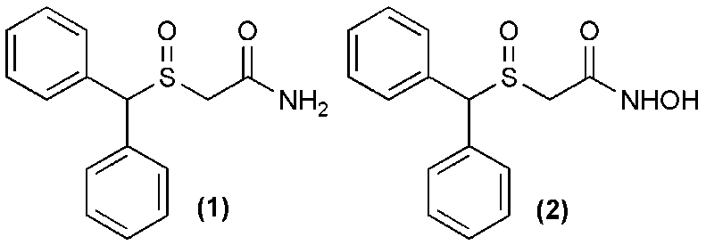
Figure 1. Structure of modafinil (1) and adrafinil (2).

The pharmacokinetics of adrafinil was investigated by liquid chromatography/tandem mass spectrometric (LC–MS/MS) method along with determination of its metabolite [2]. Very few analytical chromatographic methods were reported for determination of armodafinil in human plasma [3] and in plasma and urine [4]. Armodafinil also was determined by HPLC along with its synthetic intermediates [5-6] and enantiomeric determination was reported by capillary electrophoresis with sulfobutyl ether-β-cyclodextrin as chiral selector [7]. Spectrophotometric methods may be suitable for routine analysis as these are economic, rapid, simple, maintenance-free, and show comparable accuracy and precision with chromatographic methods [8-9]. Hitherto, as per knowledge of authors, there is no UV spectrophotometric method reported in literature for the determination of modafinil. Thus, the aim of present work was to develop spectrophotometric assay methods for determination of modafinil in the bulk drug and pharmaceutical dosage forms.

Materials and Methods
Instruments, reagents and chemicals
Ultraviolet spectrophotometer (1700 series and 1800 series Shimadzu) with 1 cm matched quartz cells were used for the measurement of absorbance of samples. Shimadzu-Ax-200 electronic balance was used for weighing. Modafinil WS (working standard) was procured from APL Research Centre (A Division of Aurobindo Pharma Limited) Hyderabad, India, as a gift sample. Analytical grade of methanol was procured from Merck Specialities, Private Limited, India and Distilled water was prepared in-house by distillation assembly. Modafinil (AMD) tablets (Armod-50, Emcure Pharmaceutical Ltd., Jammu, India) were purchased from local market.

Linear regression equation (LRE) method
About 10 mg of modafinil (AMD) was accurately weighed and dissolved in 1 mL of methanol and volume was made upto 10 mL by distilled water (1000 μg/mL, Stock P). The aliquot of stock P was diluted by 10% aqueous methanol to get stock Q of 100 μg/mL. Aliquots of stock Q were further diluted to get concentration of 10, 20, 30, 40, and 50 μg/mL of AMD and these dilutions were scanned in the range of 400-200 nm against 10% aqueous methanol as blank. The absorbances of the dilutions were measured at its absorbance maxima 252 nm and linear regression equation was calculated.

Standard absorptivity (SA) method
As per LRE method, five standard dilutions were prepared in triplicates and their absorbances were measured against 10% aqueous methanol as blank. These observations of the absorbance were used to determine standard absorptivity A (1%, 1cm) and molar extinction coefficient ε; which would be used to determine the AMD content of dosage forms.

First order derivative (FOD) method
As per LRE method, five standard dilutions were prepared and their absorbance was measured in first order derivative mode of Gaussian spectra against 10% aqueous methanol as blank. The absorbances were measured at 234 nm and linear regression equation for the FOD method was calculated.

Validation of methods
As per ICH guidelines, [10-11] the developed all three methods were validated. Five standard serial dilutions were prepared in triplicate linearity and repeatability (within day). The accuracy of the methods was assured by recovery method (standard addition to pre-analysed samples); intermediate precision was determined by three variables viz. days, analyst and instrument variation; methanol variation in solvent system was studied for the robustness (9, 10 and 11 %).

Dosage formulation analysis
Twenty AMD tablets (Armod-50, Emcure Pharmaceutical Ltd., Jammu, India) were weighed and finely powdered; a quantity equivalent to 50 mg of AMD was sonicated to dissolve in 10 mL of methanol. The solution was filtered through Whatman filter paper No. 41 and volume was made upto 100 mL by distilled water to give Stock I. Aliquots of stock I were diluted to obtain sample concentrations (20, 30 and 40 μg/mL) in the range of linearity. The absorbance values of these sample solutions were observed in Gaussian and derivative mode of spectra. The absorbances were used to determine drug content by the respective validated method.

Result and Discussion
Linear regression equation (LRE) method
AMD drug is soluble in methanol and acetone and insoluble in water. Different percentages of methanol as solvent for spectrophotometric analysis were tried to make the method more eco-friendly and cost-effective for routine analysis. The minimum concentration of methanol was 10%; in which drug was soluble and give characteristic Gaussian spectra (Figure 2). Acetone was not preferred due to its cut-off wavelength is higher than methanol. The drug AMD was found to be stable in the aqueous solution as there was no deviation from Gaussian spectrum after one week storage of the stock solutions. The six replicates of all dilutions were processed for the linear regression method and the linear regression equation was found to be Y = 0.003 x + 0.002 with correlation coefficient R² = 0.999 as shown in Figure 3.

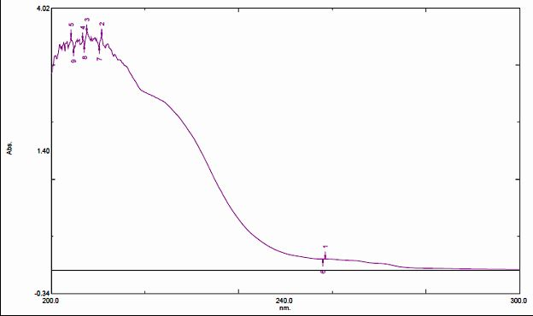
Figure 2. Gaussian spectrum of AMD in 10% methanol.

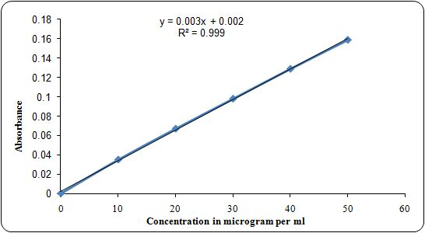
Figure 3. Linear regression line for LRE method.
Standard absorptivity (SA) method
The standard absorptivity A (1%, 1cm) and molar extinction coefficient (ε) were determined from absorbances of serial dilutions (10, 20, 30, 40 and 50 µg/mL) in three replicates, which were found to be 41.017 dl/g/cm and 1121.191 Mol⁻¹ cm⁻¹, respectively (Table 1). This standard absorptivity A (1%, 1cm) of AMD may be used for direct determination of drug content in tablet formulation in single step using single UV observation of drug sample.
Table 1. Standard absorptivity A (1%, 1cm) and molar extinction coefficient (ε)
Conc. (µg/mL) | Absorbance at 252 nm |  |  | Standard Absorptivity
Conc. (µg/mL) |  |  |  | [A (1%, 1cm) = A/bc]
Conc. (µg/mL) | I | II | III | I | II | III
10 | 0.035 | 0.048 | 0.045 | 35.0 | 48.0 | 45.0
20 | 0.067 | 0.091 | 0.090 | 33.5 | 45.5 | 45.0
30 | 0.098 | 0.135 | 0.136 | 32.7 | 45.0 | 45.3
40 | 0.129 | 0.175 | 0.177 | 32.3 | 43.8 | 44.3
50 | 0.159 | 0.222 | 0.219 | 31.8 | 44.4 | 43.8
A (1%, 1 cm)* dl/g/cm |  |  |  |  | 41.017
ε ** Mol⁻¹cm⁻¹ |  |  |  |  | 1121.191
* Mean of 15 above standard absorptivities determination; **Molar extinction coefficient ε = A (1%, 1cm) x Molecular weight/10.

First order derivative (FOD) method
The first order derivative mode of Gaussian spectra was used to nullify the effect of other analytes in determination of AMD (Figure 4). FOD technique is very useful in spectrophotometry, which is additional tool and resolve various analytical problems where chances of interference in absorbance by other analyte. The absorbances in derivative mode of six replicates of all standard serial dilutions were processed for the linear regression method and the linear regression equation was found to be Y = 0.03 x - 0.000 with correlation coefficient R² = 0.999 (Figure 5).
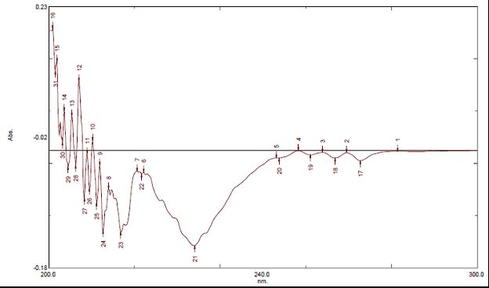
Figure 4. First order derivative of Gaussian spectrum of AMD in 10% methanol.

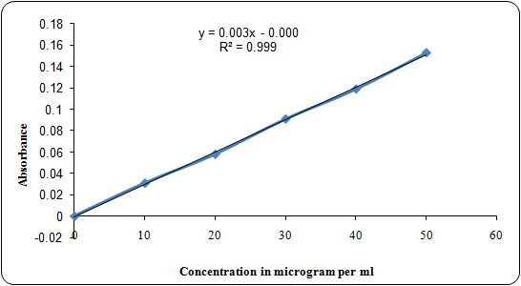
Figure 5. Linear regression line for FOD method.
Validation of the methods
All three methods were validated as per ICH guidelines to assure the reliability and applicability of the methods. Results of validation parameters for all three methods were summarized in Table 2.

Table 2. Results of validation parameters for all three methods
Validation parameter | % Result Obtained (mean)* ± SD
Validation parameter | LRE method | SA method | FOD method
Linearity | 99.89 ± 0.081 | 100.93 ± 0.087 | 100.12 ± 0.057
Accuracy | 100.63 ± 0.092 | 100.83 ± 0.092 | 100.12 ± 0.082
Precision
I. Repeatability | 99.79 ± 0.086 | 101.06 ± 0.063 | 99.85 ± 0.043
II. Intermediate precision
- Days | 100.94 ± 0.031 | 99.98 ± 0.073 | 100.04 ± 0.059
- Analysts | 99.98 ± 0.099 | 100.45 ± 0.089 | 100.86 ± 0.042
- Instruments | 100.75 ± 0.071 | 99.79 ± 0.062 | 99.96 ± 0.084
Robustness
35° C | 100.42 ± 0.059 | 100.05 ± 0.079 | 101.01 ± 0.076
30° C | 100.08 ± 0.094 | 99.79 ± 0.083 | 99.86 ± 0.065
25° C | 99.88 ± 0.069 | 100.32 ± 0.049 | 99.93 ± 0.082
* mean of six dilutions in three replicates. SD = standard deviation.
The Beer-Lambart’s law was obeyed at the concentration of 10-50 µg/mL and the linearity for the all the methods (LRE, SA and FOD method) were determined as 99.89 %, 100.93% and 100.12% respectively (Table 2), which were acceptable as standard deviation was within limit (0.057-0.087). Recovery method was adopted to assure the accuracy of the methods which was found to be in between 100.12-100.83% by all the methods with far less than one unit of standard deviation. The repeatability and intermediate precision were studied to assure the precision of the methods. The repeatability of the methods was found in between 99.79-101.06%. The intermediate precision was studied for variation in day of analysis, analyst-to-analyst and instrument-to-instrument. The results for all variations were within 99.79-100.94% limit for all methods. Robustness study was performed to assure the reliability of the methods over the temperature variation (25-35° C) during analysis of the drug and the variation results were in between 99.86-101.01% with low standard deviation. Therefore, results of the validation parameters were proved that all methods may be equally applicable.

Dosage formulation analysis
The AMD drug was freely soluble in methanol; the drug powder of tablets was sonicated in methanol to extract the drug content (AMD) from the tablet powder and finally the stock was prepared in 10% aqueous methanol. All the three methods were applied to determine the drug content in tablet formulation which was found to be in the range of 99.36-101.28%, 99.48-101.09% and 99.78-101.05%, respectively (Table 3). The standard deviation was found in the range of 0.42-0.69, which was acceptability of the all method.

At 95% confidence interval, P value less than 0.05 is considered significant. Results showed P value for tablet analysis using validated methods at all concentration levels was found to be, non-significant as: 0.904, 0.647 and 0.428 respectively. Even different concentration levels (20, 30 and 40 µg/mL) in individual method was also not significant with P value 0.774, 0.282 and 0.949 (Table 3).

Table 3. Analysis of AMD tablets.
Batch ↓ | AMD % found in modafinil tablets
Batch ↓ | LRE method |  |  | SA method |  |  | FOD method
Conc. (µg/mL) → | 20 | 30 | 40 | 20 | 30 | 40 | 20 | 30 | 40
I | 100.76 | 99.85 | 100.34 | 100.63 | 101.09 | 100.84 | 99.96 | 100.93 | 100.01
II | 99.92 | 100.67 | 101.12 | 100.92 | 100.02 | 100.06 | 101.05 | 99.87 | 99.93
III | 101.28 | 99.79 | 99.75 | 99.92 | 100.13 | 99.79 | 99.78 | 100.16 | 101.02
IV | 100.39 | 100.73 | 99.68 | 100.06 | 99.48 | 101.07 | 100.76 | 100.73 | 99.97
V | 100.82 | 100.75 | 100.29 | 100.26 | 100.16 | 101.01 | 100.47 | 99.85 | 100.06
VI | 99.36 | 100.47 | 100.02 | 99.89 | 99.78 | 100.73 | 99.99 | 99.93 | 100.81
Mean | 100.42 | 100.38 | 100.20 | 100.28 | 100.11 | 100.58 | 100.34 | 100.25 | 100.30
SD | 0.69 | 0.44 | 0.53 | 0.42 | 0.54 | 0.53 | 0.51 | 0.47 | 0.48
P value* | 0.774 |  |  | 0.282 |  |  | 0.949
Conc. (µg/mL) → | 20 |  |  | 30 |  |  | 40
P value** | 0.904 |  |  | 0.647 |  |  | 0.428
* P value (P trend) of all three concentration levels for the method. ** P value (Pearson Chi Square) of all three methods for the concentration

Conclusion

Three new spectrophotometric methods were developed and validated as per ICH guidelines and these were successfully applied for determination of modafinil in tablet formulation. All the methods were equally applicable for the assay of AMD and these may be applied for assay, dissolution studies, bio-equivalence studies as well as routine analysis in pharmaceutical industries.

Acknowledgement

One of the authors, Pawan Kumar Basniwal is earnestly indebted to Science and Engineering Research Board (SERB), DST, New Delhi, for the financial support for this research work under Fast Track Scheme for Young Scientists. Authors are highly thankful to Head, School of Pharmaceutical Sciences, RGPV, Bhopal and Principal, LBS College of Pharmacy, Jaipur for providing the experimental facilities for this research work.

References
- Keating, G.M., Raffin, M.J. (2005) Modafinil: a review of its use in excessive sleepiness associated with obstructive sleep apnoea/hypopnoea syndrome and shift work sleep disorder. CNS Drugs, 19(9): 785-803.
- Rao, N.R., Shinde, D.D., Talluri, M.V.N., Agawane, S.B., (2008). LC–ESI-MS determination and pharmacokinetics of adrafinil in rats. Journal of Chromatography B, 873: 119–123.
- Devadiga, M. P., Anandan, P., Mukhopadhyay, A. (2011). Development of a rapid and sensitive method for estimation of armodafinil in human plasma by LCMS/MS. International Journal of Applied Biology and Pharmaceutical Technology, 2(1): 323-327.
- Schwertnera, H. A., Kong, S. B. (2005). Determination of modafinil in plasma and urine by reversed phase high-performance liquid-chromatography. Journal of Pharmaceutical and Biomedical Analysis, 2005; 37, 475–479.
- Rao, N. R., Shinde, D.D., Kumar T.M.V. (2008). Enantioselective HPLC resolution of synthetic intermediates of armodafinil and related substances. Journal of Separation Science, 31(6-7): 981-989.
- Rao, N. R., Shinde, D.D., Ramesh, V., Srinivas, R. (2009). LC-MS of novel narcoepileptics and related substances. Journal of Separation Science, 32: 1312–1322.
- Wang, W., Xiang, S., Zhou, X., Ji, Y., Xiang, B. (2012). Enantiomeric separation and determination of the enantiomeric impurity of armodafinil by capillary electrophoresis with sulfobutyl ether--cyclodextrin as chiral selector. Molecules, 17: 303-314.
- Basniwal, P. K., Kumar, V., Shrivastava, P.K., Jain, D. (2010). Spectrophotometric determination of cilostazol in tablet dosage form. Tropical Journal of Pharmaceutical Research, 9(5): 499-503.
- Jain, D., Basniwal, P. K. (2013). Spectrophotometric determination of olopatadine hydrochloride in eye drops and tablets Journal of Pharmaceutical Research,12(2): 48-52.
- Text on Validation of Analytical Procedures. International conference on harmonization of technical requirements for registration of pharmaceutical for human use; Geneva; 2000.
- Validation of Analytical Procedure: Methodology; International conference on harmonization of technical requirements for registration of pharmaceutical for human Use; Geneva; 2000.

